How do I request a direction to be reissued?

This quick reference guide demonstrates how to request the reissue of a direction that has been previously issued for your consignment. The direction will be sent to the email address that is currently held in Australian Import Management System (AIMS).

1. Request a direction reissue
   1. Home page

Go to the Cargo Online Lodgement System.

Select **Request a Direction Reissue.**

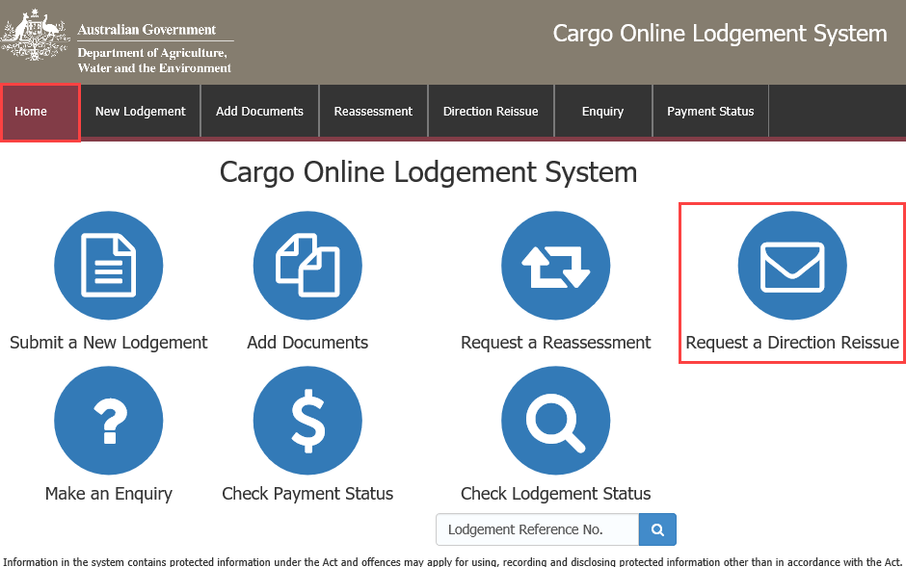

* 1. Entry details

Enter your **Full Import Declaration (FID)/Entry number** and your **Broker /Importer Branch ID**.

Your Entry Number is the number allocated from AIMS when you lodge your consignment.

Select .

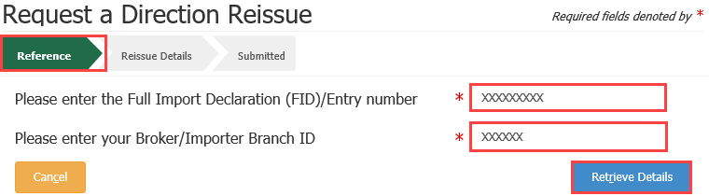

* 1. Reissue details

Using the radio buttons, select **Yes** if you wish to have the direction reissued to your email address recorded in AIMS.

If you select **No,** you will be prompted to enter a new **Distribution email**.

Declaration

Select the General Declaration check box to declare that the information provided in this form is true and correct.

Read the Privacy statement.

Select .

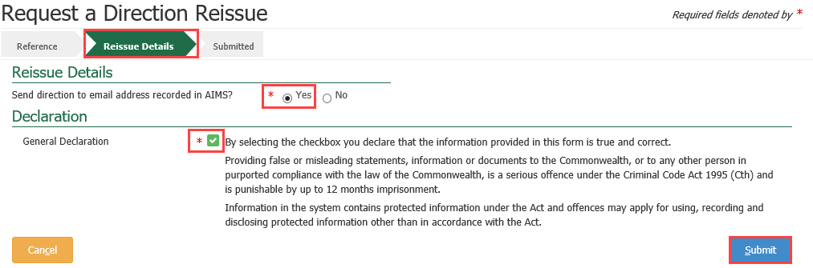

* 1. Submitted

You will receive confirmation that your request has been submitted. Record your **Lodgement Reference Number (LRN)** for future reference.

***TIP:*** *This is your unique number that can be used to identify your consignment when using other parts of the Cargo Online Lodgement System.*

Select .

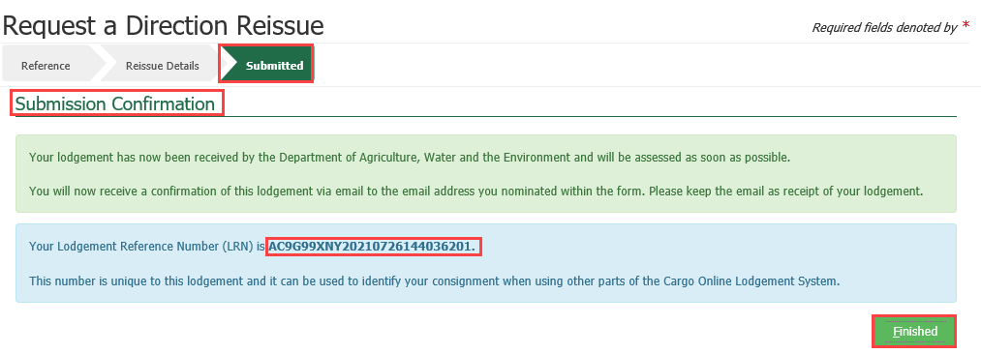

**NOTE:** You will receive an email confirmation from [DoNotReply@agriculture.gov.au](mailto:DoNotReply@agriculture.gov.au). This should be kept as a receipt of your lodgement.

Your request is now with the department for action.