How do I make an enquiry?

This quick reference guide demonstrates how to submit an enquiry to the department in the Cargo Online Lodgement System (COLS). You can use this function to make the following enquiry types: Consignment specific enquiry, Location change, Quarantine document processing, Imported food document processing, General import enquiries or to Submit a declaration.

1. Make an enquiry

* 1. Home page

Go to the Cargo Online Lodgement System.

Select **Make an Enquiry.**

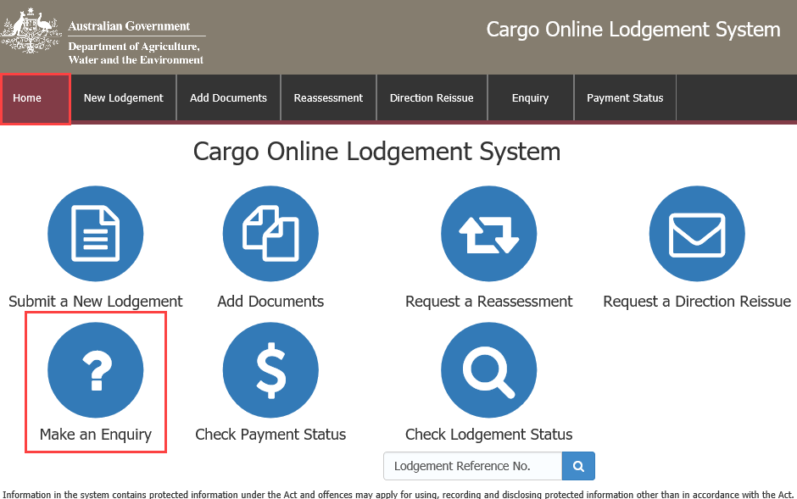

* 1. Enquiry details and contact details

Enquiry details

Select an **Enquiry type** from the drop down menu.

The following enquiry types are available for selection:

* **Consignment specific enquiry:**  Select this when enquiring about a specific consignment for which documents have been lodged and the assessment has not been completed.
* **Location Change:** Select this when needing to make a change of Inspection or Approved Arrangements site.
* **Quarantine document processing:** Select this for specific questions about importing goods that are subject to quarantine.
* **Imported food document processing:** Select this for specific questions about importing goods that are subject to imported food requirements.
* **General import enquiry:** Select this for general questions about importing goods into Australia.

Depending upon your enquiry type, you may be required to enter information regarding a current entry.

If required, enter your **Lodgement Reference Number** (LRN) and **Entry number.**

***TIP:*** You can copy and paste the *26 digit number* LRN from the email notification you received at the time of initial lodgement. *Your Entry Number is the number allocated from AIMS when you lodge your consignment.*

Contact details

Enter your Contact name, a valid Australian phone number and your email address.

**NOTE:** * denotes a mandatory field.

Select .

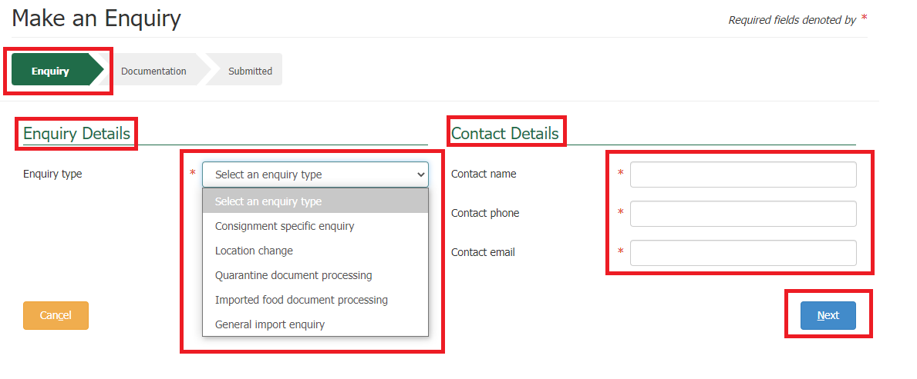

* 1. Documentation

Select  under **Actions** to add any documents relating to your enquiry.

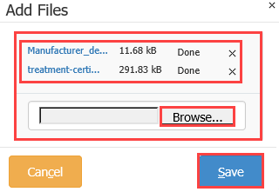This action will open a new window.

Add files

Select **Browse** to locate your file to upload.

Alternatively, select a number of files and drag and drop them into the file box at the top of the window.

Select to upload your document(s).

**NOTE:** Documents may not exceed 20.0MB in total.

Document type

Select the required **Document Type** field(s) from the drop down menu. This is a mandatory field.

Choose ‘other’ if your document type is not listed.

Document reference

**Document Reference** is any additional information that will help department staff who are interpreting this document.

Repeat for each document as necessary.

Additional comments

Add any additional information that may help the department in assessing the documentation in the **Additional Comments** field. E.g. If you have multiple import permit numbers relating to the enquiry, add them in the **Additional Comments** field.

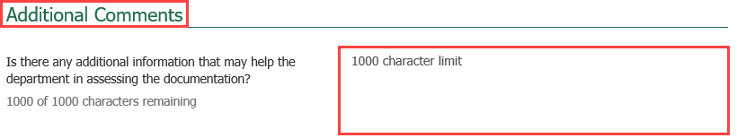

Declaration

Select the General Declaration check box to declare that the information provided in this form is true and correct.

Read the Privacy statement.

Select .

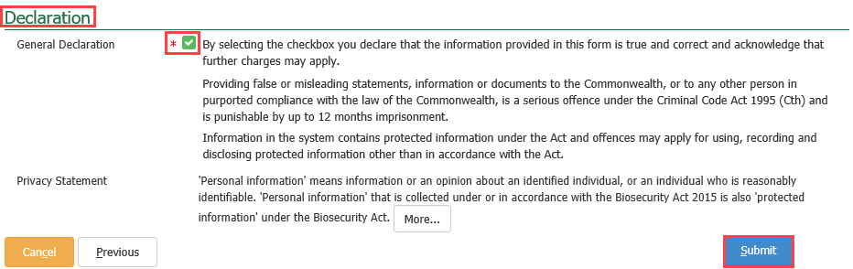

* 1. Submitted

You will receive confirmation that your enquiry has been submitted. Record your **Lodgement Reference Number(LRN)** for future reference.

***TIP:*** *This is your unique number that can be used to identify your consignment when using other parts of the Cargo Online Lodgement System.*

Select .

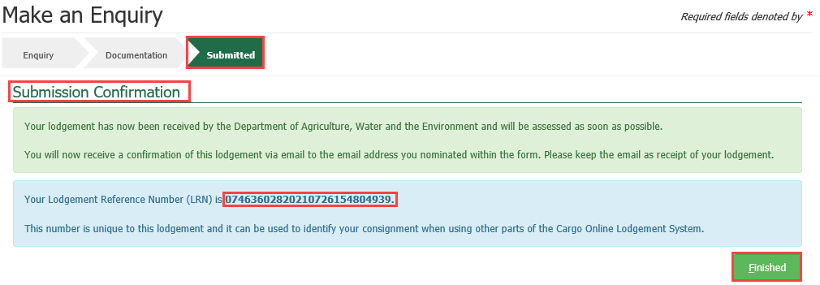

***NOTE:*** *You will receive an email confirmation from* [*DoNotReply@agriculture.gov.au*](mailto:DoNotReply@agriculture.gov.au)*. This should be kept as a receipt of your lodgement.*

Your enquiry is now with the department for assessment.