How do I check the payment status of my lodgement in COLS?

This quick reference guide demonstrates how to check the payment status of your lodgement in COLS.

1. Check payment status
   1. Home page

Go to the Cargo Online Lodgement System.

Select **Check Payment Status.**

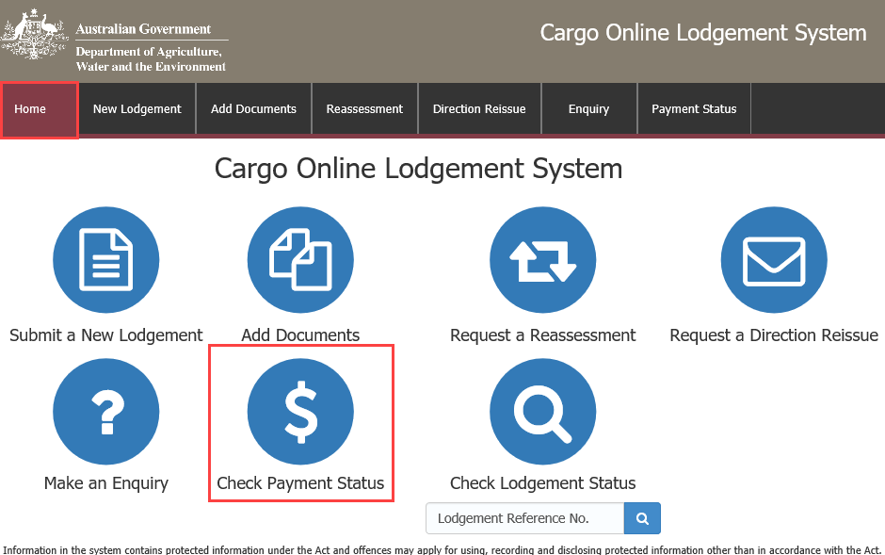

* 1. Payment enquiry

You will be redirected to the department’s **Online Payment System.**

Enter your **Reference Number.**

**NOTE:** This is a mandatory field.

Select .

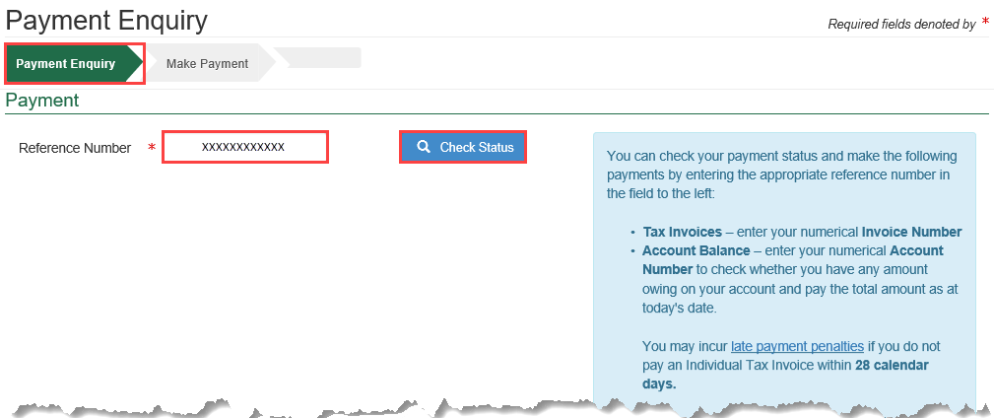

* 1. Account status – payment status fully paid

Email current statement

If your Payment Status is Fully Paid, indicated by , you can select  to send an email to the nominated recipient.

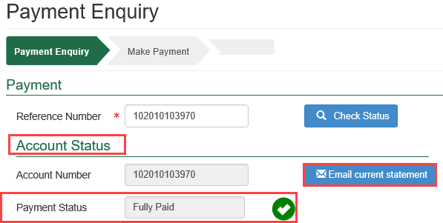

Once the email has been sent, the following notification will appear on your screen.



No further action is required.

* 1. Account status – payment status outstanding

Email current statement

If your Account Status is **Outstanding,** indicated by , you can select  to send an email to the nominated recipient.

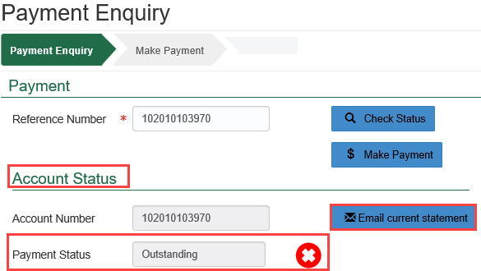

Once the email has been sent, the following notification will appear on your screen.



Make payment

Select  to pay your outstanding account.

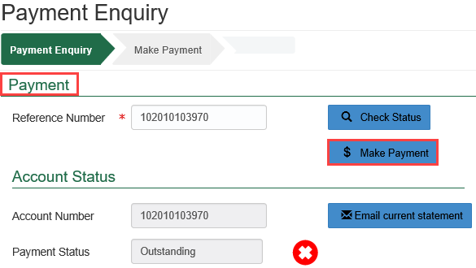

You will be directed to the department’s online payment system to complete your payment.

Complete your payment details in the required fields and select .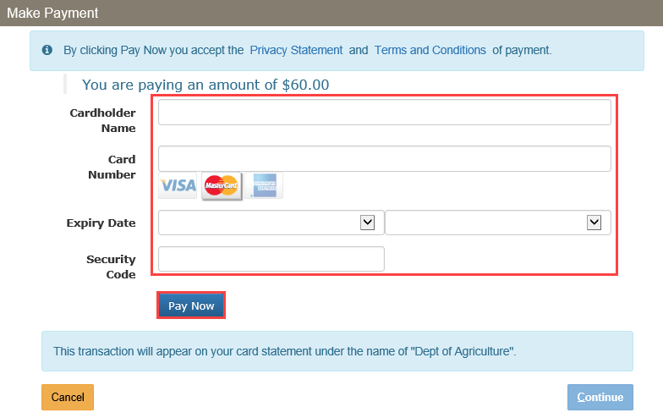

Payment confirmation

You will receive a Payment Confirmation with a Transaction Reference Number.

Select .

**NOTE:** You must select  to finalise this transaction.

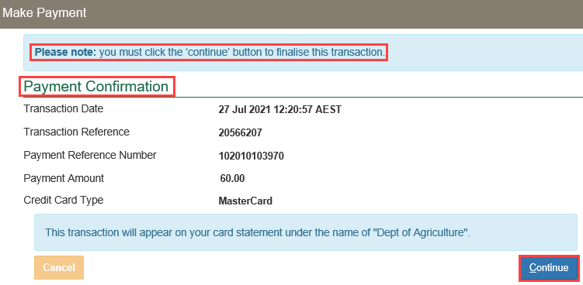

**NOTE:** Please allow two hours to receive copies of Invoices, Statements and Receipts as they do not get transmitted instantly upon request.