How do I add additional documents to my lodgement?

This quick reference guide demonstrates how to submit additional documents to a previously submitted lodgement in the Cargo Online Lodgement System. These may be documents requested by the department to complete the document assessment, or additional ones that need to be added after the initial lodgement.

1. Add a document to my lodgement

* 1. Home Page

Go to the Home page of the Cargo Online Lodgement System.

Select **Add Documents.**

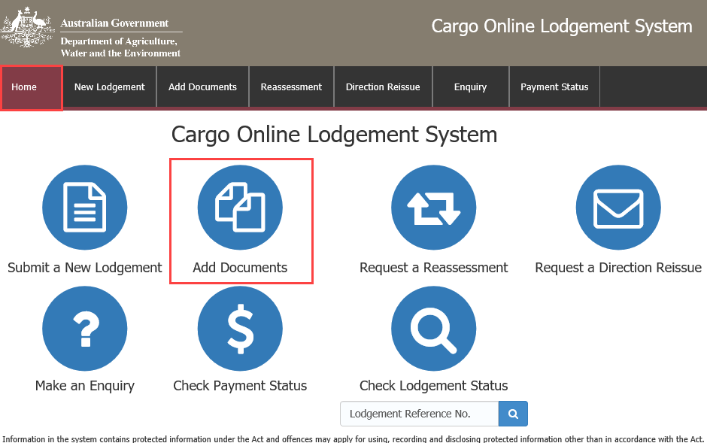

* 1. Enter your LRN

Enter the 26 digit Lodgement Reference Number (LRN) of your original lodgement.

**NOTE:** You can copy and paste the LRN from the email notification you received at the time of initial lodgement.

Select .

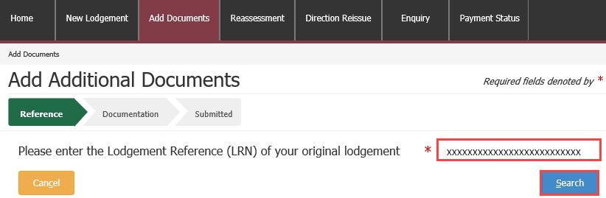

* 1. Add additional documents

Select  under **Actions** to add additional documents to your lodgement.

These are the required documents, as mandated by the import conditions in BICON.

This action will open a new window.

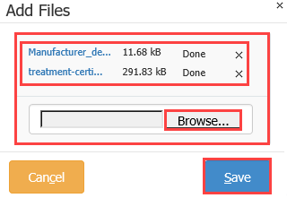Add Files

Select **Browse** to locate your file to upload.

Alternatively, select a number of files and drag and drop them into the file box at the top of the window.

Select to upload your document(s).

**NOTE:** Documents may not exceed 20.0MB in total.

Document Type

Select the required **Document Type** field(s) from the drop down menu. This is a mandatory field.

Choose ‘other’ if your document type is not listed.

Document Reference

**Document Reference** is any additional information that will help department staff who are interpreting this document.

Repeat for each document as necessary.

Additional Comments

Add any additional information that may help the department in assessing the documentation in the **Additional Comments** field. E.g. If you have multiple import permit numbers relating to the lodgement, add them in the **Additional Comments** field.

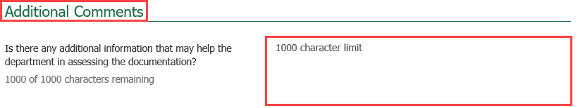

* 1. Declaration

Select the General Declaration check box to declare that the information provided in this form is true and correct.

Read the Privacy statement.

Select .

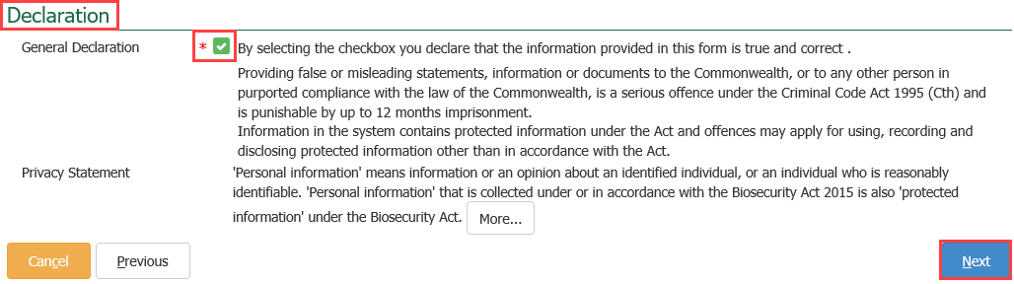

* 1. Submitted

You will receive confirmation that your lodgement has been submitted. Record your **Lodgement Reference Number(LRN)** for future reference.

***TIP:*** *This is your unique number that can be used to identify your consignment when using other parts of the Cargo Online Lodgement System.*

Select .

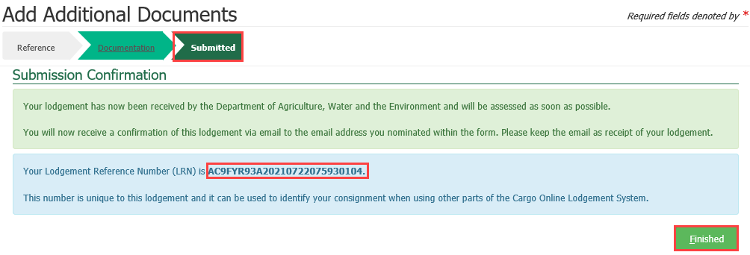

**NOTE:** You will receive an email confirmation from [DoNotReply@agriculture.gov.au](mailto:DoNotReply@agriculture.gov.au). This should be kept as a receipt of your lodgement.

Your documents are now with the department for assessment.