Class 14.4: Rural tailgate inspection informative text
Approved Arrangements Program
Version 1.0 26 July 2023
© Commonwealth of Australia 2023

Ownership of intellectual property rights
Unless otherwise noted, copyright (and any other intellectual property rights) in this publication is owned by the Commonwealth of Australia (referred to as the Commonwealth).
Creative Commons licence
All material in this publication is licensed under a Creative Commons Attribution 4.0 International Licence except content supplied by third parties, logos and the Commonwealth Coat of Arms.

Cataloguing data
This publication (and any material sourced from it) should be attributed as: DAFF 2023, Class 14.4 Rural tailgate inspection supplementary information, Department of Agriculture, Fisheries and Forestry, Canberra, July. CC BY 4.0.
This publication is available at https://www.agriculture.gov.au/biosecurity-trade/import/arrival/arrangements/requirements.
Department of Agriculture, Fisheries and Forestry
GPO Box 858 Canberra ACT 2601
Telephone 1800 900 090
Web agriculture.gov.au
Disclaimer
The Australian Government acting through the Department of Agriculture, Fisheries and Forestry has exercised due care and skill in preparing and compiling the information and data in this publication. Notwithstanding, the Department of Agriculture, Fisheries and Forestry, its employees and advisers disclaim all liability, including liability for negligence and for any loss, damage, injury, expense or cost incurred by any person as a result of accessing, using or relying on any of the information or data in this publication to the maximum extent permitted by law.
Acknowledgement of Country
We acknowledge the Traditional Custodians of Australia and their continuing connection to land and sea, waters, environment and community. We pay our respects to the Traditional Custodians of the lands we live and work on, their culture, and their Elders past and present.
Version control
Updated versions of this document will be published on the department’s website.
Date | Version | Amendments | Approved by
26/07/2023 | V1.0 | First release | Approved Arrangements Program

Contents
Guide to using this document 4
Other documents 4
Biosecurity directions and container types 5
Identifying biosecurity directions relating to class 14.4 5
Containers within scope of class 14.4 7
Inspecting the underside of the container 9
Dangerous goods 10
Identifying and managing biosecurity risk 11
External container biosecurity risks 11
Internal container biosecurity risks 14
Managing biosecurity risk 17
Releasing the container from biosecurity control and reporting inspection outcomes 18
Releasing the container from biosecurity control 18
Reporting container inspection outcomes 18

Tables
Table 1 Identifying direction type Approved Arrangements – AA Rural Tailgate Inspection 5
Table 2 Identifying direction type Approved Arrangements – AA Rural Tailgate Ext. Inspect 5
Table 3 Examples of direction types for container inspections that are out of scope for class 14.4 6
Table 4 Container types within scope of class 14.4 7
Table 5 Directed inspection activities for container types within scope of class 14.4 8
Table 6 Container position to inspect the underside 9
Table 7 Dangerous goods signage 10
Table 8 Soil and plant contamination on external container surfaces 11
Table 9 Invertebrates on external container surfaces 13
Table 10 Soil and plant contamination within the container 14
Table 11 Invertebrates and animals within the container 15
Table 12 Unacceptable packaging material 16
Table 13 Quick reference guide for managing biosecurity risk 17

Guide to using this document
This document provides information intended to assist biosecurity industry participants covered by a class 14.4 rural tailgate inspection approved arrangement to comply with the conditions of their arrangement.
This document provides supporting information only. The approved arrangement conditions for 14.4 rural tailgate inspection must be met by the biosecurity industry participant when performing biosecurity activities under class 14.4 approved arrangement.
The images used in this document are intended to contextualise the container types that are within scope of class 14.4 and the biosecurity risks associated with containers destined for unpack in a rural location. These (stock) images may not replicate all container types directed for inspection in accordance with class 14.4 and the scenarios in which biosecurity risk is detected during rural tailgate inspection.
Further information on approved arrangements, department contact details and copies of relevant approved arrangement documentation is available at Approved Arrangements.

Other documents
The class 14.4 Rural tailgate inspections conditions and the Approved Arrangements General Policies should be read in conjunction with this supplementary information document.

Biosecurity directions and container types

Identifying biosecurity directions relating to class 14.4
Rural tailgate inspections of containers to be conducted under the approved arrangement class 14.4 – rural tailgate inspection are identified by one of two biosecurity directions issued by the department, titled either:
- Approved Arrangements – AA Rural Tailgate Inspection
- Approved Arrangements – AA Rural Tailgate Ext. Inspect
Information on identifying these directions is provided at table 1 and table 2.
All other direction types are out of scope for industry performed rural tailgate inspection under approved arrangement class 14.4. Examples of direction types that are out of scope of class 14.4 is provided at table 3.
Table 1 Identifying direction type Approved Arrangements – AA Rural Tailgate Inspection
Two direction types specific to class 14.4 | Key features of the direction
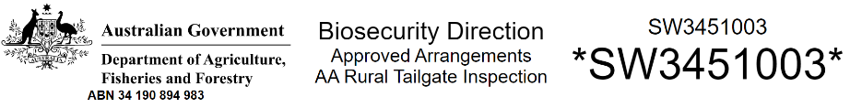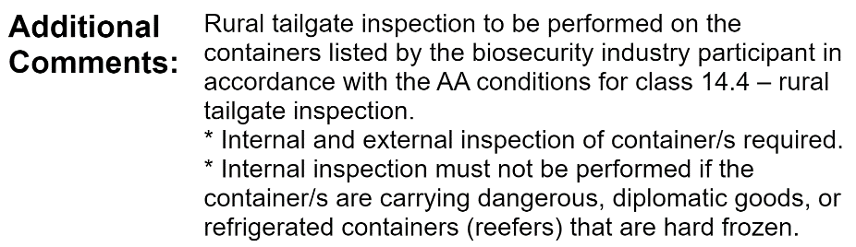 | The direction:  - title states ‘Approved Arrangement – AA Rural Tailgate Inspection’  - comments explicitly authorise rural tailgate inspection to be performed by the biosecurity industry participant in accordance with the approved arrangement conditions for AA class 14.4.  Containers subject to this direction must undergo:  - external inspection  - internal inspection, unless the container is a hard frozen reefer or is carrying dangerous goods or diplomatic goods.
Table 2 Identifying direction type Approved Arrangements – AA Rural Tailgate Ext. Inspect
Two direction types specific to class 14.4 | Key features of the direction
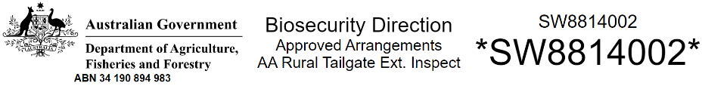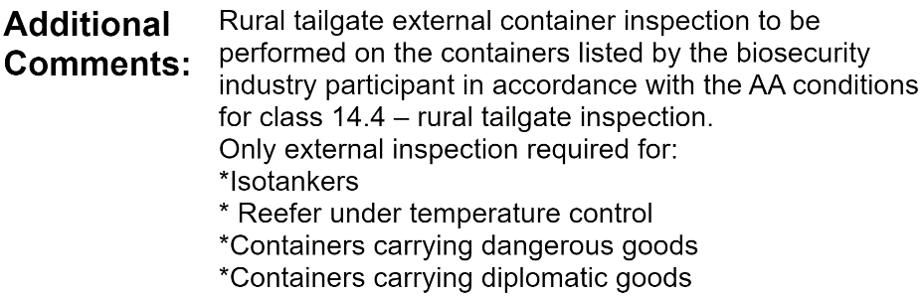 | The direction:  - title states ‘Approved Arrangement – AA Rural Tailgate Ext. Inspect’  - comments explicitly authorise rural tailgate inspection to be performed by the biosecurity industry participant in accordance with the approved arrangement conditions for AA class 14.4.  Containers subject to this direction must undergo an external inspection only.

Table 3 Examples of direction types for container inspections that are out of scope for class 14.4
Direction title: | Key features of the direction
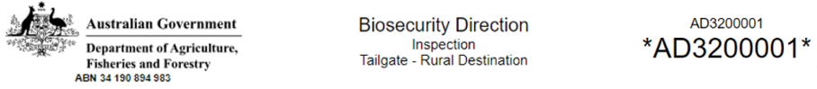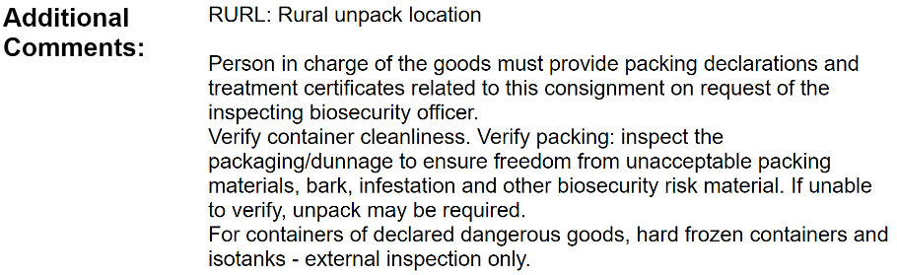 | The direction:  - title states ‘Inspection – Tailgate –Rural Destination’, which is not a direction type recognised under class 14.4 (refer table 1 and table 2)  - comments do not include reference to the inspection being performed by the biosecurity participant under class 14.4 approved arrangement.  A biosecurity officer must complete the rural tailgate inspection for this direction. It is a breach of the biosecurity direction and approved arrangement conditions if a biosecurity industry participant performed the inspection and noncompliance action may result.
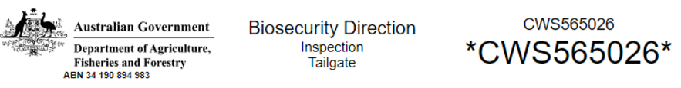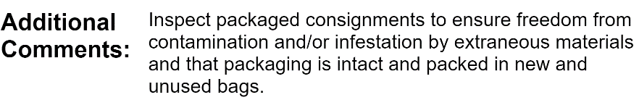 | The direction:  - title states ‘Inspection – Tailgate’, which is not a direction type recognised under class 14.4 (refer table 1 and table 2)  - comments do not include reference to the inspection being performed by the biosecurity participant under class 14.4 approved arrangement.  A biosecurity officer must complete the inspection for this direction. It is a breach of the biosecurity direction and approved arrangement conditions if a biosecurity industry participant performed the inspection and noncompliance action may result.

Containers within scope of class 14.4
Only dry box, reefer, ISO tanker and open top containers are eligible for rural tailgate inspection under class 14.4. Refer to the department’s biosecurity import conditions system (BICON) for further information on suitability of the container and the good being imported for class 14.4 rural tailgate inspection.
Table 4 Container types within scope of class 14.4
Container type | Description | Example image of container type
Dry box | Container including non-operational reefers with 6 hard sides used to transport unstable goods, general goods and cargo. | 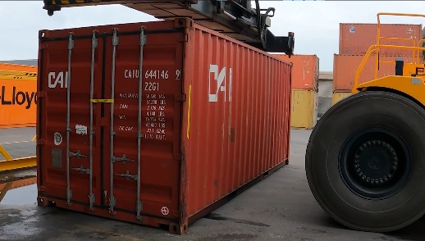
Reefer | Temperature controlled refrigerated container with 6 hard sides used for goods required to be hard frozen or refrigerated. | 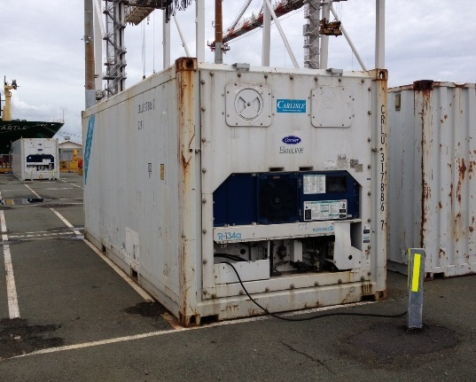
ISO tanker | Steel cylindrical containers mounted in a rigid steel framework used to carry bulk liquids or chemicals. Also known as tank containers, tanktainers, bulk liquid containers (BL) or ISOtainer. | 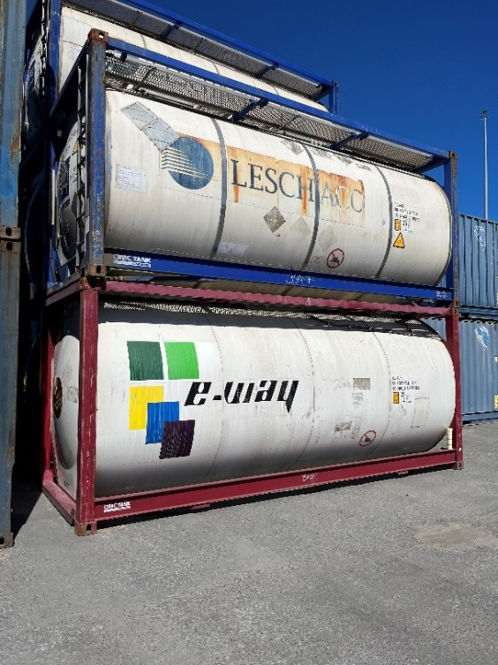
Open top | Container with solid sides and no solid roof. | 
Table 5 Directed inspection activities for container types within scope of class 14.4
Biosecurity direction title | Container types | Required inspection activities under class 14.4 conditions
Approved Arrangement – AA Rural Tailgate Inspection | Dry box  Open top  Reefers that are not hard frozen | External inspection of:  - external side walls  - along external edges and lips  - in and around twist locks and forklift tyne holes  - door handles  - door seals, without opening container doors  - the underside of the container, which involves repositioning the container if the underside cannot be inspected (e.g. where the container is on the ground or a flatbed truck/trailer)  - the topside of the container, but only where biosecurity risk material is detected on the underside or side walls.  Internal inspection (without entering the container) of:  - internal surfaces of the container including doors, door seals, floor, walls and ceiling  - free airspace  - external surfaces of the goods within the container  - surfaces of packaging material within the container, including monitoring for unacceptable packaging  Internal inspection is not required for containers carrying dangerous goods.
Approved Arrangement – AA Rural Tailgate Ext. Inspection | Reefers that are hard frozen  Containers with diplomatic goods  Containers with dangerous goods | External inspection of  - external side walls  - along external edges and lips  - in and around twist locks and forklift tyne holes  - door handles  - door seals, without opening container doors  - engine/compressor area and around the power leads  - the underside of the container, which involves repositioning the container if the underside cannot be inspected (e.g. where the container is on the ground or a flatbed truck/trailer)  - the topside of the container, but only where biosecurity risk material is detected on the underside or side walls.  Internal inspection is not required.
 | ISO tankers | External inspection of:  - external surfaces of the cylinder  - steel frame  - in and around twist locks and forklift tyne holes  - the underside of the container, which involves repositioning the container if the underside cannot be inspected (e.g. where the container is on the ground or a flatbed truck/trailer)  - the topside of the cylinder and frame, but only where biosecurity risk material is detected on other external surfaces.  Internal inspection is not required.

Inspecting the underside of the container
The accredited person performing the inspection must be able to inspect all surfaces of the underside of the container when conducting the rural tailgate inspection. Visibility of the underside is often obscured where the container is presented for external inspection on a flatbed trailer or on the ground. The approved arrangement conditions of class 14.4 require that the container be repositioned to allow sufficient access and visibility to the underside of the container.
Table 6 Container position to inspect the underside
Container position | Description
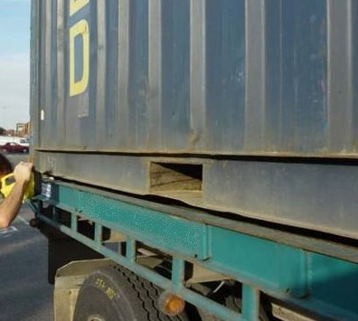 | Containers presented on a flatbed trailer, as pictured, limit visibility to the underside of the container to perform an effective inspection. The underside of the container is too close to the trailer top, only twist locks and forklift tyne holes are visible.
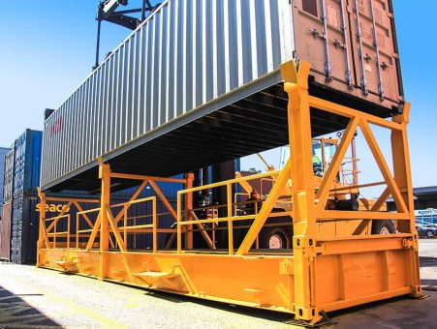 | If access to the underside of the container is restricted it will be necessary to reposition the container.  Container inspection stands, as pictured allow for greater access and visibility to the underside of the container.  Approved arrangement sites where rural tailgate inspections are performed are required to have a certified sea freight container inspection stand. These stands are required for biosecurity officers to safely inspect containers that are out of scope of class 14.4 and containers referred to the department under class 14.4.  These stands may be used by the biosecurity industry participant to facilitate access to the underside of the container for rural tailgate inspections performed under class 14.4.

Dangerous goods
If there is any indication that the container is carrying dangerous goods, an internal inspection must not be conducted.
Table 7 Dangerous goods signage
Dangerous goods | Description
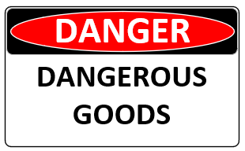  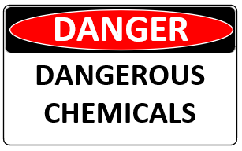  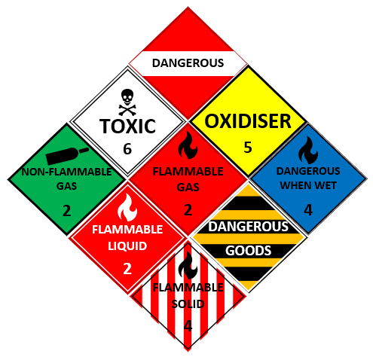 | Dangerous goods are substances or articles which are potentially dangerous to people, property or the environment.  Dangerous goods signage comes in various forms and is commonly displayed as a diamond shaped sign with wording which identifies the type of dangerous goods being transported.  The colour of the sign will vary depending on the class of dangerous goods being transported. Other variations of dangerous goods signage will display obvious warnings.  Shipping containers used to transport dangerous goods should display labelling or signage to advise the presence of dangerous goods. Dangerous goods signage should be prominently displayed on the outside of the container and at the doors.  Internal tailgate inspections are not to be conducted on containers carrying dangerous goods.

Identifying and managing biosecurity risk
Shipping containers can inadvertently carry a range of biosecurity risks which could introduce exotic pests and diseases into the Australian environment, including our fragile and vulnerable rural areas.
For example:
- Soil may contain animal disease pathogens, such as foot and mouth disease which could impact Australia's livestock industries. Soil can also contain plant diseases and exotic seeds and invertebrates.
- Seeds can introduce weeds or exotic plant diseases and harbour exotic invertebrates.
- Exotic invertebrates such as termites and borers may become established in Australia, impacting forest industries and causing damage to property and the Australian environment.
- Snails pose a significant risk to a range of Australian plant species and horticultural industries.
- Exotic moth species pose a significant risk to Australian tree species and horticultural industries.
- Used produce packaging and other unacceptable packaging material such as straw may contain plant diseases and harbour exotic invertebrates.
Rural areas pose a higher risk than metropolitan areas due to the likelihood of pests establishing quickly and the difficulty in detecting and controlling pests once established. Shipping containers destined for rural areas are subject to heightened biosecurity measures on arrival including mandatory inspection.

External container biosecurity risks
The following tables provide examples of biosecurity risk material detected on external container surfaces.
Table 8 Soil and plant contamination on external container surfaces
Example images of soil and plant contamination detected during external container inspection | Description
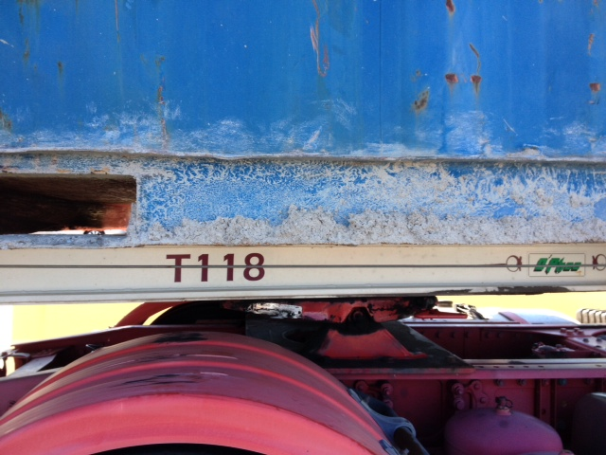 | Soil contamination pictured is detected along the bottom side rail and the forklift tyne hole of a dry box container.
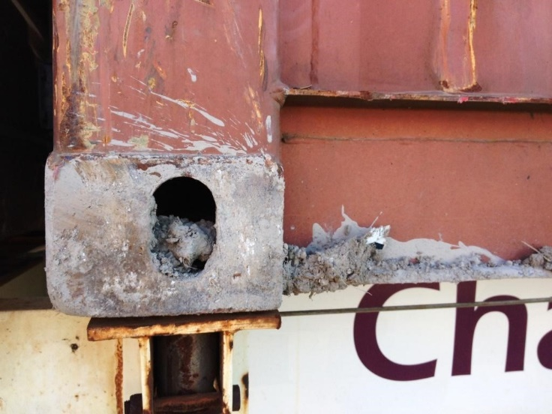 | Soil contamination pictured is detected in and around the twist lock of a container.
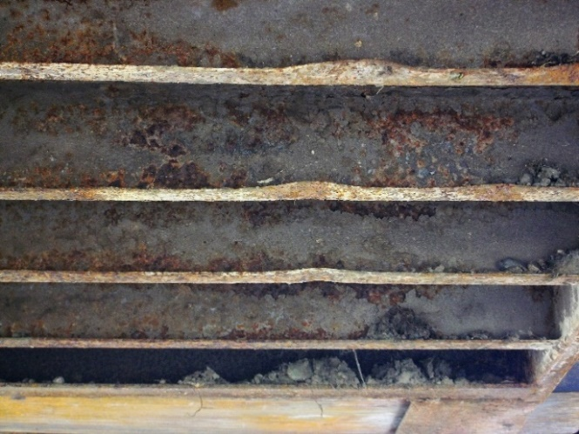 | Soil contamination pictured is detected on the underside rails of the container.
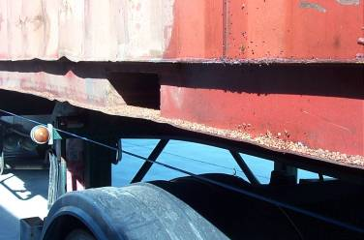 | Seed contamination pictured is detected along the bottom side rail and the forklift tyne holes of a dry box container.
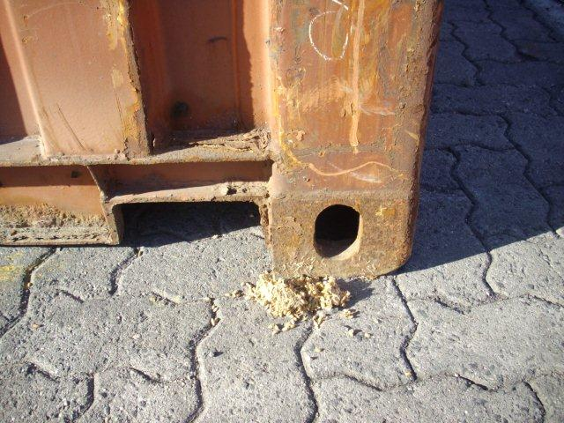 | Seed and soil contamination pictured is detected to have fallen from the twist lock of the container when grounded. Contamination could also fall from the container when presented for inspection on a trailer or certified sea freight container inspection stand.
Table 9 Invertebrates on external container surfaces
Example image of invertebrates detected during external container inspection | Description
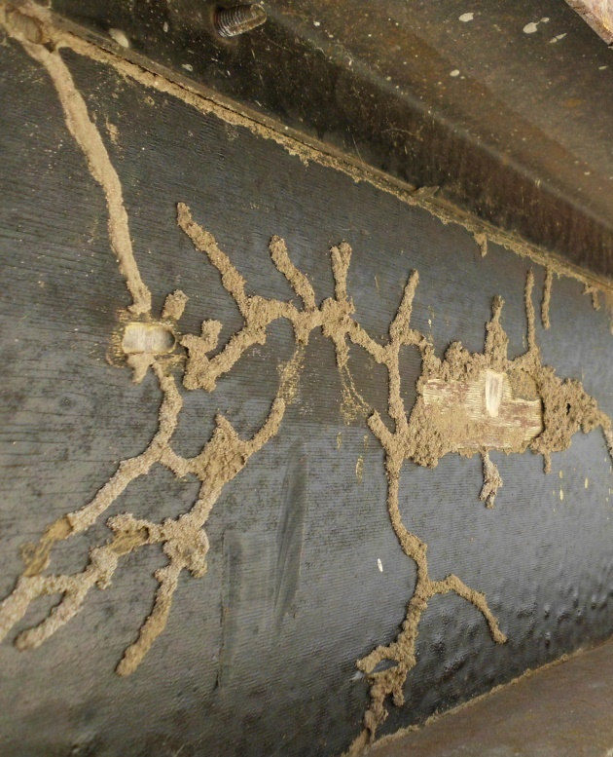 | Container pictured has timber flooring visible from the underside of the container. Timber flooring is infested with timber pests, visible by holes and damage to the timber as well as mud tubes (tracks created by termites and other boring invertebrates).

Internal container biosecurity risks
The following tables provide examples of biosecurity risk material detected within the container.
Table 10 Soil and plant contamination within the container
Example image of soil and plant contamination detected during internal container inspection | Description
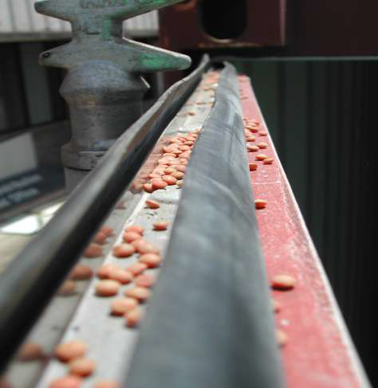 | Seed contamination pictured is detected in and around the top edge of the container door seal, indicating the container has not been cleaned prior to sealing offshore.
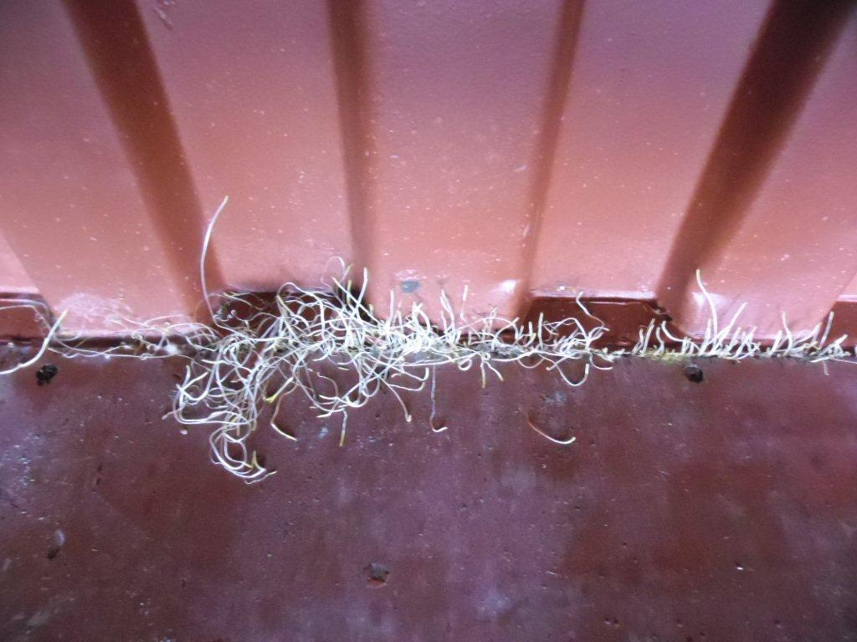 | Live plant material pictured is detected on the internal floor surfaces of the container.  In this case the seeds have fallen into the gap between the floor of the container and the side walls. The seeds have germinated and can been seen sprouting.
Table 11 Invertebrates and animals within the container
Example image of invertebrate detected during internal container inspection | Description
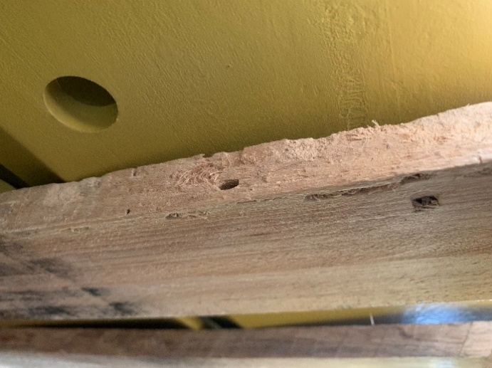 | Wooden pallets pictured are used to transport new machinery parts and show evidence of borer activity and infestation.  Indications of borer or termite activity include:  - holes in timber  - frass (the powdery sawdust-like substance produced from borers).
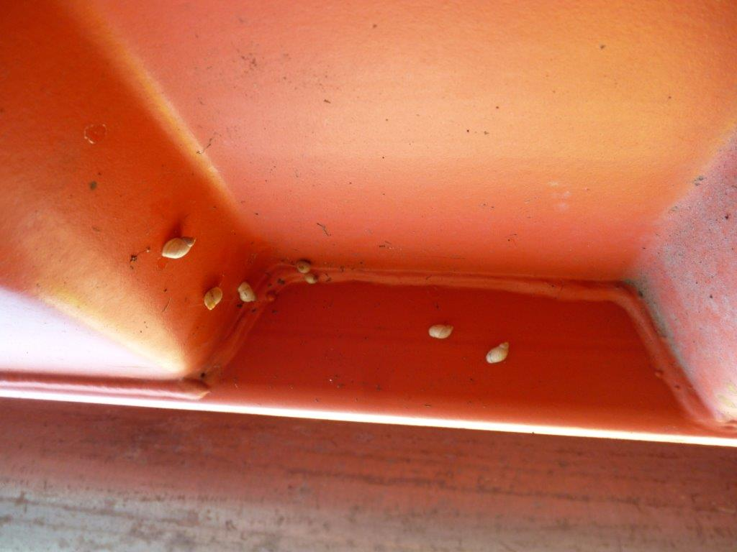 | Snails pictured is detected on an internal wall and ceiling surface of the container.
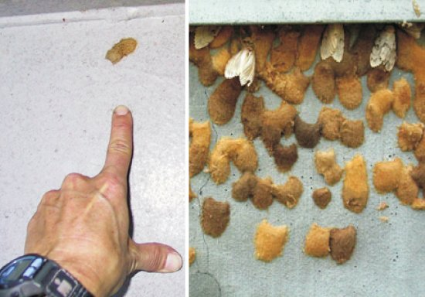 | Moth egg mass detected on an internal surface of a container during a tailgate inspection.  Egg masses may present individually or as large clusters. Live mature moths may be present.

Table 12 Unacceptable packaging material
Example images of unnacceptable packaging detected during internal container inspection | Description
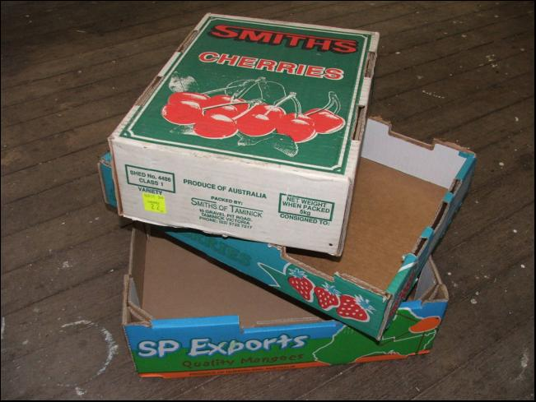 | Loose produce packaging pictured is an example of unacceptable packaging detected inside the container.
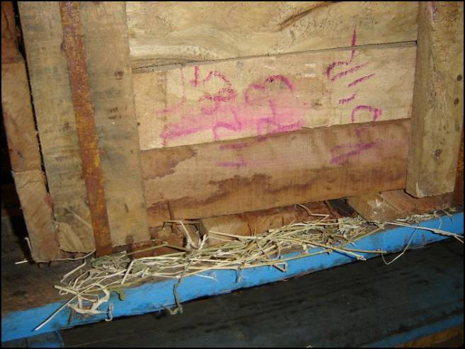 | Straw packaging pictured is an example of unacceptable packaging detected inside the container. Additionally, the timber packaging (crate) shows water/moisture marks which may have mould.

Managing biosecurity risk
Class 14.4 authorises the biosecurity industry participant to remove all contamination from external surfaces of the container, without further biosecurity direction for cleaning being issued by the department. The biosecurity industry participant is not authorised to undertake other biosecurity intervention (e.g. fumigation or unpack) without a biosecurity direction being issued by the department.
The department must be notified in the following events:
- Live or dead animals or live invertebrates are detected on external surfaces of the container.
- Contamination is detected on external surfaces which cannot be removed and managed at time of the external inspection or by washing or steam cleaning at the approved arrangement site.
- Any biosecurity risk is detected within the container.
Table 13 Quick reference guide for managing biosecurity risk
Biosecurity risk detected | Actions required to manage the biosecurity risk
Soil and plant contamination is detected on external surface of the container | If the contamination can be removed without washing or steam cleaning, immediately:  - remove the contamination from the container  - dispose of the contamination in a biosecurity waste container.  Where washing or steam cleaning is required to remove the contamination, this must occur in the onsite class 4.3 approved wash bay.  Note: complete any required internal inspection prior to moving the container to the onsite class 4.3 wash bay for cleaning.
Soil and plant contamination is detected to have fallen from or has left the container | Immediately:  - clean up the contamination  - dispose of the contamination in a biosecurity waste container.
Live or dead animals and live invertebrates are detected on or have left the container | Immediately:  - cease the inspection  - apply knockdown spray to live invertebrates  - collect the invertebrates following knockdown spray and secure in a sealed specimen jar, bag, vial  - if safe to, capture and contain the animal in a cage, receptacle or building, or if unsafe or not possible to capture and contain, maintain constant observation of the animal  - close the container doors if open  - secure the container in a biosecurity area at the approved arrangement site  - notify the department.
Any of the following is detected within the container:  - contamination  - live or dead animals including evidence of animal activity (e.g., animal droppings)  - invertebrates including evidence of invertebrate activity (e.g., frass)  - unacceptable packaging. | Immediately:  - cease the inspection  - close the container doors  - secure the container in a biosecurity area at the approved arrangement site  - notify the department.

Releasing the container from biosecurity control and reporting inspection outcomes

Releasing the container from biosecurity control
Biosecurity industry participants approved for class 14.4 are authorised to release containers from biosecurity control, provided that the:
- biosecurity direction for the container is within scope of class 14.4 (refer table 1 and table 2)
- container type is within scope of class 14.4 (refer table 4)
- container is inspected and where required cleaned in accordance with the conditions for the arrangement
- container is determined to be free of biosecurity risk material
- biosecurity industry participant has created a record of the release from biosecurity control.
The biosecurity industry participant’s record of the release from biosecurity control forms the:
- legislated legal document for release from biosecurity control under the Biosecurity Act 2015
- permission for the biosecurity industry participant to allow the container to leave the biosecurity area and the approved arrangement site (even under a ‘conditional clear’ status in the Integrated Cargo System).
The department will not issue a notice of release (final directive notice) for containers that have been released from biosecurity control by a biosecurity industry participant approved for class 14.4.
While biosecurity industry participants are not required to provide the record of release to the importer or agent (broker) for the container, it is encouraged, and the importer or agent may seek the record of release for their own record keeping and assurance purposes.

Reporting container inspection outcomes
The conditions for class 14.4 require the biosecurity industry participant to complete and submit rural tailgate container inspection outcomes to the department within 2 business days of either:
- releasing the container from biosecurity control, or
- referring the container to the department.
There are 2 reporting options for submitting rural tailgate container inspection outcomes to the department:
- Option 1: Using the Biosecurity Portal , which provides a streamlined reporting process with container and biosecurity direction information already pre-loaded into the system.
- Option 2: Complete and submit the Rural tailgate container inspection record PDF.
The department’s systems are configured to automatically assess and record container inspection outcomes in the department’s Automated Import Management System (AIMS). The biosecurity industry participant will be notified of any reporting discrepancies which can occur using the Rural tailgate container inspection record PDF.
Where the inspection outcome for all containers on the import declaration is ‘released from biosecurity control’, the department’s system will communicate this outcome to the Integrated Cargo System to reflect a ‘clear’ status.
Biosecurity industry participants must not use both options to submit rural tailgate inspection outcomes for the same container as this will lead to system automation errors. Use only one reporting option for each container.

