|  |
| --- |
| Citrus canker (*Xanthomonas citri*) |

**Likely mode of entry**

Illegal importation of infected plant material (fruit, leaves and cuttings) poses the greatest risk of introducing this bacterial disease into Australia. Citrus canker can be moved and spread over long distances on people (hands, shoes and clothing), as well as all kinds of (especially outdoor) equipment and vehicles. Islands in the Torres Strait are a potential pathway of citrus canker from countries to the north of Australia. Over short distances wind-driven rain, air currents, insects, and birds can also spread the pathogen. The disease is not transmitted by seeds.

**Symptoms (Figures 1–3)**

Infected plants have blister-like lesions that form on stems, leaves and fruit. Bacteria ooze from these lesions which increase in size to 5–10 mm over several months and then collapse, becoming crater-like. The lesions become surrounded by characteristic yellow halos, and the raised edges of lesions may appear corky. Lesions are usually visible on both sides of leaves. A ‘shot-hole’ effect can also eventuate, after the crater-like lesion falls out. Plants with the disease may grow poorly with a reduction in fruit quality and quantity. In severe cases infected plants will die.

**Host range**

Infects mainly *Citrus* species such as lime, kaffir lime, lemon, mandarin, tangerine, orange, satsuma, pomelo, yuzu, grapefruit, kumquat, pumelo and Australian desert, finger and round limes. Other affected members of the Rutaceae family are lemon aspen and white sapote. Mango is also a host (family Anacardiaceae).

**Biology**

Citrus canker is caused by *Xanthomonas citri,* which is a small, rod-shaped bacterium that is covered with slime and survives in moist conditions. The bacteria enter the plant through stomata or wounds caused by equipment or insects such as citrus leaf miner. The first visible symptom is oozing after 5–7 days. The disease can become less active when the weather is dry for long periods, and then become active again in periods of high rainfall and warm weather.

**Distribution**

Likely native to Southeast Asia. Introduced to other parts of Asia, Africa, North and South America. Not present in Australia, with previous incursions in northern Australia having been eradicated.

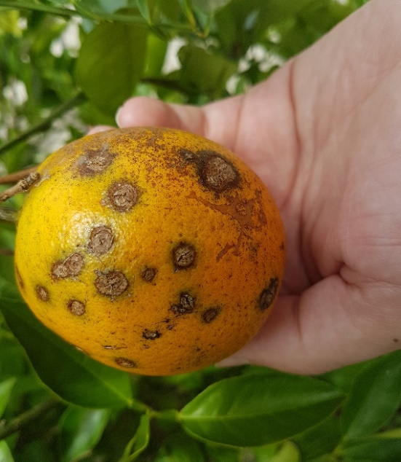

**Fig. 1** Citrus canker lesions on citrus fruit showing dark, corky edges (DAFF).

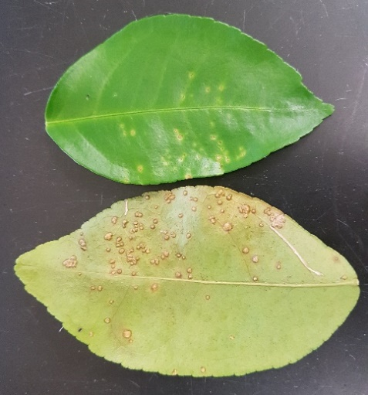

**Fig. 2** Small citrus canker lesions on upper and lower leaf surfaces (DAFF).

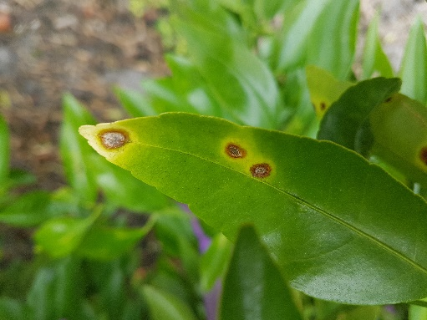

**What to do if you find suspect citrus canker**

**Department officers:** Contain the risk, collect diseased samples into a zip-lock bag and deliver to a department pathologist immediately.

**Industry and the public:** **SEE. SECURE. REPORT.**

Secure the goods to limit movement and immediately report your detection to the Department of Agriculture, Fisheries and Forestry on **1800 798 636**.

For safety, consult a department pathologist before handling specimens.

**Fig. 3** Larger leaf lesions with yellow halo, dark corky edge and collapsed centre (DAFF).