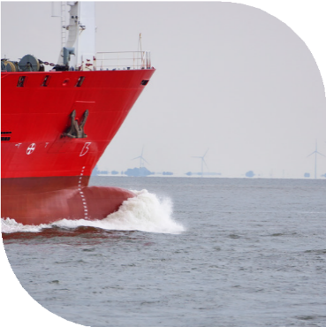

**Biosecurity Documentation**



agriculture.gov.auHYPERLINK "https://www.agriculture.gov.au/biosecurity-trade/aircraft-vessels-military/vessels/commercial-vessels/release-from-biosecurity"a.gov.au

**Within Australia 1300 004 605**

**Outside Australia +61 8 8201 6185**

BIO098.0823

Checklist for Commercial Vessels

**December 2023**

In the office

Understand and follow the department’s biosecurity directions

Submit an accurate Pre Arrival Report (PAR), Ballast Water Report and where required a request to enter a non-first point of entry

Submit requests for service such as; sanitation certificate, waste removal, crew change (departures) or releasing a vessel from Biosecurity control

Report any insects, birds or animals, including rodents found on board the vessel during the voyage

Prepare relevant original vessel documentation for inspection

Communicate biosecurity requirements to crew and passengers

On the deck

Inspect superstructure, deck and cargo areas for any insects, pests or pooling water

Keep deck and cargo areas free from grain, seed or other organic material

Remove any hitchhiking and migratory birds from the vessel prior to entering Australian waters

Ensure all waste is stowed correctly

Ensure the galley and stores are clean and free of insects and vermin such as rodents

Do not use foodstuffs as a bait for fishing while in Australian ports or waters

Pets are kept confined on board

Plants are to be stored indoors and away from open windows.

Any changes to circumstances must be reported to the department as soon as possible.

*It is a serious offence to obstruct, harm, threaten to harm or hinder a Commonwealth Public Official, such as a Biosecurity Officer, under the Criminal Code Act 1995 and you may be liable to an offence or civil penalty under the Biosecurity Act 2015.*

Further information can be found on the department’s website: [Vessels - DAFF (agriculture.gov.au)](https://www.agriculture.gov.au/biosecurity-trade/aircraft-vessels-military/vessels)

**This checklist is just one tool to help vessel operators comply with Australia’s biosecurity requirements.**

**© Commonwealth of Australia, 2023.**



This publication is licensed by Commonwealth of Australia under a Creative Commons Attribution 4.0 International licence.