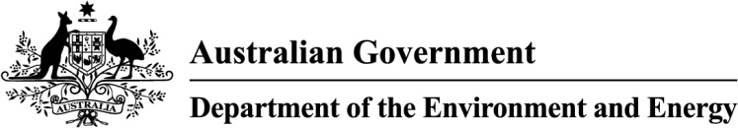

# Central Hunter Valley eucalypt forest and woodland: a nationally protected ecological community

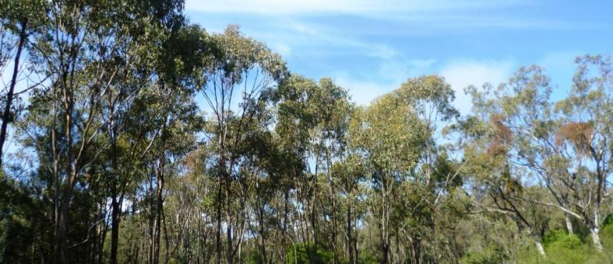

This guide is designed to assist land managers, owners and occupiers, as well as environmental assessment officers and consultants, to identify, assess and manage the Central Hunter Valley eucalypt forest and woodland ecological community; a threatened ecological community, listed as critically endangered under the *Environment Protection and Biodiversity Conservation Act 1999* (EPBC Act), Australia’s national environment law.

This guide is a companion document to the approved Conservation Advice, which can be found on the Australian Government’s species profile and threats (SPRAT) database at: [www.environment.gov.au/cgi-bin/sprat/public/publiclookupcommunities.pl](http://www.environment.gov.au/cgi-bin/sprat/public/publiclookupcommunities.pl). On this webpage, click on the details link—alongside the ecological community name—to download the documents and the map for the listed ecological community.

© Copyright Commonwealth of Australia, 2016.

creative_commons_licence.jpg

*Central Hunter Valley eucalypt forest and woodland: a nationally protected ecological community* is licensed by the Commonwealth of Australia, for use under a Creative Commons By Attribution 4.0 Australia licence with the exception of the Coat of Arms of the Commonwealth of Australia, the logo of the agency responsible for publishing the guide, content supplied by third parties, and any images depicting people. For licence conditions see: <http://creativecommons.org/licenses/by/4.0/>

This guide should be attributed as ‘*Central Hunter Valley eucalypt forest and woodland: a nationally-protected ecological community*, Commonwealth of Australia 2016’.

The Commonwealth of Australia has made all reasonable efforts to identify content supplied by third parties using the following format ‘© Copyright [name of third party] ’.

**Disclaimer**

The views and opinions expressed in this publication are those of the authors and do not necessarily reflect those of the Australian Government or the Minister for the Environment and Energy.

While reasonable efforts have been made to ensure that the contents of this publication are factually correct, the Commonwealth does not accept responsibility for the accuracy or completeness of the contents, and shall not be liable for any loss or damage that may be occasioned directly or indirectly through the use of, or reliance on, the contents of this publication.

**Images**

Front cover — Central Hunter Valley eucalypt forest and woodland © Copyright Sharon Warne.

Back cover — Central Hunter Valley eucalypt forest and woodland - grey box (*Eucalyptus moluccana*) and spotted gum (*Corymbia maculata* (syn. *Eucalyptus maculata*)) © Copyright Stephen Bell.

This guide is intended to assist the public to understand the national listing of the Central Hunter Valley eucalypt forest and woodland ecological community—to explain what it is, why it is threatened and what national protection means for people in the region.

|  |  |
| --- | --- |
| In summary:   * Australia's unique lowland native woodlands have been placed under enormous pressure since non-Indigenous settlement. However, important remnants persist across several regions, including the Hunter Valley. * The Central Hunter Valley eucalypt forest and woodland ecological community was listed in May 2015 as critically endangered under Australia’s national environment law, the Environment Protection and Biodiversity Conservation Act 1999 (EPBC Act). * The national Threatened Species Scientific Committee found that the ecological community is highly threatened. Its extent has declined severely—by more than 70 per cent—resulting in a highly fragmented and restricted distribution, the loss of many animals and the subsequent loss of ecosystem function. * National listing is an important step in securing the future of the Central Hunter Valley eucalypt forest and woodland by:   + requiring consideration of the impact of new developments on the woodlands   + encouraging priority support for conservation and recovery efforts, including through Australian Government funding opportunities.   + raising awareness of the ecological community and priority actions to combat threats * The ecological community is a eucalypt woodland/open forest. It occurs in the Hunter River catchment (including the Goulburn Valley)—commonly known as the Hunter Valley, or Hunter Region—in north-eastern New South Wales. The ecological community is mainly in the Central Hunter Valley—in the Muswellbrook, Singleton and Cessnock Local Government Areas. | * Across the range of the ecological community, one or more of, a complex of four eucalypt tree species usually dominate the canopy. Typically the woodland has a sparse mid layer of native flowering shrubs and a ground layer of grasses, daisies, lilies, orchids and other flowers. * The ecological community provides vital habitat for 11 nationally threatened animal species, such as the regent honeyeater, painted honeyeater, brush tailed rock wallaby and spotted-tail quoll, as well as being a refuge for locally-rare species such as the speckled warbler. * It contributes to the health and wellbeing of local residents. For example, the ecological community helps to cool temperatures and filter water in its surrounding area; and it also provides scenic areas for bushwalking. * The ecological community also provides other ecosystem services such as shelter for stock, improving air quality and reducing soil erosion. * The community covers a number of vegetation units, or sub-communities. These have been combined into a single nationally-significant ecological community because they are similar, adjacent and/or intergrade and share key threats that benefit from complementary management. * A Conservation Adviceis available thatoutlines a range of priority research and management actions that provide guidance on how to protect, manage and restore the ecological community. * Routine property maintenance and land management practices, carried out in line with local laws and guidelines covering native vegetation, are typically unlikely to require consideration under the EPBC Act (e.g. most farming activities and managing fire breaks). * Activities likely to have significant adverse impacts on the ecological community need to be considered under the EPBC Act—activities such as large new developments, works or infrastructure. For example, permanently clearing areas of high-quality native vegetation for mining and energy infrastructure or residential subdivision and development. |

National ecological communities

Australia’s national environment law provides a legal framework to protect and manage Matters of National Environmental Significance; these include nationally threatened species and ecological communities.

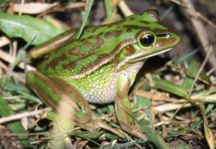The EPBC Act defines an ecological community as an assemblage of native species which inhabit a particular area in nature. In other words, ecological communities are groups of native plants, animals and other organisms that naturally occur together and interact in a unique habitat. Listed ecological communities include forests, grasslands, shrublands, wetlands, woodlands, ground springs, cave and marine communities.

The native plants and animals in an ecological community have different roles and relationships that, together, contribute to a healthy functioning natural environment.

Green and golden bell frog © Copyright Frank Lemckert, SFNSW.

Listed ecological communities may become extinct, through loss of extent and/or loss of natural function, unless threats are removed or better managed. However, remnants retain important natural values and have the potential to provide more habitat and ecosystem services, if threats are eliminated or managed to reduce their impacts and the natural composition and function of the ecological communities are restored.

Protecting ecological communities also protects ecosystem services such as clean air, land and water. These benefit people and society both within and beyond the local area and are essential to the greater productivity of our land and water.

What is the Central Hunter Valley eucalypt forest and woodland ecological community?

The Central Hunter Valley eucalypt forest and woodlandecological community is an open forest or woodland—typically with a tree canopy dominated by eucalypt species; an open to sparse mid-layer of shrubs; and a ground layer of native grasses, forbs and small shrubs. The composition of a particular area (patch) of the ecological community is influenced by its size, recent rainfall, drought conditions and by its disturbance history (e.g. clearing, grazing and fire).

The ecological community can be identified by the following general landscape, soil and vegetation features:

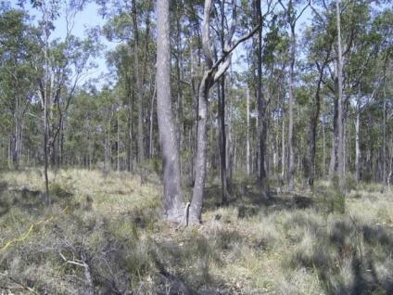Landscape and soils

* Typically occurs on lower hillslopes and low ridges, or valley floors in undulating country; on soils derived from finer grained sedimentary rocks.
* Soils typically have a high clay content and are medium in fertility, relative to nearby deep alluvial loam soils—which are more fertile—and to the skeletal soils of the bordering escarpment landscape—which is made up of less fertile, coarser–grained and sandier soils.
* Does not occur on alluvial flats, river terraces, windblown sands, Triassic sediments, or escarpments.

Central Hunter Valley eucalypt forest and woodland - spotted gum (*Corymbia maculata* (syn. *Eucalyptus maculata*)) and narrow-leaved ironbark (*Eucalyptus crebra)* © Copyright Stephen Bell.

Vegetation

* The woodland or forest canopy is dominated1 by one or more of the following four eucalypt species:
  + narrow-leaved ironbark (*Eucalyptus crebra*), spotted gum(*Corymbia maculata* (syn. *Eucalyptus maculata*)), slaty gum(*Eucalyptus dawsonii*) and grey box (*Eucalyptus moluccana*).Under certain circumstances a fifth species, *Allocasuarina luehmannii* (bulloak or buloke), may be part of the mix of dominants—i.e. in sites previously dominated by one or more of the four eucalypt species2.
* A number of other tree species may be sub-dominant or locally dominant within a limited area of a patch. These includerough-barked apple(*Angophora floribunda*), Blakely’s red gum(*Eucalyptus* *blakelyi*), slaty red gum(*Eucalyptus glaucina*) and forest red gum(*Eucalyptus tereticornis*).
* Other characteristic canopy species includekurrajong(*Brachychiton populneus* subsp*. populneus*), black cypress-pine(*Callitris endlicheri*) andcooba(*Acacia salicina*). White box(*Eucalyptus albens*) and grey gum(*Eucalyptus punctata*) are also often present.
* Older regrowth/remnants, with mature hollow bearing trees, are particularly important for the range of habitats and resources they provide to animal species in the ecological community.
* A sparse sub-canopy layer may be present; typically with young eucalypts of upper canopy species, along with other species such as wattles(*Acacia* species).
* Three tree species: forest oak (*Allocasuarina torulosa*)—also known as forest sheoak, rose oak or rose she-oak; white mahogany (*Eucalyptus acmenoides*); and red ironbark (*Eucalyptus* *fibrosa*)—also referred to as broad-leaved ironbark, are all largely absent from the canopy of a patch (i.e. no more than two trees per hectare, on average across a patch—of each of the three species).
* An open-to-sparse mid-layer of shrubs such as wattles(*Acacia species*) and native blackthorn (*Bursaria spinosa* subsp. *spinosa*) may be present.
* A ground layer is present, although it may vary in development and composition, as a sparse-to-thick layer of native grasses and/or other predominantly native groundcover (small shrubs and ferns, daisies, lilies, orchids and other flowers).

1 Dominated means that one, or more, of the four Eucalypt species, accounts for more than 50% of the projected canopy cover. Projected canopy cover of trees is calculated by assuming a solid canopy. Projected canopy cover is the preferred benchmark for dominance; except in regenerating areas with few mature canopy trees. Where this is the case, tree basal area is the next best surrogate.

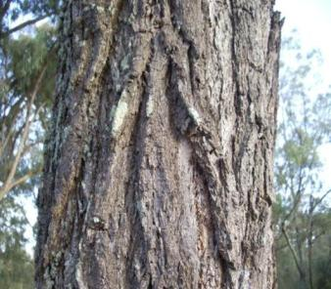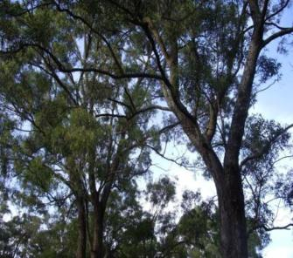2 *Allocasuarina luehmannii* plus one or more of the four Eucalypt species above, should together account for more than 50% of the projected canopy cover. Evidence that in the past at least one of the four diagnostic eucalypt species was amongst the most common canopy species could include aerial photography, past surveys, or historical journal entries/documents. Patches that are dominated solely by *Allocasuarina luehmannii* (bulloak, buloke) are excluded—i.e. patches in which all four of the typically dominant eucalypt species are entirely or mostly absent.

Narrow-leaved ironbark (*Eucalyptus crebra*) trees and bark © Copyright Matt White.

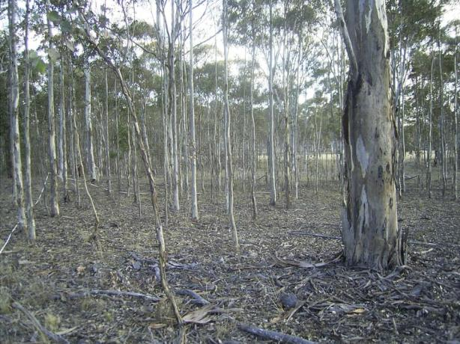

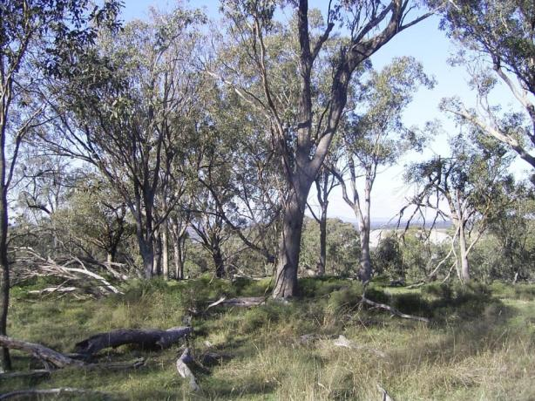

Central Hunter Valley eucalypt forest and woodland - slaty gum (*Eucalyptus dawsonii*) with seedling regrowth (top); Central Hunter Valley eucalypt forest and woodland - grey box (*Eucalyptus moluccana*) (bottom) © Copyright Stephen Bell.

Why is the Central Hunter Valley eucalypt forest and woodland ecological community important? Why is it important to protect it?

The Central Hunter Valley eucalypt forest and woodland ecological community provides habitat for a large number and variety of native plants and animals. Remnant patches of the ecological community provide wildlife corridors and refuges in a fragmented landscape. It also contributes to the area’s air and water quality and helps prevent or reduce weeds, evaporation, soil erosion and other flood damage.

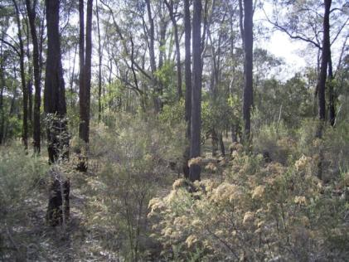When native vegetation is cleared, habitat which was once continuous becomes divided into smaller separate fragments. This makes it harder for animals to roam or migrate and for plants to disperse. In the Hunter Valley, many fragments of the ecological community are small islands—isolated from each other by grazing or agricultural land, or by roads, houses and other developments.

Connectivity between individual areas of the ecological community and with other areas of native vegetation is important for plants because it increases pollination rates and the spread of plant propagules —the parts of a plant that allow it to reproduce and spread.

Small, isolated fragments of native vegetation typically support fewer plant and animal species. Isolated populations may be more vulnerable to regional extinction. For example, once North Rothbury Persoonia plants disappear from a patch of bushland, they will not come back unless mammals or birds carry seed back to the patch. Because animals cannot travel safely between isolated patches of bushland this is now less likely.

Central Hunter Valley eucalypt forest and woodland - narrow-leaved ironbark (*Eucalyptus crebra)* © Copyright Stephen Bell.

For vertebrate fauna, their diversity and abundance may depend on the connectivity of patches, more than on the size of the patches (i.e. small patches that act as stepping stones are important). Remnants of this ecological community can bridge the gap between the more intact landscapes of the Blue Mountains to the south, with those of Barrington Tops in the north. Birds and bats, including some threatened species, use the ecological community to move from north to south through the Hunter Region and beyond, and from east to west across the Great Dividing Range to the coast as seasons change.

By listing the ecological community, additional protection is given to national, state and regionally threatened native animals and plants. These include eleven nationally-listed animal species such as: the green and golden bell frog (*Litoria aurea*), the brush-tailed rock-wallaby (*Petrogale penicillata*), the grey-headed flying fox (*Pteropus poliocephalus*), the New Holland mouse (*Pseudomys novaehollandiae*), the spotted-tailed quoll (*Dasyurus maculatus maculates*), the large-eared pied bat (*Chalinolobus dwyeri*), Corben's long-eared bat (*Nyctophilus corbeni*) and the painted honeyeater (*Grantiella picta*).

The ecological community can be particularly valuable as a source of winter-flowering eucalypts for transient threatened species such as regent honeyeater (*Anthochaera phrygia*) and swift parrot (*Lathamus discolor*). The ecological community overlaps with the Lower Hunter Valley Important Bird and Biodiversity Area (IBA). Further information on this IBA is available at: <http://birdlife.org.au/documents/OTHPUB-IBAs-in-Danger.PDF>

It is important to help prevent further decline of the ecological community by promoting recovery through landholder and community efforts. This, alongside the protection afforded by listing, reduces the risk of this unique and important part of the Hunter Valley’s natural environment being lost to future generations.

Where does the Central Hunter Valley eucalypt forest and woodland ecological community occur?

The ecological community occurs in the Hunter Valley Region (including the Goulburn Valley)—the Hunter River catchment in north east New South Wales. Much of it occurs in, or close to, the Central Hunter Valley, mainly in Muswellbrook, Singleton and Cessnock Local Government Areas (Local government area names and boundaries as at May 2016).

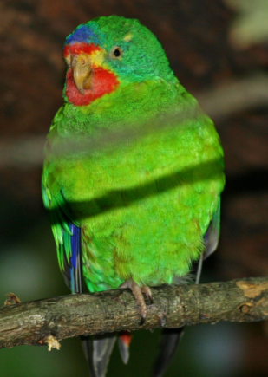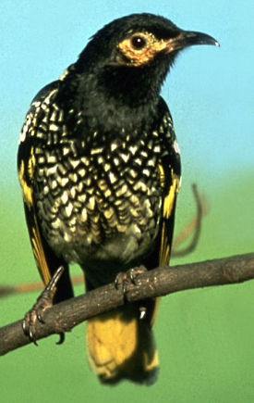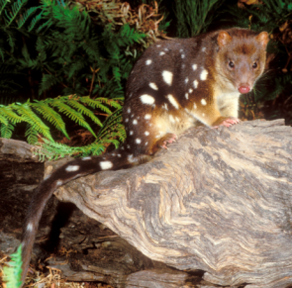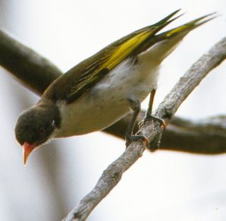

(Clockwise) Painted honeyeater © Copyright Brian Furby Collection; spotted-tailed quoll © Copyright Dave Watts;   
regent honeyeater © Copyright Graeme Chapman swift parrot © Copyright Ernst Vikne.

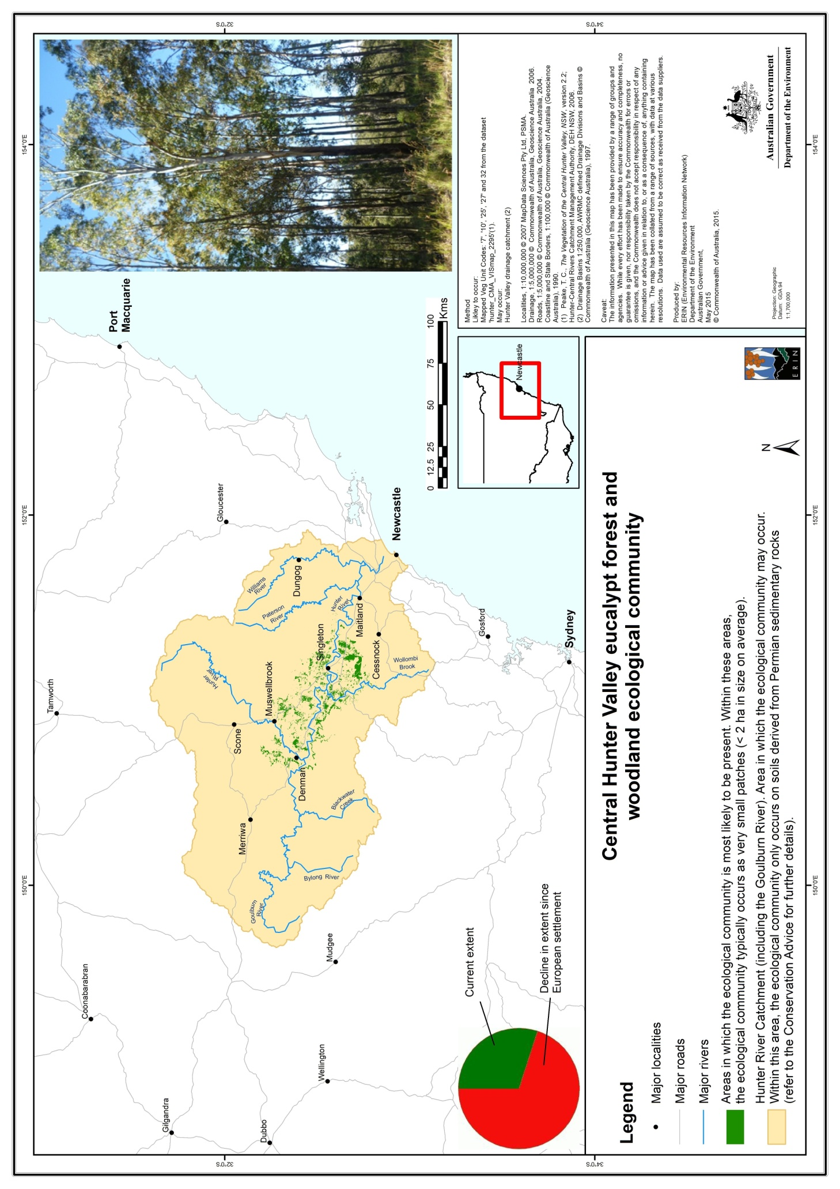This map is also available online at: <http://www.environment.gov.au/biodiversity/threatened/communities/maps/pubs/130-map.pdf>

Note that property specific maps, available from state agencies, do not always identify EPBC-listed ecological communities.

Why does the ecological community need national protection?

The Hunter Valley is the largest of the lowland plains on the New South Wales coast. Its vegetation was cleared relatively early in the European settlement of Australia due to its high value as agricultural land. More recently, the vegetation has been cleared for mining, suburbs and roads.

In May 2015 the Australian Government Minister for the Environment listed the Central Hunter Valley eucalypt forest and woodland ecological community, after considering the advice of the Threatened Species Scientific Committee (the Committee). A rigorous assessment of the scientific evidence found that it met the eligibility criteria for listing as critically endangered under the EPBC Act, Australia’s national environment law.

The Committee found that:

* the ecological community had undergone a decline of more than 70 per cent in extent (total area)
* the ecological community now occurs as highly fragmented patches, with many less than 2 ha in size
* it has experienced a severe reduction in integrity due to the combined effects of: substantial clearing and fragmentation, weed infestations, loss of fauna, heavy grazing and changes to natural fire regimes.

The overall aim of nationally listing the ecological community is to prevent its decline and support on-ground efforts to ensure its long-term survival. The Conservation Advice for the ecological community outlines a range of priority research and management actions that provide guidance on how to manage, restore and protect it. This Conservation Advice can be found on the Department’s website: <http://www.environment.gov.au/cgi-bin/sprat/public/publicshowcommunity.pl?id=130>

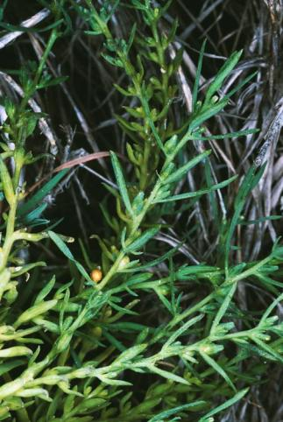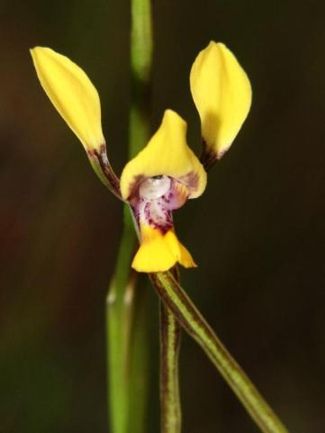

Austral toadflax © Copyright Nev Fenton; *Diuris tricolor* (painted diuris, pine donkey orchid, spotted-throat cowslip) © Copyright Colin Rowan.

Are all patches protected under the EPBC Act listing?

No, most national definitions of ecological communities specify condition thresholds which help to identify patches that are too small or degraded to be protected under the law. This allows national protection to focus on the best and most intact patches of the Central Hunter Valley eucalypt forest and woodland ecological community.

The condition thresholds mean that small, degraded patches—such as individual paddock trees, short narrow patches, or remnants where the understorey has been largely replaced by weeds—are excluded from the listed ecological community and any actions that may impact them do not need to be considered under the EPBC Act.

Condition thresholds

The Central Hunter Valley eucalypt forest and woodland ecological community is only protected under national environment law when it is in relatively good condition. A patch should first be identified as being the ecological community (using the landscape, soil and vegetation features listed on pages 2 and 3 and covered in more detail in the Conservation Advice document on the Department’s website). Then it may be identified as being in relatively good condition (Moderate quality) if it meets the condition thresholds illustrated in the flowchart in Figure 1**.**

Although not part of the protected ecological community listed under the EPBC Act, it is recognised that patches which do not meet the minimum condition thresholds for Moderate quality may still retain important natural values; particularly if they are near patches which do meet the minimum condition thresholds. As such, these patches should not be excluded from recovery and other management actions. They may also be protected under state and/or local laws or schemes.

For further details of how to determine whether a patch of vegetation meets the definition and condition thresholds for the national ecological community see the Conservation Advice at: <http://www.environment.gov.au/cgi-bin/sprat/public/publicshowcommunity.pl?id=130>

The condition of an ecological community is best assessed when:

* many plant species are flowering or fruiting (to aid identification), which   
  usually occurs between November and December; and
* there has been no recent disturbance; which means allowing at least two months, preferably longer, for the ecological community to recover after any substantial disturbance.

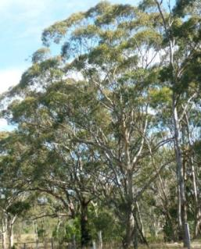More detailed guidance on identifying the ecological community is in the Conservation Advice for the ecological community on the Department’s website.

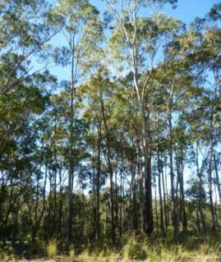

Central Hunter Valley eucalypt forest and woodland © Copyright Sharon Warne.

Figure 1: Flowchart to help identify which areas (patches) of the Central Hunter Valley eucalypt forest and woodland ecological community meet the minimum condition thresholds for national protection.

The patch is too small to be part of the protected ecological community

NO

**(1) Is the patch at least 0.5 ha in size?**

YES

The patch is too weedy to be part of the protected ecological community

NO

**(2) Is at least 50% of the perennial understorey vegetative cover of the patch (due to) native plants?**

**The patch lacks native understorey diversity, but may have other values;**

**go to Question 4.**

YES

**(3) Are there at least 12 native understorey species in the whole patch?**

NO

The patch is not part of the protected ecological community

YES

**(4) Is the patch at least 2 ha in size?**

NO

**The patch is part of the protected nationally listed ecological community**

**(6) Or, does the patch have at least one large, locally indigenous tree (at least 60 cm in diameter4), or at least one tree with hollows?**

YES

NO / DON’T KNOW

**(5) Is the patch continuous with, or near, another area of native woody vegetation that is at least 1ha3 in size?**

YES

**The patch is part of the protected nationally listed ecological community**

YES

NO

The patch is not part of the protected ecological community

In the flowchart (Figure 1), a patch that registers ‘NO’ against Question 3 is considered to be too degraded to be part of the nationally protected ecological community; unless it qualifies under the alternate pathway (‘YES’ to questions 1, 2, 4 and either 5 or 6) because of other ecological values (e.g. a larger patch, at least 2 ha in size - with at least one large, locally indigenous, tree). In either case, the answer to questions 1 and 2 must be ‘Yes’ (i.e. a patch at least 0.5 ha in size and at least 50% of the perennial understory vegetative cover comprises perennial species native to Australia; as opposed to non-native perennial species).

3Near means within 100 m of; and, the “area of native woody vegetation that is at least 1ha in size” could be more of the ecological community itself (i.e. where the whole patch is at least 3 ha in size, or where a nearby patch of the ecological community is at least 1 ha in size), or another type of native woody vegetation.

4 Tree diameter is measured at ‘breast height’ (referred to as dbh) - by convention, 1.3 metres above the ground; also, the “tree with hollows” can be a tree of any species.

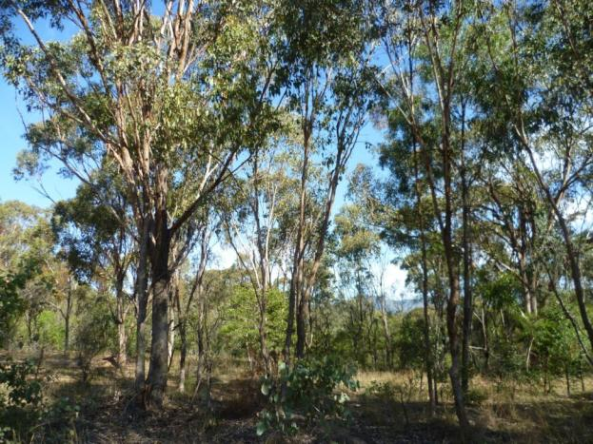

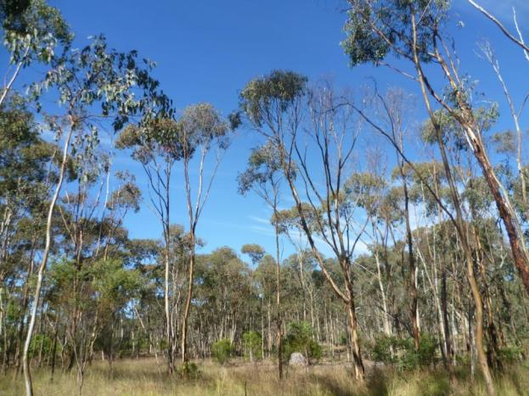

Central Hunter Valley eucalypt forest and woodland (top & bottom) © Copyright Sharon Warne.

What is a patch of the ecological community?

**A patch is a discrete and mostly continuous area** of the ecological community (e.g. tree canopies within 30 m of each other). A patch of the Central Hunter Valley eucalypt forest and woodland ecological community is the largest area within which the projected canopy cover of trees is **at least** 10% (**on average**); or within which the native tree density is **at least** 10 native tree stems per 0.5 ha [i.e. at least 20 native tree stems/ha] **(on average),** that are at least one metre in height; **or a combination of areas meeting either of these two measures**.

For the purposes of illustration: an area of the ecological community with a projected canopy cover of 15% may be adjacent to an area of predominantly native vegetation that meets all the other key diagnostic characteristics5 of the ecological community but has a projected canopy cover of 5%—but still with tree canopies within 30 m of each other. This would be considered as one patch. Similarly an area of the ecological community with a projected canopy cover of 20% (e.g. an area 4.7 ha in size) may extend out, as a patch, into an area up to twice the size (e.g. up to a further 9.4 ha) that has a projected canopy cover of 5%; as long as the tree canopies are within 30 m of each other. i.e. the one patch (up to 14.1 ha in size), would have a mean average projected canopy cover of at least 10%. A patch should also have a predominantly native understory (see item (2) in Figure 1 on page 10).

Permanent man-made structures, such as roads and buildings, are typically excluded from a patch (see   
Figure 2). A patch may include small-scale variations and disturbances, such as tracks, paths or breaks (including exposed soil, leaf litter, cryptogams and watercourses/drainage lines), or localised changes in native vegetation that do not significantly alter the overall functionality of the ecological community.

Figure 2: Example of a patch of the Central Hunter Valley eucalypt forest and woodland ecological community.

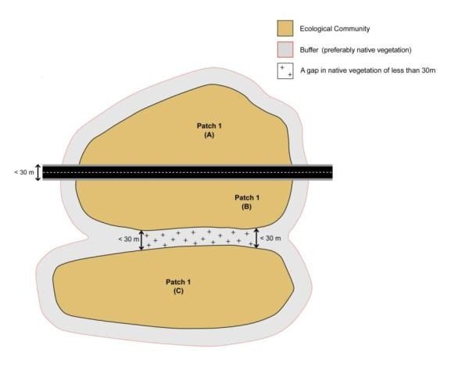

5 More detailed guidance on identifying the ecological community, including its key diagnostic characteristics and other diagnostic considerations, is in the Conservation Advice for the ecological community on the Department’s website.

Where there is a break in native vegetation cover (e.g. from the edge of the tree canopy) of 30 m or more (e.g. due to permanent artificial structures, wide roads or other barriers; or due to wide water bodies - e.g. separating the tree canopy by 30 m or more), then the gap indicates that separate patches are present. Figure 2 illustrates breaks too small to result in separate patches, but of a character (e.g. man made road, or non-native vegetation), such that they are not included in calculating the area of the patch; so the area of the patch equals areas A + B + C. Conversely, Figure 3 shows a larger break, resulting in two separate patches.

Predominantly native grasslands and/or shrublands (whether derived from the ecological community or not) are not included in this nationally protected ecological community; e.g. areas not adjacent to the ecological community, or areas adjacent to the ecological community but beyond the 10% mean average projected canopy cover boundary (20 native tree stems/ha,at least one metre in height, boundary). The exceptions are where predominantly native grasslands and/or shrublands fill a small gap in, or at the edge of, a patch; or they connect two woodland areas across a short distance (i.e. up to 30 m); in which case they are included in calculating the area of the patch (see Figure 3). Native grasslands/shrublands, beyond the boundary of the ecological community also act as buffer zones that can protect the ecological community from adjacent activities and act as stepping stones that enable the movement of fauna between remnant woodlands. More detailed information about buffer zones is in the Conservation Advice for the ecological community on the Department’s website.

Figure 3: Example of two patches of the Central Hunter Valley eucalypt forest and woodland ecological community.

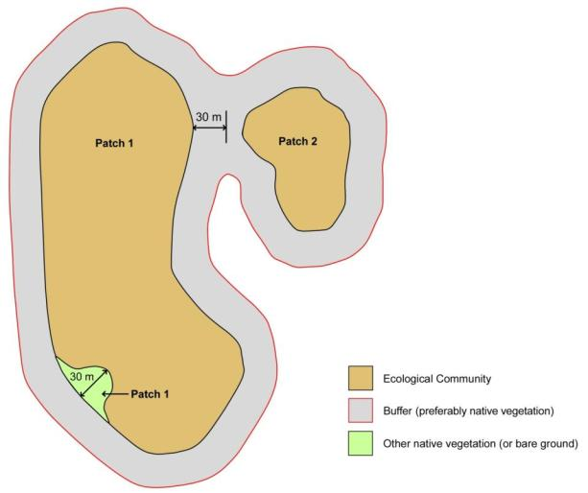

What are the benefits of listing the ecological community as nationally threatened?

There are a number of benefits to listing ecological communities under Australia’s national environment law and in the case of the Central Hunter Valley eucalypt forest and woodland ecological community, the listing will:

* help protect the landscapes that provide the connectivity of wildlife corridors and refuges essential to the long-term productivity, health and biodiversity of the region
* protect habitat critical to sustain and recruit threatened (and other) species under pressure in the region—in turn, this helps sustain ecosystem services associated with the ecological community
* complement existing national and state protection for threatened species and ecological communities in the region and help defend the ecological community from future significant human impacts that may cause further decline
* raise awareness of the ecological community and its threats and encourage agencies and community groups to undertake conservation and recovery works and apply for environmental funding—the Australian Government has a variety of funding programmes to encourage land managers to conserve biodiversity and ecosystem services.

The Conservation Advice, published at the time of listing, provides guidance and options for environmental decision-making, including priority research, conservation and rehabilitation initiatives.

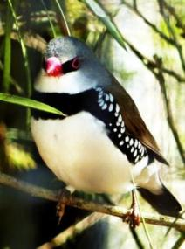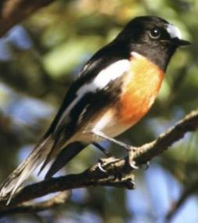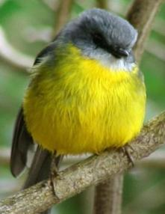The aim of the EPBC Act is to ensure that matters of national environmental significance are given due consideration, along with broader economic, social and other issues in the planning of any large projects; where possible, potentially significant, adverse impacts to the environment should be avoided. However, if impacts are unavoidable, then they must be reduced, mitigated, or offset.

Diamond firetail © Copyright Matt White; scarlet robin and eastern yellow robin © Copyright Brian Furby Collection.

What does the listing mean for landholders?

Business as usual for most routine activities

It is important to note that the EPBC Act is only triggered if a particular activity has, or will have, a significant impact on a Matter of National Environmental Significance—a threatened ecological community, in this instance.

The normal activities of individual landholders, residents and councils will typically not be affected by a listing. Routine property maintenance, land management and other established practices—such as ongoing road maintenance works—are unlikely to have a significant impact and so do not typically require referral or other consideration under national environment law, particularly if carried out in line with other national and state laws covering native vegetation.

For instance, the following actions are unlikely to trigger national environment law:

* ongoing grazing, horticultural or cropping activities
* maintaining existing roads, fences, access tracks and firebreaks
* maintaining existing farm gardens and orchards
* maintaining existing farm dams or water storages
* maintaining existing pumps and clearing drainage lines
* replacing and maintaining sheds, yards and other buildings
* controlling weeds and spraying for pests on individual properties or roadside verges.

Although the above actions are unlikely to trigger the EPBC Act, any impacts on patches of the ecological community should still be avoided where possible. For example, landholders should try to avoid native vegetation clearance in the ecological community and create a minimum 30 m buffer zone to help protect the root zone of trees and other components at the edge of the ecological community from spray drift (fertiliser, pesticide or herbicide sprayed in adjacent land) and other damage.

It is also important to note that human settlements and infrastructures, where an ecological community formerly occurred, do not form part of the natural environment and so are not considered to be part of the protected ecological community. This also applies to sites that have been replaced by crops and exotic pastures, or where the ecological community exists in a highly-degraded or unnatural state.

Whether or not an action is likely to have a significant impact depends on the sensitivity, value and quality of the environment which is impacted, and on the intensity, duration, magnitude and geographic extent of the impacts.

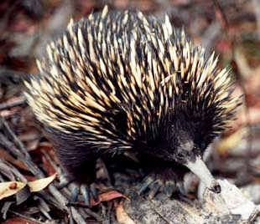*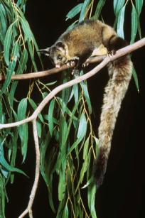*

Echidna **©** Copyright Trevor Preston; yellow-bellied glider © Copyright AHT.

Approval is required for actions likely to have a significant impact

The EPBC Act is triggered if an action is likely to have a significant impact on the ecological community. If a proposed action is likely to have such an impact, it would require:

* determining if the action may have a significant impact on the ecological community (referral)
* assessment (the scope depends on the complexity of the proposed action and impacts)
* an approval decision from the Minister (considering environmental, social and economic factors).

Social and economic matters may also be taken into account for individual projects that may have a significant impact on the ecological community, through the EPBC Act approvals process. Strict timeframes apply to assessments to ensure decisions are made as quickly as possible. For further information on referral, assessment and approval processes, refer to the following website:

[www.environment.gov.au/protection/environment-assessments/assessment-and-approval-process](http://www.environment.gov.au/protection/environment-assessments/assessment-and-approval-process)

The key diagnostics (landscape, soil and vegetation features) and condition thresholds for the ecological community (outlined on pages 2, 3 and 10) exclude many patches on properties or along roadside verges that are considered too degraded for protection. In addition, the EPBC Act provides exemptions for continuing (routine) use or where legal permission has previously been given; see previous section on ‘Business as usual for most routine activities’.

The major activity that is likely to have a significant impact on the ecological community is permanently clearing large or otherwise important areas of intact native vegetation. Examples include:

* major mining, residential, commercial or other industrial development
* building new roads or widening existing roads
* converting large areas into new pastures or cropping fields.

To help reduce the significance of actions, the EPBC Act promotes the avoidance and mitigation of impacts from the early planning stage, wherever possible.

What can I do to look after the ecological community?

You can protect and promote the recovery of bush remnants in your area. You can:

* avoid further clearance and fragmentation of the ecological community and surrounding native vegetation, with high-quality, older regrowth and unmodified areas being particularly important
* minimise unavoidable impacts from any developments or other activities in areas adjacent to the ecological community that might result in their further degradation—for example, by applying a minimum 30 m buffer zone around the ecological community, avoiding hydrological impacts and avoiding the use of fertilisers and pesticides
* plant local native species in your garden, particularly those characteristic of the ecological community
* remove non-native species from your property and don’t plant or spread potential environmental weeds (check with your local authority)
* strategically manage grazing (e.g. through fencing, stocking density, seasonality, weed prevention) and avoid mowing the understorey (unless for ecological reasons)
* practice environmentally safe bushwalking—keep to paths, don’t remove or trample on plants, keep pets on a leash and take your rubbish home with you
* where possible, allow dead and fallen trees and timber to remain where it is, to provide fauna habitat—avoid unnecessary ‘tidying up’, or collecting firewood
* report illegal or damaging behaviour (e.g. unauthorised fires or dumping) to appropriate authorities
* support local native vegetation and wildlife conservation (e.g. join a local Landcare or catchment group, natural history or a ‘friends of’ group, or Conservation Volunteers)
* participate in special events, information nights, tree planting days and weed eradication programs in your local area.

The Conservation Advice on the Department’s website gives further details of priority conservation actions for the ecological community: <http://www.environment.gov.au/cgi-bin/sprat/public/publicshowcommunity.pl?id=130>

Are there other nationally protected ecological communities within this area?

Within the Hunter River catchment there are a number of other ecological communities protected under national environment law including:

* [Hunter Valley Weeping Myall (Acacia pendula) Woodland](http://www.environment.gov.au/cgi-bin/sprat/public/publicshowcommunity.pl?id=44&status=Critically+Endangered)
* [White Box-Yellow Box-Blakely's Red Gum Grassy Woodland and Derived Native Grassland](http://www.environment.gov.au/cgi-bin/sprat/public/publicshowcommunity.pl?id=43&status=Critically+Endangered)
* [Littoral Rainforest and Coastal Vine Thickets of Eastern Australia](http://www.environment.gov.au/cgi-bin/sprat/public/publicshowcommunity.pl?id=76)
* [Lowland Rainforest of Subtropical Australia](http://www.environment.gov.au/cgi-bin/sprat/public/publicshowcommunity.pl?id=101&status=Critically+Endangered)
* [Warkworth Sands Woodland of the Hunter Valley](http://www.environment.gov.au/cgi-bin/sprat/public/publicshowcommunity.pl?id=143)

For more information regarding these ecological communities, click on the links above, or visit: [www.environment.gov.au/cgi-bin/sprat/public/publiclookupcommunities.pl](http://www.environment.gov.au/cgi-bin/sprat/public/publiclookupcommunities.pl)

Do state or local environment laws also apply?

Yes. State and local laws may also apply. Information about state-listed ecological communities and vegetation management laws are available from the following agencies:

* NSW Office of Environment and Heritage   
  [www.environment.nsw.gov.au/threatenedspecies/](http://www.environment.nsw.gov.au/threatenedspecies/)  
  [www.environment.nsw.gov.au/vegetation/](http://www.environment.nsw.gov.au/vegetation/)
* Hunter Councils Environment Division (HCCREMS)  
  <http://hccrems.com.au/>
* Hunter Local Land Services:  
  <http://hunter.lls.nsw.gov.au/land-and-water/native-vegetation>

Where can I get further information?

The Conservation Advice for the Central Hunter Valley eucalypt forest and woodland ecological community is the definitive source of information on the listing of this ecological community. For information about the development referral, assessment and approval process, please consult our environmental protection webpages. These can be found on the Department’s website—along with additional information about the EPBC Act and Australian Government programs—as listed below:

* A statutory approved Conservation Advice for the ecological community is on the Department’s species profile and threats (SPRAT) database, at: <http://www.environment.gov.au/cgi-bin/sprat/public/publicshowcommunity.pl?id=130>
* Details of the EPBC listing process at: [www.environment.gov.au/topics/threatened-species-ecological-communities](http://www.environment.gov.au/topics/threatened-species-ecological-communities)
* Details of the EPBC assessment and approval statutory process that must be followed is at: [www.environment.gov.au/topics/environment-protection](http://www.environment.gov.au/topics/environment-protection)
* Details of Australian Government National Landcare Programmes and Natural Resource Management organisations and initiatives are at: [www.nrm.gov.au](http://www.nrm.gov.au)
* A separate factsheet on farming and national environmental law at: [www.environment.gov.au/epbc/publications/factsheet-farming-and-national-environment-law-epbc-act](http://www.environment.gov.au/epbc/publications/factsheet-farming-and-national-environment-law-epbc-act)

Enquiries can also be made through the Department’s Community Information Unit, by phone on **1800 803 772** (freecall), or email to [ciu@environment.gov.au](mailto:ciu@environment.gov.au)

**environment**.gov.au

