

REFERENCE

# Plant Exports Management System (PEMS) Authorised officer user guide – Bulk into ship hold inspections

**In this document**

This document contains the following topics.

Purpose of this document 3

Initiating the bulk into ship hold inspection 3

Bulk into Ship Hold Inspection page 7

Opening the RFP details 8

Returning to the inspection record from the RFP page 9

Recording additional declarations 10

Edit Exporter name (*if applicable*) 12

Verifying import permit details 13

Verifying treatment details 15

Adding associated RFPs 17

Recording flow path inspection results 20

Recording loading rate 22

Recording rejection limit 23

Splitting lines on the inspection record 24

Recording inspection results for bulk into ship hold 25

Navigating between line inspection windows 28

Completing and submitting the inspection record 29

Recording reinspection of a consignment (if required) 31

Expiration date for bulk into ship hold inspection 31

Related material 32

Contact information 32

Document information 33

Version history 33

## Purpose of this document

This reference outlines how to use PEMS to record a Bulk into ship hold inspection.

**Note:** An overview of PEMS and general functions can be found in the Reference: *Plant Exports Management System (PEMS) Authorised Officer User Guide – Overview and general functions*.

### Initiating the bulk into ship hold inspection

To initiate the bulk into ship hold inspection, click on the **Home1** menu tab and then click the **Bulk into ship hold2** button.

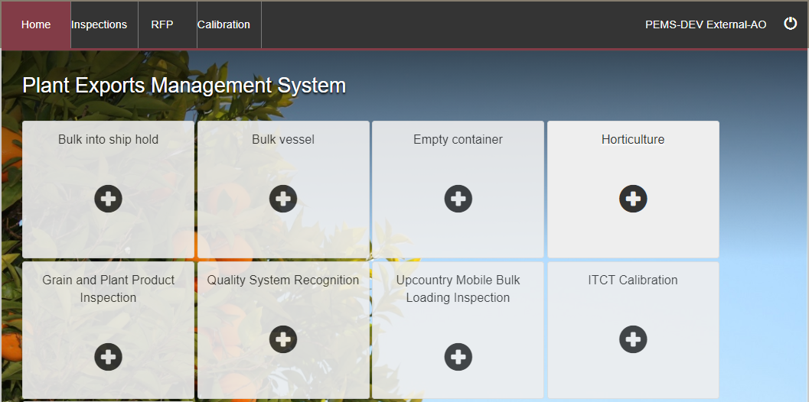

**1**

**2**

The *Create Bulk into Ship Hold Inspection* window will display.

Enter the **RFP number1.**The number should be 7 digits long.

**If a Mobile Bulk Loader2 is used, you must select the check box to confirm it as part of this inspection.**

Enter the **Establishment number3** (only mandatory for third party AOs). The establishment number should be 3 to 4 digits long.

Enter the **IMO number4** for the bulk vessel (only mandatory for flowable goods inspected during vessel loading). The IMO number will consist of the letters ‘IMO’ followed by 7 digits; for example, IMO1234567. Click **Search5**.

The **Vessel details6** will display if the vessel meets the international standard and current bulk vessel approval exists in the PEMS database for the vessel.

****Once the required information is entered, click **Create7**.

If a change is made to the RFP in EXDOC, you can select the **Reload RFP from EXDOC8** checkbox to update the relevant RFP and inspection record in PEMS. For more information see Section 4.1: Reload RFPfrom EXDOC ofReference:*PEMS AO user guide – Overview and General Functions*.

**6**

**5**

**8**

**7**

**1**

**4**

**3**

**2**

PEMS extracts RFP information from EXDOC to populate the bulk into ship hold inspection record.   
The inspection page will display by default.

****The inspection record will remain **Active1** until the record is withdrawn, submitted or cancelled.

While the inspection record is active, the date provided on the inspection record is the date the inspection record was initiated.

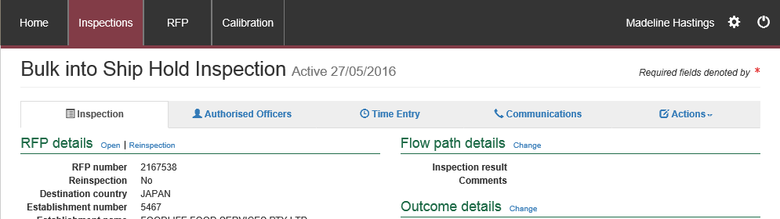

**1**



### Bulk into Ship Hold Inspection page

The *Bulk into Ship Hold Inspection* page will display the following key sections:

* **RFP details1** **–** populated based on RFP information extracted from EXDOC
* **Flow path details2** **–** allows you to record or change the flow path inspection result
* **Outcome details3 –** allows you to select the loading rate and rejection limit for the inspection and provides a summary of the inspection outcomes
* **Vessel details4** **–** read-only information populated by PEMS where relevant to the inspection
* **Results5** **–** prepopulated with the consignment information based on the RFP. The inspection results are recorded here
* **Comments6** **–** general comments regarding the inspection can be recorded here   
  (see Section 3.8 Adding comments to an inspection record ofReference:*PEMS AO user guide – Overview and General Functions*).

Step-by-step instructions on how to record or change data on this page is provided below.

**6**

**5**

**4**

**3**

**2**

**1**

### Opening the RFP details

To open the RFP details, click the **Inspection1** tab and then click **Open2** under the RFP details section.

**1**

**2**

The *Request For Permit* *(RFP)* page will display.

The RFP page will display a **Summary1** of the RFP, as well as the **Request for permit lines2**. For more information on each of the **RFP tabs3** see Section 4: RFP functions in PEMS (commodity inspections) ofReference:*PEMS AO user guide – Overview and General Functions*.

Click **Open4** beside any RFP line to view the details of that line.

**4**

**3**

**1**

**2**

**1**

When you click **Open4** (above) beside any RFP line, the *RFP Line* window will open (below) and display the details of the line as they were provided on the RFP in EXDOC.

Click **Previous** and **Next1** to navigate between the RFP line details window.

Click **Close2** to exit the RFP line window at any time and return to the *Request For Permit* page.

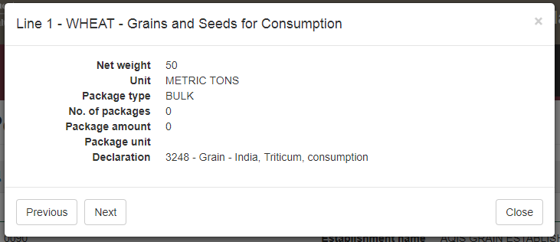

**2**

**1**

### Returning to the inspection record from the RFP page

To return to the *Bulk into Ship Hold Inspection* page, click the **Inspections1** tab.

The full list of inspections relating to the RFP will display. For more information see Section 4.3 Navigating to related inspections/calibrations from the RFP screen of Reference: *PEMS AO user guide – Overview and General Functions*.

Click **Open2** beside the Active inspection to view the record.

**2**

**1**

### Recording additional declarations

If there is additional declaration information for the consignment, it must be verified and recorded in PEMS.

To record additional declaration information, click the **Inspection1** tab and then click **Change2** under the RFP details section.

**2**

**1**

The *Change Details* window will display.

Where applicable, you must **View1** the *Link to Micor.* This will open another window and link you to the Micor case for the commodity and country. Select the **Additional declaration Verified2** checkbox in the *Change Details* window. You will not be able to click the checkbox if you have not verified the Micor case.

Click **Save3.**

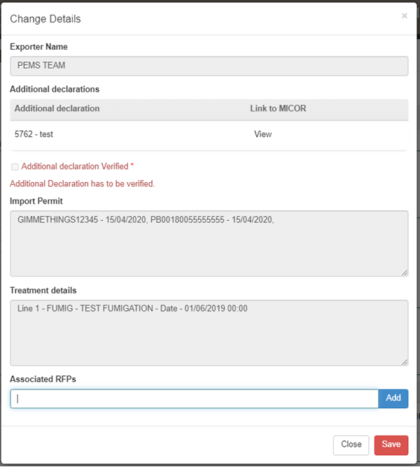

**3**

**1**

**2**

****The *Bulk into Ship Hold Inspection* page will display the updated **Additional declarations1**  information.

The inspection results grid will be enabled only when the additional declaration is set either to ‘*No*’ or ‘*Verified*’.

**1**

### Edit Exporter name (*if applicable*)

There is a field length limitation of 35 characters when the exporter name is extracted into PEMS from EXDOC (system constraint). This means that in some instances the entire exporter name will not appear in PEMS. This change can no longer be made by the AO.

You must check that the exporter name that appears in the inspection record in PEMS matches the exporter name on the RFP.

If the exporter nameis not correct, you need to contact [PEMS@agriculture.gov.au](mailto:PEMS@agriculture.gov.au) to have the name corrected in the PEMS reference table. Once this is corrected you will not need to request the change again for future inspections/calibrations, as PEMS will save the corrected version of the exporter name for all future records.

If the exporter name is different due to another reason (for example, legal change of entity name) then these changes must be made in EXDOC through the appropriate process.

### Verifying import permit details

Import permit details must be verified for the consignment. To verify the import permit details, click the **Inspection1** tab and then click **Change2** under the RFP details section.

**2**

**1**

The *Change Details* window will display.

You must verify the **Import Permit**1 details relevant to the consignment.

Click **Save2.**

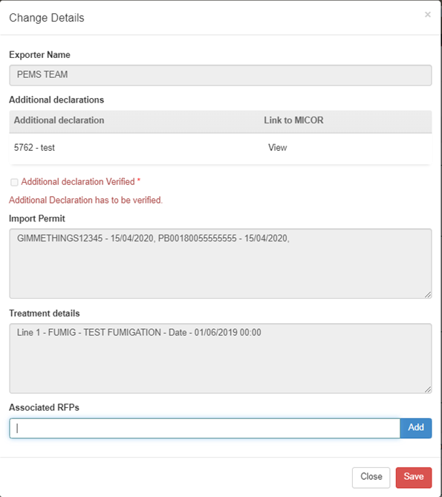

**2**

**1**

### Verifying treatment details

Treatment details must be verified for the consignment. To verify the treatment details, click the **Inspection1** tab and then click **Change2** under the RFP details section.

**2**

**1**

The *Change Details* window will display.

You must verify **Treatment details1** relevant to the consignment.

Click **Save2.**

**2**

**1**

### Adding associated RFPs

To add RFPs to the *Bulk into Ship Hold Inspection* record, click the **Inspection1** tab and then click the **Change2** tab under the RFP details section.

**2**

**1**





Where there are multiple RFPs of the same exporter to be loaded into a vessel, a single inspection record may be generated in PEMS to record the inspection results for that loading event. A separate inspection record(s) must be generated in PEMS for the inspection for each exporter that will be loaded onto the vessel.

If the destination country is the same, RFPs of the same exporter can be associated.

Insert the RFP number (which must be 7 digits long) and click **Add1**. PEMS will display all the **RFPs added2** and will extract commodity and destination country information from **EXDOC3**.

If you choose to remove any record, click **Remove4**.

Click **Save5.**

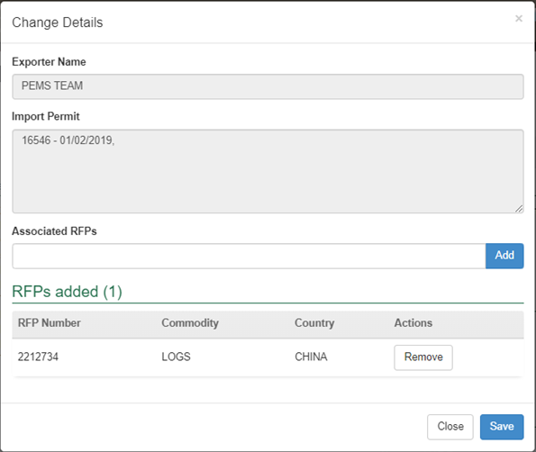

**5**

**3**

**4**

**1**

**2**

The *Bulk into Ship Hold Inspection* page will set the **Associated RFPs1** to ‘Yes’.

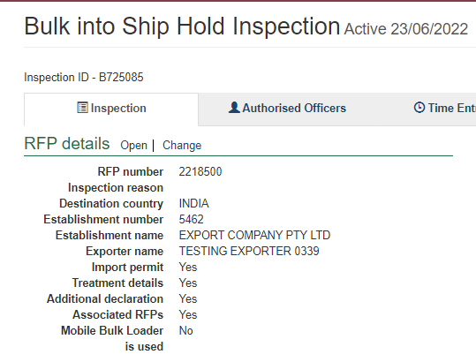

**1**



RFPs cannot be added when the inspection is checked out and PEMS is accessed in offline mode.

The RFP number that is added must be for the same exporter. Multiple RFPs with the same commodity associated to the inspection record will be consolidated in one RFP line and will display a cumulative total of the net metric weight values. Multiple RFPs with different commodities associated to the inspection record will be displayed in multiple RFP lines and will display a cumulative total of the net metric weight values against their respective RFP line.

### Recording flow path inspection results

Flow path inspection results must be recorded before entering the commodity inspection results and can be changed at any time until the record is submitted, cancelled or withdrawn.

To record flow path inspection results, click the **Inspection1** tab and then click **Change2** under the flow path details section.

**1**

**2**

The *Flow Path Details* window will display (next screenshot).

****Select a flow path **Inspection result1** of ‘Passed’ or ‘Failed’. The *Flow Path Details* window will expand and you must enter **Authorised Officer2**, **Result date3** and **Result time4**.

All AOs assigned to the inspection will be available to be chosen against a flow path result.

The flow path date/time must not be in future and must be within the start and end date of the inspection. If you fail the flow path initially and then provide a ’Passed after rectification’ result, rectification date/time must be after the flow path failed date/time.

If the flow path is failed at any time, you will have the option to change the flow path inspection result to ’Passed after rectification’, if applicable. If the flow path fails, you should not submit the inspection record. The flow path must be passed after rectification (see Section 3.3: Recording a passed after rectification flow path result ofReference:*PEMS AO User Guide – Overview and General Functions*) before submitting the inspection.

If ‘Passed after rectification’ is selected, the *Flow Path Details* window will expand and you must enter a **Result date5** and **Result time6**.

If applicable, provide **Comments7** on the flow path inspection (mandatory when the flow path fails or is passed after rectification).

****Click **Save8**.

The whole consignment presented for inspection will fail if the flow path receives a ‘Failed’ result. Do not continue with the commodity inspection as you will not be able to add results against RFP line. You must enter an appropriate time entry record, see Section 3.4: Time Entry ofReference: *PEMS AO user guide – Overview and General Functions* before the inspection record is submitted in PEMS.

**8**

**7**

**4**

**3**

**6**

**5**

**2**

**1**

The *Bulk into Ship Hold Inspection* page will display the updated flow path **Inspection result1** and PEMS will populate the name of the **Authorised Officer2** who recorded the flow path inspection results in PEMS.

**1**

**2**

### Recording loading rate

You have the option to record an average loading rate for the loading of goods onto the vessel. To record an average loading rate, or record that the loading rate is not applicable, click **Change1** under the Outcome details section.

**1**

The *Outcome Details* window will display.

Enter the average **Loading rate1** (including units) or enter not applicable (N/A), and then click **Save2**.

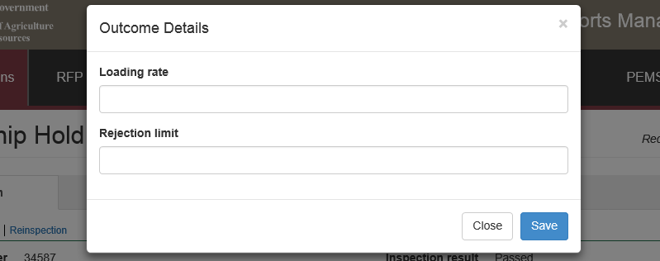

**1**

**2**

The *Bulk into Ship Hold Inspection* page will display the updated **Loading rate1** under the *Outcome details* section.

**1**

### Recording rejection limit

You have the option to record a rejection limit for the *Bulk into Ship Hold Inspection* record.

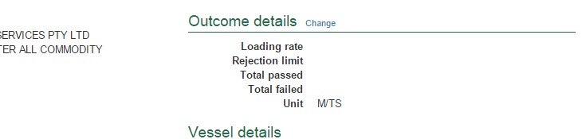To record a rejection limit, click **Change1** under the *Outcome details* section.

**1**

The *Outcome Details* window will display.

Enter the appropriate **Rejection limit1** (in tonnes) and then click **Save2**.



**1**

**2**

The *Bulk into Ship Hold Inspection* page will display the updated **Rejection limit1** under the Outcome details section.

**1**

### Splitting lines on the inspection record

For *Bulk into Ship Hold Inspection* records, you can split lines of the record where key information regarding the inspected consignment is not provided on the RFP in EXDOC or does not extract into PEMS but is important for the traceability of goods.

RFP lines should be split on the inspection record to identify, where applicable:

* for each hold, all commodity sources used to load the hold (for example, all relevant silo numbers) and the total amount passed into the hold across the loading event
* for each source or hold, the relevant rejection type used and amount rejected.

To split lines on the inspection record, click **Split line1** beside the appropriate commodity line. Any line presented for inspection can be split any number of times.

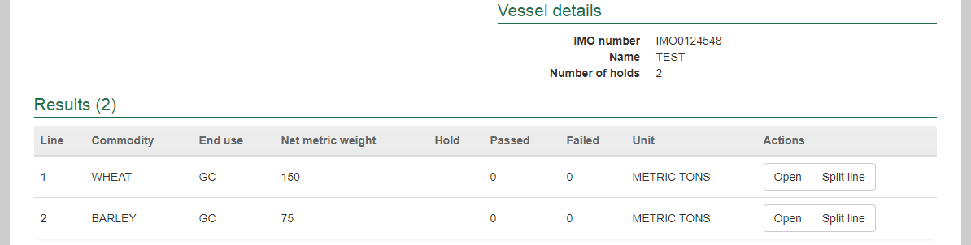

**1**

The inspection *Results* window for the new line will display (see second screenshot in the **Recording inspection results for bulk into ship hold** section below and continue to record the results for each line).

### Recording inspection results for bulk into ship hold

It is recommended that the supervising AO records the bulk into ship hold inspection results into PEMS at the end of each inspection session using each inspecting AO’s *Bulk Vessel Loading Running Record*.

To enter or change inspection results click **Open1** beside the appropriate line presented for inspection.

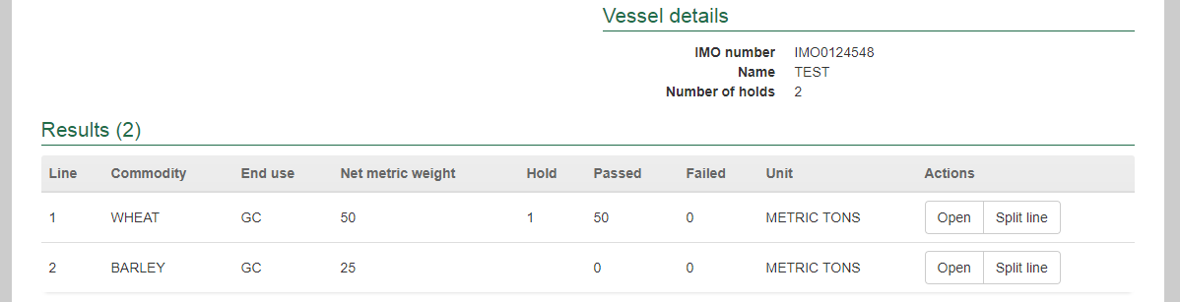

**1**



At the end of the inspection or inspection session, AO’s *Bulk Vessel Loading Running Record(s)* should be attached to the PEMS inspection record. For more information see Section 3.5: Communications of Reference: *PEMS AO user guide – Overview and General Functions*.

It is recommended that the supervising AO records the time entries for all AOs who performed inspections at the end of each inspection session. For more information see Section 3.4: Time Entry ofReference: *PEMS AO user guide – Overview and General Functions*.

The *inspection result* window will display.

For each inspection result window:

* If available, enter a single **Source1** for the goods being loaded into the hold, such as the silo number
* The appropriate **Hold number2** will be pre-selected(the hold number is only mandatory if an IMO number was provided when **Initiating the bulk into ship hold inspection**)
* If applicable, amend the **Net Metric Weight3**
* Enter the **Amount passed4** into the hold
* If applicable, select the **Rejection type5** used from 50 tonne runoff, horizontal storage source, log stockpile, vertical storage source, or woodchip pile
* If applicable, enter the **Action figure6** (mandatory if a rejection type is selected)
* ****Select the appropriate weight **Unit7** for the hold.

Only holds that have been approved for loading in the bulk vessel inspection will be displayed when the RFP is associated with the IMO. AO may choose to override and de-select the hold if the goods are not going to be loaded.

**1**

**7**

**6**

**5**

**4**

**3**

**2**

For each *Inspection Results* window you should also:

* If applicable, select one or more **Remarks1** checkboxes.
* When a remark is selected the **Tolerance Level2** drop down will appear, select the appropriate tolerance ‘above’ or ‘below’.
* A **Comment3** becomes mandatory about the tolerance level.

Click **Save4** to save the inspection result and exit the window.

**1**

**4**

**3**

**2**

Once the inspection result is saved, the *Bulk into Ship Hold Inspection* page will display the **new split line1**. You can **Remove2** the split line(s) up until the inspection is submitted, withdrawn or cancelled.

**2**

**1**

PEMS will summarise the **Total passed** and **Total action figure1** for the inspection record under the Outcome details section.

**1**

### Navigating between line inspection windows

You can navigate quickly between inspection *Results* windows by clicking **Previous** or **Next1** at the bottom of the inspection result window. The inspection result for each line will automatically save when you navigate between the windows in this manner.

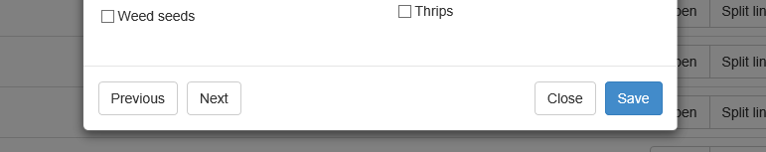

**1**

### Completing and submitting the inspection record

Any AO assigned to the inspection record can finalise and submit the inspection record in PEMS. It is recommended that the AO supervising the final inspection session performs this function.

The inspection record can only be submitted after:

* All inspection results are recorded appropriately, unless the flow path failed inspection
* If applicable, all comments relating to the inspection, such as additional RFP numbers or wharf address for log re-inspections, are recorded, see Section 3.8: Adding comments to a record of Reference: *PEMS AO user guide – Overview and General Functions*
* **Time Entry1** is provided for all AOs who recorded inspection results
* Attachments, including all AO *Bulk Vessel Loading Running Record(s)*, and correspondence are added under the **Communications2** tab.

Details on the Time Entry and Communications tabs can be found in Section 3: General PEMS functions ofReference: *PEMS AO user guide – Overview and General Functions*.

When you are ready to submit the inspection record, click the **Actions3**tab and then click **Submit4**.

For more information on **Downloading, Cancelling** or **Withdrawing5** the inspection, see Section 3.6 Actions tab of Reference: *PEMS AO user guide – Overview and General Functions*.

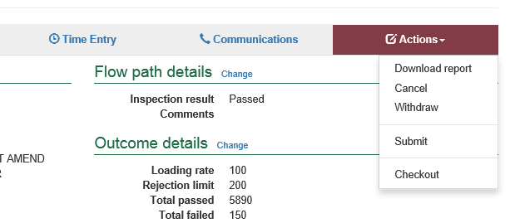

**4**

**3**

**1**

**2**

**5**

A pop-up window will ask you to confirm that you want to **submit this inspection1**.

It will also ask if you want to **email the exporter/EDI user on the submission of the inspection2.** When selecting this option, the Inspection submit confirmation box will expand.

Enter the **email address3**, this can be multiple email addresses each separated by a comma.

Enter in any **Comments4** that are to be included in the email.

Click **Save5**.

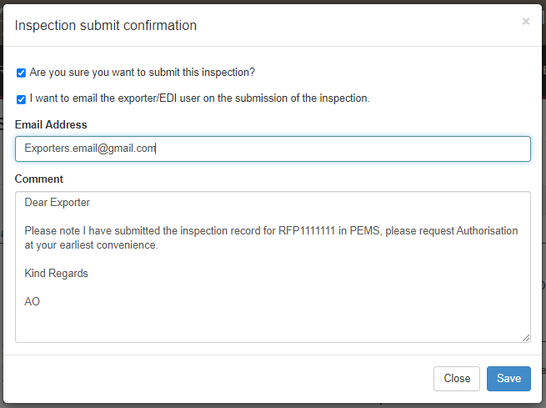

**5**

**2**

**4**

**3**

**1**

****The *Bulk into Ship Hold Inspection* record will display as **Completed1**.

The date(s) specified on the completed inspection record will be the start date and end date for the inspection. The inspection record date corresponds with the earliest and latest time entry across all AOs for the inspection.

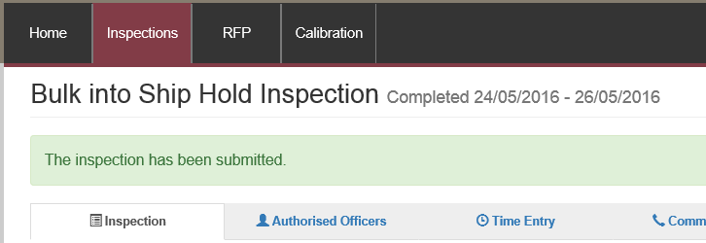

**1**



Once the inspection record is submitted the record will become read-only and you will be unable to make changes to the data provided. If you need to make changes to the record, see Section 3.6: Actions tab – Reactivating a completed record of Reference: *PEMS AO user guide – Overview and General Functions*.

### Recording reinspection of a consignment (if required)

For more information see Section 4.4 Creating inspection records where a record already exists for an RFPof Reference:*PEMS AO user guide – Overview and General Functions*.

### Expiration date for bulk into ship hold inspection

Following the submission of the *Bulk into Ship Hold Inspection* record, an expiry date will be allocated to all goods which have passed assessment. The expiry date is automatically calculated as 28 days from the first date of the first-time entry.

To view the expiration date, click the **Inspection1** tab and the **Expiry date2** will display under the inspection validity section.

If the bulk into ship hold expiry date is extended, you can view the reason for the expiry date extension by clicking **History3** under the inspection validity section.

The *Expiry History* window will display.

**2**

**3**

**1**

Click **Close1** to exit the window.

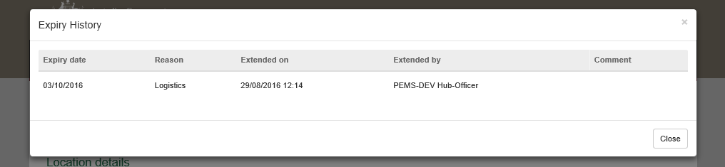

**1**

## Related material

The following related material is available on the [website](http://iml.agdaff.gov.au/Draft/General/agriculture.gov.au):

* Manual of Importing Country Requirements (Micor)
* Protocols and Work Plans
* [Plant Export Operations Manual](http://www.agriculture.gov.au/export/controlled-goods/plants-plant-products/plantexportsmanual)
* Reference: *PEMS AO user guide – Overview and General Functions*
  + *Empty container inspections*

The following related material is available on [Learnhub](https://learnhub.ssc.gov.au/login/):

* Plant Exports Management System (PEMS) video tutorials

## Contact information

* Authorised Officer Hotline: 1800 851 305
* Authorised Officer Program: PlantExportTraining@agriculture.gov.au
* PEMS Administration: [PEMS@agriculture.gov.au](mailto:PEMS@agriculture.gov.au).

## Document information

The following table contains administrative metadata.

| Instructional Material Library document ID | Instructional material owner |
| --- | --- |
| IMLS-9-7597 | Director, Digital Clearance Service, Digital Trade Initiative |

## Version history

The following table details the published date and amendment details for this document.

| Version | Date | Amendment details |
| --- | --- | --- |
| 1.0 | 08/07/2016 | New user guide. |
| 1.1 | 12/07/2016 | Minor variations for accuracy and clarity. |
| 2.0 | 30/09/2016 | * Complete document restructure. * Addition of sections on: * Logging into PEMS * Calibration records * Calibration search. |
| 2.1 | 16/12/2016 | * Minor variations for accuracy and clarity * Removal of Appendix F – Calibrations and loading * Removal of Section 2.3 – Calibration search |
| 3.0 | 09/10/2018 | AO user guide updated with PEMS v2.1 enhancements. |
| 4.0 | 23/05/2019 | AO user guide updated with PEMS v3.1 and v3.2 enhancements. |
| 5.0 | 4/11/2019 | Updated with PEMS v.3.3 and 3.4 enhancements. |
| 6.0 | 3/06/2020 | Updated with PEMS 3.5 enhancements. |
| 7.0 | 28/08/2020 | Removal of appendices from *Plant Exports Management System (PEMS) Authorised Officer user guide* to make each its own user guide. |
| 8.0 | 30/10/2020 | Updated with PEMS v3.8 enhancements. |
| 9.0 | 28/03/2021 | Updated for commencement of the *Export Control Act 2020* and associated Plant Rules. |
| 10 | 7/06/2021 | Updated with PEMS May 2021 release and added notes for workarounds. |
| 11 | 5/07/2021 | * Import permit work around is corrected * Updated with PEMS July 2021 release. |
| 12 | 13/09/2021 | Updated with PEMS September 2021 release. |
| 13 | 16/12/2021 | Updated with PEMS December 2021 release. |
| 14 | 21/02/2022 | Update with PEMS February 2022 release. |
| 15 | 04/04/2022 | Updated with PEMS April 2022 release. |
| 16 | 26/07/2022 | Updated with PEMS June 2022 release. |