|  |
| --- |
| Botrytis leaf blight (*Botrytis squamosa*) |

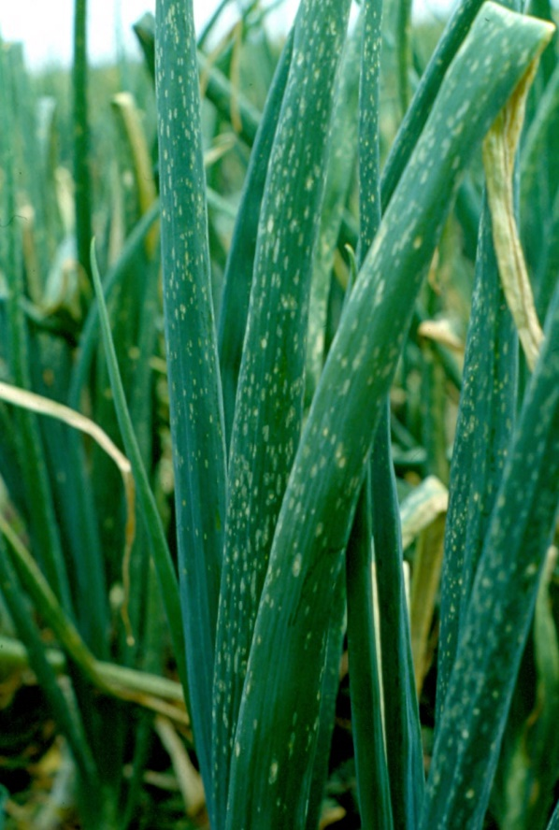

**Likely mode of entry**

This fungal plant disease can be distributed over long distances within infected plant material, including onion bulbs, garlic shoots or any other *Allium* plant material (including onion, garlic, and leek). Infective sclerotia may also be in soil. Short distance spread via infective spores occurs by wind.

**Symptoms (Figures 1–3)**

The fungus primarily attacks leaves, initially causing small (approx. 2 mm) water-soaked lesions which develop a sunken white or tan necrotic centre and a halo of pale green. Leaf lesions can develop characteristic lengthwise slits, with older leaves being more susceptible to lesion formation. Leaf spotting can be followed by blighting and more severe infections can cause leaf tip dieback and necrosis, sometimes with grey fuzzy growths (mycelia and conidiophores) and tiny black spots (sclerotia) visible. Late-stage rot symptoms and blackening can also be found on onion necks, but several other *Botrytis* spp. are more typically associated with botrytis neck rot of onions. Severely affected onion fields develop a blighted appearance, causing yield loss and smaller onion size.

**Host range**

*Botrytis squamosa* only affects *Allium* spp. such as onion, garlic, and leek, with the greatest impacts on onion and garlic.

**Biology**

The fungus overwinters as sclerotia on infected plant parts in the field, or as sclerotia in the soil. Under moist conditions and moderate temperatures sclerotia produce conidia (asexual spores) from conidiophores (specialised stalks) which serve as most of the primary inoculum for outbreaks. Sclerotia may also release ascospores (sexual spores). Conidia and ascospores will germinate on leaves and produce blights from the fungal infection. Conidia are produced in the necrotic tissues, causing secondary infections, and sclerotia will also develop in these areas. Sclerotia are black and granular and may be able to survive for several years, particularly when deeper in the soil.

**Distribution**

Present in many temperate regions, including Europe, Asia, North and South America, New Caledonia, and New Zealand. It is not present in Australia.

**Fig. 1** Onion leaves exhibiting botrytis leaf blight lesions and leaf tip dieback in the field (OMAFRA).

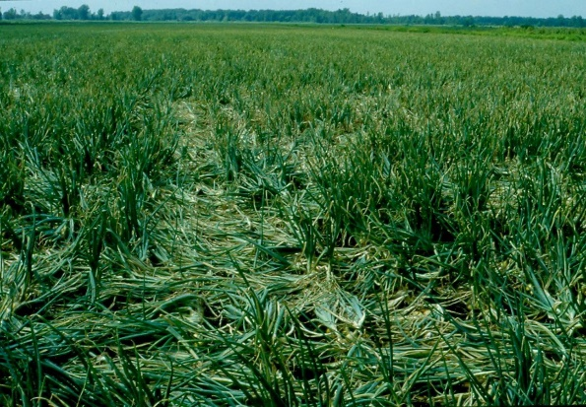

**What to do if you find suspect botrytis leaf blight**

**Department officers:** Contain the risk, collect plant specimens double-bagged into zip-lock plastic bags and deliver to a department plant pathologist immediately.

**Industry and the public:** **SEE. SECURE. REPORT.**

Secure the goods to limit movement and immediately report your detection to the Department of Agriculture, Fisheries and Forestry on **1800 798 636**.

**Fig. 2** Severely blighted fields appear yellowish from coalescing lesions and tip dieback (OMAFRA).

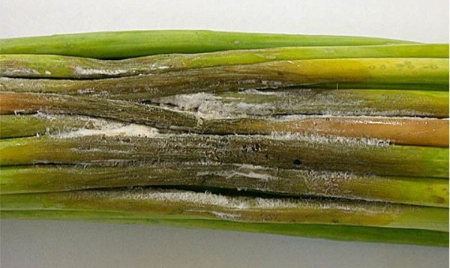

**Fig. 3** Garlic shoots infected with *Botrytis squamosa* showing fungal mycelia and conidiophores (DAFF, PaDIL).