

EPBC Act Policy Statement 3.13
Nationally Threatened Species and Ecological Communities

Significant impact guidelines for the endangered

black-throated finch (southern) (Poephila cincta cincta)

Introduction
The black-throated finch (southern) is listed as endangered under the Australian Government Environment Protection and Biodiversity Conservation Act 1999 (EPBC Act). Listed threatened species and ecological communities are a ‘matter of national environmental significance’. Under the EPBC Act an action will require approval from the federal environment minister if the action has, will have, or is likely to have a ‘significant impact’ on a matter of NES.
A ‘significant impact’ is an impact which is important, notable, or of consequence, having regard to its context or intensity. Whether or not an action is likely to have a significant impact depends upon the sensitivity, value, and quality of the environment which is impacted, and upon the intensity, duration, magnitude and geographic extent of the impacts. You should consider all of these factors when determining whether an action is likely to have a significant impact on matters of national environmental significance.
This policy statement is designed to assist you to determine whether a proposed action may have a significant impact on the black-throated finch (southern). The policy statement applies to habitats, including grassy open woodlands and forests, in which the black-throated finch (southern) is found during surveys or known from recent (post-1995) records. The black-throated finch (southern) historically occurred from the northern tablelands and north-west slope regions of New South Wales to the Atherton tablelands in north Queensland, but is now thought to be largely restricted to the northern part of its former range (figures 1 and 2).
This policy statement is based on the best available information, including:
- EPBC Act Listing Advice
- national recovery plan for the black-throated finch (southern) subspecies (Poephila cincta cincta)
- scientific literature
- consultation with the recovery team and other experts, and
- application of the national environmental legislation (EPBC Act).
This policy statement builds on the information and explanations in EPBC Act Policy Statement 1.1 Significant Impact Guidelines – Matters of National Environmental Significance.

How to interpret and apply these guidelines
The thresholds outlined in this policy statement are not designed to be prescriptive, but rather to clarify the level and types of impact likely to be significant at a national level regarding the biology, ecology and threats of the subspecies. If you are planning to undertake an action in grassy, open woodlands and forests in northern NSW and Queensland you should consider the following:
- Does my site support the black-throated finch (southern)?
  - consider vegetation, habitat, records and surveys on and near to the site (see page six)
- What impacts, both direct and indirect, could result from my action?
- Could any of these impacts exceed the thresholds outlined on page seven?
- What measures could be taken to reduce the level of impact (see page nine)?
If you think that your action is likely to have a significant impact on a matter of national environmental significance, or if you are unsure, you should refer the action to the federal environment minister. The minister will make a decision within 20 business days on whether approval is required under the EPBC Act. Substantial penalties apply for taking an action that has, will have or is likely to have a significant impact without approval.

What other laws protect the black-throated finch (southern)?
The black-throated finch (southern) is also listed as vulnerable in Queensland under the Nature Conservation Act 1992 and as endangered in New South Wales under the Threatened Species Conservation Act 1995. The listing of a species, subspecies or ecological community on the EPBC Act threatened species and ecological communities list recognises the importance of the matter from a national perspective, and does not replace listing under state, regional or local legislation or regulations.
Judgements may differ between Commonwealth, state and local decision making processes, due to the different scales of consideration. In some cases, multiple approvals or permits will be necessary before the action can commence. If your activity could affect the species or individual animals, you should contact the relevant state and local authorities regarding your obligations.

Ecology of the black-throated finch (southern)
The subspecies
The black-throated finch (southern) is one of two subspecies of black-throated finch. The information in this policy statement refers only to the southern subspecies, Poephila cincta cincta.
The black-throated finch (southern) is a small, thickset passerine (perching songbird) with brownish plumage, grey head and neck, and a prominent black bib. The black-throated finch (southern) is distinguished from the northern subspecies (P. c. atropygialis) by its white rump and richer brown plumage.
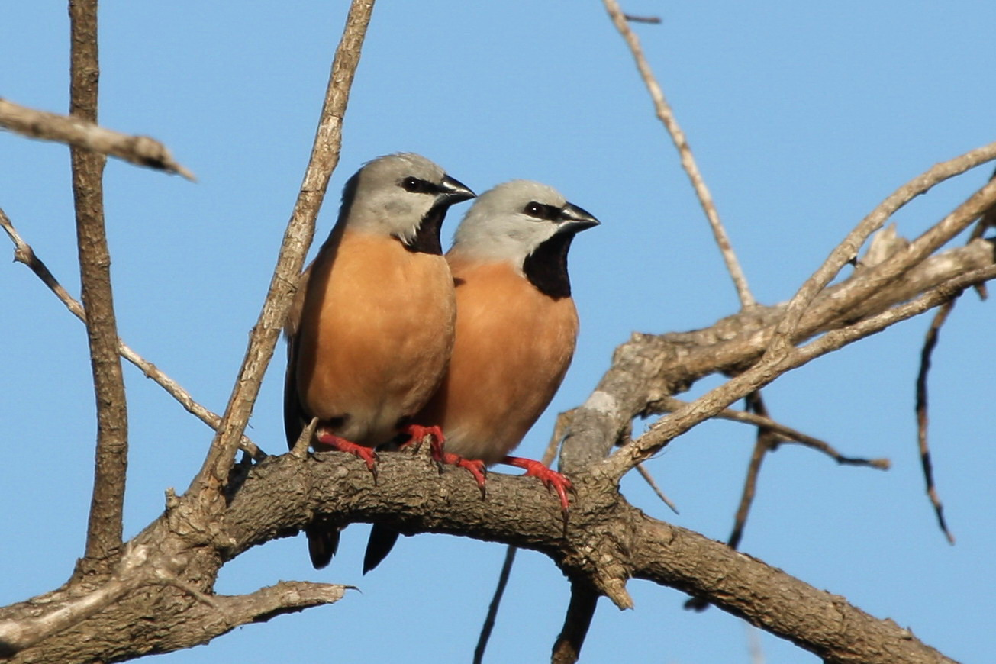
Ecology
The black-throated finch (southern) feeds on fallen grass seed and needs daily water. It nests in loose colonies in trees and shrubs, and can be a valuable indicator for assessing the health of woodland and grasslands.
The black-throated finch (southern) is a sedentary or resident bird which makes small daily movements between foraging sites. These movements may increase to up to three km a day during the non-breeding period. Breeding can occur throughout the year under optimal conditions. In the Townsville area, the peak breeding period is during the wet season between February and May.
Black-throated finch (southern) habitat is broadly defined as grassy open woodlands and forests, typically dominated by Eucalyptus, Acacia and Melaleuca.
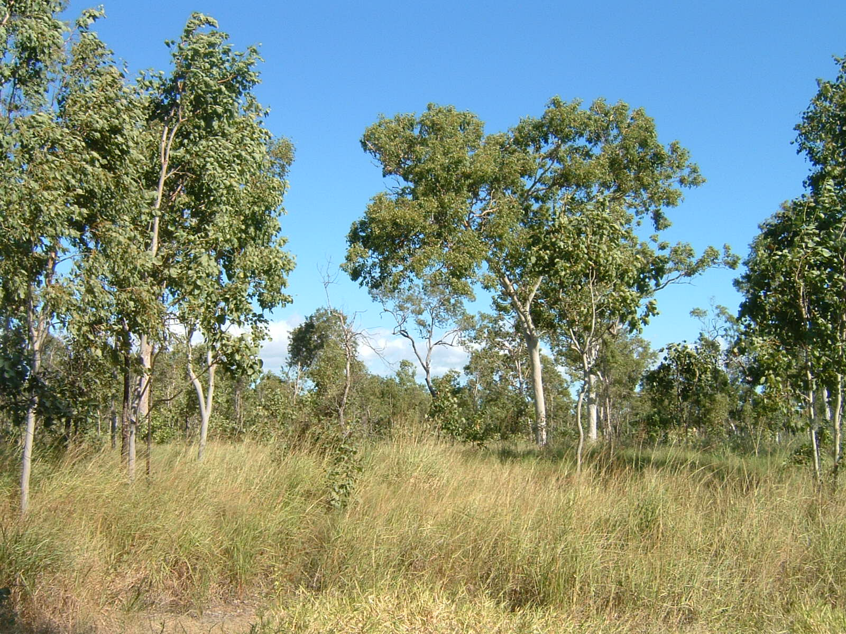
Within this habitat, the black-throated finch (southern) requires access to three key resources:
- water sources
- grass seeds, and
- trees providing suitable nesting habitat.
The presence and configuration between and within these three key resources governs the distribution of the black-throated finch (southern). Any disruption to the connectivity between these resources will have a serious impact on an area’s ability to sustain black-throated finch (southern) populations. While suitable nesting sites are likely to be relatively common in the landscape, the distribution and availability of water and foraging habitat is much more limited and will, in turn, limit the number of nesting sites available to the black-throated finch (southern).
Distribution
The black-throated finch (southern) historically occurred from north-east NSW to Queensland’s Atherton Tablelands and west to central Queensland. The subspecies now appears to be largely constricted to the northern part of its former range, with only one recent record near Stanthorpe in southern Queensland (figure 1). The subspecies remains locally common in north Queensland at sites near Townsville and Charters Towers (figure 2).
Why is the Townsville area important?
The Townsville area is seen as the best known remaining stronghold of the black-throated finch (southern). The combination of pastoralism, introduced herbivores and drought are considered to be the major cause of the subspecies extinction in the southern part of its range, and declines elsewhere. Management actions that continue to alter and reduce the quantity and availability of seed supply, nesting trees and/or water pose a significant ongoing threat to the black-throated finch (southern).
The black-throated finch (southern) is rarely observed in urban areas and it is considered that the species is unable to persist in urban and peri-urban environments. However, the subspecies continues to persist in rural residential and pastoral areas surrounding Townsville due to the prevalence of open eucalypt woodlands containing suitable water sources and a mosaic of grass species. Rural residential areas where the subspecies continues to inhabit tend to be connected to undisturbed eucalypt woodland habitat. With coordinated management and strategic planning, current and future rural residential areas will be able to provide and maintain suitable connected habitat for the black-throated finch (southern).
Long term preservation of the black-throated finch (southern) population in the Townsville area is critical to the survival of the species. Loss of a stable population in this area would contribute significantly to the risk of extinction.

Principal threats to the black-throated finch (southern)
The relatively sedentary lifestyle of the black-throated finch (southern) increases the subspecies’ vulnerability to loss, disturbance, or modification of any of its three key resources. In particular, the principal threats to the black-throated finch (southern) most relevant to judgements on significance include:
- clearing and fragmentation of nesting sites
- clearing and fragmentation of foraging habitat (grasslands and grassy woodlands)
- reduction in the availability (location and duration) of water
- alteration in grass species composition or seed availability, affecting the subspecies ability to find food throughout the seasons
- inappropriate grazing regimes
- inappropriate fire regimes, and
- introduction of exotic weeds, especially grasses that may degrade the habitat and reduce resource availability (however, the subspecies is known to eat some exotic species).

Survey guidelines for the black-throated finch (southern)
Numerous surveys for the black-throated finch (southern) in greater Townsville have resulted in a relatively clear picture of the distribution of the subspecies in this area. Given the localised movements of black-throated finch (southern) individuals between the three key resources outlined above, it is considered likely that most areas of suitable habitat within five km of a recent (post-1995) record will be utilised by the subspecies. Figures 1 and 2 illustrate the current distribution of these important areas surrounding recent records. Actions proposed in grassland or grassy woodland within five km of a recent (post-1995) black-throated finch (southern) record will require habitat assessment (see below). Where suitable habitat exists, the subspecies should be presumed to be present. Surveys for the black-throated finch (southern) are therefore not essential in these areas, but can be useful.
While some important areas are known from outside the greater Townsville area (e.g. figure 1), comprehensive large scale surveys have not been undertaken. Actions proposed in grassland or grassy woodland will require surveys to determine the likelihood of suitable habitat and subspecies presence. A guide to conducting surveys and habitat assessments for the black-throated finch (southern) are outlined in the background paper. It is an expectation of the department that surveys be conducted by appropriately experienced observers who have excellent identification skills, including familiarity with species calls and a good knowledge of avian ecology, at least in relation to the species being targeted.

Consideration should be given to the timing, effort, methods and area to be covered in the context of the proposed action. If surveys are conducted outside recommended periods or conditions, survey methods and effort should be adjusted to compensate for the decreased likelihood of detecting the species.

What sorts of actions are likely to have a significant impact on the subspecies?
Significant impact judgements must be made on a case by case basis and with consideration for the context of the action. The potential for a significant impact on a listed threatened species will depend on the:
- intensity, duration, magnitude and geographic extent of the impact
- sensitivity, value and quality of the environment on and around the site
- cumulative effect of on-site, off-site, direct and indirect impacts, and
- presence of this and other matters of national environment significance.
A significant impact on the black-throated finch (southern) is likely if an action threatens to disrupt access to or availability of one or more of the three key resources (water, seeding grasses and nesting trees).
Significant impact thresholds
It is thought that the black-throated finch (southern) continues to persist in the Townsville hinterland because the historic land use has preserved the mosaic of grassland and woodland critical to the survival of the species. The main land use in the area surrounding Townsville is low intensity agriculture (mainly beef production), however there is increasing pressure for low density residential development.
Within the area shown in figure 2 (essentially areas within five km of known black-throated finch (southern) sightings), uses and developments that markedly degrade the landscape value may have a significant impact on the black-throated finch (southern). Alternatively, activities that are designed to preserve the character and quality of the area may not have a significant impact.
Note that the presence of the black-throated finch (southern) at a site indicates that the existing management regime is likely to be compatible with maintaining suitable habitat for the subspecies.
As a guide, the character and quality of the habitat may be significantly diminished if an action results in:
- net loss or degradation of water sources (either permanent or seasonal) in the locality
- widespread or indiscriminate loss of trees, including known nest trees within one km of a water source
- a decrease in tree recruitment capacity which limits the area’s ability to be self-sustaining, or
- The degradation of foraging habitat (grassland) where black-throated finch (southern) records exist, including the intensification of biomass reduction or stocking rates.

Outside the areas shown in figures 1 and 2, caution should be taken to minimise impacts on habitat quality within five km of any black-throated finch (southern) sighting.
Actions likely to have a significant impact
The significant impact thresholds in this policy statement should be read in conjunction with the significant impact criteria in the ‘EPBC Act Policy Statement 1.1, Significant Impact Guidelines – Matters of National Environmental Significance’, and should not be taken to be exhaustive or conclusive.
Actions that may lead to the loss, degradation and/or fragmentation of black-throated finch (southern) habitat and may have a significant impact on the subspecies, could include, but are not limited to:
- clearing of grassland and/or grassy woodland
- damming or disrupting the natural flows of creeks and rivers
- earthworks or excavation
- pasture improvement (to previously unimproved grassland)
- changes in management regimes, such as burning, slashing and grazing
- construction of roads, structures and/or hard surfaces
- construction of temporary or permanent structures for storage and accommodation
- the introduction of domestic and agricultural animals
- the introduction of exotic plants, particularly exotic grasses, and
- substantial increases in human traffic and/or recreational activities (e.g. trail bike riding, dog walking etc).

Distribution maps
Figures 1 and 2 highlight important areas for the black-throated finch (southern) in Queensland and the greater Townsville region. The important areas include the habitat within five km of post-1995 sightings of the black-throated finch (southern).
The maps provided in figures 1 and 2, are based on information available at publication and should not be taken to be exhaustive, but rather to provide a guide.

What does this mean for actions in black-throated finch (southern) habitat?
If an action is proposed within an important area (within five km of a post-1995 sighting), and is likely to result in a significant impact, the action should be referred to the minister before commencing the action. The Minister will decide, within 20 business days, whether assessment and approval is required under the EPBC Act. More information on referral and assessment is available at: http://www.environment.gov.au/epbc/assessments/process.html.
Exceptions to the EPBC Act
Note that an action does not require approval under the EPBC Act if it meets the criteria for the ‘prior authorisation’ or ‘continuing use’ exemptions. The EPBC Act allows for the continuation of activities that were fully approved by state and local governments prior to the EPBC Act coming into force (16 July 2000), or unauthorised, but lawful, activities which commenced before the EPBC Act came into force and which have continued without substantial interruption. However, any enlargement, expansion or change in intensity of an existing action is not covered by the ‘prior authorisation’ or ‘continuing use’ exemptions and, if the enlargement, expansion or change in intensity is likely to have a significant impact on the black-throated finch (southern), then referral to the Minister is required.
Examples of activities that may be exempt under the ‘continuing use’ provision:
- routine grazing activities
- continuing cropping and crop rotation
- slashing to maintain existing fire breaks
- maintenance of existing dams, roads, fences etc., and
- continuing an existing weed control program.

How can my action avoid having a significant impact on the black-throated finch (southern)?
Mitigation includes all measures undertaken on the site of the action to avoid or reduce the impacts. Measures should be incorporated into the design of the action at the conceptual and planning stage(s) to:
- reduce the level of the impact to below the significant impact thresholds outlined in this policy statement
- monitor the performance of the mitigation measures (e.g. by using performance indicators measured at seasonally/annually nominated times), and
- feedback into an adaptive management plan, to quickly react to any changes in performance.
Mitigation and management actions must:
- prioritise impact avoidance over impact reduction measures
- avoid negative impacts on other matters of NES, and
- be consistent with relevant recovery, conservation or action plans.
Impacts on the black-throated finch (southern) can be minimised by:
- retaining remnant woodland within one km of water sources (nesting habitat)
- maintaining all foraging habitat within 400 m of known nesting habitat, and within three km of water sources
- maintaining connectivity between important habitat, or areas known or likely to contain the black-throated finch (southern), with corridors of at least 100 m in width. (Note: when planning corridors and buffers, priority should be given to riparian areas and alluvial plains, where early flowering perennial grasses are likely to occur. Land uses adjoining corridors should be planned and conditioned so as to not impact the ecological integrity of the corridor. Also, the effectiveness of habitat corridors diminishes with increasing length)
- building structures (e.g. buildings, roads etc.) at least one km from key water sources and nesting trees
- enhancing the availability of water in the landscape through management and construction of water sources
- limiting livestock grazing to ensure that the herbaceous layer (particularly perennial grasses) is maintained in a healthy condition. Care should be taken to plan a grazing regime that will achieve this, and
- enhancing the availability of seeding grasses in the landscape through the incorporation of conservative stocking rates and wet season spelling into any grazing regime.

Where can I get more information?
The background paper for this policy statement provides a biological and ecological context for survey guidelines, significant impact thresholds, and mitigation measures.
Other EPBC Act policy statements are available to help you to understand the EPBC Act and your obligations. They are available from the department’s website at: http://www.environment.gov.au/epbc/guidelines-policies.html, or by contacting the Community Information Unit by email: ciu@environment.gov.au or by phone: 1800 803 772.
The Protected Matters Search Tool can provide a good starting point for determining the likelihood of having matters of NES in your area. State and territory government agencies may also hold relevant information including habitat and species distribution information.
Further information including on this and other listed threatened species and ecological communities is at the department’s Species Profiles and Threats Database (SPRAT) at: http://www.environment.gov.au/cgi-bin/sprat/public/sprat.pl.

Photo credits: page four © Ray & Annette Sutton; page five © Kate Lynch

© Commonwealth of Australia 2009
This work is copyright. You may download, display, print and reproduce this material in unaltered form only (retaining this notice) for your personal, non-commercial use or use within your organisation. Apart from any use as permitted under the Copyright Act 1968, all other rights are reserved. Requests and inquiries concerning reproduction and rights should be addressed to Commonwealth Copyright Administration, Attorney General’s Department, Robert Garran Offices, National Circuit, Barton ACT 2600 or posted at http://www.ag.gov.au/cca.

Disclaimer
The contents of this document have been compiled using a range of source materials and is valid as at July 2009. The Australian Government is not liable for any loss or damage that may be occasioned directly or indirectly through the use of or reliance on the contents of the document.

SI007.0509

