

Environment Protection and Biodiversity Conservation Act 1999 referral guidelines for the vulnerable black-eyed susan, Tetratheca juncea

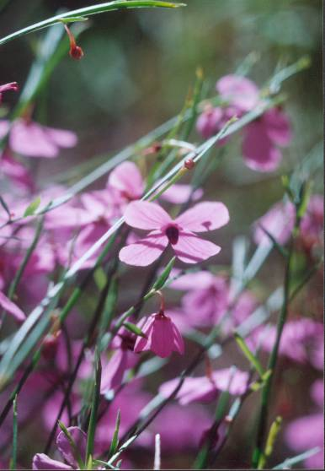

© Commonwealth of Australia 2011
This work is copyright. You may download, display, print and reproduce this material in unaltered form only (retaining this notice) for your personal, non-commercial use or use within your organisation. Apart from any use as permitted under the Copyright Act 1968, all other rights are reserved. Requests and inquiries concerning reproduction and rights should be addressed to Commonwealth Copyright Administration, Attorney General’s Department, Robert Garran Offices, National Circuit, Barton ACT 2600 or posted at www.ag.gov.au/cca.

Disclaimer
The contents of this document have been compiled using a range of source materials and is valid as at May 2011. The Australian Government is not liable for any loss or damage that may be occasioned directly or indirectly through the use of reliance on the contents of the document.

Front page photograph: Tetratheca juncea; photo by Colin Driscoll.

Important notice
Please note that these guidelines are general in nature and do not remove your obligation to consider whether you need to make a referral to the federal environment minister under the Environment Protection and Biodiversity Conservation Act 1999 (EPBC Act). While these guidelines provide information to help you decide whether to refer your action, the possible impacts of your proposal will depend on the particular circumstances of the action. These circumstances may include issues such as the precise location, mitigation measures and indirect impacts.

These guidelines were made on the basis of the best information available at the time of writing. However, the impacts of proposals will be assessed by the department on the basis of the best information available at that point in time, which may differ from the information on which this guideline is based.

These guidelines do not provide guidance on requirements under state and local government laws. Information on New South Wales and local government council laws can be obtained from the New South Wales Department of Environment, Climate Change and Water; and the local councils in or near the proposed project area.

How to use these guidelines
These guidelines are intended to assist you in determining whether your action needs to be referred to the Australian Government Department of Sustainability, Environment, Water, Population and Communities (the department). These guidelines should be read in conjunction with the EPBC Act Policy Statement 1.1 Significant Impact Guidelines – Matters of National Environmental Significance.

These guidelines apply to black-eyed susan, Tetratheca juncea, anywhere it may occur in Australia. Black-eyed susan is listed as a vulnerable species under the EPBC Act. Listed threatened species and ecological communities are matters of national environmental significance under the EPBC Act.

If you plan to undertake an action that has, will have or is likely to have a significant impact on black-eyed susan you must refer the proposal to the minister before commencing. The minister will then decide, within 20 business days, whether assessment is required under the EPBC Act. The potential significance of each action is judged on a case-by-case basis. Substantial penalties apply for undertaking an action, to which the EPBC Act applies, without approval (civil penalties up to $5.5 million or criminal penalties including up to seven years imprisonment). More information on referral, assessment and compliance is available at www.environment.gov.au/epbc/.

The decision tree in Figure 1 and the rest of these guidelines are designed to assist you in determining whether your proposed action needs to be referred. You may also refer your proposed action if you are uncertain about the need to refer, or if you think the proposal would not have significant impacts on matters of national environmental significance, but would like legal certainty.

Possible exceptions to the need to refer
Certain actions are exempt from the requirement of assessment and approval under the EPBC Act. These include lawful continuations of land use that started before 16 July 2000, or actions that were legally authorised before 16 July 2000. There are a number of criteria that must be satisfied to rely on any such exemptions. More information on exemptions under the EPBC Act is available at www.environment.gov.au/epbc/publications/exemptions.html.

Figure 1: Decision making
YES
NO

YES or UNSURE

YES
NO
Have you surveyed for black-eyed susan using the recommended methods (see Section 4)?
NO
or
UNSURE
REFERRAL RECOMMENDED
High risk of resulting in significant impact**
Assume your project may impact on an important population of black-eyed susan (see Section 5) or the species as a whole (Section 6).
NO

Could your action impact on an important population of black-eyed susan (see Section 5) or the species as a whole (Section 6)?
Is your impact mitigation best practice so that it may reduce the significance of your impacts on black-eyed susan (see Section 7)?
Could the impacts of your action affect any black-eyed susan habitat (see Section 3) or individuals?
REFERRAL MAY NOT BE REQUIRED*

Low risk that your action will result in a significant impact on black-eyed susan (see Section 8)**
Uncertainty whether your action will result in a significant impact on black-eyed susan (see Section 8)***
High risk that your action will result in a significant impact on black-eyed susan (see Section 8)**
REFERRAL RECOMMENDED
OR CONTACT THE DEPARTMENT

REFERRAL RECOMMENDED

Could the impacts of your action occur within the modelled distribution of the black-eyed susan (see section 2)?
YES or UNSURE
REFERRAL MAY NOT BE REQUIRED*
Low risk of resulting in significant impact**
YES or UNSURE
NO

REFERRAL MAY NOT BE REQUIRED*
Low risk of resulting in significant impact**
Could your action require a referral to the federal environment minister for significant impacts on black-eyed susan (see Section 8)?
REFERRAL MAY NOT BE REQUIRED*
Low risk of resulting in significant impact**
* Although it would appear a referral may not be required, you may still refer your proposed action if unsure, or if you think the proposal would not have significant impacts on matters of national environmental significance, but would like legal certainty. An example may be when other matters of national environmental significance, in addition to black-eyed susan, are potentially affected.
** Risk is the chance of something happening that will have a [significant] impact on objectives [e.g. protecting matters of national environmental significance] (adapted from Australian / New Zealand Risk Management Standard 4360: 2004).
*** If you are uncertain about the need to refer then you may also contact the Department to discuss your action by emailing epbc.referrals@environment.gov.au.

What is known about the black-eyed susan?
Black-eyed susan is a low shrub that grows as a single stem or clumps of stems arising from a single rootstock. An individual plant can grow into a clump (see glossary) of as many as 200–500 individual stems of genets (plants growing from seed) and ramets (plants growing from asexual rhizomal spread). Stems can grow up to 1.5 m long, are generally leafless and have a distinctly angular, winged structure that distinguishes black-eyed susan from other members of the Tetratheca genus. Plants of black-eyed susan are usually sprawling and can be difficult to detect amongst other vegetation when not flowering.
Black-eyed susan has hanging pink flowers, with the dark centre giving rise to the common name. The flowers face downwards and usually have four petals that range from white to pink to dark purple in colour and have pink sepals. The flowers occur singly or in pairs along the stem suspended on a short peduncle (stalk) and are bisexual, odourless and nectarless. Flowering generally occurs between July and January.
Relevant background information on the biology and ecology of black-eyed susan is provided in the department’s Species Profile and Threats (SPRAT) database.

Could the impacts of your action occur within the modelled distribution of black-eyed susan?
Black-eyed susan is endemic to New South Wales and was historically distributed from Botany Bay in Sydney north to Bulahdelah. Black-eyed susan is now presumed extinct in the Sydney area. The current distribution is divided into two metapopulations (see glossary): the central coast metapopulation (from Wyong to Beresfield) and the northern metapopulation (from Karuah to Bulahdelah). It is currently found in the local government Areas of Wyong, Lake Macquarie, Newcastle, Port Stephens, Great Lakes and Cessnock, with the Wyong and Lake Macquarie local government areas the stronghold for the species (refer to Maps 1 to 3).
The modelled distribution maps presented in this document are based on the best available information at the time of publication and remain a static product. For the most up-to-date report of whether black-eyed susan may occur in your project area, always use the Protected Matters Search Tool. The modelled distribution maps indicate where black-eyed susan habitat may occur. They do not suggest that black-eyed susan occurs throughout the entire modelled distribution. For example, large urban areas exist within the modelled distribution which does not contain black-eyed susan.
Direct and indirect impacts on black-eyed susan have been known to result from, but are not limited to, industrial and residential developments, coal mining operations, pipelines, roads, power stations and the associated infrastructure of such developments, agriculture and land clearing.
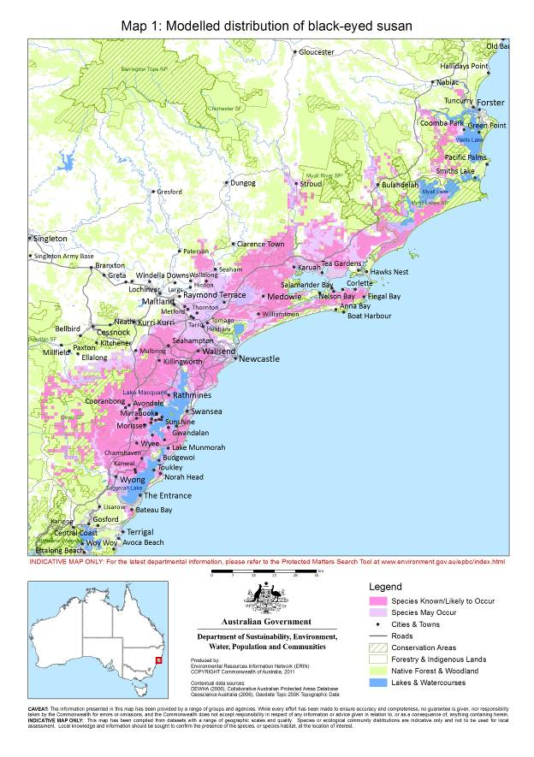

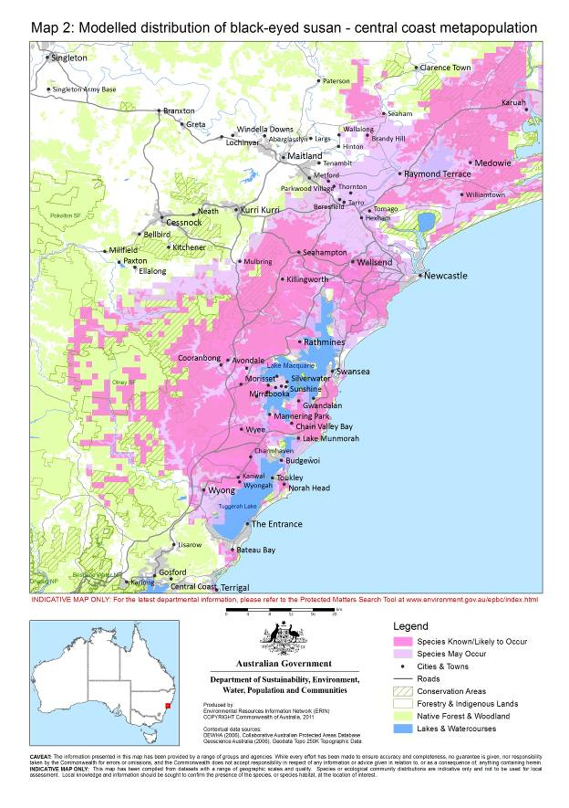

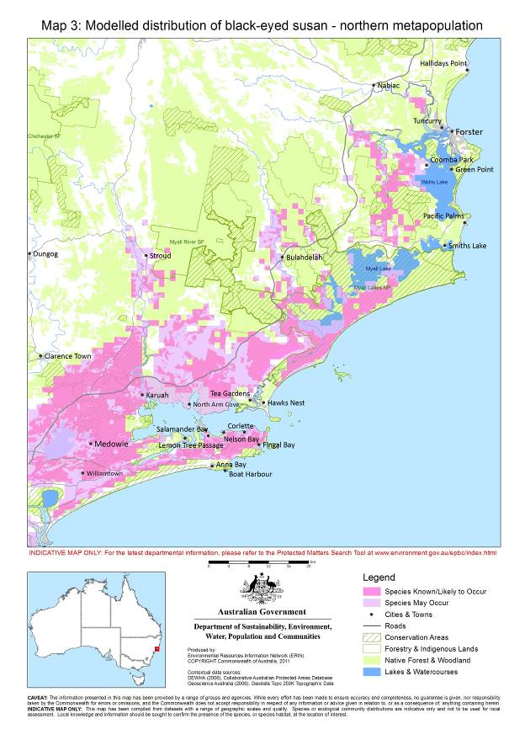

Could the impacts of your action affect habitat for the black-eyed susan?
Black-eyed susan is found in sandy, occasionally moist heath and in dry sclerophyll vegetation communities endemic to coastal New South Wales. The species occurs on low-nutrient soils in open forest with a dense understorey in areas with an annual rainfall greater than 1000 mm. The species occurs on Quaternary sands, Triassic sandstones, Triassic shales, Permian coal measures and Carboniferous volcanics.
Populations throughout the species range occur predominately in three vegetation communities,. These include:
- coastal plains smooth-barked apple woodland
- coastal plains scribbly gum woodland
- coastal foothills spotted gum-ironbark forest.
Populations also occur less frequently in the following vegetation communities (hereafter referred to as rare habitats):
- alluvial tall moist forest
- heath
- Lower Hunter spotted gum-ironbark forest
- Wyong paperbark swamp forest
- coastal sheltered apple-peppermint forest
- coastal sand wallum woodland-heath
- swamp mahogany-paperbark forest
- riparian melaleuca swamp woodland
- coastal clay heath
- coastal wet sand cyperoid heath
- coastal wet gully forest
- coastal sand apple-blackbutt forest
- Hunter Valley moist forest.

4. Have you surveyed for black-eyed susan using the recommended methods?
A guide to conducting surveys for black-eyed susan in areas of suitable habitat is outlined below. Surveys should:
- be conducted by a suitably qualified person with demonstrated skill in flora surveys
- maximise the chance of detecting the species
- account for uncertainty and error (such as false presences and absences).
The following survey methods are recommended for presence/absence surveys.
Where it is not possible to conduct surveys in this manner, failure to detect the species should not be considered indicative of its absence. Additionally, if the affected area is unable to be adequately surveyed (for example due to access restrictions), the precautionary principle applies and the species should be assumed present where suitable habitat exists.

4.1 Survey recommendations
The peak flowering period of black-eyed susan occurs from the start of September to the end of October. Surveys should therefore be conducted within the period of 1 September to 31 October. Any survey conducted outside of this period should be supported by evidence that flowering at the affected area (see glossary) was at its peak at the time of the survey.
4.1.1 Determination of peak flowering
Prior to conducting detailed surveys, preliminary field visits are required to determine whether flowering has begun at a particular affected area. Preliminary investigations should compare the number of flowers to the number of buds. A minimum of 75 per cent of buds should be in flower before conducting surveys at a proposed affected area. Refer to the SPRAT profile for black-eyed susan (www.environment.gov.au/cgi-bin/sprat/public/sprat.pl) for detailed information on determining the peak flowering period.
If no black-eyed susan plants are found in the affected area during preliminary field visits, then an adjacent site or a nearby reference population (as determined from the Atlas of NSW Wildlife Records) should be checked to determine the onset of the peak flowering period.
4.1.2 Survey of affected areas
Affected areas of less than 30 ha should be thoroughly surveyed using the procedure outlined in Figure 2. To keep the level of field work to that necessary to achieve an acceptable outcome, affected areas of greater than 30 ha will require an initial coarse level survey to determine the distribution of black-eyed susan, followed by a detailed targeted survey as outlined in Figure 2.
Refer to the SPRAT profile for more detail on survey methods for black-eyed susan (www.environment.gov.au/cgi-bin/sprat/public/sprat.pl).
Figure 2: Survey guidelines for the black-eyed susan

1. Payne, R., Stevenson, D. & Wellington, R. (2002). A standardised method for counting black-eyed susan populations. Unpublished Report

4.2 Habitat assessment
In addition to undertaking surveys for black-eyed susan, the following habitat characteristics should be assessed. Assessment of the habitat in the affected area may provide further indication of the likely presence (or absence) of the species at a site and may also provide information to determine significance:
- soil type
- landscape
- vegetation community
- botanical description (flora list) of the study area.

5. Could your action impact on an important population of black-eyed susan?
Important populations are one consideration when assessing impacts on a vulnerable species as they are important for future conservation, maintaining population viability, supporting gene flow, pollination and dispersal. A black-eyed susan population is regarded as an important population if it meets any of the following:
- has greater than 1000 plant clumps (see glossary)
- an area of habitat has an average estimated plant clump density of 20 clumps/hectare or greater
- occurs in rare habitat (see section 3)
- occurs in an area of “important habitat” as defined in Maps 4a and 4b and has greater than 500 plant clumps
- occurs at or near the distributional limits of black-eyed susan (Maps 1 to 3)
- occurs in close proximity to a protected area (e.g. National Park) where black-eyed susan is known to occur. Close proximity refers to:
  - within 500 m if connected by a suitable habitat corridor such as native vegetation
  - within 100 m over disturbed habitat or non-native vegetation.
Specific considerations for determining an important population and further information on the determination of important habitat is provided in the SPRAT profile for black-eyed susan (www.environment.gov.au/cgi-bin/sprat/public/sprat.pl).

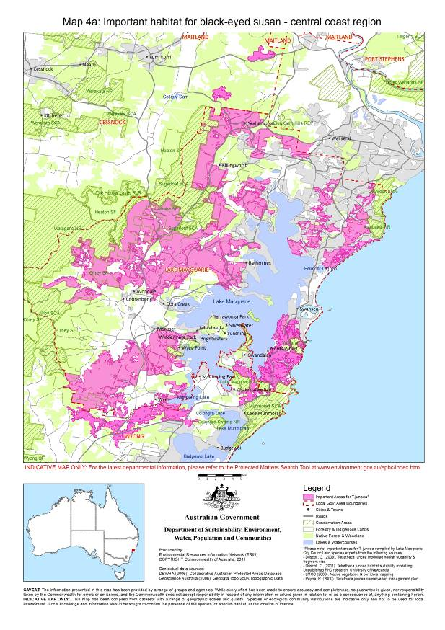
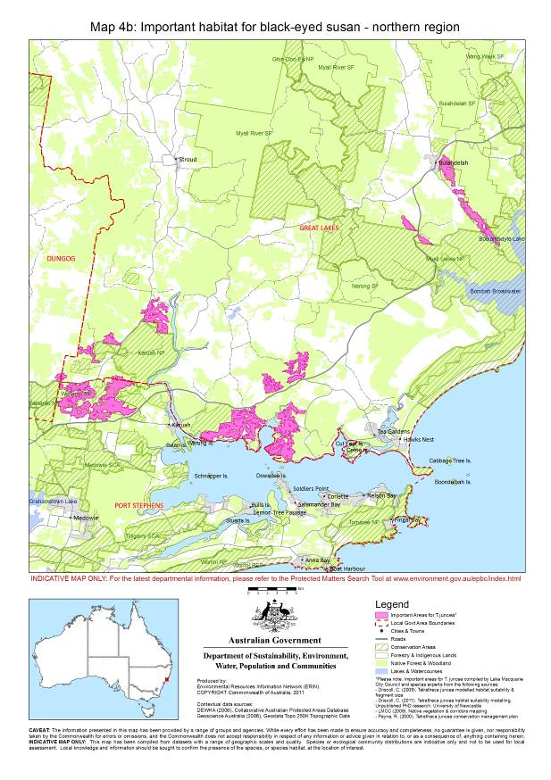

6. Could your action impact on the species as a whole?
Potential impacts on important populations should be considered when determining whether to refer your action. However, you should also consider referring your action if it is likely to have a significant impact on a vulnerable species as a whole (that is, including populations that do not meet the definition of an “important population”). Therefore, in addition to considering important populations, you should also consider impacts on a vulnerable species through the one or more of the following criteria stated in significant impact guidelines 1.1 if your action is likely to:
- adversely affect habitat critical to the survival of a species
- modify, destroy, remove, isolate or decrease the availability or quality of habitat to the extent that the species is likely to decline
- result in invasive species that are harmful to a vulnerable species becoming established in the vulnerable species’ habitat
- introduce disease that may cause the species to decline
- interfere substantially with the recovery of the species.
Section 8 provides guidance for when one or more of these criteria may trigger the need to refer your action.

7. Is your impact mitigation best practice so that it may reduce the significance of your impacts?
Mitigation has the principal aim of avoiding significant impacts and should be applied in a hierarchical order:
1. Avoid impacts – preserve important populations and habitat to avoid further loss.
2. Mitigate impacts – prevent habitat degradation and retain habitat function.
3. Monitor effectiveness of mitigation – ensure mitigation is effective and feeds back into an adaptive management plan.
Translocation does not reduce or mitigate the impact of an action. Translocation of black-eyed susan will not be considered under this policy.
Table 1 outlines the main threats to black-eyed susan, their impacts and mitigation. It is not intended to be exhaustive or prescriptive.
Table 1: Primary threats, impacts and mitigation
Threat | Impact | Mitigation
Habitat loss and fragmentation –  Connectivity is particularly important for maintaining gene flow given black-eyed susan is pollinator limited and has limited dispersal ability | - Reduced population size  - Loss of genetic variation  - Reduced opportunities for outcross pollination | - Retain habitat patches known or likely to contain black-eyed susan and manage for the species.  - Manage key threatening processes applicable to the site.  - Design the proposed development such that:  - the development footprint avoids habitat disturbance  - asset protection zones include roads, easements and services  - asset protection zones are constructed outside of buffer and/or corridor widths  - easements and services are integrated and co-located into a single corridor, and  - no services are built on conservation land.  - Provide suitable buffer zones and corridors for pollinator movement and potential habitat:  - buffer zones around habitat sites should be greater than 30 m  - vegetation corridors connecting otherwise disconnected habitat sites should be greater than 20 m wide and consist of native vegetation such as native grassland.  - Restrict access by fencing populations to minimise risk of accidental damage or destruction of plants:  - fence habitat on at least three sides to limit use as a thoroughfare  - erect interpretive/educational signage to highlight conservation significance.
Inappropriate fire regimes e.g. high frequency of slow cool fires, and high intensity fires | - Elimination of plant clumps  - Reduction in flowering plant numbers and diversity | - Develop and implement an appropriate fire management regime:  - no more than one quick, low intensity fire event in an eight-year period  - avoid slow cool or high intensity fire events.
Introduction of weeds and disease e.g. species may be adversely affected the plant pathogen Phytophthora cinnamomi. | - Competition for resources  - Smothering of plant clumps  - Loss of plant clumps | - Avoid landscaping that would introduce weeds, Phytophthora cinnamomi or non-indigenous plants  - Assess the site for the presence of Phytophthora cinnamomi and if present, undertake measures to prevent its spread and reduce its impact.  - Implement strict hygiene control procedures (on maintenance and construction vehicles, machinery, personnel and revegetation projects) to ensure weeds and Phytophthora cinnamomi are not spread or introduced.  - Avoid broad-scale chemical and pesticide use and avoid drift of herbicides onto native vegetation. For example, use carefully applied and targeted spot-spraying or ‘wiping’.  - Use sealed roads and footpaths outside the site boundary to limit the spread of weeds and help control fire.
Changes in soil and hydrology  e.g. changes in urban or agricultural run-off and rubbish dumping | - Altered hydrological regimes, nutrient load and soil permeability  - Soil loss, disturbance and compaction  - Pollution | - Control hydrological regimes including stormwater management.  - Hydrological control mechanisms should be constructed within the development area to control altered water flow.  - Developments should be designed down-slope of a subpopulation with a minimum 30 m buffer zone applied. If not possible, then:  - larger buffer areas should be implemented and urban drainage directed away from the subpopulation  - sediment basins should be constructed up-slope of subpopulations if potential runoff from fertilising activities may occur.  - Avoid soil disturbance near plants.  - Prevent stock grazing through the habitat.  - Control feral animals and invasive species on the project site.
Reduction in flowering plant numbers and diversity - black-eyed susan flowers produce no nectar and so rely on the presence of surrounding nectar producing flowers to attract pollinators | - Decline in pollinator numbers affecting recruitment  - Altered canopy resulting in invasion by weed species  - Competition for resources | - See mitigation for habitat loss and fragmentation  - Improve degraded areas of habitat on the project site (revegetated areas should be established prior to the removal of occupied habitat).

8. Could your action require a referral to the federal environment minister for significant impacts on the black-eyed susan?
As the person proposing the action it is your responsibility to decide whether or not to refer your action. If you believe your action is at high risk of having a significant impact on an important population of black-eyed susan or the species as a whole you should refer the action to the federal environment minister. If you are uncertain whether your action will have a significant impact on the black-eyed susan you may also refer your action or contact the department. Table 2 provides general guidance on what, in the department’s view, may be at high and low risk of requiring a referral to the department as well as providing some guidance on uncertainty.
Table 2: Referral guidelines
High risk of significant impacts on black-eyed susan: referral recommended
A high risk of a significant impact will occur if a proposed action will directly or indirectly affect an important population of black-eyed susan, resulting in:
- loss of greater than 25% or 1000 plant clumps (whichever is the lesser) within the affected area, or
- fragmentation of a subpopulation (see glossary) that results in:
  - subpopulations greater than 500 m apart within native vegetation; or
  - subpopulations greater than 100 m apart within degraded/developed habitat or non-native vegetation; or
- reduction in native vegetation corridor width, connecting subpopulations, to less than 20 m; or
- reduction of greater than 10% in the number of flowering plants (any species) within the affected area.
Uncertainty: referral recommended or contact the department
- uncertainty about significant impacts on black-eyed susan may exist where actions, although not directly affecting black-eyed susan, may have the potential for indirect impacts such as, but not limited to: affecting pollinators or their dispersal ability, altering flowering plant diversity, altering hydrology, or introducing non-indigenous species or disease such as the plant pathogen Phytophthora cinnamomi; or
- any degradation of suitable habitat within a 30 m buffer extending from the edge of an important population surveyed in accordance with this document.
Low risk of significant impacts on black-eyed susan: referral may not be required but you may refer for legal certainty
- proposed actions that will not directly or indirectly affect an important population of black-eyed susan habitat or affect the species as a whole; or
- actions that are proposed outside the mapped distribution of black-eyed susan and have no black-eyed susan habitat; or
- actions that retain greater than 30 m buffers to an important population of black-eyed susan and adopt mitigation measures recommended in these guidelines (see section 7).

9. Where can you get more information?
The SPRAT profile for this species provides the biological and ecological context for survey guidelines, significant impact thresholds and mitigation measures. It can be accessed at www.environment.gov.au/cgi-bin/sprat/public/sprat.pl.
Other EPBC Act policy statements are available to help you understand the EPBC Act and your obligations. They are available from the department’s website at www.environment.gov.au/epbc/guidelines-policies.html or by contacting the community information unit by email: ciu@environment.gov.au or by phone: 1800 803 772. The department can provide advice regarding the referral of proposals under the EPBC Act, especially when contacted early in the planning process.
The Protected Matters Search Tool can provide a good starting point for determining the likelihood of having matters of national environmental significance in your area. State and territory government agencies may also hold relevant information including habitat and species distribution information.

10. Glossary
Affected area: The area likely to be affected by the action. This includes the project area and any additional areas likely to be affected, either directly or indirectly. That is, anywhere on or off site where the effects, good and bad, of the proposed action would be felt. Habitat and/or populations may, and often will, extend beyond the development site boundaries. Therefore, the affected area should extend as far as necessary to take all potential impacts, including off site impacts, into account. This is the area that the person proposing an action must survey.
Metapopulation of black-eyed susan: The distance between metapopulations is such that under no circumstances (other than human intervention) or any length of time would there be any transfer of genetic material between populations.
Plant clump: a group of black-eyed susan stems separated from an adjacent group by greater than 30 cm. Black-eyed susan grows in clumps of single or multiple stems arising from a single rootstock and it is therefore difficult to determine whether adjacent plants are joined or are separate without removing them from the soil.
Population of black-eyed susan: Groups of subpopulations separated from other groups by distances of greater than 500 m within suitable native vegetation or by greater than 100 m within unsuitable degraded/developed habitat or non-native vegetation. The distance between populations allows for the rare transfer of genetic material.
Project area: The area where the action is proposed to take place and is to be directly affected by the proposed action. That is, the boundary of land directly affected including areas that would be retained, revegetated, cleared, developed and any associated infrastructure such as access roads, powerlines, easements etc.
Subpopulation of black-eyed susan: Plant clump groups separated by distances of less than 500 m within suitable habitat of native vegetation or by less than 100 m within unsuitable degraded/developed habitat or non-native vegetation. The distance between subpopulations allows for regular transfer of genetic material between subpopulations within a population.

When considering whether or not your action will have a significant impact on black-eyed susan, it is relevant to consider all adverse impacts from the action, including direct, indirect and offsite impacts such as downstream or downwind impacts, upstream impacts and facilitated impacts (impacts that result from further actions, which are made possible or facilitated by the action).
Driscoll, C. (2003). Pollination ecology of Tetratheca juncea (Tremandraceae): finding the pollinators. Cunninghamia. 8(1): 133-140
NSW National Parks and Wildlife Service (NSW NPWS) (2000). Vegetation survey, classification and mapping Lower Hunter and Central Coast region. Version 1.2. A project undertaken for The Lower Hunter and Central Coast Regional Environment Management Strategy CRA Unit Sydney Zone National Parks and Wildlife Service
This map is a product of habitat modelling, accounting for climatic, geological, topographical, ecological, land use, habitat patch connectivity and other environmental factors conducted to predict suitable habitat for black-eyed susan. The predicted suitable habitat, together with known occurrences, has been used to define areas of “important habitat” for future conservation. Areas of important habitat have been selected based on population size, habitat critical to the survival of the species, remnant patch size, proximity to reserved areas, linkage/corridors to other large patches, and cadastral boundaries etc. Important areas were identified during a 2009 workshop for these guidelines and from subsequent ecological research.
Flowering plant diversity is important to attract, support and disperse pollinators. Reproduction in black-eyed susan is pollinator limited; pollinators are in decline and are dependant on a diversity of plant species for their survival.

