Biosecurity Portal Website Upgrade release

BSDSAdmin@agriculture.gov.au

Contents

BIOSECURITY PORTAL – MYGOV ID (Digitial identity) channel 1

Home Page 1

Lodgment of Approved Arrangement Outcome for Class 14.4 Rural Tailgate Inspections 2

BIOSECURITY PORTAL – MYGOV ID (Digitial identity) and other user channel 3

Archive View 3

Additional questions in the Portal 4

Consignment Information Tab 4

Inspection Types – Mandatory Field 5

Auto select “To Meet” 5

# BIOSECURITY PORTAL – MYGOV ID (Digitial identity) channel

## Home Page

The home page for the myGovID (digital identity) authenticated channel has been modified to include a new tile “Approved Arrangement outcomes” following introduction of a new service on the Portal – lodgment of Approved Arrangement Class 14.4 inspection outcomes. This tile will only be visible when the selected organisation profile is an AA. The tile will not be visible if the organisation profile selected is Importer or Broker.

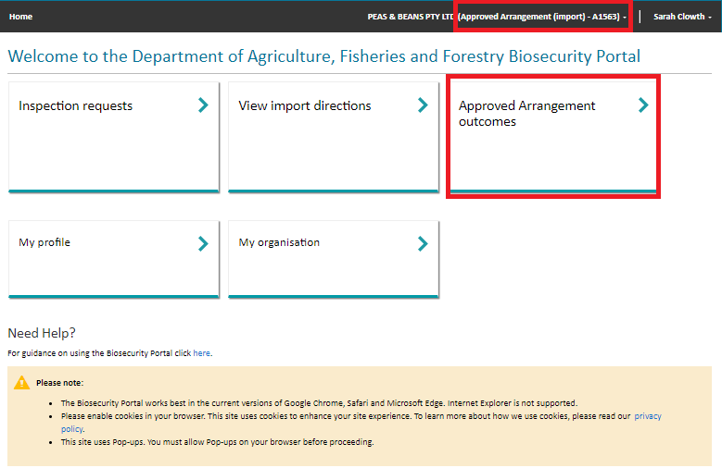

Figure 1: Digital Identify Channel – Home Page

## Lodgment of Approved Arrangement Outcome for Class 14.4 Rural Tailgate Inspections

The department is introducing a new service via the Portal, reporting of rural tailgate inspection outcomes for approved class 14.4 Biosecurity Industry Participants (BIPs) to lodge container inspection results.

To ensure the new lodgment process is fit for purpose prior to release to all Class 14.4 BIPs, the department is seeking expressions of interest from BIPs for a small beta trial. The beta will run for approximately 3 weeks and those selected will be provided with relevant supporting materials and be able to provide feedback. While the option to report results through the portal will be visible to all class 14.4 BIPs from Monday 13 February, the portal must not be used to submit results unless you are participating in the beta and directly advised by the department to use the portal, as under the current class conditions unapproved use will be considered as noncompliance.  Upon full release relevant supporting materials and information will be published on our external departmental website.

A user logged into the Portal using myGovID (digital identity) channel and who is signed into an AA profile within the Portal will be able to access a tile (link) to submit approved arrangement outcomes.

After clicking on the tile, a user will be presented with a list of Entry Ids where:

* the Approved Arrangement number matches the user’s profile
* the status of the Entry Id is Active (lodged in either line or container mode)
* the Entry Id has at least one direction from the table below which is:
  + In progress, AND
  + The location specified for that in progress direction equals the AA number.

|  |  |  |
| --- | --- | --- |
| Direction Category Code | Direction Code | Direction Name |
| AA | 04 | AA Rural Tailgate Inspection |
| AA | 05 | AA Rural Tailgate Ext. Inspect |

*Table 1: Rural Tailgate Directions*

After selecting an Entry Id, line level details are displayed with a status of Open or Submitted. A line with an Open status will allow a user to select, complete and submit an outcome form. A line with a Submitted status cannot be selected, restricting a user from being able to submit a duplicate submission.

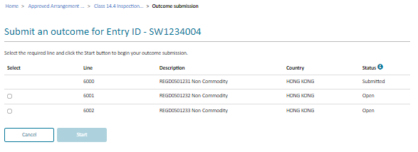

*Figure 2: Line selection to lodge a Class 14.4 outcome*

The outcome form displays the Entry Id, Line and Container number. A user completes all mandatory fields. If BRM was detected, additional questions are displayed to provide further information.

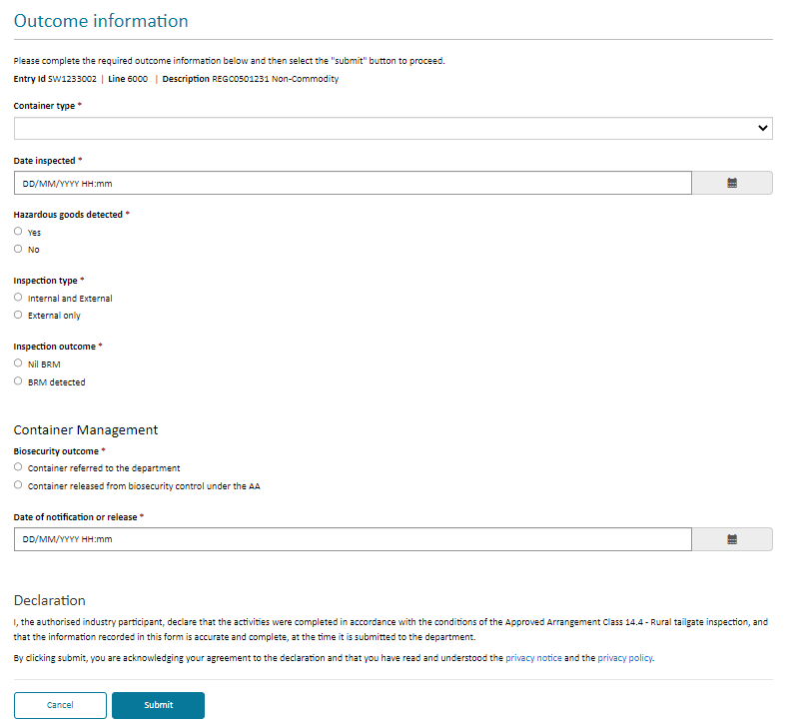

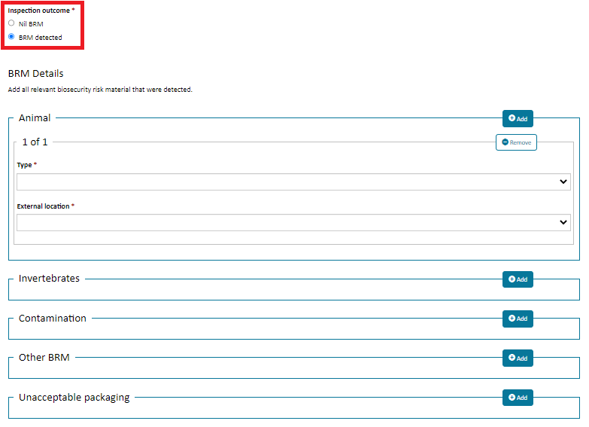

*Figure 3: Class 14.4 outcome form*

A user can view historic submissions, including Entry ID, line description with a hyperlink to display all the details entered on the submission, and the status of the submission.

# BIOSECURITY PORTAL – MYGOV ID (Digitial identity) and other user channel

## Archive View

There are currently three portal views: Inspection requests, Upcoming bookings, and Historical bookings. Items in these views remain indefinitely.

A new archive feature has been introduced where users can manually remove items from the three portal views into an archive view:

* Select the View where the Entry Id to be archived is located.
* Select the Entry Id to be archived by clicking on the Actions chevron and selecting Archive.
* The entry will be moved to the Archived View: Archives inspection requests or Archived bookings.

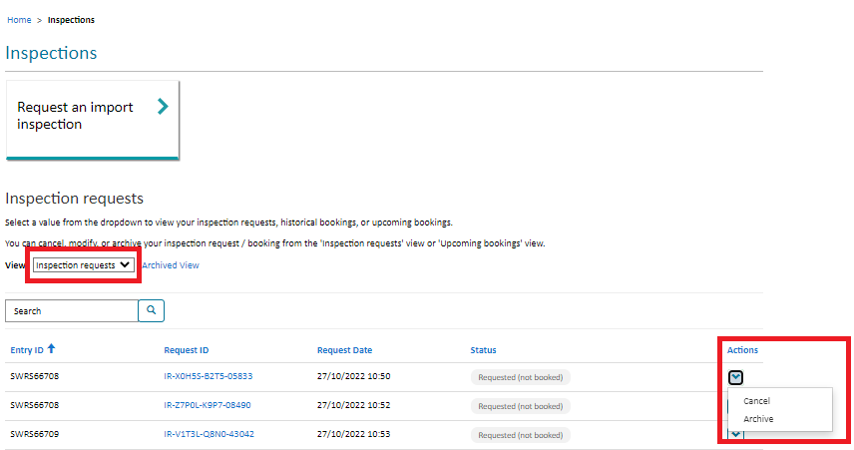

*Figure 4: Entry ID selection for archiving*

* Entries can be re-instated into the Portal View by selecting Archived View
* Select the View where the Entry Id to be re-instated is located.
* Select the Entry Id to be re-instated by clicking on the Actions drop down and selecting Restore.
* The Entry will be moved back into the View based on the status of the item when re-instated.

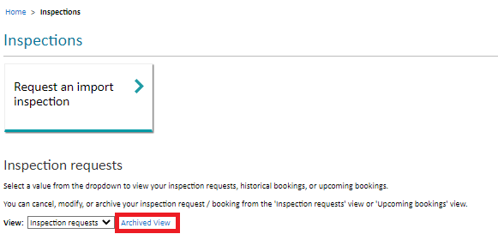

*Figure 5: Archived Entries*

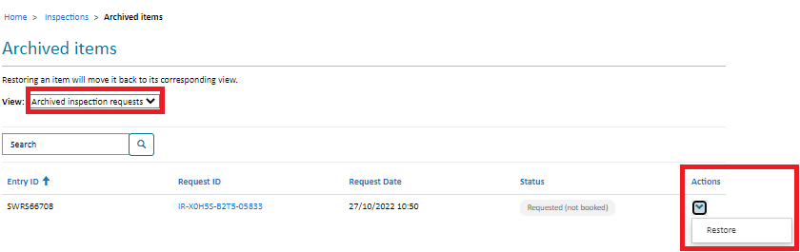

*Figure 6: Re-store an Archived Item*

## Additional questions in the Portal

### Consignment Information Tab

Additional questions on consignments will be displayed based on the inspection type when either selected by the user or auto populated. This information will further enable the system to accurately calculate the estimated duration of an inspection based on user input. Additional questions will be asked for the following:

* CCV inspection - "Provide total estimated unpack duration for CCV inspection"
* Cut Flower inspection - "Number of phytosanitary certificates" and "Number of growers
* Fish inspection - "Provide number of boxes"
* ​Fresh Produce inspection - "Number of phytosanitary certificates", "Number of varieties" and "Number of cartons/boxes".
* Nursery Stock inspection - "Number of phytosanitary certificates", "Number of varieties", "Number of cartons/boxes" and "Number of units (individual plants)".
* Seed inspection - "Number of lot codes".
* Boat inspection - "Number of boats".
* Military inspection - "Duration required for military packing and webbing inspection (in minutes) and “Number of officers required”.
* Biosecurity inspection containing the word “supervised” - "Enter the required duration for the supervised inspection” and “Provide any additional details about this supervised inspection”.

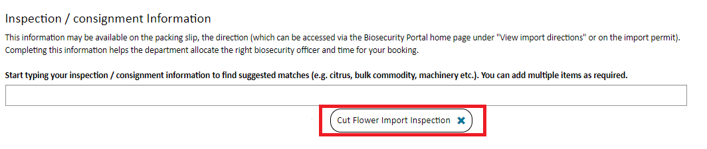

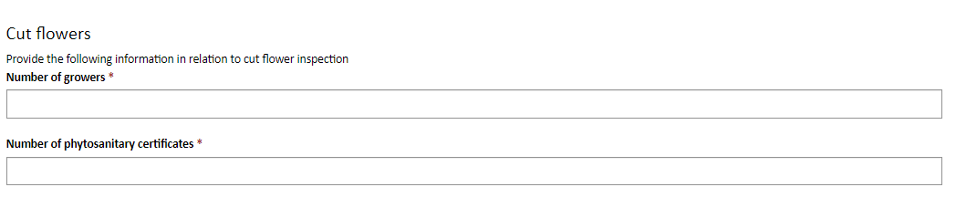

*Figure 7: Additional questions upon selection of cut flower inspection*

### Inspection Types – Mandatory Field

Inspection types are used within the system to allocate the right biosecurity officer and inspection duration to the booking.

Inspection types are manually added by the user (a user can add one or multiple inspection types to the request) or are automatically applied based on the selected Direction.

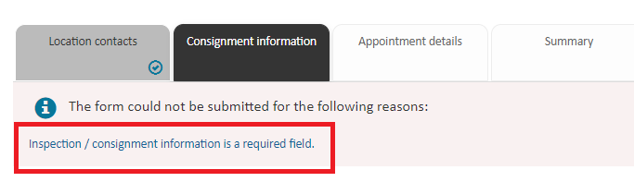

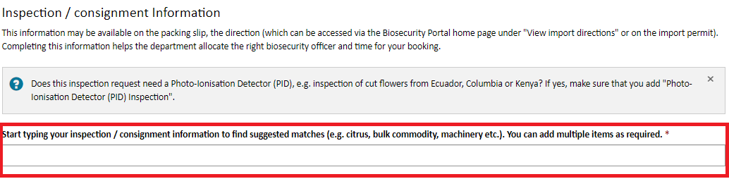

*Figure 8: Inspection type mandatory question*

### Auto select “To Meet”

If you answer ‘Yes’ to the following question "Does the consignment or conveyance contain hazardous goods or fumigants? a child question is displayed "Has the consignment been treated with Sulfuryl fluoride (SF)?".

* If the selected response is NO – No further action occurs.
* If the selected response is YES, “To Meet” is auto selected on the appointments tab and cannot be changed by the user.
* The “To Meet” response is captured and reported to the department.