Biosecurity Portal

Release Notes

Version 1.0

November 2022

Contents

Portal 3

Enhancements – Digital Identity and Other User Channels 3

Lodgement of directions 3

Automatic population of inspection types for Food Program Directions 4

Auto populated inspection types 4

Additional questions under “Consignment Information” Tab 5

Additional questions under “Appointment Details” Information Tab 6

Enhancements – Other User Channel 6

Food Program – Selection of Directions 6

Duplicate submission of RFIs 7

Enhancements – Digital Identity Channel 7

Email Notifications 7

# Portal

## Enhancements – Digital Identity and Other User Channels

### Lodgement of directions

A RFI cannot be lodged for a direction if there are other directions which need to be completed first.

Upon entering an Entry Id and/or direction, validation against business rules will occur. If an Entry Id and/or direction meets these business rules the following error messages will be displayed:

*"You cannot lodge an inspection request for this entry whilst there are other actions pending.  Please contact the broker or provide the information as requested by the Department."*

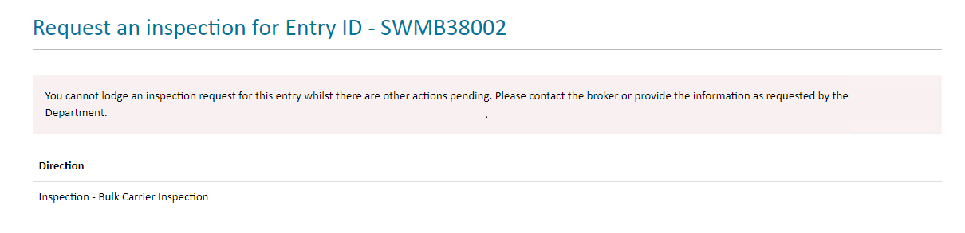 Figure 1: Digital Identify Channel – No directions against this Entry Id can be lodged

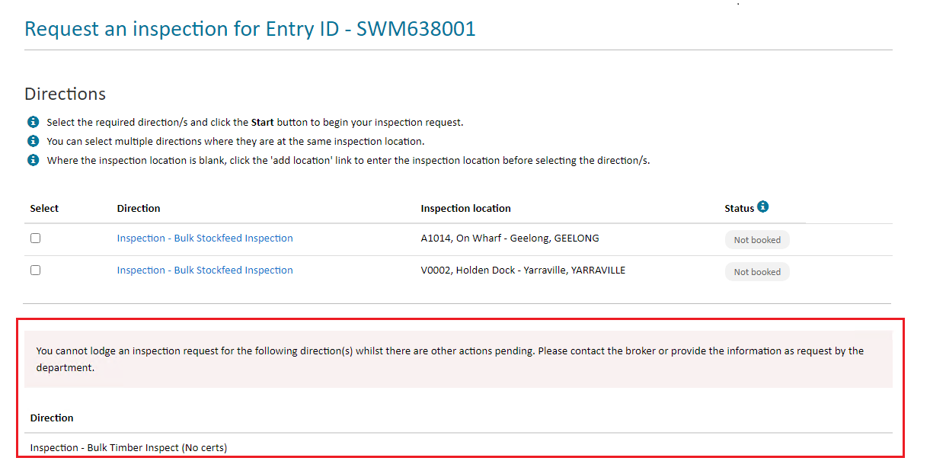

*Figure 2: Digital Identify Channel – One of the three directions against this Entry Id cannot be lodged*

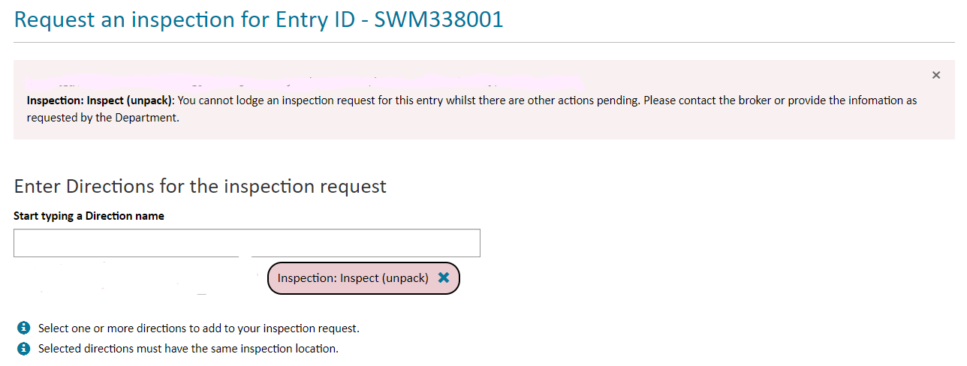

*Figure 3: Other User Channel – The direction which cannot be lodged*

### Automatic population of inspection types for Food Program Directions

When lodging an inspection request for a imported food program direction, the associated inspection types are now automatically populated. This reduces manual effort and ensures the correct details are provided to the department for the booking.

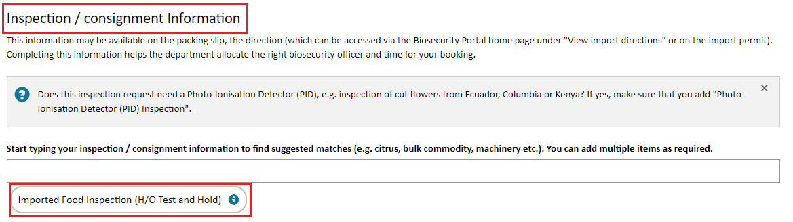

*Figure 4: Other User Channel – System populated Inspection type*

### Auto populated inspection types

Where an inspection type has been auto populated against a direction, a user can no longer remove this entry. A tool tip has been included in the Portal to advise users of this restriction.

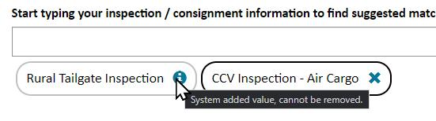

Figure 5: System populated inspection type

### Additional questions under “Consignment Information” Tab

When a request for inspection is for an imported food program direction, additional questions have been added under the consignment information tab:

Imported food inspection

*Estimated inspection duration (minutes)*

*“Please refer to your food control certificate and enter the estimated inspection duration value provided (in minutes)”*

*“Does the imported food commodity require sampling?”*

*“Please refer to the ‘likely tests’ listed on the food control certificate. If there are tests other than label and visual listed in this field, please answer “yes” to the sampling question”*

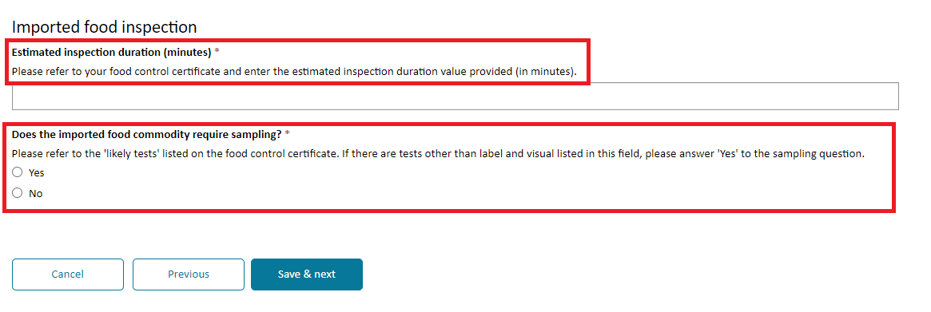

If yes, a second question is displayed.

*“Does the commodity require refrigeration or freezing?”*

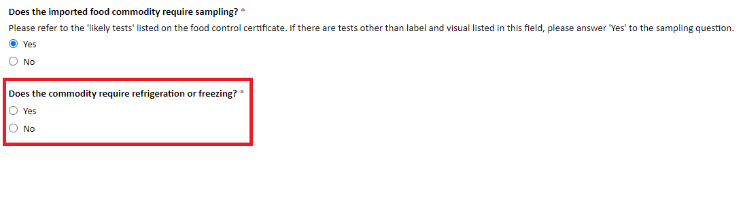

Figure 6: Imported food inspection questions

Vehicle or machinery inspections

Upon selecting an inspection / consignment type including either Vehicle or Machinery, an additional question is displayed requesting the number to be inspected.

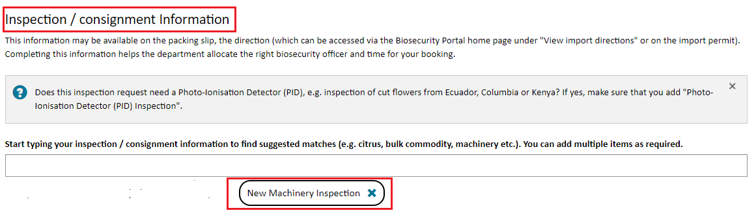

Figure 7: Inspection type selection

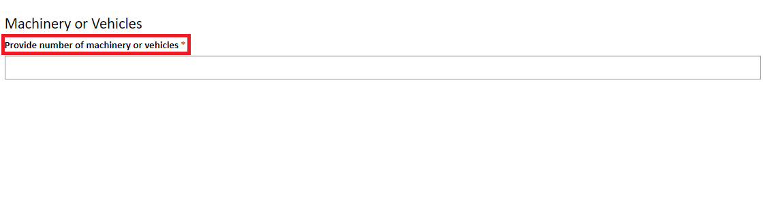

Figure 8: Vehicle or machinery question

### Additional questions under “Appointment Details” Information Tab

Users can now indicate if the consignment contains perishable and/or urgent goods.

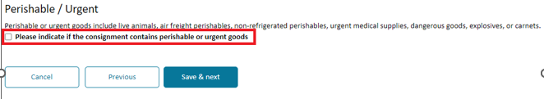

Figure 9: Perishable or urgent goods question

## Enhancements – Other User Channel

### Food Program – Selection of Directions

Two generic directions -“Imported Food: Inspection” and “Imported Food: Failed food inspection” have been introduced to streamline requests for food inspections. Users no longer need to enter the exact direction name, noting food directions are not currently displayed on the Food Control Certificate.

A user can enter either -“Imported Food: Inspection” and/or “Imported Food: Failed food inspection” and the system will match the request to the direction in the Agriculture Import Management System (AIMS).

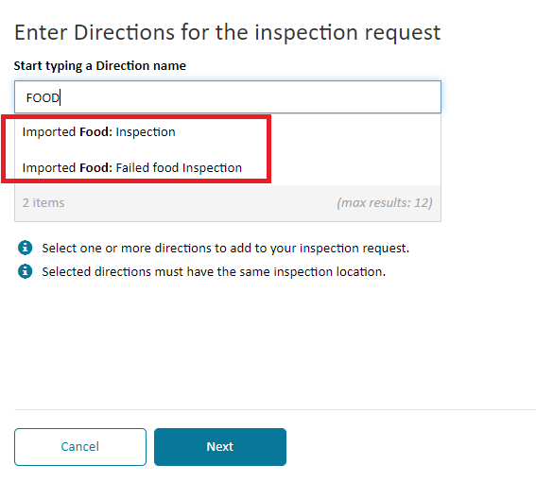

Figure 10: Generic food program directions

### Duplicate submission of RFIs

The Portal will now alert users lodging an inspection request via the ‘Other User’ channel if an inspection request for a direction has already been submitted through either the ‘Other User’ or ‘Digital Identity’ channel. Note: this feature is already available via the ‘Digital Identify’ channel.

If a user attempts to lodge an inspection request for a direction that has already been submitted, the following message appears:

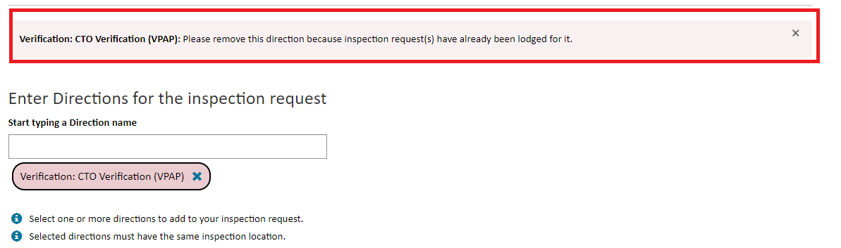

*Figure 11: Duplicate inspection request message*

A user will be unable to progress with this inspection request. Click on ‘x’ to remove the direction.

## Enhancements – Digital Identity Channel

### Email Notifications

All system generated and manual email notifications from the department will be sent to the client’s business email address entered in their Personal Profile, and not the email address used to establish their digital identity via myGovID.

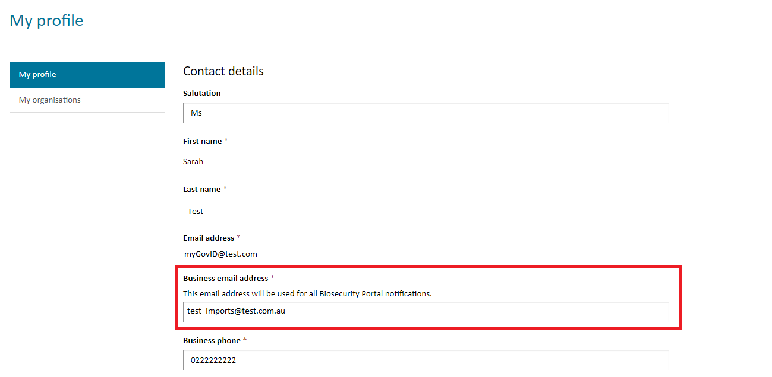

## 

*Figure 12: Inspection Location Error Message*