Biosecurity Portal Website Upgrade release notes - July 2023

BSDSAdmin@agriculture.gov.au

Contents

BIOSECURITY PORTAL – MYGOVID (Digitial identity) and other user channels 2

Bug Fix 2

Multiple modification emails for ANYTIME bookings. 2

Enhancement 2

Removal of outdated information from departmental emails 2

# BIOSECURITY PORTAL – MYGOVID (Digitial identity) and other user channels

## Bug Fix

### Multiple modification emails for ANYTIME bookings.

Multiple modification emails were sent when the *Preferred inspection period* nominated was ANYTIME and the booking was modified within the same booked date. This bug has been fixed; modification emails will only be sent for ANYTIME bookings when the modification is from one date to another date.

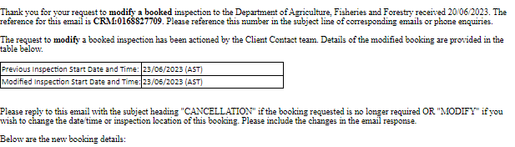

*Figure 1: Modification email showing no change*

## Enhancement

### Removal of outdated information from departmental emails

The following text has been removed from departmental emails:

Please note that Third Party Premises COVID reporting requirements have recently changed. Full details are available in [Industry notice 10/2022](https://aus01.safelinks.protection.outlook.com/?url=https:%2f%2fwww.agriculture.gov.au%2fbiosecurity-trade%2fimport%2findustry-advice%2f2022%2f10-2022&data=05%7c01%7cMegan.Wharton%40aff.gov.au%7cd98d92d429d0428078cc08db33df7f76%7c2be67eb7400c4b3fa5a11258c0da0696%7c0%7c0%7c638160807220680959%7cUnknown%7cTWFpbGZsb3d8eyJWIjoiMC4wLjAwMDAiLCJQIjoiV2luMzIiLCJBTiI6Ik1haWwiLCJXVCI6Mn0%3D%7c3000%7c%7c%7c&sdata=CI%2B7Ke3baY5tR2zNxE1rRybt%2f%2fHyp8qEOOClAuJLSoM%3D&reserved=0) **  
  
Please notify the department immediately at [agriccc@agriculture.gov.au](mailto:agriccc@agriculture.gov.au) if you have any confirmed/positive cases of COVID-19 on-site, that are known to have had an interaction with a departmental officer, or where a known positive case has had interaction with the DAFF work area at the premises within their infectious period.