Biosecurity Portal Website Upgrade release

BSDSAdmin@agriculture.gov.au

Contents

BIOSECURITY PORTAL – MYGOVID (Digitial identity) and other user channel 2

Enhancement 2

Appointment details - Preferred inspection period 2

Request for Inspection - Directions able to be booked via the Portal 2

BIOSECURITY PORTAL – other user channel 3

Enhancement 3

Inspection location for Imported Food and Cargo Compliance Verification (CCV) inspections 3

# BIOSECURITY PORTAL – MYGOVID (Digitial identity) and other user channel

## Enhancement

### Appointment details - Preferred inspection period

Under the Appointment details tab, the preferred inspection options have been updated to better inform users of how inspection requests are managed by the department and to promote the benefits of selecting the Next Available option.

|  |  |
| --- | --- |
| Previous | New |
| Anytime (6:30 to 18:30) | Next Available (to be inspected during the Available for Service hours listed in your business profile) |
| AM (06:30 to 12:00) | AM(by selecting AM, you agree to restricting inspection availability to an AM slot only) |
| PM (12:00 to 18:30) | PM (by selecting PM, you agree to restricting inspection availability to a PM slot only) |
| Overtime (outside business hours) | OVERTIME (outside departmental business hours – see charging guidelines on the departmental website) |

*Figure 1: Preferred inspection period*

### Request for Inspection - Directions able to be booked via the Portal

A request for inspection for the Directions listed below are now able to be booked through both the MyGovID and Other User channels:

* Disposal Permission: Partial Commodity
* Disposal Permission: Non-Commodity
* Disposal Permission: Deep Burial
* Disposal Permission: Incineration
* Disposal Permission: Autoclaving

# BIOSECURITY PORTAL – other user channel

## Enhancement

### Inspection location for Imported Food and Cargo Compliance Verification (CCV) inspections

Under the Inspection location tab, the help text on the Inspection Location question *“Is the inspection location the same as stated on the Biosecurity Direction?”* has been updated to assist users to correctly answer this question.

When a user hovers over the  symbol located to the right of the “Inspection Location” on the “Inspections Location Tab”, the following information is displayed:

Select **NO** for all **Imported Food** or **Cargo Compliance Verification (CCV)** inspections.

When you select No, an address field displays. Input the address listed on the Food Control Certificate or in the CCV directions.

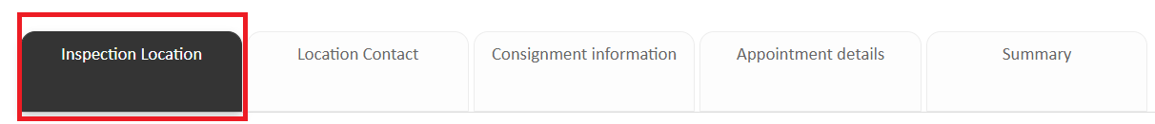

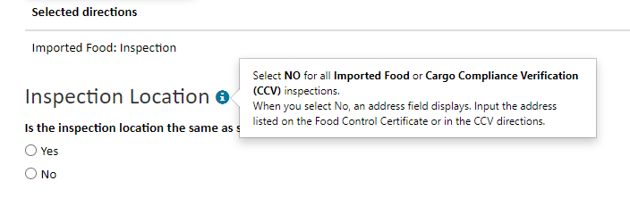

*Figure 2: Inspection location question*