|  |
| --- |
| Bacterial leaf scorch (*Xylella fastidiosa*) |

**Likely mode of entry**

Importation of infected plant material or infective insect vectors pose the greatest risk of introducing this bacterial disease into Australia.

**Symptoms (Figures 1–3)**

Leaf scorch is a common symptom, where green leaves suddenly dry and turn brown while adjacent areas turn yellow or red. In grapevines this typically appears on outer leaf margins of older leaves and moves inwards, with the whole leaf shrivelling and dropping, leaving only the leaf stem attached. Fruit may shrivel, wilt, and die.

Chlorosis where leaves lose chlorophyll and turn yellow is also common. Infected plants first appear to be water stressed, caused by the blockage of the water conducting system (xylem) by bacteria. Branches die back, and spring growth is slow. Young and susceptible plants usually die within the first year of infection, while older plants may survive several years but with new growth and fruit appearing stunted. Some hosts do not exhibit symptoms.

**Host range**

*Xylella fastidiosa* can infect 664 plant species in 88 different families, including weeds, grasses, sedges, herbs, shrubs, and trees. It causes many important diseases including Pierce’s disease in grapevines, variegated chlorosis in citrus, dwarf in lucerne, leaf scald in plum, and leaf scorch in coffee, almond, blueberry, oleander, elm, oak, plane, mulberry, olive and maple.

**Biology** **(Figure 4)**

Insects such as sharpshooter leafhoppers and froghoppers (spittlebugs) become infective after feeding from the xylem of an infected plant. Eggs of these vectors may be laid on or into plant tissue, and nymphs are sometimes beneath a frothy foam on plants. Adult insects are often attracted to bright lights.

**Distribution**

Native to the Americas. Introduced to Taiwan, the Middle East, and Western Europe. Not present in Australia.

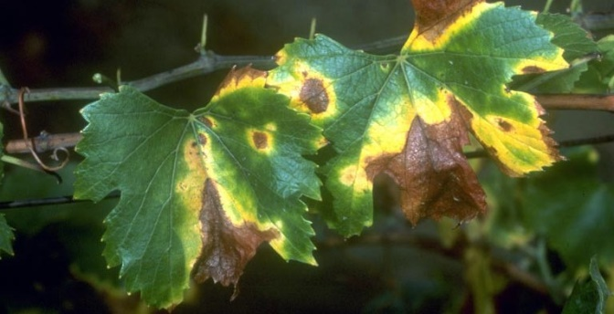

**Fig. 1** Leaf scorch on grapevines from *Xylella fastidiosa*

(J. Clark, Regents of the University of California).

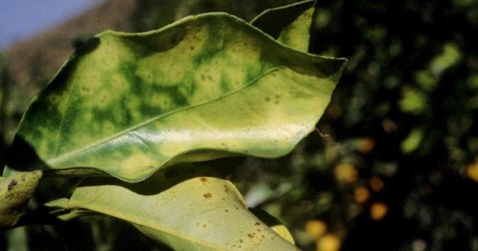

**Fig. 2** Citrus variegated chlorosis from *Xylella fastidiosa* (M. Scortichini, Instituto Sperientale per la Frutticoltura, Rome).

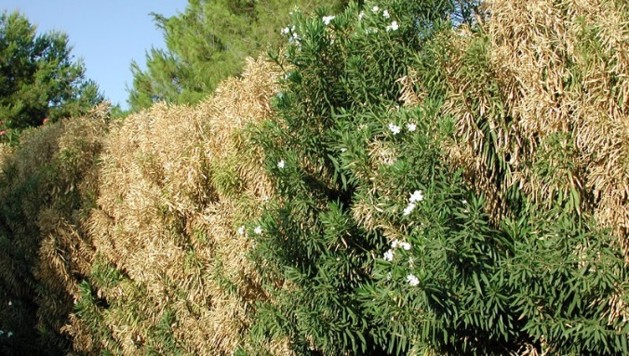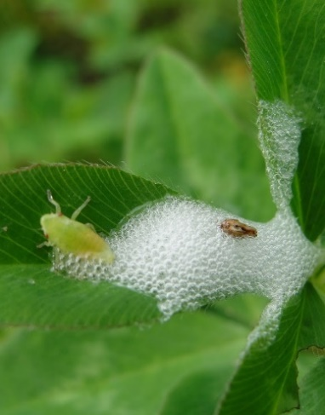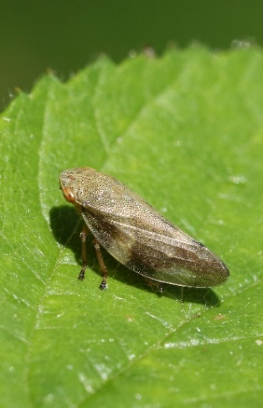

**What to do if you find a suspect infection or exotic vector of bacterial leaf scorch**

**Department officers:** Contain the risk, collect plant specimens double-bagged into zip-lock plastic bags and deliver to a department plant pathologist immediately. Collect insect specimens into a vial containing 80% ethanol and deliver to a department entomologist immediately.

**Industry and the public:** **SEE. SECURE. REPORT.**

Secure the goods to limit movement and immediately report your detection to the Department of Agriculture, Fisheries and Forestry on **1800 798 636**.

**Fig. 4** A vector of *Xylella fastidiosa,* the European meadow froghopper *Philaenus spumarius*

**Left**: nymph producing spittle (keithp2012, projectnoah.org)

**Right:** adult (Shutterstock).

**Fig. 3** Oleanders dying from infection with *Xylella fastidiosa* (Pompilid, CC BY-SA 3.0).