|  |
| --- |
| oceans & atmosphere flagship/Centre for Australian Weather and Climate Research |
| Australian HFC, PFC, Sulfur Hexafluoride & Sulfuryl Fluoride Emissions  P. Fraser, B. Dunse, P. Krummel, P. Steele and N. Derek  August 2014  Report prepared for the Department of the Environment |

|  |
| --- |
| Dept-the-Environment-inline.png |

CSIRO Oceans and Atmosphere Flagship /Centre for Australian Weather and Climate Research

Citation

Fraser P., B. Dunse, P. Krummel, P. Steele & N. Derek (2014) Australian HFC, PFC, Sulfur Hexafluoride and Sulfuryl Fluoride emissions, Report prepared for Australian Government Department of the Environment, by the Centre for Australian Weather and Climate Research, CSIRO Oceans and Atmosphere Flagship, Aspendale, Australia, ii, 27 pp.

Copyright and disclaimer

© 2014 CSIRO To the extent permitted by law, all rights are reserved and no part of this publication covered by copyright may be reproduced or copied in any form or by any means except with the written permission of CSIRO.

Important disclaimer

CSIRO advises that the information contained in this publication comprises general statements based on scientific research. The reader is advised and needs to be aware that such information may be incomplete or unable to be used in any specific situation. No reliance or actions must therefore be made on that information without seeking prior expert professional, scientific and technical advice. To the extent permitted by law, CSIRO (including its employees and consultants) excludes all liability to any person for any consequences, including but not limited to all losses, damages, costs, expenses and any other compensation, arising directly or indirectly from using this publication (in part or in whole) and any information or material contained in it.

Contents

Acknowledgments ii

1 Introduction 1

2 Measurements of HFCs, PFCs, SF6, NF3, SO2F2 & CF3SF5 at Cape Grim, Tasmania 1

3 Australian HFC, PFC and SF6 Emissions 3

3.1 Australian National Greenhouse Accounts 3

4 Australian HFC, PFC, SF6 & SO2F2 emissions from atmospheric data 6

4.1 PFC-14 emissions 6

4.2 Other PFC emissions 13

4.3 HFC, SF6 & SO2F2 emissions 14

5 Comparisons of NGA, ISC & NAME emission estimates 14

5.1 HFC-134a 14

5.2 HFC-125 15

5.3 HFC-143a 15

5.4 HFC-32 15

5.5 HFC-152a 15

5.6 HFC-23 15

5.7 HFC-227ea 16

5.8 HFC-236fa, HFC-245fa, HFC-365mfc 16

5.9 HFC-134 & HFC-4310mee 16

5.10 Total HFCs 19

5.11 Sulfur hexafluoride 19

5.12 Sulfuryl fluoride 20

5.13 Total HFCs, PFC and SF6 emissions 21

Summary 22

References 24

Figures

**Figure 1.** *In situ* observations of PFCs, HFCs, SF6, NF3, SO2F2 and CF3SF5 (1998 – 2014) showing baseline monthly mean data (dark green, Medusa; magenta, ADS) and total data (light green, Medusa; pink, ADS) obtained from the GC-MS-Medusa and GC-MS-ADS instruments at Cape Grim and from Medusa measurements at CSIRO and SIO on the Cape Grim Air Archive (orange). 2011 and 2012 NF3 annual means are derived from global data; 2008-2012 CF3SF6 annual means are assumed = 2007 (references: see text above; CSIRO unpublished Cape Grim Air Archive data). 4

**Figure 2.** Australian HFC, PFC and SF6 emissions (M tonne CO2-e) (DE, 2014). Note the impact on the reduction in emissions due to the refurbishment of potline #1 at the Kurri Kurri aluminium smelter in 2005-2006. Dashed lines are exponential best fits 9

**Figure 3.** Monthly-mean PFC-14 concentrations observed *in situ* at Cape Grim (dark green), 2004 - 2013. PFC-14 pollution episodes (light green), typically lasting up to 12 hours in duration, are also seen at Cape Grim (Mühle *et al*., 2010). 10

**Figure 4.** Australian emissions of PFC-14 as recorded in the *National Inventory Report 2012* (DoE, 2014; uncertainty 27%: DIICCSRTE, 2013) and as obtained from TAPM (scaled from Vic/Tas emissions) and NAME (scaled from Vic/Tas/NSW emissions) modelling. 10

**Figure 5.** Australian PFC-14 emission factors as reported in the *National Inventory Report 2012* (DoE, 2014)) and as derived from atmospheric measurements at Cape Grim using NAME/TAPM modelling. The grey band is the average (±1 sd) emission factor derived from NAME/TAPM. The Kurri Kurri emission factor is based on direct PFC-14 measurements made at the Kurri Kurri smelter in 2009 (Fraser *et al*., 2013). 11

**Figure 6.** Australian PFC-116, PFC-218 and PFC-318 emissions from the *National Inventory Report 2012* (DE, 2014) and as derived from atmospheric measurements at Cape Grim using NAME, TAPM and ISC modelling; error bars are ± sd. Australian PFC-116 (NAME) are from Vic/Tas data scaled by aluminium production, PFC-116 (TAPM/NAME PFC-14) are from Australian TAPM/NAME PFC-14 emissions (Table 4) and the observed PFC-116/PFC-14 ratio (0.10±0.01) in Australian smelter plumes; PFC-218 and PFC-318 are from NAME and ISC modelling, with Australian emissions obtained from regional emissions by population scaling. 13

**Figure 7.** Australian HFC-32, -125, -134a, -143a, -152a, -365mfc and SF6 emissions (NGA: DE 2014) compared to emissions calculated from Cape Grim data by interspecies correlation (ISC) and from the UK Met. Office NAME particle dispersion model. In the ISC calculations of HFC and SF6 emissions, Australian emissions are scaled from Melbourne/Port Phillip emissions on a population basis (5.4, Australia/Port Phillip); in the NAME calculations, Australian emissions are scaled from Victorian/Tasmanian emissions, also on a population basis (a scale factor of 3.7). Also shown are Australian SO2F2 emissions from ISC and NAME, scaled on a grain production basis. 18

**Figure 8.** Australian emissions of HFCs -125, -134a, -143a, -32) and other HFCs (-23, -152a, -227ea, -236fa, -365mfc) estimated from atmospheric data (ISC/NAME) measured at Cape Grim, and in the *Inventory* (DoE, 2014), expressed in units of CO2-e. 19

**Figure 9.** Australian SF6 imports and emissions (tonnes) from Cape Grim data and from the NGA (Inventory) 20

**Figure 10**. Australian SO2F2 emissions (tonnes), scaled from SE Australian emissions on a grain production basis, derived from Cape Grim in situ data, using ISC techniques; global emissions (tonnes) are from Rigby *et al*., 2014. 21

**Figure 11.** Australian HFC, PFC, SF6 emissions calculated from Cape Grim observations and in the NGGI/NGA (ageis.climatechange.gov.au) in Mt CO2-e. 21

Tables

**Table 1.** Concentrations (2012, 2013) and growth rates (2012-2013) for HFCs, PFCs, SF6, NF3, SO2F2 and CF3SF5 measured *in situ* at Cape Grim, Tasmania or on air samples collected at Cape Grim (references: see text above; CSIRO unpublished Cape Grim Air Archive data). 2

**Table 2.** Australian SGG (HFC, PFC and SF6) imports (tonnes) and HFC banks for 2012 and 2013 (Brodribb & McCann, 2013; A. Gabriel, Department of Environment, 2014); PCE = pre-charged equipment 5

**Table 3.** Australian stocks and emissions of SF6 (tonnes, DoE, 2014). 7

**Table 4.** Australian HFC, PFC and SF6 emissions (http://unfccc.int/national_reports/annex_i_ghg_inventories/national_inventories_submissions/items/7383.php). HFC-23 emissions in 1994 and 1995 from HCFC-22 production in Sydney. Not shown are small HFC-236fa emissions (0.004 tonnes in 2012) 8

**Table 5.** Australian aluminium production (kt: 103 tonnes), Australian PFC-14, PFC-116, PFC-218, PFC-318 emissions (t: tonnes) and PFC-14, PFC-116 emission factors (g/t aluminium, 2005-2012) derived from atmospheric observations – remote (Portland, Pt Henry, Bell Bay) (3 yr averages, e.g. 2010 = average of 2009, 2010, 2011), using the TAPM and NAME models, directly at Kurri Kurri and as reported in the *National Inventory Report 2012* (DoE, 2014). 12

**Table 6.** Australian HFC, PFC, SF6 and SO2F2 emissions (tonnes, 2005-2012) from atmospheric data, collected at Cape Grim, Tasmania - emissions calculated by interspecies correlation (ISC) and from inversions using the UK Met. Office NAME particle dispersion model. The emissions are 3-year running averages, i.e. ‘2010’ = average of 2009, 2010, 2011 emissions. Australian HFC and SF6 emissions are scaled from regional emissions by population; GWPs (to calculate CO2-e emissions) are from the *National Inventory Report 2012* (DoE, 2014). PFC-14 emissions are the TAPM/NAME average from Table 4. Australian PFC-116 emissions are from NAME (Vic/Tas) scaled by aluminium production; Australian PFC-218 and PFC-318 emissions are from NAME and ISC scaled by population; Australian SO2F2 emissions are from ISC and NAME estimates of SE Australian emissions scaled by grain production. 17

Acknowledgments

The authors would like to thank the Cape Grim staff for the maintenance and operation of the AGAGE (Advanced Global Atmospheric Gases Experiment) instruments at Cape Grim and for the collection of the Cape Grim Air Archive; Dr D. Ivy (MIT USA), Dr B. Miller (SIO USA and NOAA USA), Dr D. Oram (UEA UK) and the late Mr L. Porter (BoM) for gas chromatography-mass spectrometry analyses of the Cape Grim Air Archive; Dr A. Manning (UKMO) for synthetic greenhouse gas (SGG) emissions calculations (NAME-InTEM); Dr H. Wang (Georgia Institute of Tachnology, USA) and Dr M. Rigby (U. Bristol UK) for SGG emissions calculations (AGAGE 12-box model); Mr M. Hunstone and Ms. A. Gabriel (Department of the Environment) for SGG import and emissions data; Mr S. Walsh (EPA Victoria) for Port Phillip carbon monoxide emission and concentration data; CSIRO, BoM, NASA/Massachusetts Intstitute of Technology, Department of the Environment and RRA (Refrigerant Reclaim Australia) for funding in support of the Cape Grim AGAGE program.

# Introduction

Hydrofluorocarbons (HFCs), perfluorocarbons (PFCs), sulfur hexafluoride (SF6) and nitrogen trifluoride (NF3) are potent greenhouse gases (GHGs), which can be collectively described as Kyoto Protocol synthetic GHGs (KP-SGGs). HFCs are used extensively in Australia, largely in air conditioning and refrigeration, initially as ‘ozone-friendly’ replacements for chlorofluorocarbons (CFCs) and hydrochlorofluorocarbons (HCFCs). Minor uses of HFCs in Australia are as aerosol propellants, including metered dose inhalers (MDIs), as foam blowing agents and in fire extinguishers. PFCs are a by-product of the production of aluminium in Australia and overseas and, in addition, are used overseas in the electronics industry during the manufacture of integrated circuits and plasma screens. Refrigeration represents a very minor use of PFCs in Australia and overseas. Sulfur hexafluoride is used extensively in the electricity distribution industry, both in Australia and overseas, for dielectric insulation and current interruption in circuit breakers, switchgear, and other electrical equipment, and as a cover gas in metal production, for example magnesium. There does not appear to be any significant use of nitrogen trifluoride in Australia, which is used internationally in the semi-conductor production industry, initially as a replacement for PFCs.

Sulfuryl fluoride (SO2F2) and trifluoromethyl sulfurpentafluoride (CF3SF5) are potent synthetic greenhouse gases that are not part of the Kyoto Protocol suite of SGGs (KP-SGGs). Sulfuryl fluoride use in Australia is growing rapidly, as a replacement for phosphine (PH3) and possibly methyl bromide (CH3Br), in grain fumigation. It is unlikely that trifluoromethyl sulfurpentafluoride is used in Australia. Its occurrence in the atmosphere is largely as a by-product of the production of perfluorooctanesulfonic acid (PFOS: CF3(CF2)7SO3H), which has never been manufactured in Australia, but is a key ingredient in fabric stain repellants (e.g. 3M’s Scotchguard®).

Rapidly growing HFC-emissions are seen as a significant driver of climate change over the next 50 years (Velders *et al.*, 2007, 2009, 2012; Estrada *et al*., 2013; Harris *et al*., 2014; Myhre *et al*., 2014;) and projections suggest that unmitigated HFC growth could result in Global Warming Potential (GWP)-weighted emissions approaching 9 Gt CO2-e (carbon dioxide equivalent) per year by 2050 (Daniel & Velders, 2011). It has been suggested that an amended Montreal Protocol could phase out the production and consumption of HFCs (with high GWPs) sooner than possible emission mitigation under a revised Kyoto Protocol or similar agreement (Molina *et al*., 2009).

The US Environmental Protection Agency (EPA) has proposed delisting or controls on a number of high GWP HFCs by end use which were previously considered acceptable alternatives to ozone depleting substances (ODSs). There are no mandated global or Australian targets to phase-down KP-SGG emissions at present, except as contributors to the ‘basket’ of GHGs (CO2, methane – CH4, nitrous oxide – N2O, HFCs, PFCs, SF6, NF3) whose total emissions from most developed countries are regulated under the Kyoto Protocol. In early 2010, the Australian Government committed conditionally to reduce its total GHG emissions by 5 per cent below 2000 levels by 2020, but will revisit this committment at a later date, depending on the extent of comparative international action. There are no global or Australian targets to phase-down SO2F2 or CF3SF5 emissions.

Australia emitted a total of 544 million tonnes (Mt) CO2-e from all GHG sources in 2012 (not including land-use change), which was an increase from 2011 emissions (542 Mt) of 0.4%. HFC emissions were 7.9 Mt (7945 k tonnes) CO2-e in 2012, while the sum of HFC, PFC and SF6 emissions was 8.3 Mt (8333 k tonnes, Table 3) CO2-e, 1.5% of total greenhouse gas emissions and an increase in this sector of 5% compared to 2011 (Table 3; DoE, 2014). The total emission of KP-SGGs is the fastest growing emissions sector in the Australian National Greenhouse Gas Inventory (referred to subsequently as the *Inventory*).

In this Report we estimate Australian emissions of HFCs, PFCs, SF6 and SO2F2 derived by inter-species correlation (ISC), inverse and forward atmospheric modelling techniques, using Cape Grim atmospheric observations. These so-called ‘top-down’ estimates are compared to estimates of HFCs, PFCs and SF6 emissions submitted by the Australian government to the United Nations Framework Convention on Climate Change (UNFCCC) (e.g. DIICCSRTE, 2013; DoE, 2014), based on Intergovernmental Panel on Climate Change (IPCC)-recommended ‘bottom-up’ methodologies for estimating national GHG emissions. At present, Cape Grim measurements of NF3 and CF3SF5 have only been made on the Cape Grim Air Archive – these data are not suitable for estimating Australian emissions of these species.

# Measurements of HFCs, PFCs, SF6, NF3, SO2F2 & CF3SF5 at Cape Grim, Tasmania

Concentrations of HFCs, PFCs, SF6, NF3, SO2F2 and CF3SF5 have been measured *in situ* in the Southern Hemisphere atmosphere at Cape Grim, Tasmania, and/or in the Cape Grim Air Archive (1978-2013) at CSIRO (Aspendale), at the Scripps Institution for Oceanography (SIO, USA), and on a sub-set of the Cape Grim Air Archive at the University of East Anglia (UEA, UK). Other flask air samples from Cape Grim have been analysed at CSIRO, at SIO, at UEA and at the University of Heidelberg (Germany). The SGGs have been measured by CSIRO *in situ* in the atmosphere (baseline and non-baseline) at Cape Grim, Tasmania, since the late-1990s (HFCs, PFC-116: CF3CF3) and the mid-2000s (other PFCs, SF6, SO2F2).Nitrogen trifluoride (up to 2013) and trifluromethyl sulfurpentafluoride (up to 2008) have only beenmeasured on the Cape Grim Air Archive. These data are used, in conjunction with similar data collected from other Northern and Southern Hemispheric sites, to estimate global and regional concentration trends, atmospheric lifetimes, emissions and radiative forcings for these species:

HFCs Oram *et al*., 1996, 1998; Oram, 1999; O’Doherty *et al*., 2004, 2009, 2014; Greally *et al*., 2007; Stohl *et al*.,  
2009; Miller *et al*., 2010; Vollmer *et al*., 2011; Fortems-Cheney *et al*., 2013; Arnold *et al.*, 2014; Fraser *et al*., 2014a; Krummel *et al*., 2014; Rigby *et al*., 2014

PFCs Oram, 1999; Fraser *et al*., 2007, 2011, 2013; Mühle *et al*., 2010; Ivy, 2012; Ivy *et al*., 2012; Laube *et al*., 2012; Oram *et al*., 2012; Kim *et al*., 2014; Krummel *et al*., 2014; Rigby *et al*., 2014

SF6 Maiss *et al*., 1996; Oram, 1999; Fraser *et al*., 2004, 2014a; Levin *et al*., 2010; Rigby *et al*., 2010, 2014; Ganesan *et al*., 2014; Krummel *et al*., 2014

NF3 Weiss *et al*., 2008; Arnold *et al*., 2013; Rigby *et al*., 2014

SO2F2 Muhle *et al*., 2009; Krummel *et al*., 2014

CF3SF5 Sturges *et al*., 2012

The abundances and trends of HFCs, PFCs, SF6, NF3 and CF3SF6 in the global background atmosphere, as measured at Cape Grim, Tasmania, or in the Cape Grim air archive, are shown in Table 1 (2012-2013) and Figure 1 (1978-2013).

**Table 1.** Concentrations (2012, 2013) and growth rates (2012-2013) for HFCs, PFCs, SF6, NF3, SO2F2 and CF3SF5 measured *in situ* at Cape Grim, Tasmania or on air samples collected at Cape Grim (references: see text above; CSIRO unpublished Cape Grim Air Archive data).

|  |  |  |  |  |  |  |  |  |  |  |  |
| --- | --- | --- | --- | --- | --- | --- | --- | --- | --- | --- | --- |
| Species | Formula | Conc. (ppt) | | Growth | | Species | Formula | Conc. (ppt) | | Growth | |
|  |  | 2012 | 2013 | ppt/yr | %/yr |  |  | 2012 | 2013 | ppt/yr | %/yr |
| HFC-134a | CH2FCF3 | 62.7 | 67.0 | 4.2 | 6.5 | PFC-14 | CF4 | 79.3 | 79.9 | 0.56 | 0.7 |
| HFC-23 | CHF3 | 24.4 | 25.1 | 0.78 | 3.2 | PFC-14(a)1 | CF4 | 44.4 | 45.0 | 0.56 | 1.3 |
| HFC-143a | CH3CF3 | 12.5 | 13.6 | 1.1 | 8.4 | PFC-116 | C2F6 | 4.18 | 4.25 | 0.06 | 1.5 |
| HFC-125 | CHF2CF3 | 10.1 | 11.4 | 1.3 | 12 | PFC-318 | c-C4F8 | 1.31 | 1.36 | 0.05 | 3.7 |
| HFC-32 | CH2F2 | 5.2 | 6.0 | 0.85 | 15 | PFC-218 | C3F8 | 0.56 | 0.57 | 0.016 | 2.8 |
| HFC-152a | CH3CHF2 | 4.4 | 4.4 | -0.01 | 0.0 | PFC-51142 | C6F14 | 0.27 | 0.27 | 0.005 | 1.8 |
| HFC-245fa | CH3CF2CF3 | 1.3 | 1.4 | 0.13 | 10 | PFC-31102 | C4F10 | 0.17 | 0.17 | 0.002 | 1.2 |
| HFC-227ea | CHF2CF2CF3 | 0.69 | 0.77 | 0.084 | 12 | PFC-41122 | C5F12 | 0.12 | 0.12 | 0.001 | 1.1 |
| HFC-365mfc | CH3CH2CF2CF3 | 0.56 | 0.60 | 0.038 | 6.6 | PFC-61162 | C7F16 | 0.12 | 0.12 | 0.004 | 3.4 |
| HCFC-4310mee | CF3(CHF)2C2F5 | 0.20 | 0.21 | 0.01 | 4.8 | PFC-71182 | C8F18 | 0.09 | 0.09 | 0.001 | 1.1 |
| HFC-236fa | CH2FCF2CF3 | 0.088 | 0.094 | 0.006 | 6.5 | total PFCs |  | 86.1 | 86.8 | 0.70 | 0.9 |
| total HFCs |  | 122 | 131 | 8.6 | 6.8 | total PFC(a) |  | 51.2 | 51.9 | 0.70 | 1.4 |
| HFC fluorine |  | 448 | 480 | 32 | 7.1 | PFC fluorine |  | 368 | 371 | 3.3 | 0.9 |
| sulfur hexafluoride | SF6 | 7.4 | 7.7 | 0.27 | 3.6 | nitrogen trifluoride | NF3 | 0.90 | 1.00 | 0.103 | 11 |
| sulfuryl fluoride | SO2F2 | 1.68 | 1.78 | 0.10 | 5.8 | total fluorine |  | 862 | 904 | 43 | 4.8 |
| trifluoromethyl sulfurpentafluoride | CF3SF5 | 0.164 | 0.16 | 0.0 | 0.0 |  |  |  |  |  |  |
| 1 PFC-14 (a) = CF4 (anthro.) = total CF4 – natural CF4 (=34.9 ppt, Mühle *et al*., 2010)  2 extrapolated from 2011 data (Ivy *et al*., 2012)  3 estimated from Cape Grim & global data; assumed = 2011-2012 growth rate (Arnold *et al*., 2013)  4 assumed = 2007 concentration (zero emissions after 2007), no growth observed in *in situ* measurements (uncalibrated) since 2010 | | | | | | | | | | | |

The major HFC in the background atmosphere at Cape Grim (and around the globe) is HFC-134a (67 ppt in 2013), followed by HFC-23 (25 ppt), HFC-143a (14 ppt), HFC-32 (6.0 ppt) and HFC-152a (4.4 ppt). The cumulative concentration of the minor HFCs (HFC-227ea, HFC-236fa, HFC-365mfc, HFC-4310mee) is 1-2 ppt (2013). The total HFC concentration in the background atmosphere is 131 ppt (2013).

The rates of increase of the major HFCs in the global background atmosphere (HFC-32, HFC-125, HFC-134a, HFC-143a, HFC-152a) are now slowing, suggesting the rates of increase in global emissions are in decline (Rigby *et al*., 2014). Specifically, the annual rate of increase of HFC-134a has declined from 5.6 ppt (2011-2012) to 4.2 ppt (2012-2013); the HFC-23 increase (0.8 ppt, 2011-2012 & 2012-2013) has remained steady; the HFC-143a annual increase (1.1 ppt, 2012-2013) has declined from 1.3 ppt (2011-2012); the HFC-125 annual increase (1.3 ppt per year, 2012-2013) has declined from 1.6 ppt per year (2011-2012); the HFC-152a annual increase (0.2 ppt, 2011-2012) has declined (0.0 ppt, 2012-2013) such that HFC-152a is no longer growing in the background atmosphere; the HFC-32 increase (0.9 ppt, 2012-2013) has declined from 1.1 ppt (2011-2012). The minor HFCs (HFC-227ea, HFC-236fa, HFC-365mfc, HFC-4310mee) are growing in the background atmosphere with a cumulative annual growth rate of 0.2-0.3 ppt (2012-2013). The annual growth in total HFCs (9 ppt, 2012-2013) has declined from 11 ppt (2011-2012) and is now similar to the annual increase observed in 2010-2011 (9 ppt). Total HFCs in the atmosphere are growing currently (2012-2013) at 7% per year.

The major PFC in the background atmosphere at Cape Grim (and around the globe) is PFC-14 (80 ppt in 2013, about half of which is naturally-occurring), followed by PFC-116 (4.3 ppt), PFC-318 (1.4 ppt) and PFC-218 (0.57 ppt). The cumulative concentration of five minor PFCs (PFC-3110, PFC-4112, PFC-5114, PFC-6116, PFC-7118) observed at Cape Grim is 0.8-0.9 ppt (2013). The total PFC concentration in the background atmosphere is 87 ppt (2013), currently growing at 0.7 ppt per year (0.9% per year). The total anthropogenic PFC concentration in the background atmosphere is 51 ppt growing at 1.4% per year.

The annual rate of increase of PFC-14 (CF4) in the atmosphere is declining: 0.56 ppt (2012-2013) compared to 0.83 ppt (2011-2012), consistent with declining global emissions of PFC-14. The anthropogenic component (from aluminium production and the electronics industries) of the PFC-14 atmospheric abundance is growing at 1.4% per year. The annual rate of increase of PFC-116 (CF3CF3) has remained steady at 0.06 ppt in 2012-2013 compared to 2011-2012; the CF3CF2CF3 annual increase (0.016 ppt, 2012-2013) is similar to the increase observed over the previous two years (2010-2012, 0.1-0.2 ppt per year); c-C4F8 increased by 0.05 ppt (2012-2013) is similar to the increase in 2011-2012 (0.04 ppt). The minor PFCs (PFC-3110, PFC-4112, PFC-5114, PFC-6116, PFC-7118) are growing in the background atmosphere with a cumulative annual growth rate likely to be of order 0.2-0.3 ppt (2012-2013). Total industry-derived atmospheric PFCs are growing (2012-2013) at 1.4% per year.

Annual mean SF6 levels reached 7.7 ppt in 2013 at Cape Grim, growing at 0.27 ppt per year (3.6% per year), lower than the 2011-2012 growth rate (0.30 ppt, 4.1% per year). Annual mean SO2F2 levels reached 1.8 ppt in 2013 at Cape Grim, growing at 0.1 ppt per year (5.8% per year), compared to the 2011-2012 growth rate of 4.0% per year. Trifluoromethyl sulphurpentafluoride stopped growing in the Cape Grim atmosphere in 2007 (0.16 ppt), as seen in Cape Grim Air Archive measurements, following 3M’s decision to cease PFOS production (Santaro, 2000). *In situ* measurements (uncalibrated) at Cape Grim show zero growth in CF3SF5 since measurement began in 2010. If there is no further production/release of CF3SF5, its concentration in the atmosphere will remain effectively constant due to its very long atmospheric lifetime (800 yr). With zero emissions, atmospheric concentrations should decline by about 0.05% (<0.01 ppt) per year.

Nitrogen trifluoride is growing rapidly in the background atmosphere (0.11 ppt per year, 11% per year). Following the recent inclusion of NF3 into the Kyoto Protocol ‘basket’ of GHGs, it is anticipated that the current rapid growth rate will decline as alternatives are introduced into the semiconductor manufacturing industry.

# Australian HFC, PFC and SF6 Emissions

## Australian National Greenhouse Accounts

The National Greenhouse Gas Inventory (the *Inventory*: ageis.climatechange.gov.au) in 2014 contains estimates of Australian emissions of HFC-23, HFC-32, HFC-125, HFC-134 (CHF2CHF2, not measured currently at Cape Grim), HFC-134a, HFC-143a, HFC-152a, HFC-227ea, HFC-236fa, HFC-4310mee, PFC-14, PFC-116 and SF6, up to 2012, and is part of the *National Inventory Report 2012* (DoE, 2014), which is the Australian government submission to the UNFCCC and which forms a part of the Australian National Greenhouse Accounts (NGA). Note the annual emissions in the *Inventory* and in the *National Inventory Report* are for fiscal years, i.e. ‘2012’ emissions are emissions for July 2011 to June 2012.

The HFC emissions (Table 4) are based on HFC import data (Table 2; HFCs are not manufactured in Australia), as bulk HFCs or pre-charged equipment (PCE), leading to an estimate of ‘banks’ of HFCs stored in equipment or products (refrigerators, air conditioners, fire extinguishers, foams, aerosols - largely metered-dose inhalers) and appropriate application-dependent emission factors from those ‘banks’, which allow for emissions during the lifetime of the application as well as emissions from initial charging/re-charging of equipment and equipment disposal. The HFC emissions model contains some assumptions that simplify HFC emissions calculations. For example, the Australian HFC mix, as determined by HFC imports, is assumed to be invariant across all HFC use categories and the application-specific emission factors are time-invariant. This means that the emissions model is likely to be more representative for total HFC emissions than for individual HFC emissions.

The Australian HFC mix in the emissions model is 53% HFC-134a, 40% HFC-125, 5.2% HFC-143a, 0.5% HFC-32 and 1.4% HFC-227ea. The HFC mix in the 2012 import data (Table 2) is 49% HFC-134a, 24% HFC-125, 13% HFC-143a, 13% HFC-32, <1% HFC-227ea and 1% other HFCs. The HFC mix in the Australian bank in 2012 is 44% HFC-134a, 5.3% HFC-125, 28% HFC-143a and 23% HFC-32 (Brodribb & McCann, 2013).

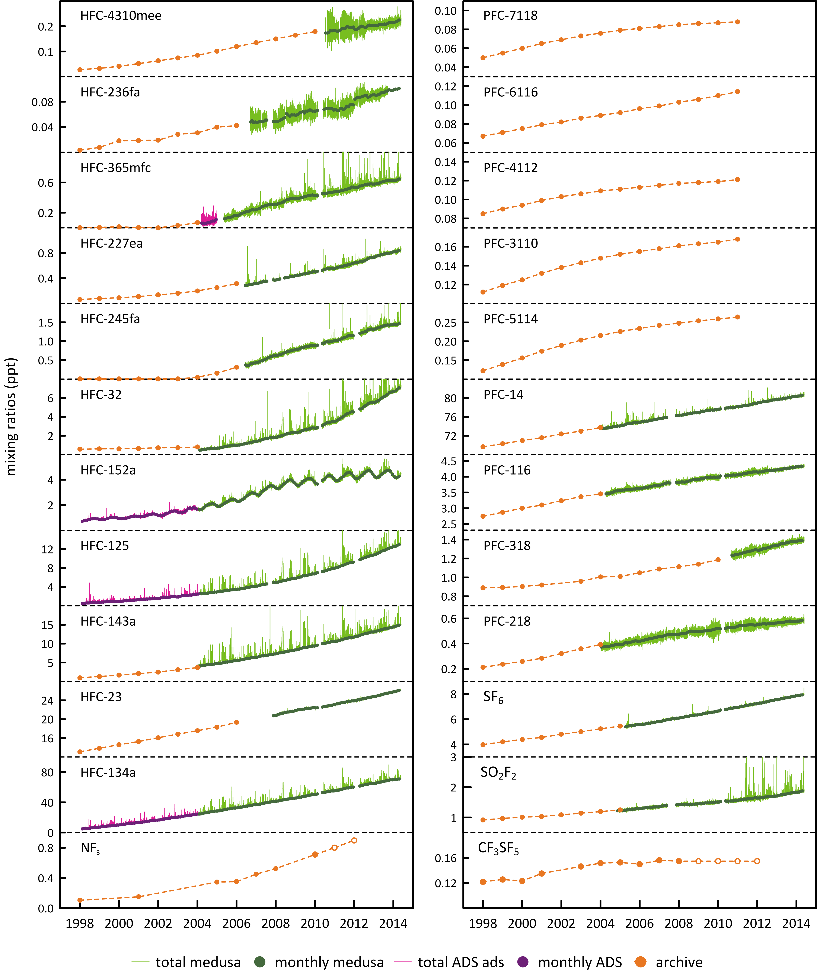

**Figure 1.** *In situ* observations of PFCs, HFCs, SF6, NF3, SO2F2 and CF3SF5 (1998 – 2014) showing baseline monthly mean data (dark green, Medusa; magenta, ADS) and total data (light green, Medusa; pink, ADS) obtained from the GC-MS-Medusa and GC-MS-ADS instruments at Cape Grim and from Medusa measurements at CSIRO and SIO on the Cape Grim Air Archive (orange). 2011 and 2012 NF3 annual means are derived from global data; 2008-2012 CF3SF6 annual means are assumed = 2007 (references: see text above; CSIRO unpublished Cape Grim Air Archive data).

**Table 2.** Australian SGG (HFC, PFC and SF6) imports (tonnes) and HFC banks for 2012 and 2013 (Brodribb & McCann, 2013; A. Gabriel, Department of Environment, 2014); PCE = pre-charged equipment

|  |  |  |  |  |  |  |  |  |  |  |
| --- | --- | --- | --- | --- | --- | --- | --- | --- | --- | --- |
| Species | bulk  SGGs & HFC blends | | PCE SGGs & HFC blends | | total bulk & PCE | | total SGGs | | HFC bank | |
|  | 2012 | 2013 | 2012 | 2013 | 2012 | 2013 | 2012 | 2013 | 2012 | 2013 |
| HFC-23 |  | 0.1 |  | <0.1 | 1 | 0.1 | 1 | 0.1 |  |  |
| HFC-32 | 58 | 0.3 | 11 | 67 | 1072 | 67 | 1141 | 941 | 7404 |  |
| HFC-125 | 104 | <0.1 | 14 |  | 2001 | <0.1 | 2119 | 899 | 1709 |  |
| HFC-134 | 2 | 2 | 1 | 2 |  | 4 | 3 | 4 |  |  |
| HFC-134a | 3992 | 93 | 65 | 802 | 258 | 895 | 4315 | 930 | 14093 |  |
| HFC-143,-143a | 58 |  | 3 | 0.2 | 1065 | 0.2 | 1126 | 20 | 8890 |  |
| HFC-152a |  | 1 |  | 12 |  | 13 |  | 13 |  |  |
| HFC-227ea | 70 |  | 1 | 1 |  | 1 | 70 | 1 |  |  |
| HFC-245fa | 44 | 74 |  |  |  | 74 | 44 | 74 |  |  |
| HFC-365mfc | 53 | 86 |  |  |  | 86 | 53 | 86 |  |  |
| total HFCs |  | 257 |  | 884 |  | 1141 |  | 2968 |  |  |
| R-404 | 1805 | 9 |  | 27 |  | 36 |  |  |  |  |
| R-407 | 440 | 13 |  | 40 |  | 53 |  |  |  |  |
| R-410 | 1962 | 1 |  | 1718 |  | 1719 |  |  |  |  |
| R-417 |  | 1 |  | 0.3 |  | 1 |  |  |  |  |
| R-422 |  | 0.2 |  | 0.2 |  | 0.3 |  |  |  |  |
| R-427 | 34 |  |  |  |  |  |  |  |  |  |
| R-438 | 8 | 16 |  | 2 |  | 18 |  |  |  |  |
| R-507 | 243 | 1 |  | 1 |  | 2 |  |  |  |  |
| total blends |  | 41 |  | 1788 |  | 1829 |  |  |  |  |
| total PFCs | 0.9 | 0.1 |  | 0.1 |  | 0.2 | 0.9 | 0.2 |  |  |
| SF6 | 36 | 4 |  | 14 |  | 18 | 36 | 18 |  |  |
| total SGGs |  | 301 |  | 2685 |  | 2986 |  | 2986 | 24696 |  |

There have been a number of refinements to the HFC emissions model used for the 2014 submission:

1. use of country-specific (Australian) annual leakage rates for commercial refrigeration and air-conditioning, transport refrigeration and heavy vehicle air rather than default leakage rates;
2. quality control checks on bulk import data showed that the previous version of the emissions model was not allocating 100% of bulk gas imports to domestic production or replenishment, leading to a minor systematic under-estimation of emissions from all equipment types; this has been corrected for the current submission to UNFCCC;
3. a revision to the quantities of bulk gas allocated to foams, aerosols and fire protection equipment; and
4. a minor revision to the calculation of emissions from initial charging of new equipment.

The relationship between HFC imports and emissions is not necessarily linear. For example there was a surge of HFC and SF6 imports into Australia in 2012 in anticipation of the imposition of the carbon tax; this presumably did not lead to a significant surge in emissions, as the HFC and SF6 imports, surplus to demand, presumably went into storage with minimal emissions.

In the Australian GHG emission inventory, PFC (PFC-14, PFC-116) emissions only arise from aluminium production, with total PFC emissions in 2012 of 0.25 Mt CO2-e (DoE, 2014). Less than 1 tonne of PFCs (PFC-14, PFC-116) were imported into Australia as refrigerant blends in bulk and in pre-charged equipment (see below). It is not clear whether these PFC imports are used to calculate corresponding contributions to PFC emissions – if they are, they are very small compared to PFC emissions from the aluminium industry.

Australian SF6 emissions are largely from the electricity supply and distribution network. Emissions (1975-2012) are estimated as leakages from SF6 ‘banks’ and from Australian manufacture of electricity supply equipment (Table 3), using a combination of default IPCC and Australian-specific emissions factors. There are only two years (2012, 2013) of SF6 import data available, which could potentially be used to verify the calculations of SF6 in banks and used in manufacture. However the 2012-2013 import data suggest SF6 may have been stock-piled in these years in anticipation of an impending carbon tax impost on the SF6 price.

Australian emission factors for electrical equipment stock are global IPCC default factors: 0.05 t/t (1975-1995), 0.02 t/t (2000); an Australian-specific factor (0.0089 t/t) has been estimated for 2009 and assumed constant thereafter. For 1995-2000-2009 periods, emissions factor are interpolated. The 2009-2012 emission factor is based on emission estimates from 15 utilities using their own data on SF6 consumption (consumption = emissions, not defaulting to the IPCC method). The emission factors assumed for Australian equipment manufacture (0.15 t/t, 1975-1995; 0.06 t/t, 1996-2012) are IPCC default factors for Europe. The original global IPCC default factor for manufacturing (0.74 t/t) was significantly higher and currently IPCC recommends 0.30-0.35 t/t (prior to 1995) and 0.12 t/t after 1995, both significantly higher than the assumed Australian emission factor for equipment manufacture. These IPCC factors are for so-called gas insulated switchgear (GIS); significantly higher factors are recommended for circuit breakers (0.55 t/t prior to 1995, 0.29 t/t after 1995). Circuit breakers are used extensively in the USA, GIS in Europe. The Australian inventory assumed GIS values, presumably because Australia uses largely GIS equipment in its electricity distribution networks.

Australian SF6 emissions from magnesium casting, tracer gas studies, eye surgery etc. have been estimated at 0.034 g per capita (M. Hunstone, DoE, 2014, personal communication). The components of the Australian SF6 emission inventory are shown in Table 3.

There are no import data available for SO2F2.

The emissions data (1995 to 2012) are detailed in Table 4. Australian HFC emissions were less than 100 tonnes in 1994, rising to 4579 tonnes (7945 CO2-e tonnes) in 2012. HFCs are the dominant emissions in CO2-e terms in this sector (95%, 2012). HFC-134a emissions increased by about 176 tonnes (6%) from 2011 to 2012, all other HFCs by about 73 tonnes (6%). Emissions of total HFCs (in CO2-e terms) in 2012 were 6% higher than in 2011. Australian PFC emissions were 190 tonnes in the mid-1990s, rising to 230 tonnes in the mid-2000s, before dropping to 37 tonnes in 2012. Total PFC emissions (in CO2-e terms) decreased by 2% from 2011 to 2012. Sulfur hexafluoride (SF6) emissions are estimated to have been 13 tonnes in 1995 falling to 6 tonnes in 2012.

Total HFC, PFC and SF6 emissions in CO2-e in 2012 (8333 k tonnes) were 5% higher than in 2011; this compares to an 8% per year increase from 2007 to 2011. The overall uncertainty on the PFC/HFC/SF6 emissions category in the *Inventory* is 25-30% (DCCEE, 2011). The HFC, PFC and SF6 contributions to total emissions from this sector are shown in Figure 2. The significant impact on total emissions in 2005-2006 due to reduced PFC emissions (the Kurri Kurri aluminium smelter upgrade) can be clearly seen. Prior to the significant reduction in PFC emissions at Kurri Kurri in 2005, Australian HFC/PFC/SF6 emissions grew at about 13% per year (). After the Kurri Kurri upgrade, these combined emissions grew at about 7% per year. The Australian KP-SGG emissions are 95% HFCs, 3% PFCs and 2% SF6.

Department of the Environment (2014) estimates of emissions (Table 4) in the *Inventory* (ageis.climatechnage.gov.au) are compared to emissions estimated from atmospheric observations below.

# Australian HFC, PFC, SF6 & SO2F2 emissions from atmospheric data

## PFC-14 emissions

South-East Australian emissions of PFC-14 (CF4) are evident in the PFC-14 data collected at Cape Grim (Figure 3). Inspection of Figure 3 shows an overall decline in intensity of PFC-14 pollution episodes due to declining emissions. The year-to-year variability of the number and intensity of PFC-14 episodes seen at Cape Grim is large, so 3-yr averaging is used when deriving PFC emissions from these data (so the latest annual emission calculated from these data is for 2012). Detailed analysis of these PFC-14 pollution episodes shows clearly that the Cape Grim PFC-14 pollution originates largely from southern Victoria (from the Point Henry and Portland smelters), with some contribution from Bell Bay, Tasmania.

The Cape Grim PFC-14 pollution episode data have been used to estimate PFC-14 emissions from these South-East Australian smelters. A regional transport model (TAPM – The Air Pollution Model; Hurley, 2008; Hurley *et al*., 2008) is used to calculate emissions in which PFC-14 is released into the model atmosphere from the Point Henry, Portland and Bell Bay locations, with annual emissions that are varied, so that the resultant PFC pollution episodes seen at Cape Grim in the model are a best-fit match to observations. The emissions are constant in any one year, varied year-by-year. Smelter-specific emission factors are calculated from the emissions by dividing by the smelter-specific annual aluminium production (Fraser *et al*., 2007, 2011).

The NAME particle dispersion model (O’Doherty *et al*., 2009; Manning *et al*., 2003, 2011) is also used to calculate PFC-14 emissions from Victoria/Tasmania/NSW (Portland/Pt Henry/Bell Bay/Kurri Kurri/Tomago smelters).

**Table 3.** Australian stocks and emissions of SF6 (tonnes, DoE, 2014).

|  |  |  |  |  |  |  |  |  |  |
| --- | --- | --- | --- | --- | --- | --- | --- | --- | --- |
|  | existing electrical equipment | | | new equipment manufacture | | | other | total | total1 |
|  | bank | emissions | emissions | amount | leak | emissions | emissions | emissions | emissions |
|  | tonnes | factor t/t | tonnes | tonnes | rate t/t | tonnes | tonnes | tonnes | tonnes |
| 1975 | 2.4 | 0.05 | 0.1 | 1.3 | 0.15 | 0.2 |  |  | 1.6 |
| 1976 | 4.8 | 0.05 | 0.2 | 1.3 | 0.15 | 0.2 |  |  | 1.8 |
| 1977 | 7.2 | 0.05 | 0.4 | 1.4 | 0.15 | 0.2 |  |  | 2.0 |
| 1978 | 9.7 | 0.05 | 0.5 | 1.4 | 0.15 | 0.2 |  |  | 2.2 |
| 1979 | 12 | 0.05 | 0.6 | 1.5 | 0.15 | 0.2 |  |  | 2.3 |
| 1980 | 27 | 0.05 | 1.3 | 7.9 | 0.15 | 1.2 |  |  | 7.8 |
| 1981 | 41 | 0.05 | 2.1 | 8.3 | 0.15 | 1.2 |  |  | 8.8 |
| 1982 | 56 | 0.05 | 2.8 | 8.6 | 0.15 | 1.3 |  |  | 9.8 |
| 1983 | 70 | 0.05 | 3.5 | 9.0 | 0.15 | 1.3 |  |  | 10.8 |
| 1984 | 84 | 0.05 | 4.2 | 9.4 | 0.15 | 1.4 |  |  | 11.8 |
| 1985 | 93 | 0.05 | 4.6 | 6.5 | 0.15 | 1.0 |  |  | 10.1 |
| 1986 | 101 | 0.05 | 5.1 | 6.8 | 0.15 | 1.0 |  |  | 10.7 |
| 1987 | 110 | 0.05 | 5.5 | 7.0 | 0.15 | 1.0 |  |  | 11.3 |
| 1988 | 118 | 0.05 | 5.9 | 7.2 | 0.15 | 1.1 |  |  | 11.9 |
| 1989 | 127 | 0.05 | 6.3 | 7.4 | 0.15 | 1.1 |  |  | 12.5 |
| 1990 | 141 | 0.05 | 7.1 | 11 | 0.15 | 1.6 |  |  | 15.7 |
| 1991 | 156 | 0.05 | 7.8 | 11 | 0.15 | 1.7 | 0.6 | 10 | 16.7 |
| 1992 | 170 | 0.05 | 8.5 | 11 | 0.15 | 1.7 | 0.6 | 11 | 17.7 |
| 1993 | 185 | 0.05 | 9.2 | 12 | 0.15 | 1.8 | 0.6 | 12 | 18.7 |
| 1994 | 199 | 0.05 | 10 | 12 | 0.15 | 1.8 | 0.6 | 12 | 19.7 |
| 1995 | 214 | 0.05 | 11 | 13 | 0.15 | 1.9 | 0.6 | 13 | 21.0 |
| 1996 | 229 | 0.044 | 10 | 13 | 0.06 | 0.8 | 0.6 | 12 | 20.2 |
| 1997 | 244 | 0.038 | 9.3 | 12 | 0.06 | 0.7 | 0.6 | 11 | 19.1 |
| 1998 | 259 | 0.032 | 8.3 | 12 | 0.06 | 0.7 | 0.6 | 9.8 | 17.7 |
| 1999 | 274 | 0.026 | 7.1 | 11 | 0.06 | 0.7 | 0.7 | 8.6 | 16.2 |
| 2000 | 313 | 0.020 | 6.3 | 22 | 0.06 | 1.3 | 0.7 | 8.4 | 23.7 |
| 2001 | 352 | 0.0188 | 6.6 | 23 | 0.06 | 1.4 | 0.7 | 8.6 | 24.6 |
| 2002 | 390 | 0.0175 | 6.8 | 23 | 0.06 | 1.4 | 0.7 | 8.9 | 25.4 |
| 2003 | 429 | 0.0163 | 7.0 | 23 | 0.06 | 1.4 | 0.7 | 9.0 | 26.3 |
| 2004 | 468 | 0.0151 | 7.1 | 23 | 0.06 | 1.4 | 0.7 | 9.1 | 27.1 |
| 2005 | 481 | 0.0139 | 6.7 | 10 | 0.06 | 0.6 | 0.7 | 8.0 | 18.1 |
| 2006 | 495 | 0.0126 | 6.3 | 10 | 0.06 | 0.6 | 0.7 | 7.6 | 18.2 |
| 2007 | 509 | 0.0114 | 5.8 | 9.8 | 0.06 | 0.6 | 0.7 | 7.1 | 18.3 |
| 2008 | 523 | 0.0102 | 5.3 | 9.6 | 0.06 | 0.6 | 0.7 | 6.6 | 18.5 |
| 2009 | 534 | 0.0089 | 4.8 | 7.8 | 0.06 | 0.5 | 0.8 | 6.0 | 17.4 |
| 2010 | 544 | 0.0089 | 4.9 | 7.5 | 0.06 | 0.4 | 0.8 | 6.1 | 17.3 |
| 2011 | 542 | 0.0089 | 4.8 |  | 0.06 |  | 0.8 | 5.6 | 17.3 |
| 2012 | 541 | 0.0089 | 4.8 |  | 0.06 |  | 0.8 | 5.6 | 17.3 |
| 1 based on SF6 emission factor 0.034 g SF6/capita,, M. Hunstone, DoE 2014, personal communication  2based on IPCC default emission factor (0.74 t/t) for electrical equipment manufacture | | | | | | | | | |

**Table 4.** Australian HFC, PFC and SF6 emissions (<http://unfccc.int/national_reports/annex_i_ghg_inventories/national_inventories_submissions/items/7383.php>). HFC-23 emissions in 1994 and 1995 from HCFC-22 production in Sydney. Not shown are small HFC-236fa emissions (0.004 tonnes in 2012)

|  |  |  |  |  |  |  |  |  |  |  |  |  |  |  |  |  |  |  |
| --- | --- | --- | --- | --- | --- | --- | --- | --- | --- | --- | --- | --- | --- | --- | --- | --- | --- | --- |
|  | HFC-134a | HFC-125 | HFC-143a | HFC-32 | HFC-227ea | HFC-134 | HFC-4310mee | HFC-23 | total HFCs | | PFC-14 | PFC-116 | total PFCs | | SF6 | | total HFCs, PFCs, SF6 | |
|  | tonnes | | | | | | | | tonnes | kt CO2-e | tonnes | | tonnes | kt CO2-e | tonnes | kt CO2-e | tonnes | kt CO2-e |
| 1994 | 0.2 | 0.1 | 0.0 | 0.0 | 0.0 | 0.0 | 0.0 | 69 | 69 | 808 | 241 | 31 | 272 | 1856 | 12 | 296 | 322 | 2960 |
| 1995 | 32 | 11 | 1.1 | 0.6 | 0.4 | 0.0 | 0.0 | 61 | 107 | 793 | 171 | 22 | 193 | 1313 | 13 | 317 | 313 | 2419 |
| 1996 | 141 | 49 | 4.7 | 2.7 | 1.7 | 0.1 | 0.0 | 0.0 | 200 | 347 | 157 | 20 | 178 | 1209 | 12 | 283 | 389 | 1840 |
| 1997 | 242 | 85 | 8.1 | 4.7 | 2.9 | 0.1 | 0.1 | 0.0 | 343 | 595 | 137 | 18 | 155 | 1053 | 11 | 260 | 509 | 1910 |
| 1998 | 345 | 121 | 12 | 6.7 | 4.1 | 0.1 | 0.1 | 0.0 | 488 | 847 | 185 | 24 | 209 | 1424 | 9.8 | 234 | 707 | 2505 |
| 1999 | 476 | 166 | 16 | 9.2 | 5.7 | 0.2 | 0.1 | 0.1 | 673 | 1168 | 127 | 16 | 143 | 977 | 8.6 | 206 | 825 | 2351 |
| 2000 | 560 | 196 | 19 | 11 | 6.7 | 0.2 | 0.2 | 0.1 | 792 | 1375 | 143 | 19 | 162 | 1103 | 8.4 | 200 | 963 | 2678 |
| 2001 | 799 | 280 | 27 | 15 | 9.5 | 0.3 | 0.2 | 0.1 | 1131 | 1963 | 201 | 26 | 227 | 1545 | 8.6 | 206 | 1367 | 3714 |
| 2002 | 1014 | 355 | 34 | 20 | 12 | 0.4 | 0.3 | 0.1 | 1435 | 2490 | 193 | 25 | 217 | 1481 | 8.9 | 212 | 1661 | 4183 |
| 2003 | 1240 | 434 | 42 | 24 | 15 | 0.5 | 0.4 | 0.2 | 1755 | 3046 | 188 | 24 | 212 | 1444 | 9.0 | 216 | 1976 | 4706 |
| 2004 | 1479 | 517 | 50 | 29 | 18 | 0.6 | 0.4 | 0.2 | 2093 | 3632 | 191 | 25 | 216 | 1469 | 9.1 | 218 | 2318 | 5319 |
| 2005 | 1734 | 607 | 58 | 34 | 21 | 0.7 | 0.5 | 0.2 | 2455 | 4259 | 200 | 26 | 225 | 1536 | 8.0 | 191 | 2688 | 5985 |
| 2006 | 1892 | 662 | 63 | 37 | 22 | 0.7 | 0.5 | 0.2 | 2677 | 4646 | 76 | 10 | 86 | 589 | 7.6 | 181 | 2771 | 5415 |
| 2007 | 2120 | 745 | 71 | 41 | 25 | 0.8 | 0.6 | 0.3 | 3013 | 5228 | 65 | 8 | 73 | 499 | 7.1 | 170 | 3094 | 5897 |
| 2008 | 2366 | 828 | 79 | 46 | 28 | 0.9 | 0.7 | 0.3 | 3349 | 5811 | 50 | 6 | 56 | 382 | 6.6 | 158 | 3411 | 6350 |
| 2009 | 2587 | 905 | 87 | 50 | 31 | 1.0 | 0.7 | 0.3 | 3661 | 6353 | 40 | 5 | 45 | 308 | 6.0 | 143 | 3713 | 6805 |
| 2010 | 2827 | 989 | 95 | 55 | 34 | 1.1 | 0.8 | 0.4 | 4001 | 6942 | 33 | 3 | 36 | 243 | 6.1 | 145 | 4043 | 7331 |
| 2011 | 3059 | 1070 | 102 | 59 | 36 | 1.2 | 0.9 | 0.4 | 4329 | 7512 | 35 | 4 | 38 | 259 | 5.6 | 134 | 4373 | 7905 |
| 2012 | 3235 | 1132 | 108 | 63 | 38 | 1.3 | 0.9 | 0.4 | 4579 | 7945 | 34 | 4 | 37 | 254 | 5.6 | 134 | 4622 | 8333 |

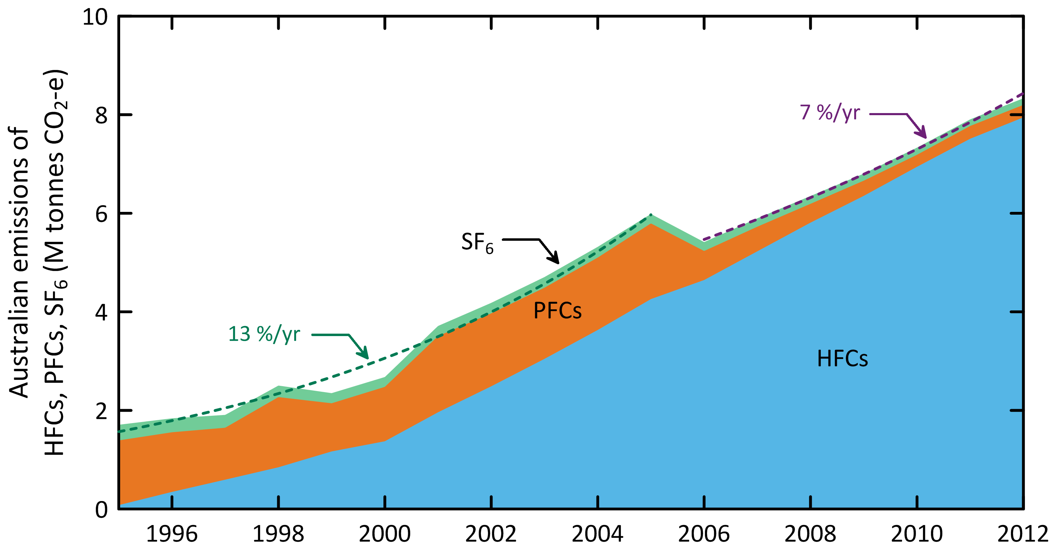

**Figure 2.** Australian HFC, PFC and SF6 emissions (M tonne CO2-e) (DE, 2014). Note the impact on the reduction in emissions due to the refurbishment of potline #1 at the Kurri Kurri aluminium smelter in 2005-2006. Dashed lines are exponential best fits

NAME (**N**umerical **A**tmospheric **D**ispersion **M**odelling **E**nvironment) is a Lagrangian particle dispersion model driven by 3-dimensional wind fields from numerical weather predictions models. NAME has a horizontal resolution (grid boxes 40 km x 40 km) and a minimum boundary layer height of 100 m. NAME operates in a backward mode, so, for example, it identifies, within a 3 hr period at Cape Grim, which grid boxes in the prescribed domain impact on Cape Grim in the previous 12 days. NAME releases 33000 particles at Cape Grim over the 3 hr period and the resultant 12-day integrated concentrations in each of the domain boxes are calculated. Operating NAME in the backward mode is numerically very efficient and is a very close approximation to the forward running mode, which is what is used to identify emission sources impacting on Cape Grim. In the inverse calculation, NAME identifies pollution episode data at Cape Grim, and starts with randomly-generated emission maps and searches for the emission map that leads to a modelled pollution time series that most accurately mimics the observations. The inversion method assumes that baseline air enters the inversion domain regardless of direction i.e. it assume that sources outside the specified domain do not impact significantly on Cape Grim. One of the major advantages of the NAME method, especially when using Cape Grim data, is that it does not require a prior estimate of emissions. Other inversion methods used to estimate regional emissions using Cape Grim data often derive emissions that are not significantly different than the prior estimates.

The TAPM and NAME estimates of regional PFC-14 emissions are scaled to derive Australian emissions on an aluminium production basis. For example, if the PFC-14 emissions derived for the South-East Australian smelters, which account for about 35% of Australia’s aluminium production, are assumed to be representative of all Australian aluminium production, then Australian PFC-14 emissions from aluminium production can be derived and compared to emissions in the *National Inventory Report 2012* (DoE, 2014) (Table 4). The emissions and emission factors calculated for the Point Henry, Portland and Bell Bay smelters are shown in Table 5 and Figure 4 and Figure 5, together with national average emission factors and emissions as published in the *National Inventory Report 2012* (DoE, 2014). The Australian PFC-14 emission factors for aluminium production (Figure 5) are below the self-imposed global industry target of 80 g/tonne aluminium by 2010 and are well on the way to achieving the 2020 target of 20 g/tonne by 2020.

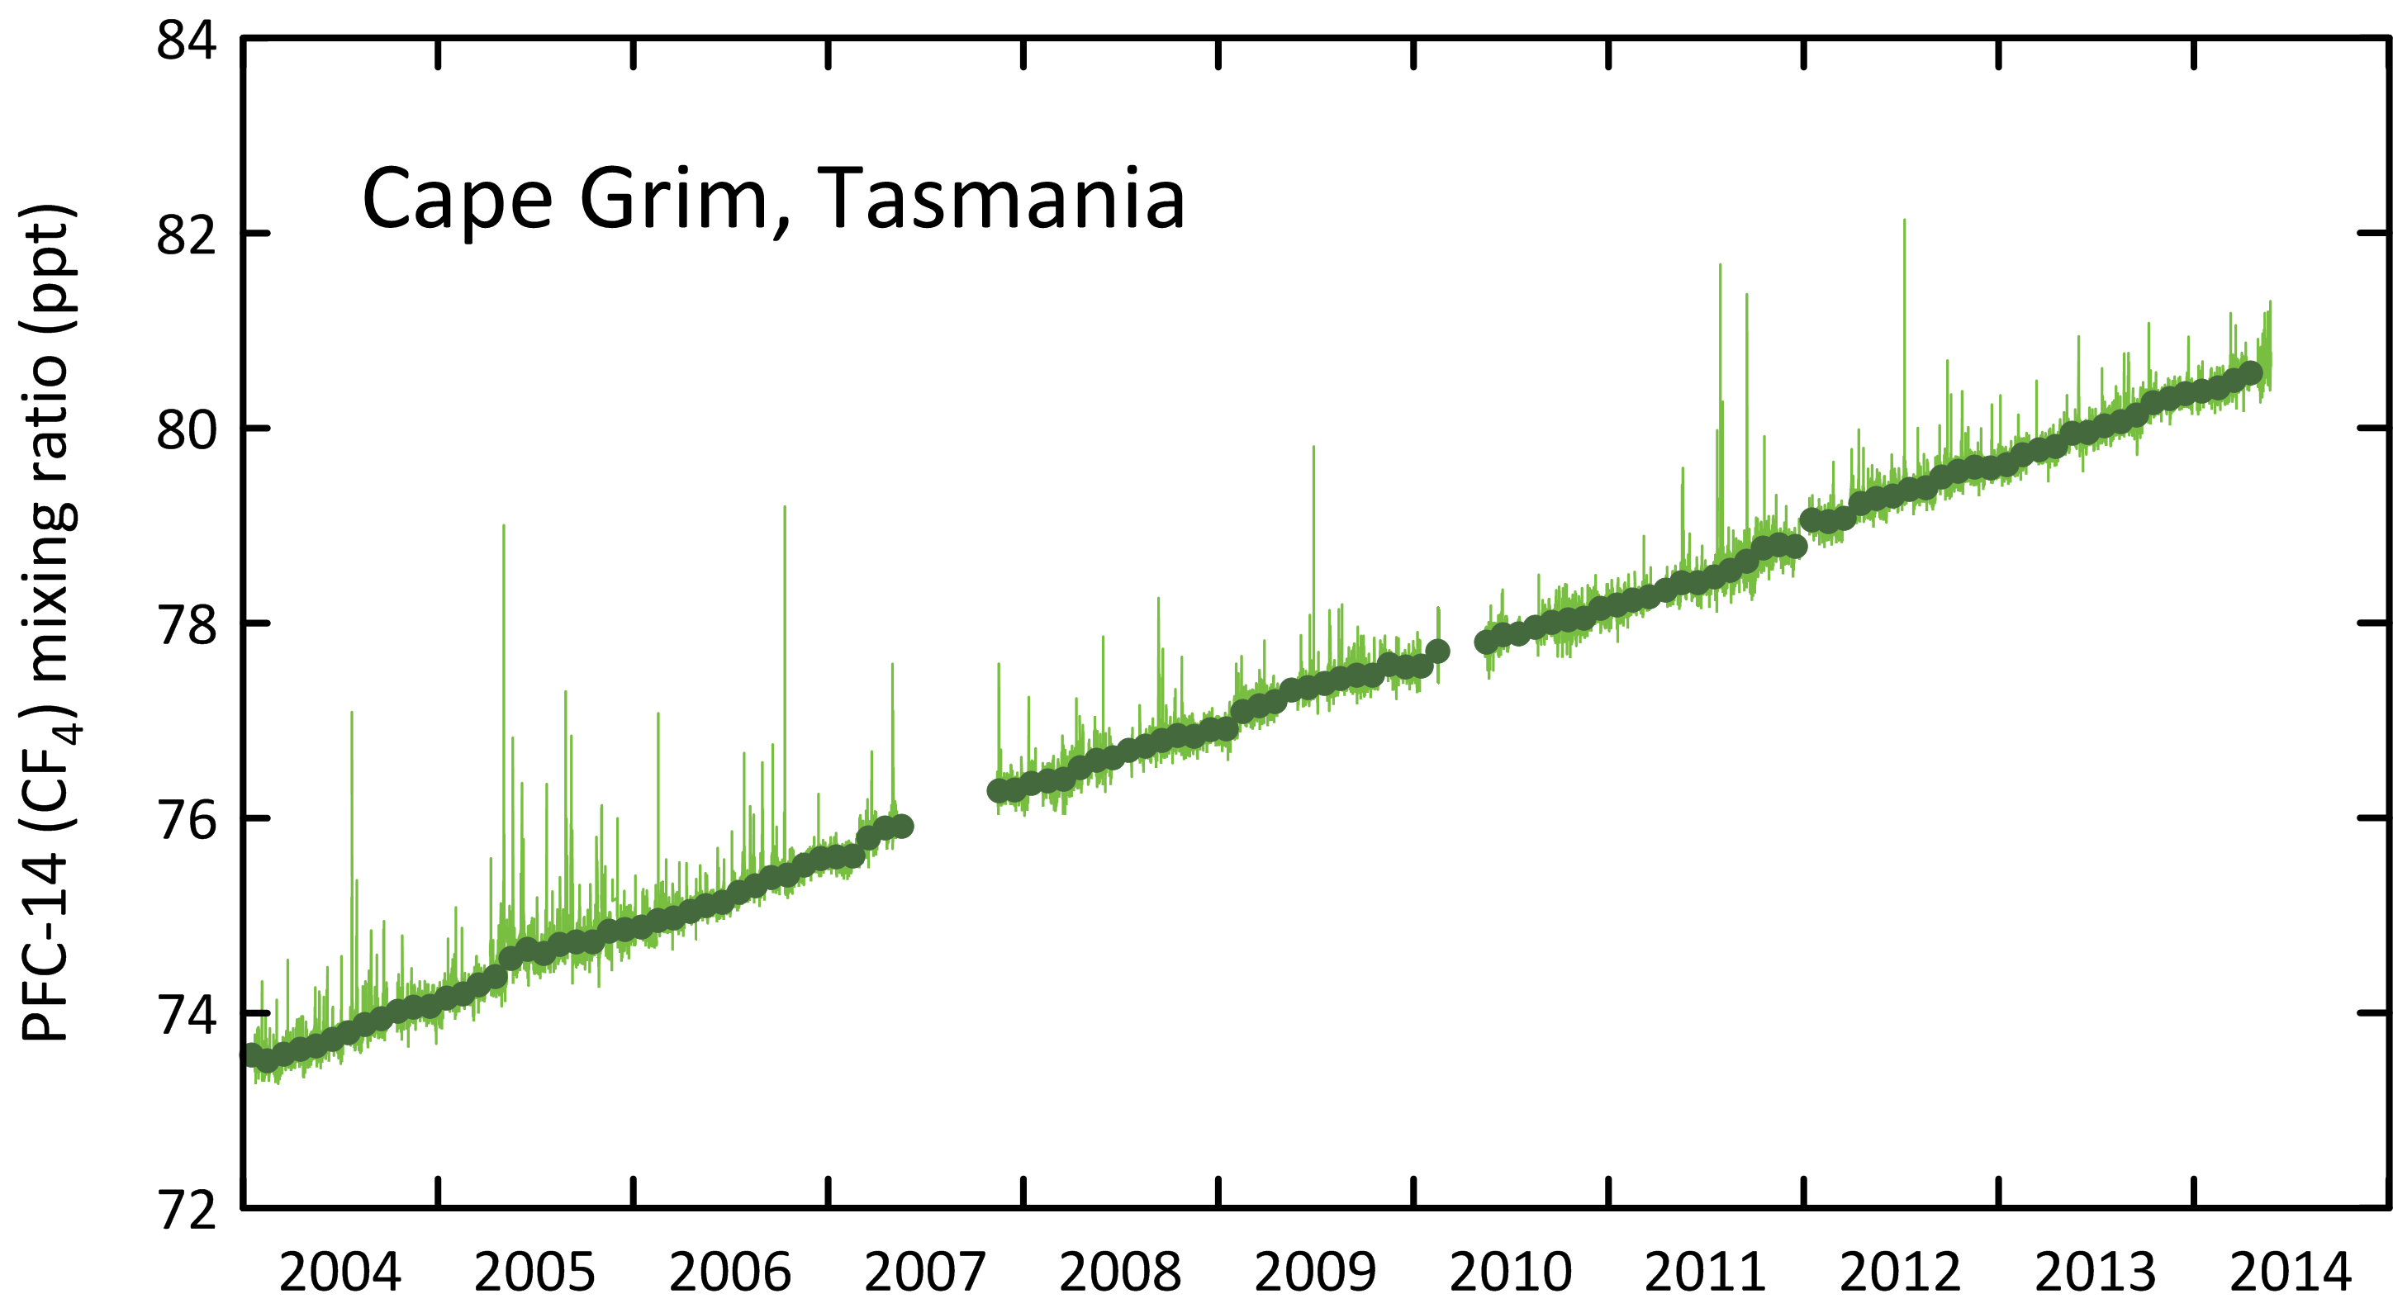

**Figure 3.** Monthly-mean PFC-14 concentrations observed *in situ* at Cape Grim (dark green), 2004 - 2013. PFC-14 pollution episodes (light green), typically lasting up to 12 hours in duration, are also seen at Cape Grim (Mühle *et al*., 2010).

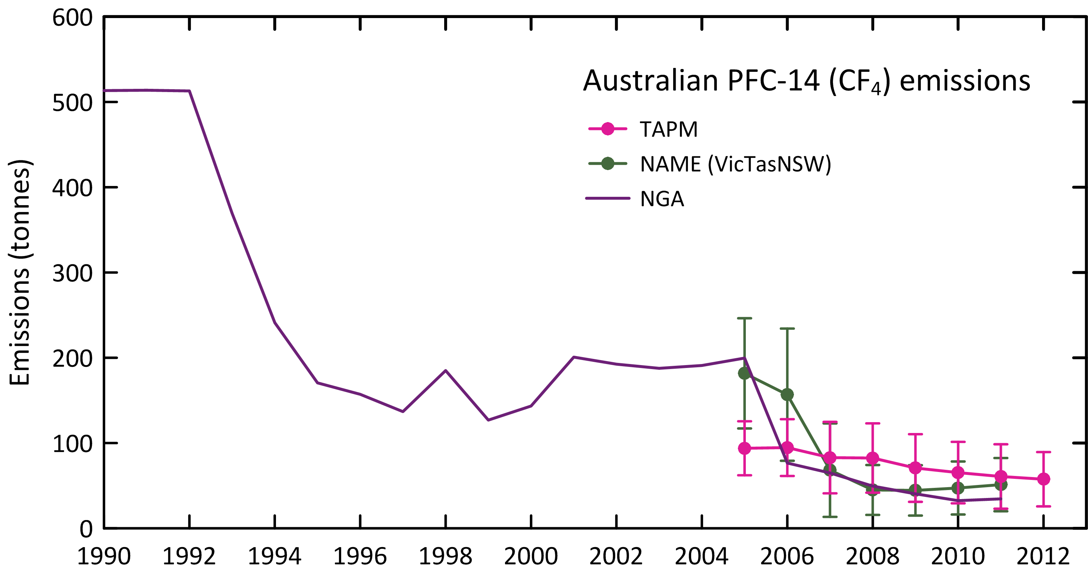

**Figure 4.** Australian emissions of PFC-14 as recorded in the *National Inventory Report 2012* (DoE, 2014; uncertainty 27%: DIICCSRTE, 2013) and as obtained from TAPM (scaled from Vic/Tas emissions) and NAME (scaled from Vic/Tas/NSW emissions) modelling.

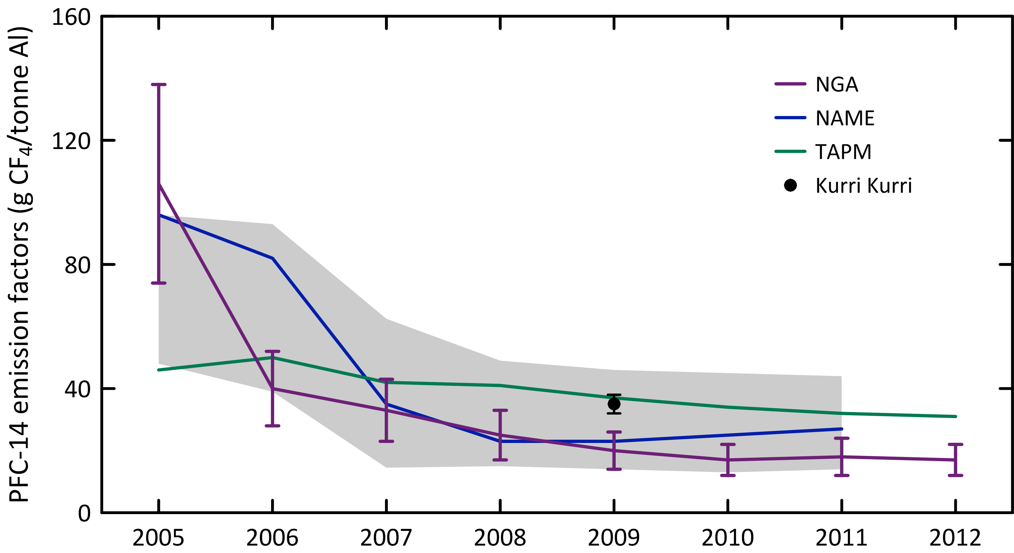

**Figure 5.** Australian PFC-14 emission factors as reported in the *National Inventory Report 2012* (DoE, 2014)) and as derived from atmospheric measurements at Cape Grim using NAME/TAPM modelling. The grey band is the average (±1 sd) emission factor derived from NAME/TAPM. The Kurri Kurri emission factor is based on direct PFC-14 measurements made at the Kurri Kurri smelter in 2009 (Fraser *et al*., 2013).

The Australian emissions derived from atmospheric data prior to 2006, using TAPM or NAME (Vic/Tas) are likely to be underestimated due to the very significant PFC-14 emissions from a single pot-line (#1) at Kurri Kurri, which accounted for nearly half of all Australian PFC emissions from aluminium smelting in 2005. The pot-line was upgraded in 2006 and this accounts for the dramatic drop in PFC-14 emissions from 2005 to 2006 in the *National Inventory Report*. The large PFC emissions prior to 2006 are not seen in the TAPM estimates of emissions, as they are based on Bell Bay/Pt Henry/Portland data. The NAME inversion, based on the Vic/Tas/NSW domain, uses all pollution episode data, including any Kurri Kurri- or Tomago-affected data that may have impacted on Cape Grim. This is why the Australian PFC-14 estimates in 2005 (182 tonnes) based on the NAME (Vic/Tas/NSW) emissions are significantly greater than the TAPM estimates for 2005 (95 tonnes).

The average Australian PFC-14 emissions for 2005-2011 based on atmospheric data are similar: TAPM - 78 tonnes and NAME (Vic/Tas/NSW) - 85 tonnes, about 13% higher than reported in the *National Inventory Report 2012* (DoE, 2014; 72 tonnes). The average Australian 2008-2011 PFC-14 emissions derived from atmospheric data using NAME (Vic/Tas/NSW) are 47 tonnes, 20% higher than in the *National Inventory Report 2011* (39 tonnes). The TAPM average for the same period is 69 tonnes and 66 tonnes for 2008-2012. Arguably the NAME estimate is more accurate as it is based on 72% of Australian aluminium production (Portland, Pt Henry, Bell Bay, Kurri Kurri, Tomago), whereas the TAPM estimate is based on 35% of Australian aluminium production (Portland, Pt Henry, Bell Bay). These South-East Australian smelters could have higher average PFC-14 emission factors than the Australian average (see below).

The overall agreement between the PFC emission factors in the *National Inventory Report 2012 (DE, 2014)* and as derived from atmospheric data using TAPM/NAME over the period 2005-2011 is good (Table 5, Figure 5, TAPM: 41 g CF4/tonne aluminium; NAME: 44 g/tonne; NGA: 37 g/tonne), with uncertainties overlapping throughout the record. For the period 2005-2012 the TAPM average CF4 emission factor is 39 g/tonne compared to the NGA: 35 g/tonne.

The atmospheric data (NAME) show a factor of 3.5 decline in the emission factors over the period 2005-2011, whereas the NGA show a factor of 6.2 decline over the same period. This decline is dominated by the influence that Kurri Kurri had on national average emissions factors between 2006 and 2007; this decline is not captured in the TAPM data which do not ‘see’ Kurri Kurri emissions. Given the overlapping uncertainties on both NAME and the NGA estimates of PFC-14 emissions, this difference in emissions decline over the period 2005-2011 may not be significant. However, the difference could be due, in part, to a larger than average decline in the emission factor at Boyne Island, which is not seen in the atmospheric data at Cape Grim, by either NAME or TAPM.

**Table 5.** Australian aluminium production (kt: 103 tonnes), Australian PFC-14, PFC-116, PFC-218, PFC-318 emissions (t: tonnes) and PFC-14, PFC-116 emission factors (g/t aluminium, 2005-2012) derived from atmospheric observations – remote (Portland, Pt Henry, Bell Bay) (3 yr averages, e.g. 2010 = average of 2009, 2010, 2011), using the TAPM and NAME models, directly at Kurri Kurri and as reported in the *National Inventory Report 2012* (DoE, 2014).

|  |  |  |  |  |  |  |  |  |  |
| --- | --- | --- | --- | --- | --- | --- | --- | --- | --- |
|  | 2005 | 2006 | 2007 | 2008 | 2009 | 2010 | 2011 | 2012 | average (2005-12) |
| **Inventory1** |  |  |  |  |  |  |  |  |  |
| **Al production** |  |  |  |  |  |  |  |  |  |
| Portland, Vic1 | 344 | 340 | 351 | 351 | 328 | 314 | 314 | 315 | 332 |
| Point Henry, Vic1 | 190 | 190 | 197 | 198 | 185 | 176 | 177 | 177 | 186 |
| Bell Bay, Tas2 | 174 | 178 | 178 | 180 | 177 | 177 | 181 | 185 | 179 |
| Vic/Tas | 708 | 708 | 727 | 729 | 690 | 667 | 672 | 678 | 695 |
| Kurri Kurri, NSW3 | 151 | 164 | 173 | 173 | 177 | 179 | 180 | 67 | 158 |
| Tomago, NSW4 | 523 | 523 | 523 | 523 | 528 | 528 | 541 | 548 | 530 |
| Vic/Tas/NSW | 1382 | 1395 | 1423 | 1425 | 1395 | 1374 | 1393 | 1293 | 1389 |
| Australia5 | 1890 | 1912 | 1954 | 1965 | 1980 | 1926 | 1943 | 1943 | 1939 |
| PFC-14 emiss. | 200±60 | 76±22 | 65±19 | 50±15 | 40±12 | 33±10 | 35±10 | 34±10 | 67±20 |
| emiss. fact. | 106±32 | 40±12 | 33±10 | 25±8 | 20±6 | 17±5 | 18±6 | 17±5 | 35±10 |
| PFC-116 emiss. | 26±8 | 10±3 | 8±3 | 7±2 | 5±2 | 4±1 | 4±1 | 4±1 | 9±3 |
| emiss. fact. | 14±4 | 5±2 | 4±1 | 3±1 | 3±1 | 2±1 | 2±1 | 2±1 | 4±2 |
| **TAPM** |  |  |  |  |  |  |  |  |  |
| PFC-14 emiss. |  |  |  |  |  |  |  |  |  |
| Portland, Vic | 18±5 | 18±6 | 15±8 | 15±8 | 12±8 | 12±7 | 11±7 | 10±6 | 13±6 |
| Point Henry, Vic | 11±3 | 11±3 | 11±3 | 10±3 | 9±3 | 7±3 | 7±3 | 7±3 | 8±3 |
| Bell Bay, Tas | 5±2 | 5±3 | 4±3 | 4±3 | 4±2 | 3±2 | 3±2 | 3±2 | 4±2 |
| Vic/Tas | 34±10 | 33±12 | 30±10 | 29±12 | 25±12 | 22±10 | 21±11 | 20±10 | 25±11 |
| Australia6 | 94±30 | 95±30 | 83±40 | 82±35 | 71±35 | 65±30 | 61±30 | 58±30 | 75±30 |
| **NAME** |  |  |  |  |  |  |  |  |  |
| PFC-14 emiss.7 | 182±65 | 157±75 | 68±55 | 45±30 | 44±30 | 47±30 | 51±30 |  | 85±50 |
| PFC-116 emiss.8 | 15±1 | 15±1 | 15±1 | 15±1 | 19±3 | 23±5 | 29±3 | 2913 | 20±2 |
| PFC-218 emiss.3 | 9±1 | 10±1 | 11±1 | 12±1 | 19±3 | 21±3 | 20±2 | 20 | 15±5 |
| **TAPM/NAME** |  |  |  |  |  |  |  |  |  |
| PFC-14 emiss. | 138±46 | 125±54 | 75±43 | 63±33 | 58±34 | 55±30 | 56±30 | 56±31 | 78±37 |
| PFC-116 emiss.8 | 14±6 | 13±7 | 8±5 | 6±4 | 6±4 | 6±3 | 6±3 | 6±3 | 8±4 |
| **ISC** |  |  |  |  |  |  |  |  |  |
| PFC-218 emiss. | 8±3 | 9±3 | 10±4 | 7±3 | 9±4 | 14±6 | 16±6 | 15±6 | 11±5 |
| PFC-318 emiss. | 27 | 27 | 27 | 2712 | 27±18 | 23±9 | 21±7 | 18±6 |  |
| **ISC/NAME** |  |  |  |  |  |  |  |  |  |
| PFC-218 emiss. | 9±3 | 9±3 | 10±4 | 10±3 | 14±5 | 17±7 | 18±6 | 17±6 | 12±7 |
| total PFC emiss. | 187±60 | 174±60 | 120±50 | 107±40 | 104±40 | 102±35 | 101±35 | 114±35 | 126±45 |
| CO2-e M t | 1.38±0.50 | 1.29±0.55 | 0.93±0.49 | 0.84±0.39 | 0.83±0.43 | 0.81±0.35 | 0.79±0.31 | 0.87±0.31 |  |
| **PFC-14 emiss. fact.** |  |  |  |  |  |  |  |  |  |
| Portland, Vic | 54±17 | 56±18 | 44±25 | 44±25 | 37±25 | 39±24 | 36±24 | 33±23 | 43±24 |
| Point Henry, Vic | 62±20 | 60±17 | 55±19 | 53±17 | 52±18 | 40±17 | 39±21 | 39±21 | 50±19 |
| Bell Bay, Tas | 28±13 | 27±18 | 25±19 | 22±15 | 20±11 | 19±7 | 19±9 | 19±11 | 22±12 |
| Australia (TAPM)9 | 48±16 | 50±17 | 42±20 | 41±20 | 37±17 | 34±18 | 32±14 | 31±10 | 39±19 |
| Australia (NAME)10 | 96±34 | 82±40 | 35±28 | 23±14 | 23±15 | 25±15 | 27±15 |  | 44±11 |
| TAPM/NAME avg | 72±24 | 66±27 | 39±24 | 32±17 | 30±16 | 29±16 | 29±15 |  | 42±15 |
| emiss. fact.  Kurri Kurri11 |  |  |  |  | 35±3 |  |  |  |  |
| 1Alcoa Annual Sustainability Reports, 2003,2004, 2005, 2006, 2009, 2011/2012  2Bell Bay Aluminium Environmental Sustainability Report 2012  3 Dalzell, E., Hydro Australia 2013, personal communication  4Rio Tinto Annual Report 2012  5DoE (2014), uncertainty 25-30% - DCCEE (2012)  6 Australian emissions scaled from Portland, Pt Henry, Bell Bay emissions by aluminium production  7 Australian emissions scaled from Portland, Pt Henry, Bell Bay, Kurri Kuri, Tomago emissions by aluminium production  8 C2F6/CF4 = 0.1, Kim *et al*., (2014)  9 TAPM (Portland, Pt Henry, Bell Bay average emissions)/aluminium production  10 NAME (Vic/Tas/NSW) emissions/aluminium production; NAME emissions for 2011 are preliminary – based on 2010-2011 data only  11emission factor for 2009 (Fraser *et al*., 2013)  12 assume = 2009 emissions  13 assume = 2011 emissions | | | | | | | | | |

## Other PFC emissions

Australian PFC emissions are dominated by the aluminium industry – only aluminium production-derived emissions of PFC-14 and PFC-116 are currently listed in the *National Inventory Report* (Table 5). PFC imports in 2012 are small (Table 2 - PFC-14: 0.3 tonne, PFC-116: 0.5 tonne, PFC-318: 0.1 tonne). These imports are presumably for minor refrigeration and fire-fighting applications, and the corresponding emissions from these non-aluminium sources are likely to be less than 1 tonne per year.

Figure 6 shows the Australian PFC-116 emissions from the *National Inventory Report*, from PFC-14 emissions (TAPM/NAME) assuming a PFC-116/PFC-14 mass emission factor of 0.10±0.01, based on atmospheric observation at Aspendale on the Pt Henry/Portland PFC plumes and on direct measurements on the Kurri Kurri exhaust stack (Fraser *et al.*, 2013; Kim *et al*., 2014). The overall agreement is good as expected, as the emissions are from the aluminium industry only, with current emissions (since 2009) of about 6 tonnes per year. However the PFC-116 emissions for Australia based on measurements at Cape Grim, again assuming coming from the aluminium industry only, show significant differences in emissions after 2007, with PFC-116 emissions rising to approaching 30 tonnes in 2011.

Since Cape Grim largely ‘sees’ PFC emissions from the Victorian smelters and any other emissions from the Melbourne/Port Phillip region, the data would suggest that significant, post -2007, a non-aluminium PFC-116 source is in operation, and this PFC-116 is not captured in the import data. Australia-wide, this source could be currently approaching 20 tonnes per year. The source of this additional PFC-116 is unknown. Further analysis of past and future Aspendale and Sydney PFC-116 data could help identify this source.

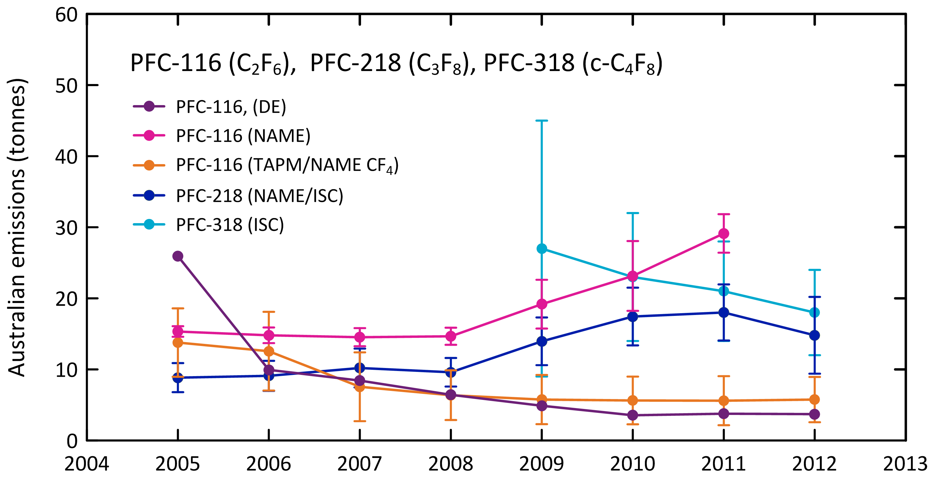

**Figure 6.** Australian PFC-116, PFC-218 and PFC-318 emissions from the *National Inventory Report 2012* (DE, 2014) and as derived from atmospheric measurements at Cape Grim using NAME, TAPM and ISC modelling; error bars are ± sd. Australian PFC-116 (NAME) are from Vic/Tas data scaled by aluminium production, PFC-116 (TAPM/NAME PFC-14) are from Australian TAPM/NAME PFC-14 emissions (Table 4) and the observed PFC-116/PFC-14 ratio (0.10±0.01) in Australian smelter plumes; PFC-218 and PFC-318 are from NAME and ISC modelling, with Australian emissions obtained from regional emissions by population scaling.

Cape Grim data also suggest that there are significant Australian PFC-218 and PFC-318 emissions, the former increasing from about 10 tonnes in the mid-2000s to nearly 20 tonnes in 2010, declining to 12 tonnes in 2012 currently and the latter declining from nearly 30 tonnes in 2009 to currently less than 20 tonnes. The sources of PFC-218 and PFC-318 are unknown; there are no significant PFC-218 or PFC-318 imports recorded. The PFC-218 emissions are about the same size as the non-aluminium PFC-116 emissions, with a similar growth pattern. This suggests their emissions may be related.

Total PFC emissions have declined from about 190 tonnes in 2005 (80% from aluminium production) to about 100 tonnes (60% from aluminium production) in 2010, rising to over 110 tonnes in 2012 (55% from the aluminium industry), compared to the *Inventory*, which has total PFCs (PFC-14, PFC-116) declining from 225 tonnes in 2005 to 37 tonnes (all from the aluminium industry). In CO2-e terms, total PFCs have declined from 1.4 Mt CO2-e in 2005 to 0.8-0.9 Mt CO2-e in 2011-2012, compared to the *Inventory* figures of 1.5 Mt CO2-e in 2005 falling to 0.25 Mt CO2-e in 2012. This is because the *Inventory* only includes PFCs from the aluminium industry, whereas Cape Grim sees PFC emissions from all potential sources (aluminium, refrigeration, fire fighting and possibly other sources).

## HFC, SF6 & SO2F2 emissions

CSIRO estimates emissions of a number of trace gases from the Melbourne/Port Phillip region (Dunse *et al*., 2001, 2005; Dunse 2002; Fraser *et al*., 2014), utilising *in situ* high frequency measurements from the Cape Grim Baseline Air Pollution Station in Tasmania and employing the interspecies correlation (ISC) technique with co-incident carbon monoxide (CO) measurements.

Port Phillip HFC, PFC-116 and SF6 emissions have been calculated, using ISC and Cape Grim data (2004-2013), obtained from the GC-MS-Medusa and GC-ECD instruments (Krummel *et al*., 2011; Miller *et al*., 2008) at Cape Grim, and presented as 3-year running averages (2005-2012; Table 6, Figure 7). The HFC, PFC-116 and SF6 emissions are derived from Port Phillip emissions, scaled to Australian emissions on a population basis (using a population-based scale factor of 5.4). NOAA air mass back trajectory analyses (Draxler & Hess, 1997) are used to ensure that the pollution events at Cape Grim used to derive Port Phillip emissions are imbedded in air masses that only pass over the Port Phillip region and do not include other possible high CO source regions, in particular the Latrobe Valley, or high CO emission events (biomass burning).

For HFC emission calculations, the NAME particle dispersion model (Manning *et al.*, 2003, 2011) ‘sees’ emissions from Victoria/Tasmania (the domain used in the model) and are presented as 3-yr running averages of emissions (i.e. 2008 annual emissions are derived from 2007-2009 data). The Australian emissions are calculated from Victoria/Tasmania using a population based scale factor of 3.7 and are shown in Table 6 and Figure 7.

Cape Grim ‘sees’ SO2F2 emissions from South-East Australia. Cape Grim SO2F2 measurements commenced in 2004, but significant pollution episodes (as selected for ISC calculations) were not observed at Cape Grim until 2010. These pollution episodes are used to calculate South-East Australian (largely Victorian) SO2F2 emissions by ISC. Grain exported from Victorian grain terminals, or produced in Victoria, accounts for about 15-20% of Australia’s grain production/exports (National Transport Commission, 2008; GrainCorp, 2012) and thus possibly 15-20% of Australia’s emissions of SO2F2. South-East Australian SO2F2 emissions calculated from Cape Grim data by ISC are scaled to Australian emissions by this factor (i.e. multiplied by 6.2±0.6) (Table 6, Figures 7 and 8). The NAME model domain used to derive SO2F2 emissions is Victoria/Tasmania/New South Wales, and the scale factor used to derive Australian emissions, based on grain production, is 2.1±0.2. Australian emissions of SO2F2 averaged about 40 tonnes per year (160 k tonnes CO2-e) over the period 2010-2012. Data on SO2F2 imports are not available.

# Comparisons of NGA, ISC & NAME emission estimates

## HFC-134a

The major HFC in the *Inventory* (ageis.climatechange.gov.au; DoE 2014) is HFC-134a, with emissions in 2012 of 3235 tonnes (Table 5). Based on Cape Grim data, Australian emissions of HFC-134a in 2012 were about 2010 tonnes (ISC), ~38% lower than reported in the *Inventory* (Table 6, Figure 7). For the 8-year period 2005-2012, the average Australian emissions of HFC-134a calculated from Cape Grim data (ISC/NAME) are about 27% lower than in the *Inventory*. From 2002 to 2011, the ISC and NAME emissions estimates agree to within 2% (NAME higher). For the period 1999-2004, Australian emissions based on Cape Grim data are higher than the *Inventory*, and, for 2006-2012, lower than the *Inventory*. As discussed in Section 3.1 above, the *Inventory* best represents total HFC emissions, not individual HFC emissions.

Cape Grim data suggest that Australian emissions of HFC-134a have been in decline since 2009, whereas the *Inventory* reports growing emissions through 2012. The assumes time-invariant emission factors, whereas the Cape Grim data may be seeing reduced emissions due to, for example, improved equipment maintenance practices, with better management of HFC emissions. Based on atmospheric data, global emissions of HFC-134a were 174 k tonnes in 2012 (Rigby *et al*., 2014). Australian emissions are about 1.1% of global emissions based on ISC/NAME data, and 1.8% based on *Inventory* data.

## HFC-125

The next major HFC emitted into the Australian environment is HFC-125 with current (2012) emissions estimated to be about 1130 tonnes in the *Inventory*. Based on Cape Grim data, Australian emissions of HFC-125 in 2012 were about 600 tonnes (ISC), about 47% lower than the *Inventory* data. For the period 2005-2012, the *Inventory* average emissions are 60% higher than emission estimates based on Cape Grim data (ISC/NAME). Over the period 2002-2011, NAME and ISC emission estimates agree to within 2% (NAME lower). ISC/NAME estimates of HFC-125 emissions have grown from 350 tonnes in 2005 to nearly 600 tonnes in 2012. Like HFC-134a, the Cape Grim HFC-125 data suggest near constant or perhaps declining emissions, whereas in the *Inventory* the emissions continue to grow through 2012 (Table 4). Based on atmospheric data, global emissions of HFC-125 were 41 k tonnes in 2012 (Rigby *et al*., 2014). Australian emissions are about 1.5% of global emissions based on ISC/NAME data, and 2.6% based on *Inventory* data.

## HFC-143a

According to the *Inventory* (Table 4), the next major HFC emitted into the Australian environment is HFC-143a with current (2012) emissions at about 110 tonnes. Based on Cape Grim data, Australian emissions of HFC-125 in 2012 were about 550 tonnes (ISC), a factor of 5 higher than *Inventory* estimates. NAME and ISC data agree to within 1% for the period 2005-2011 (NAME higher). Like HFC-134a and HFC-125, the Cape Grim HFC-143a data suggest near constant or perhaps declining emissions, whereas in the *Inventory* the emissions continue to grow through 2012 (Table 4). Based on atmospheric data, global emissions of HFC-143a were 23 k tonnes in 2012 (Rigby *et al*., 2014). Australian emissions are about 2.4% of global emissions based on ISC/NAME data, and 0.5% based on *Inventory* data.

## HFC-32

HFC-32 emission estimates are estimated in the *Inventory* to be 63 tonnes in 2012. The emissions based on Cape Grim data (211 tonnes in 2012) are significantly higher than in the *Inventory*. Over the period 2006-2011, ISC and NAME emission estimates agree to within 36% (NAME lower). Unlike HFC-134a, HFC-125 and HFC-143a, the Cape Grim data and the *Inventory* both suggest increasing emissions of HFC-32 through 2012. Based on atmospheric data, global emissions of HFC-32 were 20 k tonnes in 2012 (Rigby *et al*., 2014). Australian emissions are about 1.1% of global emissions based on ISC/NAME data, and 0.3% based on *Inventory* data.

## HFC-152a

HFC-152a emissions are not listed in the *Inventory*. The 2012 emissions have been estimated from Cape Grim data at 77 tonnes (ISC). Over the period 2002-2011, ISC and NAME estimates of Australian emissions agree to within 1% (NAME higher). With no recorded imports of HFC-152a into Australia, the source of the HFC-152a emissions is unknown. Like HFC-32, the Cape Grim data show that HFC-152a emissions continue to grow through 2012.

Based on atmospheric data, global emissions of HFC-152a were 54 k tonnes in 2012 (Rigby *et al*., 2014). Australian emissions are about 0.1% of global emissions based on ISC/NAME data. It would be unusual for Australian emissions of an industrial chemical to be less than 0.1% of global emissions. The possible reasons for the low Australian emission (low use in Australia compared to rest of world) are being investigated. One suggestion (M. Bennett, RRA, personal communication, 2011) is that a significant major-volume use in other parts of the world for HFC-152a is as an aerosol propellant, a use not taken up in Australia.

## HFC-23

HFC-23 emissions are not listed in the *Inventory*, except in the 1990s when Australian emissions were estimated as fugitive emissions from Sydney-based Australian HCFC-22 production. Since HCFC-22 production ceased in Australia, the *Inventory* does not record HFC-23 emissions. Imports are currently recorded at about 1 tonne in 2012. The 2012 emissions have been estimated from Cape Grim data at 46 tonnes (ISC). Over the period 2002-2011, ISC and NAME estimates of Australian emissions agree to within 18% (NAME lower). HFC-23 emissions have remained relatively constant since 2007. In CO2-e terms, HFC-23 is currently the 4th largest HFC emitted in Australia (after HFC-134a, HFC-143a and HFC-125), larger than HFC-32. This is because the GWP of HFC-23, at nearly 12,000, is about 2.5 times larger than the next most potent HFC (HFC-143a, GWP 38000). Based on atmospheric data, global emissions of HFC-23 were 12 k tonnes in 2012 (Rigby *et al*., 2014). Current Australian emissions are about 0.4% of global emissions based on ISC/NAME data, 0% based on the *Inventory*.

The origin of these Australian HFC-23 emissions is unknown. HFC-23 is a component of the R-508 series of refrigerants, but significant imports of R-508 refrigerants into Australia have not been recorded. The other component of the R-508 refrigerants is PFC-116; current Australian emissions of PFC-116 are significantly larger than result from to aluminium production and current imports. If significant amounts of R-508 refrigerants have been imported in the past into Australia, but not accounted for, then emissions of R-508 could explain these significant HFC-23 and PFC-116 emissions.

RRA (M. Bennett, private communication, 2014) is not aware of any significant historical use of R-508 refrigerants in Australia. RRA in their refrigerant reclaim operation have collected only one cylinder of R-508 from a CSIRO instrument testing laboratory in Sydney. It is unlikely that the unaccounted for HFC-23 and PFC-116 is from past or current use of R-508 refrigerants in Australia.

Aspendale atmospheric data on HFC-23 (unpublished) and PFC-116 (Kim *et al*., 2014) show very different concentration/wind direction (so-called concentration ‘roses’) at Aspendale. The PFC-116 data show a clear, strong maximum in the direction (W of Aspendale) of the Pt Henry and Portland smelters, confirming an aluminium-production source, and essentially noise in the other wind sectors. The HFC-23 data show a significant, but small concentration maximum in the direction NE of Aspendale (as do HFC-134a, HFC-32, HFC-125 etc). It would appear that HFC-23 is in the general mix of refrigerant emissions from Melbourne, but has not been identified in any Australian refrigerant imports.

One possible explanation is that HFC-23 (CHF3) is present in refrigerant blends as a contaminant – for example with blends containing HFC-32 (CH2F2). It is possible that overfluorination during the production of HFC-32 could produce HFC-23 and that the resultant refrigerant blends using HFC-32 could contain, likely small, amounts of HFC-23. CSIRO plan to test this hypothesis in a project designed to test the stated composition of the major refrigerants and refrigerant blends used in Australia, which are HFC-134a, R-410 (50% HFC-32, 50% HFC-125), R-404 (44% HFC-125, 4% HFC-134a, 52% HFC-143a) and R-407 (20% HFC-32, 40% HFC-125, 40% HFC-134a).

## HFC-227ea

HFC-227ea emissions are now listed in the *Inventory*, with 2012 emissions at 38 tonnes. The 2012 emissions have been estimated from Cape Grim data at 19 tonnes and 26 tonnes in 2011 (ISC). The *Inventory* average emissions (2005-2012) are 29 tonnes compared to 23 tonnes from Cape Grim data. There are no NAME estimates of HFC-227ea emissions from Cape Grim data. The *Inventory* suggests that HFC-227ea emissions continue to grow through 2012, whereas the Cape Grim data suggest that emissions peaked at just over 30 tonnes in 2009.

Based on atmospheric data, global emissions of HFC-227ea were 3.3 k tonnes in 2012 (Rigby *et al*., 2014). Australian emissions are about 0.6% of global emissions based on ISC/NAME data and 1.2% based on *Inventory* data.

## HFC-236fa, HFC-245fa, HFC-365mfc

The 2012 emissions for HFC-236fa, HFC-245fa and HFC-365mfc have been estimated (ISC) from Cape Grim data at about 5 (steady), 117 (growing rapidly) and 66 tonnes (peaked in 2010 at 70 tonnes) respectively. NAME estimates of HFC-365mfc emissions are available (2005-2011). From 2009-2011, the ISC and NAME estimates agree to within 15%, prior to 2009 NAME estimates of emissions are significantly higher than ISC by a factor of 2-3. There are no estimates of emissions of these HFCs in the *Inventory*.

Based on atmospheric data, global emissions of HFC-236fa, HFC-245fa and HFC-365mfc were 0.2, 8.2 and 3.3 k tonnes respectively in 2012 (Rigby *et al*., 2014). Australian emissions are about 2.1%, 1.4% and 2.0% of global emissions based on Cape Grim data.

## HFC-134 & HFC-4310mee

Emissions of HFC-134 and HFC-4310mee in the *Inventory* were about 1 tonne each in 2012. HFC-134 is not measured at Cape Grim and, although HFC-4310meee is measured, no significant Australian emissions have been detected to date.

**Table 6.** Australian HFC, PFC, SF6 and SO2F2 emissions (tonnes, 2005-2012) from atmospheric data, collected at Cape Grim, Tasmania - emissions calculated by interspecies correlation (ISC) and from inversions using the UK Met. Office NAME particle dispersion model. The emissions are 3-year running averages, i.e. ‘2010’ = average of 2009, 2010, 2011 emissions. Australian HFC and SF6 emissions are scaled from regional emissions by population; GWPs (to calculate CO2-e emissions) are from the *National Inventory Report 2012* (DoE, 2014). PFC-14 emissions are the TAPM/NAME average from Table 4. Australian PFC-116 emissions are from NAME (Vic/Tas) scaled by aluminium production; Australian PFC-218 and PFC-318 emissions are from NAME and ISC scaled by population; Australian SO2F2 emissions are from ISC and NAME estimates of SE Australian emissions scaled by grain production.

|  |  |  |  |  |  |  |  |  |  |  |  |  |  |  |  |  |  |  |  |  |  |  |
| --- | --- | --- | --- | --- | --- | --- | --- | --- | --- | --- | --- | --- | --- | --- | --- | --- | --- | --- | --- | --- | --- | --- |
|  | 2005 | | | 2006 | | | 2007 | | | 2008 | | | 2009 | | | 2010 | | | 2011 | | | 2012 |
| Refrigerant | ISC | | NAME | ISC | | NAME | ISC | | NAME | ISC | | NAME | ISC | | NAME | ISC | | NAME | ISC | | NAME | ISC |
|  | tonnes | | | tonnes | | | tonnes | | | tonnes | | | tonnes | | | tonnes | | | tonnes | | | tonnes |
| HFC-32 | 36±10 | | 34±5 | 62±20 | | 40±10 | 116±45 | | 61±15 | 129±45 | | 96±20 | 170±60 | | 134±20 | 196±65 | | 162±20 | 205±65 | | 172±10 | 211±65 |
| HFC-125 | 392±130 | | 311±15 | 375±120 | | 326±20 | 460±170 | | 402±60 | 516±180 | | 553±80 | 642±200 | | 685±60 | 642±210 | | 738±45 | 614±190 | | 753±25 | 598±190 |
| HFC-134a | 1686±510 | | 1613±90 | 1707±530 | | 1668±110 | 1832±620 | | 1830±150 | 1843±595 | | 1997±165 | 2148±660 | | 2279±120 | 2141±700 | | 2262±120 | 2111±650 | | 2169±140 | 2008±640 |
| HFC-143a | 454±155 | | 337±20 | 436±150 | | 352±30 | 481±170 | | 451±65 | 503±170 | | 550±60 | 624±200 | | 687±55 | 597±195 | | 750±60 | 505±165 | | 771±35 | 555±185 |
| HFC-23 | 50 | | 34 | 50 | | 34 | 50±25 | | 34 | 56±20 | | 34±3 | 58±20 | | 43±4 | 44±15 | | 44±6 | 41±15 | | 55±5 | 46±15 |
| HFC-152a | 32±10 | | 31±2 | 38±10 | | 35±3 | 51±15 | | 41±3 | 49±15 | | 43±3 | 52±15 | | 68±4 | 59±20 | | 69±5 | 56±15 | | 72±4 | 77±25 |
| HFC-227ea | 15±9 | | 15 | 12±6 | | 12 | 17±7 | | 17 | 22±8 | | 22 | 36±13 | | 36 | 33±10 | | 33 | 26±9 | | 26 | 19±5 |
| HFC-236fa | 13±10 | | 13 | 5±3 | | 5 | 5±3 | | 5 | 4±2 | | 4 | 5±2 | | 5 | 6±2 | | 6 | 6±2 | | 6 | 5±2 |
| HFC-245fa | 27±15 | | 27 | 30±12 | | 30 | 32±13 | | 32 | 28±10 | | 28 | 32±13 | | 32 | 38±14 | | 38 | 49±18 | | 49 | 117±43 |
| HFC-365mfc | 8±3 | | 13 | 25±10 | | 13±1 | 33±13 | | 15±2 | 50±18 | | 16±3 | 61±20 | | 47±13 | 74±25 | | 64±10 | 69±24 | | 68±3 | 66±23 |
| total HFCs | 2714±580 | | 2428±95 | 2741±570 | | 2515±115 | 3078±670 | | 2888±175 | 3198±650 | | 3343±195 | 3828±720 | | 4016±145 | 3830±700 | | 4166±145 | 3682±660 | | 4139±150 | 3702±690 |
| total HFCs NAME/ISC avg (t) | 2571±340 | | | 2628±340 | | | 2983±420 | | | 3271±420 | | | 3922±430 | | | 3998±420 | | | 3911±405 | | | 3702±690 |
| total HFCs (kt CO2-e) | 5364±550 | | | 5337±570 | | | 6073±750 | | | 6765±790 | | | 8164±820 | | | 8252±820 | | | 8055±750 | | | 7357±1360 |
|  |  | | |  | | |  | | |  | | |  | | |  | | |  | | |  |
| SF6 (tonnes) |  | | | 75±25 | | 29±2 | 44±26 | | 31±3 | 33±12 | | 34±2 | 34±13 | | 44±3 | 37±14 | | 43±3 | 33±12 | | 44±2 | 31±11 |
| SF6 NAME/ISC avg (t) | 52 | | | 52±25 | | | 38±26 | | | 34±12 | | | 39±13 | | | 40±14 | | | 38±12 | | | 31±11 |
| SF6 (kt CO2-e) | 1243±590 | | | 1243±590 | | | 908±620 | | | 813±280 | | | 932±310 | | | 956±330 | | | 908±280 | | | 741±260 |
|  |  | | |  | | |  | | |  | | |  | | |  | | |  | | |  |
| SO2F2 (tonnes) |  | 2±2 | |  | 2±2 | |  | 4±3 | |  | 17±14 | | 18±8 | 3±4 | | 88±36 | 14±17 | | 95±38 | 88±20 | | 81±30 |
| SO2F2 NAME/ISC avg (t) | 2±2 | | | 2±2 | | | 4±3 | | | 17±15 | | | 11±10 | | | 51±40 | | | 92±30 | | | 81±30 |
| SO2F2 ( kt CO2-e) | 8±8 | | | 8±8 | | | 16±12 | | | 70±60 | | | 45±40 | | | 209±160 | | | 375±120 | | | 331±120 |
|  |  | | |  | | |  | | |  | | |  | | |  | | |  | | |  |
| total PFCs (t, Table 5) | 187±60 | | | 174±60 | | | 120±50 | | | 107±40 | | | 104±40 | | | 102±35 | | | 101±35 | | | 96±35 |
| total PFCs (ktCO2-e) | 1378±500 | | | 1291±550 | | | 929±490 | | | 836±390 | | | 829±430 | | | 809±350 | | | 791±310 | | | 743±310 |
|  |  | | |  | | |  | | |  | | |  | | |  | | |  | | |  |
| total HFCs, PFCs, SF6 avg | 2810±420 | | | 2854±420 | | | 3141±500 | | | 3412±470 | | | 4066±470 | | | 4140±490 | | | 4049±440 | | | 3829±740 |
| total HFCs, PFCs, SF6 avg (k tonnes CO2-e) | 7985±750 | | | 7870±830 | | | 7910±930 | | | 8414±870 | | | 9924±900 | | | 10016±880 | | | 9754±810 | | | 8842±1650 |

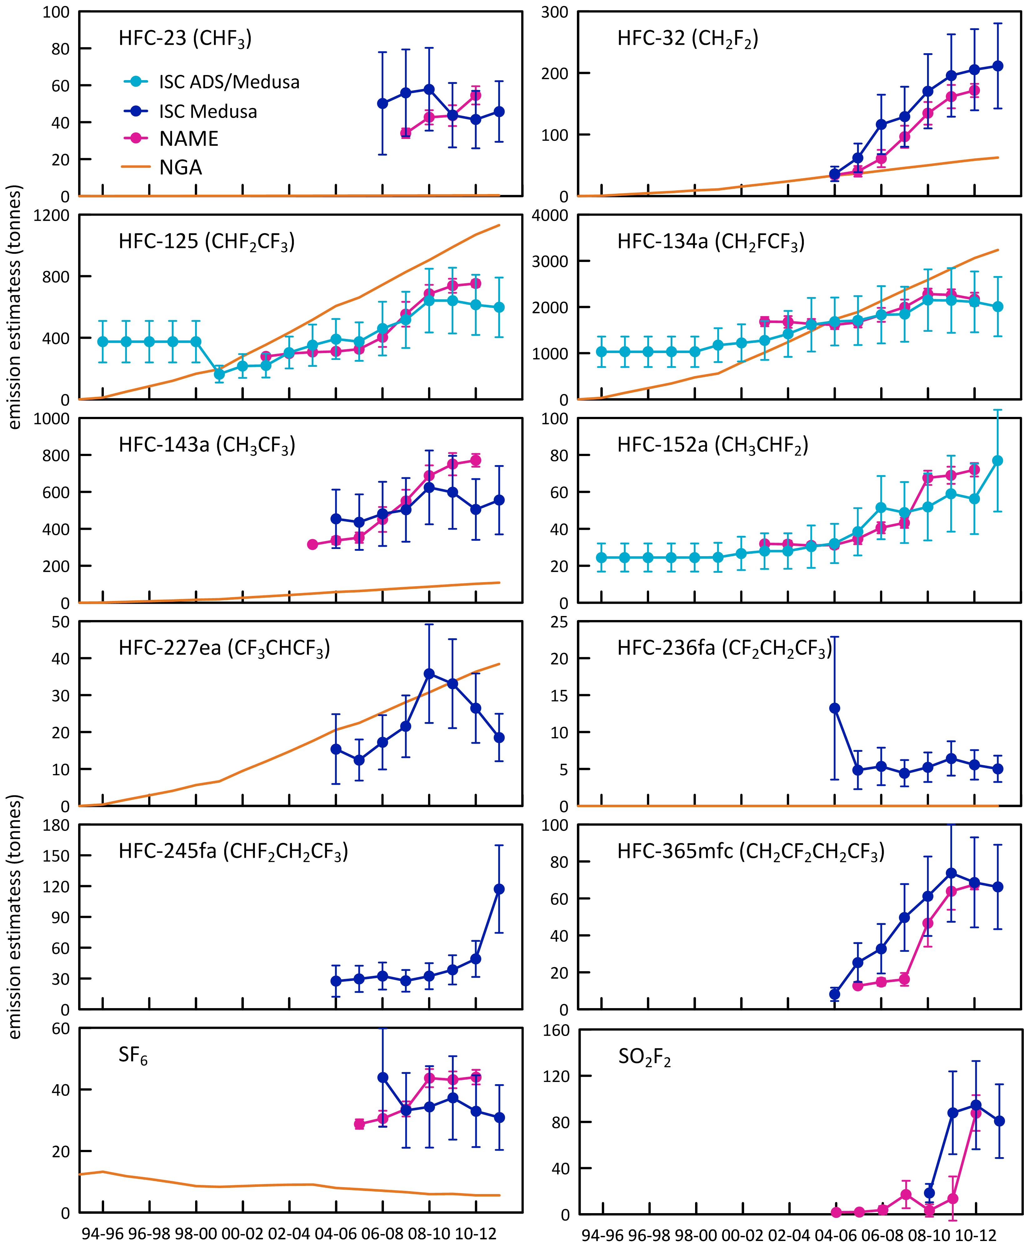

**Figure 7.** Australian HFC-32, -125, -134a, -143a, -152a, -365mfc and SF6 emissions (NGA: DE 2014) compared to emissions calculated from Cape Grim data by interspecies correlation (ISC) and from the UK Met. Office NAME particle dispersion model. In the ISC calculations of HFC and SF6 emissions, Australian emissions are scaled from Melbourne/Port Phillip emissions on a population basis (5.4, Australia/Port Phillip); in the NAME calculations, Australian emissions are scaled from Victorian/Tasmanian emissions, also on a population basis (a scale factor of 3.7). Also shown are Australian SO2F2 emissions from ISC and NAME, scaled on a grain production basis.

## Total HFCs

Total HFC emissions (Table 6), based on Cape Grim observations, have grown from over 2500 tonnes in 2005 to 4000 tonnes in 2010, declining to about 3700 tonnes in 2012. The latter estimate is from ISC data only and may change once NAME 2012 data are incorporated. Total HFC emissions in 2012 are 19% lower than in the *Inventory*, due largely to the 38% lower emissions of HFC-134a emissions from atmospheric data compared to *Inventory* data. Over the period 2005-2012, total HFC emissions in the *Inventory* are in good agreement (within 4%) of total emissions based on Cape Grim data (ISC, NAME lower).

Total HFC emissions in the *Inventory* in 2012 are 7.95 Mt CO2-e, higher (within 8%) than emissions (7.36±1.3 Mt CO2-e, ISC) based on Cape Grim data (Table 4, Table 6, Figure 8). The uncertainties on the ISC emission estimates overlap the *Inventory* estimates. Over the period 2005-2012, the total HFC emissions in the *Inventory* are 49 Mt CO2-e, compared to 55 Mt CO2-e (11% higher) from Cape Grim data (ISC/NAME).

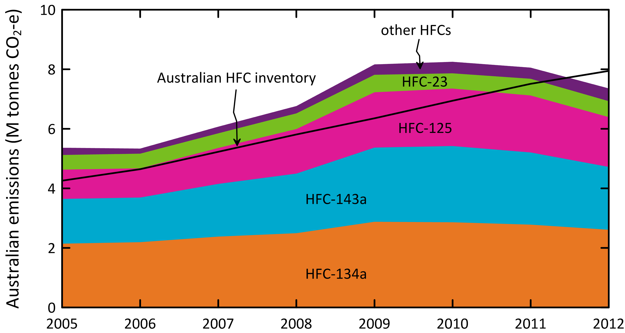

**Figure 8.** Australian emissions of HFCs -125, -134a, -143a, -32) and other HFCs (-23, -152a, -227ea, -236fa, -365mfc) estimated from atmospheric data (ISC/NAME) measured at Cape Grim, and in the *Inventory* (DoE, 2014), expressed in units of CO2-e.

## Sulfur hexafluoride

Sulfur hexafluoride emissions in the *Inventory* are about 6 tonnes per year in 2012 (Table 4, Figure 9). Estimates using Cape Grim data (ISC/NAME: Table 6, Figure 9) are 52 tonnes in 2006, decreasing to 31 tonnes in 2012, a decrease of about 8% per year. NAME estimates of SF6 emissions are about 20% lower than ISC over the period 2006-2011, but 10% higher over the period 2007-2011. In CO2-e terms SF6 emissions have fallen by 0.5 Mt CO2-e, from 1.24 Mt CO2-e in 2006 to 0.74 Mt CO2-e in 2012 based on Cape Grim data, whereas in the *Inventory* SF6 emissions have fallen by only 0.05 Mt CO2-e, from 0.19 to 0.13 Mt CO2-e over the same period.

A recent inversion study, using a combined Eulerian chemical transport model and a Lagrangian particle dispersion model (CTM-LPDM; Rigby *et al*., 2011) has been used to derive global and regional (including Australian) emissions. Using Cape Grim, the CTM-LPDM calculated emissions from Tasmania, Victoria and southern NSW (including Sydney). Scaling the results to Australian emissions, based on the fraction of the EDGAR prior estimate that is emitted into the prescribed domain (64%), results in average Australian emissions (2007-2009) of 16±10 tonnes. This study was repeated (Ganesan *et al*., 2014), with an improved estimate of emissions and their uncertainties, resulting in Australian emissions in 2012 of 17±9 tonnes (with an expanded prior region, including Adelaide, containing 85% of Australian emissions). The combined ISC/NAME data over this period suggest emissions of 37 tonnes, whereas the *Inventory* reports 6-7 tonnes per year over this period. In these studies, Sydney, the likely largest SF6 source region in Australia, is on the edge of the chosen model domain, and this may introduce potential errors into the inversion. If the inversion is not accurately capturing (underestimating) the Sydney emissions, as seen in the Cape Grim data, then the scaling factor may be too low, resulting in an underestimate of Australian emissions.

Based on atmospheric data, global emissions of SF6 were 8.1 k tonnes in 2012 (Rigby *et al*., 2014). Australian emissions are about 0.4% of global emissions based on ISC/NAME data, but < 0.1% based on the *Inventory* data. It would be unusual for Australian emissions of a widely-used industrial chemical to be <0.1% of global emissions.

The Australian SF6 emissions from atmospheric data and in the *Inventory*, and SF6 import data, are shown in Figure 9. Also shown in Figure 9 are the *Inventory* emissions recalculated using default IPCC emission factors rather than the Australian specific emissions factors currently employed in the *Inventory*. The major difference between the default and Australian-specific SF6 emission factor is for the manufacturing sector, where the current Australian-specific factor is 0.06 compared to the original IPCC default factor of 0.74. Clearly the ‘bottom-up’ estimates of SF6 emissions are very dependent on assumed emission factors. These need to be independently verified.

Ultimately, accurate import data will approximately match the sum of emissions and a growth in the banked SF6, which have grown over the past 5 years by about 5 tonnes per year. The average imports for 2012-2013 are 27 tonnes per year which may be larger than required due to stockpiling. Eventually import data will match emissions plus bank growth. Clearly, at present, a SF6 bank growth of 5 tonnes per year and emissions in the *Inventory* of 6 tonnes per year are not consistent with current imports of 27 tonnes per year.

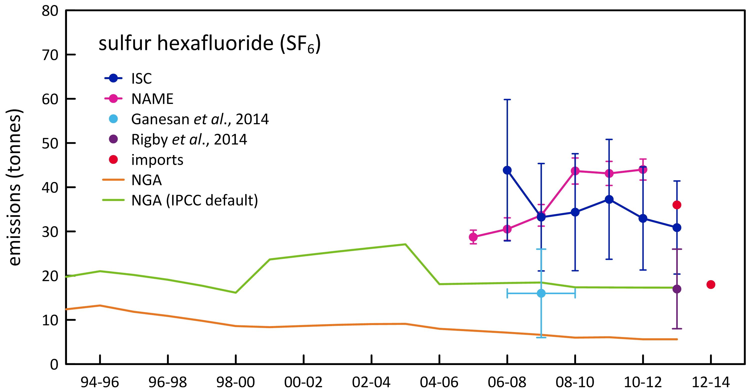

**Figure 9.** Australian SF6 imports and emissions (tonnes) from Cape Grim data and from the NGA (Inventory)

## Sulfuryl fluoride

Based on Cape Grim data, Australian sulfuryl fluoride emissions averaged less than 10 tonnes per year from 2005-2007, but then increased rapidly to average about 80-90 tonnes per year in 2011-1012. Presumably this reflects a change in grain fumigation practices away from using methyl bromide and phosphine. Global emissions were 3000 tonnes per year (2011-2012, Rigby *et al*., 2014). Australian emissions are 2-3% of global emissions. Australia is responsible for 3% of global wheat production, but 10-15% of wheat exports. SO2F2 is more closely related to wheat production (grain storage in Australia’s interior) than to wheat export (grain storage at export ports, fumigated with methyl bromide).

In CO2-e terms, SO2F2 emissions averaged about 350 k tonnes CO2-e in 2011-2012, compared to 820 k tonnes CO2-e for SF6 and 770 k tonnes CO2-e for PFCs; HFCs averaged about 7700 k tonnes CO2-e in 2011-2012.

In climate change terms, Australian SO2F2 emissions are now about 50% of the radiative forcing of PFCs, and possibly growing quite rapidly. Clearly there needs to be a close watch on future SO2F2 emissions in relation to their contribution to radiative forcing due to SGGs.

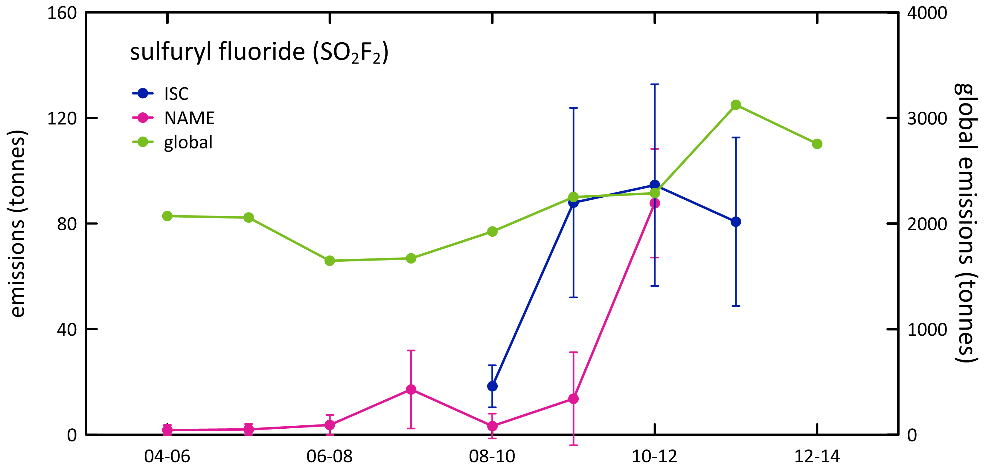

**Figure 10**. Australian SO2F2 emissions (tonnes), scaled from SE Australian emissions on a grain production basis, derived from Cape Grim in situ data, using ISC techniques; global emissions (tonnes) are from Rigby *et al*., 2014.

## Total HFCs, PFC and SF6 emissions

Total HFCs, PFCs, SF6 emissions in CO2-e are shown in Table 6 and Figure 11.

Total Australian HFC, PFC and SF6 emissions in the *Inventory* are 4.6 k tonnes in 2012, higher (19%) than estimates based on Cape Grim data: 3.8±0.7 k tonnes (ISC). Over the period 2005-2012 the *Inventory* estimates are 1% higher than estimates based on Cape Grim data (ISC/NAME).

Total Australian HFC, SF6 and PFC emissions, expressed as CO2-e, in the *Inventory* are 8.3 Mt CO2-e in 2012, 6% lower than estimates based on Cape Grim data: 8.8±1.6 Mt CO2-e (ISC) (Figure 8). Over the period 2005-2012, total Australian emissions of HFCs, PFCs and SF6, based on Cape Grim data (70 Mt CO2-e) are about 30% higher than the same emissions in the *Inventory* (54 Mt CO2-e). In all categories (HFCs, PFCs, SF6) the atmospheric data give higher estimates of emissions than in the *Inventory*. The relative contributions to the difference (2.7 Mt CO2-e) in 2011 are HFCs (~50%), SF6 (~34%) and PFCs (16%).

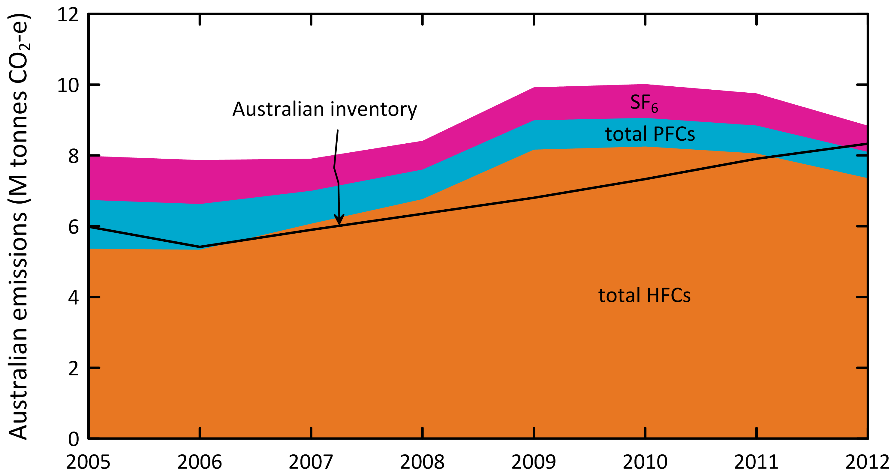

**Figure 11.** Australian HFC, PFC, SF6 emissions calculated from Cape Grim observations and in the NGGI/NGA (ageis.climatechange.gov.au) in Mt CO2-e.

Summary

* CSIRO, through involvement in the international AGAGE (Advanced Global Atmospheric Gases Experiment) program, has now measured and reported atmospheric concentrations, temporal trends and emissions for eleven HFCs (HFC-23, -32, -125, -134a, -143a, -152a, -227ea, -236fa, -245fa, -365mfc, -4310meee), nine PFCs (PFC-14, -116, -218, -318, -3110, -4112, -5114, -6116, -7118), SF6, CF3SF5 and SO2F2, utilizing data from the background atmosphere at Cape Grim, Tasmania, and from the urban atmosphere at Aspendale, Victoria. The AGAGE program involves collaborating scientists from the USA, Australia, China, Italy, Korea, Norway, Switzerland and the UK, who operate a global measurement network and, through a variety of modelling initiatives, estimate lifetimes and emissions of all the significant non-CO2 GHGs, from both ozone depletion and climate forcing perspectives.
* All HFCs (except HFC-152a), all PFCs, SF6, SO2F2 (but not CF3SF5) show increasing concentrations in the background atmosphere at Cape Grim, which accurately reflects global background atmospheric changes. Significant increases in 2012 (ppt per year) are seen in HFC-134a (4.2), HFC-125 (1.3), HFC-143a (1.1), HFC-32 (0.9), HFC-23 (0.8), PFC-14 (0.6), SF6 (0.3) and SO2F2 (0.1). Total HFCs are growing at 8.5 ppt per year or 6.5% per year, total anthropogenic PFCs at 0.70 ppt per year (1.4% per year), SF6 at 3.6% per year and SO2F2 at 5.8% per year.
* Regional Australian emissions have been detected in the Cape Grim data for all HFCs (except HFC-4310mee), the first four PFCs listed above and SF6. The emissions have been quantified using a variety of modelling techniques, including interspecies correlation (ISC), forward modelling using the CSIRO TAPM model and inverse modelling using the UK Meteorological Office model NAME. South-East Australian emissions of HFC-4310mee are expected to be seen at Cape Grim over the next few years.
* Import data for 2012 show significant use for most of these HFCs and SF6 in Australia: HFC-134a (4315 tonnes), HFC-125 (2119 tonnes), HFC-32 (1141 tonnes), HFC-143a (1126 tonnes), HFC-227ea (70 tonnes), HFC-365mfc (53 tonnes), HFC-245fa (44 tonnes) and SF6 (36 tonnes). Less than 1 tonne of PFCs are imported into Australia. There are no import data available for SO2F2. HFC-134 is imported into Australia (2 tonnes) but not measured currently at Cape Grim.
* The *National Greenhouse Accounts (Inventory)* reports significant Australian annual (2012) emissions of HFC-134a (3235 tonnes), HFC-125 (1132 tonnes), HFC-143a (108 tonnes), HFC-32 (63 tonnes), HFC-227 ea (38 tonnes), PFC-14 (34 tonnes), SF6 (6 tonnes) and PFC-116 (4 tonnes). Emissions of other HFCs are about or less than 1 tonne each (HFC-23, HFC-134, HFC-4310mee). Emissions of all HFCs are increasing. The *Inventory* emissions calculations are constructed to best estimate total HFC emissions in CO2-e terms, and are not necessarily representative of the emissions of individual HFCs. Emissions of PFCs (from aluminium production only) and SF6 in the *Inventory* are declining. Overall the emissions of HFCs, PFCs and SF6 are increasing due to the dominant influence of HFC emissions.
* Australian HFC, minor PFCs, SF6 and SO2F2 emissions have been estimated from Cape Grim atmospheric data using two independent methods: ISC and NAME. ISC and NAME estimates for HFC, PFC and SF6 emissions agree, on average over the period 2005-2011, to within 2% for HFC-125, HFC-134a, HFC-143a and HFC-152a, within 15% for HFC-23, HFC-365mfc and SF6, within 35% for HFC-32, within 50% for SO2F2.
* PFC-14 and PFC-116 emissions from the aluminium industry have been estimated using NAME and TAPM (PFC-116 indirectly via PFC-14). TAPM and NAME estimates for PFC-14 emissions agree to within 8%.
* As indicated above, comparisons of emissions of individual HFCs (*Inventory* v. atmospheric data) are not likely to be meaningful, but comparisons of total HFCs could be informative. Over the period 2005-2012, total HFC emissions in the *Inventory* are about 4% higher than total HFC emissions estimated from Cape Grim data (NAME/ISC), with the *Inventory* reporting 4579 tonnes emitted in 2012, compared to 3702 tonnes estimated from Cape Grim data. Unlike the *Inventory*, which shows Australian total HFC emission continuing to grow, Cape Grim data suggest that total HFC emissions peaked in 2010 at close to 4000 tonnes, with 2012 emissions 7% below the peak. There will be an update of 2012 HFC emissions once NAME 2012 data are available.
* Over the period 2005-2012, total HFC emissions, expressed as CO2-e emissions in the *Inventory* are about 7% lower than total HFC emissions (CO2-e) estimated from Cape Grim data (NAME/ISC), with the *Inventory* reporting 7.9 M tonnes emitted in 2012, compared to 7.3 M tonnes estimated from Cape Grim data (2012 is the first year that *Inventory* estimates of HFC emissions in CO2-e exceed estimates from Cape Grim data). Total HFC emissions in CO2-e terms also peaked in 2010 at 8.2 M tonnes, with 2012 emissions 10% below the peak.
* Australian PFC-14 emissions over the period 2005-2012 have been estimated from atmospheric data by NAME and TAPM inverse and forward modelling respectively. Over the period 2005-2012, PFC-14 emissions in the *Inventory* are in decline and are about 15% lower than PFC-14 emissions estimated from Cape Grim data (NAME/ISC), with the *Inventory* reporting 34 tonnes emitted in 2012, compared to 56 tonnes estimated from Cape Grim data. Both the *Inventory* and Cape Grim data show PFC-14 emissions from the aluminium industry have declined at a similar rate: 55% since 2006 or 9% per year.
* Total Australian PFC-116 emissions and PFC-116 emissions specifically from the aluminium industry have been estimated from atmospheric data using ISC, NAME and TAPM. Over the period 2005-2012, PFC-116 emissions in the *Inventory* (assumed only from the aluminium industry) and as seen at Cape Grim are in decline. The *Inventory* emissions are about 10% higher than emissions derived from Cape Grim data for the aluminium industry and, like PFC-14 emissions, have declined by close to 60% since 2006.
* Total PFC-116 emissions as seen at Cape Grim are increasing, approximately doubling since 2006, currently at 23 tonnes per year. The data suggest that a significant, post -2007, non-aluminium PFC-116 source is in operation in Australia, and this is not captured in the import data. The source of this additional PFC-116 is unknown. Globally, the primary non-aluminium source of PFC-116 is from etching processes used in the electronics industry. Further analysis of past and future Aspendale and Sydney PFC-116 data could help identify this source.
* There is a small but significant source of HFC-23 emissions in Australia. HFC-23 has not been identified in past or current imports of refrigerants or refrigerant blends. It may be present as an unidentified contaminant in imported refrigerant blends. This will be investigated in the 2015 Report.
* Cape Grim observations show that Australian emissions of PFC-218 are growing and PFC-318 emissions are declining, with current emissions for both at about 20 tonnes (PFC-218, 2012; PFC-318, 2011). There are no significant Australian imports identified for these PFCs. Globally PFC-218 and PFC-318 are used in the electronics industry (etching), in refrigeration, in fire suppression and in medical applications. As with PFC-116, further analysis of past and future Aspendale and Sydney PFC-218 and PFC-318 data could help identify source(s) of these PFCs.
* Not surprisingly, total Australian PFCs declined from 2005 to 2008, largely driven by emissions from the aluminium industry and then increased from 2008 to 2011, driven by increasing emissions of non-aluminium derived PFC-116, PFC-218 and PFC-318 emissions. NAME emissions for 2012 are required to confirm (or not) this trend.
* Over the period 2006 – 2012, both the *Inventory* and Cape Grim data show that Australian SF6 emissions are in decline (25% decline in the *Inventory*, 40% seen at Cape Grim). However the *Inventory* SF6 emissions are significantly lower than emissions estimated from Cape Grim data; over the period 2006 to 2012 the SF6 emissions in the *Inventory* average 7 tonnes per year, about a factor of 6 lower than estimates from Cape Grim over the same period (39 tonnes per year). This is a major discrepancy and is currently under investigation. The *Inventory* estimates are sensitive to the assumed (and uncertain) emission factor in the manufacture of SF6 containing equipment.
* Australian SF6 emissions in the *Inventory* are less <0.1% of global emissions. It would be unusual for Australian emissions of a widely-used industrial chemical like SF6 to be <0.1% of global emissions. A number approaching 1% would be consistent with several other widely used HFCs and HCFCs. The Cape Grim data indicate that Australian emissions of SF6 were 0.4% of global emissions in 2012.
* Total Australian HFC, PFC and SF6 emissions, expressed as CO2-e emissions, over the period 2005-2012 estimated from atmospheric data (Cape Grim, ISC, NAME, TAPM ) are about 30% higher than in the *Inventory*, although in 2012 the agreement is much closer (7%, *Inventory* lower). As indicated above, this comes about due to a reasonable agreement over the period 2005-2012 between the *Inventory* and atmospheric data for HFCs (7%, *Inventory* lower), whereas, for PFCs and SF6, the *Inventory* emissions are substantially lower than those derived from Cape Grim data. In 2012, the combined PFC and SF6 emissions calculated from Cape Grim data were 146 tonnes, more than a factor of 3 higher than combined PFC and SF6 emissions in the *Inventory* (44 tonnes).

References

Arnold, T., C. Harth, J. Mühle, P. Salameh, A. Manning, D. Ivy, P. Steele, J. Kim, V. Petrenko, J. Severinghaus, D. Baggenstos & R. Weiss, Nitrogen trifluoride global emissions estimated from updated atmospheric measurements, *Proc. Nat. Acad. Sci.*, 110, 2029-2034, doi:10.1073/pnas.1212346110, 2013.

Arnold, T., D. Ivy, C. Harth,M. Vollmer, J. Mühle, P. Salameh, P. Steele, P. Krummel, R. Wang, G. Young, C. Lunder, O. Hermansen, T. Rhee, M. Rigby, J. Kim, S. Reimann, S. O**’**Doherty, P. Fraser, P. Simmonds, R. Prinn & R. Weiss, HFC-43-10mee atmospheric abundances and global emission estimates, *Geophys. Res. Letts.*, 41, 2228-2235, 2014.

Brodribb, P. & M. McCann, *Cold Hard Facts 2: a study of the refrigeration and air conditioning industry in Australia*, Expert Group/Thinkwell Australia, for DSEWPAC, Commonwealth of Australia, 134 pp, 2013.

Daniel, J. & G. Velders, A Focus on Information and Options for Policymakers, Chapter 5 in *Scientific Assessment of Ozone Depletion: 2010*, WMO Global Ozone Research and Monitoring Project – Report No. 52, 5.1-5.56, 2011.

DCCEE 2012, *National Inventory Report 2010, Volume 1,* Australian Government, Department of Climate Change and Energy Efficiency, April 2012, 292 pp.

DIICCSRTE 2013, *National Inventory Report 2011, Volume 1,* Australian Government Department of Industry, Innovation, Climate Change, Science, Research and Tertiary Education, April 2013, 299 pp.

DoE 2014, *National Inventory Report 2012, Volume 1,* Australian Government Department of the Environment, April 2014, 351 pp.

Dunse, B., P. Steele, P. Fraser & S. Wilson, An analysis of Melbourne pollution episodes observed at Cape Grim from 1995-1998, In: *Baseline Atmospheric Program (Australia) 1997-98*, edited by N. Tindale, R. Francey, and N. Derek, pp 34-42, Bureau of Meteorology and CSIRO Atmospheric Research, Melbourne, Australia, 2001.

Dunse, B., Investigation of urban emissions of trace gases by use of atmospheric measurements and a high-resolution atmospheric transport model, *PhD thesis*, Wollongong University, Wollongong, NSW, Australia, 2002.

Dunse, B., P. Steele, S. Wilson, P. Fraser & P. Krummel, Trace gas emissions from Melbourne Australia, based on AGAGE observations at Cape Grim, Tasmania, 1995-2000, *Atmospheric Environment*, 39, 6334-6344, 2005.

Draxler, R. & D. Hess, Description of the HYSPLIT_4 Modeling 389 System, NOAA Technical Memorandum ERL ARL-224, 24 pp, NOAA, 1997.

Estrada, F., P. Perron & B. Martínez-López, Statistically derived contributions of diverse human influences to twentieth-century temperature changes, *Nature Geoscience*, 6(11), 1–6, 2013.

Fortems-Cheiney, A., M. Saunois, I, Pison, F. Chevallier, P. Bousquet, C. Cressot, S. Montzka, P. Fraser, M. Vollmer, P. Simmonds, D. Young, S. O'Doherty, F. Artuso, B. Barletta, D. Blake, S. Li, C. Lunder, B. Miller, S. Park, R. Prinn, T. Saito, P. Steele & Y. Yokouchi, Increase in HFC-134a emissions in response to the success of the Montreal Protocol, *J. Geophys. Res*., submitted, 2013.

Fraser, P. J., L. W. Porter, S. B. Baly, P. B. Krummel, B. L. Dunse, L. P. Steele, N. Derek, R. L. Langenfelds,  
I. Levin, D. E. Oram, J. W. Elkins, M. K. Vollmer & R. F. Weiss, Sulfur hexafluoride at Cape Grim: long term trends and regional emissions, in: *Baseline Atmospheric Program Australia 2001-2002*, J. M. Cainey, N. Derek, and P. B. Krummel (editors), Melbourne: Bureau of Meteorology and CSIRO Atmospheric Research, 18-23, 2004.

Fraser, P., C. Trudinger, B. Dunse, P. Krummel, P. Steele, D. Etheridge, N. Derek, L. Porter & B. Miller, PFC emissions from global and Australian aluminium production, *Proceedings of the 9th Australasian Aluminium Smelting Technology Conference and Workshops*, Skyllas-Kazacos, M. & B. Welch (eds.), Terrigal, NSW, Australia, 4-9 November 2007.

Fraser, P., B. Dunse, P. Steele, P. Krummel & N. Derek, Perfluorocarbon (PFC) emissions from Australian aluminium smelters, 2005-2009, *Proceedings of the 10th Australasian Aluminium Smelting Technology Conference*, Launceston, Tasmania, Australia, 9-14 October, 2011, B. Welch, G. Stephens, J. Metson & M. Skyllos-Kazacos (eds.), Copyright School of Chemical Engineering, University of New South Wales, ISBN: 978-0-7334-3054-1, 14 pp.

Fraser. P., P. Steele & M. Cooksey, PFC and CO2 emissions from an aluminium smelter measured using integrated stack sampling, GC-MS and GC-FID, *Light Metals 2013*, B. Sadler (ed.), Wiley/TMS 2013, 871-876, 2013.

Fraser, P., P. Krummel, P. Steele, C. Trudinger, D. Etheridge, N. Derek, S. O’Doherty, P. Simmonds, B. Miller, J. Muhle, R. Weiss, D. Oram, R. Prinn & R. Wang, Equivalent effective stratospheric chlorine from Cape Grim Air Archive, Antarctic firn and AGAGE global measurements of ozone depleting substances, *Baseline Atmospheric Program (Australia) 2009-2010*, N. Derek P. Krummel & Cleland (eds.), Australian Bureau of Meteorology and CSIRO Marine and Atmospheric Research, Melbourne, Australia, 17-23, 2014a

Fraser, P., B. Dunse, A. Manning, R. Wang, P. Krummel, P. Steele, L. Porter, C. Allison. S. O’Doherty, P. Simmonds, J. Mühle & R. Prinn, Australian carbon tetrachloride (CCl4) emissions in a global context, *Environ. Chem*., 11, 77-88, 2014b.

Ganesan, A., M. Rigby, A. Zammit-Mangion, A. Manning, R. Prinn, P. Fraser, C. Harth, K-R. Kim, P. Krummel, S. Li, J. Muhle, S. O’Doherty, S. Park, P. Salameh, P. Steele & R. Weiss, Characterisation of uncertainties in trace gas inversions using hierarchical Bayesian methods, *Atmos. Chem. Phys.*, 14, 3855-3864, 2014.

GrainCorp, 2012

Greally, B., A. Manning, S. Reimann, A. McCulloch, J. Huang, B. Dunse, P. Simmonds, R. Prinn, P. Fraser, D. Cunnold, S. O’Doherty, L. Porter, K. Stemmler, M. Volmer, C. Lunder, N. Schmidbauer, O. Hermansen, J. Arduini, P. Salameh, P. Krummel, R. Wang, D. Folini, R. Weiss, M. Maione, G. Nickless, F. Stordal & R. Derwent, Observations of 1,1-difluoroethane (HFC-152a) at AGAGE and SOGE monitoring stations in 1994-2004 and derived global and regional emission estimates, *J. Geophys. Res*., 112, D06308, doi:10.1029/2006JD007527, 2007.

Harris, N., D. Wuebbles, J. Daniel, J. Hu, L. Kuijpers, K. Law, M. Prather & R. Schofield, Scenarios, Information and Options for Policy Makers, Chapter 5 in *Scientific Assessment of Ozone Depletion: 2014*, in press, 2014.

Ivy, D., Trends and inferred emissions of atmospheric high molecular weight perfluorcarbons, *PhD thesis*, MIT, Cambridge, Massachusetts, USA, 2012.

Ivy, D., T. Arnold, C. Harth, P. Steele, J. Muhle, M. Rigby, P. Salameh, M. Leist, P. Krummel, P. Fraser, R. Weiss & R. Prinn, Atmospheric histories and growth trends of the high molecular weight perfluorocarbons: C4F10, C5F12, C6F14, C7F16 and C8F18, *Atmos. Chem. Phys.*, 12, 4313-4325, 2012.

Kim, J., P. Fraser, S. Li, J. Muhle, A. Ganesan, P. Krummel, P. Steele, S. Park, S.-K. Kim, M.-K. Park, T. Arnold, C. Harth, P. Salameh, R. Prinn, R. Weiss & K.-R. Kim, Quantifying aluminium and semiconductor industry perfluorocarbon emissions from atmospheric measurements, *Geophys. Res. Lett*., 41, 4787-4794, doi:10.1002/2014GL059783, 2014

Krummel, P., P. Fraser, P. Steele, L. Porter, N. Derek, C. Rickard, J. Ward, B. Dunse, R. Langenfelds, S. Baly, M. Leist & S. McEwan, The AGAGE *in situ* program for non-CO2 greenhouse gases at Cape Grim, 2007-2008: methane, nitrous oxide, carbon monoxide, hydrogen, CFCs, HCFCs, HFCs, PFCs, halons, chlorocarbons, hydrocarbons and sulfur hexafluoride, *Baseline 2007-2008*, 67-80, 2011.

Krummel, P., P. Fraser, P. Steele, N. Derek, C. Rickard, J. Ward, N. Somerville, S. Cleland, B. Dunse, R. Langenfelds, S. Baly & M. Leist, The AGAGE *in situ* program for non-CO2 greenhouse gases at Cape Grim, 2009-2010, *Baseline Atmospheric Program (Australia) 2009-2010*, N. Derek P. Krummel & S. Cleland (eds.), Australian Bureau of Meteorology and CSIRO Marine and Atmospheric Research, Melbourne, Australia, 55-70, 2014

Laube, J., C. Hogan, M. Newland, F. Mani, P. Fraser, C. Brenninkmeijer, P. Martinerie, D. Oram, T. Rockmann, J. Schwander, E. Witrant, G. Mills, C. Reeves & W. Sturges, Distributions, long-term trends and emissions of four perfluorocarbons in remote parts of the atmosphere and firn air, *Atmos. Chem. Phys.*, 12, 4081-4090, 2012.

Maiss, M., Steele, L. P., Francey, R. J., Fraser, P. J., Langenfelds, R. L., Trivett, N. B. A. & Levin, I., Sulfur hexafluoride: a powerful new atmospheric tracer, *Atmospheric Environment,* 30 (10/11): 1621-1629, 1996.

Manning, A., D. Ryall, R. Derwent, P. Simmonds & S. O’Doherty, Estimating European od ozone depleting and greenhouse egases using observations and a modellinh attribution technique, *J. Geophys. Res*., 108, 4405, doi:10.1029/2002JD002312, 2003.

Manning, A., S. O’Doherty, A. R. Jones, P. G. Simmonds and R. G. Derwent, Estimating UK methane and nitrous oxide emissions from 1990 to 2007 using an inversion modeling approach, *J. Geophys. Res*., 116, D02305, doi:10.1029/2010JD004763, 2011.

Miller, B., R. Weiss, P. Salameh, T. Tanhua, B. Greally, J. Muhle & P. Simmonds, Medusa: a sample pre-concentration and GC-MS detector system for *in situ* measurements of atmospheric trace halocarbons, hydrocarbons and sulphur compounds, *Anal. Chem*., 80, 1536-1545, 2008.

Miller, B., M. Rigby, L. Kuijpers, P. Krummel, P. Steele, M. Leist, P. Fraser, A. McCulloch, C. Harth, P. Salameh, J. Mühle, R. Weiss, R. Prinn, R. Wang, S. O’Doherty, B. Greally & P. Simmonds, CHF3 (HFC-23) emission trend response to CHClF2 (HCFC-22) production and recent CHF3 emissions abatement measures, *Atmos. Chem. Phys.*, 10, 7875-7890, 2010.

Molina, M., D. Zaelke, K. Sharma, S. Andersen, V. Ramanathan & D. Kaniaru, Reducing abrupt climate change risk using the Montreal Protocol and other regulatory actions to complement cuts in CO2 emissions, *Proc. Nat. Acad. Sci*., 106 (49), 20615-20621, 2009.

Mühle, J., J. Huang, R. Weiss, R. Prinn, B. Miller, P. Salameh, C. Harth, P. Fraser, L. Porter, B. Greally, S. O’Doherty, P. Simmonds, P. Steele & P. Krummel, Sulfuryl fluoride in the global atmosphere, *J. Geophys. Res.*, 114, D05306, doi:10.1029/2008JD011162, 2009.

Mühle, J., A. Ganesan, B. Miller, P. Salameh C. Harth, B. Greally, M. Rigby, L. Porter, P. Steele, C. Trudinger, P. Krummel, S. O’Doherty,P. Fraser, P. Simmonds, R. Prinn & R. Weiss, Perfluorocarbons in the global atmosphere: tetrafluoromethane, hexafluoroethane and octofluoropropane, *Atmos. Chem. Phys.,* 10, 5145-5164*,* 2010.

Myhre, G., D. Schindell, F.-M. Breon, W. Collins, J. Fuglestvedt, J. Huang, D. Koch, J.-F. Lamarque, D. Lee, B. Mendoza, T. Nakajima, A. Robock, G. Stephens, T. Takemura, & H. Zhang, Anthropogenic and Natural Radiative Forcing, Chapter 8 in *Climate Change 2013 – The Physical Science Basis*, Working Group I Contribution to the Fifth Assessment Report of the Intergovernmental Panel on Climate Change, Stocker, T., D. Qin, G.-K. Plattner, M. Tignor, S. Allen, J. Boschung, A. Nauels, Y. Xia, V. Bex & P. Midgley (eds.), Cambridge University Press, Cambridge, UK & New York, NY, USA, 659-740, 2014.

O'Doherty, S., D. Cunnold, A. Manning, B. Miller, R. Wang, P. Krummel, P. Fraser, P. Simmonds, A. McCulloch, R. Weiss, P. Salameh, L. Porter, R. Prinn, J. Huang, G. Sturrock, D. Ryall, R. Derwent & S. Montzka, Rapid growth of hydrofluorocarbon-134a and hydrochlorofluorocarbons-141b, -142b, and -22 from Advanced Global Atmospheric Gases Experiment (AGAGE) observations at Cape Grim, Tasmania, and Mace Head, Ireland, *J. Geophys. Res.*, 109, doi:10.1029/2003JD004277, 2004.

O’Doherty, S., D. Cunnold, B. Miller, J. Mühle, A. McCulloch, P. Simmonds, A. Manning, S. Reimann, M. Vollmer, B. Greally, R. Prinn, P. Fraser, P. Steele, P. Krummel, B. Dunse, L. Porter, C. Lunder, N. Schmidbauer, O. Hermansen, P. Salameh, C. Harth, R. Wang & R. Weiss, Global and regional emissions of HFC-125 (CHF2CF3) from *in situ* and air archive observations at AGAGE and SOGE observatories, *J. Geophysical Research*, 114, D23304, doi:10.1029/2009JD012184, 2009.

O’Doherty, S., M. Rigby, J. Mühle, D. Ivy, B. Miller, D. Young, P. Simmonds, S. Reimann, M. Vollmer, P. Krummel, P. Fraser, P. Steele, B. Dunse, P. Salameh, C. Harth, T. Arnold, R. Weiss, J. Kim, S. Park, S. Li, C. Lunder, O. Hermansen, N. Schmitbauer, L. Zhou, B. Yao, R. Wang, A. Manning & R. Prinn, Global emissions of HFC-143a (CH3CF3) and HFC-32 (CH2F2) from in situ and air archive atmospheric observations, *Atmos. Chem. Phys. Discuss*., 14, 6471-6500, 2014.

Oram, D., C. Reeves, W. Sturges, S. Penkett, P. Fraser & R. Langenfelds, Recent tropospheric growth rate and distribution of HFC-134a (CF3CH2F), *Geophysical Research Letters,* 23 (15): 1949-1952, 1996.

Oram, D., W. Sturges, S. Penkett, A. McCulloch & P. Fraser, Growth of fluoroform (CHF3, HFC-23) in the background atmosphere, *Geophysical Research Letters,* 25 (1): 35-38, 1998.

Oram, D., Trends in long-lived anthropogenic halocarbons in the Southern Hemisphere and model calculations of global emissions, *PhD thesis*, University of East Anglia, Norwich, UK, 1999.

Oram, D., F. Mani, J. Laube, M. Newland, C. Reeves, W. Sturges, S. Penkett, C. Brenninkmeijer, T. Röckmann & P. Fraser, Long-term tropospheric trend of octafluorocyclobutane (c-C4F8 or PFC-318), *Atmos. Chem. Phys*., 12, 261-269, 2012.

Rigby, M., J. Mühle, B. Miller, R. Prinn, P. Krummel, P. Steele,P. Fraser, P. Salameh, C. Harth, R. Weiss, B. Greally, S. O’Doherty, P. Simmonds, M. Vollmer, S. Reimann, J. Kim, K. Kim, R. Wang, J. Olivier, E. Dlugokencky, G. Dutton, B. Hall & J. Elkins, History of atmospheric SF6 from 1973 to 2008, *Atmos. Chem. Phys.*, 10, 10305-10320, 2010.

Rigby, M., R. Prinn, S. O’Doherty, B. Miller, D. Ivy, J. Muhle, C. Harth, P. Salameh, T. Arnold, R. Weiss, P. Krummel, P. Steele, P. Fraser, D. Young & P. Simmonds, Recent and future trends in synthetic greenhouse gas radiative forcing, *Proc. NY. Acad. Sci.*, submitted, 2014.

Santoro, M., Clarifying the SF5CF3 record, *Science*, 290, 935, 2000.

Stohl, A., P. Seibert, J. Arduini, S. Eckhardt, P. Fraser, B. Greally, C. Lunder, M. Miaone, J. Mühle, S. O’Doherty, R. Prinn S. Reimann, T. Saito, N. Schmidbauer, P. Simmonds, M. Vollmer, R. Weiss & Y. Yokouchi, An analytical inversion method for determining regional and global emissions of greenhouse gases: sensitivity studies and application to halocarbons, *Atmos. Chem. Phys.*, 9, 1597-1620, 2009.

Sturges, W., D. Oram, J. Laube, C. Hogan, C. Reeves, M. Newland, P. Martinerie, E. Witrant, C. Brenninkmeijer, T. Schuck & P. Fraser, Emissions halted of the potent greenhouse gas CF3SF5, *Atmos. Chem. Phys.,* 12, 3653-3658, 2012.

Velders, G., S. Anderson J. Daniel, D. Fahey & M. McFarland, The importance of the Montreal Protocol in protecting climate, *Proc. Nat. Acad. Sci*., 104 (12), 4814-4819, 2007

Velders, G., D. Fahey, J. Daniel, M. McFarland & S. Anderson, The large contribution of projected HFC emissions to future climate forcing, *Proc. Nat. Acad. Sci*., 106, 10949-10954, 2009

Velders, G. , A. Ravishankara, M. Miller, M. Molina, J. Alcamo, J. Daniel, D. Fahey, S. Montzka & S. Reimann, Preserving Montreal Protocol climate benefits by limiting HFCs, *Science*, 335 (6071), 922–923, 2012.

Vollmer, M., B. Miller, M. Rigby, S. Reimann, J. Muhle, P. Krummel, S. O’Doherty, J. Kim, T.-S. Rhee, R. Weiss, P. Fraser, P. Simmonds, P. Salameh, C. Harth, R. Wang, P. Steele, D. Young, C. Lunder, O. Hermansen, D. Ivy, T. Arnold, N. Schmidbauer, K.-R. Kim, B. Greally, M. Hill, M. Leist, A. Wenger & R. Prinn, Atmospheric histories and global emissions of the anthropogenic hydrofluorocarbons (HFCs) HFC-365mfc, HFC-245fa, HFC-227ea and HFC-236fa*, J. Geophys. Res.*, 116, D08304, doi:10.1029/2010JD015309, 2011.

Weiss, R., J. Muhle, P. Salameh, & C. Harth, Nitrogen trifluoride in the global atmosphere, *Geophys. Res. Lett*., 35, L20821, 2008.

R., J. Muhle, P. Salameh, & C. Harth, Nitrogen trifluoride in the global atmosphere, *Geophys. Res. Lett*., 35, L20821, 200 Weiss, R., J. Muhle, P. Salameh, & C. Harth, Nitrogen trifluoride in the global atmosphere, *Geophys. Res. Lett*., 35, L20821, 20088

|  |  |  |
| --- | --- | --- |
|  | | |
| CONTACT US  t 1300 363 400  +61 3 9545 2176  e enquiries@csiro.au  w www.csiro.au  Your CSIRO  Australia is founding its future on science and innovation. Its national science agency, CSIRO, is a powerhouse of ideas, technologies and skills for building prosperity, growth, health and sustainability. It serves governments, industries, business and communities across the nation. |  | For further information  CSIRO Oceans & Atmosphere Flagship  Paul Fraser  t +61 3 9239 4526  e paul.fraser@csiro.au  w www.csiro.au/Organisation-Structure/Flagships/Oceans-and-Atmosphere.aspx |