# Publication details

#### Title:

## LaND Tenure of Australia 2010–11 TO 2020–21

#### Alternative title:

AUSTEN_v2_250m_2011_2021

#### Date published:

31 October 2024

#### Date prepared:

27 October 2024

#### Preview:

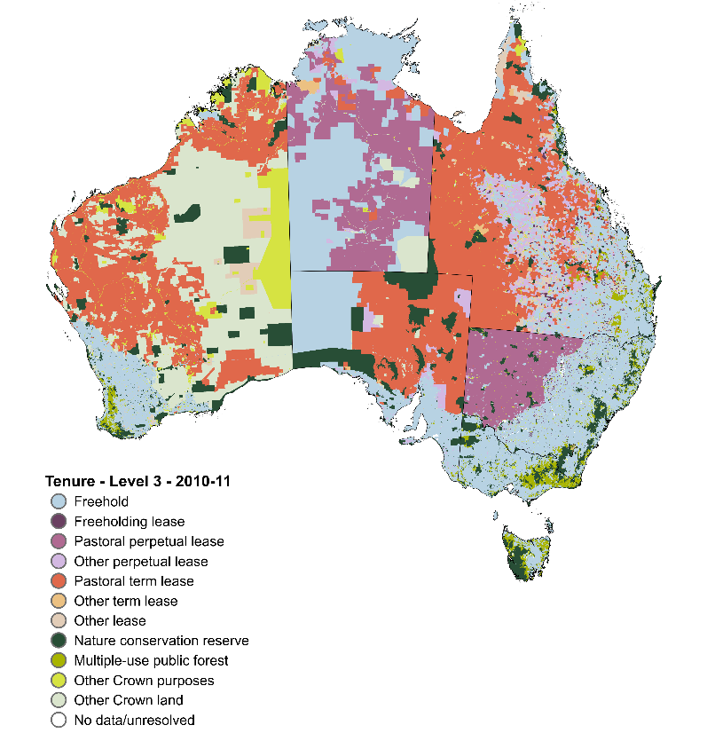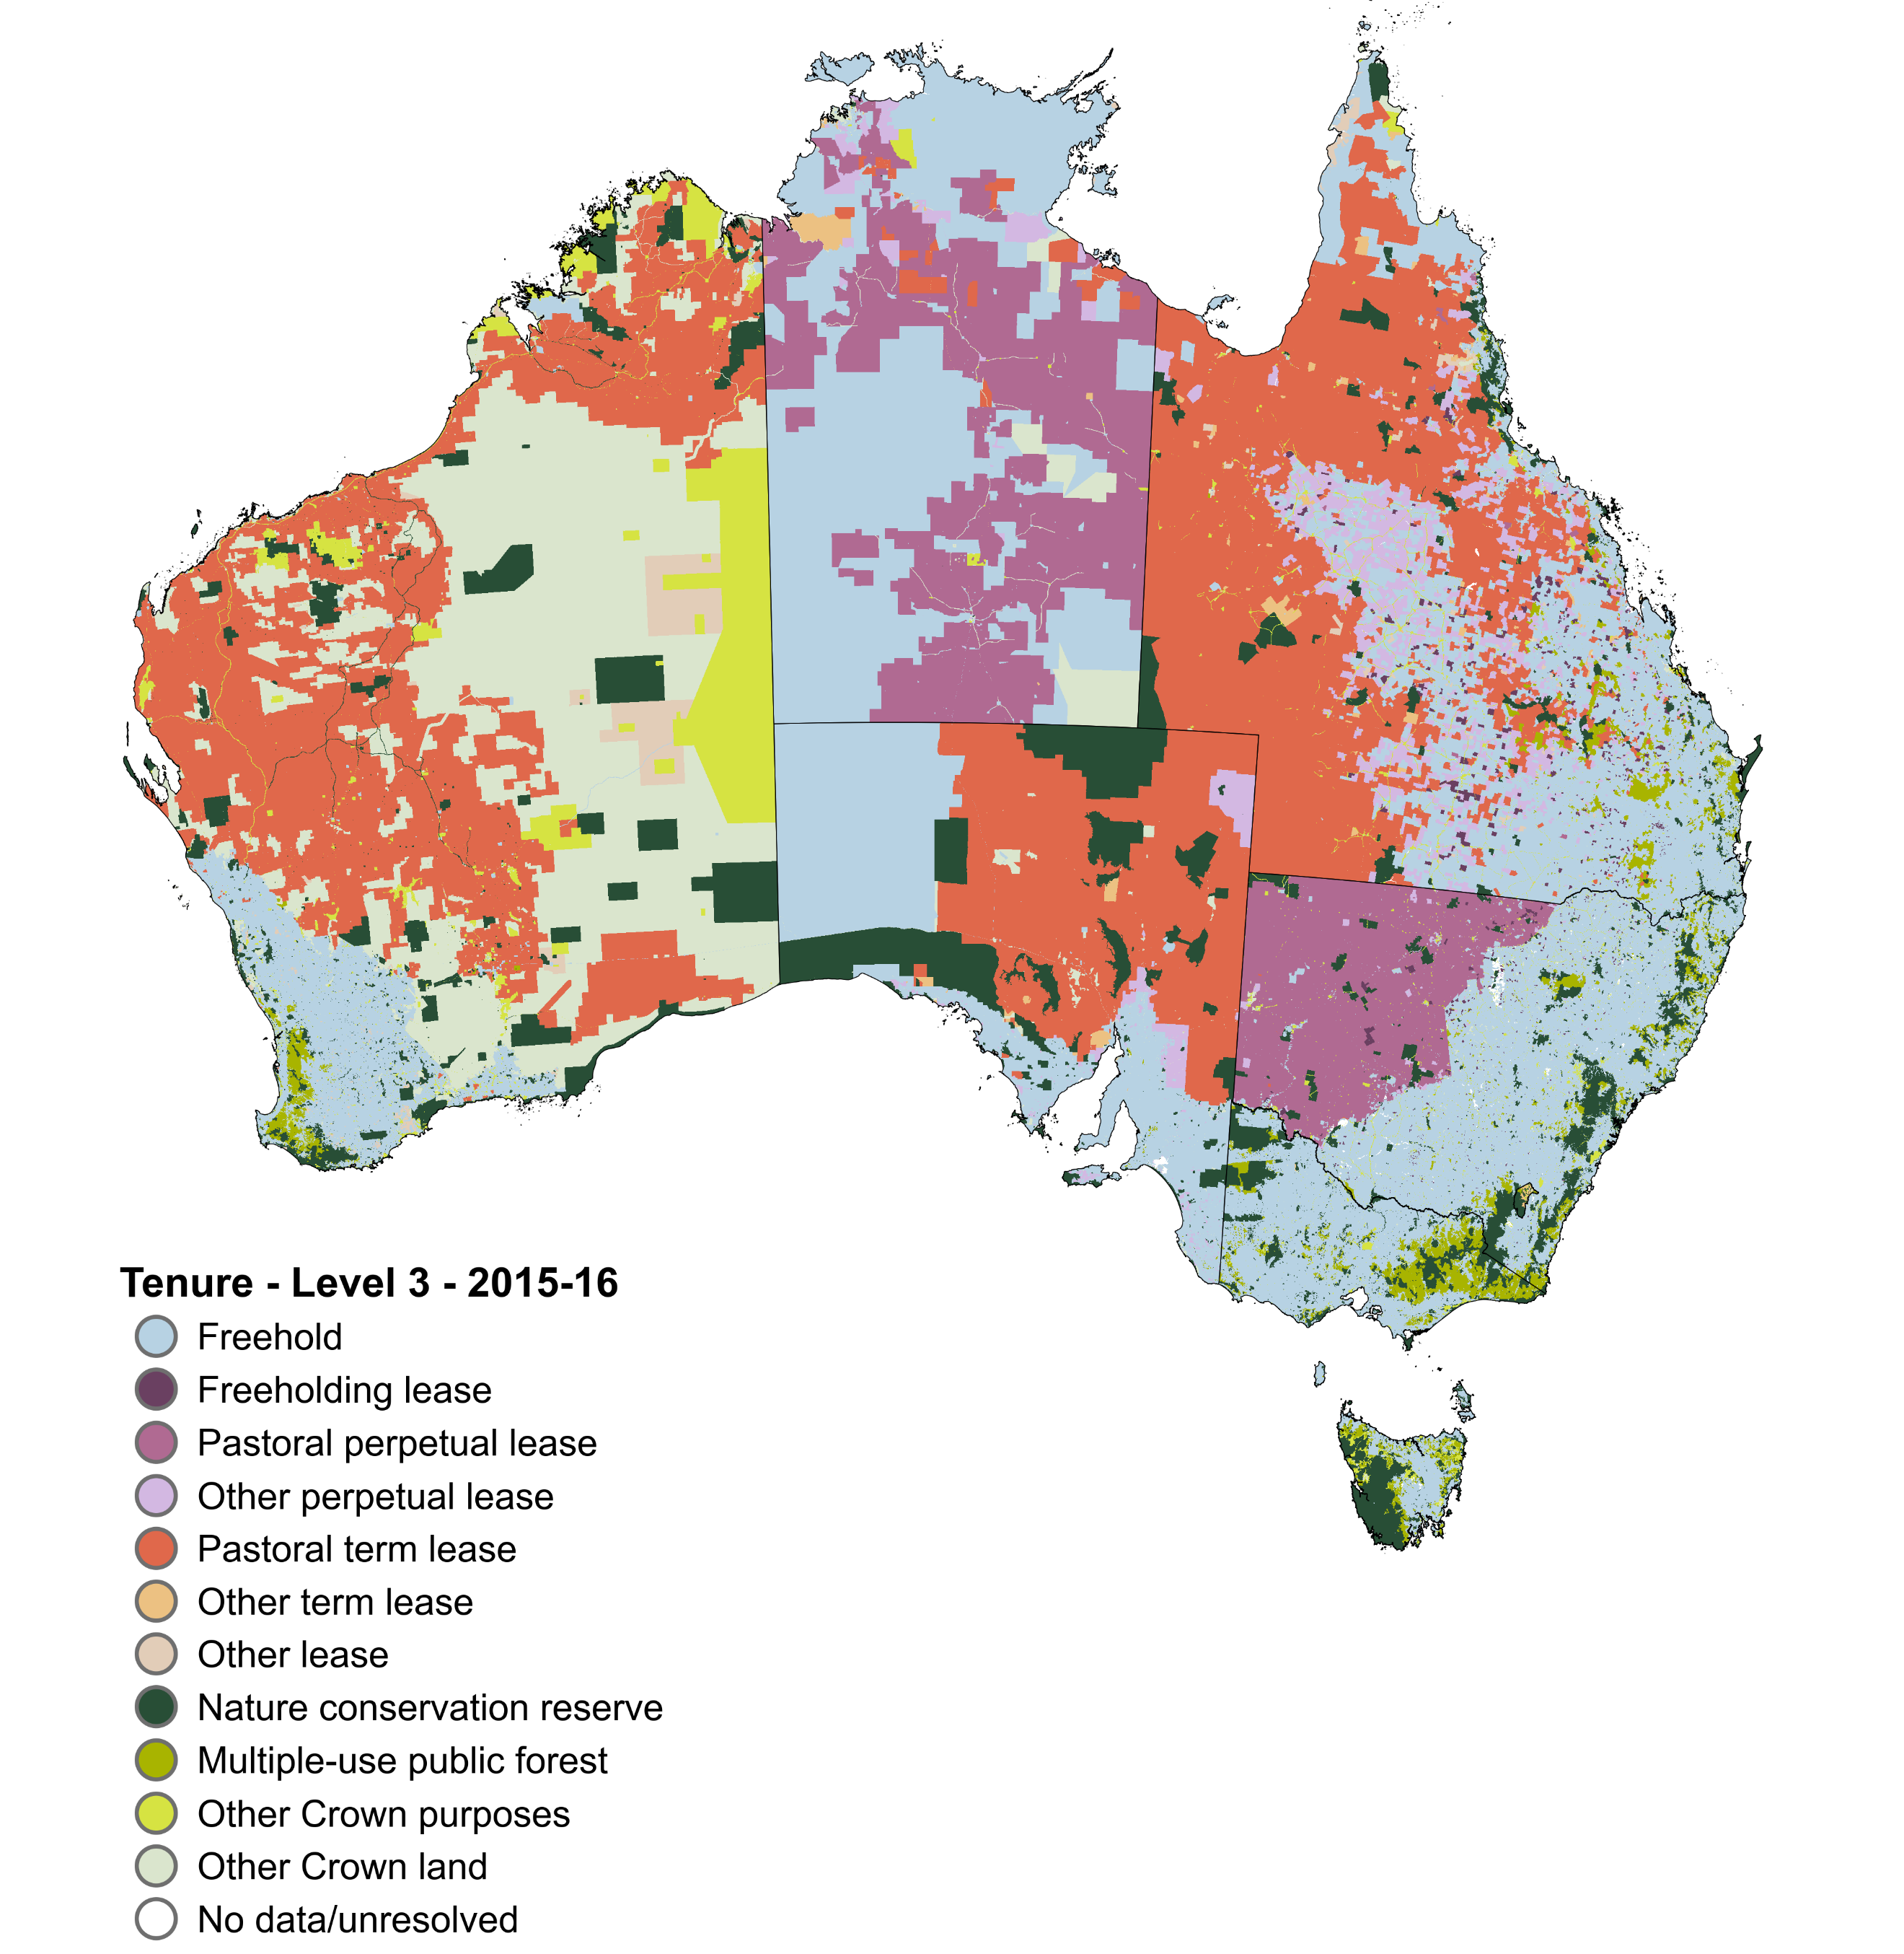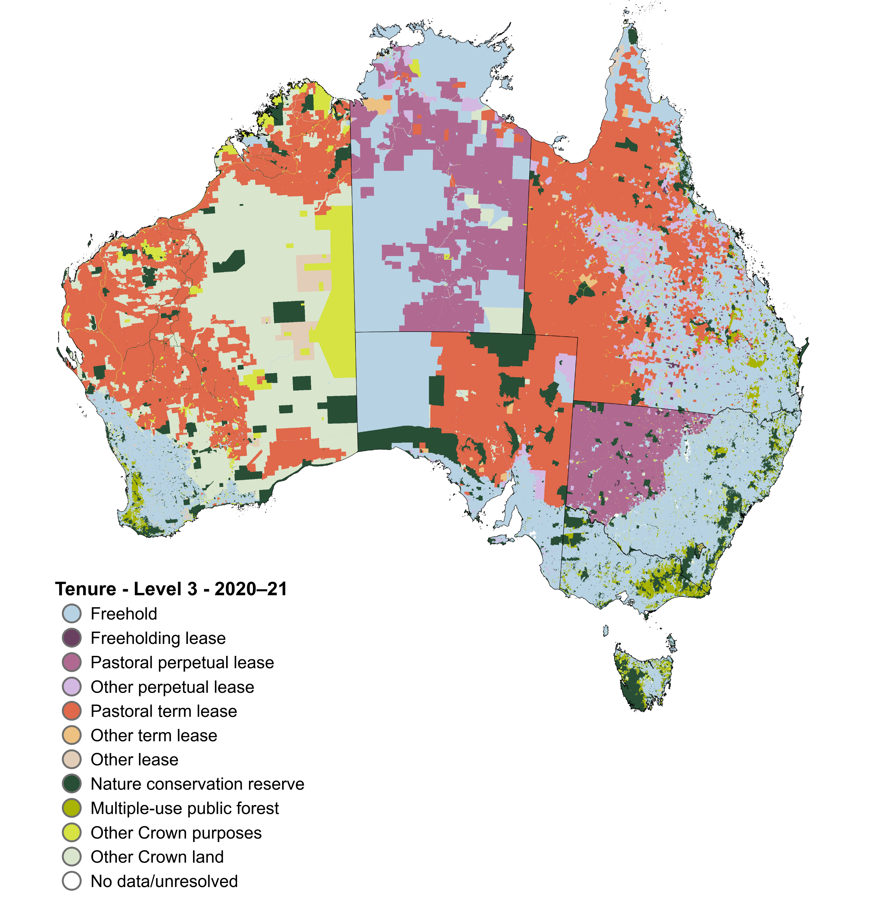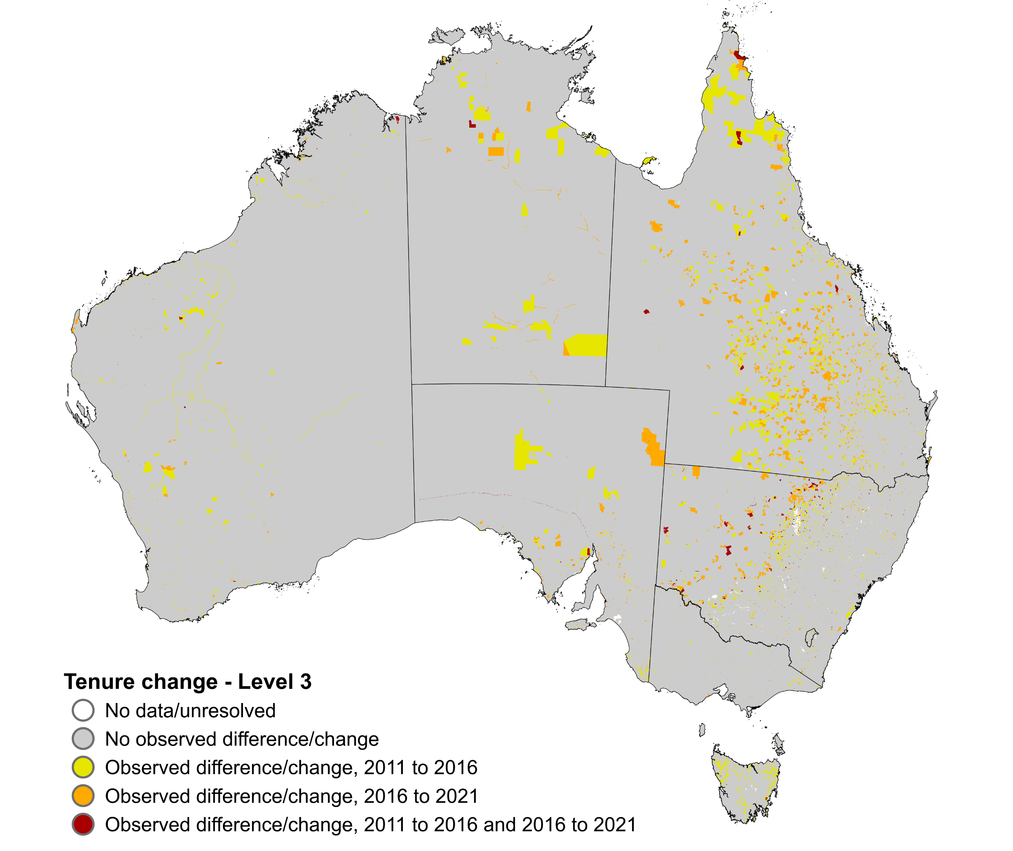

## Abstract

The *Land tenure of Australia 2010–11 to 2020–21* data package consists of seamless continental rasters showing Australia’s land tenure, and land tenure change, for 3 time periods 2010–11, 2015–16, and 2020–21. Using a 4-tiered hierarchical classification, the datasets show where land is owned, leased, reserved or unallocated to a defined purpose in Australia. The datasets were constructed by combining jurisdictional land title information from digital cadastral databases or their equivalents with Indigenous land grant instruments areas. The data package contains for each of the 3 time periods an independent raster and data caveat raster of known uncertainties in the product, plus a combined change raster at the most detailed classification level. The 5-yearly data is at a resolution of 250 by 250 metres.

The *Land tenure of Australia 2010–11 to 2020–21* data package is a product of the Australian Collaborative Land Use and Management Program. This data package replaces the *Land tenure of Australia 2010–11 to 2015–16* data package, with updates to these time periods.

#### Citation

ABARES 2024, *Land tenure of Australia 2010–11 to 2020–21*, Australian Bureau of Agricultural and Resource Economics and Sciences, Canberra, October, CC BY 4.0. DOI: [10.25814/89rx-zs30](https://doi.org/10.25814/89rx-zs30)

#### Custodian

Australian Bureau of Agricultural and Resource Economics and Sciences (ABARES)

GPO Box 858 Canberra ACT 2601 AUSTRALIA  
Telephone 1800 900 090

Email [info.ABARES@agriculture.gov.au](mailto:info.ABARES@agriculture.gov.au)

Web [agriculture.gov.au/abares](https://www.agriculture.gov.au/abares)

#### Acknowledgements

This data package was produced by the Australian Bureau of Agricultural and Resource Economics and Sciences (ABARES) within the Australian Government Department of Agriculture, Fisheries and Forestry as part of the Australian Collaborative Land Use and Management Program (ACLUMP). ACLUMP, of which ABARES is a partner, is a consortium of Australian Government, and state and territory government partners that promotes the development of nationally consistent land use, land cover and land management practice information for Australia.

Spatial data was sourced from, and used with permission of, the following government agencies: ACT Office of the Surveyor-General and Land Information, Australian Government Department of Climate Change, Energy, the Environment and Water, NSW Department of Customer Service – Spatial Services, NSW Department of Planning, Housing and Infrastructure – Crown Lands, NT Department of Lands, Planning and Environment, PSMA Australia Limited, Queensland Department of Resources, SA Department for Infrastructure and Transport, SA Department for Environment and Water, Department of Natural Resources and Environment Tasmania, Victorian Department of Energy, Environment and Climate Action, WA Department of Planning, Lands and Heritage, WA Department of Biodiversity, Conservation and Attractions, and WA Department of Primary Industries and Regional Development.

# Constraints

#### 

#### Disclaimer

The Australian Government acting through the Department of Agriculture, Fisheries and Forestry, represented by the Australian Bureau of Agricultural and Resource Economics and Sciences, has exercised due care and skill in preparing and compiling the information and data in this publication. Notwithstanding, the Department of Agriculture, Fisheries and Forestry, ABARES, its employees and advisers disclaim all liability, including liability for negligence and for any loss, damage, injury, expense or cost incurred by any person as a result of accessing, using or relying on any of the information or data in this publication to the maximum extent permitted by law.

**Acknowledgement of Country**

We acknowledge the Traditional Custodians of Australia and their continuing connection to land and sea, waters, environment and community. We pay our respects to the Traditional Custodians of the lands we live and work on, their culture, and their Elders past and present.

#### Constraints on using the material

Copyright

#### Creative Commons licence

Licence type: Copyright  
© Commonwealth of Australia 2024



All material in this publication is licensed under a Creative Commons Attribution 4.0 Australia Licence, save for content supplied by third parties, logos and the Commonwealth Coat of Arms.

# Additional information about this material

#### Purpose for which the material was obtained

The land tenure datasets provide the spatial representation of the legal regime in which land is owned, leased, reserved or unallocated to a defined purpose in Australia. Land tenure at its simplest is either freehold (private) or non-freehold Crown (public) land. These datasets allow change in Australia’s land tenure to be explored between 2010–11, 2015–16, and 2020–21 for various tenure types. These land tenure datasets are also input layers to the *Land use of Australia 2010–11 to 2020–21* data package.

#### How to use this data

1. These datasets replace the *Land tenure of Australia 2010–11 to 2015–16, 250 m* released in September 2021. Data updates and revisions are listed in the Lineage Statement.
2. These datasets have been made available for change analysis. With the nature of archived datasets, change may reflect improved data quality. The data caveat rasters should be used to track possible data issues with the data.
3. The equal area projection (Australian Albers EPSG:3577) is provided for area calculations. The accuracy of the raw area estimates is affected by the 250 by 250 m resolution of the tenure dataset and the input datasets used in their construction.
4. This dataset does not provide a comprehensive assessment of Australia’s nature conservation reserve system. Only the tenure type of Crown land Nature conservation reserve is captured. Nature conservation reserves can occur on freehold land.
5. Freehold land owned by government and government entities, where declared, are included in Other Crown purposes, as they are not consistently defined across state and territories as public or private land.
6. These datasets do not consider Indigenous peoples’ rights and interests in all lands, only for land granted under Indigenous land grant instruments. For example, native title, which sits alongside land tenure, and Indigenous owned freehold land outside Indigenous land grant instruments are not included.
7. No data/unresolved tenure captures areas where there is no tenure data or conflicting data sources. This category includes water features that have unallocated tenure categories in state and territory registers.

#### About the land tenure classification

Land tenure is classified according to a four-tiered hierarchical structure, ordered in increasing level of detail (Appendix 1). Level 1 distinguishes between the basic land title types of Freehold and Crown land. Level 2 splits Crown land into Leasehold, dedicated or reserved for Crown purposes and Other Crown land. Level 3 further distinguishes Crown land, defining leasehold type or Crown purposes type based on term and purpose. Leasehold types are split into Freeholding lease, Pastoral perpetual lease, Other perpetual lease, Pastoral term lease, Other term lease, and Other lease. Crown purposes are split into Nature conservation reserve, Multiple-use public forest and Other Crown purposes. Level 4 distinguishes land with an Indigenous land grant, either Crown land held on behalf of, or freehold land owned by, traditional owner groups. Level 4 does not include native title which applies alongside tenure.

#### Progress status of this material:

Final

#### Maintenance and update frequency:

As needed

## KEYWORD(S)

#### ANZLIC search words:

AGRICULTURE

BOUNDARIES

BOUNDARIES Administrative

FORESTS

FORESTS Natural

FORESTS Plantation

LAND

LAND Ownership

LAND Conservation

LAND Conservation Reserve

LAND Use

#### General keywords:

Tenure

Land tenure

Ownership

Ownership Indigenous

Crown land

Public land

Reserve

Leasehold

Pastoral lease

Freehold

Private land

Land use

Australian Collaborative Land Use and Management Program (ACLUMP)

## TOPICS

#### ABARES topic categories:

Agriculture

Land Use

Environment and Natural Resource Management

Models, Risk, Spatial Data and Datasets

#### ISO topic categories:

PlanningCadastre

Boundaries

Farming

Environment

## SPATIAL EXTENT(S)

#### Description of spatial extent:

Australian Land

#### Spatial bounding box included in:

North: -9.995 degrees; South: -44.005 degrees; East: 154.004 degrees; West: 112.505 degrees.

#### Spatial area included in:

Australian Mainland. Australia excluding external territories.

#### Projection:

The datasets are available in equal area EPSG:3577 projections.

#### Coordinate reference details in Well-Known Text:

**PROJCS**["GDA94 / Australian Albers",

**GEOGCS**["GDA94",

**DATUM**["Geocentric_Datum_of_Australia_1994",

**SPHEROID**["GRS 1980",6378137,298.257222101, AUTHORITY["EPSG","7019"]],

**TOWGS84**[0,0,0,0,0,0,0], AUTHORITY["EPSG","6283"]],PRIMEM["Greenwich",0,

AUTHORITY["EPSG","8901"]],

**UNIT**["degree",0.0174532925199433, AUTHORITY["EPSG","9122"]], AUTHORITY["EPSG","4283"]],

**PROJECTION**["Albers_Conic_Equal_Area"],PARAMETER["standard_parallel_1",-18],

**PARAMETER**["standard_parallel_2",-36],

**PARAMETER**["latitude_of_center",0],

**PARAMETER**["longitude_of_center",132],

**PARAMETER**["false_easting",0],PARAMETER["false_northing",0],

**UNIT**["metre",1, AUTHORITY["EPSG","9001"]],

**AXIS**["Easting",EAST],

**AXIS**["Northing",NORTH], AUTHORITY["EPSG","3577"]]

## Data Package Contents

Table 1 Description of the Land tenure of Australia 2010-11 to 2020-21 data package

| File name | File description |
| --- | --- |
| AUSTEN_v2_250m_20YY_YY_alb.zip | AUSTEN raster dataset providing either 2010–11, 2015–16 or 2020–21 tenure. GeoTIFF, 16-bit integer; coordinate system GDA94/Australian Albers (EPSG: 3577); resolution 250 by 250 metres. For attribute table description, see Table 2. Replaces AUSTEN_250m_20YY_YY_alb.zip for 2010–11 or 2015–16. |
| AUSTEN_v2_250m_L[classification level]_CHANGE_DETAIL_2011_to_2021_alb.zip | AUSTEN observed change raster dataset providing 2010–11 tenure, 2015–16 tenure, 2020–21 tenure, 2010–11 to 2015–16 to 2020–21 observed tenure change and change attributes across the three time periods. Separate rasters provided for AUSTEN Level 3 and AUSTEN Level 4. GeoTIFF, 16-bit integer; coordinate system GDA94/Australian Albers (EPSG: 3577); resolution 250 by 250 metres. For attribute table description, see Table 3. |
| AUSTEN_v2_250m_ L[classification level]_ CHANGE_SUMMARY_2011_to_2021_alb.zip | AUSTEN observed change raster dataset providing change attributes which identify whether or not a pixel was observed to change tenure classes across the three time periods (2010–11, 2015–16 and 2020–21). Separate rasters provided for AUSTEN Level 3 and AUSTEN Level 4. GeoTIFF, 16-bit integer; coordinate system GDA94/Australian Albers (EPSG: 3577); resolution 250 by 250 metres. For attribute table description, see Table 4. |
| AUSTEN_v2_250m_DC_20YY_YY_alb.zip | AUSTEN data caveat layer for either 2010–11, 2015–16 or 2020–21 tenure. GeoTIFF, 16-bit integer; coordinate system GDA94/Australian Albers (EPSG: 3577); resolution 250 by 250 metres. For attribute table description, see Table 5. |
| Maps.zip | Zipped folder containing the files below. |
| AUSTEN_v2_250m_L[classification level]_20YY_YY.png; .pdf | Map showing the AUSTEN dataset tenure classes in Level 1, Level 2, Level 3 or Level 4; either 2010–11, 2015–16, or 2020–21. |
| AUSTEN_v2_250m_DC_20YY_YY.png; .pdf | Map showing the AUSTEN datasets data caveats for change reporting; either 2010–11, 2015–16, or 2020–21. |
| AUSTEN_v2_250m_CHANGE_L[classification level]_20YY_YY_to_20YY_YY.png; .pdf | Map showing for the AUSTEN dataset where tenure change occurred between 2010–11, 2015–16, and 2020–21, at Level 3 and Level 4. |
| Symbology.zip | Zipped folder containing files to visualise rasters in ESRI ArcGIS Pro (.lyrx), ESRI ArcMap (.lyr) and QGIS (.qml). |

Note: Each .tif raster dataset contains a .tif.aux.xml auxiliary file storing information including raster attributes. ‘YY’ denotes the year; ‘10_11’ for 2010–11, ‘15_16’ for 2015–16 and ‘20_21’ for 2020–21. [classification level]: 1, 2 ,3 or 4

## Data Dictionary

Table 2 Attributes of each tenure target period raster (AUSTEN_v2_250m_20YY_YY_alb.tif)

| Field name | Field description | Data type |
| --- | --- | --- |
| Value | Tenure code in the target year. First digit represents Level 1, second digit Level 2, third digit Level 3 and the fourth digit Level 4 of the land tenure hierarchical classification. Refer to Table A1.5. **a** | Integer, range: 1001 to 2302 |
| Count | Count of the number of raster cells in each class of Value. | Integer count |
| L1N | Level 1 tenure classification code. Refer to Table A1.2. **a** | Integer, range: 1 to 2 |
| L1_DESC | Description of the Level 1 land tenure classes in the target period. Refer to Table A1.2. | Text |
| L2N | Level 2 tenure classification code. Refer to Table A1.3. **a** | Integer, range: 10 to 23 |
| L2_DESC | Description of the Level 2 land tenure classes in the target period. Refer to Table A1.3. | Text |
| L3N | Level 3 tenure classification code. Refer to Table A1.4. **a** | Integer, range: 100 to 230 |
| L3_DESC | Description of the Level 3 land tenure classes in the target period. Refer to Table A1.4. | Text |
| L4N | Level 4 tenure classification code. Refer to Table A1.5. **a** | Integer, range: 1001 to 2302 |
| L4_DESC | Description of the Level 4 land tenure classes in the target period. Refer to Table A1.5. | Text |

**a** The first two integers are -1 for Offshore and 0 for No data/unresolved tenure.

Table 3 Attributes of the change detail raster dataset (AUSTEN_v2_250m_L[classification]_CHANGE_DETAIL_2011_to_2021_alb.tif)

| Field name | Field description | Data type |
| --- | --- | --- |
| Value | Number assigned to each unique combination of land tenure change by jurisdiction. | Integer, range varies by level. **a** |
| Count | Count of the number of raster cells in each class of Value. | Integer count |
| TEN11 | Tenure code in the year 2010–11. First digit represents Level 1, second digit Level 2, third digit Level 3 and, where relevant, the fourth digit Level 4 of the land tenure hierarchical classification. **b, c** | Integer, range varies by level. **d** |
| TEN11_DESC | Description of the Level 3 or Level 4 land tenure classes in the year 2010–11. **c** | Text |
| TEN16 | Tenure code in the year 2015–16. First digit represents Level 1, second digit Level 2, third digit Level 3 and, where relevant, the fourth digit Level 4 of the land tenure hierarchical classification. **b, c** | Integer, range varies by level. **d** |
| TEN16_DESC | Description of the Level 3 or Level 4 land tenure classes in the year 2015–16 **c** | Text |
| TEN21 | Tenure code in the year 2020–21. First digit represents Level 1, second digit Level 2, third digit Level 3 and, where relevant, the fourth digit Level 4 of the land tenure hierarchical classification. **b, c** | Integer, range varies by level. **d** |
| TEN21_DESC | Description of the Level 3 or Level 4 land tenure classes in the year 2020–21. **c** | Text |
| TCH | Observed tenure change code for the relevant AUSTEN level. Refer to Table A2.1. | Integer, range: -1 to 4 |
| TCH_DESC | Description of observed tenure change code. Refer to Table A2.1. | Text |
| T11_16_21 | Change in tenure code from the years 2010–11 to 2015–16 to 2020–21. | Text |
| T11_16_21D | Change in tenure class description from the years 2010–11 to 2015–16 to 2020–21. | Text |
| STE | Code assigned to state or territory jurisdiction. | Integer, range 0 -9 |
| STE_DESC | Name of state or territory jurisdiction. | Text |

**a** Level 3 range: 0 to 1193. Level 4range: 0 to 1483. **b** The first two integers are -1 for Offshore and 0 for No data/unresolved tenure. **c** Refer to Table A.1.4 for Level 3 and Table A1.5 for Level 4.  
**d** Level 3 range: 100 to 230. Level 4 range: 1001 to 2302.

Table 4 Attributes of the change summary raster dataset (AUSTEN_v2_250m_L[classification]_CHANGE_SUMMARY_2011_to_2021_alb.tif)

| Field name | Field description | Data type |
| --- | --- | --- |
| Value | Observed tenure change code for the relevant AUSTEN level. Refer to Table A2.1. | Integer, range: -1 to 4 |
| Count | Count of the number of raster cells in each class of Value. | Integer count |
| TCH_DESC | Description of observed tenure change code. Refer to Table A2.1. | Text |

Table 5 Attributes of each tenure target period data caveat raster (AUSTEN_v2_250m_DC_20YY_YY_alb.tif)

|  |  |  |
| --- | --- | --- |
| **Field name** | **Field description** | **Data type** |
| Value | Data caveat code. The code describes the data caveat related to using the cell for change detection. Refer to Tables A2.2-A2.4. | Integer, range: -1 to 8 |
| Count | Count of the number of raster cells in each class of Value. | Integer count |
| DC_DESC | Description of data caveat code. Describes the data caveat related to using the cell for change detection. Refer to Tables A2.2-A2.4. | Text |

# Process used to generate this material

## Lineage Statement

Lineage:   
ABARES has produced these raster datasets from vector datasets provided by state, territory and Australian government agencies and other entities. The date of mapping reflects the best available data sources for the time periods (2010–11, 2015–16 and 2020–21). The datasets were constructed by combining jurisdictional land title information from digital cadastral databases or their equivalents with Indigenous land grant instruments areas. All vector data was rasterised by cell centre to a resolution of 50 by 50 metres, then resampled by mode to 250 by 250 metres. This corresponded to a simple majority rasterisation. All data processing used the Python spatial libraries Geospatial Data Abstraction Library (GDAL) (v3.3.3) and GeoPandas (v2.0.2). All geo-processing occurred in Australian Geographic GDA 1994 (EPSG:4283) with the raster datasets provided in Australian Albers 1994 (EPSG:3577).

All input datasets (Appendix 4) were reclassified into nationally consistent tenure classes using a four-tiered hierarchy (Appendix 1). Level 1 describes the land title type, distinguishing between freehold or non-freehold and held by the Crown as the state, territory, or the Commonwealth of Australia. Level 2 splits Crown land into Leasehold, Crown purposes or Other Crown land. Level 3 describes leasehold and Crown purpose types. Level 4 distinguishes whether land is granted to Indigenous peoples under Indigenous land grant instruments. Each level of the hierarchy is maintained within a 4-digit code.

The approach to constructing tenure adopted here is generally consistent with the approach used previously in *Land tenure of Australia 2010-11 to 2015-16, 250m* and described below. Key exceptions are listed in Box 1.

Digital Cadastral Databases (DCDB) or relevant derived layers were obtained from New South Wales, the Northern Territory, Queensland, South Australia, Tasmania and Victoria. For Western Australia, the respective departments provided properties of agricultural significance, of environmental interest, or properties maintained by the WA Department of Biodiversity, Conservation and Attractions. The Australian Capital Territory (ACT) supplied a territory plan overlay dataset which provided reserve locations. This was supplemented by a dataset from the ACT specifying Multiple-use public forest which have not changed extent since 2008. PSMA Australia CadLite and Land Tenure datasets (PSMA Australia 2012a, b; 2017a, b; 2019a, b) were used for Jervis Bay, parts of the ACT and parts of Western Australia to supplement the tenure information provided. No data patches were filled with Stock routes – Queensland (Department of Natural Resources 2007) or a digitised version of Stock routes in Western Australia (Department of Lands and Surveys 1968), or Tenure of Australia’s forests (2018) (ABARES 2018). Tenure of Australia’s forests (2018) was not applied in Queensland, as outlined in Box 1.

***PSMA Australia data processing***

*Land tenure of Australia 2010*–*11 to 2015*–*16, 250m* assigned tenure for the PSMA Australia data based on its most detailed tenure level. For *Land tenure of Australia 2010*–*11 to 2020*–*21* additional information in the PSMA Australia Land tenure (PSMA Australia 2012a, b; 2017a, b; 2019a, b) data was used to assign a tenure class to some areas which had no data at that level. This was the approach used in Tenure of Australia’s forests (2018) (ABARES 2018). Additionally, in any year where PSMA Australia classified WA tenure as freehold, but jurisdictional tenure information included in the PSMA Australia data suggested that the land was owned by or vested in the Crown, tenure was assigned to Other Crown land or Other Crown purposes.

***PSMA Australia data and stock routes in Western Australia***

Based on advice that the Canning Stock routes in Western Australia should be allocated to either Other Crown land or Other Crown purposes, *Land tenure of Australia* *2010*–*11 to 2015*–*16, 250m* allocated all freehold land which overlapped with stock routes in Western Australia to Other Crown purposes.

*Land tenure of Australia 2010*–*11 to 2020*–*21* refines this approach. It intersects the PSMA Australia data for Western Australia for all three time periods with the stock routes, identifies any areas where the PSMA Australia data changed from Other Crown Land or Other Crown purposes in 2010–11 to Freehold in 2015–16 or 2020–21, and corrects those areas to Other Crown land or Other Crown purposes based on their 2010–11 PSMA Australia values.

***Tenure of Australia’s forests (2018) in Queensland***

*Land tenure of Australia 2010*–*11 to 2015*–*16, 250m,* used Tenure of Australia’s forests (2018) to address no data voids in all jurisdictions. The Queensland Digital Cadastral Database (DCDB) deals with overlapping tenures by allocating ‘Base’ or ‘B’ COVER_TYP to parcels with the highest level of tenure. Both versions of Land tenure of Australia assign tenure values to Queensland DCDB data only where the cover type is ‘base’ or its equivalent. Tenure of Australia’s forests (2018), however, applies strata-level information from the DCDB to allocate tenure, where this information does not exist at the base-level. Given this discrepancy, *Land tenure of Australia 2010*–*11 to 2020*–*21,* uses Tenure of Australia’s forests (2018) to address no data patches in all jurisdictions except Queensland.

***Northern Territory reserves***

*Land tenure of Australia 2010*–*11 to 2015*–*16, 250m* assigned all reserves in the Northern Territory DCDB (Department of Infrastructure, Planning and Logistics 2007) to Other Crown purposes as the type of reserve was not apparent.

In the current version, reserves in the NT DCDB which intersect with a separate parks and reserves dataset (Department of Environment, Parks and Water Security 2000) are assigned to Nature conservation reserves instead of Other Crown purposes. All other allocations remain the same.

***Victorian Alpine areas***

*Land tenure of Australia 2010*–*11 to 2020*–*21* identifies alpine resorts in Victoria from the PLM data and classifies these as Other Crown purposes. Previously, alpine resorts were classified as Nature conservation reserves.

***Indigenous tenure in South Australia***

In *Land tenure of Australia 2010*–*11 to 2015*–*16, 250m,* the SA DCDB incorporated Indigenous status. This is no longer the case in 2020–21, requiring an additional layer on Indigenous interests to be sourced from the SA Department of Planning, Transport and Infrastructure and overlaid on the preferentially combined SA datasets. The definition of Indigenous status used for South Australia in 2020–21 is consistent with the definition applied in the SA DCDB for 2010–11 and 2015–16.

Box 1 Changes from *Land tenure of Australia 2010-11 to 2015-16, 250m,* as published September 2021

These layers were combined with jurisdictional registers which capture land granted to traditional owner groups. Spatial locations of the Indigenous land grant arrangements were provided by all jurisdictions except for Victoria, Jervis Bay and the ACT. Data received for New South Wales was incomplete and supplemented by the Indigenous owned category from Australia’s Indigenous forest estate (2020) (ABARES 2020). In Western Australia, Indigenous status has been maintained on parcels which were leased to WA Aboriginal Lands Trust and are now leased to the Ngaanyatjarra Land Council (Aboriginal Corporation) with similar requirements. For Victoria’s Indigenous land grant arrangements, parcels corresponding to the *Aboriginal Lands Act 1970* (Vic) and *Aboriginal Land (Lake Condah and Framlingham Forest) Act 1987* (Vic) were extracted from Victoria’s Vicmap Property Parcel database (Department of Environment, Land, Water & Planning 2019). The boundaries of the Booderee National Park and Booderee Botanic Gardens were extracted from the Collaborative Australian Protected Areas Database 2018 (Department of the Environment and Energy 2019) for those areas granted to the Wreck Bay Aboriginal Community Council under the *Aboriginal Land Grant (Jervis Bay Territory) Act 1986* (Cth). At the date of construction, the ACT has not implemented any Aboriginal land rights legislation, although the Namadgi National Park is jointly managed and interim arrangements are inplace to obtain a 99-year lease on behalf of the Ngunnawal People, no evidence of a final agreement could be found. Where a jurisdiction had multiple datasets for title information, datasets were preferentially overlayed according to the title register data structure of each jurisdiction and the data quality of each layer. Digital cadastral databases were prioritised, followed by registers kept within administrating departments and then other data providers. Datasets with clear data governance such as collection mandate, maintenance status and inclusiveness are given higher preference. If no difference between the quality of the datasets could be established, the dataset with the largest average parcel size was given preference, to minimise loss of those features in the rasterisation process. For overlaps, where more detail could be derived from a lower preferenced dataset, these were constrained to the previous level of the tenure hierarchy, identified in the higher preferenced layer. For example, where Crown land type (Level 2) could be derived from a lower preferenced dataset, it was constrained to Crown land (Level 1). Where leasehold and Crown purposes type (Level 3) could be derived from a lower preferenced dataset these were constrained to the appropriate Level 2 class. Where leasehold type could not be derived from a lower preferenced dataset, these parcels were added to Leasehold at Level 2 and Other lease at Level 3. Where Commonwealth-owned land was identified, this was allocated to Other Crown purposes. Where Indigenous land grant registers did not allocate tenure, these were derived by overlaying with other title register data. For NSW, under the *Aboriginal Land Rights Act 1983* (NSW) section 9 transfer to Aboriginal Land Councils (ALC) is only in the form of freehold or perpetual lease, where the DCDB indicated other lease types, these were interpreted to be leased on behalf of the ALC and allocated to Freehold.

Tenure was constructed at a jurisdictional level then mosaicked into a national raster dataset by allocating the jurisdiction’s pixel value to the equivalent pixel in a 250 m rasterised version of the Statistical Area Level 2 (SA2) Australian Statistical Geography Standard shapefile (ABS 2021). As outlined in Box 2, no data voids were filled through deterministic imputation which preferenced recent, prior data where possible. Where undefined leases were defined in one year but not the other, the defined lease types were assigned. No data voids smaller than 0.0002 degrees squared (~41 pixels, ~2.5km2) were filled with the most frequent value within a radius equivalent to 5 pixels around each no data void. No data voids larger than 0.0002 degrees squared were filled with Stock routes – Queensland (Department of Natural Resources 2007) or a digitised version of Stock routes in Western Australia (Department of Lands and Surveys 1968). Finally, Tenure of Australia’s forests (2018) (ABARES 2018) was applied where features had unresolved tenure in all states except Queensland, as described in Box 1. The auxiliary data caveat raster includes which technique was used to fill a no data pixel.

Box 2 Approach to deterministic imputation

***Gap filling across time***

*Land tenure of Australia 2010-11 to 2015-16, 250m* used deterministic imputation to fill data gaps where data was available for an alternative time period (e.g. 2010-11 data was filled with 2015-16 data where available, and *vice versa*). In *Land tenure of Australia 2010-11 to 2020-21* deterministic imputation has been adapted to bring forward the last known tenure data, then prioritise tenure which is closest to the time period being filled, making sure that missing data is filled with data no more than ten years earlier or later than the time period being filled. Specifically, we prioritise:

1. Last observation (five years prior) carried forward
2. Next observation (five years post) carried backward
3. Last plus one (ten years prior) observation carried forward
4. Next plus one (ten years post) observation carried backward.

Victoria has restructured its Public Land Management (PLM) dataset from 1:100,000 (PLM100) to 1:25,000 (PLM25). Between 2010 and 2012 dataset attribution in the PLM is inconsistent and incomplete. To address this a hybrid PLM layer was created for 2010–11. The PLM25 datasets from 2011, 2012 and 2016 and the PLM100 dataset from 2011 were analysed and tenure allocated manually for 2010–11 based on the most consistent evidence between the datasets.

Crown land held in fee simple is not consistently defined in state or territory legislation or consistently recorded in registers. To achieve the most nationally consistent capture of Crown land held in fee simple, lands either purchased on the open market, acquired, or vested in a government entity were allocated to Other Crown purposes. As these lands are acquired (by purchase or by legislation) or vested for the purpose of the government entity they fit the Other Crown purposes definition.

Data structure changes in source datasets for Western Australia introduced an inconsistency in how Crown land held in fee simple was captured for the 3 time periods. Crown land held in fee simple is freehold land owned by the Crown. In 2010–11, the PSMA Australia Land tenure dataset had many parcels assigned to classes which were allocated to Other Crown land or Other Crown purposes. In 2015–16 and 2020-21, many of these same parcels were assigned to private freehold in the PSMA Australia data, though they appeared to be Crown land held in fee simple. Where possible, land in Western Australia allocated to Other Crown land and Other Crown purposes in 2010–11 based on classifications in the relevant PSMA Australia data which would have been allocated to Freehold in 2015–16 or 2020–21 based on classifications in the relevant PSMA Australia data, was instead allocated to its 2010–11 tenure type. This correction addressed most affected parcels in Western Australia. Additional corrections have been applied for stock routes in Western Australia, as described in Box 1. However, some artefacts remain.

Figure 1 provides the process flow diagram for the construction of the tenure data package.



Figure 1 Process flow for generation of the Land tenure of Australia rasters

#### Positional accuracy:

Horizontal: ±250 metres

Vertical: not applicable

#### Attribute accuracy:

Attributes are compiled exercising due care and skill. However, attribute accuracy depends in part on the accuracy of input datasets and therefore cannot be guaranteed. The methods for mapping and classifying tenure depended on jurisdictional input data available. These are available as spreadsheets for each jurisdiction.

#### Logical consistency:

Data was used from authoritative sources and are reliant on the logical consistency of input datasets.

#### Completeness:

Dataset provides coverage for Australian mainland. Tenure attribution is present for 99.88% of Australia. Residual no data voids is 0.12% of mainland Australia which includes some water features.

# Additional metadata

## References

ABARES 2018, [Tenure of Australia’s forests (2018)](https://www.agriculture.gov.au/abares/forestsaustralia/forest-data-maps-and-tools/spatial-data/forest-tenure), Australian Bureau of Agricultural and Resource Economics and Sciences, Canberra, CC BY 4.0, DOI: doi.org/10.25814/5c592792c780e

—— 2020, [Australia’s Indigenous forest estate (2020)](https://www.agriculture.gov.au/abares/forestsaustralia/forest-data-maps-and-tools/spatial-data/indigenous-forest), Australian Bureau of Agricultural and Resource Economics and Sciences, Canberra, CC BY 4.0, DOI: doi.org/10.25814/bqr0-4m20

—— 2024, [Catchment scale land use of Australia – Update December 2023](https://doi.org/10.25814/2w2p-ph98), Australian Bureau of Agricultural and Resource Economics and Sciences, Canberra, CC BY 4.0, DOI: 10.25814/2w2p-ph98

ABS 2021, [Australian Statistical Geography Standard (ASGS) Edition 3, July 2021 – June 2026](https://www.abs.gov.au/statistics/standards/australian-statistical-geography-standard-asgs-edition-3/latest-release), Australian Bureau of Statistics, Canberra.

Department of the Environment and Energy 2019, [Collaborative Australian Protected Areas Database (CAPAD) 2018 – Terrestrial](https://www.dcceew.gov.au/environment/land/nrs/science/capad/2018), Commonwealth of Australia, Canberra.

Department of Environment, Land, Water & Planning 2019, [Vicmap Property – Parcel Map Polygons](https://discover.data.vic.gov.au/dataset/vicmap-property-parcel-polygon), Victoria State Government, Melbourne.

Department of Environment, Parks and Water Security 2000, [Northern Territory Parks and Reserves](https://www.ntlis.nt.gov.au/metadata/export_data?type=html&metadata_id=2DBCB77120CA06B6E040CD9B0F274EFE), Northern Territory Government.

Department of Infrastructure, Planning and Logistics 2007, DCDB Administrative Boundary, Northern Territory Government.

Department of Lands and Surveys 1968, [Stock routes in Western Australia](https://archive.sro.wa.gov.au/index.php/stock-routes-in-western-australia-cd2067), Western Australia Government.

Department of Natural Resources 2007, [Stock routes – Queensland](https://www.data.qld.gov.au/dataset/stock-routes-queensland), Queensland State Government.

Department of Regional New South Wales 2018, [Conservation value of NSW Travelling Stock Reserves (TSRs)](https://data.nsw.gov.au/data/dataset/97cd8bc2-917d-48e4-b0a0-6bab1b3972b4), New South Wales Government.

Jacobsen R, Mutendeudzi M, Howell CL & Read SM 2019, [Development of a national tenure dataset for reporting the tenure of Australia’s forests](https://doi.org/10.25814/5d5e34e2d3dcc), ABARES technical report 19.4, Australian Bureau of Agricultural and Resource Economics and Sciences, Canberra, [DOI: doi.org 10.25814/5d5e34e2d3dcc](DOI:%2010.25814/5d5e34e2d3dcc)

PSMA Australia 2012a, CadLite February 2012, Public Sector Mapping Agency Australia Limited, Canberra.

—— 2012b, Land Tenure February 2012, Public Sector Mapping Agency Australia Limited, Canberra.

—— 2017a, CadLite February 2017, Public Sector Mapping Agency Australia Limited, Canberra.

—— 2017b, Land Tenure February 2017, Public Sector Mapping Agency Australia Limited, Canberra.

—— 2019a, CadLite February 2019, Public Sector Mapping Agency Australia Limited, Canberra.

—— 2019b, Land Tenure February 2019, Public Sector Mapping Agency Australia Limited, Canberra.

# Appendix 1 – Tenure descriptions

Table A1.1 Land tenure of Australia hierarchical classification

|  |  |  |  |  |  |  |  |
| --- | --- | --- | --- | --- | --- | --- | --- |
| L1N | Level 1 | L2N | Level 2 | L3N | Level 3 | L4N | Level 4 |
| 1 | Freehold | 10 | Freehold | 100 | Freehold | 1001 | Freehold |
|  |  |  |  |  |  | 1002 | Freehold - Indigenous |
| 2 | Crown land | 21 | Leasehold | 211 | Freeholding lease | 2111 | Freeholding lease |
|  |  |  |  |  |  | 2112 | Freeholding lease – Indigenous**a** |
|  |  |  |  | 212 | Pastoral perpetual lease | 2121 | Pastoral perpetual lease |
|  |  |  |  |  |  | 2122 | Pastoral perpetual lease – Indigenous |
|  |  |  |  | 213 | Other perpetual lease | 2131 | Other perpetual lease |
|  |  |  |  |  |  | 2132 | Other perpetual lease - Indigenous |
|  |  |  |  | 214 | Pastoral term lease | 2141 | Pastoral term lease |
|  |  |  |  |  |  | 2142 | Pastoral term lease - Indigenous |
|  |  |  |  | 215 | Other term lease | 2151 | Other term lease |
|  |  |  |  |  |  | 2152 | Other term lease - Indigenous |
|  |  |  |  | 216 | Other lease | 2161 | Other lease**b** |
|  |  |  |  |  |  | 2162 | Other lease - Indigenous |
|  |  | 22 | Crown purposes **c** | 221 | Nature conservation reserve **d** | 2211 | Nature conservation reserve |
|  |  |  |  |  |  | 2212 | Nature conservation reserve - Indigenous |
|  |  |  |  | 222 | Multiple-use public forest**e** | 2221 | Multiple-use public forest |
|  |  |  |  |  |  | 2222 | Multiple-use public forest – Indigenous **a** |
|  |  |  |  | 223 | Other Crown purposes | 2231 | Other Crown purposes |
|  |  |  |  |  |  | 2232 | Other Crown purposes - Indigenous |
|  |  | 23 | Other Crown land | 230 | Other Crown land**f** | 2301 | Other Crown land |
|  |  |  |  |  |  | 2302 | Other Crown land - Indigenous |

**a** These classes are included for completeness but are not present in the datasets. **b** For Tasmania, Other lease contains licences in 2010–11 as they are not differentiated in the source data. **c** This class is equivalent to the PSMA Australia Level 2 class Reserve. **d** This class is equivalent to the definition of Nature conservation reserve used by the National Forest Inventory (Appendix A in Jacobsen et al. 2019). **e** This class is equivalent to the definition of Multiple-use public forest used by the National Forest Inventory (Appendix A in Jacobsen et al. 2019). As states differ in their classification of state forests and timber reserves, they are included in Multiple-use public forest. **f** This class aligns with PSMA Australia definition of Vacant, unallocated, unreserved or other Crown land. This is not equivalent to the tenure class Other Crown land used by the National Forest Inventory which also includes other reserves (Appendix A in Jacobsen et al. 2019).

Table A1.2 Land tenure of Australia Level 1 tenure descriptions and meanings

|  |  |  |
| --- | --- | --- |
| Code | Description | Meaning |
| 1 | Freehold | The highest form of land ownership. Land title is held in perpetuity. Includes land held by Indigenous land trusts. |
| 2 | Crown land | Land owned by the Crown; non-freehold land. |

Note: Code = L1N; Description = L1_DESC

Table A1.3 Land tenure of Australia Level 2 tenure descriptions and meanings

|  |  |  |
| --- | --- | --- |
| Code | Description | Meaning |
| 10 | Freehold | The highest form of land ownership. Land title is held in perpetuity. Includes land held by Indigenous land trusts. |
| 21 | Leasehold | The exclusive use of Crown land leased to an entity for a specified term and purpose. |
| 22 | Crown purposes | Land reserved, dedicated, vested to, acquired, or purchased by the Crown or its authorised entities. |
| 23 | Other Crown land | Crown land unallocated to a purpose or purposes. |

Note: Code = L2N; Description = L2_DESC

Table A1.4 Land tenure of Australia Level 3 tenure descriptions and meanings

|  |  |  |
| --- | --- | --- |
| Code | Description | Meaning |
| 100 | Freehold | The highest form of land ownership. Land title is held in perpetuity. Includes land held by Indigenous land trusts. |
| 211 | Freeholding lease | Crown leasehold land where a lessee is in the process of transferring lease to freehold with instalments. |
| 212 | Pastoral perpetual lease | Crown leasehold land granted in perpetuity to an entity for primarily pastoral purposes. |
| 213 | Other perpetual lease | Crown leasehold land granted in perpetuity to an entity for non-pastoral or non-specified purposes. |
| 214 | Pastoral term lease | Crown leasehold land granted for a specified term of years to an entity for primarily pastoral purposes. |
| 215 | Other term lease | Crown leasehold land granted to an entity for a specified term of years for non-pastoral or non-specified purposes. |
| 216 | Other lease | Crown leasehold land where the purpose is specified as other or undefined. |
| 221 | Nature conservation reserve | Crown land set aside for conservation purposes. Includes heritage reserves where specified. |
| 222 | Multiple-use public forest | Crown land set aside for multiple-use forest values such as wood harvesting, recreation, and environmental protection, includes state forests and timber reserves. |
| 223 | Other Crown purposes | Crown land set aside for all other purposes including water, infrastructure, institutional, defence and other undefined reserves; or lands vested to, acquired, or purchased by the Crown or its authorised entities to deliver essential services. |
| 230 | Other Crown land | Crown land unallocated to a purpose or purposes. |

Note: Code = L3N; Description = L3_DESC

Table A1.5 Land tenure of Australia Level 4 tenure descriptions and meanings

|  |  |  |
| --- | --- | --- |
| Code | Description | Meaning |
| 1001 | Freehold | Land title holder has the power to sell, lease, licence and mortgage the land. Minerals and petroleum remain property of the Crown. All dealings are subject to compliance to planning and environmental laws, including the protection of heritage and sacred sites. May include freehold land owned by Indigenous land trusts, such as land purchased through the open market. |
| 1002 | Freehold - Indigenous | Land granted to an Indigenous land trust as freehold. The power to sell, lease and licence the land varies with jurisdiction legislation. Minerals and petroleum rights and acquisition powers of the Crown varies between jurisdictions. |
| 2111 | Freeholding lease | Crown leasehold land where a lessee is in the process of transferring lease to freehold with instalments. |
| 2121 | Pastoral perpetual lease | Crown leasehold land granted in perpetuity to an entity for primarily pastoral purposes. |
| 2131 | Other perpetual lease | Crown leasehold land granted in perpetuity to an entity for non-pastoral or non-specified purposes. |
| 2132 | Other perpetual lease - Indigenous | Crown leasehold land granted in perpetuity to an Indigenous land trust for non-pastoral or non-specified purposes. |
| 2141 | Pastoral term lease | Crown leasehold land granted for a specified term of years to an entity for primarily pastoral purposes. |
| 2142 | Pastoral term lease - Indigenous | Crown leasehold land granted for a specified term of years to an Indigenous land trust for primarily pastoral purposes. |
| 2151 | Other term lease | Crown leasehold land granted to an entity for a specified term of years for non-pastoral or non-specified purposes. |
| 2152 | Other term lease - Indigenous | Crown leasehold land granted to an Indigenous land trust for a specified term of years for non-pastoral or non-specified purposes. |
| 2161 | Other lease | Crown leasehold land where the purpose is specified as other or undefined. |
| 2162 | Other lease - Indigenous | Crown leasehold land where the purpose is specified as other or undefined and held by an Indigenous land trust. |
| 2211 | Nature conservation reserve | Crown land set aside for conservation purposes. Includes heritage reserves where specified. |
| 2212 | Nature conservation reserve - Indigenous | Crown land vested or reserved to an Indigenous lands trust and set aside for conservation purposes. Includes heritage reserves where specified. |
| 2221 | Multiple-use public forest | Crown land set aside for multiple-use forest values such as wood harvesting, recreation, and environmental protection, includes state forests and timber reserves. |
| 2231 | Other Crown purposes | Crown land set aside for all other purposes including, water, infrastructure, institutional, defence and other undefined reserves; or lands vested to, acquired, or purchased by the Crown or its authorised entities to deliver essential services |
| 2232 | Other Crown purposes - Indigenous | Crown land vested or reserved to an Indigenous land trust for the benefit of Indigenous people. |
| 2301 | Other Crown land | Crown land unallocated to a purpose or purposes. |
| 2302 | Other Crown land - Indigenous | Unallocated Crown land held by an Indigenous land trust. |

Note: Code = VALUE or L4N; Description = L4_DESC

# Appendix 2 – Change and data caveat descriptions

Table A2.1 Meaning of values in the tenure observed change map

|  |  |  |
| --- | --- | --- |
| Value | Description | Meaning |
| -1 | Offshore | Offshore |
| 0 | No data/unresolved | No data/unresolved tenure. Captures areas where there is no tenure data or conflicting data sources; includes water features with unallocated tenure. |
| 1 | No observed difference/change | No change in tenure observed between 2010–11 and 2015–16, nor between 2015–16 and 2020–21, at Level 3 or Level 4. |
| 2 | Observed difference/change between 2010–11 and 2015–16 | Change in tenure observed between 2010–11 and 2015–16 but no change observed between 2015–16 and 2020–21, at Level 3 or Level 4. |
| 3 | Observed difference/change between 2015–16 and 2020–21 | No change in tenure observed between 2010–11 and 2015–16 but change observed between 2015–16 and 2020–21, at Level 3 or Level 4. |
| 4 | Observed difference/change between 2010–11 and 2015–16 and between 2015–16 and 2020–21 | Change in tenure observed between 2010–11 and 2015–16 and between 2015–16 and 2020–21, at Level 3 or Level 4. |

Note: Level 4 change maps will show more tenure change than Level 3 change maps, reflecting the increased tenure detail at Level 4.

Table A2.2 Values, description, and meanings of the data caveat (DC) attribute for 2010-11

|  |  |  |
| --- | --- | --- |
| DC | DC_DESC | Meaning |
| -1 | Offshore | Offshore |
| 0 | No data/unresolved | No data/unresolved tenure for this pixel. Captures where there is no tenure data or conflicting data sources; includes water features with unallocated tenure. |
| 1 | No data caveat | No known data caveats for this pixel. |
| 2 | No data in 2010–11, filled with 2015–16 data | The pixel was populated with the same dataset for 2015–16 as no data was available for 2010–11. Change detection may be limited due to data availability issues. |
| 3 | No data in 2010–11, filled with 2020–21 data | The pixel was populated with the same dataset for 2020–21 as no data was available for either 2010–11 or 2015–16. Change detection may be limited due to data availability issues. |
| 4 | No data in the 10 years prior or post, filled with despeckling process | No data was available for all target periods, so a modelled approach was used to fill no data voids. Only no data voids <0.0002 degrees squared were filled using this method. Change detection may be limited due to data availability and modelling issues. |
| 5 | No data in the 10 years prior or post, filled with Tenure of Australia’s forests (2018) **a** | No data was available for all target periods and filled from ABARES' Tenure of Australia’s forests (2018) dataset. Latest date of information/currency is 30 June 2016. This was not applied to Inland water bodies in Tasmania which remain no data. Change detection may be limited due to data availability and modelling issues. |
| 6 | Updated lease with 2015–16 data | Leasehold pixel where lease type was defined by 2015–16 data. Data attribution improved, but change detection may be limited due to data availability issues. |
| 7 | Updated lease with 2020–21 data | Leasehold pixel where lease type was defined by 2020–21 data. Data attribution improved, but change detection may be limited due to data availability issues. |
| 8 | No data in the 10 years prior or post, filled with stock route data **b** | The pixel was identified as a stock route and filled. This applies to areas of no data in Western Australia and Queensland. Change detection may be limited due to data availability and modelling issues. |

**a** Tenure of Australia’s forests (2018) provides tenure for forests and land. LEASE is assigned to Other lease, with the other classes transferring to the equivalent class name if used to fill; Freehold, Nature conservation reserve, Multiple-use public forest or Other Crown land. **b** Stock routes assigned to Other Crown purposes.

Table A2.3 Values, description, and meanings of the data caveat (DC) attribute for 2015-16

|  |  |  |
| --- | --- | --- |
| **DC** | **DC_DESC** | **Meaning** |
| -1 | Offshore | Offshore |
| 0 | No data/unresolved | No data/unresolved tenure for this pixel. Captures where there is no tenure data or conflicting data sources; includes water features with unallocated tenure. |
| 1 | No data caveat | No known data caveats for this pixel. |
| 2 | No data in 2015–16, filled with 2010–11 data | The pixel was populated with the same dataset for 2010–11 as no data was available for 2015–16. Change detection may be limited due to data availability issues. |
| 3 | No data in 2015–16, filled with 2020–21 data | The pixel was populated with the same dataset for 2020–21 as no data was available for either 2015–16 or 2010–11. Change detection may be limited due to data availability issues. |
| 4 | No data in the 10 years prior or post, filled with despeckling process | No data was available for both target periods, so a modelled approach was used to fill no data voids. Only no data voids <0.0002 degrees squared were filled using this method. Change detection may be limited due to data availability and modelling issues. |
| 5 | No data in the 10 years prior or post, filled with Tenure of Australia’s forests (2018) **a** | No data was available for both target periods and filled from ABARES' Tenure of Australia’s forests (2018) dataset. Latest date of information/currency is 30 June 2016. This was not applied to Inland water bodies in Tasmania which remain no data. Change detection may be limited due to data availability and modelling issues. |
| 6 | Updated lease with 2010–11 data | Leasehold pixel where lease type was defined by 2010–11 data. Data attribution improved, but change detection may be limited due to data availability issues. |
| 7 | Updated lease with 2020–21 data | Leasehold pixel where lease type was defined by 2020–21 data. Data attribution improved, but change detection may be limited due to data availability issues. |
| 8 | No data in the 10 years prior or post, filled with stock route data **b** | The pixel was identified as a stock route and filled. This applies to areas of no data in Western Australia and Queensland. Change detection may be limited due to data availability and modelling issues. |

**a** Tenure of Australia’s forests (2018) provides tenure for forests and land. LEASE is assigned to Other lease, with the other classes transferring to the equivalent class name if used to fill; Freehold, Nature conservation reserve, Multiple-use public forest or Other Crown land. **b** Stock routes assigned to Other Crown purposes.

Table A2.4 Values, description, and meanings of the data caveat (DC) attribute for 2020-21

|  |  |  |
| --- | --- | --- |
| DC | DC_DESC | Meaning |
| -1 | Offshore | Offshore |
| 0 | No data/unresolved | No data/unresolved tenure for this pixel. Captures where there is no tenure data or conflicting data sources; includes water features with unallocated tenure. |
| 1 | No data caveat | No known data caveats for this pixel. |
| 2 | No data in 2020–21, filled with 2015–16 data | The pixel was populated with the same dataset for 2015–16 as no data was available for 2020–21. Change detection may be limited due to data availability issues. |
| 3 | No data in 2020-21, filled with 2010–11 data | The pixel was populated with the same dataset for 2010–11 as no data was available for either 2020–21 or 2015–16. Change detection may be limited due to data availability issues. |
| 4 | No data in the 10 years prior or post, filled with despeckling process | No data was available for both target periods, so a modelled approach was used to fill no data voids. Only no data voids <0.0002 degrees squared were filled using this method. Change detection may be limited due to data availability and modelling issues. |
| 5 | No data in the 10 years prior or post, filled with Tenure of Australia’s forests (2018) **a** | No data was available for both target periods and filled from ABARES' Tenure of Australia’s forests (2018) dataset. Latest date of information/currency is 30 June 2016. This was not applied to Inland water bodies in Tasmania which remain no data. Change detection may be limited due to data availability and modelling issues. |
| 6 | Updated lease with 2015–16 data | Leasehold pixel where lease type was defined by 2015–16 data. Data attribution improved, but change detection may be limited due to data availability issues. |
| 7 | Updated lease with 2010–11 data | Leasehold pixel where lease type was defined by 2010–11 data. Data attribution improved, but change detection may be limited due to data availability issues. |
| 8 | No data in the 10 years prior or post, filled with stock route data **b** | The pixel was identified as a stock route and filled. This applies to areas of no data in Western Australia and Queensland. Change detection may be limited due to data availability and modelling issues. |

**a** Tenure of Australia’s forests (2018) provides tenure for forests and land. LEASE is assigned to Other lease, with the other classes transferring to the equivalent class name if used to fill; Freehold, Nature conservation reserve, Multiple-use public forest or Other Crown land. **b** Stock routes assigned to Other Crown purposes.

# Appendix 3 – Colour tables

Table A3.1 Level 1 tenure classification symbology (RGB and hexadecimal colour values)

|  |  |  |  |  |  |  |
| --- | --- | --- | --- | --- | --- | --- |
| Level 4 code | Tenure classification - Level 1 | Red | Green | Blue | Hex | Colour |
| 1001, 1002 | Freehold | 183 | 210 | 227 | #B7D2E3 |  |
| 2111, 2112, 2121, 2122, 2131, 2132, 2141, 2142, 2151, 2152, 2161, 2162, 2211, 2212, 2221, 2222, 2231, 2232, 2301, 2302 | Crown land | 236 | 193 | 130 | #ECC182 |  |

Table A3.2 Level 2 tenure classification symbology (RGB and hexadecimal colour values)

|  |  |  |  |  |  |  |
| --- | --- | --- | --- | --- | --- | --- |
| Level 4 code | Tenure classification - Level 2 | Red | Green | Blue | Hex | Colour |
| 1001, 1002 | Freehold | 183 | 210 | 227 | #B7D2E3 |  |
| 2111, 2112, 2121, 2122, 2131, 2132, 2141, 2142, 2151, 2152, 2161, 2162 | Leasehold | 242 | 175 | 0 | #F2AF00 |  |
| 2211, 2212, 2221, 2222, 2231, 2232 | Crown purposes | 106 | 127 | 16 | #6A7F10 |  |
| 2301, 2302 | Other Crown land | 218 | 229 | 205 | #DAE5CD |  |

Table A3.3 Level 3 tenure classification symbology (RGB and hexadecimal colour values)

|  |  |  |  |  |  |  |
| --- | --- | --- | --- | --- | --- | --- |
| Level 4 code | Tenure classification - Level 3 | Red | Green | Blue | Hex | Colour |
| 1001, 1002 | Freehold | 183 | 210 | 227 | #B7D2E3 |  |
| 2111, 2112 | Freeholding lease | 106 | 64 | 97 | #6A4061 |  |
| 2121, 2122 | Pastoral perpetual lease | 176 | 106 | 146 | #B06A92 |  |
| 2131, 2132 | Other perpetual lease | 211 | 184 | 226 | #D3B8E2 |  |
| 2141, 2142 | Pastoral term lease | 224 | 104 | 75 | #E0684B |  |
| 2151, 2152 | Other term lease | 236 | 193 | 130 | #ECC182 |  |
| 2161, 2162 | Other lease | 226 | 205 | 184 | #E2CDB8 |  |
| 2211, 2212 | Nature conservation reserve | 40 | 78 | 54 | #284E36 |  |
| 2221, 2222 | Multiple-use public forest | 168 | 180 | 0 | #A8B400 |  |
| 2231, 2232 | Other Crown purposes | 214 | 227 | 66 | #D6E342 |  |
| 2301, 2302 | Other Crown land | 218 | 229 | 205 | #DAE5CD |  |

Table A3.4 Level 4 tenure classification symbology (RGB and hexadecimal colour values)

|  |  |  |  |  |  |  |
| --- | --- | --- | --- | --- | --- | --- |
| Level 4 code | Tenure classification - Level 4 | Red | Green | Blue | Hex | Colour |
| 1001 | Freehold | 183 | 210 | 227 | #B7D2E3 |  |
| 1002 | Freehold - Indigenous | 84 | 130 | 171 | #5482AB |  |
| 2111 | Freeholding lease | 106 | 64 | 97 | #6A4061 |  |
| 2112 | Freeholding lease – Indigenous **a** | 223 | 212 | 215 | #DFD4D7 |  |
| 2121 | Pastoral perpetual lease | 176 | 106 | 146 | #B06A92 |  |
| 2122 | Pastoral perpetual lease - Indigenous | 195 | 173 | 195 | #AFADC3 |  |
| 2131 | Other perpetual lease | 211 | 184 | 226 | #D3B8E2 |  |
| 2132 | Other perpetual lease - Indigenous | 131 | 141 | 203 | #8F8DCB |  |
| 2141 | Pastoral term lease | 224 | 104 | 75 | #E0684B |  |
| 2142 | Pastoral term lease - Indigenous | 213 | 43 | 30 | #D52B1E |  |
| 2151 | Other term lease | 236 | 193 | 130 | #ECC182 |  |
| 2152 | Other term lease - Indigenous | 200 | 143 | 66 | #C88F42 |  |
| 2161 | Other lease | 226 | 205 | 184 | #E2CDB8 |  |
| 2162 | Other lease - Indigenous | 81 | 43 | 27 | #512B1B |  |
| 2211 | Nature conservation reserve | 40 | 78 | 54 | #284E36 |  |
| 2212 | Nature conservation reserve - Indigenous | 32 | 108 | 73 | #206C49 |  |
| 2221 | Multiple-use public forest | 168 | 180 | 0 | #A8B400 |  |
| 2222 | Multiple-use public forest – Indigenous  **a** | 106 | 127 | 16 | #6A7F10 |  |
| 2231 | Other Crown purposes | 214 | 227 | 66 | #D6E342 |  |
| 2232 | Other Crown purposes - Indigenous | 122 | 184 | 0 | #7AB800 |  |
| 2301 | Other Crown land | 218 | 229 | 205 | #DAE5CD |  |
| 2302 | Other Crown land - Indigenous | 232 | 227 | 190 | #E8E3BE |  |

**a** These classes are included for completeness but are not present in the datasets.

# Appendix 4 – Data sources

Table A4.1 Land tenure of Australia, data sources obtained for each jurisdiction

| **Jurisdiction** | **Dataset** | **Data custodian** | **Dataset date used** | | |
| --- | --- | --- | --- | --- | --- |
| 2010–11 | 2015–16 | 2020–21 |
| Australia | Tenure of Australia’s forests (2018) | ABARES for the National Forest Inventory | 2018  (up to June 2016) | 2018  (up to June 2016) | 2018  (up to June 2016) |
| Australian Capital Territory | Territory Plan Overlay Zones | ACT Office of the Surveyor-General and Land Information | May 2011 | May 2016 | May 2021 |
| Australian Capital Territory | Cadlite and Land Tenure | PSMA Australia | February 2012 **a** | February 2017 **a** | August 2019 **b** |
| Australian Capital Territory | Multiple Use Forests **c** | ACT Government | 2008 **c** | 2008 **c** | 2008 **c** |
| New South Wales | National Parks and Wildlife Reserves Digital Cadastral Database (DCDB) | NSW Department of Customer Service – Spatial Services | May 2011 | May 2016 | June 2021 |
| New South Wales | State Forests Digital Cadastral Database (DCDB) | NSW Department of Customer Service – Spatial Services | May 2011 | May 2016 | June 2021 |
| New South Wales | Lot Digital Cadastral Database (DCDB) | NSW Department of Customer Service – Spatial Services | May 2011 | May 2016 | May 2021 |
| New South Wales | Crown Reserve Tenure | NSW Department of Planning, Housing and Infrastructure – Crown Lands | 2011 | 2016 | 2021 |
| New South Wales | Aboriginal Land Council (ALC) – Aboriginal land trusts | NSW Department of Planning, Housing and Infrastructure – Crown Lands | December 2011 | December 2016 | May 2022 |
| New South Wales | Australia’s Indigenous forest estate (2020) | ABARES for the National Forest Inventory | June 2016 | June 2016 | June 2016 |
| Northern Territory | Digital Cadastral Database of the Northern Territory | NT Department of Lands, Planning and Environment | May 2010 | May 2016 | December 2021 |
| Northern Territory | Aboriginal Land Trusts | NT Department of Lands, Planning and Environment | 2011 | 2016 | June 2021 |
| Northern Territory | Parks and reserves | NT Parks and Wildlife Commission | April 2022 | April 2022 | April 2022 |
| Queensland | Digital Cadastral Database | Queensland Department of Resources | December 2010 | May 2016 | April 2021 |
| Queensland | Digital Cadastral Database – Lease aspatial table | Queensland Department of Resources | March 2011  (February 2020) **d** | March 2016  (February 2020) **d** | February 2020 **d** |
| Queensland | Indigenous Interests | Queensland Department of Resources – Land and Native Title Service | March 2011  (2020) **d** | March 2016  (2020) **d** | March 2021  (2022) **d** |
| Queensland | Stock routes - Queensland | Queensland Department of Resources | 2007 **e** | 2007 **e** | 2007 **e** |
| South Australia | Parcel Cadastre | SA Department for Infrastructure and Transport | 2009 | 2015 | May 2021 |
| South Australia | NPWS and Conservation Reserve Parcels | SA Department for Environment and Water | 2011 **d**  (Feb 2019) | 2016 **d**  (Feb 2019) | February 2019 |
| South Australia | Collaborative Australian Protected Areas Database (CAPAD) **f** | Australian Government Department of Climate Change, Energy, the Environment and Water | June 2012 | Not applicable | Not applicable |
| South Australia | Indigenous Interests | SA Department for Environment and Water | Not applicable | Not applicable | June 2021 |
| Tasmania | LIST Land Tenure | Department of Natural Resources and Environment Tasmania | November 2011 | April 2016 | May 2021 |
| Tasmania | LIST Crown Leases | Department of Natural Resources and Environment Tasmania | March 2011  (July 2018) **d** | March 2016  (September 2019) **d** | March 2021  (May 2021) **d** |
| Tasmania | LIST Crown Licenses | Department of Natural Resources and Environment Tasmania | March 2011  (July 2018) **d** | March 2016  (July 2018) **d** | March 2021  (May 2021) **d** |
| Tasmania | LIST Authority Land **g** | Department of Natural Resources and Environment Tasmania | March 2011  (2020) **d** | March 2016  (2020) **d** | March 2021  (May 2021) **d** |
| Victoria | Public Land Management (PLM25) **h** | Victoria Department of Energy, Environment and Climate Action | December 2012, July 2011  (July 2016) | July 2016 | July 2021 |
| Victoria | Public Land Management (PLM100) **h** | Victoria Department of Energy, Environment and Climate Action | 2011 | Not applicable | Not applicable |
| Victoria | Vicmap Crown Land Tenure | Victoria Department of Energy, Environment and Climate Action | May 2011 | May 2016 | April 2021 |
| Victoria | Victorian Land Use Information System | Victoria Department of Department of Energy, Environment and Climate Action | 2010–11 | 2016–2017 | 2021–2022 **i** |
| Victoria | Vicmap Property – Parcel Map Polygons **j** | Victoria Department of Department of Energy, Environment and Climate Action | May 2019 | May 2019 | May 2019 |
| Western Australia | DBCA – Lands of Interest (DBCA-012) | WA Department of Biodiversity, Conservation and Attractions | June 2011 | June 2016 | April 2021 |
| Western Australia | DBCA – Legislated Lands and Waters (DBCA-011) **k** | WA Department of Biodiversity, Conservation and Attractions | June 2011 | June 2016 | April 2021 |
| Western Australia | Client Property Event System - Properties (DPIRD-018) | WA Department of Primary Industries and Regional Development | March 2011 | August 2016 | April 2021 |
| Western Australia | CadLite and Land Tenure | PSMA Australia | February 2012 **a** | February 2017 **a** | August 2019 **b** |
| Western Australia | Aboriginal Land Trust (ALT) Estate | WA Department of Planning, Lands and Heritage | March 2011 | June 2016 | June 2021 |
| Western Australia | Stock routes in Western Australia | State Records Office of Western Australia | 1968 **e** | 1968 **e** | 1968 **e** |
| Jervis Bay | Collaborative Australian Protected Areas Database (CAPAD) **l** | Australian Government Department of Climate Change, Energy, the Environment and Water | June 2020 | June 2020 | June 2020 |
| Jervis Bay | CadLite and Land Tenure | PSMA Australia | February 2012 **a** | February 2017 **a** | August 2019 **b** |

Note: Custodian names may have changed since publication. Dataset date used may be the date of the dataset obtained or a cutoff date applied for the time period.

**a** PSMA Australia data ranges between the previous 2 to 3 years (i.e. 2010–2011 and 2014–16)

**b** CadLite and Land Tenure was not produced after 2019

**c** ACT multiple use forests was most recently updated 2008. As at 2023 the ACT government advised that there were no changes and it is still current.

**d** Single data file was sorted to identify relevant data; where a lease, licence, or instrument started before and did not expire before 31 March of the capture year. (Latest data available in the dataset used is in brackets.)

**e** Stock route features were constructed from this dataset, rather than the dataset being employed directly. No timepoint specific datasets were available for stock routes.

**f** Used to spatially define the parcels for the Nullarbor conservation reserves for 2010–11 as the CAPAD 2012 parcels align with the SA 2009 cadastral parcels.

**g** Only those parcels where the GOVERN_ACT is Aboriginal Lands Act are selected.

**h** The PLM25 datasets from 2011, 2012 and 2016 and the PLM100 dataset from 2011 were analysed and tenure allocated manually for 2010–11 based on the most consistent evidence between the datasets.

**i** VLUIS was paused after the 2016–17 release. A draft layer for VLUIS 2021–22 which was also used in the construction of *Catchment scale land use of Australia – Update December 2023* (ABARES 2024) was used for 2021.

**j** Extracted manually those areas identified in the *Aboriginal Lands Act 1970*, *Aboriginal Land (Lake Condah and Framlingham Forest) Act 1987*, and *Alpine Resorts Act 1993*.

**k** Date reflects most of the data. An additional DBCA-011 dataset from May 2019 was used to address specific gaps identified in 2010–11 and 2015–16.

**l** Booderee National Park and Booderee Botanic Gardens extracted. It is assumed that the Gazettal of these areas is consistent.