

Australian National Guidelines for Whale and Dolphin Watching 2017

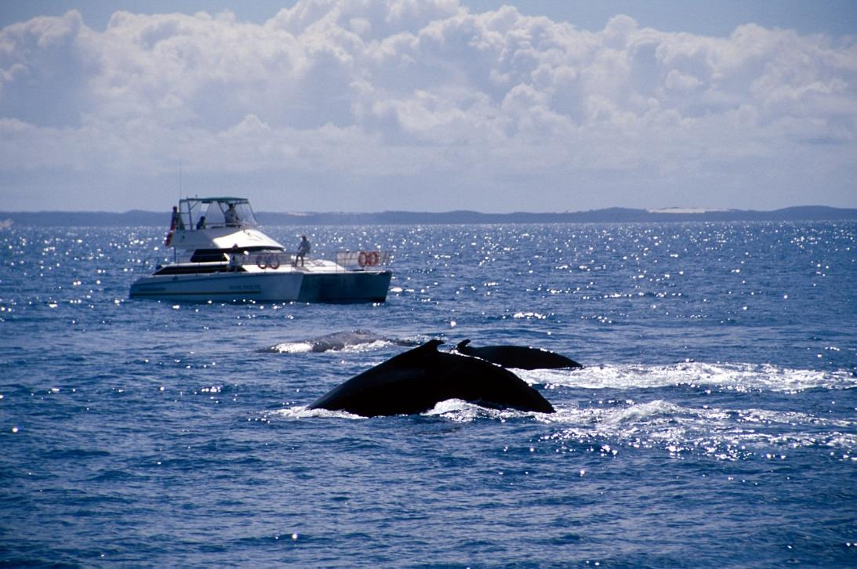

Commonwealth of Australia, 2017.

*Australian National Guidelines for Whale and Dolphin Watching 201*7 is licensed by the Commonwealth of Australia for use under a Creative Commons Attribution 4.0 International licence with the exception of the Coat of Arms of the Commonwealth of Australia, the logo of the agency responsible for publishing the report, content supplied by third parties, and any images depicting people. For licence conditions see: http://creativecommons.org/licenses/by/4.0/au/

This report should be attributed as ‘Australian National Guidelines for Whale and Dolphin Watching 2017, Commonwealth of Australia 2017’.

The Commonwealth of Australia has made all reasonable efforts to identify content supplied by third parties using the following format ‘© Copyright, [name of third party] ’.

Disclaimer

The views and opinions expressed in this publication are those of the authors and do not necessarily reflect those of the Australian Government or the Minister for the Environment and Energy.

Cover image: Whale watching in Hervey Bay, Queensland. © Robert Thorn

Contents

Introduction 4

Disturbed or Injured Whales and Dolphins 6

How to Use the National Guidelines 7

1—Requirements in Commonwealth waters 7

2—Additional management 7

Special Interest Animals 8

Watching Whales and Dolphins 9

Vessels 9

Part 1—Requirements for operating a vessel in Commonwealth waters 9

Part 2—Additional management considerations for vessels 13

Swimming 15

Part 1—Requirements for swimming in Commonwealth waters 15

Part 2—Additional management considerations for swimming and diving 15

Aircraft 17

Drones 17

Part 1—Requirements for operating aircraft in Commonwealth waters 18

Part 2—Additional management considerations for aircraft 19

Land-based Whale and Dolphin Watching 20

Feeding 20

Part 1—Feeding whales and dolphins in Commonwealth waters 20

Part 2—Additional management considerations for feeding 20

Touching cetaceans in Commonwealth waters 21

Noise 22

Operation of Vessels 22

Design of Whale and Dolphin Watching Vessels 23

# Introduction

Australia’s vast coastline provides many opportunities for people to watch whales and dolphins by boat, aircraft or from land.

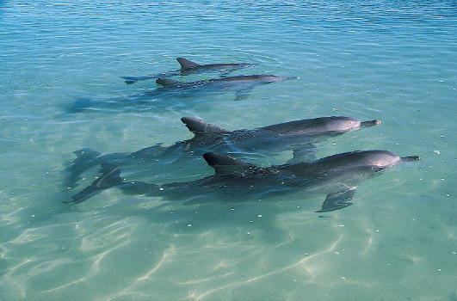  
Common bottlenose dolphins. Copyright – Ian Anderson

While dolphin watching tends to occur all year round, the highest intensity whale watching activities are focussed on humpback whales and southern right whales that migrate through our coastal waters from May until November.

In recent times, whale and dolphin watching has increased in popularity and it now presents an important economic opportunity for many coastal communities. To ensure this activity remains sustainable and minimises impacts on whales and dolphins, the Australian Government has established a legal regime under the Environment Protection and Biodiversity Conservation Act 1999 (EPBC Act) and *Environment Protection and Biodiversity Conservation Regulations 2000* (EPBC Regulations) that addresses the management of whale and dolphin watching in Commonwealth waters. The Australian Government works closely with state and territory governments and the Great Barrier Reef Marine Park Authority to help develop complementary management regimes in all Australian waters.

The Australian National Guidelines for Whale and Dolphin Watching 2017 (the national guidelines) replace the Australian National Guidelines for Whale and Dolphin Watching 2005. They have been developed in consultation with the state and territory governments and relevant stakeholders, such as the whale and dolphin watching industry, to ensure they are applicable across all Australian waters.

The purpose of the national guidelines is to:

* provide information to commercial operators and the general public on how they can watch whales and dolphins safely and consistently with the EPBC Act and EPBC Regulations which apply in Commonwealth waters
* encourage a consistent approach to whale and dolphin watching across all jurisdictions
* make recommendations to state and territory governments in relation to additional management measures to be applied in situations where there is a need to better protect either whales and dolphins or people. Typically this would occur in situations where there is a high level of whale and dolphin watching activity, where animals may be particularly sensitive to disturbance, or where new techniques are being proposed.

It is important to note that the state and territory governments must implement their own laws and guidelines to best suit their jurisdictions. In some cases, these will differ from the national guidelines and so it is the responsibility of the public and whale watching industry to be aware of the laws that apply in their specific location.

The EPBC Act and EPBC Regulations apply to whale watching undertaken in Commonwealth waters. Typically, the boundary for Commonwealth waters starts 3 nautical miles from the shore and extends to the edge of our exclusive economic zone at 200 nautical miles.

Figure 1 shows the extent of Commonwealth waters around Australia’s mainland and territories. State and territory regulations apply in the coastal waters adjacent to each state and territory.

Figure 1—A map showing the extent of Commonwealth waters and state and territory waters

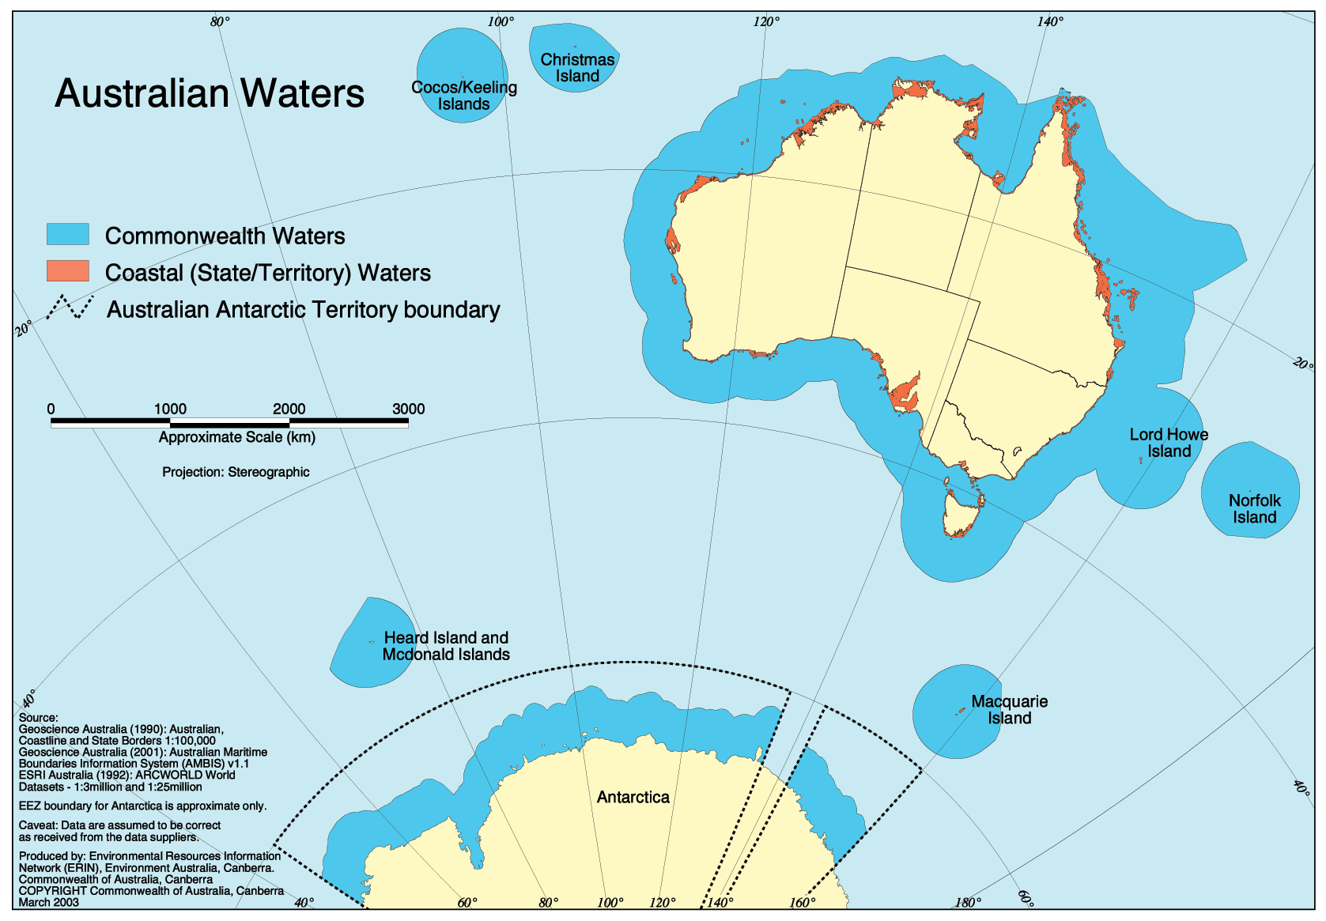

## Disturbed or Injured Whales and Dolphins

It is not always possible or desirable to get close to a whale or dolphin. Some animals may become disturbed by the presence of vessels, aircraft or people or may be injured, including through entanglement with fishing gear or marine debris. Disturbed and injured whales behave unpredictably and even aggressively and so it is important that they are not approached, except by authorised personnel.

The following may indicate that a whale or dolphin is disturbed or injured:

* moves away erratically and at speed
* stops feeding
* evidence of ropes, nets or buoys being attached to the animal
* the presence of lacerations
* changes in direction or speed of swimming
* hasty dives
* changes in breathing patterns
* increased time spent below the surface
* changes in body posture
* changes in acoustic behaviour
* aggressive behaviours, such as tail slaps and trumpet blows.

Whales and dolphins that are disturbed or injured may stop feeding or nursing their young. They may also alter their migration paths and become displaced from important habitats used for resting, breeding, calving or feeding.

For your safety, it is important that you do not approach a disturbed or injured animal and that you stay outside the caution zones outlined in the national guidelines if in a vessel or as a swimmer. Injured, stranded or entangled animals should be reported to the relevant authority. Contact details for reporting injured, stranded or entangled animals in the states and Northern Territory are provided below.

Table 1: State and territory contact details for reporting injured, stranded or entangled whales and dolphins.

|  |  |
| --- | --- |
| State/Territory | Contact details |
| New South Wales | NSW National Parks & Wildlife Service State Duty officer: (02) 9895 6444  ORRCA whale and dolphin rescue: (02) 9415 3333 (24 hours hotline) |
| South Australia | 24 hour FISHWATCH hotline: 1800 065 522 |
| Tasmania | Department of Primary Industries, Parks, Water and Environment  Marine Conservation Program Whale Hotline: 0427 942 537 |
| Victoria | Department of Environment Land Water and Planning  Whale and Dolphin Emergency Hotline: 1300 136 017 |
| Western Australia | Wildcare Helpline: (08) 9474 9055 |
| Queensland | RSPCA Qld: 1300 ANIMAL (1300 264 625) |
| Northern Territory | Marine Wild Watch hotline: 1800 453 941 |

# How to Use the National Guidelines

The national guidelines address the various ways people watch whales and dolphins, including from a vessel, an aircraft, while swimming and from shore. It also provides information on other issues associated with whale and dolphin watching, such as feeding, and touching animals, as well as managing noise.

Most sections in this document contain two parts. The first part of these sections provides a plain English version of the EPBC Regulations that apply to whale and dolphin watching in Commonwealth waters, while the second part outlines recommended management that may be applied in certain situations where a greater level of protection or an alternative management approach is needed.

## 1—Requirements in Commonwealth waters

When interacting with whales and dolphins, people must comply with the requirements of the EPBC Regulations that apply to whale and dolphin watching activities in Commonwealth waters.

These requirements are described in the standards outlined under Part 1 of the sections on watching whales and dolphins from vessels, from aircraft and while swimming and the section on feeding.

These standards have also largely been reflected in state guidelines and regulations. However, if you are whale and dolphin watching in state or territory waters you will need to be familiar with the relevant legislation that applies there since, in some cases, the requirements are different.

## 2—Additional management

Many species of whales and dolphins are resident in or dependent upon specific areas for their survival. In these areas, there is a greater potential for whale and dolphin watching to have a detrimental impact, which may include disruption of important behaviour or displacement from favoured habitat areas.

The Conservation Values Atlas ([www.environment.gov.au/webgis-framework/apps/ncva/ncva.jsf](http://www.environment.gov.au/webgis-framework/apps/ncva/ncva.jsf)) identifies Biologically Important Areas (BIAs) for some whale and dolphin species. BIAs are spatially defined areas where aggregations of individuals of a species are known to display biologically important behaviour such as breeding, foraging, resting or migration. For more information on BIAs visit the Department of the Environment and Energy’s website at: [www.environment.gov.au/marine/marine-species/bias](http://www.environment.gov.au/marine/marine-species/bias).

In areas such as BIAs, or where there is a substantial whale and dolphin watching industry, or when new techniques for watching whales and dolphins are being introduced, there may be a need to implement additional management measures. These measures may be applied through various administrative means including regulations, permits, licenses, management plans and codes of practice.

Additional management requirements may lead to different measures to those currently required under the EPBC Regulations, including the potential to allow closer interactions that are coupled with more stringent restrictions on other elements of an operation (e.g. limits on the time spent with animals, number of trips per day, area closures etc).

Additional management requirements will apply primarily to the commercial whale and dolphin watching industry. Under the EPBC Act and EPBC Regulations they may be implemented through the declaration of an Important Cetacean Habitat Area ( an area of important habitat for one or more species of whale or dolphin that requires enhanced protection), which then requires commercial operators to obtain a permit to undertake whale watching in that area. They may also be reflected in laws, guidelines and management plans adopted by the states or territories.

### Special Interest Animals

In some circumstances particular animals may require additional protection. Examples include predominately white whales and entangled animals, which often attract the attention of the media and members of the public. In order to prevent this attention from causing additional disturbance or distress to an animal, state and territory governments may impose different restrictions on vessels, aircraft and swimmers when approaching a special interest animal. It is recommended that vessels maintain a distance of at least 500m from ‘Special Interest Animals’, as required under Queensland legislation.

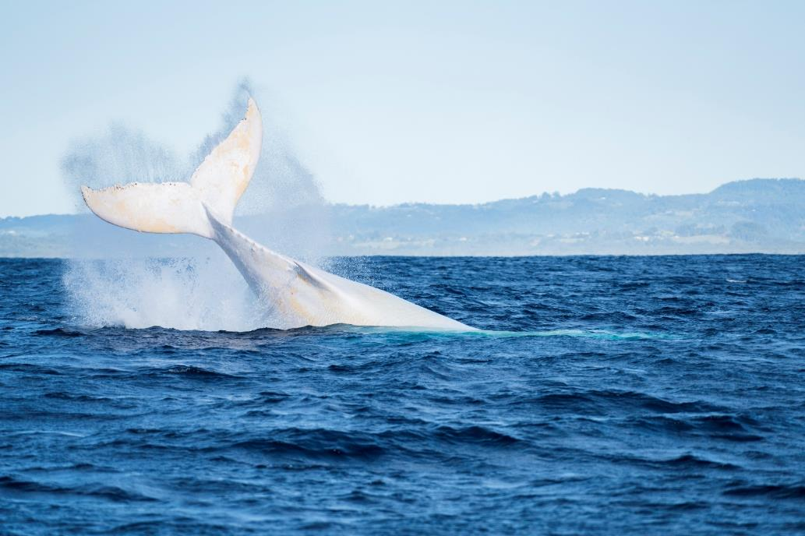  
Migaloo the albino humpback whale. Copyright - Craig Parry

# Watching Whales and Dolphins

To protect whales and dolphins and achieve ‘best practice’ in whale and dolphin watching, interactions must allow animals to move freely without being chased or harassed if they choose not to interact. The national guidelines stipulate approach distances and practices for watching whales and dolphins under different circumstances. If the whale or dolphin chooses to approach more closely the EPBC Regulations will not be breached. If, while approaching a whale or dolphin the animal shows signs of disturbance then the approach must be abandoned immediately.

## Vessels

One of the most common ways of watching a whale or dolphin is from a vessel. If vessels are appropriately designed and operated the impacts of whale and dolphin watching can be minimised. Vessels should be manoeuvred with care around whales and dolphins, and erratic vessel behaviour around animals should not occur. Responsible vessel operation, that allows the animals the choice to interact, will not only minimise impacts but may also provide people with a safer and more enjoyable experience.

### Part 1—Requirements for operating a vessel in Commonwealth waters

Certain vessel types, due to the noise they generate or the speed at which they travel, may lead to greater negative impacts. Due to this some vessels are prohibited from engaging in whale and dolphin watching. These are referred to as prohibited vessels.

***Prohibited vessels***

Vessels prohibited for use in whale and dolphin watching include all personal motorised watercraft (e.g. jet skis and underwater scooters), parasails, remotely operated craft, wing-in-ground effect craft, and hovercraft.

Prohibited vessels must not approach closer than 300m to any whale or dolphin. If a prohibited vessel unintentionally moves to within this distance it should slow down and avoid the whale or dolphin, moving away from the animal at a speed of less than 6 knots, to at least 300m.

***Allowable Vessels***

Vessels which may engage in whale and dolphin watching include all other motorised, paddle and/or sail craft (e.g. motorboats, yachts, kayaks, canoes, surf skis and inflatable craft).

***Approach Distances***

To operate allowable vessels consistent with the EPBC Regulations and minimise potential impacts on whales and dolphins, vessels must comply with the approach distances and operating procedures described in this section and summarised in Table 2.

Note, if a whale or dolphin surfaces in the vicinity of your vessel when you are travelling for a purpose other than whale and dolphin watching, take all care necessary to avoid collisions. This may include stopping, slowing down and/or slowly steering away from the animal.

***Whales***

Figure 2 illustrates the approach distances for vessels near adult whales. The no approach zone is within 100m to an adult whale; this is a zone of total vessel exclusion and also includes the area directly in front of or behind a whale out to 300m. Vessels must not enter the no approach zone and must not wait in front of the direction of travel of an animal or pod of animals.

Figure 2—Vessel approach distances for adult whales

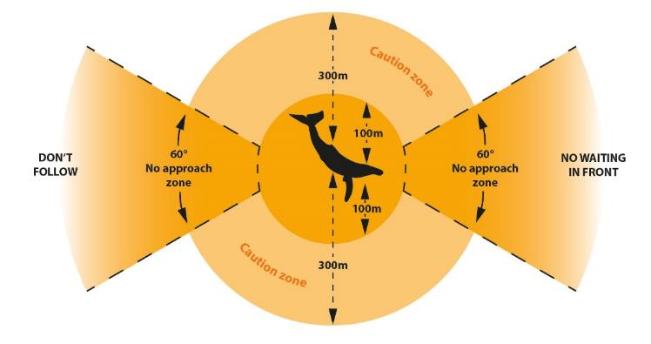

The caution zone is the area within 300m either side of a whale. No more than three vessels are allowed within the caution zone at any one time and vessels must operate at speeds of less than 6 knots within this zone.

Figure 3 illustrates the approach distances for vessels near whale calves. Vessels must not enter the caution zone when a calf is present. Vessels must not enter or remain in the caution zone of a whale if it shows signs of disturbance.

**Figure 3 illustrates the approach distances for vessels near whale calves.**

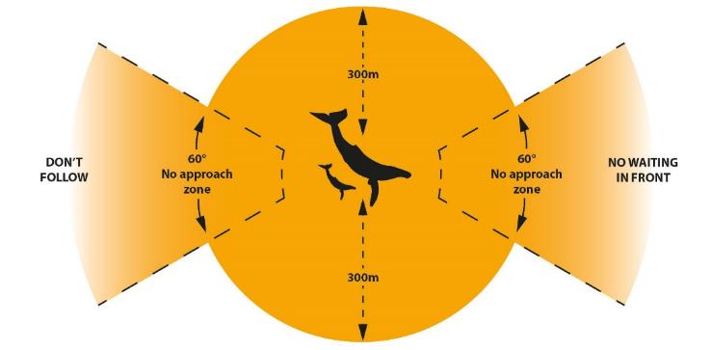

***Dolphins***

Figure 4 illustrates the approach distances for vessels near adult dolphins. The no approach zone is within 50m of an adult dolphin; this is a zone of total vessel exclusion and also includes the area directly in front of or behind a dolphin out to 150m. Vessels must not enter the no approach zone and must not wait in front of the direction of travel of an animal or pod of animals.

**Figure 4 – Vessel approach distances for adult dolphins**

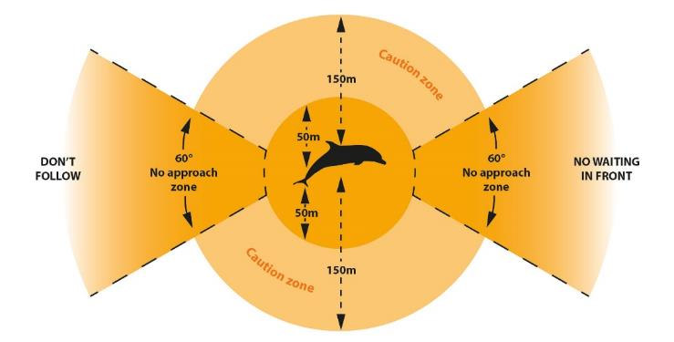

The caution zone is the area within 150m either side of a dolphin. No more than three vessels are allowed within the caution zone at any one time and vessels must operate at speeds of less than 6 knots within this zone.

Figure 5 illustrates the approach distances for vessels near dolphin calves. Vessels must not enter the caution zone when a calf is present. Vessels must not enter or remain in the caution zone of a dolphin if it shows signs of disturbance.

**Figure 5 - Vessel approach distances for dolphin calves**

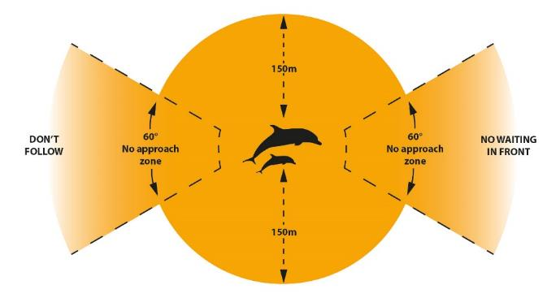

For the purposes of the national guidelines, a calf is defined as an animal which is less than half the length of the mother to which it usually remains in close proximity.

Table 2 – summary of vessel approach distances and operation

|  |  |  |
| --- | --- | --- |
| Requirements | Distance to an adult whale | Distance to an adult dolphin |
| No approach zone   * a zone of total vessel exclusion * no waiting in front of direction of travel * no following directly behind | Within  100 metres to the side  300m in front and to the rear | Within  50 metres to the side  150m in front and to the rear |
| Caution zone   * speed must be no more than 6 knots * maximum of 3 vessels * do not enter caution zone if animals are injured, stranded, entangled or distressed * **do not enter the caution zone if a calf is present** * do not enter if operating a prohibited vessel | Between  300 and 100 metres | Between  150 and 50 metres |
| Bow riding   * do not deliberately encourage bow riding * when animals are bow riding - do not change course or speed suddenly * if there is a need to stop – reduce speed gradually | | |

### Part 2—Additional management considerations for vessels

Recent research and experience shows that whale and dolphin watching from vessels has a relatively low impact on target animals when appropriate management measures, such as those described in these guidelines, are adhered to. There are, however, some situations where this is not the case and special management considerations may apply.

Whales

In some situations whale watching can have a greater impact on whales or pose an increased risk to human safety. Whales that are calving, accompanied by young, resting or feeding can be more sensitive to disturbance and so should not be approached.

Southern right whales use sheltered near-shore areas along the southern Australian coast. Their preference for remaining in these areas for relatively long periods of time and using shallow water makes them an obvious focus for whale watchers. Being so close to the coast also makes southern right whales more prone to disturbance, particularly when they are about to give birth or while nursing a calf. Being disturbed by a vessel may lead to the whales moving away into less suitable habitat or behaving aggressively. For this reason both commercial and recreational whale watching vessels should be extra vigilant when operating near southern right whales and other whale species that are remaining in an area to rest or nurse calves.

A number of whale species are known to feed in Australian waters and these include blue, brydes, humpback and killer whales. It is important that whale watching vessels do not interrupt feeding whales. If a vessel encounters a whale feeding it is recommended that it moves outside the caution zone to reduce the risk of disturbance.

If a particular location attracts a large number of whale watching vessels or is regularly frequented by resting, feeding or calving whales then additional management measures may need to be implemented. These can include:

* requiring boat skippers and owners to participate regularly in a certified training course
* limiting the number of boats that can offer commercial whale watching experiences
* limiting the time for interactions by commercial whale watching boats
* increasing no-approach distances

***Dolphins***

When dolphin watching is undertaken in enclosed bays and estuaries, where dolphins are restricted to relatively small areas or where there are a large number of both recreational and commercial vessels operating, additional management may be required to provide enhanced protection for dolphin populations. It is recommended that state and territory governments consider introducing a mechanism that involves authorising commercial activities through the use of permits or licenses, or the use of an industry code of conduct to enhance the protection of inshore dolphin populations. The following measures should be considered when establishing a management regime:

* requiring boat skippers and owners to participate regularly in a certified training course
* limiting the number of boats that can offer commercial dolphin watching experiences in a given area
* limiting the time for interactions by commercial dolphin watching boats
* increasing the no- approach distance to dolphins for all vessels to at least 100m, except where a permit, license or code of conduct allows for a closer approach
* closing important areas of habitat to all dolphin watching
* requiring a propeller guard on commercial dolphin watching boats
* implementing an independent monitoring program to determine the effectiveness of management measures
* raising awareness amongst the boating community and general public of the applicable regulations and threats (not just vessel disturbance) facing dolphin populations in heavily utilised waterways
* ongoing compliance activities.

CONFINED WATERWAYS AND CLOSE TO THE SHORE

In confined or crowded waterways such as bays, estuaries, channels and rivers it may not be possible for vessels to maintain the specified approach distances or the appropriate number of boats within the caution zone. Whale and dolphin watching should not be undertaken when approach distances cannot be maintained. If a vessel is inadvertently within the specified approach distance it should take all necessary caution to avoid whales and dolphins, including reducing vessel speed and posting extra lookouts. Do not trap, drive or corral animals.

Where possible and practical vessels should position themselves on the landward side of the whale or dolphin to prevent interactions with sandbars and shark nets.

**Whale and dolphin watching while fishing**When fishing is undertaken in conjunction with whale or dolphin watching all fishing lines should be reeled in and equipment stowed prior to engaging in whale and dolphin watching activities. This will reduce the risk of an entanglement should a whale or dolphin approach the boat.

## Swimming

Swimming (which includes snorkelling and diving) with a whale or dolphin may place both people and animals at risk. Risks to people include injury and possible death from forceful interactions with a whale or dolphin. The greatest risk to whales and dolphins is disturbance caused by the misuse of vessels and the inappropriate placement of people in the water, forcing animals to actively avoid interaction.

These impacts and risks may be minimised by ensuring that swim programs are only conducted by operators who are authorised by the relevant state, territory or Commonwealth agency. In addition permits may be issued that allow people to swim or dive with whales and dolphins for scientific or educational purposes.

Definition of a swimmer.  
A swimmer is a person who is entering or in the water.

### Part 1—Requirements for swimming in Commonwealth waters

Deliberately swimming (including snorkelling or diving) with whales and dolphins is not recommended unless under the authorisation of the relevant state, territory or Commonwealth agency. If a person is in the vicinity of a whale or dolphin:

* they must not enter the water closer than 100m to a whale or 50m to a dolphin, and must not approach closer than 30m to any whale or dolphin
* they are not in contravention of the EPBC Regulations if whales or dolphins approach or pass close to that person. If approached by a whale or dolphin a swimmer must move slowly to avoid startling the animal and must not attempt to touch it or swim towards it.

Vessels carrying swimmers must always abide by the requirements outlined under Part 1 for vessels, which includes the requirement to remain outside the caution zone of a pod when a calf is present.

### ***Part 2—Additional management considerations for swimming and diving***

Authorised swimming programs

In order to ensure the long-term sustainability and safety of swimming operations, commercial swim programs that involve close approaches to whales and dolphins by vessels and swimmers should include:

* authorisation from a relevant authority
* a comprehensive risk assessment and risk management plan
* an appropriately trained captain and guides
* an ongoing research program to monitor whale and dolphin responses to swimmers
* adaptive management to ensure compliance occurs and negative impacts are avoided.

Consideration should also be given to undertaking research prior to the development or expansion of operations. Research should focus on the biology and behaviour, seasonal requirements, and habitat requirements of the target population of whales or dolphins and be able to detect behavioural changes in response to swim-with activities.

Authorised swim programs may apply a different management regime than that specified in the EPBC Regulations because of more stringent restrictions on swimmer behaviour and increased management and oversight from the relevant authority. This may include allowing swimmers to enter the water closer than 100m from a whale or 50m from a dolphin.

Specific issues to be considered when developing or reviewing swimming operations include:

* the sensitivity of the target animals to disturbance. Species such as the southern right whale are not suitable due to their sensitivity to disturbance
* the management of swimmers if the behaviour of animals becomes boisterous
* limits on the number of vessels and swimmers
* the risk of vessel strike with a swimmer or whale
* maximum cumulative time with a pod, individual or population per day
* maximum time for each interaction
* time required between successive swim attempts
* establishment of no approach times (e.g. when the animals are likely to be feeding, resting etc)
* the need for temporal or spatial exclusion zones
* the locations swimmers can be placed in the water relative to the position of the target whales or dolphins
* the distance of swimmers to animals
* the risks associated with different techniques to manage swimmers such as mermaid lines or boom nets (for example long mermaid lines may pose an entanglement risk to whales or dolphins).

Vessels should be operated in accordance with the national guidelines or any other relevant regulations, codes of practice or restrictions. Vessels should not actively tow swimmers and no other vessel should be closer than 100m to a vessel conducting swims.

Swimming should not occur with whale or dolphin calves, or pods containing calves, animals that are feeding or with disturbed, injured or entangled whales or dolphins.

Attempts at swimming with whales or dolphins should stop if the animals show signs of disturbance or agitation.

|  |  |
| --- | --- |
| This photo shows six swimmers in the water with a humpback whale on Ningaloo Reef in Western Australia.  Swimmers in the water with a humpback whale on Ningaloo Reef, Western Australia. Copyright – K. Waples | This is an underwater photo of a dwarf minke whale.  Dwarf minke whale. Copyright Commonwealth of Australia (GBRMPA) |

## 

## Aircraft

Aircraft, including drones (unmanned aerial vehicles or remotely piloted aircraft) may disturb whales and dolphins due to their speed, noise, shadow, or downdraft in the case of helicopters. Aircraft should be operated in accordance with the provisions outlined below.

### Drones

Drones are considered to be aircraft and this means that people operating drones near whales and dolphins must abide by the requirements of the EPBC Regulations that apply to aircraft or the relevant marine park, state or territory legislation. The requirements under the EPBC Regulations are inconsistent with requirements for operating drones under the Civil Aviation Act 1988 and so a person who wishes to operate a drone in close proximity to a whale or dolphin will need to apply for a permit from the Department of the Environment and Energy (in Commonwealth waters), the relevant state or territory government or the Great Barrier Reef Marine Park Authority and, depending on the height the drone will be operated at, may also need approval from the Civil Aviation Safety Authority (CASA).

Details regarding the lawful operation of drones can be found on CASAs website at: [www.casa.gov.au/aircraft/landing-page/remotely-piloted-aircraft-system](https://www.casa.gov.au/aircraft/landing-page/remotely-piloted-aircraft-system)

Information regarding cetacean permits can be found on the Department of the Environment and Energy’s website at: [www.environment.gov.au/marine/marine-species/cetaceans/research-permits](http://www.environment.gov.au/marine/marine-species/cetaceans/research-permits)

### Part 1—Requirements for operating aircraft in Commonwealth waters

Helicopters (including gyrocopters)

As illustrated in Figure 6, a person operating a helicopter or gyrocopter in the vicinity of whales and dolphins must not:

* fly lower than 500m within a 500m radius of a whale or dolphin; and
* approach a whale or dolphin from head on.

Figure 6—Helicopter approach distances for whales and dolphins

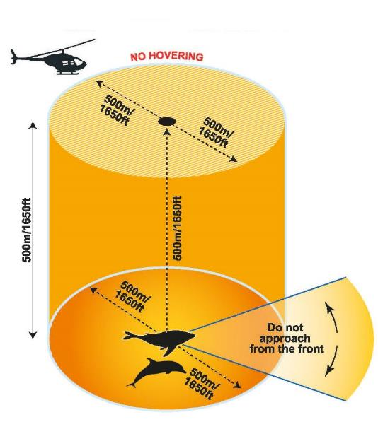

Other aircraft

As illustrated in Figure 7, a person operating any other airborne craft including drones, fixed wing aircraft, gliders, hang-gliders, hot air balloons and airships in the vicinity of whales and dolphins must not:

* fly lower than 300m within a 300m radius of a whale or dolphin
* approach a whale or dolphin from head on
* land on the water within 300m of a whale or dolphin.

**Figure 7—Aircraft approach distances for whales and dolphins**

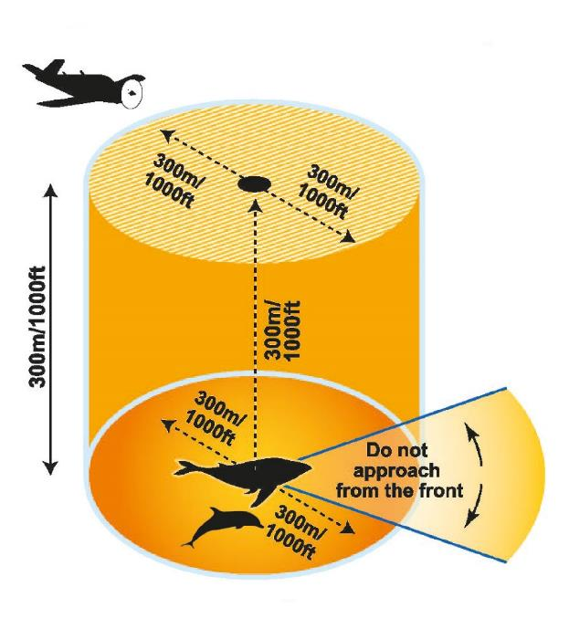

### Part 2—Additional management considerations for aircraft

In some instances such as for scientific or educational purposes, or commercial filming it may be necessary for aircraft to approach closer to a whale or dolphin than outlined in the EPBC Regulations or state and territory regulations. This may only occur under the authorisation of the relevant state, territory or Commonwealth authority. In these cases all aircraft must operate within the conditions of the authorisation.

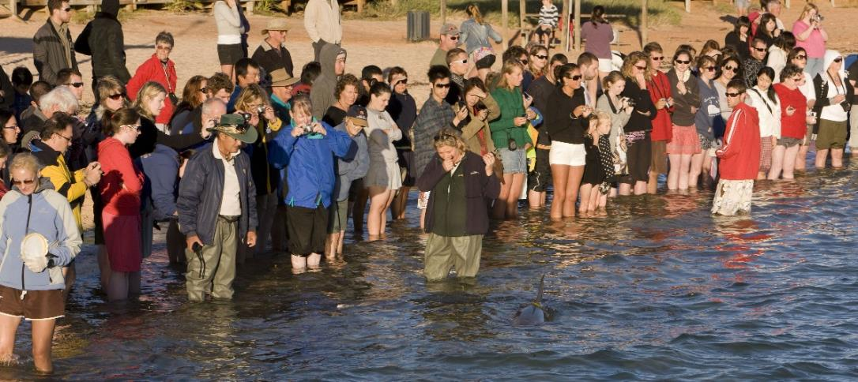  
Feeding dolphins at Monkey Mia in the Shark Bay World Heritage Area. Copyright Dragi Markovic

## Land-based Whale and Dolphin Watching

Watching from land causes the least disturbance to whales and dolphins. Cliffs and headlands can provide excellent vantage points for viewing many different species of whales and dolphins. It is important to be aware of the impact you may have on the environment and remember coastal dunes and headlands can be sensitive areas. At all times consider the safety of yourself and others and move cautiously around cliffs and rocky shores.

## Feeding

There are environmental, health and safety concerns associated with deliberate feeding of whales and dolphins. In most cases feeding by humans has been shown to have adverse effects, sometimes severe, on the whales and dolphins concerned. Feeding wildlife is illegal in most states and territories.

### Part 1—Feeding whales and dolphins in Commonwealth waters

A person must not deliberately feed or attempt to feed wild whales or dolphins. This includes throwing food or rubbish in the water in the vicinity of whales and dolphins, and feeding from vessels.

### Part 2—Additional management considerations for feeding

Feeding programs

Feeding is only permitted under existing programs authorised by the relevant Commonwealth, state or territory agency. In these cases, feeding programs must operate within the conditions of authorisation and permit compliance must be monitored regularly. There should be no further establishment or expansion of feeding programs. In the event an approved program needs to replace an animal then a risk assessment should be undertaken by the relevant state or territory government agency before approval is given to recruit a new animal.

The management of permitted feeding programs should include consultation with appropriately qualified stakeholders.

All existing feeding programs should be accompanied by ongoing research to monitor whale and dolphin responses to help track any changes in animal behaviour.

Touching cetaceans in Commonwealth waters

Touching whales and dolphins is illegal unless allowed under a relevant permit issued by the Minister for the Environment and Energy or another relevant authority. If you are approached by a whale or dolphin, avoid touching or sudden movements that might startle it and move away to a safe distance. Do not encourage interactions with a whale or dolphin.

STRANDED ANIMALS  
For the safety of both people and animals, people must avoid interacting with stranded animals unless under the guidance and approval of the relevant Commonwealth, state or territory management authority.All jurisdictions have laws that prohibit people, without approval, from interfering with whales or dolphins.  
  
If you come across a stranded animal please contact the relevant state or territory based authority using the contact details provided in Table 1.

**Habituated solitary dolphins**Sometimes solitary dolphins become habituated to people and their activities. This can lead to people feeding, touching or swimming with the animal, as they believe this is not in breach of regulations because the animal approached them. These interactions are not beneficial to the dolphin and puts the animal at greater risk of injury or death due to boat strike or entanglement. In addition these interactions are often in breach of state regulations

## Noise

Whales and dolphins have sensitive hearing and sound plays an important role in their communication, navigation and prey location. Noise that humans introduce into the environment can cause disorientation, mask important sounds or damage an animal’s hearing. It is very difficult to determine how whales and dolphins may react to a particular sound or how severe the effects may be, so production of noise, while whale and dolphin watching, should be minimised.

## Operation of Vessels

An important feature of noise generated by vessels is the rate at which noise changes, especially as it increases. Rapid increases in noise have a greater impact than slower changes. Vessels engaged in whale and dolphin watching should, where possible, be constructed to be as quiet as possible and follow the guidelines below:

* vessels should be left to drift out of gear but with engines running
* re-positioning and constant re-starting of engines should be minimised
* the starting and running of engines should avoid rapid changes in revolutions
* the departure of vessels should be controlled so that engine revolutions build up slowly
* vessels should avoid using the reverse gear
* vessel operators and passengers should not intentionally make any noise to attract whales or dolphins. This includes underwater playback of recorded whale or dolphin sounds or song and hitting the side of the boat.

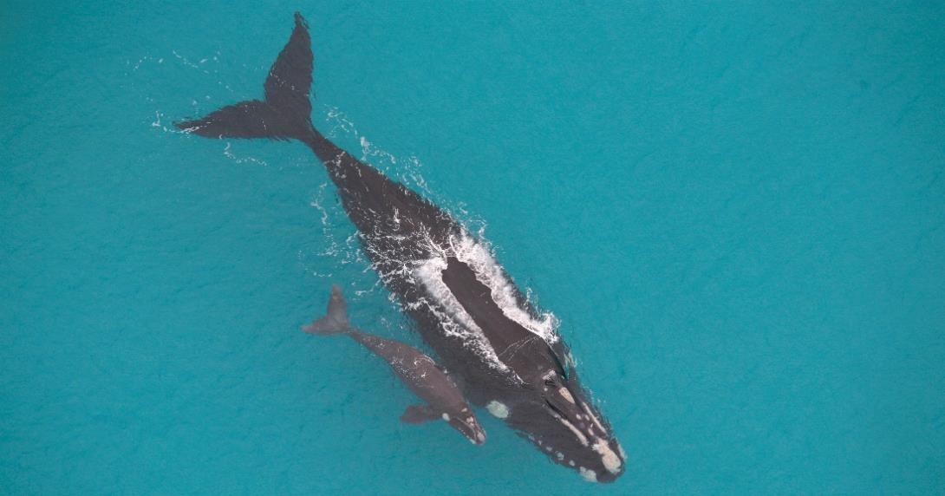  
A southern right whale and her calf. Copyright- J. Bannister

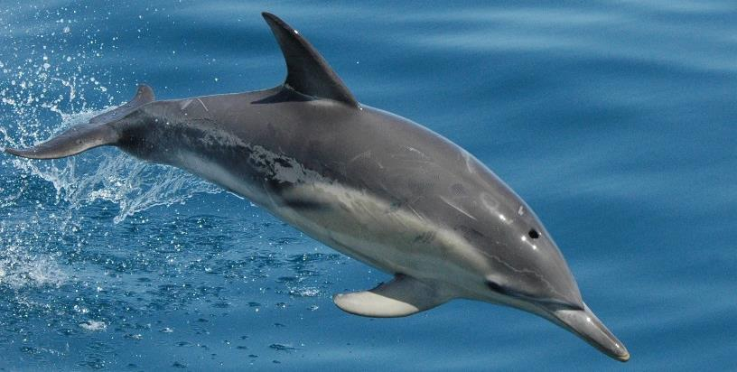  
Dolphin. Copyright L. Parsons

## Design of Whale and Dolphin Watching Vessels

Some vessels are better designed to minimise noise and so are more appropriate for whale and dolphin watching. Since commercial whale and dolphin operators spend a lot of time in close proximity to whales and dolphins, it is recommended that they use vessels that are as quiet as possible. Vessels whose primary use is whale and dolphin watching should, where possible, apply the [*International Maritime Organization Guidelines for the Reduction of Underwater Noise from Commercial Shipping to Address Adverse Impacts on Marine Life*](http://cetsound.noaa.gov/Assets/cetsound/documents/MEPC.1-Circ%20883%20Noise%20Guidelines%20April%202014.pdf).

Regular hull and propeller maintenance and removal of fouling is encouraged along with sound reduction features such as machinery isolation and low-cavitation propellers. Other aspects of boat design and operation that should also be considered are:

* the station keeping ability of the vessel. Poor station keeping and steerage require vessels to move often and use reverse gear
* poor viewing access for passengers requires skippers to frequently move a vessel to give all passengers good viewing access
* high windage in relation to draft requires frequent manoeuvring to account for the vessel drifting off station.

Skilled captains, who are familiar with whale and dolphin behaviour, can minimise noise and compensate for design limitations in a vessel.