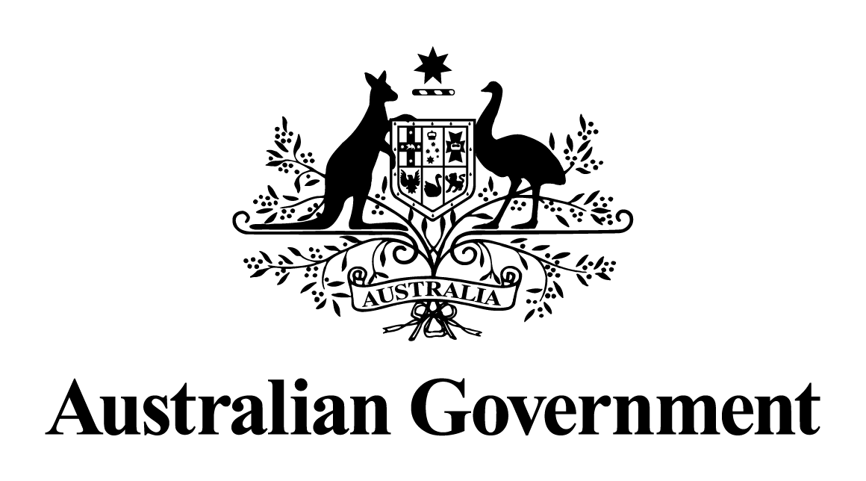

Australian Government response to the   
House of Representatives Standing Committee on Agriculture and Water Resources report:

Safe Keeping: Inquiry into the biosecurity of Australian honey bees

August 2017

On Thursday, 20 October 2016, the House of Representatives Standing Committee on Agriculture and Water Resources resolved to inquire into a matter arising from the 2014-15 annual report of the Department of Agriculture, namely the biosecurity of the Australian honey bee industry.

The Committee report *Safe Keeping: Inquiry into the biosecurity of Australian honey bees* was tabled on 2 March 2017.

The Australian Government would like to thank the Committee for its examination of this important issue and the recommendations it has presented for consideration.

## Recommendation 1

The Committee recommends that the National Bee Pest Surveillance Program implement, by 30 June 2017, the proposed enhanced Model 3 program, as outlined in the recent review and redesign. The appropriate proportion of funds should be provided by the relevant Commonwealth agencies involved in the program partnership.

The Government supports this recommendation in principle.

The National Bee Pest Surveillance Program delivers a range of surveillance activities at likely entry points of bee pests and pest bees, like Asian honey bees, throughout Australia. Its primary objective is to be an early warning system for new threats before they establish, to limit the scale and cost eradication, and to support trade by proving pest absence.

While Model 3 would reduce the number of standard catchboxes, it will provide an enhancement over Model 2 by further increasing port coverage, virus surveillance as well as increasing the number of remote and Asian honey bee catchboxes. It will also increase the amount of floral sweep netting. To ensure that Model 3 presents the best return on investment, it will be important to consider implementation of these improvements once the sensitivity of methodologies developed in Model 2 are tested and evaluated, which will be after 30 June 2017.

The Government contributed to the recent review and redesign of the National Bee Pest Surveillance Program and supports improvements to the program. Horticulture Innovation Australia and Plant Health Australia support the full implementation of Model 2 before moving to implementation of Model 3. The Australian Honey Bee Industry Council participated in the original review process through the steering committee and have been advised of the redesigned surveillance program through their participation on the National Bee Biosecurity Program Steering Committee.

The Government has also invested more than $587,000 for Plant Health Australia to make additional enhancements to the National Bee Pest Surveillance Program through the *Agricultural Competitiveness White Paper* to ensure it builds on its successes and continues to meet its core work.

This includes virus diagnostics and surveillance around a range of bee viruses that are exotic to Australia, increased Asian honey bee surveillance, improved and updated operational protocols, deploying improved remote catchboxes in remote locations or areas of high risk and the trial of Asian hornet traps at key ports.

## Recommendation 2

The Committee recommends that the Australian Government investigate the development of an easy to use smart phone application which may help members of the public to more easily contribute to eradication programs.

The Government supports this recommendation.

Several smart phone applications exist or are under development that could assist members of the public identify or report pest sightings and potentially facilitate public engagement in general surveillance as well as eradication programs. For example, the Western Australia Department of Agriculture and Food has developed a suite of applications called MyPestGuide which were promoted to members of the public for reporting pest detections during the recent tomato-potato psyllid response. Similarly, Plant Health Australia has been funded through a Rural Industries Research and Development Corporation (RIRDC) funded project to develop a bee pest identification application over the next two years.

The Australian Department of Agriculture and Water Resources will raise this matter with Plant Health Australia as the custodian of the Emergency Plant Pest Response Deed and managers of the National Bee Pest Surveillance Program.

## Recommendation 3

The Committee recommends that the Australian Government immediately initiate the necessary research and development that will allow the efficiency of the National Bee Pest Surveillance Program to be assessed, with a view to the development of any program refinements, adjustments or modifications. The rigorous statistical analysis of all methodologies should be the highest priority, with particular focus on the effectiveness or optimisation of standard and remote catch boxes. The research and analysis should aim to be completed by June 2018.

The Government supports this recommendation in principle.

There are surveillance data capture and management methods already in place that will enable efficiency of the National Bee Pest Surveillance Program to be assessed. The redesigned Model 2 program will need to be operational for a period of time before any statistical analysis of methodologies can be conducted. The timeframe must, therefore, take into account an initial period of data capture and will not be able to be completed by June 2018.

## Recommendation 4

The Committee recommends that the Australian Government complete the analysis of pest bee risk ratings for the Australian ports that do not have such ratings. The assessment should include airports, and it should also include pre-embarkation inspections and processes at various ports. The assessment should be completed by the end of 2017 and a copy of the completed assessment provided to the Committee.

The Government supports this recommendation.

Plant Health Australia is undertaking preliminary scoping of the activities required to complete an analysis of pest bee risk ratings for the Australian ports that do not have such ratings. A timeframe for the completion of the analysis of these ratings will be known once the preliminary scoping work is completed.

## Recommendation 5

The Committee recommends that the Australian Government undertake a detailed analysis of the smuggling of bees into Australia. The analysis should include, but not be limited to, the total number of incidents, the percentage of incidents where pests were discovered, the potential for further incursions, and how to prevent, detect or combat such incidents. A copy of the analysis should be provided to the Committee upon completion.

The Government supports this recommendation.

The Government has systems in place to allow the importation of queen bees and bee semen from specific overseas countries. This helps mitigate the risk of bee smuggling by providing a legal pathway for the importation of new genetic material from overseas. Australia also has systems in place to increase our protection from introduced bee pests and diseases such as *Varroa* mites including:

* incursion prevention systems, which include the requirement for all vessels arriving into Australia from overseas to provide the department with a pre-arrival report so that a biosecurity risk assessment of the vessel can be undertaken prior to its arrival;
* cargo can only be imported to Australia under approved, strict biosecurity conditions that effectively manage pest and disease risks;
* inspections at the border to intercept smuggling and reduce the risk of entry of foreign bees and any pests and diseases they carry;
* early detection systems, such as general surveillance activities at airports, seaports, and premises under approved arrangements;
* the National Bee Pest Surveillance Program, which uses sentinel hives, catchboxes and other methods to detect exotic bees and bee pests; and
* established emergency response procedures to address any detections of exotic bees or associated pests onshore.

The department responds to all reports of bee smuggling and has taken enforcement action where this has been proven to occur, such as the successful prosecution of a New South Wales beekeeper in 2000 after being detected trying to smuggle queen bees into Australia that were concealed in pens. The department has undertaken an investigation into a number of potential importation pathways to determine their vulnerability to abuse. A number of pathways have been examined and no instances of illegal bee smuggling have been detected as part of the investigation.

## Recommendation 6

The Committee recommends that the Australian Government, in conjunction with domestic and possibly international industry partners, initiate research and development into selective breeding of honey bees that are resistant to pests and diseases that may have a detrimental effect on the Australian honey bee industry.

The Government supports this recommendation.

The Australian Government and industry jointly invest in honey bee research through the rural research and development system. Research and development levies on honey and pollination-dependent industries are supported by matching Commonwealth funding. Horticulture Innovation Australia Limited and RIRDC in consultation with industry stakeholders determine research priorities and project funding in the interests of the honey bee and pollination-dependent industries respectively.

A pilot project by RIRDC on genetic evaluation of Australian honey bees has shown there is real potential for genetic improvement of production and health traits in Australian honey bees. Selective breeding is being done in Australia to improve bee and hive hygiene which may aid in defence against pests and diseases. It is important to note though that selective breeding of bees resistant to exotic pests and diseases would be more appropriate to be undertaken outside Australia due to the inherent biosecurity risks involved.

An efficient and cost-effective approach to improve Australia’s honey bee stock would be to utilise the resistant lines of bees that are already available through overseas breeding programs. Import conditions are currently available to facilitate the introduction of these improved bee genetics to Australia.