|  |
| --- |
| Asian citrus psyllid (*Diaphorina citri*) |

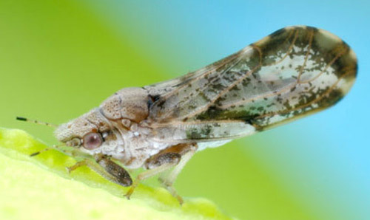

**Fig. 1** Adults feed on the underside of leaves and appear angled at about 45° to the surface (Jeffrey Lotz, FDACS, Division of Plant Industry).

**Likely mode of entry**

Importation of citrus plants and budwood pose the greatest threat of introduction of this insect and the important bacterial plant disease (huanglongbing) that it vectors. Fresh curry leaves and kaffir lime leaves may also be infested. Commercially produced fruit which has been brushed, washed with leaves and stems removed and has gone through a packing house process is not considered to pose a risk.

**Signs of infestation (Figures 1–4)**

Feeding damage from Asian citrus psyllid causes premature leaf drop, curled leaves and twisted young shoots which may be covered in honeydew and sooty mould. Examine new flushing growth for adults, nymphs and eggs, while adults are more likely to be underneath mature leaves. Look for the white, waxy threads from nymphs, the small immature stages (under 2 mm) which are ovoid and may be pale yellow/orange or brown, and the mottled brown adults (≈4 mm) which adopt a “head down, tail up” posture.

**Host range**

Able to feed on many species within the Rutaceae, preferring all *Citrus* spp. cultivars (e.g. orange, mandarin, grapefruit, lemon, lime, tangelo, kumquat, pomelo, trifoliate orange and native species), as well as most forms of mock orange (*Murraya* spp.) and curry leaf (*Bergera koenigii*, formerly known as *Murraya koenigii*).

**Biology (Figures 1–4)**

***Eggs*:** 0.3 mm long, almond-shaped; pale when laid, turning yellow then orange; laid in groups on buds, young tips and leaf crevices. ***Nymphs*:** five instars (stages), from 0.25–1.7 mm long; body yellow to brown, with red eyes and increasingly large wing pads; produce white, thread-like, waxy secretions. ***Adults*:** 3–4 mm long; head light brown, body mottled brown dusted with a whitish waxy secretion. Antennae yellow with the two terminal segments black. Forewings mottled, broader in the apical half which has a brown band extending around most of the periphery.

Females can lay more than 800 eggs, and up to 30 generations per year is possible. Asian citrus psyllid is an important vector of huanglongbing, the devastating bacterial plant disease also known as citrus greening.

**Distribution**

Native to southern Asia, and spreading further through the Middle East, Africa, the Americas, and some Pacific islands, especially those with close associations with the USA, and Papua New Guinea. Not present in Australia.

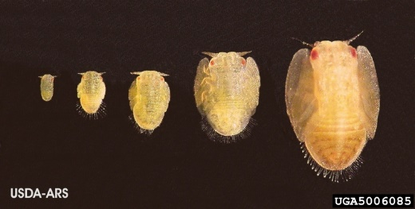

**Fig. 2** Nymphs of the Asian citrus psyllid (David Hall, USDA ARS, Bugwood.org).

**Fig. 3** Eggs are tiny, yellowish, almond-shaped and laid in batches on new growth or leaf crevices (David Hall, USDA ARS, Bugwood.org).

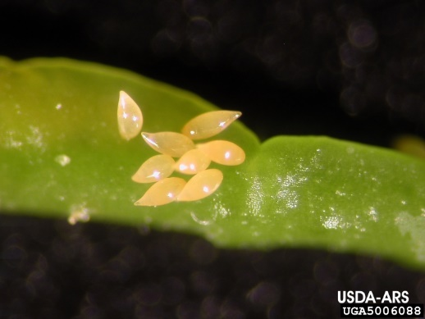

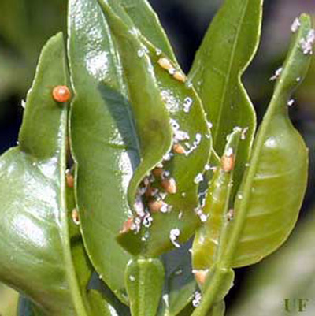

**What to do if you find suspect Asian citrus psyllid**

**Department officers:** Contain the risk, collect insect specimens into a vial containing 80% ethanol and deliver to a department entomologist immediately.

**Industry and the public:** **SEE. SECURE. REPORT.**

Secure the goods to limit movement and immediately report your detection to the Department of Agriculture, Fisheries and Forestry on **1800 798 636**.

**Fig. 4** Young citrus leaves with white, waxy, thread-like secretions and nymphs of the Asian citrus psyllid (Douglas L. Caldwell, University of Florida).