Australian Standards for the Export of Livestock: rejection criteria guidebook 2.0

Sheep and goats

© Commonwealth of Australia 2024
Ownership of intellectual property rights
Unless otherwise noted, copyright (and any other intellectual property rights) in this publication is owned by the Commonwealth of Australia (referred to as the Commonwealth).
Creative Commons licence
All material in this publication is licensed under a Creative Commons Attribution 4.0 International Licence except content supplied by third parties, logos and the Commonwealth Coat of Arms.

Cataloguing data
This publication (and any material sourced from it) should be attributed as: DAFF 2024, Australian Standards for the Export of Livestock: rejection criteria guidebook – sheep and goats, Department of Agriculture, Fisheries and Forestry, Canberra. CC BY 4.0.
This publication is available at Australian Standards for the Export of Livestock – DAFF (agriculture.gov.au).
Department of Agriculture, Fisheries and Forestry
GPO Box 858 Canberra ACT 2601
Telephone 1800 900 090
Web agriculture.gov.au
Disclaimer
The Australian Government acting through the Department of Agriculture, Fisheries and Forestry has exercised due care and skill in preparing and compiling the information and data in this publication. Notwithstanding, the Department of Agriculture, Fisheries and Forestry, its employees and advisers disclaim all liability, including liability for negligence and for any loss, damage, injury, expense or cost incurred by any person as a result of accessing, using or relying on any of the information or data in this publication to the maximum extent permitted by law.
Acknowledgements
The department would like to thank the Australian Accredited Veterinarians whose valuable contributions made this guidance material possible. Contributors included Tony Brightling, Holly Ludeman and Rob McPherson.
The department would also like to thank the team at the National Animal Disease Information Service, United Kingdom, for permitting us to use a selection of their images.
Acknowledgement of Country
We acknowledge the Traditional Custodians of Australia and their continuing connection to land and sea, waters, environment and community. We pay our respects to the Traditional Custodians of the lands we live and work on, their culture, and their Elders past and present.
Contents
Glossary vii
Introduction 1
ASEL rejection criteria for all species by sea 2
ASEL rejection criteria for all species by air 4
General requirements 6
Pregnancy status not confirmed as appropriate for export 6
Lactating animals/lactating animals with young at foot 7
Animals displaying clinical signs of infectious or contagious disease or external parasites, including viral diseases 7
Animals showing signs of injury such as but not limited to fractures or swelling 8
Systemic conditions 11
Body condition score not appropriate for export (such as emaciated or over-fat) 11
Anorexia (inappetence or ‘shy feeders’) 12
Uncoordinated, collapsed, weak 13
Unwell, lethargic, dehydrated/ill-thrift 14
Gastrointestinal system 16
Dysentery or profuse diarrhoea 16
Bloat 17
Musculoskeletal system 18
Abnormal gait or lameness of any kind 18
Abnormal soft tissue or bony swellings 19
Nervous system 22
Nervous symptoms such as head tilt, circling, incoordination 22
Abnormal or aggressive behaviour/intractable or violent 22
External/skin 24
Generalised papillomatosis or generalised ringworm or dermatophilosis 24
Generalised skin disease or infection 25
External skin cancer 27
Lacerations that penetrate the full thickness of the dermis or are likely to affect the health or welfare of the animal 28
Discharging wounds or abscesses 29
Cutaneous myiasis (flystrike) 30
Posthitis (pizzle rot in sheep) 31
Blood/abnormal discharge from reproductive tract (vulva/prepuce) 32
Visible external parasites 33
Head 35
Blindness in 1 or both eyes 35
Cancer eye 36
Keratoconjunctivitis 37
Excessive salivation 38
Nasal discharge consistent with signs of contagious or infectious disease 38
Coughing consistent with signs of a contagious or infectious disease 39
Respiratory distress or difficulty breathing 39
Sharp horns, horns that could injure the animal or other animals, horns that could restrict access to feed or water, bleeding and/or not fully healed horn stumps, horns longer than 1 full curl 40
Scabby mouth 41
Other 43
Disparities in sex, size, weight or age that could cause an issue with the health or welfare of the animals (redraft animals in this case) 43

Figures
Figure 1 Example of a ewe that gave birth – the ewe was loaded with a line of wethers 7
Figure 2 Secondary infection from flystrike 8
Figure 3 Scabby mouth 8
Figure 4 Nasal and ocular discharge 8
Figure 5 Swollen left hock 9
Figure 6 Injury to right hock 9
Figure 7 Swollen joint 9
Figure 8 Injury to left carpus, unable to weight bear 10
Figure 9 Emaciated sheep 11
Figure 10 Example of a clear depression in the paralumbar fossa 12
Figure 11 Emaciated sheep 13
Figure 12 Sheep in recumbent position, unwilling to stand 14
Figure 13 Animal showing discolouration of the sclera and mucus membranes 14
Figure 14 Animal with evidence of faecal staining associated with diarrhoea 16
Figure 15 Overgrown hooves causing lameness 18
Figure 16 Abnormal, ulcerated swelling on the right hock/tarsal joint and lameness 19
Figure 17 Injury to left carpus, unable to weight bear 19
Figure 18 Goat with swollen carpal joints 20
Figure 19 Foot abscess 20
Figure 20 Various abnormal facial swellings 21
Figure 21 Swollen hock 21
Figure 22 Sheep showing signs of stargazing 22
Figure 23 Classification of sheep body regions 24
Figure 24 Dermatophilosis in sheep 25
Figure 25 Classification of sheep body regions 26
Figure 26 Evidence of facial eczema showing redness, inflammation, oedema and exposure of underlying tissue 26
Figure 27 Photosensitisation along left side of body 26
Figure 28 Chronic photosensitisation with fibrosed ears 27
Figure 29 Photosensitisation (or burn) on back 27
Figure 30 Irregular legions around the eye 28
Figure 31 Vulval cancer 28
Figure 32 Severe laceration 29
Figure 33 Open wound on hock 29
Figure 34 Discharging abscess on sheep 30
Figure 35 Flystrike of the belly (body strike) 31
Figure 36 Flystrike of the breech (breech strike) 31
Figure 37 Swollen prepuce of sheep 32
Figure 38 Pizzle rot 32
Figure 39 Purulent discharge from vulva 33
Figure 40 Sheep with lice infestation 33
Figure 41 Blind sheep with corneal opacity, separate from mob 35
Figure 42 Blind sheep separated from rest of mob 36
Figure 43 Evidence of cancerous masses around eye 36
Figure 44 Clinical presentation and grading system of KCV 37
Figure 45 Sheep with clinical signs of KCV – inspection is required to determine whether treatment or rejection is appropriate 38
Figure 46 Sheep with excessive bilateral nasal discharge and corneal oedema 39
Figure 47 Horn of shape and direction that is causing damage to the eye region 41
Figure 48 Sheep with scabby mouth lesions around lips and nostril 42

Tables
Table 1: Rejection criteria for all species by sea 2
Table 2: Rejection criteria for all species by air 4

Maps
Map 1 Arabian Sea and Red Sea 11

Glossary
Term | Definition
Australian Standards for the Export of Livestock (ASEL) | The ASEL sets the requirements for exporting livestock from Australia by sea and air. The standards outline the minimum animal health and welfare conditions exporters must meet.
Blepharospasm | Spasm of the eyelids.
Conjunctiva | Membrane that covers the front of the eye. It is transparent in the central portion, where it is specialised to form the covering of the cornea.
Cornea | Clear part at the front of the eye.
Depression | A reduction or lowering in the animal’s activity or consciousness.
Epiphora | Tears from one or both eye(s) that is unable to pass down the tear duct to the inside of the nose. Can be due to blocking of the tear duct or inflammation of cornea or conjunctiva.
Inflamed | Reaction to tissue injury. Shows signs of heat, pain, redness, swelling and loss of function.
Intractable | Difficult or impossible to control.
Intraocular | Within the eyeball.
Mucoid | Involving, resembling, or of the nature of mucus.
Mucopurulent | Containing a mixture of mucus and pus.
Neovascularisation | The development of new blood vessels, especially in tissues where circulation has been impaired by trauma or disease.
Opacity | Lacking transparency or translucence.
Ophthalmalgia | Eye pain.
Photophobia | Sensitive to light/sunlight.
Recumbency | Lying down and a failure to get up.
Ruptured globe | Burst eyeball.
Sclera | Outermost hard fibrous coat of the eye, also known as the ‘whites of the eye(s)’.
Tympany | A hollow drum-like sound that is produced when a gas-containing cavity is tapped sharply.

Introduction
The Australian Standards for the Export of Livestock (ASEL) sets the minimum animal health and the Australian Standards for the Export of Livestock (ASEL) outlines criteria that, when met, deem an animal ineligible for export. These criteria are termed rejection criteria. Rejection criteria should be understood and used in all parts of the supply chain from farm sourcing, selection and during quarantine/isolation preparation.
This Rejection Criteria Guidebook aims to:
- provide clarification and technical information to users of ASEL (government and non-government) for the selection of export livestock to promote the consistent application of rejection criteria
- improve welfare outcomes for export livestock through better management prior to loading
- provide clear guidelines and images for use by all supply chain stakeholders around livestock that are not suitable for export or to enter the export supply chain.
This guidebook is intended to be a living document that is expanded and improved over time. We ask that if you have photographs or videos of animals that could be included as rejection examples, please contact ASELreview@agriculture.gov.au. If you have comments or feedback on the text or the layout, please let us know.
As this is a living document, we recommend you access the guidebook via the weblink rather than download your own copy.
This is guidance material only and is not intended to replace any state, territory or Australian animal welfare standards or fit to load guidance.
Where a notifiable animal disease is suspected, there is an obligation to report this to government authorities.
Veterinarians should use their discretion when assessing an animal’s eligibility for export.

ASEL rejection criteria for all species by sea
Table 1: Rejection criteria for all species by sea
Category | Rejection criteria
General requirements | Sheep wool or hair longer than 25 mm ª
 | Failure to meet importing country requirements including sex or breed if specified
 | Pregnancy status not confirmed as appropriate for export
 | Lactating animals/lactating animals with young at foot
 | Viral diseases such as scabby mouth or infectious bovine rhinotracheitis
 | Animals displaying clinical signs of infectious or contagious disease or external parasites
 | Animals showing signs of injury such as but not limited to fractures or swelling
Systemic conditions | Body condition score not appropriate for export (such as emaciated or over-fat)
 | Anorexia (inappetence or ‘shy feeders’)
 | Uncoordinated, collapsed, weak
 | Unwell, lethargic, dehydrated
 | Ill-thrift
Gastrointestinal system | Dysentery or profuse diarrhoea
 | Bloat
Musculoskeletal system | Abnormal gait or lameness of any kind
 | Abnormal soft tissue or bony swellings
Nervous system | Nervous symptoms such as head tilt, circling, incoordination
 | Abnormal or aggressive behaviour/intractable or violent
External/skin | Generalised papillomatosis or generalised ringworm or dermatophilosis
 | Generalised and extensive buffalo fly lesions
 | Generalised skin disease or infection
 | External skin cancer
 | Lacerations that penetrate the full thickness of the dermis or are likely to affect the health or welfare of the animal
 | Discharging wounds or abscesses
 | Cutaneous myiasis (flystrike)
 | Balanitis (pizzle rot in sheep)
 | Blood/abnormal discharge from reproductive tract (vulva/prepuce)
 | Visible external parasites
Head | Blindness in 1 or both eyes
 | Cancer eye
 | Keratoconjunctivitis (pink eye)
 | Excessive salivation
 | Nasal discharge consistent with signs of a contagious or infectious disease
 | Coughing consistent with signs of a contagious or infectious disease
 | Respiratory distress or difficulty breathing
 | Sharp horns
 | Horns that could injure the animal or other animals
 | Horns that could restrict access to feed or water
 | Bleeding and/or not fully healed horn stumps or broken antlers
 | For sheep, horns longer than 1 full curl ª
 | For cattle, horns longer than 12 cm ^{b}
 | Scabby mouth
Other | Groups of animals with unusual mortalities
 | Disparities in sex, size, weight or age that could cause an issue with the health or welfare of the animals (redraft animals in this case)
Note: For some rejection criteria, management procedures may occur after sourcing so livestock meet eligibility criteria at the time of export. a Unless otherwise provided in a relevant management plan approved in writing by the department. b Horns may be longer than 12 cm if they are pointing downwards parallel to the face or unless otherwise provided for in a relevant management plan approved in writing by the department.

ASEL rejection criteria for all species by air
Table 2: Rejection criteria for all species by air
Category | Rejection criteria
General requirements | Failure to meet importing country requirements including sex or breed if specified.  Pregnancy status not confirmed as appropriate for export  Viral diseases such as scabby mouth or infectious bovine rhinotracheitis  Animals displaying clinical signs of infectious or contagious disease or of external parasites  Animals showing signs of injury such as but not limited to fractures or swelling  Evidence of imminent parturition
Systemic conditions | Body condition score not appropriate for export (such as emaciated or over-fat)  Anorexia (inappetence or ‘shy feeders’)  Uncoordinated, collapsed, weak  Unwell, lethargic, dehydrated  Ill-thrift
Gastrointestinal system | Dysentery or profuse diarrhoea  Bloat
Musculoskeletal system | Abnormal gait or lameness of any kind  Abnormal soft tissue or bony swellings
Nervous system | Nervous symptoms such as head tilt, circling, incoordination  Abnormal or aggressive behaviour/intractable or violent
External/skin | Generalised papillomatosis or generalised ringworm or dermatophilosis  Generalised and extensive buffalo fly lesions  Generalised skin disease or infection  External skin cancer  Lacerations that penetrate the full thickness of the dermis or are likely to affect the health or welfare of the animal  Discharging wounds or abscesses  Cutaneous myiasis (flystrike)  Balanitis (pizzle rot in sheep)  Blood/abnormal discharge from reproductive tract (vulva/prepuce)  Visible external parasites
Head | Blindness in 1 or both eyes  Cancer eye  Keratoconjunctivitis (pink eye)  Excessive salivation  Nasal discharge consistent with signs of a contagious or infectious disease  Coughing consistent with signs of a contagious or infectious disease  Respiratory distress-difficulty breathing  Sharp horns  Horns that could injure the animal or other animals  Horns that could restrict access to feed or water  Bleeding and/or not fully healed horn stumps or broken antlers  For sheep, horns longer than 1 full curl ª  For cattle, horns longer than 12 cm ^{b}  Scabby mouth
Other | Groups of animals with unusual mortalities  Disparities in sex, size, weight or age that could cause an issue with the health or welfare of the animals (redraft animals in this case)
Note: For some rejection criteria, management procedures may occur after sourcing so livestock meet eligibility criteria at the time of export. a Unless otherwise provided in a relevant management plan approved in writing by the department. b Horns may be longer than 12 cm if they are pointing downwards parallel to the face or unless otherwise provided in a relevant management plan approved in writing by the department.

General requirements

Pregnancy status not confirmed as appropriate for export

Reject if:
- The required certification for an animal cannot be provided (see Considerations).

Considerations:
Female feeder or slaughter goats and sheep (where sheep weigh 40 kg or more or are a fat-tailed breed) by sea or air require the following:
- Pregnancy certificate by competent pregnancy tester stating:
  - name and signature
  - attestation to current experience and skill in sheep/goat pregnancy diagnosis
  - not detectably pregnant
  - method used (ultrasound)
  - animal identification (can be mob based)
  - date of procedure (within 30 days of export).
Female breeder sheep/goats by sea require the following:
- Pregnancy certificate by competent pregnancy tester stating:
  - name and signature
  - attestation to current experience and skill in sheep/goat pregnancy diagnosis
  - not detectably pregnant, or pregnant and number of days pregnant
  - method used (ultrasound foetal measurement)
  - individual animal identification numbers
  - date of procedure (within 30 days of export).
Important: Check the number of days pregnant and confirm:
Sheep/goats must be max. 100 days pregnant at scheduled discharge date.
Note: Errors can occur on farm, for example female sheep tagged as male sheep, and thus having an unknown pregnancy status. Lambs are uncommonly born on board vessels in reported all-wether consignments. Supply chain personnel undertaking inspection processes should be aware of this, and if female sheep are identified in mobs of wethers, this should be addressed (e.g. pregnancy test if required or remove from consignment).
Female breeder sheep/goats by air require the following:
- Pregnancy certificate by competent pregnancy tester stating:
  - name and signature
  - attestation to current experience and skill in sheep/goat pregnancy diagnosis
  - not detectably pregnant, or pregnant and number of days pregnant
  - method used (ultrasound foetal measurement)
  - individual animal identification numbers
  - date of procedure (within 60 days of export).
Important: Check the number of days pregnant and confirm:
Sheep/goats must be max. 100 days pregnant at scheduled discharge date (unless under a last third of pregnancy management plan).

Lactating animals/lactating animals with young at foot

Technical information:
- Lactation is the secretion of milk by the mammary glands.
- When lactating, there is increased potential for infection to penetrate the teat duct, which is an important consideration in export animals.
Note: Lactating animals with young at foot are not permitted to be exported by sea.

Reject if:
- The animal has evidence of lactation (unless under a livestock with young at foot management plan (air only)) e.g. milk dripping from teats, engorged/ distended mammary glands.

Rejection examples:
Figure 1 Example of a ewe that gave birth – the ewe was loaded with a line of wethers
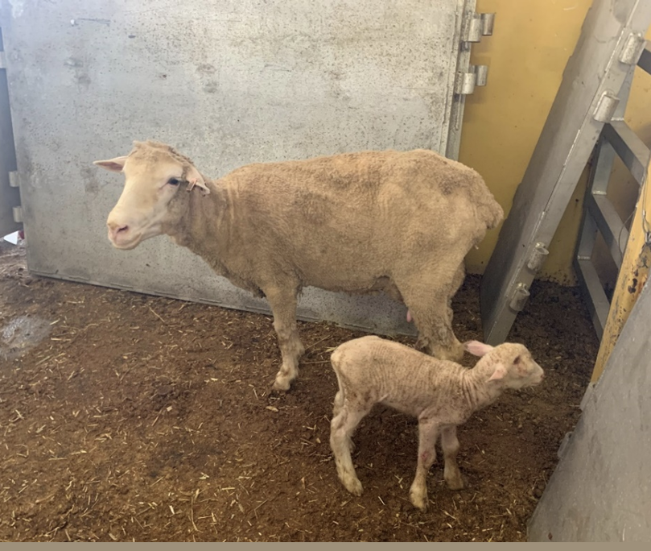

Considerations:
- Accuracy of pregnancy test certification – could the animal be pregnant/nearing parturition?

Animals displaying clinical signs of infectious or contagious disease or external parasites, including viral diseases

Technical information:
- Sheep and goats are susceptible to a range of infectious and contagious diseases. For more information on scabby mouth specifically, see Scabby mouth.
- They are also susceptible to various internal and external parasites. For more information on external parasites specifically, see Visible external parasites.

Reject if:
- The animal has any infectious or contagious disease or parasitic infection not otherwise specified in ASEL or this guidebook that compromises animal health and welfare.

Rejection examples:
Figure 2 Secondary infection from flystrike
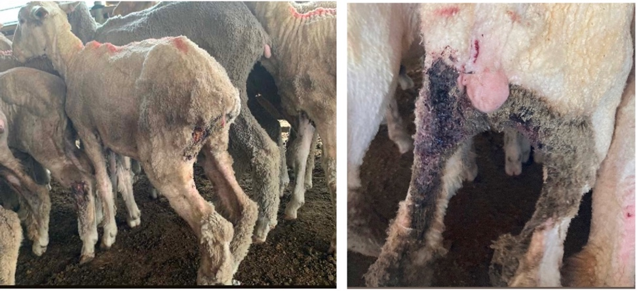
Figure 3 Scabby mouth
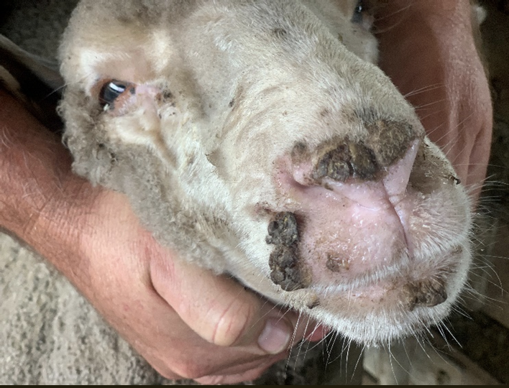
Figure 4 Nasal and ocular discharge
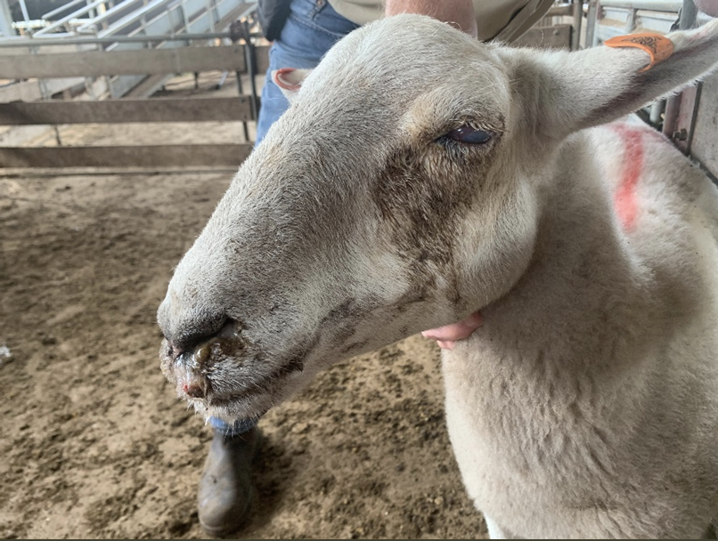

Animals showing signs of injury such as but not limited to fractures or swelling

Technical information:
- Injuries are physical harm or damage present on an animal’s body which can compromise the health and welfare of the animal.
- May be associated with bleeding, swelling, discharge, pain, abnormal behaviour, lameness, hair loss and discolouration of skin.
- Injuries in the export supply chain can lead to onboard mortalities, or morbidities. Examples of these injuries include:
  - injury due to dog bites
  - shearing cuts.

Reject if:
- The animal is showing signs of injury or swellings on body or limbs.

Rejection examples:
Figure 5 Swollen left hock
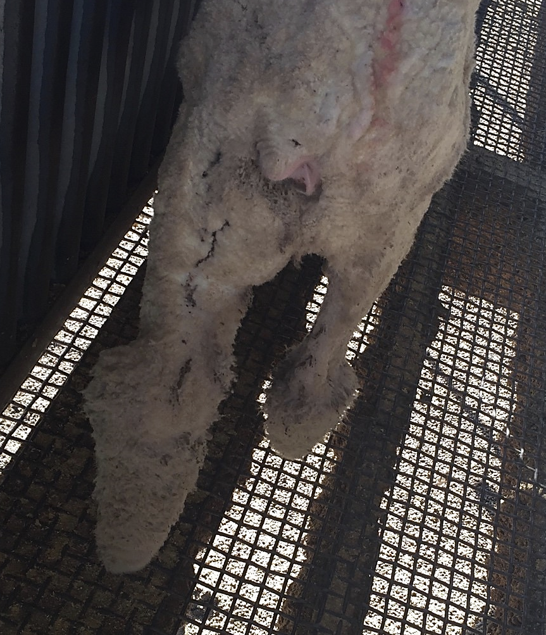
Figure 6 Injury to right hock
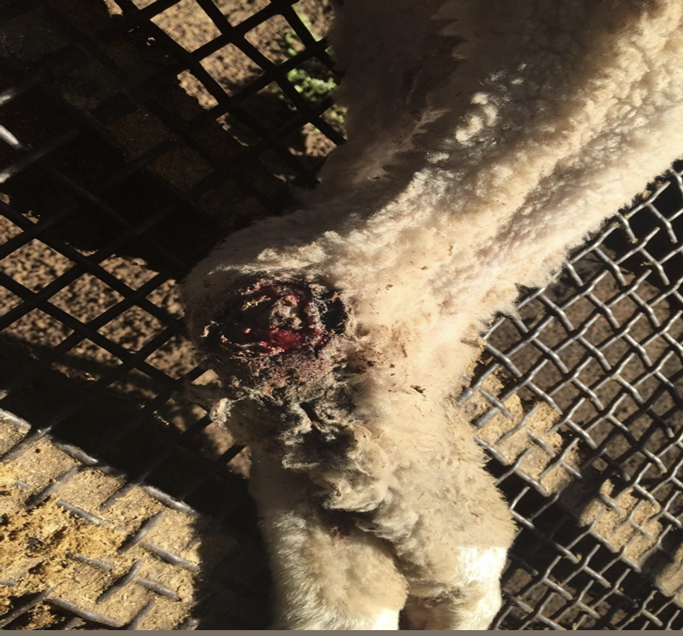
Figure 7 Swollen joint
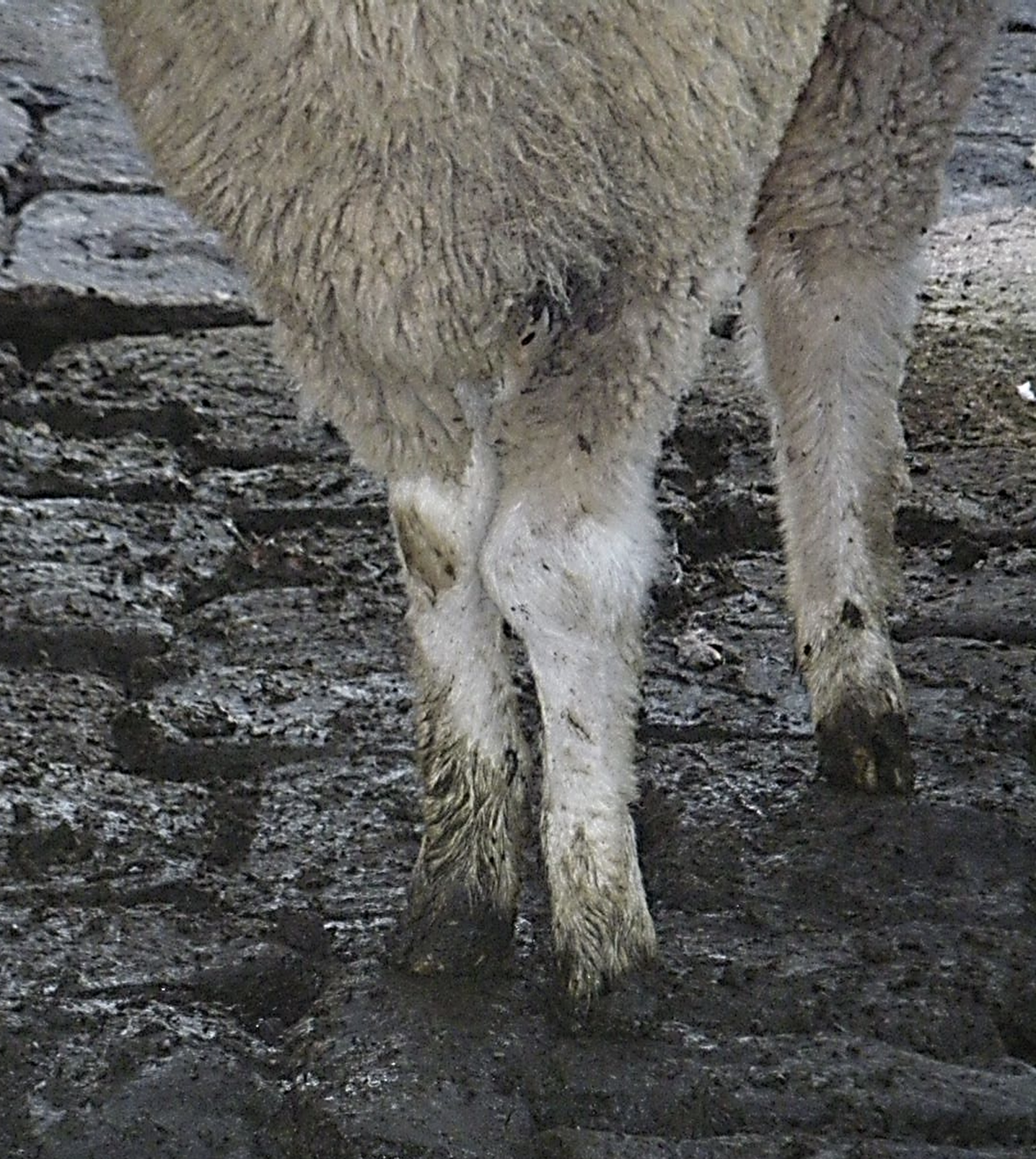
Figure 8 Injury to left carpus, unable to weight bear
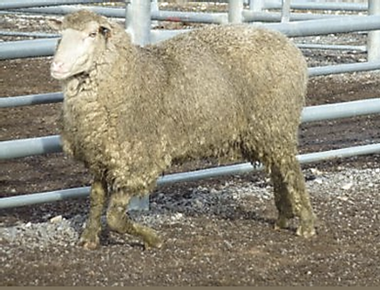

Considerations:
- If unsure, draft the animal out for close inspection.
- If used, dogs should be muzzled to prevent dog bite injuries.

Systemic conditions

Body condition score not appropriate for export (such as emaciated or over-fat)

Reject if:
- The animal does not meet BCS requirements (see Considerations).

Rejection examples:
Figure 9 Emaciated sheep
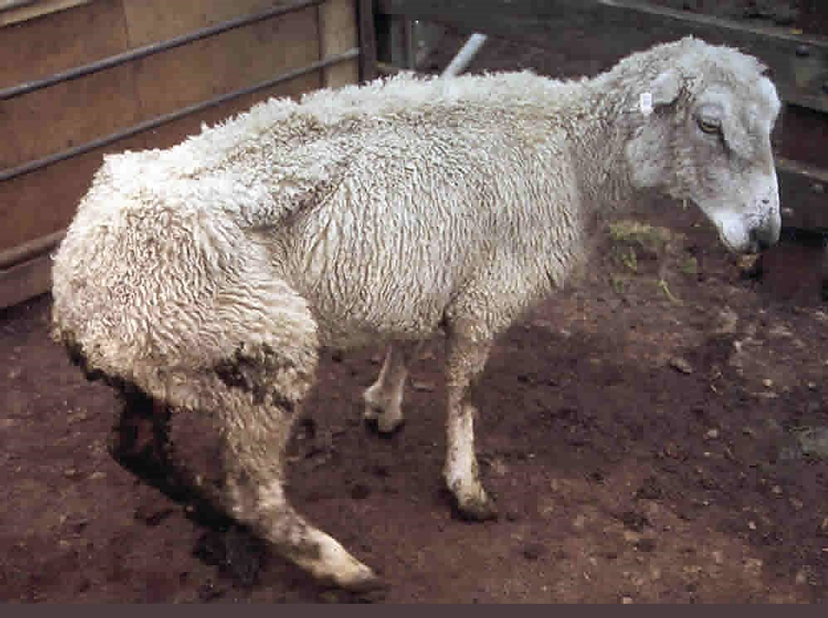
Animals will not be presented for export in this state and should not enter the export supply chain.
Needed: photographs of sheep in BCS >3 and >4

Considerations:

Sea
- Under ASEL, sheep exported by sea must have a body condition score of 2 to 4 on a scale of 1 to 5
OR
- Under the Export Control (Animals) Rules 2021, sheep exported between 1 May and 31 October inclusive and will travel through waters in the Arabian Sea, or the Red Sea, north of latitude 11°N. These sheep must have a BCS or 2 or 3 on a scale of 1 to 5.
Map 1 Arabian Sea and Red Sea
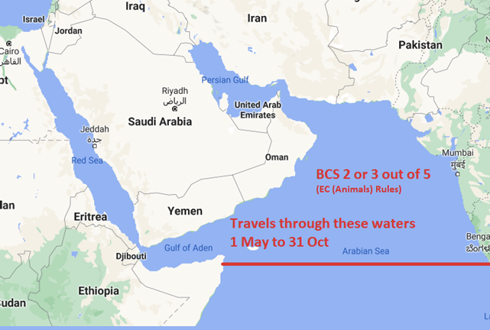
A lower BCS in the hotter months is in place to reduce risks of heat stress.

Air
- Under ASEL, sheep exported by air must have a body condition score of 2 to less than 4 on a scale of 1 to 5.

General
- Breed influences the distribution of fat and muscle.
- Inspect animals while they are standing to accurately estimate BCS.

Anorexia (inappetence or ‘shy feeders’)
Alternative names: inanition, inappetence, poor doers

Technical information:
- Lack or loss of appetite for food.
- Shy feeders (prolonged lack or loss of appetite) may be a result of failure to adapt to diet changes or the environment (mixing with unfamiliar animals, novel feed and environment, competition, increased human contact, etc.).
- Rumen fill assessment: observation of the paralumbar (‘rumen’) fossa on the left side of the animal can indicate the animal has not eaten enough if a clear triangular depression is present.

Reject if:
- The animal has evidence or history of poor feed/water intake compared to cohort.
- A rumen fill assessment of the animal shows clear depression in paralumbar fossa and demonstrates other abnormal or dull behaviour relative to cohort.

Rejection examples:
Figure 10 Example of a clear depression in the paralumbar fossa
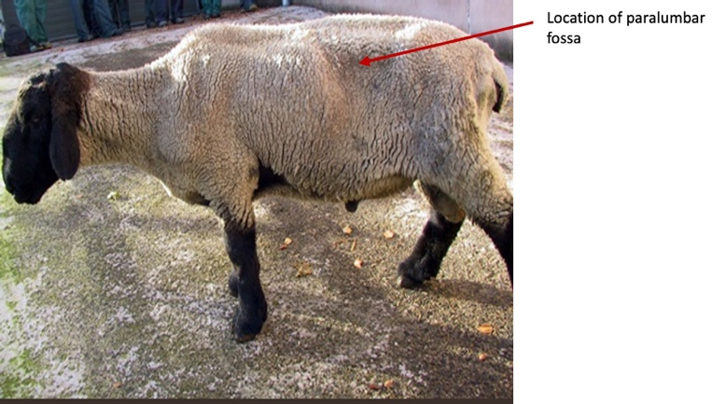
Credit: Phil Scott. NADIS – National Animal Disease Information Service.
Figure 11 Emaciated sheep
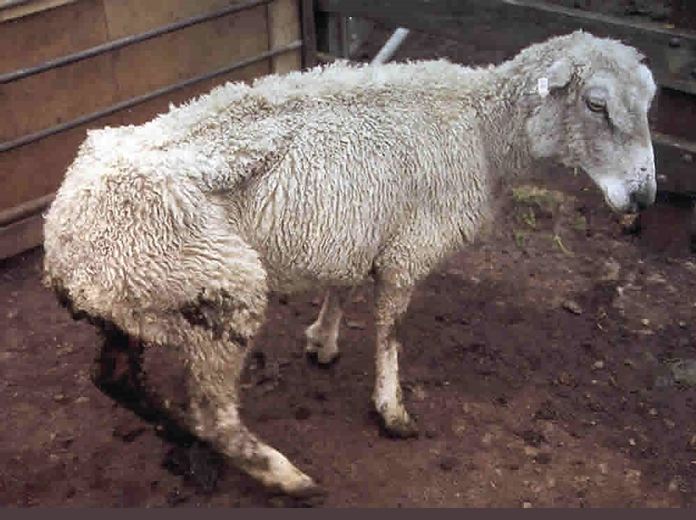
Animals will not be presented for export in this state and should not enter the export supply chain.

Considerations:
- This condition may not be noticed by brief inspection but may be evident from daily observation over time.
- Anorexic animals may not show interest in feed/water, or maintain physical condition relative to their cohort.
- Anorexia and related conditions may result in the animal being rejected under other criteria e.g. ill-thrift, poor body condition score.
- If the animal has been under extended curfew there may be depression in paralumbar fossa. Consider this finding in relation to any curfew.
- Consider the species and breed of the animal when looking at the paralumbar fossa. Some animals, such as dairy goats, will show a depression in their normal physical appearance.

Uncoordinated, collapsed, weak

Technical information:
- Uncoordinated animals show irregular movements e.g. movements which are not smooth and coordinated. Also referred to as ataxia (failure of musculature coordination).
- Collapsed animals are in a state of prostration (exhaustion or lack of energy) and depression +/–failure of circulation.
- Weak animals show reluctance to and difficulty in rising, a disinclination to move, and then only slowly. They may not eat, or eat slowly, and may exhibit a drooping posture.

Reject if:
- The animal is showing signs of incoordination, collapse, and/or weakness.
- The animal is not bright, alert or responsive to human/animal interaction.

Rejection examples:
Figure 12 Sheep in recumbent position, unwilling to stand
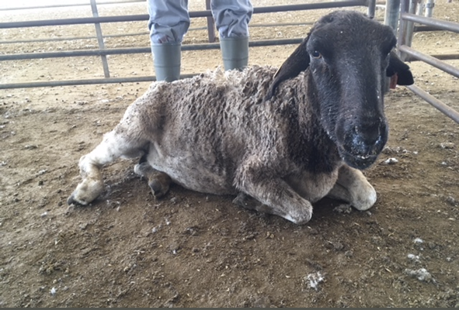
Animals will not be presented for export in this state however weakness or collapse may occur for a variety of reasons in the export supply chain.

Unwell, lethargic, dehydrated/ill-thrift

Technical information:
- Unwell is a broad term to describe animals that may be displaying a range of clinical signs indicating they are not healthy. An animal that is not bright, alert and responsive in response to human/animal interaction is considered unwell.
- Lethargic animals show signs of drowsiness and/or indifference (lack of interest in surroundings/stimuli).
- Dehydrated animals may have a loss of skin elasticity, sunken/dry-looking eyes, signs of lethargy, a dry nose and dry, sticky gums. They may also display panting.
- Ill-thrift animals may show a failure to grow compared to their cohort and an inability to maintain weight despite seemingly adequate food available.

Reject if:
- The animal is showing signs of ill-thrift or of being unwell, lethargic or dehydrated.
- The animal is not bright, alert or responsive to human interaction/animal.

Rejection examples:
Figure 13 Animal showing discolouration of the sclera and mucus membranes
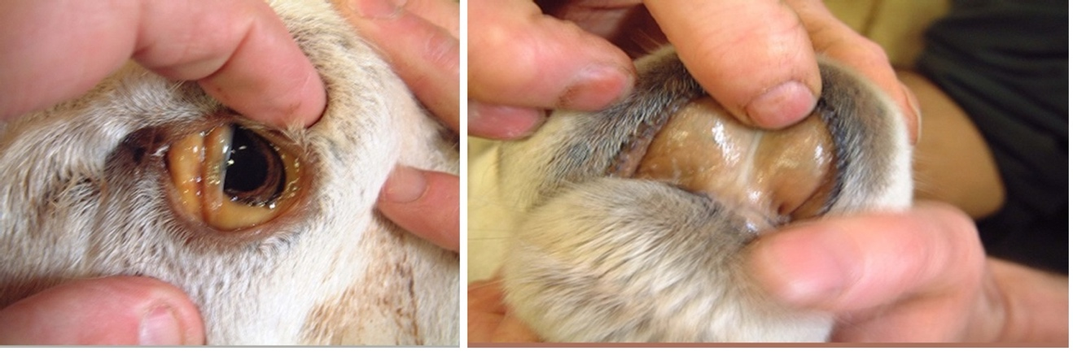

Considerations:
- Heat waves may cause animals to show lethargy. A plentiful supply of clean cool water and shade is essential.
- Recent travel over a long distance or in the heat may cause lethargy. Animals should be given sufficient time to recover prior to further handling.

Gastrointestinal system

Dysentery or profuse diarrhoea
Alternative name: salmonellosis

Technical information:
- Rapid movement of faecal matter through the intestine resulting in poor absorption of water, nutritive elements and electrolytes, and producing frequent evacuation of watery droppings.
- Causes include:
  - local irritation of the intestinal mucosa by infectious (e.g. bacteria, viral, protozoa) or chemical agents
  - seasonal considerations e.g. fresh green grass, wet weather
  - increased worm burden
  - disease, stress and nutritional deficiencies
  - indigestion associated with dietary changes.
- May be associated with abdominal pain, tenesmus (straining), dehydration, loss of body condition and faecal contamination of hindquarters and fleece.
- An affected animal may also show signs of lethargy, and dull demeanour compared to cohort.

Reject if:
- The animal has:
  - a large volume of faecal staining evident on the hindlimbs
  - liquid diarrhoea not forming small balls/pellets
  - bloody diarrhoea
  - diarrhoea and is not bright, alert and responsive
  - evidence of straining and/or abdominal pain
  - foul smelling faeces.

Rejection examples:
Figure 14 Animal with evidence of faecal staining associated with diarrhoea
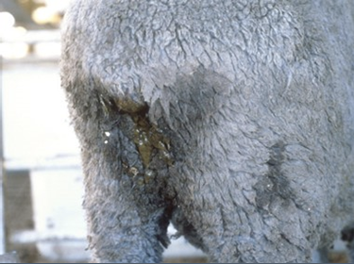

Considerations:
- Progression and response to treatment.
- A transient dietary diarrhoea from a recent change in diet and the animal is otherwise bright, alert and responsive and eating/drinking does not require rejection, but should be resolved prior to transport to the port.
- It may be necessary to undertake further assessment of the group if diarrhoea is visible in pen/yard.

Bloat

Technical information:
- Tympany/swelling/distention of the rumen, abomasum, and omasum. May be frothy (gas mixed with liquid to form stable froth) or free gas bloat.
- An acute condition not associated with over-eating.

Reject if:
- The animal is bloated unilaterally, bilaterally symmetrically or asymmetrically.

Rejection examples:
Needed: photographs of bloat

Considerations:
- Mild left abdominal distention indicating a full rumen or having just fed in the absence of other symptoms suspicious of bloat does not require rejection.

Musculoskeletal system

Abnormal gait or lameness of any kind

Technical information:
- A lame animal is incapable of normal locomotion; there is a deviation from the normal gait.
- Most commonly caused by pain in a limb/trunk or supporting structures. Contractures of joints and deformities, including shortness of limbs, may also be causes.

Reject if:
- The animal is:
  - not bearing weight evenly on all four legs
  - redistributing weight to avoid placing weight on particular limb/s
  - arching its back or bobbing its head when walking and its strides are obviously shortened
or the animal has:
  - swollen limb/s
  - knuckling of limb/s
  - persistence lameness
  - an obvious injury to the foot/leg
  - a hoof deformity
  - an abnormal gait other than due to conformation.

Rejection examples:
Figure 15 Overgrown hooves causing lameness
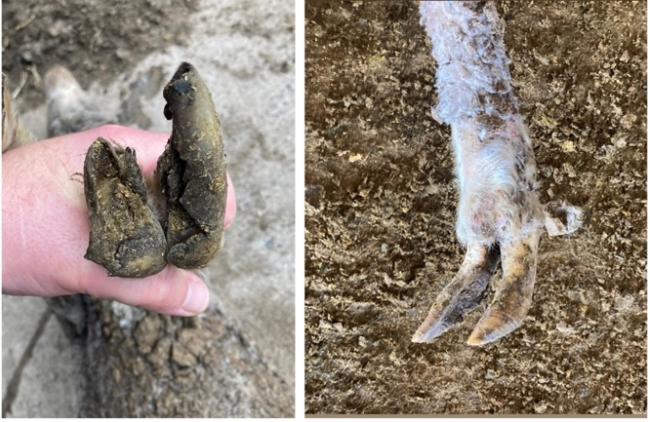
Figure 16 Abnormal, ulcerated swelling on the right hock/tarsal joint and lameness
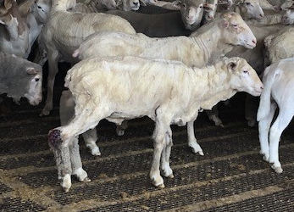
Figure 17 Injury to left carpus, unable to weight bear
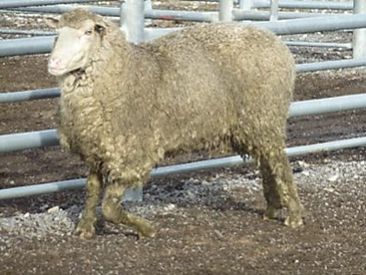

Considerations:
- Is there a reason the animal is footsore and is it possible this will resolve onboard the vessel without welfare being compromised?
- Is the lameness suspected to be due to age and size (e.g. arthritis in a mature, heavy animal)? Consider pain associated with this and whether the animal is appropriate for an export journey.
  - If the welfare of the animal would be placed at risk due to voyage (consider penning, voyage length, etc.) it may be more appropriate to transport the animal to a local abattoir, provided the animal is fit to load.
Note: treating animals on board can be difficult and conditions may worsen lameness, therefore avoid allowing any lameness to be exported.

Abnormal soft tissue or bony swellings

Technical information:
- Abnormal soft tissue or bony swellings may be associated with the following (this list is not exhaustive):
  - tumour e.g. skin tumours, enlarged lymph nodes
  - infection e.g. lumpy jaw, cheesy gland, trauma to body
  - abscess e.g. from vaccination, grass seed penetration
  - haematoma e.g. around bony prominences from trauma
  - hernia e.g. on ventral abdomen due to trauma
  - oedema e.g. submandibular (woody tongue, heart failure), brisket
  - urine e.g. ventral abdomen following urethral obstruction/rupture
  - gas e.g. over rump/back/shoulder (blackleg), sucking wounds.

Reject if:
- The animal has any visible abnormal soft tissue or bony swelling that may adversely affect animal health and welfare.

Rejection examples:
Figure 18 Goat with swollen carpal joints
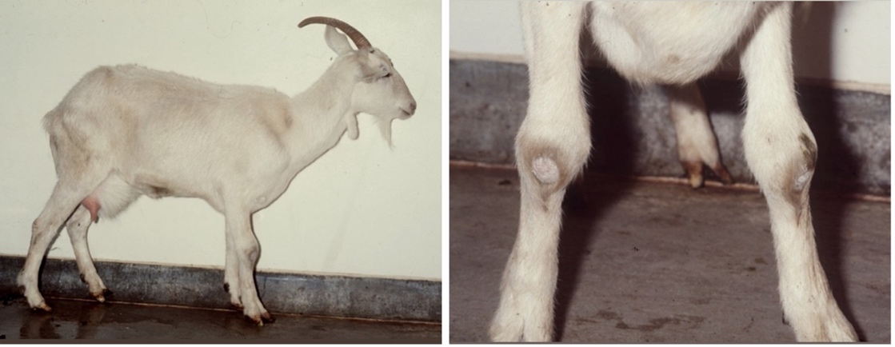
Figure 19 Foot abscess
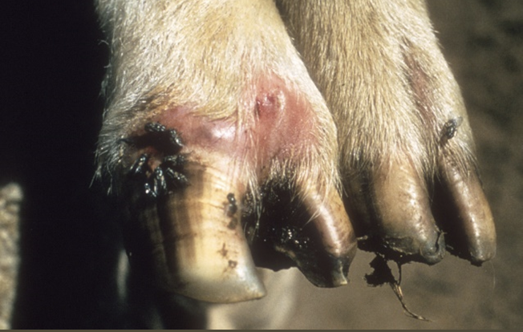
Figure 20 Various abnormal facial swellings
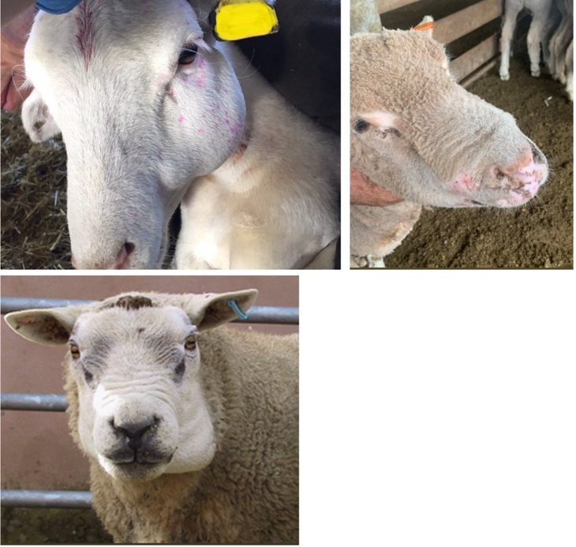
Figure 21 Swollen hock
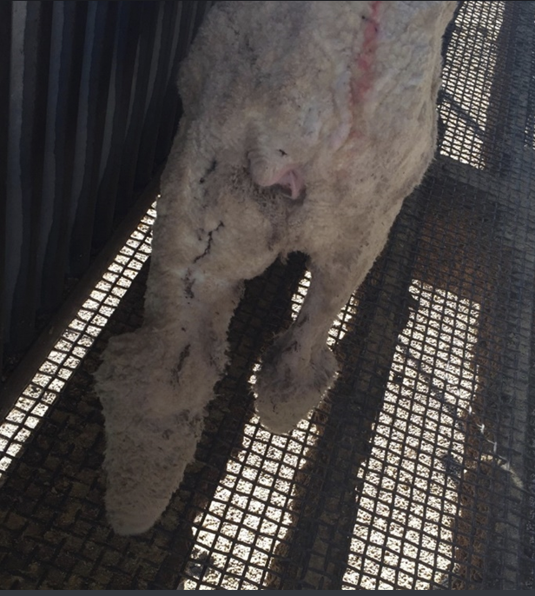

Nervous system

Nervous symptoms such as head tilt, circling, incoordination

Technical information:
- Examples of nervous system symptoms include, but are not limited to:
  - head tilt or circling
  - head pressing
  - stargazing: back tends to be arched and head in upwards position
  - staggers: incoordination, including a tendency to fall over
  - ataxia: abnormal or uncoordinated movements
  - tremors or seizures
  - abnormal chomping of jaws.
- Animals with any of these signs should be drafted out and clinically assessed.

Reject if:
- The animal is persistently or repeatedly displaying nervous system signs such as those described under Technical information.

Rejection examples:
Figure 22 Sheep showing signs of stargazing
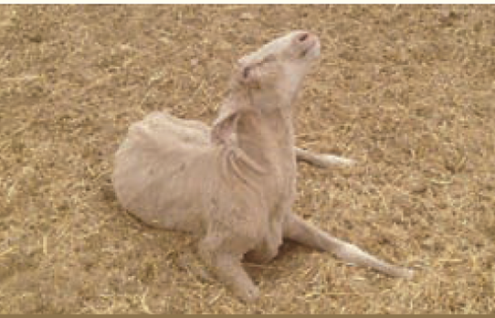
Animals will not be presented for export in this state however nervous signs may develop for a variety of reasons whilst animals are held in registered establishments. Credit: PIRSA 2015.

Considerations:
- Animals may appear normal when standing however will walk with abnormal gait or posture, or will only show obvious neurological signs when stressed, such as when driven.

Abnormal or aggressive behaviour/intractable or violent

Technical information:
- Aggression is more of an issue in males, particularly bucks (male goats). Aggressive behaviour is often associated with sexual behaviour.
- Rams may display pawing at the ground, nibbling, head butting, charging and gargling vocalisations.
- Bucks may show signs of mounting smaller, subservient bucks in the mob.
- Aggressive or violent behaviour may not be witnessed, but signs of being attacked, mounted or bitten may be evident in the flock e.g. pulled wool/hair, injuries.
- Aggression towards handlers can be an safety issue.

Reject if:
- The animal is displaying abnormal aggressive, intractable, or violent behaviour such as that described under Technical information.

Rejection examples:
Needed: photographs or video of abnormal or aggressive behaviour

Considerations:
- If there are signs in the flock of animals being attacked, mounted, or bitten, the flock should be observed to identify and separate the inciting animal/s.
- An animal demonstrating behaviour limited to nibbling, pawing or vocalisation that is not resulting in welfare issues for other animals does not require rejection.
- Any goat buck with obvious back rubbing from being ridden by other goats should be inspected for injury and may need to be rejected from export.
- Appropriate drafting and separation of animals should reduce risks of aggressive behaviour.

External/skin

Generalised papillomatosis or generalised ringworm or dermatophilosis
Alternative name for papillomatosis: warts
Alternative name for ringworm: dermatophytosis
Alternative names for dermatophilosis: lumpy wool, rain scald

Technical information:
- Papillomatosis: Hairless, normally benign growths on skin or mucosa caused by papilloma virus. It is uncommon in sheep and goats. Can spread via direct contact with infected animals, and fomites such as contaminated feed troughs, ear tagging pliers and injection equipment. Lesions vary in appearance from single, discrete growths, to large, broad masses that hang from the body.
- Ringworm: Usually hairless, circular skin lesions caused by a fungal infection. It is uncommon in sheep and goats. Can be spread by close contact with an infected animal or contaminated environment. Varies in appearance from single, discrete lesions, to large, coalescing patches.
- Dermatophilosis: Dermatitis caused by the bacterium Dermatophilus congolensis. Chronically infected animals with minor active lesions are the main source of infection, and infection spreads when the hair/wool is wet for an extended period and wet animals are in close contact. Lesions may be limited to parts of the body that were wet for an extended period but may become generalised in animals with reduced resistance due to undernutrition or other stressors.
- All three conditions are uncommonly seen in sheep/goats in the export supply chain.

Reject if:
- The animal has generalised papillomatosis (multiple coalescing lesions on multiple regions).
- The animal has generalised ringworm (multiple coalescing lesions on multiple regions).
- The animal has generalised dermatophilosis (multiple coalescing lesions on multiple regions).
Figure 23 Classification of sheep body regions
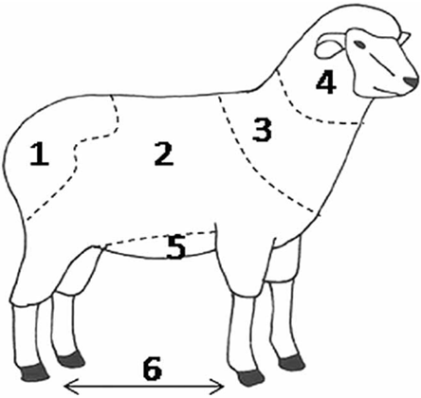
1=breech, 2=body, 3=shoulders, 4=head, 5=belly, 6=foot. Credit: Pickering et al. 2015.

Rejection examples:
Figure 24 Dermatophilosis in sheep
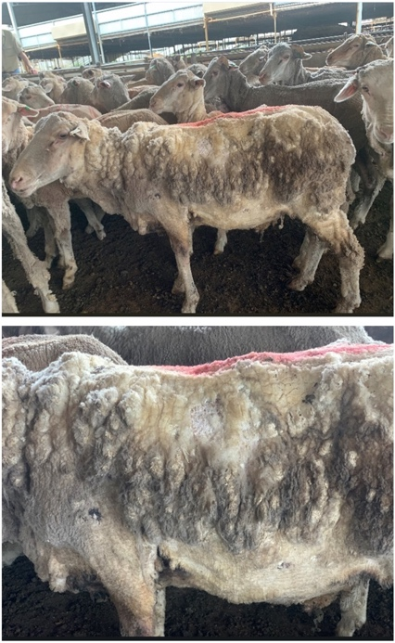
Lower image is a close up of the top animal.

Considerations:
- Professional discretion is required when evaluating these conditions, considering the size and location/s of lesions, number, likelihood of further welfare issues to the individual animal and/or its cohort.

Generalised skin disease or infection

Technical information:
- Generalised skin disease or infection can manifest in several conditions affecting the health and welfare of livestock. Conditions can include but are not limited to:
  - photosensitisation/facial eczema
  - dermatitis from lantana poisoning
  - digital/interdigital dermatitis
  - cellulitis.

Reject if:
- The animal has skin disease or infection that extends over 80% of one region or extends over more than two regions.
Figure 25 Classification of sheep body regions
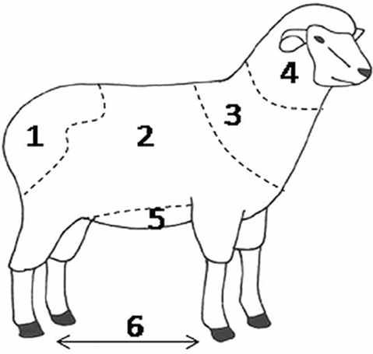
1=breech, 2=body, 3=shoulders, 4=head, 5=belly, 6=foot. Credit: Pickering et al. 2015.
- The animal has chronic skin disease e.g. photosensitisation with fibrosis.
- The animal has skin disease or infection that is likely to impact its health or welfare e.g.:
  - open lesions or lesions with exudate
  - evidence of pain or severe irritation
  - other signs of systemic illness e.g. loss of appetite, jaundice.

Rejection examples:
Figure 26 Evidence of facial eczema showing redness, inflammation, oedema and exposure of underlying tissue
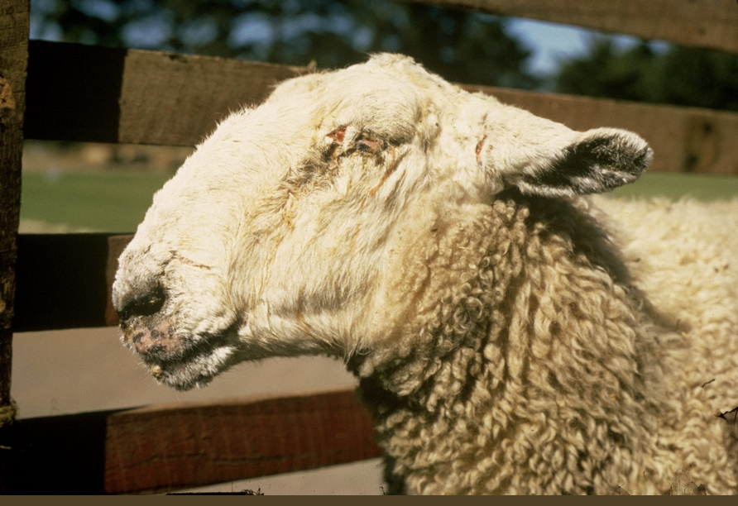
Figure 27 Photosensitisation along left side of body
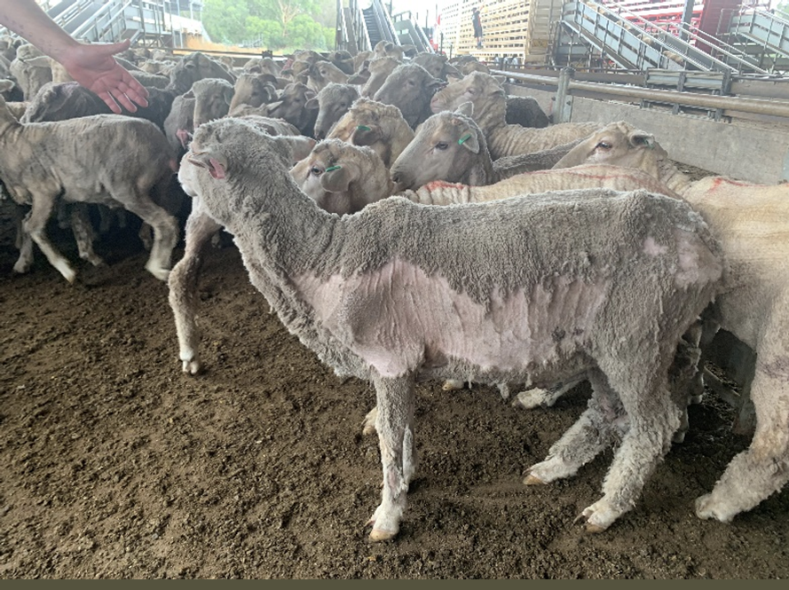
Figure 28 Chronic photosensitisation with fibrosed ears
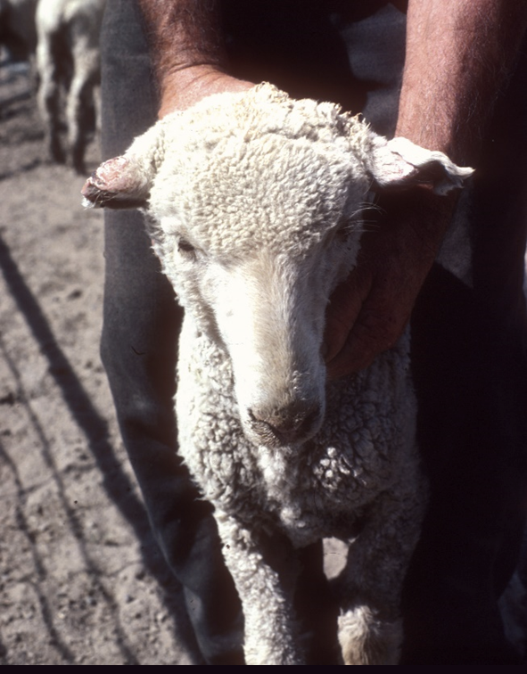
Figure 29 Photosensitisation (or burn) on back
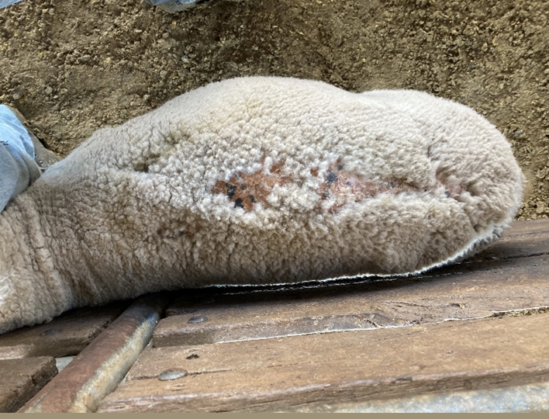

External skin cancer

Technical information:
- External skin cancers can be present on most body regions but are predominately found on the exposed, non-wool/hair covered areas in sheep and goats. Animals with light coloured skin may have a higher prevalence of skin cancers, as may sheep that have been poorly mulesed or have had their tailed docked too short.
- External skin cancers can form lesions of varying size, colour and texture. Some cystic lesions may affect the hoof wall resulting in lameness or deformity of the hoof. Squamous cell carcinomas are common in breeds with white hair and poorly pigmented skin.
- Lesions start as thickened areas of reddened, flaking skin that later become ulcerated, necrotic, bleeding masses. Animals with noticeable lesions should be excluded from the export process. Lesions are easily missed when animals are grouped, hence a systematic inspection method is required.
- External skin cancers are uncommonly seen in sheep/goats in the export supply chain.

Reject if:
- The animal has a lesion with appearance indicative of skin cancer.
- The animal has a visible tumour/lesion of any size or location that:
  - is open/exudating
  - is causing severe irritation and/or distress to the animal
  - could be damaged in the pen or during transport leading to an open wound.

Rejection examples:
Figure 30 Irregular legions around the eye
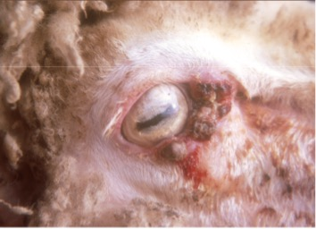
Figure 31 Vulval cancer
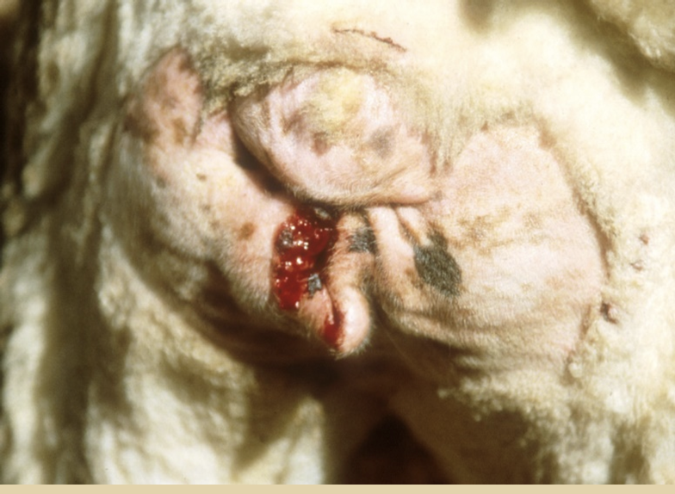

Lacerations that penetrate the full thickness of the dermis or are likely to affect the health or welfare of the animal

Technical information:
- Lacerations can be caused by sharp objects such as a sharp edge to a gate. They have the potential to become infected and treatment may be required to reduce animal pain and discomfort.

Reject if:
- The animal has a full thickness laceration that:
  - is unhealed
  - has exudate present
  - has fresh blood present or a newly developed scab that may be damaged in the pen or on transport.

Rejection examples:
Figure 32 Severe laceration
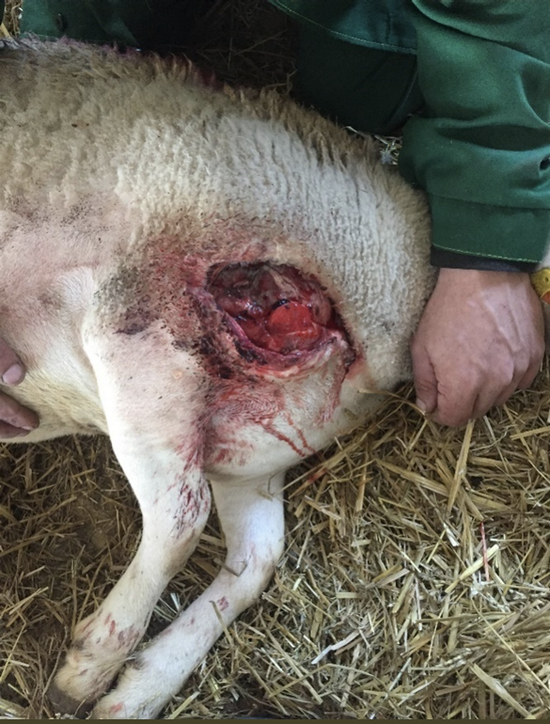
This animal requires immediate treatment or humane euthanasia.

Discharging wounds or abscesses

Technical information:
- A discharging wound is one that secretes serous, sanguineous, serosanguineous or purulent discharge. The presence of serous fluid is normal in a healing wound; however these animals cannot join the consignment until the wound is completely healed to prevent re-injury or infection.
- Abscesses can occur on any part of the body and may not be visible, however the animal may display other clinical signs indicative of pain or irritation. E.g. foot abscesses are quite common, and lameness may be a clinical sign.
- If there is a suspected dog bite, the animal should be examined thoroughly for any signs of wounds or abscesses.

Reject if:
- The animal has a visible discharging wound or visible abscess.

Rejection examples:
Figure 33 Open wound on hock
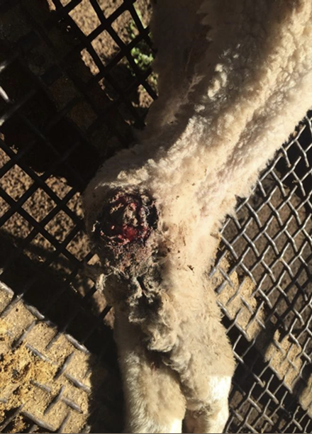
Figure 34 Discharging abscess on sheep
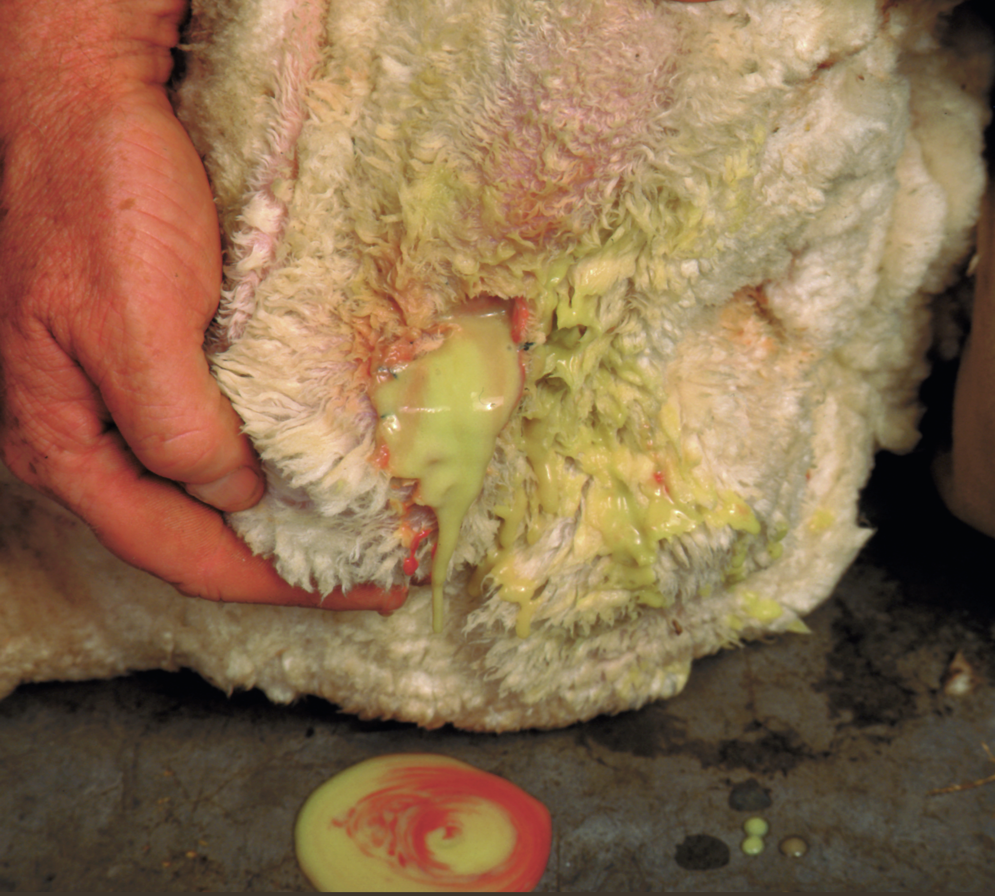

Considerations:
- The environment during holding and transport via sea may lead to infection of open wounds therefore it is important to reject animals with open wounds.
- If treatment has been administered and the wound/abscess is fully healed without further discharge or signs of pain/irritation, the animal may be fit for export.
- Injection site reactions can produce firm, fibrous swellings of golf ball size or larger but should be clinically evaluated to differentiate from other conditions.
- Dogs used at any stage of export preparation and transport must be muzzled to prevent dog bite injuries.

Cutaneous myiasis (flystrike)

Technical information:
- This condition primarily affects sheep over goats.
- In early stages of flystrike, animals may show signs of irritation (e.g. foot stamping, shaking, muscle twitching) and local discomfort, and will typically scratch or bite at the affected area. More advanced flystrike can cause systemic issues such as inappetence, lethargy and depression. Wool may appear moist and darkened in areas with presence of maggots and there may be a noticeable odour.

Reject if:
- The animal has presence of flystrike.

Rejection examples:
Figure 35 Flystrike of the belly (body strike)
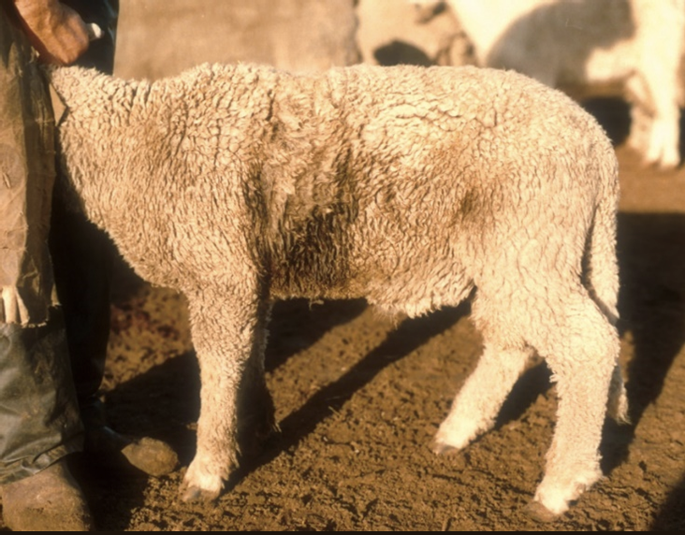
Figure 36 Flystrike of the breech (breech strike)
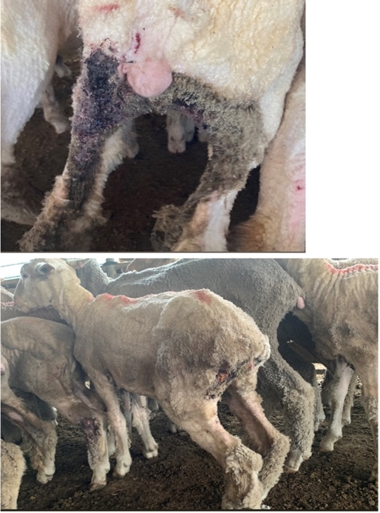

Posthitis (pizzle rot in sheep)
Alternative names: Sheath Rot, Enzootic Balanoposthitis, Ulcerative Posthitis

Technical information:
- Mainly affects castrated males fed on high protein diets.
- The predominant sign is swelling of the prepuce that can lead to straining and pooling of urine in the prepuce. Animals can exhibit signs of discomfort and kick at their belly.

Reject if:
- The animal has a swollen and/or inflamed prepuce.
- The animal has dark staining at the distal prepuce.

Rejection examples:
Figure 37 Swollen prepuce of sheep
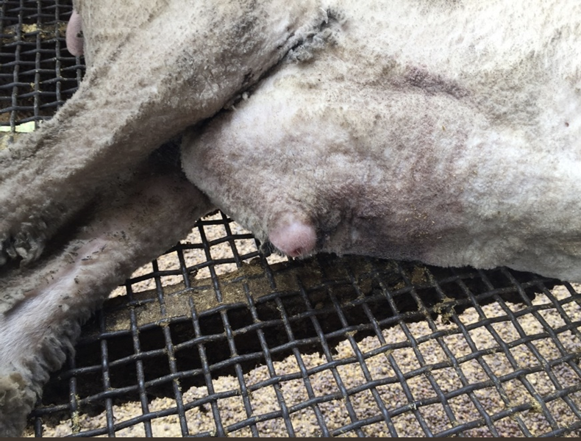
Figure 38 Pizzle rot
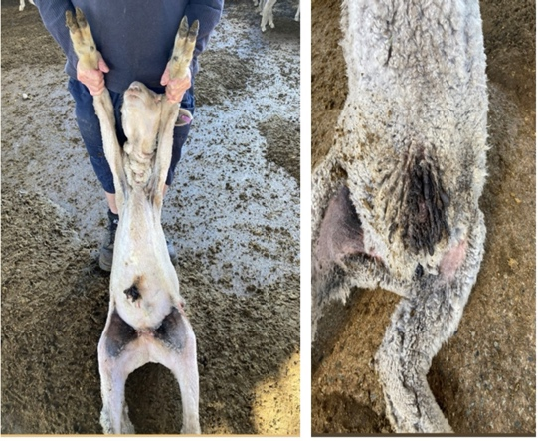

Blood/abnormal discharge from reproductive tract (vulva/prepuce)

Technical information:
- Clinical examination of blood or abnormal discharge from the reproductive tract is important. Pregnancy status, use of prostaglandins, traumatic injury, lesions, disease, recent caesarean or abortion are some causes of abnormal discharge in livestock and should be clinically evaluated.

Reject if:
- The animal has any abnormal discharge.

Rejection examples:
Figure 39 Purulent discharge from vulva
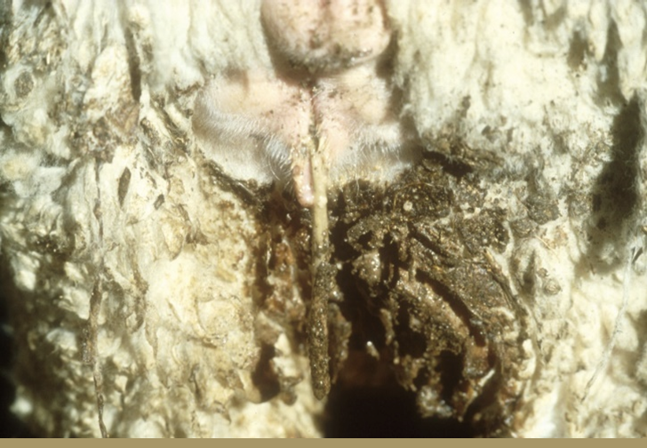

Considerations:
- Differentiate between abnormal discharge and normal discharge in breeding animals or post-partum discharge.

Visible external parasites

Technical information:
- Sheep and goats may be infected by external parasites such as flies, lice, mites and ticks. Negative impacts on health and welfare can include blood loss, irritation and reduced grazing behaviour (fly worry).
Reject if:
- The animal has any visible external parasites, including dead ticks, or evidence of active external parasite infection.

Rejection examples:
Figure 40 Sheep with lice infestation
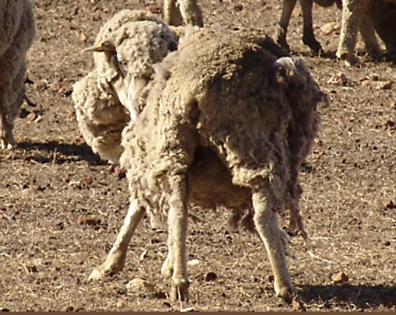
Animals will not be presented for export in this state; however, external parasite infestation may be observed earlier in the supply chain. Credit: WA Department of Primary Industries and Regional Development, Sheep lice spread and detection.

Considerations:
- Rubbing is a common behavioural indicator for the presence of parasites but can occur after treatment due to lingering irritation to the skin.
- Livestock actively displaying signs of irritation or rubbing should be examined further to determine the cause.
- Evidence of external parasites may require treatment of all in-contact animals.
- Consider treating for external parasites prior to commencement of export preparation to decrease risk of spread and avoid dead ticks remaining attached to livestock at time of inspection.

Head

Blindness in 1 or both eyes

Technical information:
- Animals that are blind in one or both eyes may be disorientated and may not react to external visual stimuli consistent with their cohort. Care should be taken when approaching blind animals to minimise alarm.
- Signs of partial or full blindness may include, but are not limited to:
  - disorientation
  - non-reactive to external visual stimuli
  - standing separate from rest of mob/looking in different direction to mob
  - head raised above flock level
  - unusual eye colour e.g. uveitis (inflammation, redness), blue/opaque cornea
  - lower body condition score compared to cohort.
  - ocular discharge may or may not be present, depending on cause of blindness.
- To assess for blindness, test reactions compared to cohort.

Reject if:
- The animal is visually impaired in one or both eyes to a degree that animal does not react to visual stimuli.
- The animal is constantly blinking or holding eye/s closed.

Rejection examples:
Figure 41 Blind sheep with corneal opacity, separate from mob
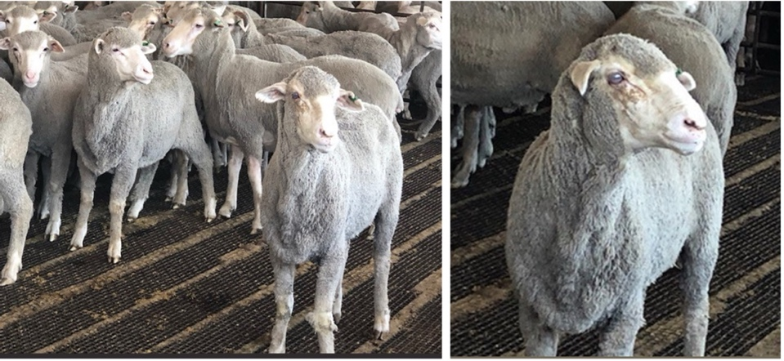
Figure 42 Blind sheep separated from rest of mob
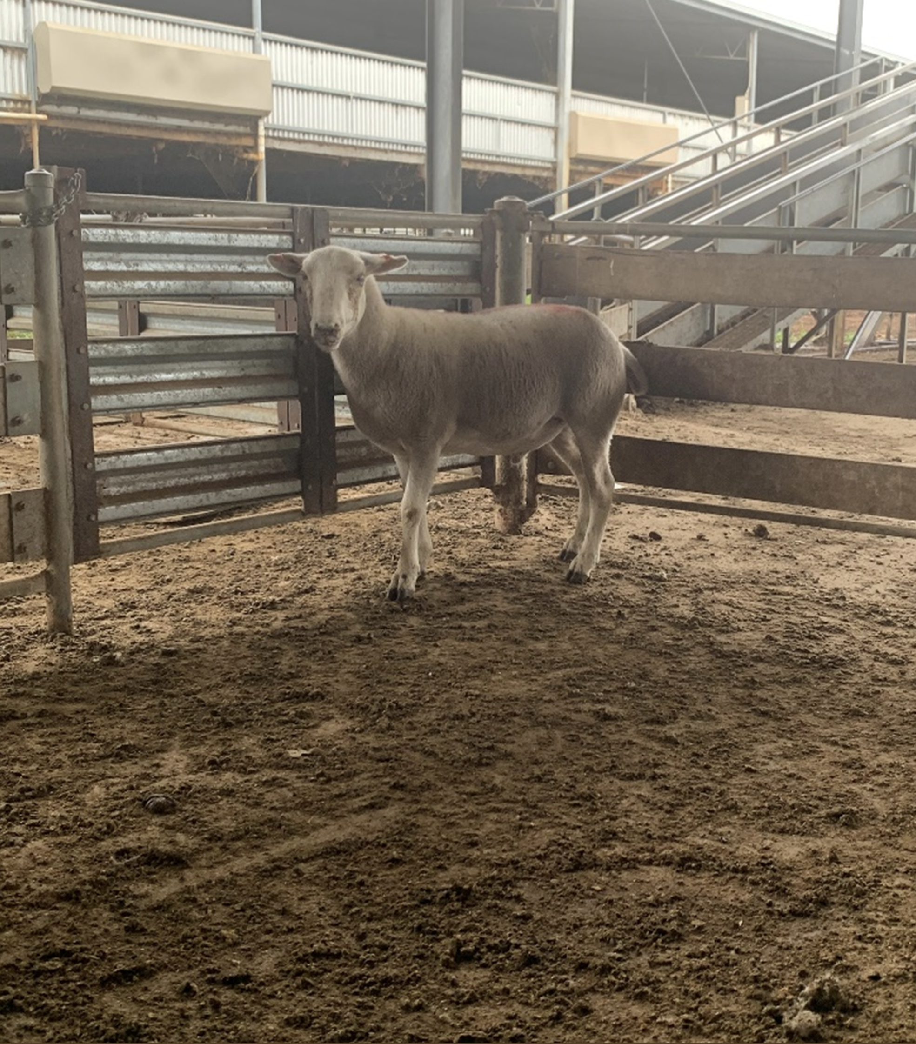

Considerations:
- Consideration should be given as to whether the process is temporary and will completely resolve.
- Severe pink eye (infectious keratoconjunctivitis) may lead to permanent blindness and veterinary advice should be sought if animals in a mob are displaying pink eye.
- Several infections and environmental factors (e.g. irritants such as dust, feed fines, grass seeds) can lead to an animal constantly blinking or holding its eye/s closed. In this case, the animal should be drafted and inspected to determine the underlying cause, and treatment provided as appropriate.

Cancer eye

Technical information:
- Cancer eye, or ocular squamous cell carcinoma, is not very common in sheep or goats.
- Lesions are typically found on the eye and/or eyelids and tend to invade lymph glands in the surrounding areas. The lesions tend to be ulcerated, necrotic and painful.

Reject if:
- The animal has presence of proliferative or ulcerative lesion on its eye or surrounding structures.

Rejection examples:
Figure 43 Evidence of cancerous masses around eye

Keratoconjunctivitis
Alternative names: pink eye, infectious keratoconjunctivitis, infectious ophthalmia

Technical information:
- Keratoconjunctivitis (KCV) is inflammation of the cornea and conjunctiva. Signs of active KCV will include a combination of:
  - blepharospasm (twitching, blinking or closure of eyelids)
  - epiphora (watery eyes, excessive tears) –staining of face is usually evident
  - conjunctivitis (inflammation of the white part of the eyeball) –Note conjunctivitis on its own is not a rejection criterion and often transient
  - hyperaemia (blood shot eyes).
- It may affect one or both eyes. Initially the cornea may be red and then progress through cloudy hues of red, blue, grey, and white during sequential stages of healing.
- It is an infectious process and can spread through the mob if affected animals remain within mob or left untreated.
- The condition can be painful and some animals may be left with corneal scarring or blindness. Most cases are transient and self-limiting.
- A grading system exists, from 0 (normal eye) to 6 (chronic eye damage) (see Figure 44).
Figure 44 Clinical presentation and grading system of KCV
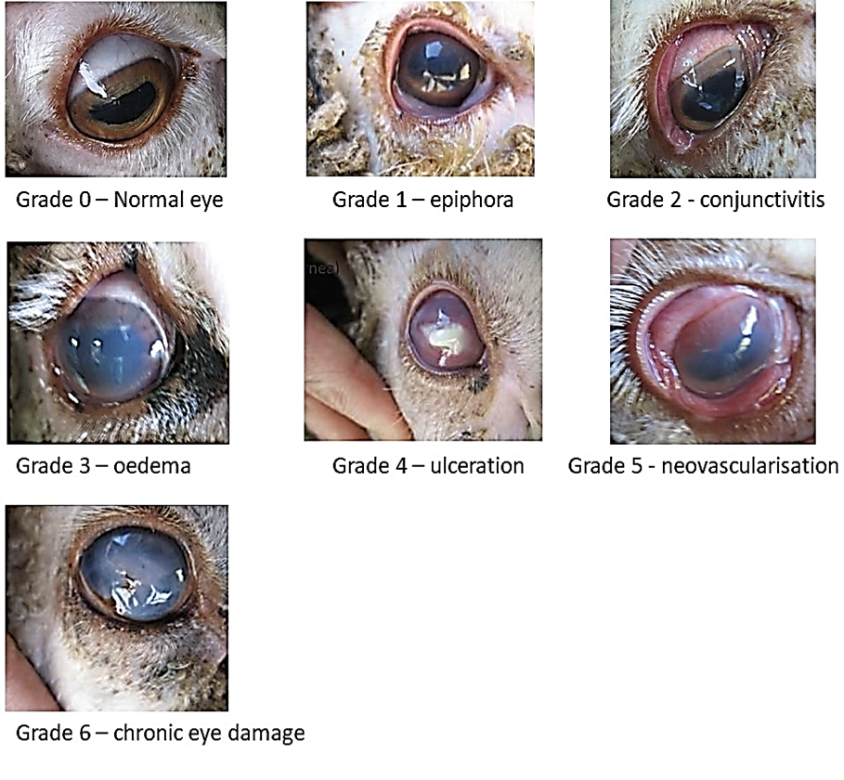
Credit: Chapman et al. 2010.

Reject if:
- The animal has one or two eyes with a grade of 4 or higher.
- The animal has one or two eyes with a grade of 3 and the animal has not been treated with oxytetracycline or another effective antibiotic under veterinary advice (see Considerations).
Figure 45 Sheep with clinical signs of KCV – inspection is required to determine whether treatment or rejection is appropriate
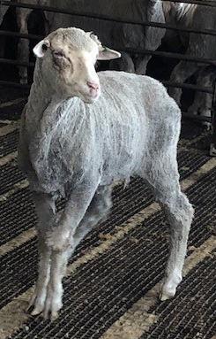

Considerations:
- Treated animals may require a second treatment if clinical signs do not improve.
- Withholding periods should be considered in feeder/slaughter animals.
- Treated animals with grade 3 or below should be identified (e.g. marked with coloured paint) and penned separately where possible. The animals should be managed during the journey in a way that allows them to monitored and provided with additional effective antibiotics if they do not respond adequately to initial treatment.

Excessive salivation

Technical information:
- This is uncommon in sheep and goats and the animal will likely be showing other clinical signs.
- Sheep and goats, unlike cattle, do not tend to hypersalivate with heat. However, diseases such as botulism, grass tetany, listeriosis and phalaris poisoning may result in excessive salivation.

Reject if:
- The animal has excessive salivation alone or in conjunction with other symptoms.

Rejection examples:
Needed: photographs or video of excessive salivation.

Nasal discharge consistent with signs of contagious or infectious disease

Technical information:
- Nasal discharge is excess fluid from the nasal cavity. It can be unilateral or bilateral, and:
  - serous (thin, clear, colourless)
  - catarrhal (grey)
  - purulent (thick, yellow)
  - haemorrhagic (red, bloody)
or a combination.
- Common causes in sheep and goats include nasal bots, dusty feed, poor air quality (e.g. dust, ammonia), fly worry and upper respiratory tract disease.

Reject if:
- The animal has excessive nasal discharge that cannot be attributed to transient environmental causes.

Rejection examples:
Figure 46 Sheep with excessive bilateral nasal discharge and corneal oedema
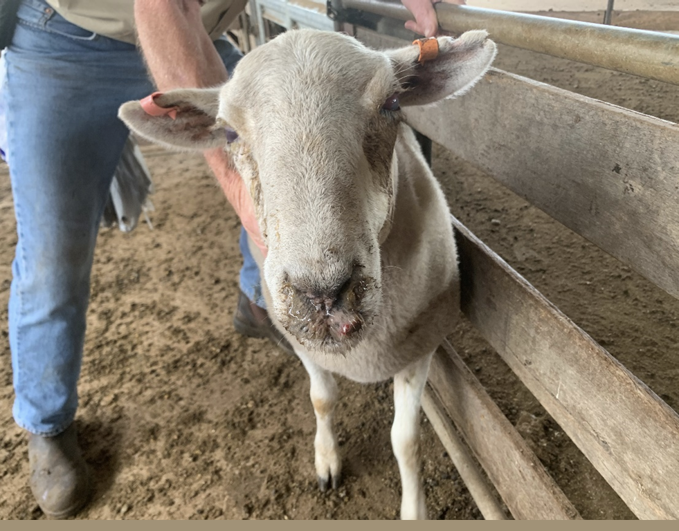

Considerations:
- Control of flies and dust, and good ventilation in sheds, can decrease the incidence of nasal discharge due to environmental factors.

Coughing consistent with signs of a contagious or infectious disease

Technical information:
- A cough is a sudden noisy expulsion of air from the lungs. Coughs may be:
  - dry: cough without expectoration (no material ‘coughed up’)
  - productive: cough with expectoration of material from the respiratory tract.
- Lungworm infection and pneumonia can result in coughing. Sometimes, drenching may cause irritation of the trachea leading to coughing.

Reject if:
- The animal has a persistent cough i.e. you are able to identify the animal that is coughing within a mob, and is associated with other clinical signs of disease.

Rejection examples:
Needed: photographs or video of coughing.

Respiratory distress or difficulty breathing

Technical information:
- Respiratory distress or difficulty breathing can take several forms and be a result of disease or environmental factors.
- An animal in respiratory distress or having difficulty breathing may:
  - have laboured breathing (dyspnoea)
  - have marked inspiratory effort
  - stand with the neck extended and/or head held lowered
  - have flared nostrils and/or mouth open
  - be reluctant to move.

Reject if:
- The animal is showing signs of respiratory distress or difficulty breathing such as those under Technical information.

Rejection examples:
Needed: photographs or video of respiratory distress or difficulty breathing.

Sharp horns, horns that could injure the animal or other animals, horns that could restrict access to feed or water, bleeding and/or not fully healed horn stumps, horns longer than 1 full curl

Reject if:
- The animal has horn/s that do not meet ASEL requirements (see Considerations).

Considerations:
Under ASEL, horns must:
- be blunt (unless for goats, the horns are no longer than 22 cm and tips are no more than 20 cm apart)
- be of a shape/direction that does not cause damage to the head or eyes (e.g. curling into head/eyes)
- be of a shape/direction that does not endanger other animals
- not restrict access to feed or water
- for sheep, be no more than 1 full curl (unless under an approved long-horned livestock management plan)
- for goats, either (unless under an approved long-horned livestock management plan)
  - be no more than 22 cm long with tips no more than 20 cm apart, or
  - be no more than 15 cm long if tips are further than 20 cm apart.
Animals under an approved long-horned livestock management plan cannot be mixed with animals that are not under the same plan.
Under ASEL, if an animal has been dehorned, wounds must be fully healed. Broken horns or scurs must be fully healed.
Note: Horns that are curled towards the head may lead to welfare issues. Consideration should be given to welfare impacts as horns grow.

Rejection examples:
Figure 47 Horn of shape and direction that is causing damage to the eye region
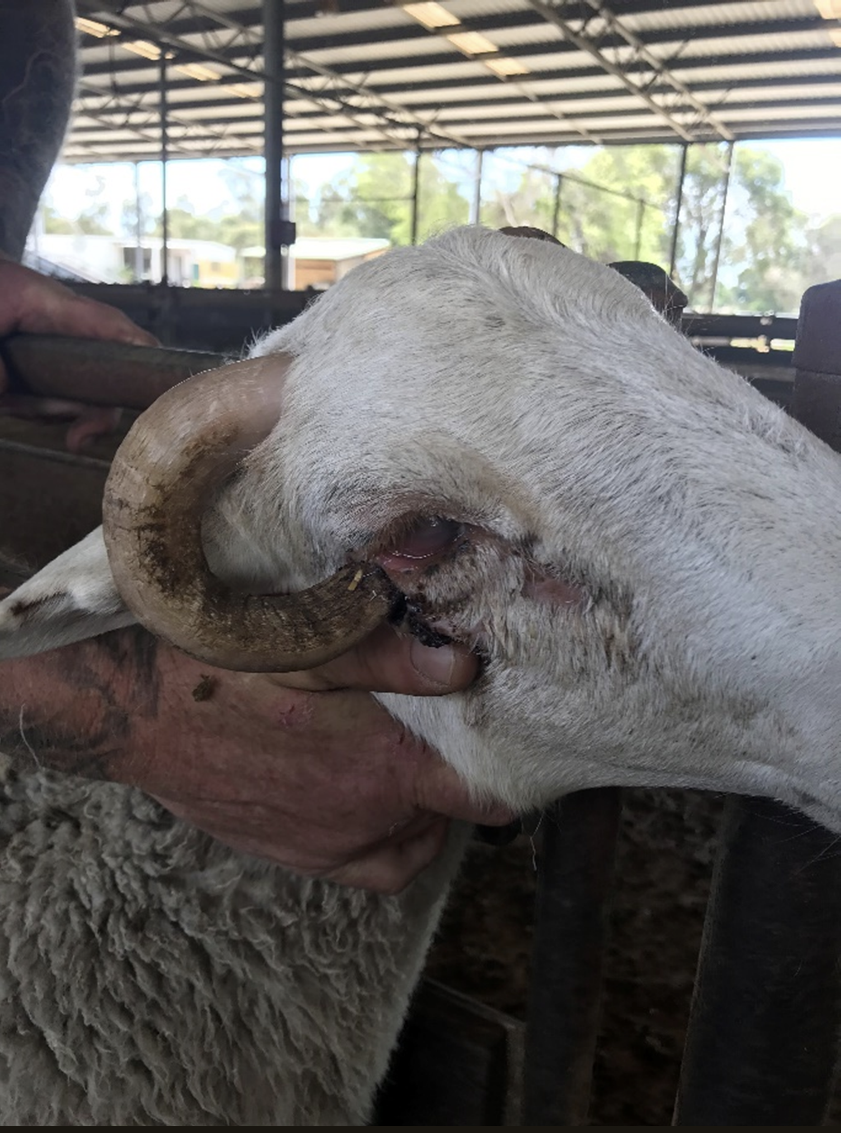

Scabby mouth
Alternative names: Orf, contagious ecthyma, contagious pustular dermatitis

Technical information:
- Scabby mouth is recognised as endemic worldwide and is highly contagious. The causal virus can survive for years in the environment. Infection occurs by contact with infected animals or environment.
- Lesions are generally found on non-wooled areas.
  - The mucocutaneous junction of the lips (i.e. where the mucosa transitions to skin) and around erupting incisor teeth are common locations.
  - Lesions may also occur on the feet e.g. around the coronet (referred to as ‘scabby foot’) and on teats.
- Infected animals may be inappetent and lose weight, and those with foot or teat lesions may suffer lameness or mastitis.

Reject if:
- The animal has visible scabby mouth lesions.

Rejection examples:
Figure 48 Sheep with scabby mouth lesions around lips and nostril
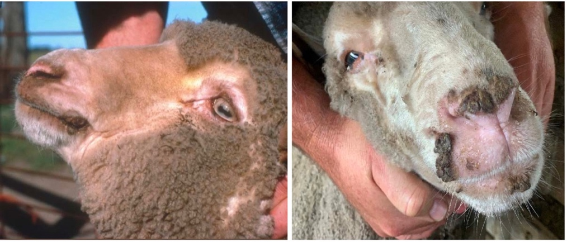

Other

Disparities in sex, size, weight or age that could cause an issue with the health or welfare of the animals (redraft animals in this case)

Technical information:
- Disparities in sex, size, weight or age may lead to certain animals dominating access for food, water and space, and bullying of more submissive animals.
- This behaviour may be observed, or there may be signs such as evidence of back-rubbing/mounting injury or ill-thrift.

Reject/redraft if:
- there is a disparity in sex, size, weight and/or age in a group of penned animals that is likely to cause negative welfare impacts, such as those described under Technical information. Animals should be redrafted, and individual animals should be rejected from the consignment if:
  - it is dominating or bullying others and this cannot be resolved by drafting the animal into another group
  - it is being dominated or bullied by others and this cannot be resolved by redrafting the animal into another group
  - it is not possible to redraft or separate the animal/s.

Rejection examples:
Needed: photographs of disparities that could cause an issue with the health or welfare of the animals

Considerations:
- In penned groups that have been well socialised with an established order, disparities in the group are less of an issue.
- If groups with disparities in sex, size, weight or age are mixed during transport to the port, they should be appropriately separated during loading onto the vessel to minimise issues arising on board in a penned group where is it more difficult to redraft animals.

