Australian Standards for the Export of Livestock: rejection criteria guidebook 2.0

Cattle and buffalo
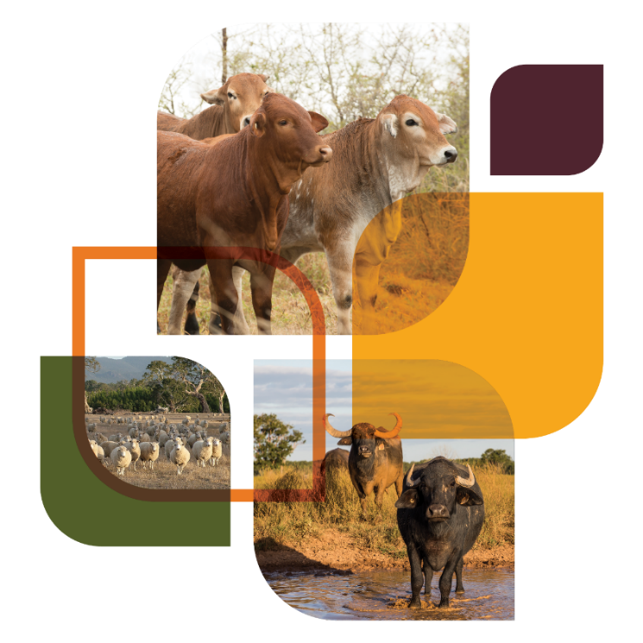
© Commonwealth of Australia 2024
Ownership of intellectual property rights
Unless otherwise noted, copyright (and any other intellectual property rights) in this publication is owned by the Commonwealth of Australia (referred to as the Commonwealth).
Creative Commons licence
All material in this publication is licensed under a Creative Commons Attribution 4.0 International Licence except content supplied by third parties, logos and the Commonwealth Coat of Arms.

Cataloguing data
This publication (and any material sourced from it) should be attributed as: Australian Standards for the Export of Livestock: rejection criteria guidebook – cattle and buffalo, 2024, Department of Agriculture, Fisheries and Forestry (DAFF), Canberra. CC BY 4.0.
This publication is available at Australian Standards for the Export of Livestock – DAFF (agriculture.gov.au).
Department of Agriculture, Fisheries and Forestry
GPO Box 858 Canberra ACT 2601
Telephone 1800 900 090
Web agriculture.gov.au
Disclaimer
The Australian Government acting through the Department of Agriculture, Fisheries and Forestry has exercised due care and skill in preparing and compiling the information and data in this publication. Notwithstanding, the Department of Agriculture, Fisheries and Forestry, its employees and advisers disclaim all liability, including liability for negligence and for any loss, damage, injury, expense or cost incurred by any person as a result of accessing, using or relying on any of the information or data in this publication to the maximum extent permitted by law.
Acknowledgements
The department would like to thank the Australian Accredited Veterinarians whose valuable contributions made this guidance material possible. Contributors included Tony Brightling, Linda Nelson and Glenn Kenneally.
The department would also like to thank the team at the National Animal Disease Information Service, United Kingdom, for permitting us to use a selection of their images.
Acknowledgement of Country
We acknowledge the Traditional Custodians of Australia and their continuing connection to land and sea, waters, environment and community. We pay our respects to the Traditional Custodians of the lands we live and work on, their culture, and their Elders past and present.

Contents
Glossary vii
Introduction 1
ASEL rejection criteria for all species by sea 2
ASEL rejection criteria for all species by air 4
General requirements 6
Pregnancy status not confirmed as appropriate for export 6
Lactating animals/lactating animals with young at foot 8
Animals displaying clinical signs of infectious or contagious disease or external parasites, viral diseases such as infectious bovine rhinotracheitis 9
Animals showing signs of injury such as but not limited to fractures or swelling 10
Systemic conditions 11
Body condition score (BCS) not appropriate for export (such as emaciated or over-fat) 11
Anorexia (inappetence or ‘shy feeders’) 12
Uncoordinated, collapsed, weak 13
Unwell, lethargic, dehydrated/ill-thrift 14
Gastrointestinal system 15
Dysentery or profuse diarrhoea 15
Bloat 17
Musculoskeletal system 18
Abnormal gait or lameness of any kind 18
Abnormal soft tissue or bony swellings 18
Nervous system 21
Nervous symptoms such as head tilt, circling, incoordination 21
Abnormal or aggressive behaviour/intractable or violent 21
External/skin 23
Generalised papillomatosis 23
Generalised ringworm 24
Generalised dermatophilosis 25
Generalised and extensive buffalo fly lesions 26
Generalised skin disease or infection 27
External skin cancer 29
Lacerations that penetrate the full thickness of the dermis or are likely to affect the health or welfare of the animal 30
Discharging wounds or abscesses 31
Balanitis 32
Blood/abnormal discharge from reproductive tract (vulva/prepuce) 34
Visible external parasites 35
Head 36
Blindness in one or both eyes 36
Cancer eye 37
Keratoconjunctivitis (pink eye) 37
Excessive salivation 40
Nasal discharge consistent with signs of contagious or infectious disease 40
Coughing consistent with signs of a contagious or infectious disease and respiratory distress or difficulty breathing 41
Sharp horns, horns that could injure the animal or other animals, horns that could restrict access to feed or water, bleeding and/or not fully healed horn stumps, horns longer than 12cm 42
Other 45
Disparities in sex, size, weight or age that could cause an issue with the health or welfare of the animals (redraft animals in this case) 45

Tables
Table 1: Rejection criteria for all species by sea 2
Table 2: Rejection criteria for all species by air 4

Figures
Figure 1 Recently calved livestock 9
Figure 2 Ocular discharge associated with infectious bovine rhinotracheitis (IBR) 9
Figure 3 Large abnormal swelling on front right leg 10
Figure 4 Abnormal abdominal swelling – should be inspected to determine cause 10
Figure 5 Bos indicus with BCS 1 out of 5 11
Figure 6 Bos taurus with BCS not appropriate for export 11
Figure 7 Location of rumen fossa 13
Figure 8 Cattle showing weakness, depressed demeanour and reduced responsiveness 14
Figure 9 Evidence of diarrhoea, straining with passage of only mucus 16
Figure 10 Heavy faecal contamination of the hind quarters from chronic diarrhoea 16
Figure 11 Animal showing evidence of bloat 17
Figure 12 Large abnormal swelling 19
Figure 13 Abnormal swelling of the lower jaw 19
Figure 14 Large abnormal soft tissue swelling on the lower eyelid 20
Figure 15 Large abnormal soft tissue mass on abdomen 20
Figure 16 An animal displaying left-sided ataxia as seen by crossed forelegs 21
Figure 17 Classification of cattle body regions 23
Figure 18 Animal with multiple, coalescing lesions on head and shoulders 23
Figure 19 Classification of cattle body regions 24
Figure 20 Animal with generalised ringworm 24
Figure 21 Classification of cattle body regions 25
Figure 22 Animal with multiple coalescing lesions over body and belly 26
Figure 23 Classification of cattle body regions 26
Figure 24 Classification of cattle body regions 27
Figure 25 External symptoms of Lantana poisoning seen in the lower legs 28
Figure 26 Animal displaying generalised skin disease around the rump and upper hind legs 28
Figure 27 An animal displaying photosensitisation reactions across the back 28
Figure 28 Abnormal skin reaction on the flank 29
Figure 29 Abnormal tumours on the head 30
Figure 30 Tumour of the right ear 30
Figure 31 Unhealed laceration of the front left leg 31
Figure 32 Sheath above the level of the hock 32
Figure 33 Sheath at the level of the hock requiring inspection 32
Figure 34 Sheath below the level of the hock – rejectable 33
Figure 35 Bull with dysfunction to the retraction of the penis 33
Figure 36 Pendulous sheath which could result in further damage or infection 34
Figure 37 Lesion on the globe 37
Figure 38 Lesions of the third eyelid and periocular tissues 37
Figure 39 Livestock showing excessive epiphora and blepharospasm 38
Figure 40 Animal showing oedema and ulceration 38
Figure 41 Neovascularisation and inflammation of the cornea 39
Figure 42 Chronic eye damage with severe inflammation and neovascularisation 39
Figure 43 Cloudy eye with discharge and epiphora 39
Figure 44 Excessive salivation with viscosity not associated with recent drinking 40
Figure 45 Bilateral purulent discharge 41
Figure 46 Animal with longer and sharper horns than prescribed by ASEL 42
Figure 47 Long and pointed horns – rejection, tipping or export under an approved management plan are options 43
Figure 48 Livestock displaying hollowed and bleeding horn stumps increasing risk of infection 43
Figure 49 Severe horn piping (left) and poorly packed horn resulting in ruptured sinus abscess (right) 43
Figure 50 Disparities in size 45

Glossary
Term | Definition
Australian Standards for the Export of Livestock (ASEL) | The ASEL sets the requirements for exporting livestock from Australia by sea and air. The standards outline the minimum animal health and welfare conditions exporters must meet.
Blepharospasm | Spasm of the eyelids.
Conjunctiva | Membrane that covers the front of the eye. It is transparent in the central portion, where it is specialised to form the covering of the cornea.
Cornea | Clear part at the front of the eye.
Depression | A reduction or lowering in the animal’s activity or consciousness.
Epiphora | Tears from one or both eye(s) that is unable to pass down the tear duct to the inside of the nose. Can be due to blocking of the tear duct or inflammation of cornea or conjunctiva.
Inflamed | Reaction to tissue injury. Shows signs of heat, pain, redness, swelling and loss of function.
Intractable | Difficult or impossible to control.
Intraocular | Within the eyeball.
Mucoid | Involving, resembling, or of the nature of mucus.
Mucopurulent | Containing a mixture of mucus and pus.
Neovascularisation | The development of new blood vessels, especially in tissues where circulation has been impaired by trauma or disease.
Opacity | Lacking transparency or translucence.
Ophthalmalgia | Eye pain.
Photophobia | Sensitive to light/sunlight.
Recumbency | Lying down and a failure to get up.
Ruptured globe | Burst eyeball.
Sclera | Outermost hard fibrous coat of the eye, also known as the ‘whites of the eye(s)’.
Tympany | A hollow drum-like sound that is produced when a gas-containing cavity is tapped sharply.

Introduction
The Australian Standards for the Export of Livestock (ASEL) outlines criteria that, when met, deem an animal ineligible for export. These criteria are termed rejection criteria. Rejection criteria should be understood and used in all parts of the supply chain from farm sourcing, selection and during quarantine/isolation preparation.
This Rejection Criteria Guidebook aims to:
- provide clarification and technical information to users of ASEL (government and non-government) for the selection of export livestock to promote the consistent application of rejection criteria
- improve welfare outcomes for export livestock through better management prior to loading
- provide clear guidelines and images for use by all supply chain stakeholders around livestock that are not suitable for export or to enter the export supply chain.
This guidebook is intended to be a living document that is expanded and improved over time. We ask that if you have photographs or videos of animals that could be included as rejection examples, please contact ASELReview@aff.gov.au. If you have comments or feedback on the text or the layout, please let us know.
As this is a living document, we recommend you access the guidebook via the weblink rather than download your own copy.
This is guidance material only and is not intended to replace any state, territory or Australian animal welfare standards or fit to load guidance.
Where a notifiable animal disease is suspected, there is an obligation to report this to government authorities.
Veterinarians should use their discretion when assessing an animal’s eligibility for export.

ASEL rejection criteria for all species by sea
Table 1: Rejection criteria for all species by sea
Category | Rejection criteria
General requirements | Sheep wool or hair longer than 25 mm ª
 | Failure to meet importing country requirements including sex or breed if specified
 | Pregnancy status not confirmed as appropriate for export
 | Lactating animals/lactating animals with young at foot
 | Viral diseases such as scabby mouth or infectious bovine rhinotracheitis
 | Animals displaying clinical signs of infectious or contagious disease or external parasites
 | Animals showing signs of injury such as but not limited to fractures or swelling
Systemic conditions | Body condition score not appropriate for export (such as emaciated or over-fat)
 | Anorexia (inappetence or ‘shy feeders’)
 | Uncoordinated, collapsed, weak
 | Unwell, lethargic, dehydrated
 | Ill-thrift
Gastrointestinal system | Dysentery or profuse diarrhoea
 | Bloat
Musculoskeletal system | Abnormal gait or lameness of any kind
 | Abnormal soft tissue or bony swellings
Nervous system | Nervous symptoms such as head tilt, circling, incoordination
 | Abnormal or aggressive behaviour/intractable or violent
External/skin | Generalised papillomatosis or generalised ringworm or dermatophilosis
 | Generalised and extensive buffalo fly lesions
 | Generalised skin disease or infection
 | External skin cancer
 | Lacerations that penetrate the full thickness of the dermis or are likely to affect the health or welfare of the animal
 | Discharging wounds or abscesses
 | Cutaneous myiasis (flystrike)
 | Balanitis (pizzle rot in sheep)
 | Blood/abnormal discharge from reproductive tract (vulva/prepuce)
 | Visible external parasites
Head | Blindness in 1 or both eyes
 | Cancer eye
 | Keratoconjunctivitis (pink eye)
 | Excessive salivation
 | Nasal discharge consistent with signs of a contagious or infectious disease
 | Coughing consistent with signs of a contagious or infectious disease
 | Respiratory distress or difficulty breathing
 | Sharp horns
 | Horns that could injure the animal or other animals
 | Horns that could restrict access to feed or water
 | Bleeding and/or not fully healed horn stumps or broken antlers
 | For sheep, horns longer than 1 full curl ª
 | For cattle, horns longer than 12 cm ^{b}
 | Scabby mouth
Other | Groups of animals with unusual mortalities
 | Disparities in sex, size, weight or age that could cause an issue with the health or welfare of the animals (redraft animals in this case)
Note: For some rejection criteria, management procedures may occur after sourcing so livestock meet eligibility criteria at the time of export. a Unless otherwise provided in a relevant management plan approved in writing by the department. b Horns may be longer than 12 cm if they are pointing downwards parallel to the face or unless otherwise provided for in a relevant management plan approved in writing by the department.

ASEL rejection criteria for all species by air
Table 2: Rejection criteria for all species by air
Category | Rejection criteria
General requirements | Failure to meet importing country requirements including sex or breed if specified.  Pregnancy status not confirmed as appropriate for export  Viral diseases such as scabby mouth or infectious bovine rhinotracheitis  Animals displaying clinical signs of infectious or contagious disease or of external parasites  Animals showing signs of injury such as but not limited to fractures or swelling  Evidence of imminent parturition
Systemic conditions | Body condition score not appropriate for export (such as emaciated or over-fat)  Anorexia (inappetence or ‘shy feeders’)  Uncoordinated, collapsed, weak  Unwell, lethargic, dehydrated  Ill-thrift
Gastrointestinal system | Dysentery or profuse diarrhoea  Bloat
Musculoskeletal system | Abnormal gait or lameness of any kind  Abnormal soft tissue or bony swellings
Nervous system | Nervous symptoms such as head tilt, circling, incoordination  Abnormal or aggressive behaviour/intractable or violent
External/skin | Generalised papillomatosis or generalised ringworm or dermatophilosis  Generalised and extensive buffalo fly lesions  Generalised skin disease or infection  External skin cancer  Lacerations that penetrate the full thickness of the dermis or are likely to affect the health or welfare of the animal  Discharging wounds or abscesses  Cutaneous myiasis (flystrike)  Balanitis (pizzle rot in sheep)  Blood/abnormal discharge from reproductive tract (vulva/prepuce)  Visible external parasites
Head | Blindness in 1 or both eyes  Cancer eye  Keratoconjunctivitis (pink eye)  Excessive salivation  Nasal discharge consistent with signs of a contagious or infectious disease  Coughing consistent with signs of a contagious or infectious disease  Respiratory distress-difficulty breathing  Sharp horns  Horns that could injure the animal or other animals  Horns that could restrict access to feed or water  Bleeding and/or not fully healed horn stumps or broken antlers  For sheep, horns longer than 1 full curl ª  For cattle, horns longer than 12 cm ^{b}  Scabby mouth
Other | Groups of animals with unusual mortalities  Disparities in sex, size, weight or age that could cause an issue with the health or welfare of the animals (redraft animals in this case)
Note: For some rejection criteria, management procedures may occur after sourcing so livestock meet eligibility criteria at the time of export. a Unless otherwise provided in a relevant management plan approved in writing by the department. b Horns may be longer than 12 cm if they are pointing downwards parallel to the face or unless otherwise provided in a relevant management plan approved in writing by the department.

General requirements

Pregnancy status not confirmed as appropriate for export

Reject if:
- Required certification cannot be provided (see Considerations).

Considerations:
To facilitate efficient verification by departmental staff, all declarations/certifications should:
- have NLIS numbers itemised (1. XXX 2. XXX and so on) or the total count of animals spayed/tested provided
- link to or include property of origin/property of testing details.

For consignments by sea
Female feeder or slaughter cattle/buffalo by sea require one of the following:
- If spayed, a spay declaration stating:
  - owner/manager name, contact information and signature
  - NLIS number
  - date of procedure
AND
  - spayed 30+ days prior to export by Willis dropped ovary technique
OR
  - spayed 280+ days prior to export
- Pregnancy certificate by registered veterinarian stating:
  - veterinarian name, registration no. and signature
  - method used (manual palpation, blood test or ultrasound as permitted)
  - not detectably pregnant
  - NLIS number
  - date of procedure/sample collection (within 30 days of export)
- Pregnancy certificate by competent pregnancy tester stating:
  - name and signature
  - state or territory accreditation or other authorisation (not all jurisdictions allow non-veterinarians to diagnose pregnancy: ensure this is permitted in jurisdiction of testing)
  - method used (manual palpation only)
  - not detectably pregnant
  - NLIS number
  - date of procedure (within 30 days of export)
Female breeder cattle/buffalo by sea require one of the following:
- For voyages less than 10 days and animal can be manually palpated – pregnancy certificate by registered veterinarian stating:
  - veterinarian name, registration no. and signature
  - attestation to current experience and competency in cattle/buffalo pregnancy diagnosis
  - method used (approved blood test or manual palpation)
  - not detectably pregnant or number of days pregnant
  - NLIS number
  - date of procedure (within 30 days of export if pregnant, within 60 days of export if not detectably pregnant)
- For voyages 10 days or more and/or animals are too small to be manually palpated – pregnancy certificate by registered veterinarian accredited under PREGCHECK (NCPD) Scheme stating:
  - veterinarian name, registration no., accreditation no., statement of current accreditation and signature
  - method used (approved blood test, manual palpation or, if animal is too small to be manually palpated, ultrasound)
  - not detectably pregnant or number of days pregnant
  - NLIS number
  - date of procedure (within 30 days of export if pregnant, within 60 days of export if not detectably pregnant)
IMPORTANT: Check the number of days pregnant and confirm:
Cattle: max. 190 days pregnant at scheduled discharge date
Buffalo: max. 220 days pregnant at scheduled discharge date
For consignments by air
Female feeder or slaughter cattle/buffalo by air require one of the following:
- If spayed, a spay declaration stating:
  - owner/manager name, contact information and signature
  - NLIS number
  - date of procedure
AND
  - spayed 30+ days prior to export by Willis dropped ovary technique
OR
  - spayed 280+ days prior to export
- Pregnancy certificate by registered veterinarian stating:
  - veterinarian name, registration no. and signature
  - method used (manual palpation, approved blood test or ultrasound as permitted)
  - not detectably pregnant
  - NLIS number
  - date of procedure/sample collection (within 30 days of export)
Female breeder cattle/buffalo by air require one of the following:
- A pregnancy certificate by registered veterinarian stating:
  - veterinarian name, registration no. and signature
  - method used (approved blood test or manual palpation)
  - not detectably pregnant or number of days pregnant
  - NLIS number
  - date of procedure
- Where the animal is too small to be manually palpated and ultrasound diagnosis is used, a pregnancy certificate by registered veterinarian accredited under PREGCHECK (NCPD) Scheme stating:
  - veterinarian name, registration no., accreditation no. and signature
  - method used (ultrasound)
  - not detectably pregnant or number of days pregnant
  - NLIS number
  - date of procedure
IMPORTANT: Check the number of days pregnant and confirm:
Cattle: max. 190 days pregnant at scheduled date of export (unless under a last third of pregnancy management plan)
Buffalo: max. 220 days pregnant at scheduled date of export (unless under a last third of pregnancy management plan)

Lactating animals/lactating animals with young at foot

Technical information:
- Lactation is the secretion of milk by the mammary glands.
- Engorged/ distended mammary glands are evidence of lactation.
- When lactating, there is increased potential for infection to penetrate the teat duct, which is an important consideration in export animals.
Note: Lactating animals with young at foot are not permitted to be exported by sea.

Reject if:
- The animal has evidence of lactation (unless under a livestock with young at foot management plan (air only)) e.g. milk dripping from teats (including milk dripping from unjoined heifers).

Rejection examples:
Figure 1 Recently calved livestock
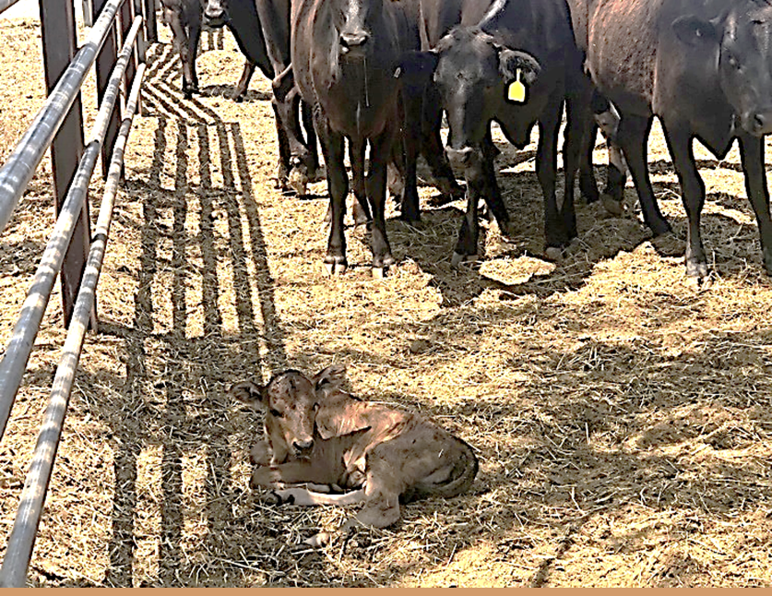
Note: It is important to identify the lactating cow.

Considerations:
- Accuracy of pregnancy test certification – could the animal be pregnant/nearing parturition?
- Are there seasonal and/or compositional differences in feed that may have caused premature lactation?

Animals displaying clinical signs of infectious or contagious disease or external parasites, viral diseases such as infectious bovine rhinotracheitis

Technical information:
- Cattle and buffalo are susceptible to a range of infectious and contagious diseases and internal and external parasites.
- They are also susceptible to various internal and external parasites. For more information on external parasites specifically, see Visible external parasites.

Reject if:
- The animal has any infectious or contagious disease or parasitic infection not otherwise specified in ASEL or this guidebook that compromises animal health and welfare.
Rejection examples:
Figure 2 Ocular discharge associated with infectious bovine rhinotracheitis (IBR)
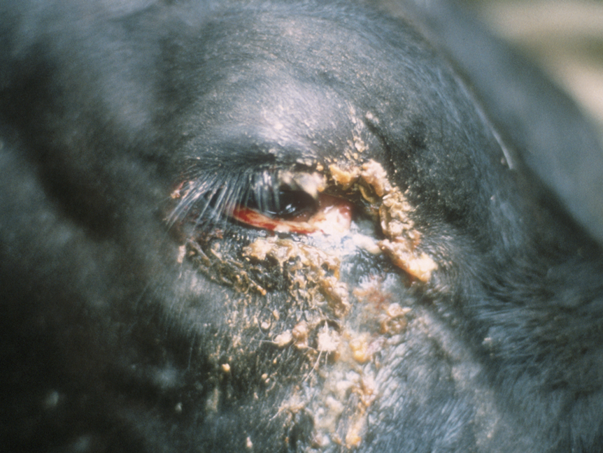

Animals showing signs of injury such as but not limited to fractures or swelling

Technical information:
- Injuries are physical harm or damage inflicted on an animal’s body and can compromise the health and welfare of the animal.
- May be associated with bleeding, swelling, discharge, pain, abnormal behaviour, lameness, hair loss and discolouration of skin.

Reject if:
- The animal is showing signs of injury.
Figure 3 Large abnormal swelling on front right leg
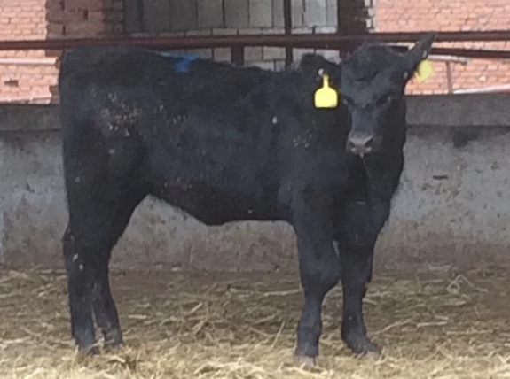
Figure 4 Abnormal abdominal swelling – should be inspected to determine cause
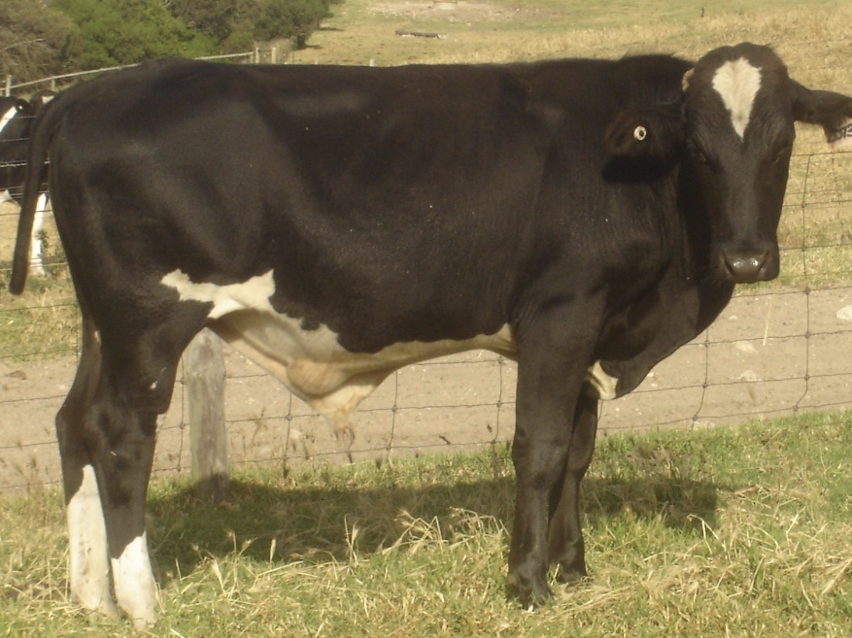

Considerations:
- If unsure, draft the animal out for close inspection.

Systemic conditions

Body condition score (BCS) not appropriate for export (such as emaciated or over-fat)

Reject if:
- The animal does not meet BCS requirements (see Considerations).

Rejection examples:
Figure 5 Bos indicus with BCS 1 out of 5
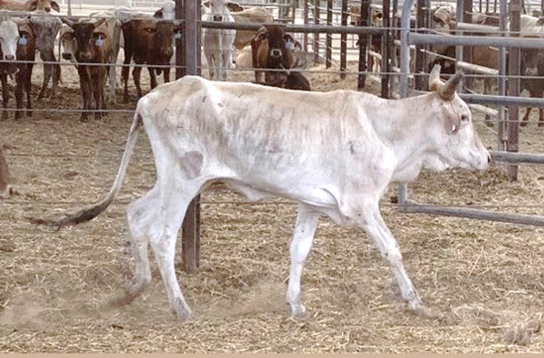
Figure 6 Bos taurus with BCS not appropriate for export
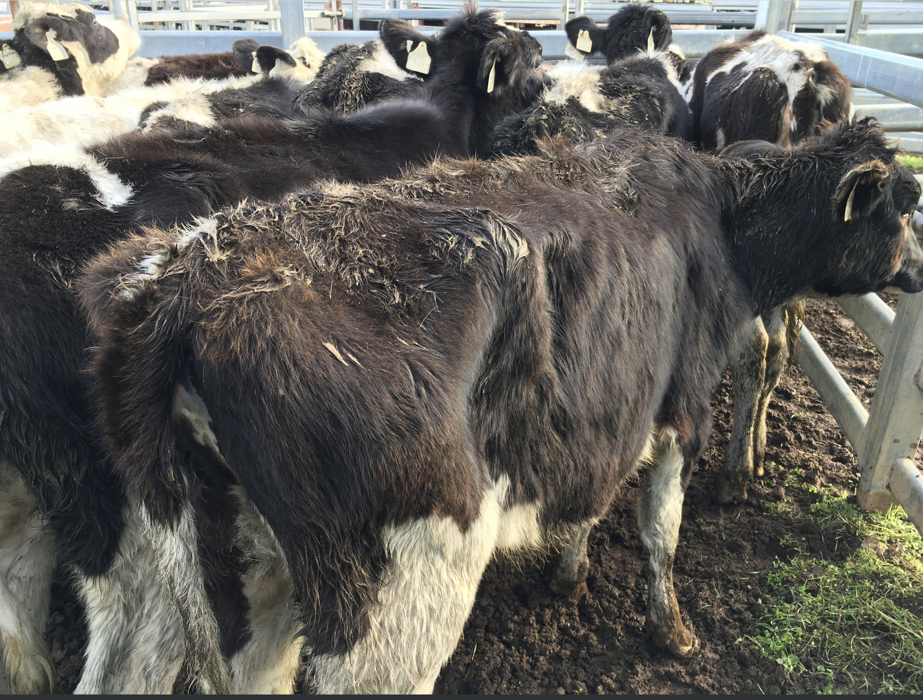
Needed: photographs of rejectable Bos taurus (both ends of scale) meat and dairy breeds.

Considerations:

Sea
- Dairy breed cattle must have a BCS of 3.5 or more but less than 5.5 (on a scale of 1 to 8).
  - unless Bos taurus and sourced from, or exported through, any area north of latitude 26°S between 1 Oct and 31 Dec inclusive, then they must have a BCS of 3.5 or more but less than 5 (on a scale of 1 to 8).
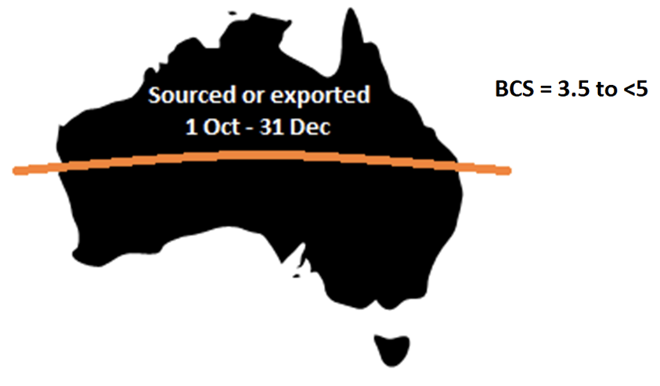
- Non-dairy breed cattle must have a BCS of 2 to 4 (inclusive) (on a scale of 0 to 5).
  - unless Bos taurus and sourced from, or exported through, any area north of latitude 26°S between 1 Oct and 31 Dec inclusive, then they must have a BCS of 2 to 3 (inclusive) (on a scale of 0 to 5).
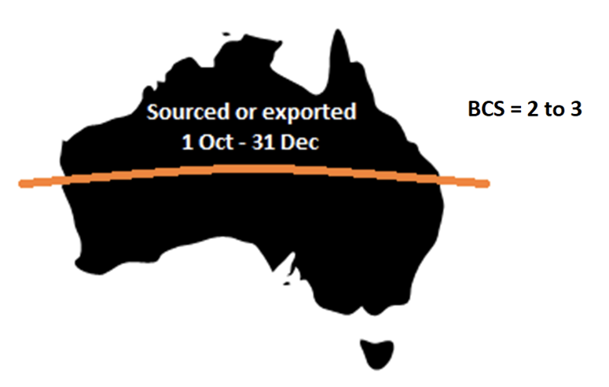
- Buffalo must have a BCS of 2 to 4 (inclusive) (on scale of 1 to 5).

Air
- Dairy breed cattle must have a BCS of 3.5 or more but less than 5.5 (on a scale of 1 to 8).
- Non-dairy breed cattle must have a BCS of 2 or more but less than 5 (on scale of 0 to 5).
- Buffalo must have a BCS of 2 or more but less than 5 (on scale of 1 to 5).

General
- Breed influences the distribution of fat and muscle.
- Inspect animals while they are standing to accurately estimate BCS.

Anorexia (inappetence or ‘shy feeders’)
Alternative names: inanition, inappetence, poor doers

Technical information:
- Lack or loss of appetite for food.
- Shy feeders (prolonged lack or loss of appetite) may be a result of failure to adapt to diet changes or the environment (mixing with unfamiliar animals, novel feed and environment, competition, increased human contact, etc.).
- Rumen fill assessment: observation of the paralumbar (‘rumen’) fossa on the left side of the animal (see Figure 7). The animal has not eaten enough if a clear triangular depression (score 1–2 out of 5) is present.
Figure 7 Location of rumen fossa
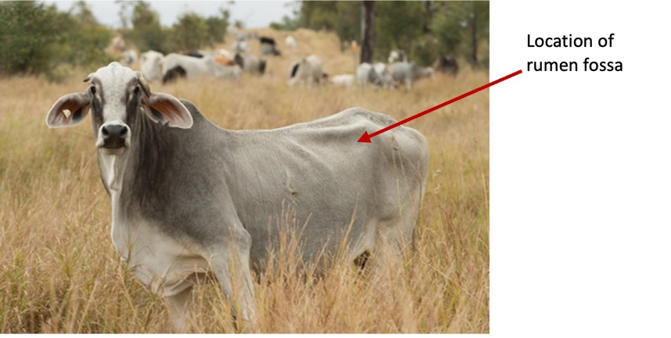

Reject if:
- Any animal with evidence or history of poor feed/water intake.
- Rumen fill score of 1–2 (and the animal has not been under curfew).

Rejection examples:
Needed: Examples of rumen fill score 1 and 2 in beef and dairy breeds.

Considerations:
- Compare a suspect anorexic animal to its cohort – it should stand out. If many animals have no rumen fill, there may an issue with feed delivery or palatability, illness, overcrowding or insufficient trough space.
- Anorexia may not be noticed by brief inspection but may be evident from daily observation over time.
- Anorexia may result in the animal being rejected under other criteria e.g. ill-thrift, poor body condition score.
- If anorexia is as a result of bullying behaviour, redrafting of animals may be required.

Uncoordinated, collapsed, weak

Technical information:
- Uncoordinated animals show irregular movements e.g. movements which are not smooth and coordinated. Also referred to as ataxia (failure of musculature coordination).
- Collapsed animals are in a state of prostration (exhaustion or lack of energy) and depression ± poor circulation.
- Weak animals show reluctance to and difficulty in rising, a disinclination to move, and then only slowly. They may not eat, or eat slowly, and may exhibit a drooping posture.

Reject if:
- The animal is showing signs of incoordination, collapse and/or weakness.
- The animal is not bright, alert or responsive to human/animal interaction.

Rejection examples:
Figure 8 Cattle showing weakness, depressed demeanour and reduced responsiveness
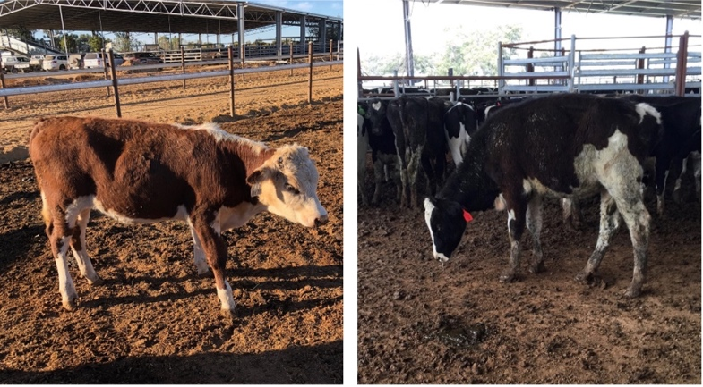

Unwell, lethargic, dehydrated/ill-thrift

Technical information:
- Unwell is a broad term to describe animals that may be displaying a range of clinical signs indicating they are not healthy. An animal that is not bright, alert and responsive to human/animal interaction is considered unwell.
- Lethargic animals show signs of drowsiness and/or indifference (lack of interest in surroundings/stimuli).
- Dehydrated animals may have a loss of skin elasticity, sunken/dry-looking eyes, signs of lethargy, a dry nose and dry, sticky gums. They may also display panting.
- Ill-thrift animals may show a failure to grow compared to their cohort and an inability to maintain weight despite seemingly adequate food available.

Reject if:
- The animal is showing signs of ill-thrift or of being unwell, lethargic or dehydrated.
- The animal is not bright, alert or responsive to human interaction/animal.

Rejection examples:
Needed: photographs/video of rejectable animals

Considerations:
- Heat waves may cause animals to show lethargy. A plentiful supply of clean cool water and shade is essential. Water sprinklers may be useful to cool animals.
- Recent travel over a long distance or in the heat may cause lethargy. Animals should be given sufficient time to recover prior to further handling.

Gastrointestinal system

Dysentery or profuse diarrhoea

Technical information:
- Rapid movement of faecal matter through the intestine resulting in poor absorption of water, nutritive elements and electrolytes, and producing frequent evacuation of watery droppings.
- Causes include:
  - local irritation of the intestinal mucosa by infectious (e.g. bacteria, viral, protozoa) or chemical agents
  - seasonal considerations e.g. fresh green grass, wet weather
  - increased worm burden
  - disease, stress and nutritional deficiencies
  - indigestion associated with dietary changes.
- May lead to acidosis, or be a sign of acidosis.
- May be associated with abdominal pain, tenesmus (straining), dehydration, loss of body condition and faecal contamination of hindquarters.
- An affected animal may also show signs of lethargy, and dull demeanour compared to cohort.

Reject if:
The animal has:
- heavy faecal contamination of hindquarters or diarrhoea observed, and the animal is not bright, alert and responsive
- bloody diarrhoea
- straining and/or evidence of abdominal pain.

Rejection examples:
Figure 9 Evidence of diarrhoea, straining with passage of only mucus
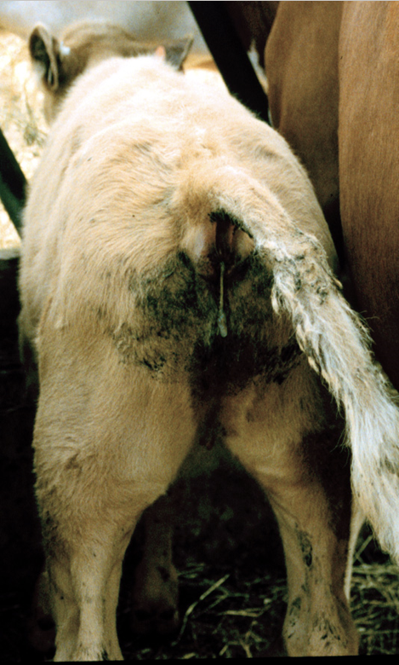
Credit: Phil Scott. National Animal Disease Information Service
Figure 10 Heavy faecal contamination of the hind quarters from chronic diarrhoea
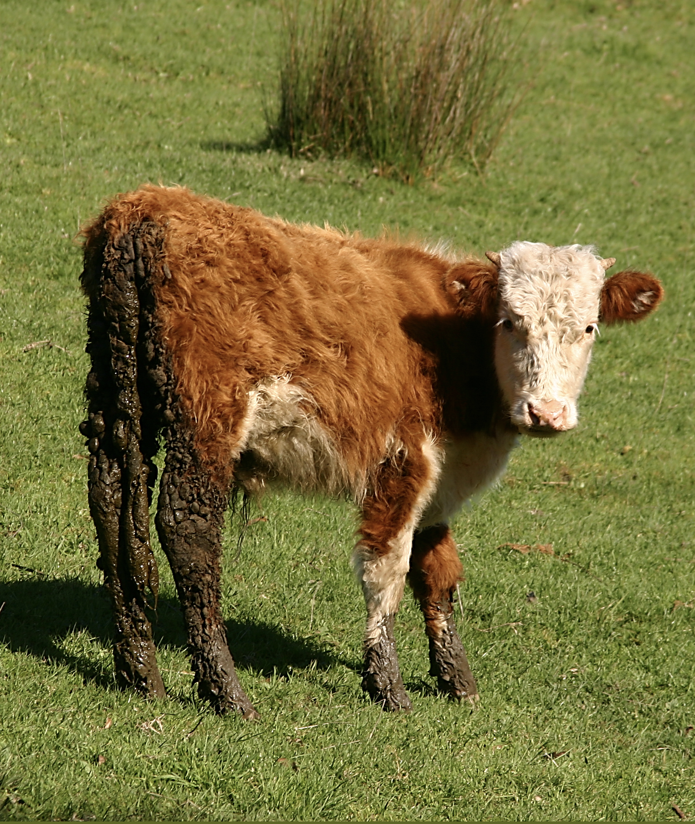
Note: Animals will not be presented for export in this state, however, this may be observed earlier in the supply chain.

Considerations:
- History: progression and response to treatment.
- A transient dietary diarrhoea from a recent change in diet and the animal is otherwise bright, alert and responsive and eating/drinking does not require rejection, but must be resolved prior to transport to the port.
- It may be necessary to undertake further assessment of the group if diarrhoea is visible in pen/yard.

Bloat

Technical information:
- Tympany/swelling/distention of the rumen, abomasum or caecum. May be frothy (gas mixed with liquid to form stable froth) or free gas bloat.
- Usually sudden in onset.
- Usually associated with discomfort and vocalisation (bellowing).

Reject if:
- The animal is bloated unilaterally, bilaterally symmetrically or asymmetrically.

Rejection examples:
Figure 11 Animal showing evidence of bloat
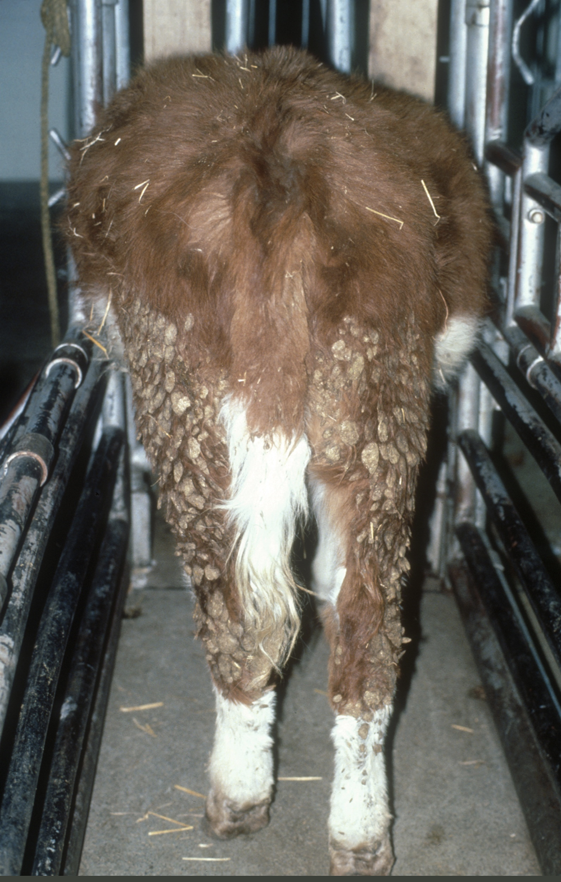

Considerations:
- Mild left abdominal distention indicating a full rumen or having just fed in the absence of other symptoms suspicious of bloat does not require rejection.
- Animals in late pregnancy can appear bloated.
- Bloat can be an emergency, so consider contacting a veterinarian promptly if bloat is suspected.

Musculoskeletal system

Abnormal gait or lameness of any kind

Technical information:
- A lame animal is incapable of normal locomotion; there is a deviation from the normal gait.
- Most commonly caused by pain in a limb/trunk or supporting structures. Contractures of joints and deformities, including shortness of limbs, may also be causes.

Reject if:
The animal is:
- not bearing weight evenly on all 4 legs
- redistributing weight to avoid placing weight on particular limb/s
- arching its back or bobbing its head when walking and its strides are obviously shortened
or the animal has:
- swollen limb/s
- knuckling of limb/s
- persistence lameness
- an obvious injury to the foot/leg
- a hoof deformity
- an abnormal gait other than due to conformation.

Rejection examples:
Needed: photographs/video of rejectable animals.

Considerations:
- Is there a reason the animal is footsore but this will resolve onboard the vessel and its welfare is not compromised?
- Is the lameness suspected to be due to age and size (e.g. arthritis in a mature, heavy bull)?
  - If the welfare of the animal would be placed at risk due to voyage (consider penning, voyage length, etc.) it may be more appropriate to transport the animal to a local abattoir, provided the animal is fit to load.
Note: treating animals on board can be difficult, therefore avoid allowing any lameness on board.

Abnormal soft tissue or bony swellings

Technical information:
- Abnormal soft tissue or bony swellings may be associated with the following (this list is not exhaustive):
  - tumour e.g. skin tumours, enlarged lymph nodes
  - infection e.g. lumpy jaw, cheesy gland, trauma to body
  - abscess e.g. from vaccination, grass seed penetration
  - haematoma e.g. around bony prominences from trauma
  - hernia e.g. on ventral abdomen due to trauma
  - oedema e.g. submandibular (woody tongue, heart failure), brisket
  - urine e.g. ventral abdomen following urethral obstruction/rupture
  - gas e.g. over rump/back/shoulder (blackleg), sucking wounds.

Reject if:
- The animal has any visible abnormal soft tissue or bony swelling that may adversely affect animal health and welfare.

Rejection examples:
Figure 12 Large abnormal swelling
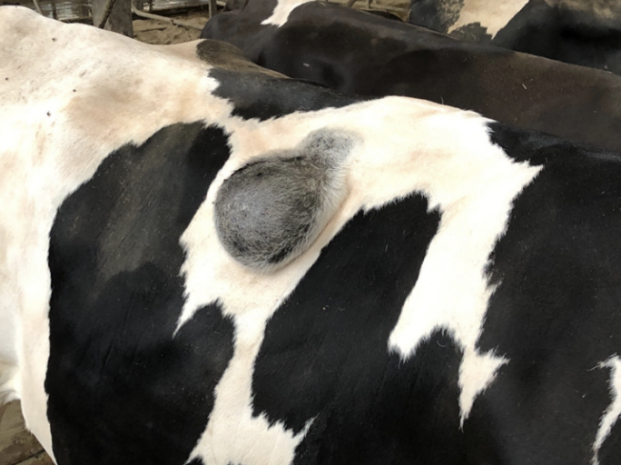
Figure 13 Abnormal swelling of the lower jaw
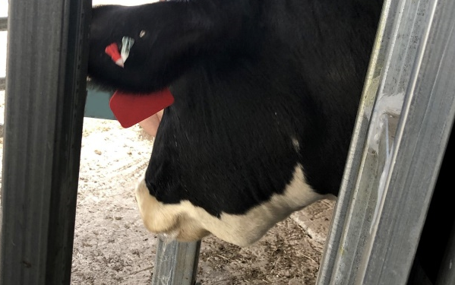
Figure 14 Large abnormal soft tissue swelling on the lower eyelid
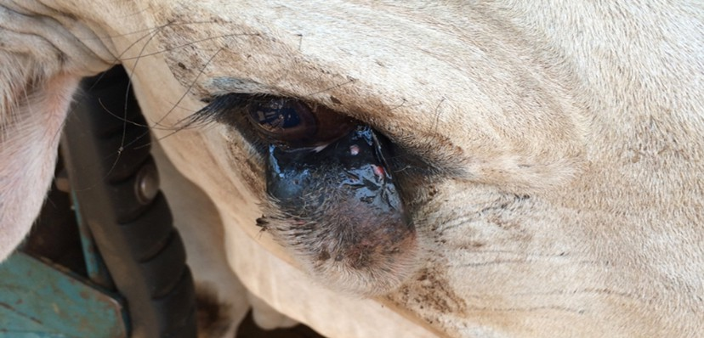
Figure 15 Large abnormal soft tissue mass on abdomen
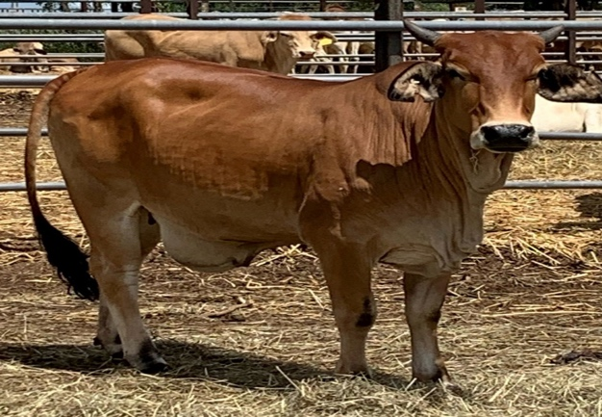

Considerations:
- Enlargements in lymph nodes (glands) may be transient with illness and return to normal upon returning to good health. These animals may not be appropriate for export until illness has resolved.

Nervous system

Nervous symptoms such as head tilt, circling, incoordination

Technical information:
- Examples of nervous system symptoms include, but are not limited to:
  - head tilt or circling
  - head pressing
  - stargazing: back tends to be arched and head in upwards position
  - staggers: incoordination, including a tendency to fall over
  - ataxia: abnormal or uncoordinated movements
  - tremors or seizures
  - abnormal chomping of jaws.
- Animals with any of these signs should be drafted out and clinically assessed.

Reject if:
- The animal is persistently or repeatedly displaying nervous system signs such as those described under Technical information.

Rejection examples:
Figure 16 An animal displaying left-sided ataxia as seen by crossed forelegs
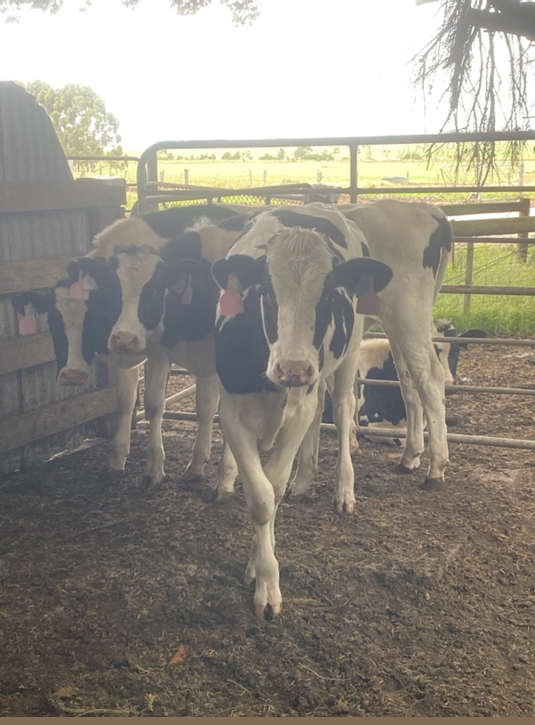

Abnormal or aggressive behaviour/intractable or violent

Technical information:
- Aggressive cattle and buffalo can be dangerous and should be handled carefully.
- Groups of bulls are more likely to become aggressive amongst themselves in the presence of cows.
- Aggressive behaviours can include but are not limited to:
  - repeated charging
  - charging through fences
  - targeting people
  - repeated pawing
  - tail swishing
  - head nodding
  - standing ground or not moving away
  - aggressive vocalisation.

Reject if:
- The animal is displaying abnormal aggressive, intractable, or violent behaviour such as that described under Technical information.

Rejection examples:
Needed: photographs or video of abnormal or aggressive behaviour

Considerations:
- Cattle kept on large properties where little human contact occurs are more likely to become agitated/fearful when confined or placed in new environments.
  - Differentiate between aggressive behaviour and stressed behaviour.

External/skin

Generalised papillomatosis
Alternative name for papillomatosis: warts

Technical information:
- Hairless, normally benign growths on skin or mucosa caused by papilloma virus. Can spread via direct contact with infected animals, and fomites such as contaminated feed troughs, ear tagging pliers and injection equipment. Lesions vary in appearance from single, discrete growths, to large, broad masses that hang from the body.
- Papillomatosis warts are generally confined to the neck and shoulder region in cattle but can be located on the teats or penis.

Reject if:
- The animal has generalised papillomatosis (multiple coalescing lesions on multiple regions).
Figure 17 Classification of cattle body regions
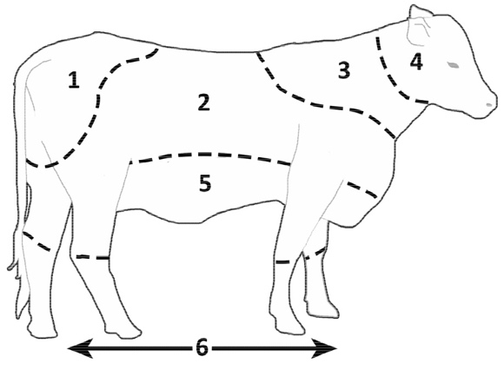
1=rump, 2=body and upper leg, 3=shoulders, 4=head, 5=belly, 6=lower leg and foot. Credit: Adapted from Pickering et al. 2015.

Rejection examples:
Figure 18 Animal with multiple, coalescing lesions on head and shoulders
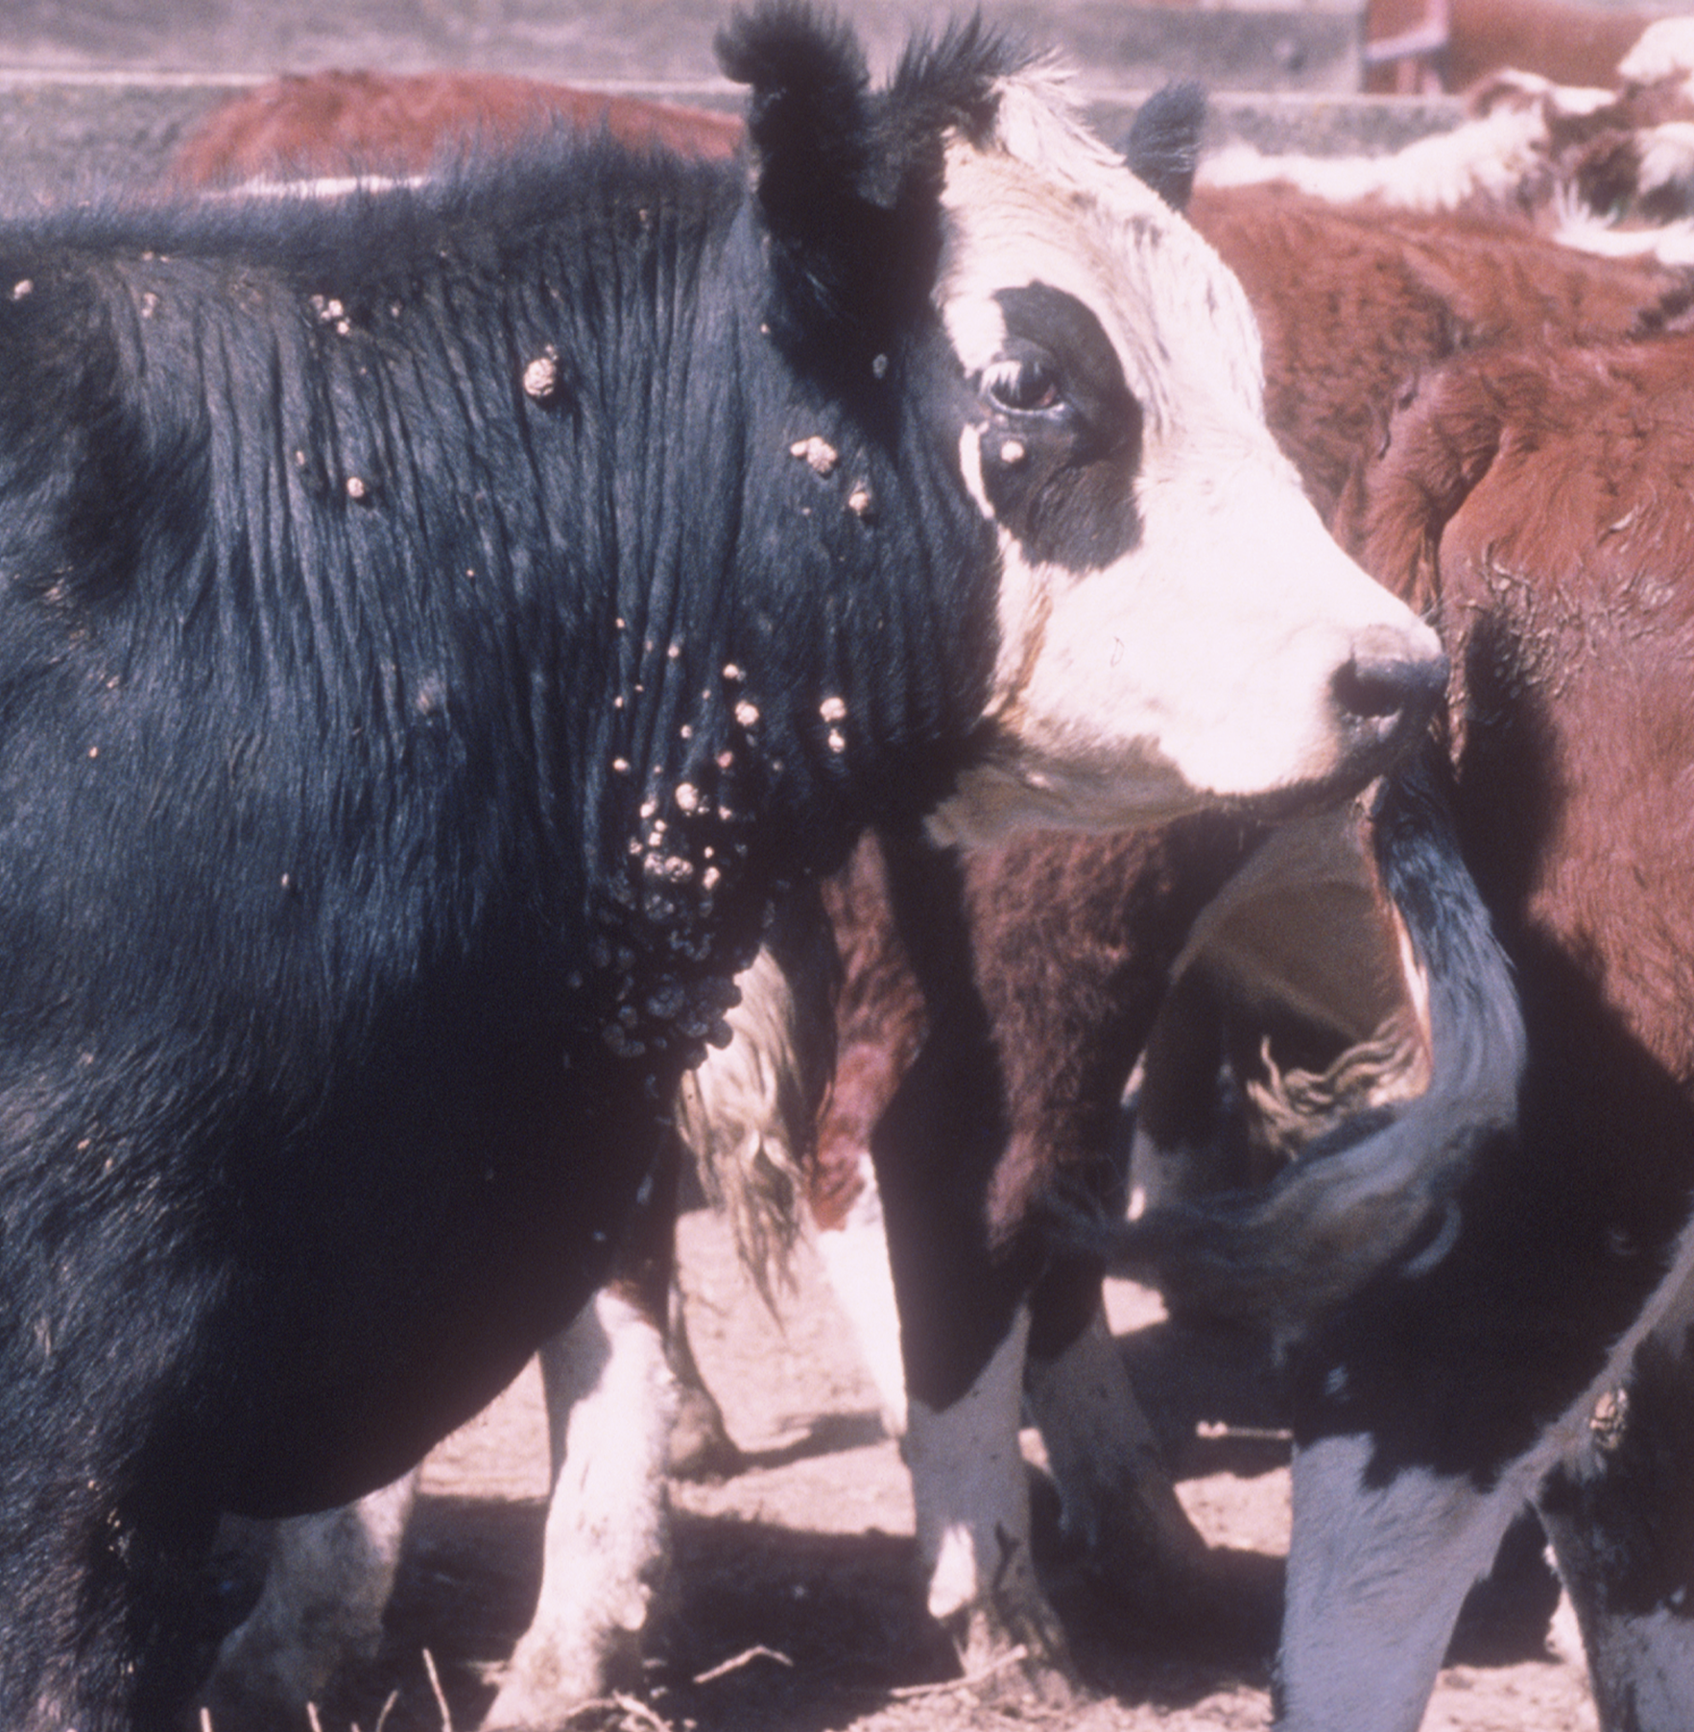

Considerations:
- Professional discretion is required when evaluating this condition, considering the size and location/s of lesions, number, likelihood of further welfare issues to the individual animal and/or its cohort.

Generalised ringworm
Alternative name for ringworm: dermatophytosis

Technical information:
- Usually hairless, circular skin lesions around the eye, with grey-white crust formation but can become thickly crusted. Lesions can also occur on the chest, limbs, dewlap and intermaxillary skin. Can be spread by close contact with an infected animal or contaminated environment. Varies in appearance from single, discrete lesions, to large, coalescing patches. This disease is zoonotic.

Reject if:
- The animal has generalised ringworm (multiple coalescing lesions on multiple regions).
Figure 19 Classification of cattle body regions
1=rump, 2=body and upper leg, 3=shoulders, 4=head, 5=belly, 6=lower leg and foot. Credit: Adapted from Pickering et al. 2015.
Rejection examples:
Figure 20 Animal with generalised ringworm
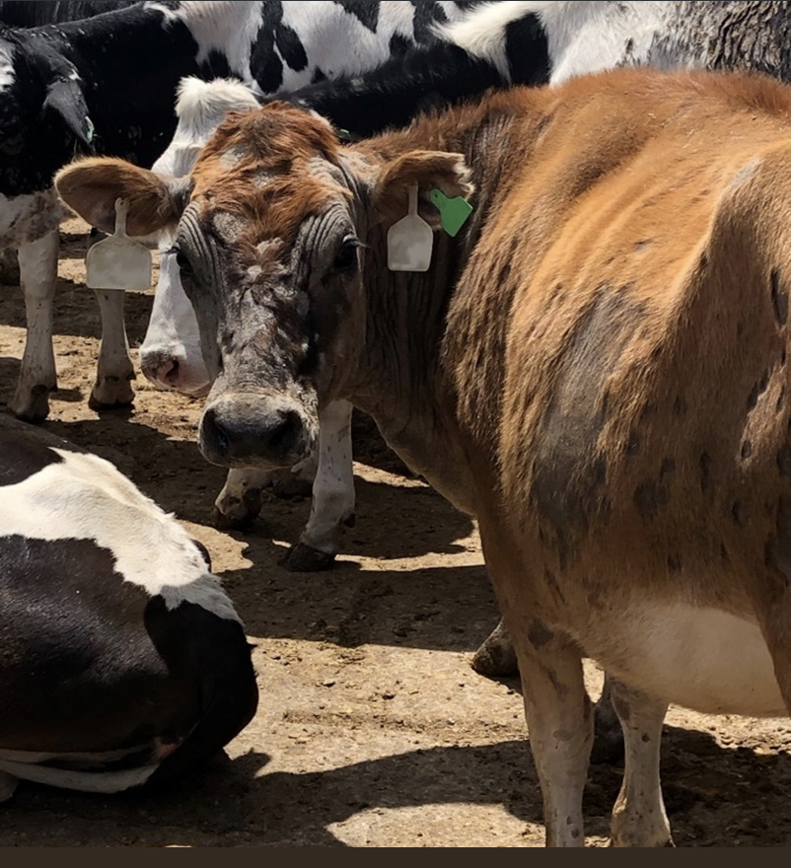

Considerations:
- Professional discretion is required when evaluating this condition, considering the size and location/s of lesions, number, likelihood of further welfare issues to the individual animal and/or its cohort.

Generalised dermatophilosis
Alternative names for dermatophilosis: rain scald

Technical information:
- In cattle, lesions can be observed in 3 stages:
  - Stage 1 – hairs matted together as paintbrush lesions
  - Stage 2 – crust or scab formation as the initial lesions coalesce
  - Stage 3 – accumulations of cutaneous keratinized material forming wart-like lesions 0.5–2 cm in diameter.
- Typical lesions consist of raised, matted tufts of hair.
- Lesions can be found on any part of the body exposed to moist environments including head, neck, udders, back, axillae, groin and scrotum.

Reject if:
The animal has generalised dermatophilosis (multiple coalescing lesions on multiple regions).
Figure 21 Classification of cattle body regions
1=rump, 2=body and upper leg, 3=shoulders, 4=head, 5=belly, 6=lower leg and foot. Credit: Adapted from Pickering et al. 2015.

Rejection examples:
Figure 22 Animal with multiple coalescing lesions over body and belly
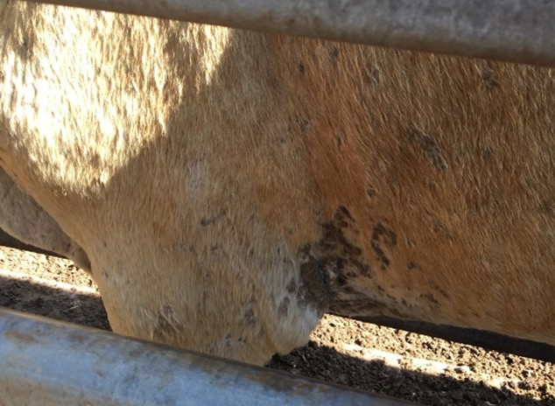

Considerations:
- Professional discretion is required when evaluating this condition, considering the size and location/s of lesions, number, likelihood of further welfare issues to the individual animal and/or its cohort.

Generalised and extensive buffalo fly lesions

Technical information:
- Buffalo fly are a primary pest of cattle in northern Australia with a life cycle taking as few as 7–10 days depending on weather conditions. Bites typically occur around the shoulders and withers causing irritation, decrease in performance and can result in hide damage. Bites can also occur on other parts of the body. Buffalo fly bites pose a potential route for the development of secondary infection and should be treated.

Reject if:
- The animal has generalised buffalo fly lesions (3 or more active lesions on 2 or more regions of the body).
- The animal has an open and active lesion that may adversely affect animal health and welfare.
Figure 23 Classification of cattle body regions
1=rump, 2=body and upper leg, 3=shoulders, 4=head, 5=belly, 6=lower leg and foot. Credit: Adapted from Pickering et al. 2015.

Rejection examples:
Needed: photographs/video of rejectable animals.

Generalised skin disease or infection

Technical information:
- Generalised skin disease or infection can manifest in several conditions affecting the health and welfare of livestock. Conditions can include but are not limited to:
  - photosensitisation/facial eczema
  - dermatitis from lantana poisoning
  - digital/interdigital dermatitis
  - cellulitis.

Reject if:
- The animal has skin disease or infection that extends over 80% of one region or extends this amount over multiple regions.
- The animal has chronic active skin disease e.g. photosensitisation with fibrosis.
- The animal has skin disease or infection that is likely to impact its health or welfare e.g.:
  - open lesions or lesions with exudate
  - evidence of pain or severe irritation
  - other signs of systemic illness e.g. loss of appetite, jaundice.
Figure 24 Classification of cattle body regions
1=rump, 2=body and upper leg, 3=shoulders, 4=head, 5=belly, 6=lower leg and foot. Credit: Adapted from Pickering et al. 2015.

Rejection examples:
Figure 25 External symptoms of Lantana poisoning seen in the lower legs
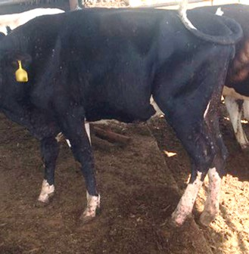
Figure 26 Animal displaying generalised skin disease around the rump and upper hind legs
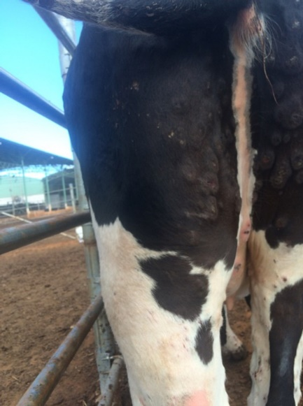
Figure 27 An animal displaying photosensitisation reactions across the back
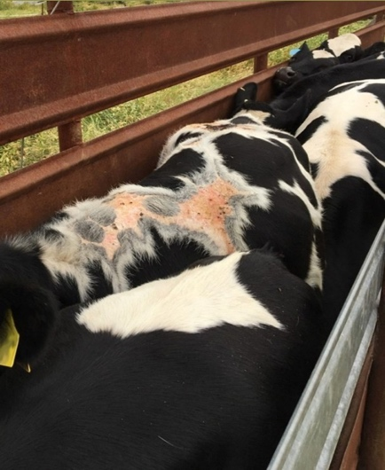
Figure 28 Abnormal skin reaction on the flank
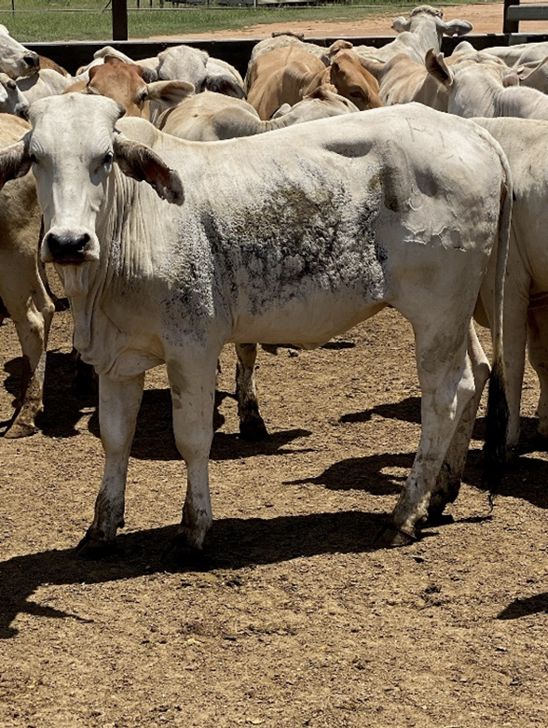

External skin cancer

Technical information:
- External skin cancers can be present on the upper or lower body and commonly form lesions of varying size, colour and texture in cattle. Some cystic lesions may affect the hoof wall resulting in lameness or deformity of the hoof. Squamous cell carcinomas are common in breeds with white hair and poorly pigmented skin and have been recorded in the horn core of aged bullocks.
- Lesions start as thickened areas of reddened, flaking skin that later become ulcerated, necrotic, bleeding masses. Animals with noticeable lesions should be excluded from the export process. Lesions may be missed when animals are grouped, hence a systematic inspection method is required.

Reject if:
- The animal has a lesion with appearance indicative of skin cancer.
- The animal has a visible tumour/lesion of any size or location that:
  - is open/exudating
  - is causing severe irritation and/or distress to the animal
  - could be damaged in the pen or during transport leading to an open wound.

Rejection examples:
Figure 29 Abnormal tumours on the head
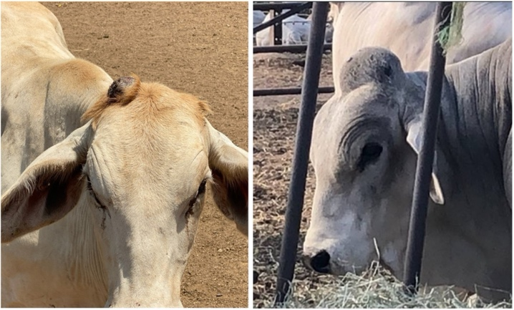
Figure 30 Tumour of the right ear
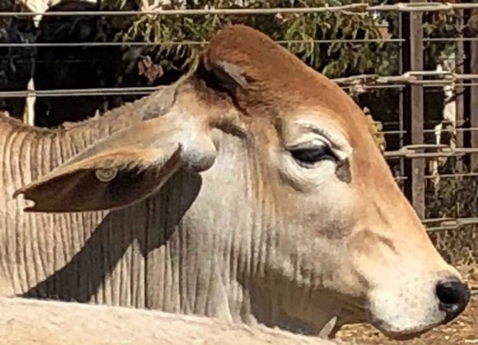

Lacerations that penetrate the full thickness of the dermis or are likely to affect the health or welfare of the animal

Technical information:
- Lacerations can be caused by sharp objects such as a sharp edge to a gate. They have the potential to become infected and treatment may be required to reduce animal pain and discomfort.

Reject if:
- The animal has a full thickness laceration that:
  - is unhealed
  - has exudate present
  - has fresh blood present or a newly developed scab that may be damaged in the pen or on transport.

Rejection examples:
Figure 31 Unhealed laceration of the front left leg
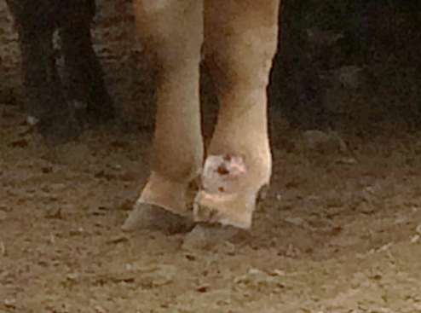

Considerations:
- The location of the wound needs to be considered as it could lead to other problems such as lameness.
- When assessing any full thickness wound, also consider the presence of inflammation or cellulitis. Presence of additional issues could result in the animal being rejected for this reason despite a healed wound.

Discharging wounds or abscesses

Technical information:
- A discharging wound is one that secretes serous, sanguineous, serosanguineous or purulent discharge. The presence of serous fluid is normal in a healing wound; however these animals cannot join the consignment until the wound is completely healed to prevent re-injury or infection.
- Abscesses can occur on any part of the body and may not be visible; however the animal may display other clinical signs indicative of pain or irritation. E.g. foot abscesses are quite common, and lameness may be a clinical sign.

Reject if:
- The animal has a visible discharging wound or visible abscess.

Rejection examples:
Need photographs/videos of rejectable animals.

Considerations:
- The environment on the vessel may lead to infection of open wounds therefore it is important to reject animals with open wounds.
- If treatment has been administered and the wound/abscess is fully healed without further discharge or signs of pain/irritation, the animal may be fit for export.
- Injection site reactions can produce firm, fibrous swellings of golf ball size or larger but should be clinically evaluated to differentiate from other conditions.

Balanitis

Technical information:
- Balanitis is the infection of the glans penis resulting in swelling, reddening and ulceration of the penis.
- Pendulous sheaths can increase the chance of traumatic injury or infection from the environment resulting in balanitis.

Reject if:
- The animal has any inflammation of the penis with or without discharge.
- The animal has any visible trauma.
- The animal has a penis or sheath that predisposes to trauma or infection including:
  - a sheath extending beyond the level of the hock and poses a welfare concern
  - a penis not functioning as normal and/ or unable to be retracted.
Figure 32 Sheath above the level of the hock
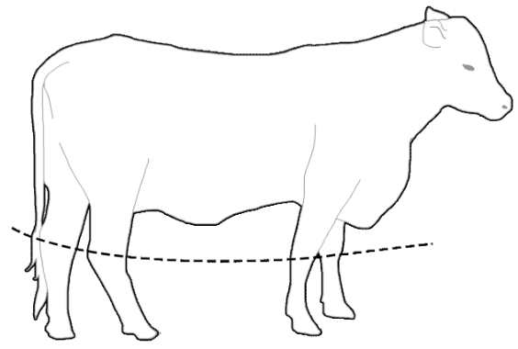
Figure 33 Sheath at the level of the hock requiring inspection
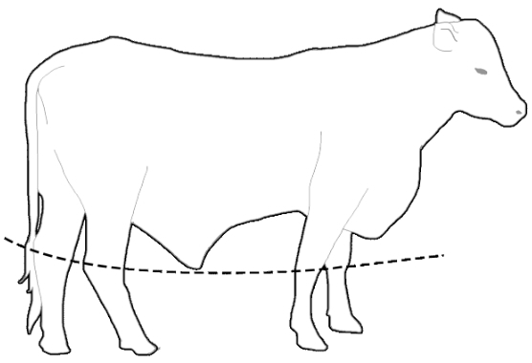
Figure 34 Sheath below the level of the hock – rejectable
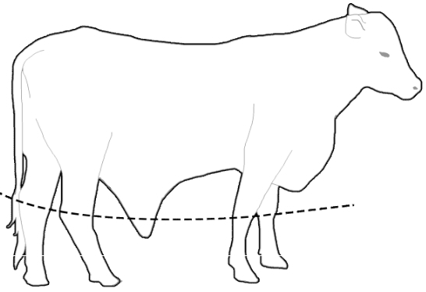
Figure 35 Bull with dysfunction to the retraction of the penis
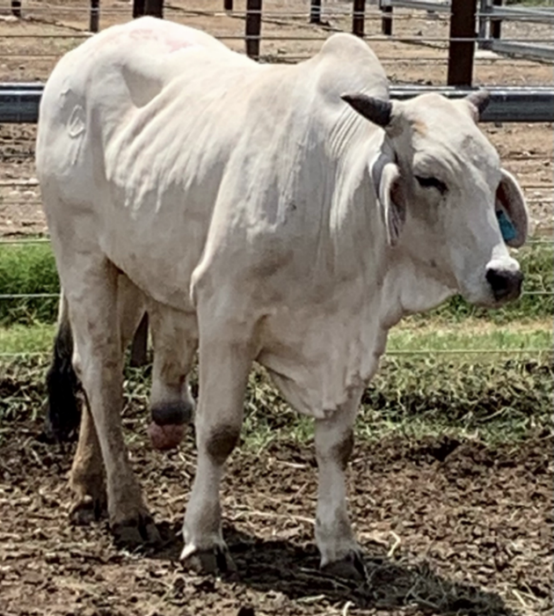
Figure 36 Pendulous sheath which could result in further damage or infection
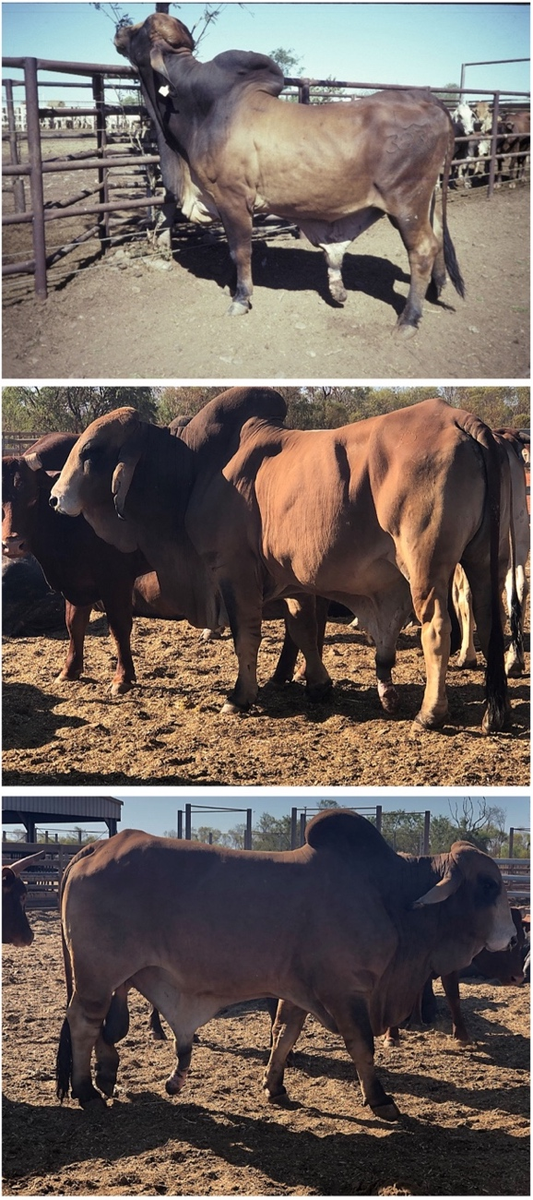

Considerations:
- Where the sheath is below the level of the hock, also consider preputial eversion and ability to retract penis into sheath.
- Professional discretion is required when evaluating this condition.

Blood/abnormal discharge from reproductive tract (vulva/prepuce)

Technical information:
- Clinical examination is important when discharge or blood is observed. Pregnancy status, use of prostaglandins, traumatic injury, lesions, disease, recent caesarean, retained placentae or abortion are some causes of abnormal discharge in livestock and should be clinically evaluated.

Reject if:
- The animal has any abnormal discharge from the reproductive tract.

Rejection examples:
Needed: photographs/video of rejectable animals.

Considerations:
- Differentiate between abnormal discharge and normal discharge in breeding animals or post-partum discharge.

Visible external parasites

Technical information:
- Cattle and buffalo may be infected by external parasites such as flies, lice, mites and ticks. Negative impacts on health and welfare can include blood loss, irritation and reduced grazing behaviour (fly worry).
Reject if:
- Any visible external parasites, including dead ticks.
- Other evidence of active external parasite infection.

Rejection examples:
Needed: photographs/video of rejectable animals.

Considerations:
- Rubbing is a common behavioural indicator for the presence of parasites but can occur after treatment due to lingering irritation to the skin.
- Livestock actively displaying signs of irritation or rubbing should be examined further to determine the cause.
- Evidence of external parasites may require treatment of all in-contact animals and/or environmental management procedures.
- Consider treating for external parasites prior to commencement of export preparation to decrease risk of spread and avoid dead ticks remaining attached to livestock at time of inspection.

Head

Blindness in one or both eyes

Technical information:
- Animals that are blind in one or both eyes may be disorientated and may not react to external visual stimuli consistent with their cohort. Care should be taken when approaching blind animals to minimise alarm.
- Signs of partial or full blindness may include, but are not limited to:
  - disorientation
  - non-reactive to external visual stimuli
  - standing separate from rest of herd/looking in different direction to herd
  - head raised above herd level
  - unusual eye colour e.g. uveitis (inflammation, redness), blue/opaque cornea
  - lower body condition score compared to cohort
  - ocular discharge may or may not be present, depending on cause of blindness.
- To assess for blindness, test reactions compared to cohort.

Reject if:
- The animal is visually impaired in one or both eyes to a degree that animal does not react to visual stimuli.
- The animal is constantly blinking or holding eye/s closed.

Rejection examples:
Needed: photographs/video of rejectable animals.

Considerations:
- Consideration should be given as to whether the blindness is an active process or because of scar tissue or prior damage to the eye. Active cases requiring treatment should be assessed for appropriate management.
- Severe pink eye (infectious keratoconjunctivitis) may lead to permanent blindness and veterinary advice should be sought if animals in a herd are displaying pink eye (also see section on Keratoconjunctivitis).
- Several infections and environmental factors (e.g. irritants such as dust, feed fines, grass seeds) can lead to an animal constantly blinking or holding its eye/s closed. In this case, the animal should be drafted and inspected to determine the underlying cause, and treatment provided as appropriate.
- Environmental factors, such as dust or feed fines, may result in irritation to the eye that can be transient when treated effectively.

Cancer eye

Technical information:
- Cancer eye is more common in animals which lack pigmentation in the tissue surrounding the eye, e.g. in breeds such as Hereford and Friesian. Lesions usually can begin as benign, smooth growths on the conjunctival surface, cornea or third eyelid and may progress to a papilloma or squamous cell carcinoma. Tumours can become large without invading the globe or remain small and spread to other areas such as lymph nodes.

Reject if:
- The animal has presence of proliferative or ulcerative lesion on its eye or surrounding structures.

Rejection examples:
Figure 37 Lesion on the globe
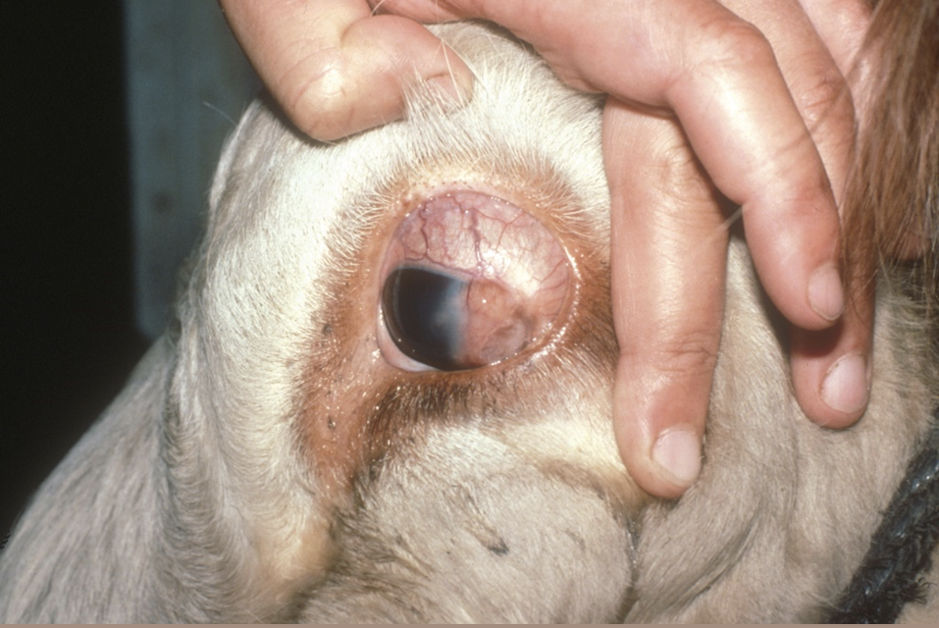
Figure 38 Lesions of the third eyelid and periocular tissues
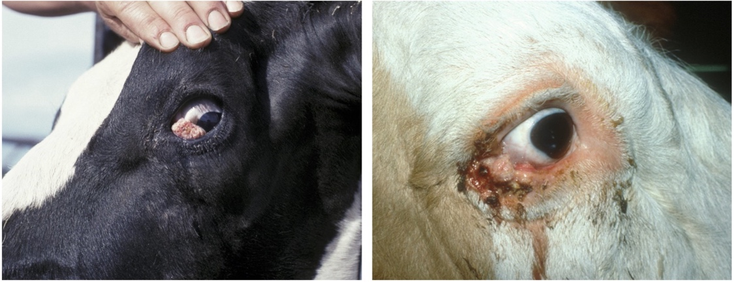

Considerations:
- Complete resection of small (<2cm) masses restricted to the third eyelid or conjunctiva may be considered in the absence of clinical symptoms or signs of malignancy e.g. enlargement, asymmetry or hardening of the regional lymph nodes (glands).
- Allow time for adequate wound healing and compliance with relevant drug withholding periods prior to export.

Keratoconjunctivitis (pink eye)
Alternative names: pink eye, infectious keratoconjunctivitis, infectious ophthalmia

Technical information:
- Keratoconjunctivitis (KCV) is inflammation of the cornea and conjunctiva. Signs of active KCV can include:
  - blepharospasm (twitching, blinking or closure of eyelids)
  - epiphora (watery eyes, excessive tears) – staining of face is usually evident
  - conjunctivitis (inflammation of the white part of the eyeball)
  - hyperaemia (blood shot eyes).
- It may affect one or both eyes. Initially the cornea may be red and then progress through cloudy hues of red, blue, grey, and white during sequential stages of healing.
- The condition is painful and some animals may be left with corneal scarring or blindness.

Reject if:
- The animal has one or 2 eyes with KCV and signs of ulceration, neovascularisation and/or chronic eye damage.
- The animal has one or 2 eyes with mild KCV and has not been treated with an effective antibiotic under veterinary advice (see Considerations).

Rejection examples:
Figure 39 Livestock showing excessive epiphora and blepharospasm
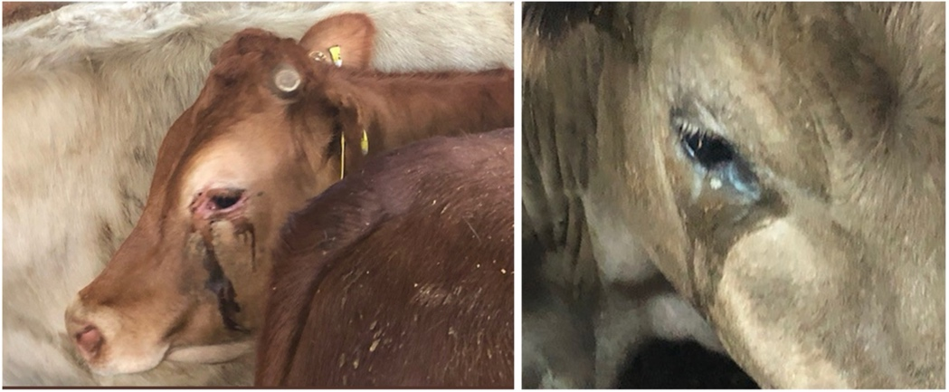
Figure 40 Animal showing oedema and ulceration
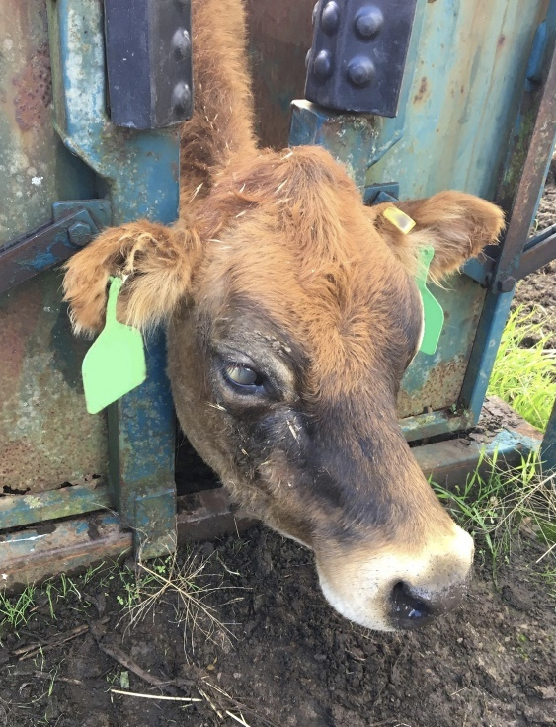
Figure 41 Neovascularisation and inflammation of the cornea
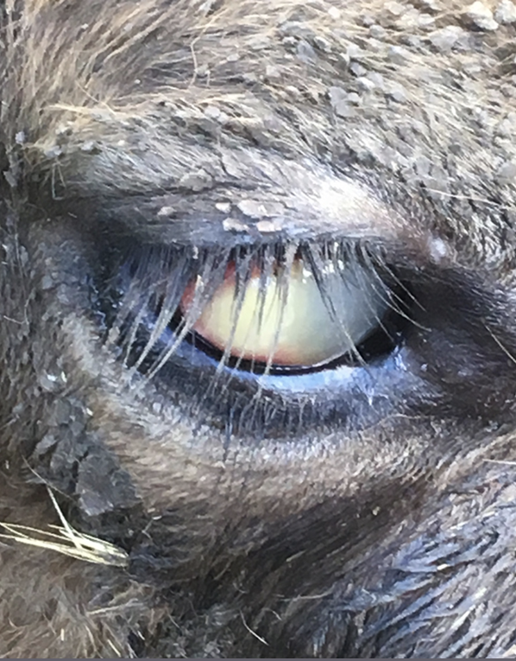
Figure 42 Chronic eye damage with severe inflammation and neovascularisation
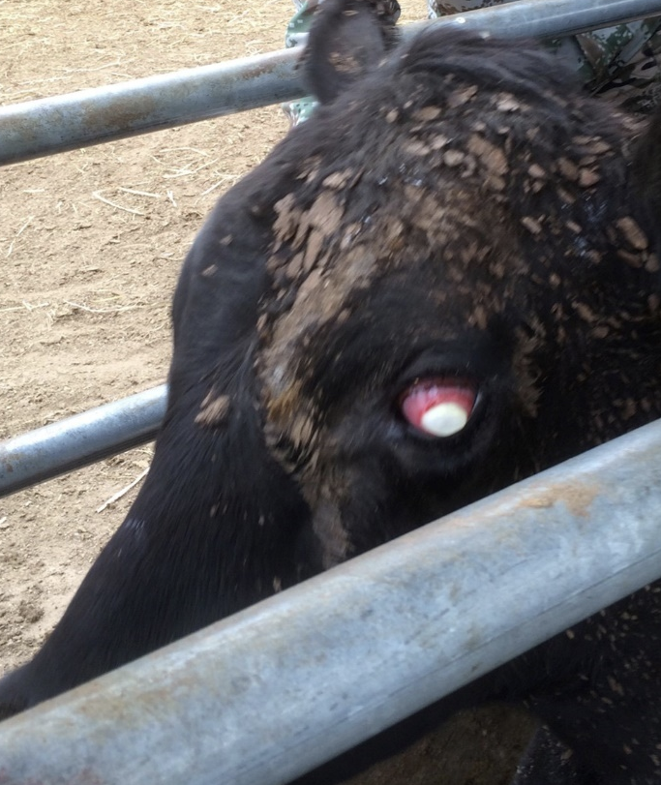
Figure 43 Cloudy eye with discharge and epiphora
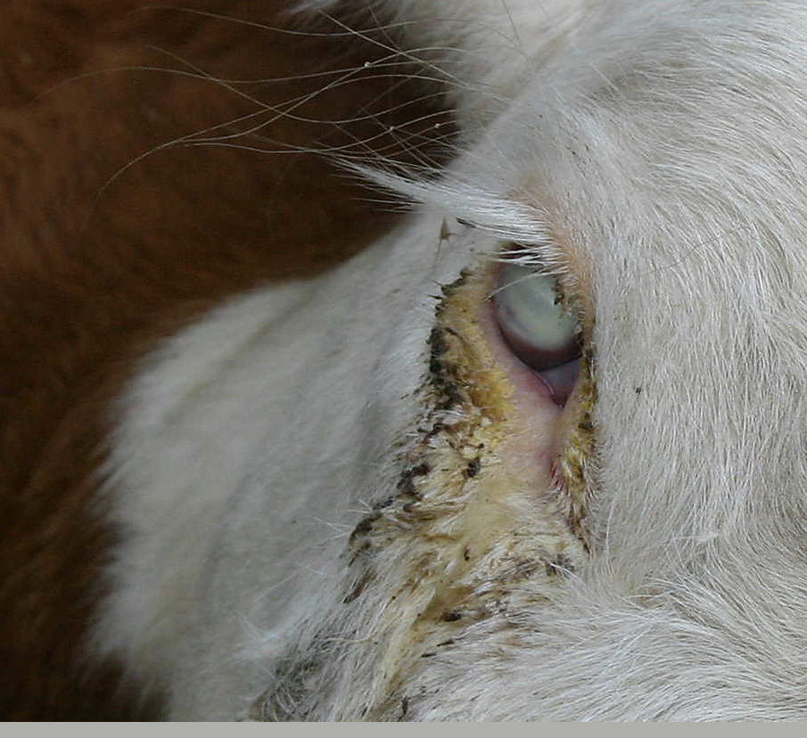

Considerations:
- Treated animals should be identified (e.g. marked with coloured paint) and penned separately where possible. The animals should be managed during the journey in a way that allows them to monitored and provided with additional effective antibiotics if they do not respond adequately to initial treatment.

Excessive salivation

Technical information:
- Hypersalivation is not an indicator of disease by itself, however, can be a clinical sign of a number of serious conditions such as, but not limited to:
  - foreign body or choke
  - bovine viral diarrhoea (BVD)
  - wooden tongue (actinobacillosis) and lumpy jaw (actinomycosis).
- Hypersalivation should be clinically investigated promptly to determine cause.
- The volume and viscosity of saliva should be evaluated to differentiate from other causes or recent drinking.

Reject if:
- Persistent excessive salivation and/or frothing from the mouth in addition to other clinical signs.

Rejection examples:
Figure 44 Excessive salivation with viscosity not associated with recent drinking
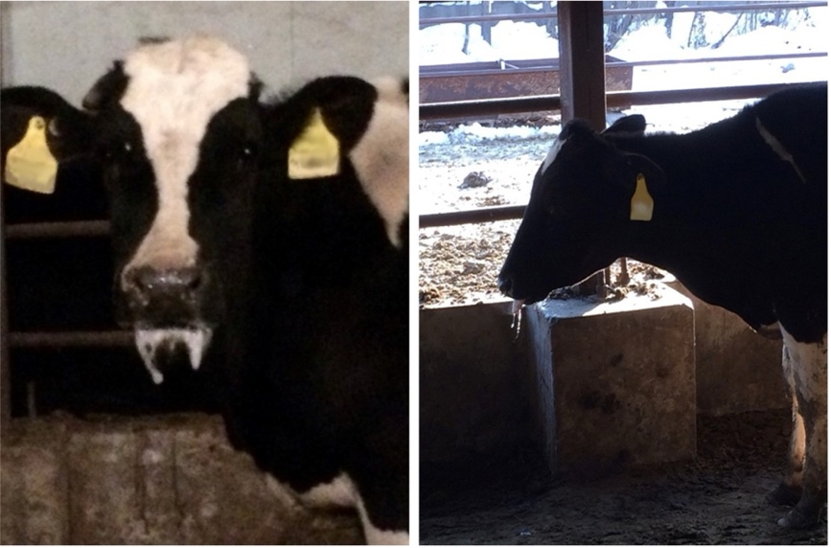

Considerations:
- Hypersalivation can also be as a result from injuries or blisters in the mouth, respiratory disease and pica (licking or chewing items with no nutritional value).
- Hypersalivation in cattle, unlike in sheep, can be a response to hot weather.
- Veterinary advice may need to be sought.

Nasal discharge consistent with signs of contagious or infectious disease

Technical information:
- Nasal discharge is excess fluid from the nasal cavity. It can be unilateral or bilateral, and:
  - serous (thin, clear, colourless)
  - catarrhal (grey)
  - mucoid (white)
  - purulent (thick, yellow)
  - haemorrhagic (red, bloody)
or a combination.

Reject if:
- The animal has excessive nasal discharge that cannot be attributed to transient environmental causes and is accompanied by another clinical sign of contagious disease.

Rejection examples:
Figure 45 Bilateral purulent discharge
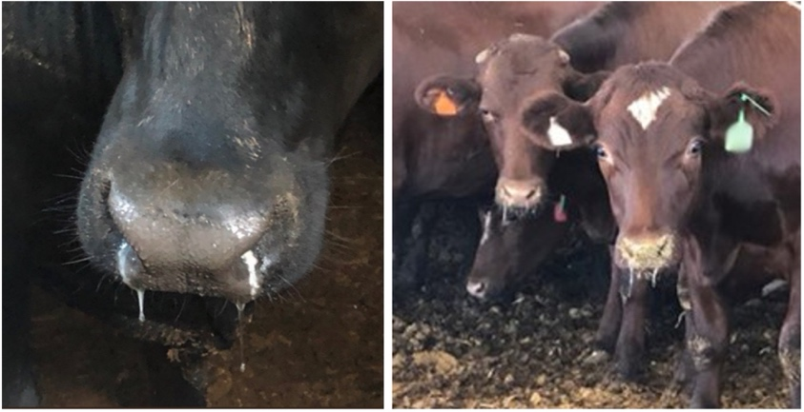
Note: Further examination of these animals is needed to determine underlying cause.

Considerations:
- Changes to environmental conditions, recent transport and post-vaccination reactions can cause transient nasal discharge but should be clinically evaluated for underlying cause.
- Control of flies and dust, and good ventilation in sheds, can decrease the incidence of nasal discharge due to environmental factors.
- Nasal discharge can be a result of a foreign body, therefore removing the foreign body can resolve the issue (but treatment still may be required).

Coughing consistent with signs of a contagious or infectious disease and respiratory distress or difficulty breathing

Technical information:
- A cough is a sudden noisy expulsion of air from the lungs. Coughs may be:
  - dry: cough without expectoration (no material ‘coughed up’)
  - productive: cough with expectoration of material from the respiratory tract.
- Lungworm infection and pneumonia can result in coughing. Sometimes, drenching may cause irritation of the trachea leading to coughing.
- Clinical signs associated with respiratory disease include but are not limited to:
  - depression or dull demeanour
  - fever
  - coughing
  - reluctance to eat
  - wheezing
  - conjunctivitis
  - increased respiratory rate or effort
  - mucopurulent discharge
  - recumbency.

Reject if:
- The animal has a persistent cough i.e. you are able to identify the animal that is coughing within a mob, and is associated with other clinical signs of disease.

Rejection examples:
Needed: photographs/video of rejectable animals.

Considerations:
- Environmental factors such as dust and smoke inhalation can result in coughing. Inhalation of fodder fines can increase irritation to the respiratory system leading to coughing.
- Any animal with suspected respiratory disease should be drafted out and clinically examined.

Sharp horns, horns that could injure the animal or other animals, horns that could restrict access to feed or water, bleeding and/or not fully healed horn stumps, horns longer than 12cm

Reject if:
- The animal has horn/s that do not meet ASEL requirements (see Considerations).

Rejection examples:
Figure 46 Animal with longer and sharper horns than prescribed by ASEL
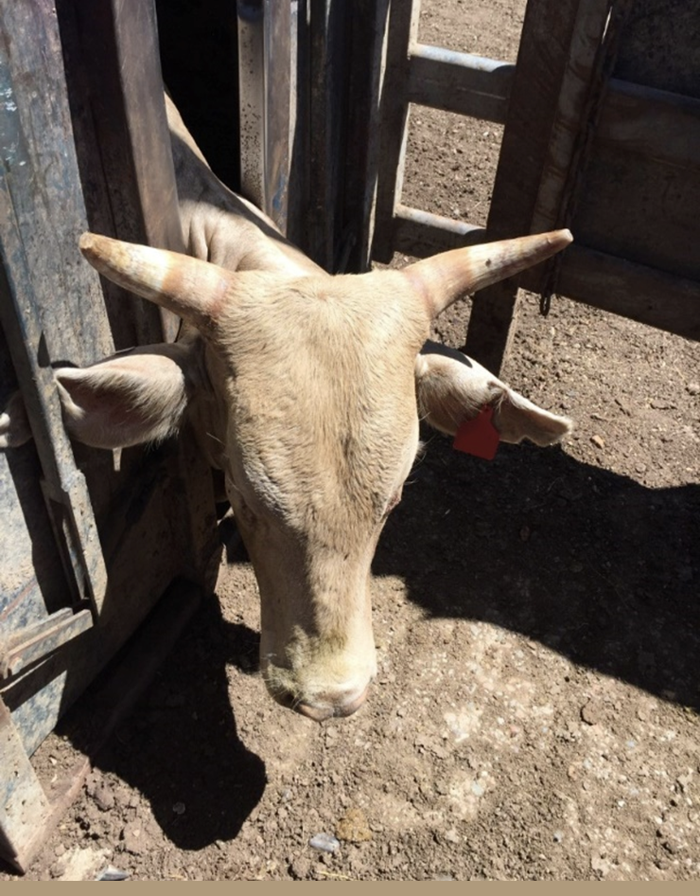
Figure 47 Long and pointed horns – rejection, tipping or export under an approved management plan are options
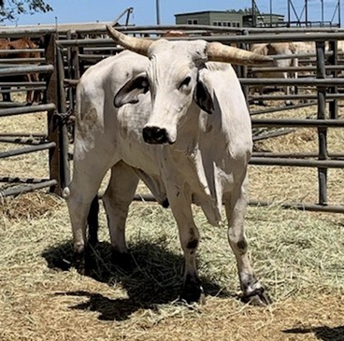
Figure 48 Livestock displaying hollowed and bleeding horn stumps increasing risk of infection
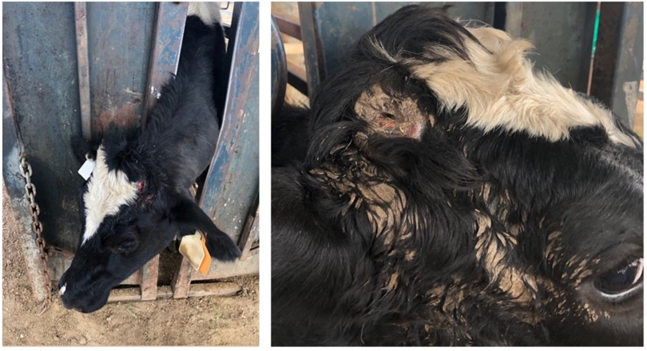
Figure 49 Severe horn piping (left) and poorly packed horn resulting in ruptured sinus abscess (right)
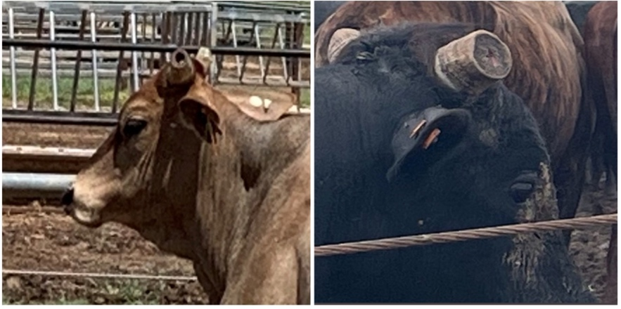

Considerations:
- Tipping should only be done to a length that avoids horn vasculature.
- Piped horns (hollowing) present a risk of infection to livestock and animals with piped horns should be rejected. Piped horns should not be packed to allow for transport.
- Horns that curl back towards the head of the animal may also pose a welfare issue and may need to be assessed.
- Any procedures performed on horns, e.g. tipping or dehorning, must be healed prior to delivery to the registered establishment.
Under ASEL:
- Buffalo with horns must only be sourced for export or exported if (unless otherwise provided in a long-horned livestock management plan) they have:
  - blunt horns; and
  - horns that are less than the spread of the ears.
- Cattle with horns must only be sourced for export or exported if (unless otherwise provided in a long-horned livestock management plan) the:
  - solid non-vascular tip has been removed to a diameter of 3 cm (or less if the horn vasculature does not allow) and horns have a blunt horn end; and
  - horns are no longer than 12 cm in length at the time of export (unless they are pointing downwards parallel to the face)
- Animals under an approved long-horned livestock management plan cannot be mixed with animals that are not under the same plan.
- Under ASEL, if an animal has been dehorned or tipped, wounds must be fully healed prior to any transport. Broken horns or scurs must be fully healed.

Other

Disparities in sex, size, weight or age that could cause an issue with the health or welfare of the animals (redraft animals in this case)

Technical information:
- Disparities in sex, size, weight, age or sexual maturity may lead to certain animals dominating access for food, water and space, and bullying of more submissive animals. This behaviour may be observed, or there may be signs such as evidence of back-rubbing/mounting injury or ill-thrift.

Reject/redraft if:
- There is a disparity in sex, size, weight, age, and/or sexual maturity in a group of penned animals that is likely to cause negative welfare impacts, such as those described under Technical information. Animals should be redrafted, and then should be rejected from the consignment if:
  - a particular animal is dominating or bullying others and this cannot be resolved by redrafting the animal into another group
  - a particular animal is being dominated or bullied by others and this cannot be resolved by redrafting the animal into another group
  - it is not possible to redraft or separate the animal/s.

Rejection/redrafting examples:
Figure 50 Disparities in size
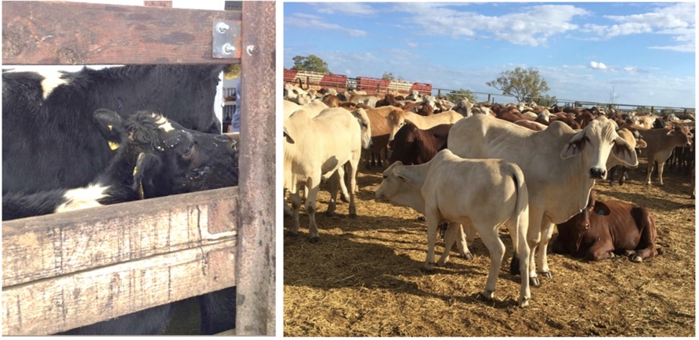

Considerations:
- In penned groups that have been well socialised with an established order, disparities in the group are less of an issue.
- If groups with disparities in sex, size, weight or age are mixed during transport to the port, they should be appropriately separated during loading onto the vessel to minimise issues arising on board in a penned group where it is more difficult to redraft animals.

