# Apply to approve permits in NEXDOC

## Apply to become an Automated Export Permit Issuer (AEPI)

### Log in to the Online Services portal

1. Go to the [Online services](https://online.agriculture.gov.au/portal/#/) portal
2. Enter your **email or Client ID and password**
3. Select **login**.

You must use the Online Services portal even if you use third party software.

If you’re not registered in the Agriculture Online Services Portal, you will need to create an account.

### Apply to become an Automated Export Permit Issuer (AEPI)

Once you’ve logged into [Online services](https://online.agriculture.gov.au/portal/#/), you will need to connect to NEXDOC.

1. Select ‘**Connect to a service’** orselect the **‘Services’** tab.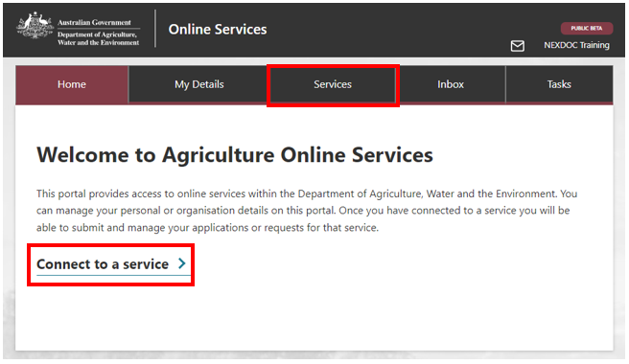
2. Select **‘Request to be an Automated Export Permit Issuer (AEPI)’**

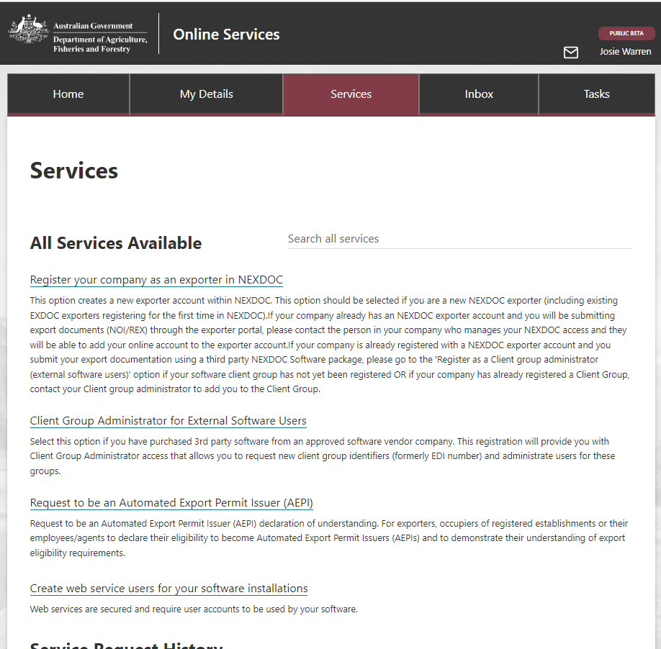

1. Complete steps 1-5 below.

#### Step 1: Applicant details

Enter your company name and the commodities you are applying to issue permits for:

Screenshot of user interface titled "Request to be an Automated Export Permit Issuer (AEPI)"; the subheading is "Applicant details" and there is a space for the user to add their company's name.


Select ‘**Next**’ to proceed.

#### Step 2: Applicant status

Tell us about your role – you may select one or more options.

Screenshot of user interface, subtitle is "Applicant status" with tick boxes for the user to indicate their status.




Select ‘**Save and Next**’.

#### Step 3: Eligibility

When approved as an AEPI you will be responsible for the export documentation you authorise. We must ensure that your company has documented systems in place to support the documentation you authorised. If you can confirm your company has a system to support you in each of the components listed, tick the boxes which apply. 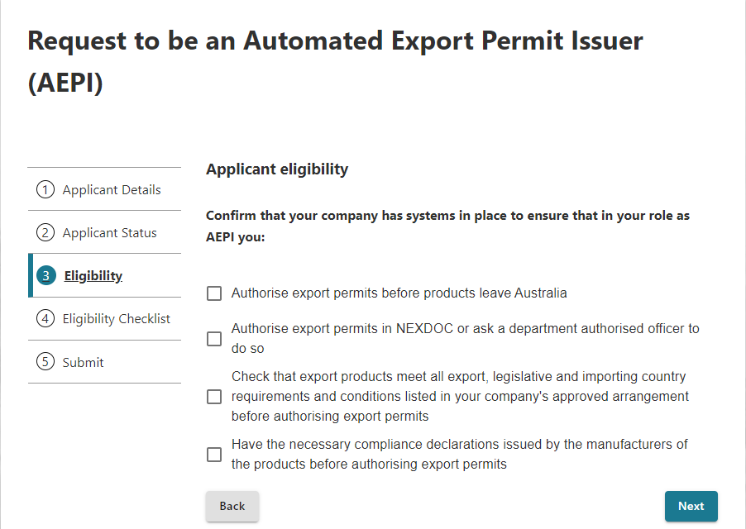

Select ‘**Next**’.

#### Step 4: Eligibility checklist

Each permit you authorise must be supported by a checklist signed by you, stating the shipment is eligible for export. Your checklist must contain, at a minimum, the components listed in the sample provided. You are responsible for maintaining copies of each checklist and these may be requested by the department during audit or verification activities.

In this step, you must upload a copy of your checklist.

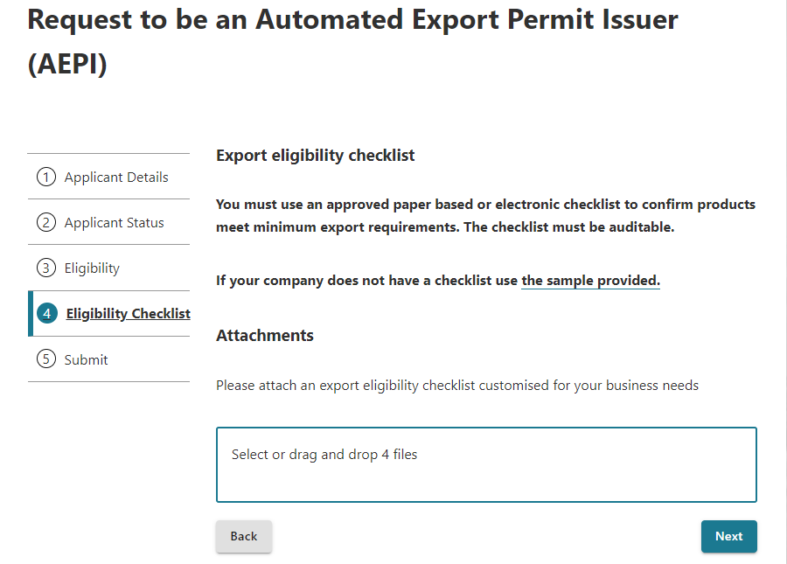If you do not already have one, you may use the sample provided as a guide to create your own.

Select ‘**Next**’.

#### Step 5: Submit

To complete your registration:

1. read the declaration and privacy notice
2. if you agree, tick the ‘**I agree**’ box
3. select ‘**Submit**’.

### Application review

Your application will be sent to the department for assessment. We will review the information you have provided and your *Export eligibility checklist*. If any changes are required, we will contact you to request amendments before a decision is made.

Once your application has been assessed you will be notified of the decision through the NEXDOC inbox within the NEXDOC portal.

## Contact us for assistance

For more information or assistance, please contact [dairyeggsfish@aff.gov.au](mailto:dairyeggsfish@aff.gov.au)