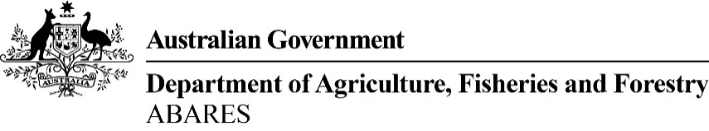

ABARES Toowoomba Regional Outlook conference
Wednesday, 27 July 2022
Venue: City Golf Club, 254 South Street, South Toowoomba

To register go to https://agriculture.eventsair.com/2022-2-toowoomba-roc/delegates/Site/Register

CONFERENCE PROGRAM

8.30 AM Registration

SESSION 1: Agriculture’s contribution to Australia’s prosperity

CHAIR Lucy Cooper, ABC Southern Queensland

9.00 AM Welcome to Country

9.10 AM Opening address
Senator the Hon Murray Watt
Minister for Agriculture, Fisheries and Forestry, and Senator for Queensland (video message)

9.15 AM Kurt Hockey
ABARES
Big picture issues affecting local farmers

9.30 AM Carmel Onions
Commonwealth Bank
Market insights adding value to farmers

9.45 AM Johnelle Stevens
Bureau of Meteorology
$100b in a changing climate

10.00AM Jo-Marie Moore
Australian Bureau of Statistics
Modernising the agricultural data collection

10.15 AM Questions and panel discussion

10.30 AM Morning tea

SESSION 2: Adopting and adapting for sustainable growth

11.00 AM Our experienced panel members will share their stories of innovation and adaptation driving sustainability and business success. Join in and ask questions.

MODERATOR: Justin Heaven, Toowoomba & Surat Basin Enterprise

PANELLISTS:
Belinda Frentz, Owner/Manager of Salad Makers and Chair, Growcom
Kerriann Lamb, Wickham Farms Killarney
Bronwyn and David Neuendorf, 9Dorf Farms
Craig Baillie, University of Southern Queensland
Angus Woods, Woods Foods

12.30 PM Lunch

SESSION 3: Driving value in agriculture and food

CHAIR Richard Routley, Department of Agriculture and Fisheries QLD

1.30 PM Jonathan Wong
ABARES
Commodity outlook and issues

1.45 PM Mirjana Prica
Food and Agribusiness Growth Centre
The $43 billion food and agribusiness opportunity for Queensland

2.00 PM Jonny Arkins
Wellcamp Airport
Driving value in agriculture and food - Gate2Gate

2.15 PM Ed Matthews
Australian Rail Track Corporation
Inland Rail – generating new opportunities for industries and regional communities

2.30 PM Jordan Hatch
Department of Agriculture, Fisheries and Forestry
Helping farmers get to market

2.45 PM Questions and panel discussion

3.15 PM Close and invitation to stay for afternoon tea/networking

About ABARES and the Regional Outlook conferences
The Australian Bureau of Agricultural and Resource Economics and Sciences (ABARES) is the research arm of the Australian Government Department of Agriculture, Fisheries and Forestry. ABARES provides professionally independent research, analysis, forecasts and statistics. ABARES Regional Outlook conferences are an essential part of our delivery of commodity forecasts and research results directly to rural and regional communities, with each conference program tailored to the region. For more visit www.agriculture.gov.au/abares.

ENDS

