

AQUAVETPLAN

Australian Aquatic Veterinary Emergency Plan



Disease strategy

Abalone viral ganglioneuritis

Version 1, 2014

This disease strategy forms part of: AQUAVETPLAN

This strategy will be reviewed regularly. Suggestions and recommendations for   
amendments should be forwarded to:

AQUAVETPLAN Coordinator  
Aquatic Animal Health Program  
Animal Health Policy  
Australian Government Department of Agriculture  
GPO Box 858, Canberra ACT 2601  
Tel: (02) 6272 5402; Fax: (02) 6272 3856  
email: aah@agriculture.gov.au

Approved citation: Department of Agriculture (2014). Disease strategy: Abalone viral ganglioneuritis (Version 1.0). In: *Australian Aquatic Veterinary Emergency Plan (AQUAVETPLAN)*, Australian Government Department of Agriculture, Canberra, ACT.

Record of amendments:

Version 1.0, 2014

AQUAVETPLAN is available on the internet at:   
www.agriculture.gov.au/animal-plant-health/aquatic/aquavetplan

ISBN 978-0-9874972-0-8

© Commonwealth of Australia 2014

Ownership of intellectual property rights

Unless otherwise noted, copyright (and any other intellectual property rights, if any) in this publication is owned by the Commonwealth of Australia (referred to as the Commonwealth).

Creative Commons licence

All material in this publication is licensed under a Creative Commons Attribution 3.0 Australia Licence, save for content supplied by third parties, logos and the Commonwealth Coat of Arms.

**\\ACT001CL04FS02\parliamentmedia$\ParliamentMedia\Corporate Communications\Production\Temp\GRG\by [Converted]-01.jpg**

Creative Commons Attribution 3.0 Australia Licence is a standard form licence agreement that allows you to copy, distribute, transmit and adapt this publication provided you attribute the work. A summary of the licence terms is available from creativecommons.org/licenses/by/3.0/au/deed.en. The full licence terms are available from creativecommons.org/licenses/by/3.0/au/legalcode.

This publication (and any material sourced from it) should be attributed as: Department of Agriculture 2014, AQUAVETPLAN Disease strategy: Abalone viral ganglioneuritis. CC BY 3.0

Cataloguing data

Department of Agriculture 2014, AQUAVETPLAN Disease strategy: Abalone viral ganglioneuritis, Department of Agriculture, Canberra.

Internet

AQUAVETPLAN Disease strategy: Abalone viral ganglioneuritis is available at agriculture.gov.au

**Contact**

Department of Agriculture

Postal address:

GPO Box 858  
Canberra ACT 2601  
Australia  
Web: agriculture.gov.au

Inquiries regarding the licence and any use of this document should be sent to copyright@agriculture.gov.au

The Australian Government acting through the Department of Agriculture has exercised due care and skill in the preparation and compilation of the information and data in this publication. Notwithstanding, the Department of Agriculture, its employees and advisers disclaim all liability, including liability for negligence, for any loss, damage, injury, expense or cost incurred by any person as a result of accessing, using or relying upon any of the information or data in this publication to the maximum extent permitted by law.

The information in this publication is for general guidance only and does not override common law, laws of the Commonwealth or any Australian state or territory, or place any legal obligation of compliance or action on the Commonwealth, a state or a territory.

It is the responsibility of the users of this publication to identify and ensure they have complied with all legislative or regulatory requirements of the relevant Australian state or territory and the Commonwealth prior to undertaking any of the response options set out within this publication.

Being a guide only, outbreaks or suspected outbreaks must be assessed on a case by case basis and expert advice should be obtained to determine the most appropriate management plan in response to the risk.

IMPORTANT NOTE: Regulatory information for abalone viral ganglioneuritis (listed by the World Organisation for Animal Health [OIE] as ‘infection with abalone herpesvirus’) is contained in the OIE *Aquatic animal health code* (OIE 2012a), which is updated annually and is available on the OIE website: www.oie.int/en/international-standard-setting/aquatic-code/access-online.

Disease watch hotline

1800 675 888

The Disease Watch Hotline is a toll-free telephone number that connects callers to the relevant state or territory officer to report concerns about any potential emergency animal disease situation. Anyone suspecting an emergency disease outbreak should use this number to get immediate advice and assistance.

AQUAVETPLAN is a series of manuals that outline Australia’s approach to national disease preparedness and proposes the technical response and control strategies to be activated in a national aquatic animal disease emergency.

**National Biosecurity Committee**

# Preface

This disease strategy for the control and eradication of abalone viral ganglioneuritis (AVG) is an integral part of the **Australian Aquatic Veterinary Emergency Plan (AQUAVETPLAN).**

AQUAVETPLAN disease strategy manuals are response manuals and do not include information about preventing the introduction of disease into Australia.

The Australian Government Department of Agriculture provides quarantine inspection for international passengers, cargo, mail, animals, plants, and animal or plant products arriving in Australia. The Department of Agriculture also inspects and certifies a range of agricultural products exported from Australia. Quarantine controls at Australia’s borders minimise the risk of entry of exotic pests and diseases, thereby protecting Australia’s favourable status for human, animal and plant health. Information on current import conditions can be found at the Department of Agriculture ICON website.[1]

This disease strategy sets out the disease control principles for use in an aquatic veterinary emergency incident caused by the suspicion or confirmation of AVG in Australia. The strategy was scientifically reviewed by the Sub-Committee on Aquatic Animal Health (April 2012), before being endorsed by the Animal Health Committee of the Standing Council on Primary Industries in February 2013.

AVG is listed by the World Organisation for Animal Health (OIE) in the *Aquatic animal health code* as infection with abalone herpesvirus (OIE 2012a). AVG is listed on Australia’s National List of Reportable Diseases of Aquatic Animals.[2]

Detailed instructions for the field implementation of AQUAVETPLAN are contained in the disease strategies, operational procedures manuals and management manuals. Industry-specific information is given in the enterprise manual. The full list of AQUAVETPLAN manuals[3] that may need to be accessed during an aquatic animal disease emergency is shown below.

## Disease strategies

Individual strategies for specific diseases

## Operational procedures manuals

Disposal

Destruction

Decontamination

## Management manual

Control centres management

## Enterprise manual

Includes sections on:

* open systems
* semi-open systems
* semi-closed systems
* closed systems

This manual was initially drafted by Dr Paul Hardy-Smith (Panaquatic® Health Solutions Pty Ltd), Dr Tracey Bradley (Victorian Department of Primary Industries) and Dr Mark Crane (Fish Diseases Laboratory of the CSIRO Australian Animal Health Laboratory). The authors drafted the strategy in consultation with a wide range of stakeholders from aquaculture, wild-capture and recreational fishing sectors, and government agencies throughout Australia. However, the text was amended at various stages of the consultation and endorsement process, and the policies expressed in this version do not necessarily reflect the views of the authors. Contributions made by others not mentioned here are gratefully acknowledged.

The format of this manual has been adapted from similar manuals in AUSVETPLAN (the Australian Veterinary Emergency Plan for terrestrial animal diseases). A similar format and content have been used to enable personnel trained in AUSVETPLAN procedures to work efficiently with this document in the event of an aquatic animal disease emergency involving AVG. The work of the AUSVETPLAN writing teams and the permission to use the original AUSVETPLAN documents are gratefully acknowledged.

Scientific editing was by Biotext Pty Ltd, Canberra.

This current version of the AQUAVETPLAN **Disease Strategy—Abalone viral ganglioneuritis** has been reviewed and approved by the following representatives of government and industry:

## Government

CSIRO Australian Animal Health Laboratory

Department of Primary Industries, New South Wales

Department of Primary Industries and Fisheries, Northern Territory

Queensland Department of Agriculture, Fisheries and Forestry

Department of Primary Industries, Parks, Water and Environment, Tasmania

Department of Fisheries, Western Australia

Department of Primary Industries, Victoria

Department of Primary Industries and Regions, South Australia

Biosecurity Animal Division, Australian Government Department of Agriculture

Australian Government Environment Department

## Industry

National Aquatic Animal Health Industry Reference Group

Australian Abalone Growers Association

Abalone Council of Australia Ltd

Contents

Preface

Disease strategies iv

Operational procedures manuals iv

Management manual iv

Enterprise manual iv

Government v

Industry v

1 Nature of the disease 1

1.1 Aetiology 1

1.2 Susceptible species 1

1.3 World distribution and occurrence in Australia 2

1.4 Diagnosis of abalone viral ganglioneuritis 2

1.4.1 Presumptive diagnosis 2

1.4.2 Confirmatory diagnosis 3

1.4.3 Field methods: clinical signs and gross pathology 4

1.4.4 Laboratory tests 5

1.4.5 Confirmation of disease 9

1.4.6 Differential diagnosis 10

1.5 Resistance and immunity 10

1.6 Epidemiology 10

1.6.1 Incubation period 11

1.6.2 Persistence of the agent in the environment 11

1.6.3 Modes of transmission 11

1.6.4 Factors influencing transmission and expression of disease 12

1.7 Impact of the disease 12

2 Principles of control and eradication 13

2.1 Introduction 13

2.2 Aquatic animal production and fisheries systems 14

2.2.1 Open systems 14

2.2.2 Semi-open systems 14

2.2.3 Semi-closed systems 14

2.2.4 Closed systems 14

2.3 Methods to prevent spread and eliminate pathogens 15

2.3.1 Quarantine and movement controls 15

2.3.2 Eradication in semi-closed, semi-open and closed systems 17

2.3.3 Containment, control and zoning in open systems 18

2.3.4 Tracing 18

2.3.5 Surveillance 19

2.3.6 Treatment of infected animals 20

2.3.7 Treatment of animal products and byproducts 20

2.3.8 Destruction of animals 20

2.3.9 Disposal of animals 20

2.3.10 Decontamination 21

2.3.11 Vaccination 21

2.3.12 Vector control 21

2.4 Environmental considerations 22

2.5 Sentinel animals and restocking 22

2.5.1 Farms 22

2.5.2 In the wild 22

2.6 Public communications strategy 22

2.7 Feasibility of control or eradication of abalone viral ganglioneuritis in Australia 23

2.7.1 Open systems 23

2.7.2 Semi-open systems 23

2.7.3 Semi-closed systems 23

2.7.4 Closed systems 23

2.7.5 Trade and industry considerations 24

3 Policy and rationale 25

3.1 Overall policy for abalone viral ganglioneuritis 25

3.2 Response options 26

3.2.1 Option 1—eradication 28

3.2.2 Option 2—containment, control and zoning 29

3.3 Criteria for proof of freedom 30

3.4 Funding and compensation 30

Appendix 1 Approval of agricultural and veterinary chemicals for use in Australia 31

Appendix 2 Sampling of abalone ganglia 32

Glossary 37

Abbreviations 41

References 42

Tables

Table 1.1 Samples for laboratory diagnosis of AVG (listed in order of preference) 6

Figures

Figure 1.1 Clinical signs of abalone viral ganglioneuritis, including curling of the foot (yellow arrows) and swollen mouth with an everted radula (red arrow) 5

Figure 1.2 A. Longitudinal dissection of abalone, exposing the ganglia for laboratory examination. B. Depth (5–10 mm) of cut required to sample the ganglia. The area where the ganglia occur are circled, and arrows indicate the ganglia. 7

Figure 1.3 Infiltration of haemocytes in ganglion of abalone viral ganglioneuritis–affected abalone (haematoxylin and eosin stain) 8

Figure 2.1 Establishment of specified areas to control abalone viral ganglioneuritis 15

Figure 3.1 Decision flowchart if abalone viral ganglioneuritis is suspected 27

Figure 3.2 Decision flowchart to determine the most appropriate response option if abalone viral ganglioneuritis is confirmed 28

# 1 Nature of the disease

Abalone viral ganglioneuritis (AVG) is a disease of abalone, and is caused by a herpesvirus (Crane et al. 2006; Savin et al. 2010). AVG was first identified in Australia in late 2005 (Hooper et al. 2007a). The disease can cause high mortalities in both farmed and wild abalone populations. In Australia, clinical manifestation of the disease has been reported in Victoria and Tasmania (Ellard et al. 2009; NACA & FAO 2010).

## 1.1 Aetiology

A herpesvirus, abalone herpesvirus (AbHV), has been found in association with AVG and is regarded as the causative agent of the disease. Virions of AbHV are morphologically similar to viruses from the family *Herpesviridae*. A phylogenetic analysis of known invertebrate and vertebrate herpesviruses separated abalone, oyster and amphioxus herpesviruses into a single clade (Savin et al. 2010). Two hypotheses have been proposed to explain the positioning of the molluscan herpesvirus clade within vertebrate herpesviruses. A better understanding of herpesvirus classification will result from additional sequencing and gene structure information (Savin et al. 2010).

Although the infectious aetiology has not been fully investigated, transmission experiments (see Section 1.6.3) and virus titration experiments[4] indicate that the aetiological agent is AbHV. No other disease agent has been detected by electron microscopy in the inocula used in these experiments. The term AbHV is therefore used in this document to refer to the abalone virus that causes AVG in Australia; this also maintains consistency with World Organisation for Animal Health (OIE) Quarterly Aquatic Animal Disease Report and national reporting guidelines.

Currently, five variants of AbHV are known from Australia (Cowley et al. 2012). All variants may cause mortality in susceptible animals, although clinical presentation can vary (see Section 1.4). Clinical presentation differs between Victorian and Tasmanian isolates (see Section 1.4.1).

The OIE Aquatic Animal Health Standards Commission recommended that AVG be included in the complex of abalone viral mortalities (OIE 2008). Within the abalone viral mortality complex, two syndromes are recognised:

* abalone herpesvirus disease (including ganglioneuritis diseases reported from Taiwan and Australia, and the acute disease reported from southern China)
* crack-shell-amyotrophia virus disease (including amyotrophia from Japan and cracked-shell disease from northern China).

The relationships between the viral causative agent of AVG in Australia and Taiwan, and abalone diseases elsewhere, are unknown.

## 1.2 Susceptible species

To date, species known to be susceptible to AVG in Australia are greenlip abalone (*Haliotis laevigata*), blacklip abalone (*Haliotis rubra*) and hybrids of these two species. Clinical signs of AVG have not been reported in other molluscan species from areas enzootic for AVG (OIE 2012b).

In Taiwan, a herpes-like viral infection resulted in ganglioneuritis and high mortalities in the local abalone *Haliotis diversicolor supertexta* (Chang et al. 2005).

Herpes-like viruses have been identified previously in bivalve molluscs in Australia, including the flat oyster (*Ostrea angasi*) (Hine & Thorne 1997) and clams (*Katelysia scalarina*) (Handlinger 1999), but not in gastropod molluscs such as abalone.

AbHV is not known to infect humans, and there are no known food safety implications associated with this disease.

## 1.3 World distribution and occurrence in Australia

The known areas in which AbHV has occurred in Australia are areas of Victoria that are enzootic for the disease, and live holding and processing facilities in Tasmania.

AVG was eradicated from Victorian abalone farms in 2006, but is distributed in wild abalone populations along more than 200 km of coastline in western Victoria, from Discovery Bay to near Cape Otway (as of early 2011). However, there have been no detections of the disease in the wild since January 2010 (T Bradley [Victorian Department of Primary Industries], 2014, pers. comm.).

AVG was confirmed in, and subsequently eradicated from, two separate processing facilities in southern Tasmania in 2008 and 2009. In December 2010, AVG was again reported from one farm and two processors in Tasmania, requiring a cessation of water discharge, destocking and decontamination of all infected premises. The source of infection for all outbreaks within processors is considered to be Tasmanian abalone entering these premises from wild populations. The occurrence of disease within the abalone farm is considered to have been a result of disease in a neighbouring processor. Current opinion is that AbHV is endemic to Tasmanian waters, with recent work suggesting prevalence levels approximating 7%. Although clinical disease has never been detected in the natural environment in Tasmania, investigations have shown that handling and holding of sub-clinically infected abalone may result in virus shedding and/or expression of clinical disease. The various strains of AbHV (Tas-1 through to Tas-5) are considered to have localised geographical distribution within the marine environment, mainly due to the sessile nature of abalone and the short survival time for the virus within the water column, however this has not yet been confirmed (K. Ellard 2014 pers. comm.).

A national disease survey of commercially exploited abalone species in Australia (Handlinger et al. 2006) found no histological evidence of AVG in more than 3000 abalone.[5] This survey included approximately 210 randomly sampled wild abalone and 240 farmed abalone from Victoria. A total of 912 animals were randomly sampled from Tasmania, comprising 425 wild abalone and 487 farmed abalone. Tissue samples (processed histological sections stained with haematoxylin and eosin [H&E]) were examined by light microscopy. Survey results in 2006 showed no indication of active AVG in Tasmania or Victoria.

A herpesvirus has been documented as the causative agent of AVG in *H. diversicolor supertexta* from Taiwan and in abalone from elsewhere in China (Song et al. 2000; Wang et al. 2004). The level of genetic similarity between the Australian and Taiwanese viruses is high: the Taiwan variant is 99% homologous with the Victorian isolate of AbHV in the viral polymerase gene (Chen et al. 2012).

The OIE *Manual of diagnostic tests for aquatic animals* describes the distribution of AVG as Australia (Victoria and Tasmania) and Chinese Taipei (Taiwan) (OIE 2012b). Herpes-like viruses have also been reported to cause pathology in neural tissue of Japanese abalone (Nakatsugawa 1999).

## 1.4 Diagnosis of abalone viral ganglioneuritis

### 1.4.1 Presumptive diagnosis

A presumptive diagnosis of AVG can be made if positive results are obtained from at least one of gross signs, microscopic signs or TaqMan real-time PCR results. These three diagnostic methods are described below.

#### Gross signs

##### Tasmanian presentation

Affected abalone may display one or more of the following signs:

* absence of the marked extension of the foot shown in the righting reflex when healthy abalone are turned onto their backs
* tetanic paralysis of the foot and mantle tissue
* excessive mucus production, forming distinct rope-like strands

abnormal spawning and ‘bloating’.

##### Victorian presentation

In wild abalone, there may be high mortality; usually only shells are present, as a result of predation on affected abalone.

In farmed abalone, signs include:

* swollen mouth parts, occasionally with the mouth protruding from under the anterior foot (where it is usually only partially visible)
* reduced pedal adhesion to surfaces
* absence of marked foot extension seen in the righting reflex of healthy abalone
* curled mantle edge
* high mortalities (up to 90%).

#### Microscopic signs

Affected abalone may display some or all of the signs described below.

Major lesions are confined to nervous tissue, centred on the cerebral, pleuropedal and buccal ganglia, the cerebral commissure, and the peripheral nerves arising from the ganglia. The lesions have increased cellularity (glial cells and/or haemocytes), individual neural cell necrosis and oedema. Occasional neurones have marginated chromatin and central pallor, resembling ground-glass nuclei, which is morphologically suggestive of intranuclear viral inclusions.

Mouth parts show severe multifocal oedema in the muscle, fascia and interstitial tissues. Affected areas have dilated sinuses and ruptured connective tissue and muscle fibres, leading to poorly delineated spaces, some of which are filled with haemolymph and haemocytes. In particular, increased numbers of haemocytes are present in the sinuses and within the oedematous connective tissue of the interstitial tissue surrounding and supporting the odontophore muscles. Much of the odontophore muscle is unaffected in areas surrounding the severe neuropathy.

Histopathology from the Tasmanian syndrome may show much less florid examples of ganglioneuritis than the Victorian syndrome (J Handlinger, [Tasmanian Department of Primary Industries, Parks, Water and Environment], 2010, pers. comm.).

#### TaqMan real-time PCR results

Positive diagnosis is associated with cycle threshold (CT) values of less than 35.0 in TaqMan real-time PCR assay on first testing, or on second testing if the first test result was inconclusive (CT < 36.0 and ≥ 35.0). No-template controls must have no evidence of specific amplicons, and all samples (including positive and negative controls) must be tested in triplicate or duplicate. Corbeil et al. (2010) and the OIE *Manual of diagnostic tests for aquatic animals* (OIE 2012b) provides additional information on the TaqMan real-time PCR assay for AbHV.

### 1.4.2 Confirmatory diagnosis

The presence of AbHV is confirmed if, in addition to the criteria for presumptive diagnosis, one or more of the following criteria are met:

* positive result using quantitative real-time PCR (qPCR) on at least one repeat sample of abalone
* positive result using in situ hybridisation on neural tissue section.

The OIE *Manual of diagnostic tests for aquatic animals* (OIE 2012b) includes a chapter on diagnostic tests for infection with abalone herpesvirus. These include qPCR tests targeted to ORF66 and ORF77, which can detect all AbHV variants identified to date (see Section 1.4.4 for further details).

The in situ hybridisation procedure uses a digoxygenin-labelled DNA probe to detect AbHV in formalin-fixed, paraffin-embedded tissue sections. A detailed explanation of the procedure can be obtained from the OIE *Manual of diagnostic tests for aquatic animals* (OIE 2012b). Specific dark blue–black intracellular staining is indicative of AbHV DNA.

Five variants of AbHV have been identified from Australia (Cowley et al. 2012). Conserved areas of the genome have been identified for diagnostic purposes, but sequence variability must be considered when investigating suspected outbreaks of AVG, particularly when PCR tests are negative, but pathology or clinical signs are suggestive of AVG.

### 1.4.3 Field methods: clinical signs and gross pathology

Monitoring and diagnosing AVG in wild abalone can be impeded by adverse weather conditions that limit access to areas where abalone occur. In the event of an outbreak of disease, dead or sick abalone are quickly consumed by predators and scavengers. Since abalone are harvested regularly by commercial and recreational fishers, diseased or dead abalone are rapidly detected and can be reported to the relevant authorities for follow-up and diagnosis.

High mortality rates (up to 90%) are a feature of AVG outbreaks in both farmed and wild populations, but clinical disease has never been reported from Tasmanian abalone from the wild. There is little gross pathology associated with this disease. Clinically, a variable proportion of affected abalone may display irregular peripheral concave elevation of the lateral foot margins (sometimes referred to as ‘curling of the foot’; see Figure 1.1) and swollen mouth parts, with the mouth protruding from under the anterior foot (in healthy animals, it is usually only partially visible). Abalone may have excess mucus production, forming distinct rope-like strands, and abnormal spawning and ‘bloating’.

Affected abalone may have tetanic paralysis of the foot and mantle, minimal movement of the pedal muscle, and absence of the normally marked extension of the foot shown in the righting reflex of healthy abalone (when turned onto their dorsal surface). Reduced pedal adhesion to the substrate is also common in affected individuals.

Protrusion (eversion) of the radula[6] may also be present (Figure 1.1). In an outbreak situation, moribund abalone exhibiting an everted radula can be suggestive of AVG. However, many of the abalone that died on farms during the outbreak in Victoria in late 2005 and early 2006 did not have everted radulae. It is unclear if everted radulae are a feature of wild abalone affected by this disease.

Figure .1 Clinical signs of abalone viral ganglioneuritis, including curling of the foot (yellow arrows) and swollen mouth with an everted radula (red arrow)

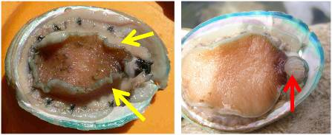  
Source: P Hardy-Smith

### 1.4.4 Laboratory tests

#### Specimens required

Initially, abalone suspected of being affected by AVG should be submitted to the relevant state or territory laboratory. Where possible, the laboratory should be contacted directly to ensure that samples are collected and stored appropriately for laboratory examination, laboratory personnel are aware of samples being forwarded to the laboratory for examination, and the laboratory will confirm the arrival of samples.

The nature of the sample submitted for laboratory analysis will depend on the availability of specimens, fixatives and transportation (Table 1.1). In all cases, the key tissues for diagnosis of AVG are the ganglia (e.g. cerebral, pleuropedal and buccal ganglia; Hooper et al. 2007a) (Figure 1.2). Where possible, live moribund animals should be selected for sampling; alternatively, freshly dead abalone can be sampled.

Table 1.1 Samples for laboratory diagnosis of AVG (listed in order of preference)

|  |  |  |  |
| --- | --- | --- | --- |
| *Fixative not available in the field—transport to laboratory possible in <24 hours* | *Fixative not available in the field—transport to laboratory possible in >24 hours* | *Fixative available in the field—transport to laboratory possible in <24 hours* | *Fixative available in the field—transport to laboratory possible in >24 hours* |
| Whole, moribund abalone (i.e. clinically affected but still alive) that are kept moist and chilled on ice (even though they might die by the time they reach the laboratory) | Whole, moribund abalone that have been euthanaseda and immediately frozen (they should not be allowed to thaw before reaching the laboratory) | Whole, moribund abalone (i.e. clinically affected but still alive) that are kept moist and chilled on ice (even though they might die by the time they reach the laboratory) | Moribund abalone that have been euthanaseda and frozen, and/or freshly dead abalone that have been frozen |
| Whole, freshly dead abalone (i.e. abalone that have died within a few hours) that are kept chilled on ice | Whole, freshly dead abalone that have been frozen (they should not be allowed to thaw before reaching the laboratory) | Tissue from euthanaseda moribund abalone that has been preserved with one of the following fixatives:   * 10% formalin (for histological examination) * 2.5% glutaraldehyde (for electron microscopy) * 95% ethanol (for molecular analysis); alternatives are tissue frozen at –80 °C, if available, or sample stabilised using nucleic acid stabilisers | Tissue from euthanaseda moribund abalone that has been preserved with one of the following fixatives:   * 10% formalin (for histological examination) * 2.5% glutaraldehyde (for electron microscopy) * 95% ethanol (for molecular analysis); alternatives are tissue frozen at –80 °C, if available, or sample stabilised using nucleic acid stabilisers |
| If neither moribund nor freshly dead abalone are available, collect dead abalone and, if available, some cohabiting live abalone and forward them to the laboratory chilled on ice | If neither moribund nor freshly dead abalone are available, dead abalone (as fresh as possible) that have been frozen (they should not be allowed to thaw before reaching the laboratory) |  |  |

a For euthanasia and destruction techniques for abalone, refer to the AQUAVETPLAN **Operational Procedures Manual—Destruction** (www.agriculture.gov.au/animal-plant-health/aquatic/aquavetplan)

Note: The nature of samples sent for diagnosis will vary, depending on the availability of specimens, fixatives and transportation.

Figure 1.2 A. Longitudinal dissection of abalone, exposing the ganglia for laboratory examination. B. Depth (5–10 mm) of cut required to sample the ganglia. The area where the ganglia occur are circled, and arrows indicate the ganglia. (See Appendix 2 for detailed photos showing sampling of abalone ganglia.)

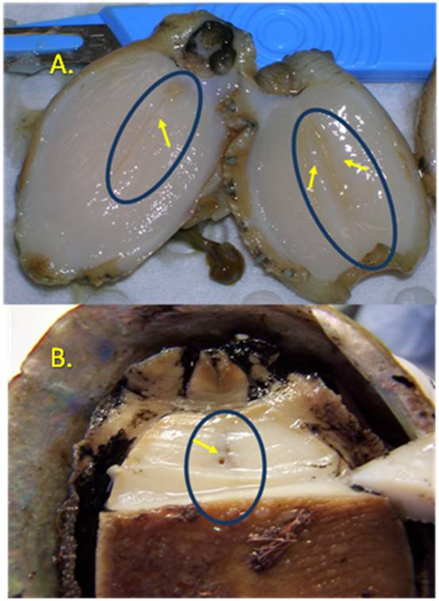

Source: A. Fish Diseases Laboratory, CSIRO Australian Animal Health Laboratory; B.  
 Victorian Department of Primary Industries

#### Transport of specimens

Samples should be kept chilled (on ice) and forwarded to the laboratory within 24 hours of collection, or sent frozen. Where fixatives are available, samples should be preserved (fixed) for examination. The fixative used will vary, depending on the diagnostic method to be used (Table 1.1). Fixed material will expedite diagnosis because samples can be processed immediately. Fixatives should not be mixed.

For molecular analysis, samples should be stored at –80 °C, where possible. Nucleic acid stabilisers may also be used for samples for molecular analysis (e.g. saturated ammonium sulfate or commercial products such as RNA*later*); confirm details with the laboratory where samples are to be sent. Nucleic acid stabilisers may expedite transport as they are not classed as dangerous goods.

Further advice on sample packaging for shipment is available from state and territory laboratories, and the Fish Diseases Laboratory at the CSIRO Australian Animal Health Laboratory (CSIRO-AAHL), Geelong.

#### Laboratory diagnosis

##### Microscopy

Microscopy showing the presence of ganglioneuritis in neural tissue can provide a presumptive diagnosis of AVG (see Section 1.4.1).

##### Histopathology

Inflammation (infiltration of haemocytes) confined to nervous tissue is the distinguishable histopathological lesion associated with AVG. Inflammation can be observed in the cerebral, pleuropedal and buccal ganglia, as well as the cerebral commissure and the peripheral nerves arising from the ganglia (Hooper et al. 2007a). Nerve bundles within the foot (branches of the pedal nerve) and viscera can also be affected. Tissue sections should ideally be stained with H&E and viewed by light microscopy (Figure 1.3).

Figure 1.3 Infiltration of haemocytes in ganglion of abalone viral ganglioneuritis–affected abalone (haematoxylin and eosin stain)

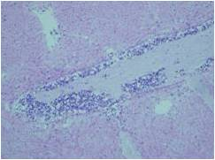

Source: Victorian Department of Primary Industries

Lesions are characterised by cellular inflammation (predominantly haemocytes and glial cells) and individual cell necrosis within affected nerves. Smaller nerves are also affected by tissue necrosis and increased cellularity, especially near the mouth parts. Adjacent interstitial tissue may also be necrotic and exhibit areas with cellular inflammation. No lesions are consistently present in other tissues (Hooper et al. 2007a).

##### Transmission electron microscopy

Transmission electron microscopy can be used to confirm the presence of viral particles in infected ganglia (Figure 1.4). Virions are icosahedral in shape, with electron-dense cores, and have a diameter of 100–110 nm. The cores (toroids) become dense during morphogenesis of the virus as a result of accumulation of nucleic acid (DNA), and change in density and shape during replication. The intranuclear location of the virus particles, their size and the varied nature of the electron-dense cores are characteristic of members of the *Herpesviridae*. Empty capsids are occasionally visible in the nucleus of infected cells.

Figure 1.4 Transmission electron micrograph of intranuclear herpesvirus capsids with non-dense cores (black arrows) and dense cores (white arrows) within a glial cell of infected pedal ganglia C = cytoplasm; E = extracellular space; N = nucleus

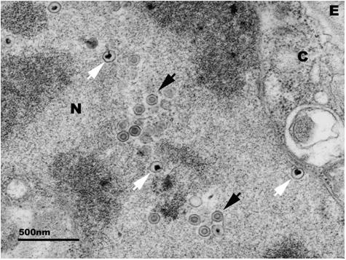

Source: Electron Microscopy Group, CSIRO Australian Animal Health Laboratory

##### Culture methods

No appropriate cell lines are available for culturing AbHV.

##### Molecular techniques

The genome of AbHV has been sequenced (Savin et al. 2010). This has allowed development of a number of molecular diagnostic tests, which are described below.

###### Polymerase chain reaction

A PCR assay for detection of AbHV has been developed. Since PCR detects the presence of the viral nucleic acid (DNA), a positive result provides a presumptive diagnosis. The OIE *Manual of diagnostic tests for aquatic animals* (OIE 2012b) details both conventional and qPCR tests for AbHV.

A TaqMan real-time PCR assay has been developed and validated for the detection and identification of AbHV (Corbeil et al. 2010; Crane et al. 2009). The discovery of genotypic variants in Australia that are not recognised by this test necessitated development of other qPCR tests, which are based on more conserved regions of the viral genome. These methods have not been formally validated but have sensitively detected all AbHV variants identified in Australia, as well as the Taiwanese isolate (OIE 2012b). These assays could also be used to screen other aquatic animal species in Australia for AbHV DNA, either from current, active infection or from residual material from previous exposure to the virus.

###### In situ hybridisation

An in situ hybridisation assay, which permits localisation of a specific nucleic acid sequence within tissue, has been developed for AbHV. Although the assay is included in the OIE *Manual of diagnostic tests for aquatic animals* (OIE 2012b), it has yet to be validated.

### 1.4.5 Confirmation of disease

Presumptive diagnosis of AVG requires the observation of gross signs of disease (Section 1.4.1), ganglioneuritis (histopathology) in neural tissue sections or positive qPCR results (which may or may not be associated with high mortality rates).

Confirmatory diagnosis of AVG if only one of the above three indicators is apparent requires visualisation of viral particles in infected tissues using transmission electron microscopy or a positive in situ hybridisation result from neural tissue.

### 1.4.6 Differential diagnosis

Clinical signs are not specific for AVG. They may be suggestive of AVG if abalone exhibit swollen mouth parts, with or without eversion of the radula, sometimes (but not always) associated with increased mortality.

Mortality in wild and farmed abalone can result from infectious and non-infectious (e.g. environmental) aetiologies. For example, increased mortality on farms may be associated with system failure (e.g. interruption to the water supply), which can result in a sudden decline in water quality (e.g. dissolved oxygen). Mortality rates associated with system failure are generally severe and usually occur over a very short period—for example, 24 hours. Mortality associated with an AVG outbreak usually begins with a few animals or tanks being affected, with increasing mortality over a period of 1–2 weeks. Other causes of mortality include increased water temperatures, spawning and bacterial septicaemia.

Given the non-specific nature of clinical signs associated with AVG infection and the difficulty in differentiating AVG-associated mortality from mortality due to other causes, samples from suspected cases of AVG infection should be submitted for further diagnosis to confirm or rule out AbHV infection.

## 1.5 Resistance and immunity

Molluscs, including abalone, have a well-developed innate immune system but are not known to possess an adaptive immune system (Hooper et al. 2007b; Roch 1999). There is no available information regarding abalone developing resistance to AbHV infection and the subsequent development of AVG.

Surviving abalone from the Victorian outbreak were tested for susceptibility to AbHV and results suggested that they were not resistant to infection (Crane et al. 2012). Anecdotal information regarding mortality rates indicates that there is variability in the incidence and prevalence of the disease over time in both farmed and wild populations.

No vaccines or vaccine-like prophylactics are available for AVG, or for use in abalone species in Australia. It is not known whether non-specific stimulators of innate immune system mechanisms could provide any resistance to AVG.

## 1.6 Epidemiology

Epidemiological knowledge of AVG is incomplete. This includes details of virus shedding from infected abalone, abalone immune responses to infection, infectious doses required to elicit disease, and the effect of environmental factors such as water temperature on virus transmission and abalone susceptibility.

Farmed abalone populations show variable mortality from AVG. During the outbreaks in Victoria throughout 2005 and 2006, mortality in infected tanks varied from 10% to 90%. It is not known whether these differences were due to differences in tanks (environmental effects), the level of exposure (infective dose) or variable susceptibility. During the on-farm outbreaks in Victoria in late 2005 and early 2006, AVG spread rapidly through farmed populations, probably via human movement, through the water column and via fomites (e.g. contaminated equipment).

Mortality in wild abalone populations is also variable. In Victoria in 2006, it varied between and within reef systems. Mortality rates ranging from 5% to 90% were reported for large, easily observed abalone. Young abalone in wild populations had a tendency to remain hidden during the day, making it difficult to assess mortality rates in younger age groups.

Potential mechanisms for spread of AVG in wild abalone include contaminated mucus shed from infected abalone, drifting seaweed, movement of fish species associated with wild-capture equipment and diver movement. None of these modes of transmission have been confirmed.

Transmission studies at CSIRO-AAHL have demonstrated that AbHV can be transmitted horizontally through the water column (McColl et al. 2007).

The origin of AbHV in Australia is unknown. Based on the investigation into the Victorian outbreak in late 2005 (Hardy-Smith 2006), the ‘best fit’ scenario suggested that the source of infection was associated with interstate movements of live wild-caught abalone. Abalone had come onto farms either directly from the wild or via a ‘rehydration facility’ that also maintained other species of live aquatic animals in on-site tanks. There was no evidence that infection was introduced from interstate sources during the Tasmanian outbreaks in 2008 and 2009 (Ellard et al. 2009).

PCR testing has detected AbHV nucleic acid in abalone without clinical or histological signs of disease (Crane et al. 2009), but it is not known whether abalone can remain carriers of the virus if they have recovered from disease or have been subclinically infected (see Section 1.6.1). To date, experimental evidence to demonstrate shedding, transmissibility and viability of virus from subclinical abalone is unavailable.

Persistent, subclinical viral infections are different from latent infections because virus replication continues to occur, albeit at subclinical levels. If such persistent subclinical infections were a feature of AbHV, the virus could go undetected in wild abalone populations. Arzul et al. (2002) have shown that ostreid herpesvirus 1 (OsHV-1) can persist in healthy adult oysters.

Although a PCR test for detection of AbHV has been developed, detection of subclinical infections will depend on the prevalence of the virus in the population, the quantity of viral genetic material in samples and the sensitivity of the test.

The significance of viral latency, should it be a feature of the AbHV, is that re-emergence of disease from asymptomatic carriers is possible, when conditions permit.

### 1.6.1 Incubation period

Infection studies have demonstrated that the period between exposure of abalone to AbHV-contaminated water and the onset of clinical disease is as short as 60 hours (Corbeil et al. 2012a). During the incubation period, abalone are infected but may appear healthy (i.e. subclinical infection).

### 1.6.2 Persistence of the agent in the environment

The persistence of AbHV in the environment has not been fully investigated. However, it is well established that enveloped viruses such as herpesviruses are relatively labile and cannot survive for prolonged periods outside the host (e.g. Donofrio et al. 2000). The virus may remain viable if the viral envelope or viral DNA is not damaged—for example, by exposure to detergents or drying, which could damage the viral envelope, or exposure to ultraviolet radiation (sunlight), which could damage the DNA.

Conditions favourable to virus survival could exist in shaded water that has near-neutral pH and organic material present (Prince 2007). Recent work (Corbeil et al. 2012b) indicates that AbHV is stable at water temperatures of 4 °C or 15 °C for one day, and is partially infectious after 5 days at 4 °C.

### 1.6.3 Modes of transmission

The point of entry for infection of abalone by AbHV is currently unknown. As with other viral pathogens of aquatic animals, infection via the gills is likely, but has not been confirmed. Other points of entry may be the gastrointestinal tract or mucous membranes.

Transmission of the disease through the water column has been experimentally demonstrated. It is likely AVG spreads through direct contact of abalone and possibly through contact of abalone with virus-contaminated mucus and seawater.

The disease has been experimentally transmitted by exposing healthy abalone to either diseased abalone (without direct contact) or to water that was inhabited by diseased abalone. It has also been transmitted using intramuscular injection of healthy abalone with a filtered tissue homogenate from diseased abalone. No other infectious agents were observed by electron microscopy in the inocula used for these experiments.

Mechanical vectors (e.g. fishing and diving equipment) and biological vectors might be important in disease transmission, but their role and significance has not been demonstrated.

### 1.6.4 Factors influencing transmission and expression of disease

Very little is known about factors influencing transmission and expression of AVG in farmed or wild abalone.

Adult bivalve molluscs appear to be less sensitive to herpesvirus infections than juveniles (Renault & Novoa 2004). However, there was no observed difference in susceptibility of adult and juvenile abalone to AVG during the 2005 and 2006 AVG outbreaks on farms.

A number of factors might influence the onset and course of disease in a farmed abalone population. Stress factors that influence the development of bacterial diseases in abalone include temperature, dissolved oxygen, salinity, and ammonia and nitrate levels (Cheng et al. 2003, 2004a, 2004b, 2004c; Lee et al. 2001). These factors might also influence the development of viral diseases in abalone, but their effect on AVG is unknown.

In wild abalone, transmission is likely to be influenced by the presence of natural vectors (e.g. marine animals, fomites, mucus, water currents) and the density of, and distance between, abalone populations (e.g. separation of reefs). Density dependence may be of particular importance if AbHV is labile.

## 1.7 Impact of the disease

Abalone viral ganglioneuritis can cause high mortality rates in both farmed and wild populations. The disease can kill more than 50% of farmed abalone within a population. In wild abalone populations, accurate mortality rates are more difficult to determine. However, mortality rates of up to 90% have been reported in all age classes (OIE 2012b). Abundance surveys by state fisheries authorities and commercial catch reporting will assist in estimating the broader impact on abalone populations.

The impact of AVG on abalone farms may include loss of stock, direct costs of decontamination and lost production. Together, these factors may amount to tens of millions of dollars.

The impact of AVG on abalone fisheries is more difficult to determine because long-term impacts are unknown. However, the immediate impacts include loss of resource (abalone biomass) and reduced resource access (e.g. closed areas and quota reductions). Long-term impacts on abalone recruitment could occur as a result of reduced breeding populations and effects on reef ecology.

Long-term impacts have the potential to threaten the sustainability of the industry, valued at approximately $188 million across Australia in financial year 2008–09, and estimated to be worth $212 million by 2014–15 (Mazur et al. 2010). The flow-on effects of AVG on associated supply chains and service industries will be significant.

# 2 Principles of control and eradication

## 2.1 Introduction

This section provides background information to assist decision making with respect to the most appropriate response option following detection of abalone herpes-like virus (AbHV) outside its known geographical range.

Given current understanding of abalone viral ganglioneuritis (AVG), there are essentially two control options for this disease in Australia:

* eradication—eradication of AbHV from a facility or group of facilities, or recognised compartment in Australia; this is the preferred option in semi-open, semi-closed and closed systems, including farms and processing facilities where live abalone are held
* containment, control and zoning—containment of AbHV in wild abalone to areas with identified clinical disease or subclinical cases, minimising further spread and protecting areas where there is no evidence of AVG or AbHV.

A third option, control and mitigation of disease—that is, the implementation of management practices that decrease the incidence and severity of clinical outbreaks—is not favoured for the following reasons:

* Mitigation of the disease in wild populations is not considered possible.
* Mortality rates in farmed abalone populations are so high that eradication of clinical disease is preferred over mitigation. Removing all abalone from the facility will remove the primary source of virus.

These options may change as more is understood about the disease.

The basic principles of eradication and other response options are described in the AQUAVETPLAN **Enterprise Manual** and the AQUAVETPLAN **Control Centres Management Manual**. Appendix 1 of the AQUAVETPLAN **Enterprise Manual** lists the state and territory legislation relating to disease control and eradication.

The general principles for control and eradication of AVGinclude:

* rapid detection, identification and confirmation of clinical disease
* rapid definition of the nature and extent of the outbreak
* rapid definition and implementation of control measures
* preventing viral spread by controlling stock movement—this is possible within and between farms, and between reef systems where translocation of stock may occur
* preventing viral spread by controlling movement of abalone or contaminated materials (e.g. through commercial abalone divers, recreational divers, other commercial fishers, other user groups) in regions where wild abalone are known to be affected
* limiting or ceasing discharge of contaminated water from infected abalone holding facilities into adjacent marine environments, or treating such water before it is discharged
* implementing good management practices and biosecurity control measures on farms, and for those involved in collecting or harvesting wild abalone.

Selecting the most appropriate control option will depend on:

* successfully eradicating clinical disease from a facility or group of facilities—eradication of clinical disease is the preferred option on farms and processing plants but is not considered feasible in the wild
* the level of risk accepted for future spread of disease (e.g. associated with grow-out of infected populations)
* short-term costs of control and disruption to production in farmed abalone, and short-term effects on populations of wild abalone
* long-term costs of control and disruption to production in farmed abalone, and effects on populations of wild abalone, with or without the presence of disease.

The possible presence and location of reservoirs of infection (i.e. subclinical infections) is a critical factor that should be considered.

## 2.2 Aquatic animal production and fisheries systems

Broadly, the preferred control option will be influenced by whether the affected populations are growing in the wild (open systems) or are held within culture facilities (semi-closed, semi-open and closed systems). In Australia, abalone are collected from the wild (capture fisheries, classified as open systems); grown in floating cages or barrels moored off ropes, in concrete hides situated on the sea floor or in plates within ring cages (all semi-open systems); and grown in tanks on shore (semi-closed systems). Abalone are also held live for varying periods (days to weeks) in facilities, which may use recirculation technology (closed systems).

More information about these systems can be found in the AQUAVETPLAN **Enterprise Manual**. Following is a brief summary of each system as it relates to abalone and AVG.

### 2.2.1 Open systems

In open systems (e.g. wild abalone in oceans), there is no control over movement of animals or water. In these systems, the capture of all affected animals would rarely be feasible. Wild abalone are, however, sedentary animals and are usually confined to specific reef systems. Predators (e.g. fish including stingrays, octopus, lobsters and birds) have access to abalone in open systems.

### 2.2.2 Semi-open systems

In semi-open systems, abalone are either housed in baskets, cages or pipes that are suspended in the open ocean, or are grown in structures moored or placed on the sea floor. In semi-open systems, there is reasonable control over movement of abalone but not over movement of water. Predators (e.g. fish) may have access to abalone in semi-open systems.

### 2.2.3 Semi-closed systems

In semi-closed systems (e.g. systems using seawater pumped ashore from the sea), there is control of both abalone movement and water flow. The majority of these systems do not have the capability to disinfect inflow or outflow water. Ceasing water exchange would result in an emergency harvest or destruction of stock. Predators (e.g. birds) may have access to abalone in semi-closed systems.

### 2.2.4 Closed systems

Closed systems (e.g. holding or processing facilities holding live abalone in fully enclosed facilities using recirculation technology) provide control over both abalone movement and water flow. To ensure effective biosecurity, closed systems must operate according to a health management or biosecurity plan. In some jurisdictions there are regulations to manage disease risks associated with discharge water from processing plants.

## 2.3 Methods to prevent spread and eliminate pathogens

### 2.3.1 Quarantine and movement controls

The following quarantine and movement restrictions should be implemented immediately upon suspicion of AVG outside its known distribution.

#### Establishment of quarantine areas

Specified quarantine areas (Figure 2.1; see AQUAVETPLAN **Enterprise Manual** for more details) include:

* declared area—includes restricted area and control area
* infected premises or area—the premises (e.g. farm) or area (e.g. reef system in the wild) where the infection is present, and the immediate vicinity
* restricted area—area around infected premises or area
* control area—a buffer between the restricted area and free area
* free area—non-infected area (this area is not considered a ‘declared area’ and may include large areas of Australia that are presumed to be free from AVG)

Figure 2.1 Establishment of specified areas to control abalone viral ganglioneuritis

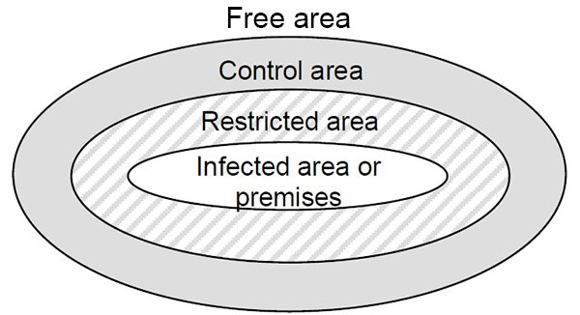

In the declaration of quarantine areas under state or territory fisheries or livestock legislation, the following factors need to be taken into account:

* location of affected facilities (e.g. farms, processing facilities) or affected wild abalone populations
* other facilities and operations in the area (e.g. farms, processors, commercial fishing) and their practices, including
  + the level of biosecurity routinely practised by the facilities (e.g. whether there is movement of vehicles, equipment or personnel between farms, and the biosecurity precautions taken)—this will influence the risk to other facilities
  + the level of biosecurity practised by commercial fishers for wild abalone (e.g. divers)
  + the level of biosecurity practised by other users of the area (e.g. commercial and amateur fishers, recreational divers) with respect to their contact with potentially infected material
  + whether farms and commercial catchers of wild abalone use the same processing facilities, and what biosecurity measures are in place at these shared facilities
  + where the abalone farm or processing facility discharges water to, and where neighbouring abalone farms or processing facilities pump water from (see Section 1.6.4)
* distribution of wild abalone populations in the area
* predominant water movement (e.g. current flow) with respect to affected wild or farmed abalone in the area
* presence of potential vectors (e.g. fish, birds)
* natural barriers to spread of the disease (e.g. areas without populations of suitable hosts).
* The following practices must be considered when implementing response options:
* abalone harvesting (both wild and farmed) and transportation of live abalone to processing plants or live holding facilities
* live abalone movement for non-harvest purposes (e.g. translocation of live abalone between farms, from the wild to farms, or between reef systems)
* movement of potential vectors (e.g. predators, scavengers) between regions (wild and farmed)
* discharge of effluent from processing plants (including holding facilities) and farms
* movement of commercial abalone fishers
* movement of other commercial fishing equipment and fishers
* movement of other users (e.g. recreational divers)
* disposal of dead abalone
* recreational fishing
* possible poaching activities within the area
* decontamination.

#### Implementation of movement controls

Movement controls may include:

* bans on people moving abalone into, within, or out of restricted and control areas
* bans on people moving abalone into non-infected areas
* restrictions or bans on movement of people, vehicles or equipment within and between farms or water bodies containing abalone within the declared area
* bans on the use of high-risk products (e.g. abalone as bait)
* restrictions on, or suspension of, commercial or recreational abalone fishing within the declared area.

Implementation of bans and restrictions will be a dynamic process, determined by the location and extent of the disease outbreak. Bans and restrictions will also depend on whether the purpose is to eradicate AbHV (e.g. in semi-closed or semi-open systems) or to control its spread (e.g. in open systems).

Some restrictions may be impractical or unnecessary, but others will be of critical importance to eradication or control. The feasibility of restrictions and bans, and the extent to which they are able to be enforced, will depend on the location of infection, the location and type of enterprises affected, and the response option chosen.

#### Zoning and compartmentalisation

AVG is known to occur in wild abalone populations throughout Victoria. To date, Tasmania has reported low levels of AbHV in wild abalone, but not AVG. Surveillance and monitoring using a sensitive diagnostic test are required to determine the distribution of AbHV. Such surveillance would allow the implementation of zoning policies that apply to areas where disease occurs and to areas of subclinical infection.

To minimise spread of AVG from recognised infected areas, policies and procedures involving quarantine and biosecurity need to be implemented. For example, guidelines regarding containment and zoning of disease outbreaks were implemented during the Tasmanian outbreak in 2008. Zones would be based on the distribution of AVG and/or AbHV, recognised fishing zones, the geographical and hydrological characteristics of water bodies and landforms, and predictions of the most likely method of spread of infection. Biogeographic barriers such as long stretches of coast without suitable abalone habitat may limit further spread of the disease.

Principles of creation of infected and non-infected zones in Australia are outlined in the AQUAPLAN *Zoning policy guidelines[7]* and the OIE *Aquatic animal health code* (OIE 2012a).

Compartmentalisation could be considered for aquaculture facilities, particularly where its application could be of benefit for export certification purposes. Compartmentalisation requirements are covered in the OIE *Aquatic animal health code* (OIE 2012a).

### 2.3.2 Eradication in semi-closed, semi-open and closed systems

#### Unexposed abalone

In an aquaculture facility where AbHV has been detected, there may be specific areas that have not been exposed to the virus. Unexposed abalone may be grown out or sold for human consumption. Rigorous adherence to internal biosecurity measures at all times (irrespective of whether an outbreak has occurred) is essential for demonstrating that stocks of abalone are ‘unexposed’.

#### Exposed or potentially exposed but clinically normal abalone

Rapid removal of these populations from the water is essential in semi-open and semi-closed systems, since the ongoing release of discharge water to the environment poses a risk of disease spread. It is important to consider the cryptic habits of abalone and their ability to access seemingly isolated areas on an abalone farm. Complete and thorough destocking must be achieved, and no exposed or potentially exposed abalone should remain hidden in pipework, crevices or other areas where they may not be immediately apparent.

Normal or controlled grow-out is not an option in an eradication campaign for exposed or potentially exposed but clinically normal farmed abalone, since they may be subclinically infected and act as a potential source for future outbreaks. There are two options for the treatment of these abalone:

* The abalone may be harvested for human consumption. This activity carries a risk of further transfer of infection, which may jeopardise the success of an eradication strategy unless it is carried out under strict control measures.
* Abalone that cannot be harvested for human consumption (i.e. not market size) should be immediately destroyed. This is likely to decrease the infectious load on a site and minimise the spread of infection. Disposal of destroyed abalone must be carried out under strict controls to prevent further spread of infection.

Measures necessary to prevent further spread of infection include:

* disinfection of all equipment and personnel involved in harvesting, destruction, disposal and processing
* application of quarantine restrictions and procedures to the infected facility, personnel, equipment and vehicles
* on-site processing for farms—this may be the only option if quarantine restrictions are in place (but would need to meet relevant requirements for processing)
* strict movement and disinfection procedures for the transport of abalone to off-site processing plants, which will then become infected sites that are subject to quarantine procedures
* holding, treatment and safe disposal of harvest or processing effluent (including holding water and any waste material) from farms or processing facilities
* safe disposal of affected abalone and abalone products (see the AQUAVETPLAN **Operational Procedures Manual—Disposal**)
* ensuring that the final product will not result in the spread of infection.

#### Clinically diseased abalone

Immediate removal, destruction and appropriate disposal of all diseased and dead abalone are essential to the success of an eradication strategy for AVG. Clinically diseased abalone and infectious waste are likely to be the main source of the virus in the environment.

### 2.3.3 Containment, control and zoning in open systems

#### Unexposed abalone

Control options for unexposed abalone in an open system within a declared zone are the same as for unexposed abalone in semi-open, semi-closed and closed systems (see Section 2.3.2).

Risk reduction measures should be implemented to minimise the risk of spread of the disease. Translocation of stock from reef to reef for harvest management or other purposes should cease immediately in disease-free zones. All commercial harvesters should adopt preventive biosecurity measures, such as disinfection of gear between trips (i.e. according to current Victorian wash-down instructions, Gavine et al. 2009).

#### Exposed or potentially exposed but clinically normal abalone

A successful zoning program will rely on the implementation of movement restrictions for exposed or potentially exposed abalone and potential vectors (e.g. divers, equipment, boats), to prevent the spread of AbHV to disease-free zones. The feasibility of a zoning program will depend on wild harvesting practices, the extent to which infection has already spread, and the location of reservoirs of infection, which might only be assumed and not confirmed. This can only be assessed at the time of an outbreak, taking into account movement restrictions on abalone, people, vehicles and boats, and market access for the abalone products and byproducts. Young abalone in the disease zone must be treated as infected.

To prevent spread of infection, care must also be taken when harvesting, processing and transporting final products to the designated market.

#### Diseased abalone

Diseased abalone and infectious wastes are the main source of AbHV in the environment and constitute the greatest risk for spreading the infection to disease-free zones. If diseased wild abalone are observed in a disease zone, they should not be handled, and the responsible authorities should be informed immediately.

### 2.3.4 Tracing

Tracing a disease outbreak is the process of retrospectively determining the method and pattern of disease spread. Tracing investigations are crucial in determining all confirmed and potential locations of the disease, as well as defining restricted and control areas. The information gathered from tracing will assist in determining the most appropriate response action. The immediate steps required are to trace-back all contacts to infected abalone, premises and areas (to establish the origin of the outbreak) and to trace-forward all contacts with infected abalone, premises and areas (to establish the current location and potential spread of infection).

The Australian abalone fishery is highly regulated, and most states require that farms and fishers submit detailed records of abalone movements to enable quota monitoring. These records provide a valuable resource for disease tracing.

The presence or absence of predisposing factors for expression of disease must be examined when determining the duration of the outbreak and estimating the time and source of initial infection. It is possible that AbHV may have been present for some time before clinical disease becomes apparent.

The following items must be traced:

* abalone
* abalone products
* water—input and output
* vehicles and boats—abalone transport vessels and vehicles, divers’ boats, feed trucks, visitors’ cars
* materials and equipment—including items such as grading equipment and feed that might be transferred between farms, divers’ equipment (e.g. catch bags) that may be used on different reef systems, and crates used to transport abalone to processing facilities
* personnel—farm workers, abalone divers, other commercial fishers, recreational divers and fishers, sales and feed producer representatives, tradespeople, veterinarians, scientists, technicians and visitors
* processing facilities—particularly if there is a possibility that infected abalone have been harvested and sent for processing, or abalone have been shipped live through these facilities.

### 2.3.5 Surveillance

Surveillance is necessary to:

* define the extent (geographical and host ranges) of AVG and AbHV
* detect new outbreaks
* establish restricted and control areas, to which quarantine and movement restrictions are applied
* establish disease and disease-free areas and zones for AVG
* monitor the progress and success of an eradication strategy for AVG and AbHV
* provide evidence to support a self-declaration of disease freedom for trade purposes.

Techniques for sensitive screening of large numbers of animals have been developed and validated. The polymerase chain reaction (PCR) assays discussed in Section 1.4.4 can be effectively applied in any large-scale surveillance plan to determine the extent of spread of the pathogen. In an emergency situation, detection of viral nucleic acid would be a rapid surveillance technique that may also be used to diagnose subclinical infections. Caution is required in interpreting the results because of the potential for false positives or detection of viral nucleic acids that are not associated with viable virus.

The World Organisation for Animal Health (OIE) guidelines on surveillance[8] are sufficient for all aquatic animal diseases. The specific disease chapters of the *Aquatic animal health code* (OIE 2012a) outline a country’s requirements for self-declaration of freedom from a given OIE-listed disease. The surveillance chapters in the *Aquatic animal health code* and *Manual of diagnostic tests for aquatic animals* (OIE 2012b) provide guidelines for surveillance to meet requirements for self-declaration. A specific chapter in the *Aquatic animal health code* on ‘infection with abalone herpesvirus’ includes the standard requirements and different pathways used for self-declaration of disease freedom (OIE 2012a).

### 2.3.6 Treatment of infected animals

There is no treatment for AVG.

### 2.3.7 Treatment of animal products and byproducts

Trade regulations, market requirements, food safety standards and potential spread of the pathogen must be considered when determining the treatment, processing and destination of abalone products and by-products.

It is not known how long AbHV can survive in abalone products, waste or transport water. There is currently no information on methods to render the virus non-viable in infected products; however, it is highly likely that the virus would be inactivated in processed (e.g. canned) products. As a precaution, during the recent outbreak of AVG in Tasmania, all discharges from affected processing and live holding facilities were disinfected before discharge and destocking. For further information regarding the inactivation of viruses, refer to the AQUAVETPLAN **Operational Procedures Manual—Decontamination**.[9]

AVG is not a recognised zoonosis. In an outbreak situation, healthy abalone are therefore suitable for human consumption, provided that the product complies with food safety regulations.

### 2.3.8 Destruction of animals

Destruction of infected abalone should be conducted in a hygienic manner that avoids spillage of infectious waste. Destruction should be humane and minimise stress to the abalone.

Occupational health, safety and the environment should be considered when destruction of abalone is to be undertaken.

For more information on destruction, refer to the AQUAVETPLAN **Operational Procedures Manual—Destruction**.[10] The manual describes alternative methods for the destruction of gastropod molluscs, including the use of chemicals (e.g. anaesthetics).

### 2.3.9 Disposal of animals

During an outbreak of AVG in a facility (e.g. farm or processing facility), abalone will either die from the disease, be harvested for human consumption or be destroyed. The options chosen will depend on the cause of death:

* Healthy abalone that are likely to have been exposed to AbHV may be harvested and processed for human consumption (emergency harvest).
* Affected abalone that die or are destroyed may be disposed of by burial, composting or other procedures.

For more details on disposal, see the AQUAVETPLAN **Operational Procedures Manual—Disposal**.[11]

During an AVG outbreak in wild abalone populations, abalone that die from the disease are likely to be consumed by predatory or scavenging aquatic animals (e.g. fish, crayfish, crabs, seals). Disposal of abalone is not likely to be practical in these situations.

### 2.3.10 Decontamination

Because of differences in types of enterprise, farming practices and commercial fishing equipment, decontamination protocols may need to be determined on a case-by-case basis. This will involve liaison between the enterprise manager or owner, the state or territory chief veterinary officer, and/or the state or territory director of fisheries. The decontamination protocol should take into consideration the factors outlined in Section 1.6, particularly:

* the source and location of infection
* the nature of the enterprise (e.g. farm, processing plant, wild populations in close proximity) and its water source
* the construction materials of the buildings and structures on the site
* the design of the site and its proximity to other waterways or buildings
* effective disinfection measures
* workplace safety concerns
* environmental impact of the decontamination protocol
* legislative requirements (occupational health and safety, environmental protection, chemical use)
* availability of appropriate and effective disinfectants.

Effective decontamination of equipment, materials, tanks, boating and buildings requires thorough cleaning before disinfection. Details of disinfectants and their indications are provided in the AQUAVETPLAN **Operational Procedures Manual—Decontamination**.[12]

### 2.3.11 Vaccination

No vaccine-like prophylactic treatments are available for the prevention of AVG.

### 2.3.12 Vector control

The role of vectors in AVG transmission is not known. However, it is reasonable to consider whether control of potential vectors is possible. Potential vectors are described in the following subsections.

#### Wild fish and other aquatic animals

Wild fish and other aquatic animals might eat infected abalone and move to other reef systems. It is not known whether AbHV can survive passage through the digestive systems of predatory or scavenging aquatic animals.

Controlling these potential vectors is impossible in most, if not all, areas.

#### Birds

Birds that feed on infected abalone could potentially spread the virus through faeces after passage through the digestive tract.

Open-air tanks and ponds may attract predatory and scavenging birds, and must be covered (e.g. using nets or tank roofs) if birds are to be prevented from feeding on sick and moribund abalone. It is highly unlikely that birds could be controlled in open systems.

#### Fomites

Fomites are mechanical vectors of pathogenic agents. Boats, diving equipment, fishing equipment (commercial and recreational) and other equipment that may have come in contact with infected abalone or infected water may act as vectors.

Control of fomites could include movement or access controls, thorough decontamination after exposure, and public awareness campaigns. Control measures can be compromised by ignorance and illegal activities, such as poaching.

## 2.4 Environmental considerations

Environmental considerations regarding the control of AVG include:

* release of infected or potentially infected discharge water into the ocean, which may result in further spread of infection and establishment of reservoirs of infection in wild abalone populations
* environmental impact from the large-scale use of disinfectants and anaesthetics for decontamination; the local environmental protection agency may need to be consulted (see the AQUAVETPLAN **Operational Procedures Manual—Decontamination** for contact information)
* development of pathogens resistant to management chemicals used on sick animals and then subsequently discharged into the environment
* impact on the environment from the disposal of infected abalone, abalone products and material; this impact must be minimised while ensuring that there is no dissemination of infection (see the AQUAVETPLAN **Operational Procedures Manual—Disposal[13]**).

## 2.5 Sentinel animals and restocking

### 2.5.1 Farms

AbHV was successfully eradicated from farms following the Victorian and Tasmanian AVG outbreaks by completely destocking and thoroughly decontaminating the facilities. Sentinel abalone were stocked after a fallow/dry-out period, and subsequently tested negative for AbHV. These facilities have re-established large populations of abalone without the recurrence of AVG.

### 2.5.2 In the wild

Natural recruitment has been observed on reefs previously infected with AVG, and is the subject on ongoing research.

## 2.6 Public communications strategy

Appropriately timed, accurate and well-drafted media coverage is vital to:

* maintain community and political support for the management campaign
* increase alertness for signs of disease and encourage early recognition and reporting
* fulfil legal obligations for freedom of information
* increase knowledge of, and compliance with, movement restrictions and other disease control activities.

A public awareness campaign must emphasise education, surveillance and cooperation from industry and the community, to control future outbreaks of AVG in Australia. Such campaigns should emphasise that AVG does not pose a human health risk and include appropriate material to assist members of the general public to minimise disease spread.

## 2.7 Feasibility of control or eradication of abalone viral ganglioneuritis in Australia

The feasibility of controlling an outbreak of AVG depends on the nature and location of the outbreak, the management strategy adopted and whether the outbreak is in farmed or wild abalone. There are essentially two response options (see Section 2.1):

* Eradication. Eradication of disease from closed and semi-closed facilities has been demonstrated and is a viable option. Successful eradication of the disease from wild abalone populations in Australia is considered unlikely.
* Containment, control, and zoning or compartmentalisation. For facilities that can demonstrate effective biosecurity and surveillance, the establishment of a recognised AVG-free compartment may be feasible.

### 2.7.1 Open systems

Eradication of AbHV would be extremely difficult in an open system (e.g. abalone growing wild)—the principles of eradication are not easily applied in open systems because of the inability to control movement of water or stock. Instead, containment, control and zoning of AbHV should be attempted, to limit spread of clinical disease.

Since AbHV is likely to be transmitted through the water column and via other vectors, it is very unlikely (if not impossible) that the natural spread of AbHV could be controlled in open systems. It is unlikely that all susceptible abalone could be removed from a reef system for the purpose of AbHV eradication.

Control of human activity could be effective, since jurisdictions have legal powers to prohibit commercial and recreational diving, or limit access for all users of an area, particularly in disease control situations. However, illegal poaching or ignorance of measures in place may reduce the chance of success of such controls. Effective communication of any controls on human activity would be an important component of control actions.

### 2.7.2 Semi-open systems

Sea-based farms may be able to eradicate AbHV infections. Infected facilities in Victoria have eradicated the disease by removing all remaining abalone and equipment from the water, except for mooring lines, and decontaminating the equipment. Subsequent monitoring found no evidence of AbHV in wild abalone populations in the area in which these farms were located. In systems where complete removal of all stock and decontamination of all equipment is possible, and nearby populations of stock are not infected, eradication of the disease might be achieved.

### 2.7.3 Semi-closed systems

Eradication of AbHV in semi-closed systems is feasible and has been successfully undertaken.

Semi-closed facilities (e.g. pump-ashore facilities, where water is pumped to an on-shore farm) were totally destocked and decontaminated based on principles in the AQUAVETPLAN **Operational Procedures Manual—Decontamination**.[14] The facilities remained empty (fallow) for at least six weeks before restocking. Restocking and ongoing surveillance confirmed successful eradication.

### 2.7.4 Closed systems

Eradication of AbHV in closed systems is feasible and has been successfully undertaken.

Abalone in closed systems are mainly live animals being held before transport to national and international markets, or wild broodstock being held on farms in a facility separate from the production area. Eradication from processing facilities has been successful, as shown by the lack of an outbreak since 2006 in farmed abalone in Victoria. Eradication involved destocking, decontamination, a fallow period, restocking of sentinel abalone and testing to confirm eradication.

### 2.7.5 Trade and industry considerations

Trade regulations, market requirements and food safety standards must be considered as part of a response strategy.

AVG has been officially reported from Australia (Victoria, NSW and Tasmania only). The NSW report was for disease occurrence in contained facilities, and was successfully eradicated. AbHV has been reported from Chinese Taipei (OIE 2008), where it caused a disease similar to AVG (Chang et al. 2005).

#### Export markets

The Department of Agriculture is responsible for the health certification of all exports and should be contacted for further information on export of any product potentially infected with AbHV.

#### Domestic markets

A cautious approach is required for the harvest of exposed or potentially exposed product for the domestic market, because of the potential for further spread of infection. However, AVG is not a zoonotic disease. Decisions regarding the release of abalone or abalone products to the domestic market will depend on the response strategy implemented.

##### Eradication

For successful eradication of AbHV, decisions relating to the release of product for the domestic market must ensure that there is no potential for spread of AbHV outside its current known range in Australia.

##### Containment, control and zoning

The release of exposed or potentially exposed abalone product to the domestic market must be carefully managed to minimise the risk of spread of viable virus to areas or zones outside the known range of AbHV.

# 3 Policy and rationale

## 3.1 Overall policy for abalone viral ganglioneuritis

**Summary of policy**

Abalone viral ganglioneuritis (AVG) is a disease of abalone caused by abalone herpesvirus (AbHV). The disease can cause high mortalities in both farmed and wild abalone populations. It has been reported in Victorian wild abalone, and has been eradicated from four facilities in Victoria and several facilities in Tasmania.

AbHV can be detected in the absence of clinical disease, allowing surveillance and monitoring during disease outbreaks, and subsequent monitoring and zoning for management purposes. Because of the risk posed by the disease and its substantial impacts, abalone industries in Victoria, Tasmania and other states need to be well prepared for further outbreaks of clinical disease.

The policy for response to an outbreak of AVG in Australia depends on the nature of the outbreak. The response option will be decided by the chief veterinary officer (CVO) and/or the director of fisheries of the state or territory in which the outbreak occurs. Epidemiological investigation will be used to assist with this decision.

There are two possible response options for AVG in Australia, given current understanding of this disease:

* option 1—eradication of AbHV from affected facilities
* option 2—containment, control and zoning of AVG and/or AbHV to minimise further spread and protect areas where there is no evidence of AVG or AbHV.

These options may change as more is understood about the disease.

Both these options involve a combination of strategies, which may include:

* quarantine and movement controls on abalone, abalone products, equipment and other items in declared areas to prevent spread of infection
* controls (e.g. retention, disinfection) on release of potentially infected water from land-based facilities where AbHV has been detected
* restrictions on access to, and activities in, areas with active disease or AbHV
* destruction and disposal of all clinically diseased and dead abalone on farms or in holding facilities as soon as possible, to prevent further virus shedding
* decontamination of facilities, products, equipment and other items, such as vehicles, to eliminate AbHV from infected premises and prevent spread of infection
* surveillance to determine the source and extent of clinical disease
* zoning to define and maintain disease-free zones
* restocking with sentinel abalone
* effective public relations.

The CVO and/or director of fisheries in the state or territory in which an outbreak of AVG occurs will be responsible for developing an emergency animal disease response plan (EAD response plan). This plan may be submitted to the Aquatic Consultative Committee on Emergency Animal Diseases (AqCCEAD), which can provide advice on the technical soundness of the plan and its consistency with AQUAVETPLAN.

CVOs and/or directors of fisheries will implement disease control measures in accordance with the agreed EAD response plan and relevant legislation. They will make ongoing decisions on follow-up disease response measures in consultation with AqCCEAD. The detailed response measures adopted will be determined using the principles of control and/or eradication (Section 2), epidemiological information about the outbreak, and the financial and logistic feasibility of the option.

For information on the responsibilities of state or territory disease control headquarters and local disease control centres, see the AQUAVETPLAN **Control Centres Management Manual**.[15]

## 3.2 Response options

Factors that influence the potential for successful control or eradication of an infectious disease include:

* the level of knowledge about the cause of disease, including transmission routes, maintenance, host range and vectors
* the stability of the pathogen in the environment and its susceptibility to disinfection measures
* diagnostic feasibility
* adequacy of surveillance programs
* availability of resources for a control program
* legislative frameworks
* speed of the response and implementation of management measures to limit spread of the disease.

Diseases that are more likely to be successfully controlled and eradicated are those for which there is a high level of understanding of the epidemiology of the disease, availability of diagnostic tests and the necessary resources for undertaking disease control programs.

The inherent features of AVG and the current limits of understanding of many of the factors listed above limit the response options for an outbreak of AVG.

Figure 3.1 details the actions that should occur on initial suspicion of AVG. Figure 3.2 can be used to identify the most appropriate response option if AbHV is confirmed (see Section 1.4.2). These decision flowcharts are flexible, depending on the specific situations experienced. They are based on current understanding of the disease and could change as more is understood about AVG.

Figure 3.1 Decision flowchart if abalone viral ganglioneuritis is suspected

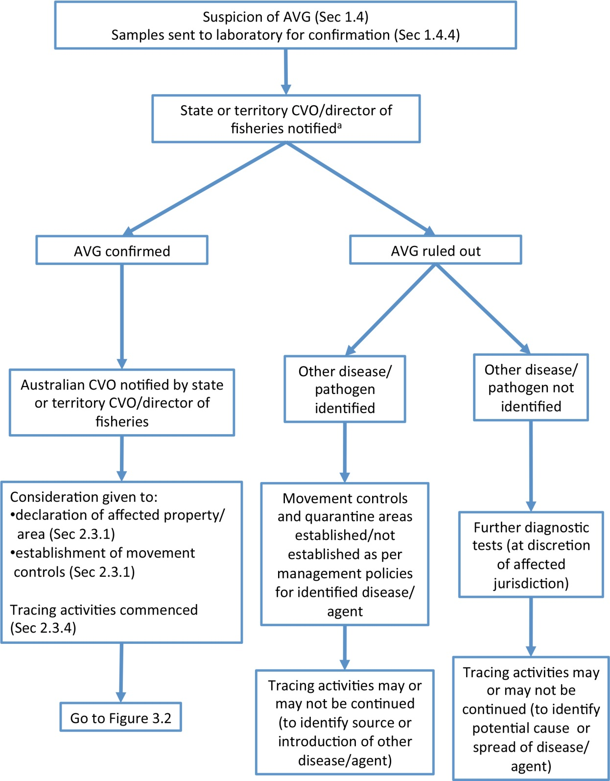

AVG = abalone viral ganglioneuritis; CVO = chief veterinary officer; Sec = Section

As appropriate in the affected jurisdiction—for example, not every abalone submitted by members of the general public will result in notification of the CVO or director of fisheries

Figure 3.2 Decision flowchart to determine the most appropriate response option if abalone viral ganglioneuritis is confirmed

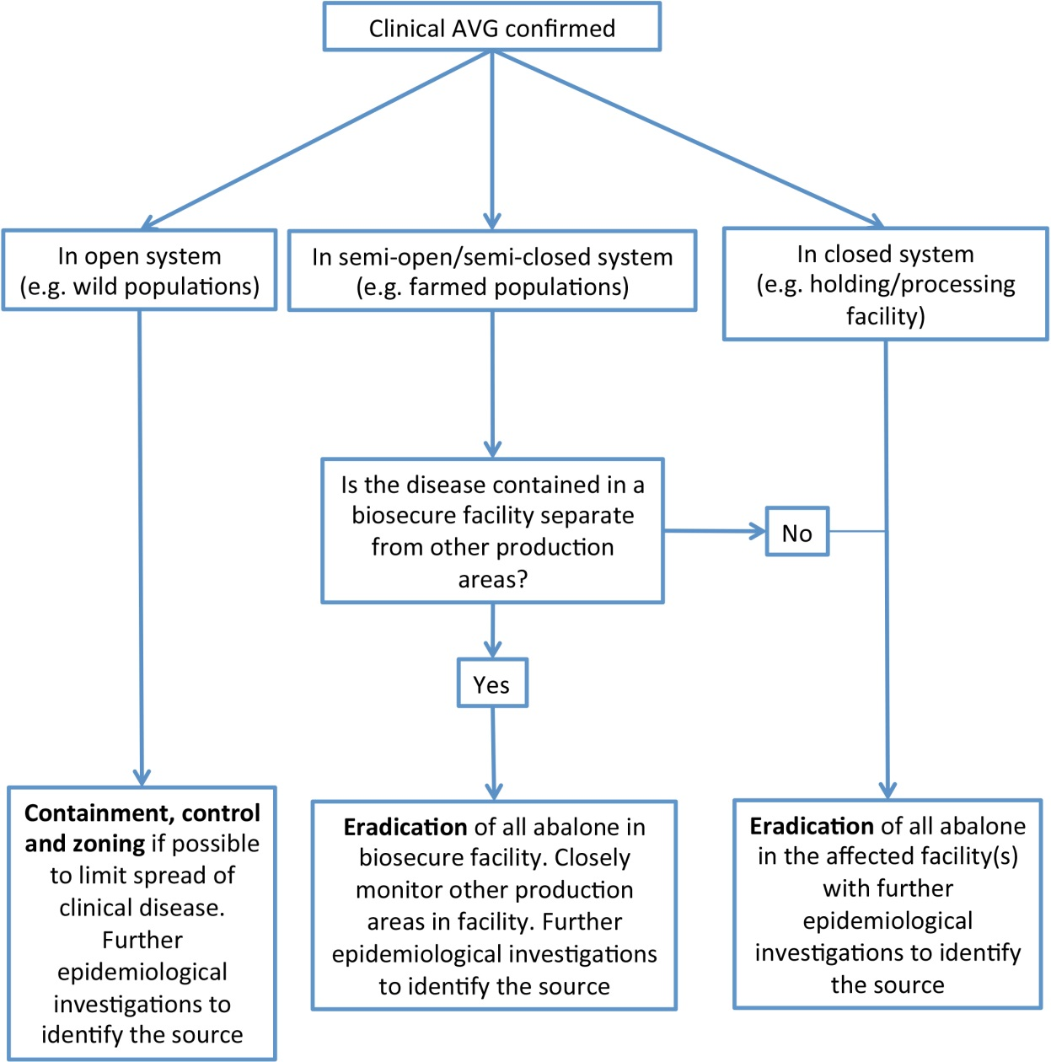

AVG = abalone viral ganglioneuritis

Note: Eradication can include the emergency harvesting of abalone.

### 3.2.1 Option 1—eradication

For more information on eradication, see Section 2.3.2.

Eradication of AVG from facilities might have high short-term economic costs, depending on the number of abalone to be destroyed. Eradication is not feasible in an open system (e.g. wild abalone on reefs), given current knowledge of the disease and the virus. It is likely to be successful in closed, semi-closed and semi-open systems, provided that the disease is detected early, clinically diseased and exposed abalone are rapidly removed, and the appropriate measures are implemented to reduce discharge of large volumes of infected, untreated water.

An eradication plan must include the following activities:

* Quarantine and movement controls must be declared immediately, and stringently enforced on abalone products and any known vectors located in declared areas.
* Movement controls should be maintained until the agent is eradicated from the facility(s), and must apply to
* movement out of the infected area of anything capable of transmitting the virus from infected to uninfected abalone
* aquaculture facilities or processing plants.
* All diseased and dead abalone must be removed, destroyed and disposed of as quickly as possible.
* Any exposed or potentially exposed abalone must be either removed, destroyed and disposed of, or emergency harvested, depending on the potential for spread of disease.
* Any product from exposed or potentially exposed but clinically normal abalone must be either destroyed and disposed of or sent to market, depending on the potential for spread of disease. If the product has been processed in a way that inactivates the virus (e.g. canning), the risk of spread is minimised.
* All buildings, tanks, materials and equipment that may be contaminated—including nets, boats and vehicles—must be decontaminated (see Section 2.3.8 and the AQUAVETPLAN **Operational Procedures Manual—Decontamination** for further details).
* All infected abalone, wastes, effluent and equipment that cannot be decontaminated effectively must immediately be disposed of safely. This includes water from farms or holding facilities that may have had contact with infected abalone.
* Restocking with sentinel abalone can occur only after the site has been thoroughly decontaminated.

### 3.2.2 Option 2—containment, control and zoning

Eradication is not considered feasible if disease is present in wild abalone. Under these conditions, containment, control and zoning are more feasible options.

A containment, control and zoning plan must include the following activities:

* Quarantine and movement controls must be declared and stringently enforced on abalone, abalone products and any vectors located in declared areas. Movement controls must apply to movement out of the infected area of anything capable of transmitting AVG to abalone outside the area. Movement controls should be maintained until it is possible to determine the extent of infection with the virus.
* Any product from exposed or potentially exposed but clinically normal abalone must be either destroyed and disposed of or sent to market, depending on the potential for spread of disease.
* If zoning is implemented, a targeted surveillance program for AVG is required within and surrounding the disease-free zone.
* Surveillance programs should make use of new, proven and validated diagnostic techniques as they are developed and refined.
* Thorough cleaning and disinfection of equipment—including nets, boats and vehicles that may move from a zone in which there are abalone with AVG to a disease-free zone—are important (see Section 2.3.8 and the AQUAVETPLAN **Operational Procedures Manual—Decontamination** for further details).
* Restocking with sentinel abalone is one method of ascertaining freedom from infection in open systems, where sparse populations of infected abalone could remain. Large-scale restocking with susceptible species should only occur once the water body is likely to be disease-free.
* Increased vigilance is required at times of stress to abalone (e.g. following handling or spawning, changes of diet, temperature changes, salinity changes, other stressors relating to water quality, change of seasons), to detect and investigate mortalities and minimise disease spread.

## 3.3 Criteria for proof of freedom

Proof of freedom from AVG, which may be important for trade, can be demonstrated at the level of the aquaculture establishment, zone and country. Criteria for proof of freedom at each level are given in the OIE *Aquatic animal health code* (OIE 2012a). If proof of freedom is required for trade purposes, the same criteria may be used as a guide for Australia, or zones within Australia, to demonstrate proof of freedom from AVG.

## 3.4 Funding and compensation

There are currently no national cost-sharing agreements in place for emergency responses to AVG. It is the responsibility of the users of this publication to seek advice in relation to any relevant funding or compensation arrangements within the relevant jurisdiction.

# Appendix 1 Approval of agricultural and veterinary chemicals for use in Australia

The Australian Pesticides and Veterinary Medicines Authority (APVMA) evaluates, registers and regulates agricultural and veterinary chemicals. Before an antibiotic or vaccine for use in animals can enter the Australian market, it must go through the APVMA’s rigorous assessment process to ensure that it meets high standards of safety and effectiveness. In addition, an import permit is required from the Department of Agriculture if a product containing biological material is to be sourced from overseas.

Detailed data about the product and its proposed use pattern must be submitted to the APVMA with the application for registration or permits. Since the assessment process is so detailed, the evaluation may take some time to complete.

Minor use permit system

The minor use permit (MUP) system, devised by the APVMA, is a temporary approval system for the use of agricultural and veterinary chemicals. The system allows the restricted use of a limited amount of a veterinary chemical in a specified species when inadequate data are available to satisfy APVMA requirements for registration. Conditions are applied to the permit, and often include the collection of data relating to the use of the product. The MUP system aims to enable restricted use of a chemical until sufficient data are available to enable full registration.

For example, the APVMA may set a temporary withholding period with a wide margin of safety for a MUP. This withholding period may have been extrapolated from data relating to the use of the product in other species. In such cases, a condition of the MUP will be the collection of residue testing data. The data are assessed by the APVMA (usually after 12 months—the duration of most permits) and used to set a more accurate withholding period for the product.

Emergency use permits

The APVMA has a permit system for the emergency use of a product that is either unregistered in Australia, or registered for use in a different species or for a different use pattern. The APVMA will verify with the appropriate state and territory coordinators that the emergency is genuine.

For further details or permit application forms, visit the APVMA website.[16]

# Appendix 2 Sampling of abalone ganglia

The photographs below show the process for cutting through abalone tissues to obtain material around the ganglia for histology. The photographs are in a series from the initial specimen, as submitted, to the final blocks of tissue.

Buccal ganglion

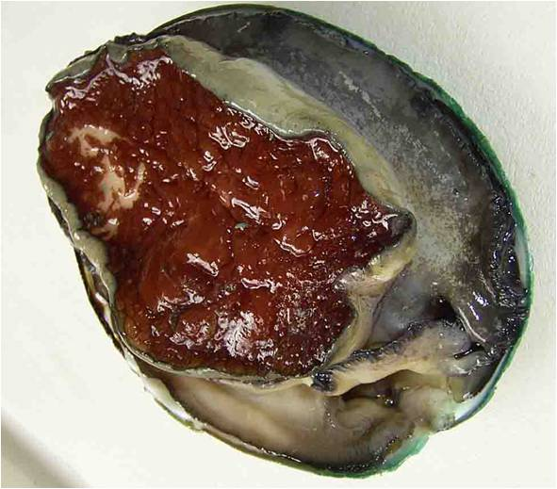

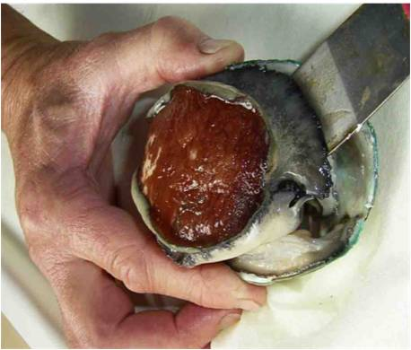

Pedal ganglion

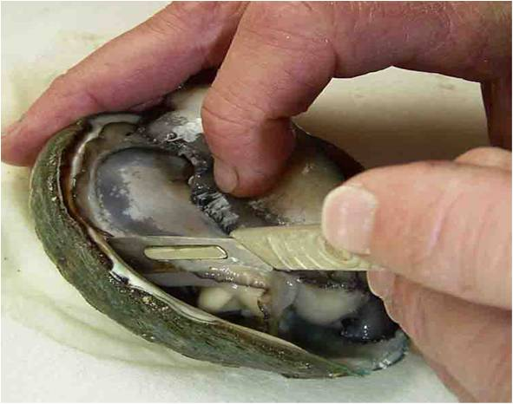

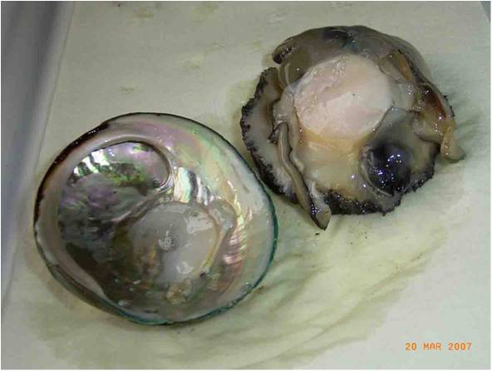

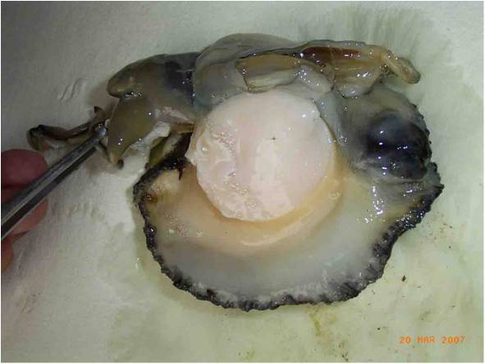

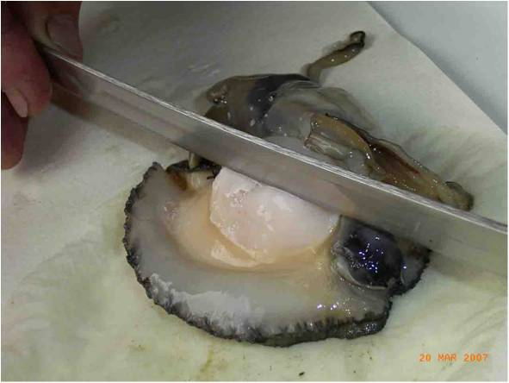

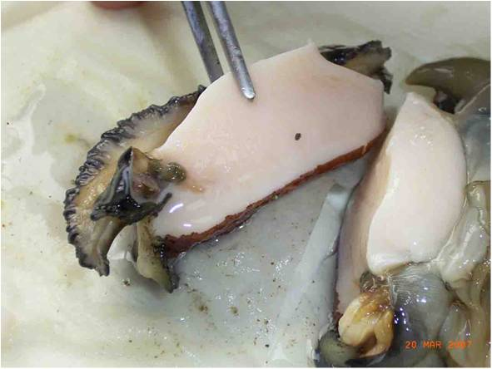

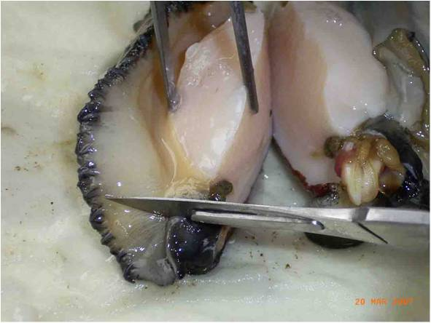

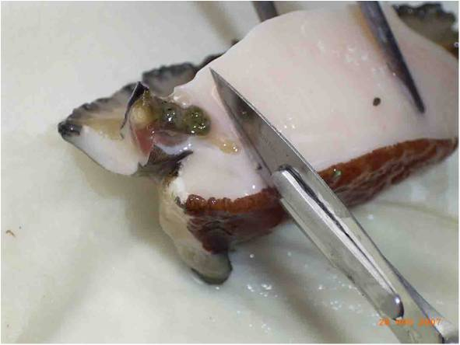

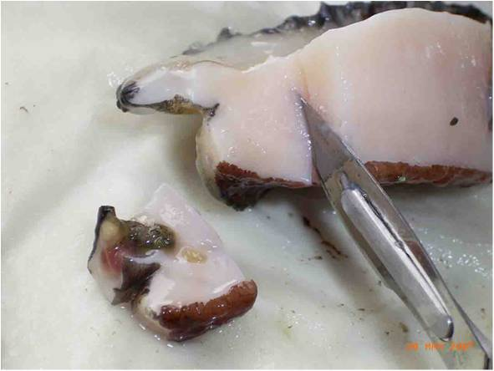

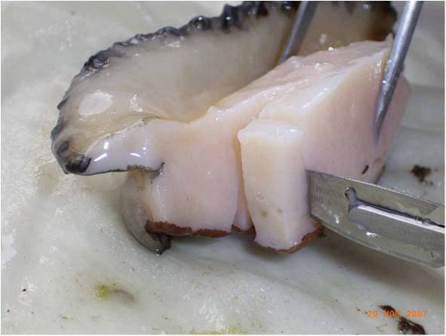

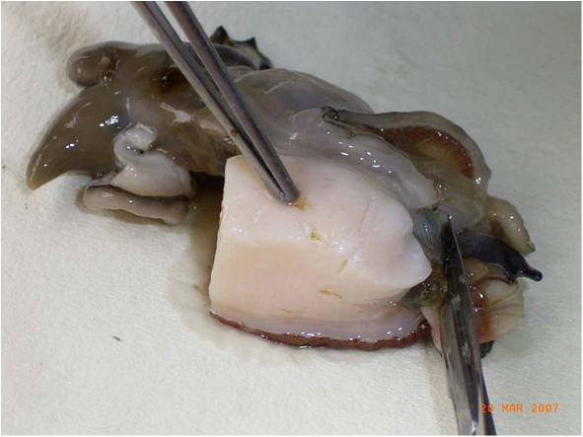

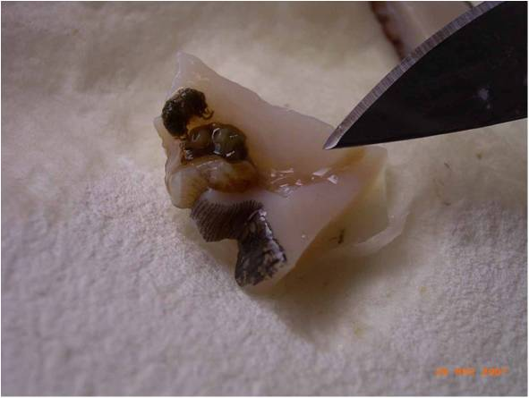

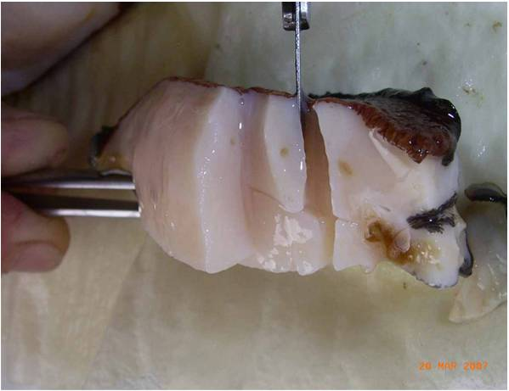

# Glossary

|  |  |
| --- | --- |
| Animal Health Committee | A committee whose members are the Australian and state and territory chief veterinary officers, the Director of the CSIRO Australian Animal Health Laboratory, and the Director of Environmental Biosecurity in the Australian Government Department of Sustainability, Environment, Water, Population and Communities. The committee provides advice to the Standing Council on Primary Industries on animal health matters, focusing on technical issues and regulatory policy (formerly called the Veterinary Committee).  *See also* Standing Council on Primary Industries |
| AQUAVETPLAN | *A*ustralian A*qua*tic *Ve*terinary Emergency *Plan*. A series of manuals that outlines Australia’s approach to national disease preparedness, and proposes the technical response and control strategies to be activated in a national aquatic animal disease emergency. The manuals provide guidance based on sound analysis that links policy, strategies, implementation, coordination and emergency management plans. |
| Australian Chief Veterinary Officer | The nominated senior veterinarian in the Australian Government Department of Agriculture officer who manages international animal health commitments and the Australian Government’s response to an animal disease outbreak.  *See also* Chief Veterinary Officer |
| AUSVETPLAN | *Aus*tralian *Ve*terinary Emergency *Plan*. A series of technical response plans that describes the proposed Australian approach to an emergency animal disease incident. The documents provide guidance based on sound analysis that links policy, strategies, implementation, coordination and emergency-management plans. |
| Chief veterinary officer (CVO) | The senior veterinarian of the animal health authority in each jurisdiction (national, state or territory) who has responsibility for animal disease control in that jurisdiction.  *See also* Australian Chief Veterinary Officer |
| Compartment | One or more aquaculture establishments under a common biosecurity management system containing an aquatic animal population with a distinct health status with respect to a specific disease or diseases for which required surveillance and control measures are applied and basic biosecurity conditions are met for the purpose of international trade. Such compartments must be clearly documented by the Competent Authority(ies) (OIE 2012a). |
| Competent authority | The veterinary authority or other governmental authority of a member of the OIE having the responsibility and competence for ensuring or supervising the implementation of aquatic animal health and welfare measures, international health certification and other standards and recommendations in the Aquatic Code in the whole territory (OIE 2012a). |
| Control | Reduction in morbidity and mortality from disease by measures intended to interfere with the unrestrained occurrence of disease. |
| Control area | A buffer between the restricted area and areas free from disease. Restrictions on this area will reduce the likelihood of the disease spreading further afield. As the extent of the outbreak is confirmed, the control area may decrease or increase in size. The shape of the area may be modified according to circumstances (e.g. water flows, catchment limits). In most cases, permits will be required to move animals and specified product out of the control area into the free area. |
| Dangerous contact premises or area | A premises that may or may not contain a susceptible animal(s), including those not showing clinical signs, but that, following a risk assessment, is considered highly likely to contain an infected animal(s) or contaminated animal products, wastes or things, which present an unacceptable risk to the response if the risk is not addressed. |
| Declared area | A defined tract of land or water that is subjected to disease control restrictions under emergency animal disease legislation. Types of declared areas include restricted area, control area, infected premises, dangerous contact premises and suspect premises. |
| Decontamination | Includes all stages of cleaning and disinfection to remove contamination. |
| Disease agent | A general term for a transmissible organism that causes an infectious disease. |
| Disinfectant | A chemical used to destroy disease agents outside a living animal. |
| Disinfection | The application, after thorough cleansing, of procedures intended to destroy the infectious or parasitic agents of animal diseases, including zoonoses; applies to premises, vehicles and different objects that may have been directly or indirectly contaminated |
| Disposal | Sanitary removal of aquatic animal carcasses, aquatic animal products, materials and wastes by burial, burning or some other process to prevent the spread of disease. |
| Emergency animal disease | A disease that is (a) exotic to Australia or (b) a variant of an endemic disease or (c) a serious infectious disease of unknown or uncertain cause or (d) a severe outbreak of a known endemic disease, and that is considered to be of national significance with serious social and/or trade implications.  *See also* Endemic animal disease, Exotic animal disease |
| Endemic animal disease | A disease affecting animals (which may include humans) that is known to occur in Australia.  *See also* Emergency animal disease, Exotic animal disease |
| Enterprise | *See* Risk enterprise |
| Epidemiological investigation | An investigation to identify and qualify the risk factors associated with the disease. |
| Eradication | Elimination of a disease from a specified area. |
| Exotic animal disease | A disease affecting animals (which may include humans) that does not normally occur in Australia.  *See also* Emergency animal disease, Endemic animal disease |
| Fish | Any aquatic animal within the finfish, mollusc and crustacean groups. |
| Fomite | Any inanimate object (e.g. boots, clothing, equipment, instruments, vehicles, crates, packaging) that can carry an infectious disease agent and may spread the disease through mechanical transmission. |
| Free area | An area known to be free from the disease agent. |
| Infected premises or area | A defined area (which may be all or part of a property) in which an emergency disease meeting the case definition exists or is believed to exist, or in which the causative agent of that emergency disease exists or is believed to exist. The term ‘infected area’ is more likely to apply to an open system, such as an oceanic lease. |
| Local disease control centre | An emergency operations centre responsible for the command and control of field operations in a defined area. |
| Monitoring | Routine collection of data for assessing the health status of a population.  *See also* Surveillance |
| Movement control | Restrictions placed on the movement of fish, people and fomites to prevent the spread of disease. |
| OIE *Aquatic animal health code* | Sets out standards for the improvement of aquatic animal health and welfare, and veterinary public health worldwide, including through standards for safe international trade in aquatic animals and their products. Published on the internet at www.oie.int/en/international-standard-setting/aquatic-code/access-online. |
| OIE *Manual of diagnostic tests for aquatic animals* | Provides a uniform approach to the detection of the diseases listed in the OIE Aquatic Code, so that the requirements for health certification in connection with disease prevention and control programs and with trade in aquatic animals and aquatic animal products can be met. The current edition is published on the internet at www.oie.int/en/international-standard-setting/aquatic-manual/access-online. |
| Operational procedures | Detailed instructions for carrying out specific disease control activities, such as disposal, destruction, decontamination and valuation. |
| Polymerase chain reaction (PCR) | A method of amplifying targeted nucleic acid sequences to detectable levels that can be used to detect the presence of nucleic acid from a disease agent. |
| Premises or area | A tract of land or sea including its buildings, or a separate farm or facility that is maintained by a single set of services and personnel. A production site which might range from an aquarium to an aquaculture lease in the open ocean. |
| Quarantine | Legal restrictions imposed on a place by the serving of a notice limiting access or egress of specified animals, persons or things. |
| Restricted area | A relatively small declared area (compared with a control area) around an infected premises that is subject to intense surveillance and movement controls. |
| Risk enterprise | A defined livestock or related enterprise that is potentially a major source of infection for many other premises. Includes hatcheries, aquaculture farms, processing plants, packing sheds, fish markets, tourist angling premises, veterinary laboratories, road and rail freight depots, and garbage depots. |
| Standing Council on Primary Industries (SCoPI) | The council of Australian national, state and territory and New Zealand ministers of agriculture that sets Australian and New Zealand agricultural policy (formerly the Primary Industries Ministerial Council).  *See also* Animal Health Committee |
| State or territory disease control headquarters | The emergency operations centre that directs the disease control operations to be undertaken in that state or territory. |
| Sub-Committee on Aquatic Animal Health (SCAAH) | Provides high-level scientific and technical advice to the AHC in supporting policy and program development on national aquatic animal health affecting the capture and recreational fishing industries; aquaculture industries; and the ornamental fish industry. SCAAH comprises representation from the Australian, state and Northern Territory and New Zealand governments, the CSIRO Australian Animal Health Laboratory and Australian universities. Other aquatic animal health experts from both government and non-government agencies—including specialists from academia, industry and the private sector—may also be invited to participate. |
| Surveillance | A systematic program of investigation designed to establish the presence, extent or absence of a disease, or of infection or contamination with the causative organism. It includes the examination of animals for clinical signs, antibodies or the causative organism.  *See also* Monitoring |
| Susceptible animal | An animal that can be infected with a particular disease agent. |
| Tracing | The process of locating animals, persons or other items that may be implicated in the spread of disease, so that appropriate action can be taken. |
| Vector | A living organism that transmits an infection from one host to another. A biological vector is one in which the infectious agent must develop or multiply before becoming infective to a recipient host. A mechanical vector is one that transmits an infectious agent from one host to another but is not essential to the life cycle of the agent.  *See also* Fomite |
| Zoning | The process of defining, implementing and maintaining a disease-free or infected area in accordance with OIE guidelines, based on geopolitical and/or physical boundaries and surveillance, in order to facilitate disease control and/or trade. |

# Abbreviations

|  |  |
| --- | --- |
| AbHV | abalone herpesvirus |
| APVMA | Australian Pesticides and Veterinary Medicines Authority |
| AqCCEAD | Aquatic Consultative Committee on Emergency Animal Diseases |
| AQUAVETPLAN | Australian Aquatic Veterinary Emergency Plan |
| AUSVETPLAN | Australian Veterinary Emergency Plan |
| AVG | abalone viral ganglioneuritis |
| CSIRO-AAHL | Commonwealth Scientific and Industrial Research Organisation Australian Animal Health Laboratory |
| CVO | chief veterinary officer |
| DNA | deoxyribonucleic acid |
| MUP | minor use permit |
| OIE | World Organisation for Animal Health |
| PCR | polymerase chain reaction |
| qPCR | quantitative real-time polymerase chain reaction |

# References

Arzul, I, Renault, T, Thebault, A & Gerard, A 2002, ‘Detection of oyster herpesvirus DNA and proteins in asymptomatic *Crassostrea gigas* adults’, *Virus Research*,vol. 84, pp. 151–60.

Chang, PH, Kuo, ST, Lai, SH, Yang, HS, Ting, YY, Hsu, CL & Chen, HC 2005, ‘Herpes-like virus infection causing mortality of cultured abalone *Haliotis diversicolor supertexta* in Taiwan’, *Diseases of Aquatic Organisms*, vol.65, pp. 23–7.

Chen, MH, Kuo, ST, Renault, T, Friedman, CS & Chang,PH 2012, ‘Development of a polymerase chain reaction for the detection of abalone herpesvirus infection based on the DNA polymerase gene’, *Journal of Virological Methods*, vol. 185, pp. 1–6.

Cheng, W, Li, CH & Chen, JC 2003, ‘Effect of dissolved oxygen on the immune response of *Haliotis diversicolor supertexta* and its susceptibility to *Vibrio parahaemolyticus*’, *Aquaculture*, vol. 232, pp. 103–15.

Cheng, W, Hisao, IS & Chen, JC 2004a, ‘Effect of nitrate on immune response of Taiwan abalone *Haliotis diversicolor supertexta* and its susceptibility to *Vibrio parahaemolyticus*’, *Diseases of Aquatic Organisms*, vol. 60, pp. 157–64.

Cheng, W, Hisao, IS & Chen, JC 2004b, ‘Effect of ammonia on immune response of Taiwan abalone *Haliotis diversicolor supertexta* and its susceptibility to *Vibrio parahaemolyticus*’, *Diseases of Aquatic Organisms*, vol. 17, pp. 193–202.

Cheng, W, Juang, FM & Chen, JC 2004c, ‘The immune response of Taiwan abalone *Haliotis diversicolor supertexta* and its susceptibility to *Vibrio parahaemolyticus* at different salinity levels’, *Fish & Shellfish Immunity*, vol. 16, pp. 295–306.

Corbeil, S, Colling, A, Williams, LM, Wong, FYK, Savin, K, Warner, S, Murdoch, B, Cogan, NOI, Sawbridge, TL, Fegan, M, Mohammad, I, Sunarto, A, Handlinger, J, Pyecroft, S, Douglas, M, Chang, PH & Crane M 2010, ‘Development and validation of a TaqMan® PCR assay for the Australian abalone herpes-like virus’, *Diseases of Aquatic Organisms*, vol. 92, pp. 1–10.

Corbeil, S, McColl, KA, Williams, LM, Mohammad, I, Hyatt, AD, Crameri, SG, Fegan, M & Crane, MS 2012a, ‘Abalone viral ganglioneuritis: establishment and use of an experimental immersion challenge system for the study of abalone herpes virus infections in Australian abalone’, *Virus Research*, vol. 165, pp. 207–13.

Corbeil, S, Williams, LM, Bergfeld, J & Crane, M 2012b, ‘Abalone herpes virus stability in sea water and susceptibility to chemical disinfectants’, *Aquaculture*, vol. 326–329, pp. 20–6.

Cowley, JA, Corbeil, S, Bulach, D, Moody, NJ, Ellard, K, Fegan, M, Savin, K, Warner, S & Crane, MStJ 2012, ‘Complete genome sequences of abalone herpes virus (AbHV) strains from Victoria and Tasmania provide insights into its origins and identify variations useful for epidemiology’, abstract from 8th International Abalone Symposium, 6–11 May 2012, Hobart.

Crane, M, Lancaster, M, Corbeil, S & McColl, K 2006, ‘Abalone herpesvirus—results of current research’, Abalone Virus—Scientific Forum, 21 September 2006, Melbourne.

Crane, MStJ, Corbeil, S, Colling, A, Williams, LM, Wong, F, Savin, K, Cogan, N, Fegan, M, Mohammad, I, Sunarto, A, Handlinger, J, Pyecroft, S, Douglas, M, Murdoch, B & Warner, S 2009, ‘Development and validation of a real-time PCR (TaqMan) assay for the detection and identification of abalone herpes-like virus (AbHv)’, *Proceedings of the 4th FRDC Aquatic Animal Health Subprogram Scientific Conference*, 22–24 July 2009, Cairns.

Crane, M, Corbeil, S, Williams, L & Gannon, V 2012, ‘Determining the susceptibility of remnant populations of abalone previously exposed to AVG’, FRDC project 2009/075, Commonwealth Scientific and Industrial Research Organisation Livestock Industries, Geelong.

Donofrio, G, Flammini, CF, Scatozza, F & Cavirani, S 2000, ‘Detection of bovine herpesvirus 4 (BoHV-4) DNA in the cell fraction of milk of dairy cattle with history of BoHV-4 infection’, *Journal of Clinical Microbiology*, vol. 38, pp. 4668–71.

DPIPWE (Tasmanian Department of Primary Industries, Parks, Water and Environment) 2011, ‘2011 abalone viral ganglioneuritis (AVG) outbreak’, DPIPWE, Hobart.

Ellard, K, Pyecroft, S, Handlinger, J & Andrewartha, R 2009, ‘Findings of disease investigations following the recent detection of AVG in Tasmania’, FRDC Aquatic Animal Health Subprogram Conference, Cairns, Queensland.

Gavine, FM, Ingram, BA, Hardy-Smith, P & Doroudi, M 2009, *Biosecurity control measures for abalone viral ganglioneuritis: a code of practice*, prepared as part of FRDC project no. 2006/243.   
www.dpi.vic.gov.au/fisheries/about-fisheries/legislation-and-regulation/fisheries-acts-and-codes/abalone-viral-ganglioneuritis

Handlinger, J 1999, ‘Notes on herpes virus associated larval mortality in the Australian clam *Katelysi scalarina* in Tasmania*’,* in GB Maguire, S Riley, LM Bellchambers, GN Kent, A Paturusi, S Soh, J Handlinger & I Taylor (eds), *Enhancing Tasmanian clam resources: final report for FRDC,* FRDC project 93/232, Manuscript 19, Fisheries Research and Development Corporation, Canberra.

Handlinger, J, Bastianello, S, Callinan, R, Carson, J, Creeper, J, Deveney, M, Forsyth, WM, Freeman, K, Hooper, C, Jones, B, Lancaster, M, Landos, M, Loh, R, Oyay, BS, Phillips, P, Pyecroft, S & Stephens, F 2006, ‘Abalone Aquaculture Subprogram: a national survey of diseases of commercially exploited abalone species to support trade and translocation issues and the development of health surveillance programs’, FRDC project 2002/201, Fisheries Research and Development Corporation, Canberra.

Hardy-Smith, P 2006, *Report on the events surrounding the disease outbreak affecting farmed and wild abalone in Victoria*, confidential report for the Victorian Department of Primary Industries, Panaquatic Health Solutions Pty Ltd.

Hine, PM & Thorne, T 1997, ‘Replication of herpes-like viruses in haemocytes of adult flat oysters *Ostrea angasi*: an ultrastructural study’, *Diseases of Aquatic Organisms*, vol. 29, pp. 189–96.

Hooper, C, Hardy-Smith, P & Handlinger, J 2007a, ‘Ganglioneuritis causing high mortalities in farmed Australian abalone (*Haliotis laevigata* and *Haliotis rubra*)’, *Australian Veterinary Journal*, vol. 85, pp. 188–93.

Hooper, C, Day, R, Slocombe, R, Handlinger, J & Benkendorff, K 2007b, ‘Stress and immune responses in abalone: limitations in current knowledge and investigative methods based on other models’, *Fish & Shellfish Immunology*, vol. 22, pp. 363–79.

Lee, KK, Liu, PC, Chen, YC & Huang, CY 2001, ‘The implication of ambient temperature with the outbreak of vibriosis in cultured small abalone *Haliotis diversicolor supertexta* Lischke’, *Journal of Thermal Biology*, vol. 26, pp. 585–7.

Mazur, K, Curtotti, R, Perks, C, Vieira, S, Pham T & George, D 2010, *Australian fisheries—the global context*, Issues insights 10.3, Australian Bureau of Agricultural and Resource Economics, Canberra.

McColl, K, Corbeil, S, Williams, L, Lancaster, M & Crane, M 2007, ‘Abalone ganglioneuritis—a transmission trial, and time-course study’, *Proceedings of the third national FRDC Aquatic Animal Health Scientific Conference*, 25–27 July 2007, Cairns.

NACA (Network of Aquaculture Centres in Asia–Pacific) & FAO (Food and Agriculture Organization of the United Nations) 2010, *Quarterly Aquatic Animal Disease Report* (Asia and Pacific Region), July–September 2010, NACA, Bangkok, Thailand.

Nakatsugawa, T, Nagai, T, Hiya, K, Nishizawa, T & Muroga, K 1999, ‘A virus isolated from juvenile Japanese black abalone *Nordotis discus discus* affected with amyotrophia’, *Diseases of Aquatic Organisms*, vol. 36, pp. 159–61.

OIE (World Organisation for Animal Health) 2008, *A report of the meeting of the OIE Aquatic Animal Health Standards Commission*, Annex XVII, report of the ad hoc Group on the OIE List of Aquatic Animal Diseases—Mollusc Team, 76 SG/12/CS4 B, 3–7 March 2008, Paris.

OIE (World Organisation for Animal Health) 2012a, *Aquatic animal health code.* OIE, Paris. www.oie.int/international-standard-setting/aquatic-code/access-online

OIE (World Organisation for Animal Health) 2012b, *Manual of diagnostic tests for aquatic animals.* OIE, Paris. www.oie.int/international-standard-setting/aquatic-manual/access-online

Prince, J 2007, *A review of the outbreak of a herpes-like virus in the abalone stocks of western zone Victoria, and the lessons to be learnt,* report for Australian Abalone Council, Biospherics Pty Ltd, South Fremantle. www.vada.com.au/Virus/Reports/Prince%20Review%20of%20Viral%20Outbreak%20Final%20Draft%20March%202007.pdf

Renault, T & Novoa, B 2004, ‘Viruses infecting bivalve molluscs’, *Aquatic Living Resources*, vol.17, pp. 397–409.

Roch, P 1999, ‘Defence mechanisms and disease prevention in farmed marine invertebrates’, *Aquaculture*, vol.172, pp. 125–45.

Savin, K, Cocks, BG, Wong, F, Sawbridge, T, Cogan, N, Savage, D & Warner, S 2010, ‘A neurotrophic herpesvirus infecting the gastropod, abalone, shares ancestry with oyster herpesvirus and a herpesvirus associated with the amphioxus genome’, *Virology Journal*, vol. 7, pp. 308–16.

Song, ZHR, Ji, RX, Yan, SF & Chen, CS 2000, ‘A spherovirus resulted in mass mortality of *Haliotis diversicolor* *aquatilis*’, *Journal of Fisheries of China*, vol. 24, pp. 463–7.

Wang, J, Guo, Z, Feng, J, Liu, G, Xu, L, Chen, B & Pan, J 2004, ‘Virus infection in cultured abalone, *Haliotis diversicolor* Reeve in Guangdong Province, China’, *Journal of Shellfish Research*, vol. 23, pp. 1163–8.

1. www.aqis.gov.au/icon32/asp/homecontent.asp
2. www.agriculture.gov.au/__data/assets/word_doc/0003/346521/reportable-aquatic-diseases.doc
3. The complete series of AQUAVETPLAN documents is available on the internet at www.agriculture.gov.au/animal-plant-health/aquatic/aquavetplan.
4. Inocula can be diluted up to one million times and remain infectious.
5. The primary species of abalone sampled in the survey were greenlip abalone (*Haliotis laevigata*) and blacklip abalone (*H. rubra*). A small number of brownlip abalone (*H. conicopora*), Roe’s abalone (*H. roei*) and donkey ear abalone (*H. asinina*) were also sampled.
6. The radula is a flexible band of sharp, hooked teeth that is used to rasp food, such as algae, off underlying substrate.
7. www.agriculture.gov.au/animal-plant-health/aquatic/resources
8. www.oie.int/index.php?id=171&L=0&htmfile=chapitre_1.1.4.htm
9. www.agriculture.gov.au/__data/assets/pdf_file/0008/617183/decontamination-manual.pdf
10. www.agriculture.gov.au/animal-plant-health/aquatic/aquavetplan/destruction
11. www.agriculture.gov.au/animal-plant-health/aquatic/aquavetplan/disposal
12. www.agriculture.gov.au/__data/assets/pdf_file/0008/617183/decontamination-manual.pdf
13. www.agriculture.gov.au/animal-plant-health/aquatic/aquavetplan/disposal
14. www.agriculture.gov.au/__data/assets/pdf_file/0008/617183/decontamination-manual.pdf
15. www.agriculture.gov.au/animal-plant-health/aquatic/aquavetplan/control-centres
16. www.apvma.gov.au