## No. 15/2025 17 April 2025

# Summary of key issues

* In the week ending 16 April 2025 low-pressure systems and troughs brought rainfall to the west, far north and east of Australia.
  + Rainfall totals were low in many cropping regions, with exceptions in Western Australia where 5-150 millimetres of rainfall were recorded.
  + Little to no rainfall across most eastern cropping regions is likely to contribute to a drawdown in soil moisture and allow for the resumption of the harvest of remaining summer crops.
* Over the coming eight days, wet conditions are expected across parts of western, northern and south-eastern Australia.
  + Across cropping regions rainfall totals of between 5-50 millimetres are expected in Western Australia, while remaining cropping regions are likely to see little to no rainfall. The lack of autumn rainfall across large areas of south-eastern Australia continues to present a downside risk to the timely planting of winter crops particularly in areas with low stored soil moisture.
* Rainfall in March 2025 was variable across the world’s major grain- and oilseed-producing regions, leading to differing crop production outcomes.
  + Global production conditions were generally favourable for rice and maize, but variable for soybeans and wheat.
  + Global production conditions have been slightly more favourable compared to those used to formulate ABARES forecasts of global grain supplies and world prices for 2024–25 in its March 2025 edition of the Agricultural Commodities Report. As a result, global grain and oilseed production are likely to increase slightly compared to those presented in the March forecast, due to slight improvements in global wheat, maize and soybean production.
* Water storage levels in the Murray-Darling Basin (MDB) decreased between 10 April 2025 and 17 April 2025 by 153 gigalitres (GL). Current volume of water held in storage is 11,930 GL, equivalent to 54% of total storage capacity. This is 29 percent or 4,906 GL less than at the same time last year. Water storage data is sourced from the Bureau of Meteorology.
* Allocation prices in the Victorian Murray below the Barmah Choke increased from $193 on 10 April 2025 to $262 on 17 April 2025. Prices are the same in regions above the Barmah choke and below due to the relaxing of constraints for trade between regions, prices are equal in the Murrumbidgee and VIC Murray Below.

## **Climate**

### Rainfall this week

In the week ending 16 April 2025, **low-pressure systems and troughs** brought rainfall to northern, eastern, and western regions of the country. High-pressure systems kept much of the remainder of Australia largely dry.

* The Northern Tropics, including Cape York Peninsula and the far north of the Northern Territory saw rainfall of between 5-300 millimetres of rainfall, while parts of northern Western Australia recorded between 5-100 millimetres.
* Rainfall totals of between 5-150 millimetres were also recorded across coastal areas of southern Queensland and northern New South Wales, as well as southwest Western Australia. In Tasmania, up to 50 millimetres of rainfall was recorded over the period.
* Little to no rainfall was observed across much of the remainder of the country

Cropping regions were largely dry, with the exception of Western Australia:

* Large areas of southern Western Australia received between 5-150 millimetres, with higher rainfall totals in southeast regions.
* Cropping regions in Queensland, New South Wales, Victoria, and South Australia saw little to no rainfall over the period.
* Little to no rainfall across most eastern cropping regions is likely to contribute to a drawdown in soil moisture and allow for the resumption of the harvest of remaining summer crops.

#### Rainfall for the week ending 16 April 2025

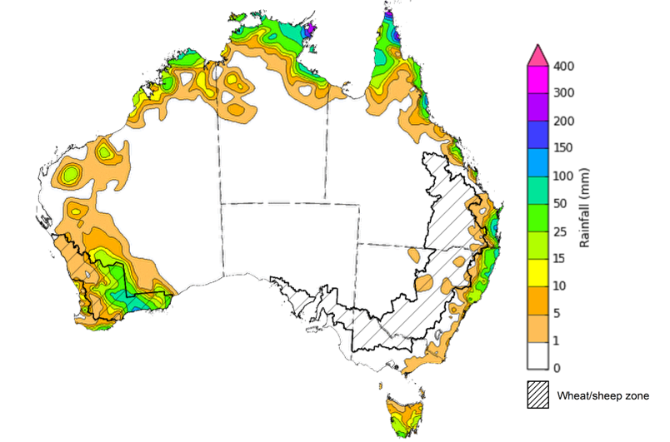

©Commonwealth of Australia 2025, Australian Bureau of Meteorology Issued: 16/4/2025

Note: The rainfall analyses and associated maps utilise data contained in the Bureau of Meteorology climate database, the Australian Data Archive for Meteorology (ADAM). The analyses are initially produced automatically from real-time data with limited [quality control](http://www.bom.gov.au/climate/headers/qc.shtml). They are intended to provide a general overview of rainfall across Australia as quickly as possible after the observations are received. For further information go to <http://www.bom.gov.au/climate/rainfall/>

### Rainfall forecast for the next eight days

Over the 8 days to 24 April 2025, **low-pressure systems and Tropical Cyclone (TC) Errol** are expected to bring rainfall to western, northern and south-eastern Australia.

* Falls of between 10-100 millimetres are likely for much of the northern tropics, including the north of the Northern Territory, northern Queensland, and northern Western Australia.
  + Southern regions of Western Australia are also expected to receive between 10- 100 millimetres of rainfall.
* The eastern and southern margins of New South Wales, Victoria, and South Australia, as well as much of Tasmania are expected to receive falls of between 5-50 millimetres.
* High-pressure systems are expected to keep most central and eastern regions of the country relatively dry, with 1-10 millimetres of rainfall expected.

Rainfall totals across cropping regions over the coming week are forecast to be low in the east, but higher in the west.

* Rainfall totals of between 5-50 millimetres are expected in Western Australia
* In contrast, remaining cropping regions are expected to receive little to no rainfall, will falls of between 5-15 millimetres expected in Victoria, South Australia and parts of southern New South Wales.
* If realised, these low rainfall totals across Queensland and northern New South Wales are likely to support the uninterrupted competing of summer crop of harvest. However, the lack of autumn rainfall continues to present a downside risk to the timely planting of winter crops particularly in areas with low stored soil moisture.

#### Total forecast rainfall for the period 17 April to 24 April 2025

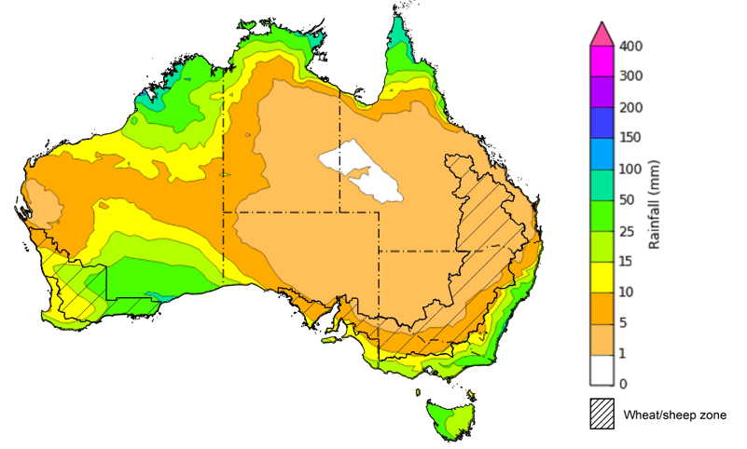

©Commonwealth of Australia 2025, Australian Bureau of Meteorology Issued 17/4/2025

Note: This rainfall forecast is produced from computer models. As the model outputs are not altered by weather forecasters, it is important to check local forecasts and warnings issued by the Bureau of Meteorology.

### March precipitation percentiles and current production conditions

Crop production is affected by long-term trends in average rainfall and temperature, interannual climate variability, shocks during specific growth stages, and extreme weather events. Some crops are more tolerant than others to certain types of stresses, and at each growth stage, different types of stresses affect crop species in different ways.

Precipitation anomalies and outlooks presented below indicate the current and expected future production conditions for major grain and oilseed producing countries (responsible for over 80% of global crop production). This is an important input to assessing the global grain supply outlook.

Rainfall in March 2025 was variable across the world’s major grain- and oilseed-producing regions:

* In the **southern hemisphere**, precipitation was below average across most of Brazil and parts of Argentina. Above average precipitation occurred in parts of southeast Asia, including much of Indonesia, southern Africa and north-eastern Australia. March precipitation was generally average across remaining major southern hemisphere grain- and oilseed-producing regions.
* In the **northern hemisphere**, precipitation was below average across scattered areas of the United States, parts of northern and south-eastern Europe, and across parts of southern China. Precipitation was above average in the north of the United States, central China and parts of central Europe. March precipitation was generally average across remaining major northern hemisphere grain- and oilseed-producing regions.

**Global precipitation percentiles, March 2025**

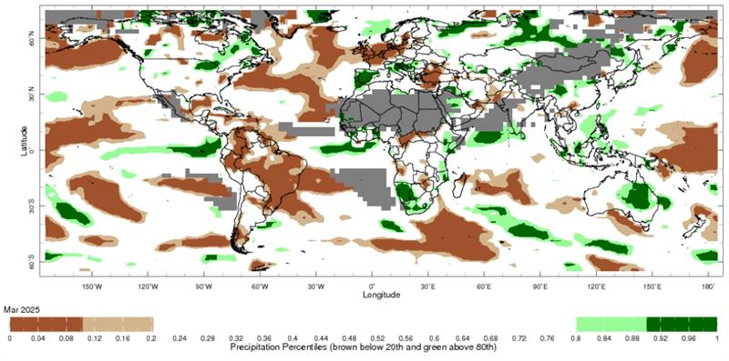

Note: The world precipitation percentiles indicate a ranking of precipitation for March, with the driest (0th percentile) being 0 on the scale and the wettest (100th percentile) being 1 on the scale. Percentiles are based on precipitation estimates from the NOAA Climate Prediction Center’s [Climate Anomaly Monitoring System Outgoing Precipitation Index](https://iridl.ldeo.columbia.edu/maproom/Global/Precipitation/Percentiles.html) dataset. Precipitation estimates for March 2025 are compared with rainfall recorded for that period during the 1981 to 2010 base period.

Source: International Research Institute for Climate and Society

As of 28 March 2025, global production conditions were generally favourable for rice and maize, but variable for soybeans and wheat:

* **Wheat –** Conditions are highly variable in major northern hemisphere growing regions, with winter wheat for harvest in 2025–26 emerging early from dormancy due to warm than condition with dryness negatively impacting yield potential across part of the European Union and the United States, as well as much of Russian Federation, Ukraine and the United Kingdom.
* **Maize –** Conditions are mixed in the southern hemisphere with some downturns in production expected in parts of northern Brazil and Argentina, while sowing is underway in the northern hemisphere under generally favourable conditions.
* **Rice –** Conditions are generally favourable for the harvest and planting of wet and dry season rice across most of Southeast Asia, Indonesia and the Americas.
* **Soybeans –** In the southern hemisphere, harvest is progressing in Brazil under mostly favourable to exceptional conditions. Recent rainfall has improved crop conditions in Argentina.

**Crop conditions, AMIS countries, 28 March 2025**

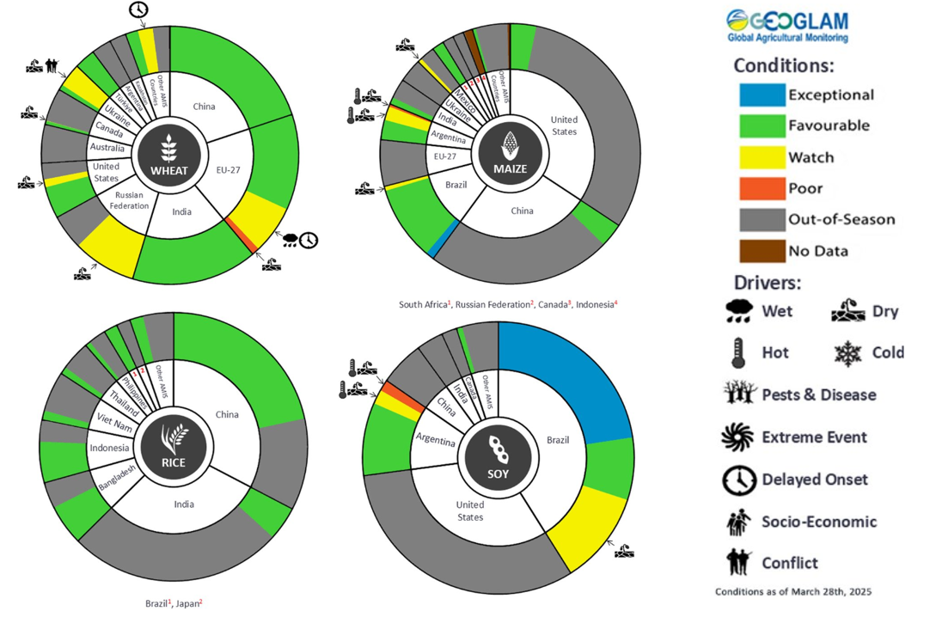

**AMIS** Agricultural Market Information System.

Source: AMIS

The global climate outlook for May 2025 to July 2025 indicates that mixed rainfall conditions are expected for the world’s major grain-producing and oilseed-producing regions. Outlooks and potential production impacts for the major grain and oilseed producing countries are presented in the following table.

**Rainfall outlook and potential impact on the future state of production conditions, May-July 2025**

|  |  |  |
| --- | --- | --- |
| **Region** | **May-July rainfall outlook** | **Potential impact on production** |
| **Argentina** | Average rainfall is more likely across much of Argentina. | Average rainfall is likely to support the development of cotton, corn, sorghum, rice and millet, as well as the planting of wheat. |
| **Black Sea Region** | Below average to average rainfall is expected across much of the Black Sea region. | Below average rainfall in southern parts of Kazakhstan, Ukraine, Turkey and southern Russia may adversely affect grain filling of wheat and canola, as well as cotton, corn and sunflower from July 2025. Average rainfall across remaining areas across the Black Sea region is likely to support the growth of similar crops during this period. |
| **Brazil** | Below average rainfall likely in southern areas, with much of the remainder of Brazil likely to record average to above average rainfall. | Average to above average rainfall across central and northern Brazil may interrupt the harvesting of cotton and corn. Below average rainfall in the south is likely to impede the germination and establishment of wheat in June and July. |
| **Canada** | Generally average rainfall is expected over much of Canada. | Average rainfall is likely to be sufficient to support spring wheat and canola flowering in July, and the planting corn and soybeans. |
| **China** | Above average rainfall is expected throughout much of central and northern China, with below average rainfall expected in the east. | Average to above average rainfall across much China is likely to support the flowering of major crops over the season, including spring wheat, rice, cotton, corn and soybeans. Below average rainfall across parts of eastern China may affect the development of these crops from May 2025. |
| **Europe** | Average to above average rainfall is likely for most of Europe. | Average rainfall is likely to support the planting and establishment of corn, soybeans and sunflower, as well as the development of canola and winter wheat through critical reproductive stages. |
| **South Asia (India)** | Average rainfall is expected across much of central India, with areas of the north and south forecast to receive above average rainfall. | Average rainfall is likely to support the vegetative development of major crops, including corn, rice, millet and sorghum. |
| **Southeast Asia (SEA)** | Average to above average rainfall is likely across much of Indonesia and the Philippines, with below average rainfall expected Malaysia. In the remaining regions, average rainfall if likely. | Average to above average rainfall in SEA may support the flowering of rice and corn in major growing regions. |
| **The United States of America** | Below average rainfall is likely for much of western and central United States, with average rainfall more likely across the east. | Below average rainfall in western and central areas is likely to impact yield potential of winter wheat as it comes out of dormancy, as well as the planting and development of spring wheat, canola, corn, cotton, and rice. |

## **Water**

### Water markets – current week

Water storage levels in the Murray-Darling Basin (MDB) decreased between 10 April 2025 and 17 April 2025 by 153 gigalitres (GL). Current volume of water held in storage is 11,930 GL, equivalent to 54% of total storage capacity. This is 29 percent or 4,906 GL less than at the same time last year. Water storage data is sourced from the Bureau of Meteorology.

Allocation prices in the Victorian Murray below the Barmah Choke increased from $193 on 10 April 2025 to $262 on 17 April 2025. Prices are the same in regions above the Barmah choke and below due to the relaxing of constraints for trade between regions, prices are equal in the Murrumbidgee and VIC Murray Below.

#### Surface water trade activity, Southern Murray–Darling Basin

|  |
| --- |
| The trades shown reflect estimated market activity and do not encompass all register trades. The price is shown for the VIC Murray below the Barmah choke. Historical prices (before 1 July 2019) are ABARES estimates after removing outliers from BOM water register data. Prices after 1 July 2019 and prior to the 30 October 2019 reflect recorded transaction prices as sourced from Ruralco. Prices after the 30 October 2019 are sourced from Waterflow. Data for volume traded is sourced from the BOM water register. Only the price data shown is current on 17 October 2024. |

To access the full, interactive, weekly water dashboard, which contains the latest and historical water storage, water market and water allocation information, please visit <https://www.agriculture.gov.au/abares/products/weekly_update/weekly-update-170425>

## **Commodities**

|  |  |  |  |  |  |  |  |  |
| --- | --- | --- | --- | --- | --- | --- | --- | --- |
| **Indicator** | **Week average** | **Unit** | **Latest Price** | **Previous Week** | **Weekly change** | | **Price 12 months ago** | **Annual change** |
| **Selected world indicator prices** |  |  |  |  |  |  | |  |
| AUD/USD Exchange rate | 16-Apr | A$/US$ | 0.63 | 0.61 | 4% | 0.65 | | -3% |
| Wheat – US no. 2 hard red winter wheat, FOB Gulf | 16-Apr | US$/t | 250 | 253 | -1% | 272 | | -8% |
| Corn – US no. 2 yellow corn, FOB Gulf | 16-Apr | US$/t | 221 | 218 | 1% | 191 | | 16% |
| Canola – Rapeseed, Canada, FOB Vancouver | 16-Apr | US$/t | 522 | 503 | 4% | 502 | | 4% |
| Cotton – Cotlook A Index | 16-Apr | USc/lb | 77 | 78 | 0% | 90 | | -15% |
| Sugar – Intercontinental Exchange, nearby futures, no.11 contract | 16-Apr | USc/lb | 18 | 18 | -2% | 20 | | -13% |
| Wool – Eastern Market Indicator | 16-Apr | Ac/kg clean | 1,273 | 1,262 | 1% | 1,157 | | 10% |
| Wool – Western Market Indicator | 16-Apr | Ac/kg clean | 1,373 | 1,425 | -4% | 1,291 | | 6% |
| **Selected Australian grain export prices** |  |  |  |  |  |  | |  |
| Australian Premium White (APW) Wheat, FOB Port Adelaide, SA | 16-Apr | A$/t | 399 | 407 | -2% | 391 | | 2% |
| Australian Standard White (ASW) Wheat, FOB Port Adelaide, SA | 16-Apr | A$/t | 394 | 399 | -1% | 371 | | 6% |
| Feed Barley – FOB Port Adelaide, SA | 16-Apr | A$/t | 372 | 376 | -1% | 360 | | 3% |
| Canola – FOB Kwinana, WA | 16-Apr | A$/t | 790 | 794 | -1% | 692 | | 14% |
| Grain Sorghum – FOB Brisbane, QLD | 16-Apr | A$/t | 441 | 444 | -1% | 451 | | -2% |
| **Selected domestic livestock indicator prices** |  |  |  |  |  |  | |  |
| Beef – Eastern Young Cattle Indicator | 16-Apr | Ac/kg cwt | 700 | 704 | -1% | 603 | | 16% |
| Mutton – Mutton indicator (18–24 kg fat score 2–3), VIC | 16-Apr | Ac/kg cwt | 447 | 517 | -14% | 256 | | 75% |
| Lamb – National Trade Lamb Indicator | 16-Apr | Ac/kg cwt | 808 | 809 | 0% | 642 | | 26% |
| Pig – Eastern Seaboard (60.1–75 kg), NSW buyer price | 26-Mar | Ac/kg cwt | 448 | 453 | -1% | 418 | | 7% |
| Live cattle – Light steers to Indonesia | 16-Apr | Ac/kg lwt | 360 | 360 | 0% | 350 | | 3% |
| **Global Dairy Trade (GDT) weighted average prices** |  |  |  |  |  |  | |  |
| Dairy – Whole milk powder | 16-Apr | US$/t | 4,171 | 4,062 | 3% | 3,258 | | 28% |
| Dairy – Skim milk powder | 16-Apr | US$/t | 2,795 | 2,876 | -3% | 2,546 | | 10% |
| Dairy – Cheddar cheese | 16-Apr | US$/t | 4,923 | 5,018 | -2% | 4,157 | | 18% |
| Dairy – Anhydrous milk fat | 16-Apr | US$/t | 6,838 | 6,705 | 2% | 6,998 | | -2% |
|  | | | | | | | | |

### Selected world indicator prices

### 3.2 Selected domestic crop indicator prices

### Selected domestic livestock indicator prices

### Global Dairy Trade (GDT) weighted average prices

1. A group of graphs with numbers and lines

   AI-generated content may be incorrect.

### Selected fruit and vegetable prices

Due to technical issues updated fruit and vegetable price data is not available this week, data in the charts below is current as at 10 April 2025

### 3.6 Selected domestic fodder indicator prices

## **4. Data attribution**

### Climate

* Bureau of Meteorology
* Weekly rainfall totals: www.bom.gov.au/climate/maps/rainfall/
* Monthly and last 3-month rainfall percentiles: [www.bom.gov.au/water/landscape/](http://www.bom.gov.au/water/landscape/)
* Temperature anomalies: [www.bom.gov.au/jsp/awap/temp/index.jsp](http://www.bom.gov.au/jsp/awap/temp/index.jsp)
* Rainfall forecast: [www.bom.gov.au/jsp/watl/rainfall/pme.jsp](http://www.bom.gov.au/jsp/watl/rainfall/pme.jsp)
* Seasonal outlook: [www.bom.gov.au/climate/outlooks/#/overview/summary/](http://www.bom.gov.au/climate/outlooks/#/overview/summary/)
* Climate drivers: <http://www.bom.gov.au/climate/enso/>
* Soil moisture: [www.bom.gov.au/water/landscape/](http://www.bom.gov.au/water/landscape/)
* Other
* Pasture growth: [www.longpaddock.qld.gov.au/aussiegrass/](http://www.longpaddock.qld.gov.au/aussiegrass/)
* 3-month global outlooks: [Environment and Climate Change Canada](https://weather.gc.ca/saisons/image_e.html?img=s234pfe1p_cal&bc=prob), [NOAA Climate Prediction Center](https://www.cpc.ncep.noaa.gov/products/predictions/long_range/seasonal.php?lead=2), [EUROBRISA CPTEC/INPE](http://eurobrisa.cptec.inpe.br/), European Centre for Medium-Range Weather Forecasts, [Hydrometcenter of Russia](https://meteoinfo.ru/en/climate/seasonal-forecasts), [National Climate Center Climate System Diagnosis and Prediction Room (NCC)](https://cmdp.ncc-cma.net/pred/cs2gen.php?pred_elem=RAINP#pred_seasonal), [International Research Institute for Climate and Society](https://iri.columbia.edu/our-expertise/climate/forecasts/seasonal-climate-forecasts/)
* Global production: <https://ipad.fas.usda.gov/ogamaps/cropmapsandcalendars.aspx>
* Autumn break: Pook et al., 2009, <https://rmets-onlinelibrary-wiley-com.virtual.anu.edu.au/doi/epdf/10.1002/joc.1833>

### Water

Prices

* Waterflow: <https://www.waterflow.io/>
* Ruralco: <https://www.ruralcowater.com.au/>
* Bureau of Meteorology:
* Allocation trade: <http://www.bom.gov.au/water/dashboards/#/water-markets/mdb/at>
* Storage volumes: <http://www.bom.gov.au/water/dashboards/#/water-storages/summary/drainage>
* Trade constraints:
* Water NSW: <https://www.waternsw.com.au/customer-service/ordering-trading-and-pricing/trading/murrumbidgee>
* Victorian Water Register: <https://www.waterregister.vic.gov.au/TradingRules2019/>

### Commodities

* Fruit and vegetables
* Datafresh: [www.freshstate.com.au](http://www.freshstate.com.au)
* Pigs
* Australian Pork Limited: [www.australianpork.com.au](http://www.australianpork.com.au)
* Dairy
* Global Dairy Trade: [www.globaldairytrade.info/en/product-results/](http://www.globaldairytrade.info/en/product-results/)
* World wheat, canola
* International Grains Council
* World coarse grains
* United States Department of Agriculture
* World cotton
* Cotlook: [www.cotlook.com/](http://www.cotlook.com/)
* World sugar
* New York Stock Exchange - Intercontinental Exchange
* Wool
* Australian Wool Exchange: [www.awex.com.au/](http://www.awex.com.au/)
* Domestic wheat, barley, sorghum, canola and fodder
* Jumbuk Consulting Pty Ltd: http://www.jumbukag.com.au/
* Cattle, beef, mutton, lamb, goat and live export
* Meat and Livestock Australia: [www.mla.com.au/Prices-and-market](http://www.mla.com.au/Prices-and-market)

© Commonwealth of Australia 2025

### Ownership of intellectual property rights

Unless otherwise noted, copyright (and any other intellectual property rights, if any) in this publication is owned by the Commonwealth of Australia (referred to as the Commonwealth).

### Creative Commons licence

All material in this publication is licensed under a [Creative Commons Attribution 4.0 International Licence](https://creativecommons.org/licenses/by/4.0/legalcode) except content supplied by third parties, logos and the Commonwealth Coat of Arms.

Inquiries about the licence and any use of this document should be emailed to [copyright@awe.gov.au](mailto:copyright@awe.gov.au).

https://www.agriculture.gov.au/sites/default/files/images/creative-commons-logo-small.png

### Cataloguing data

This publication (and any material sourced from it) should be attributed as:

ABARES 2025, Weekly Australian Climate, Water and Agricultural Update, Australian Bureau of Agricultural and Resource Economics and Sciences, Canberra, 17 April 2025. CC BY 4.0 DOI: <https://doi.org/10.25814/5f3e04e7d2503>

ISSN **2652-7561**

This publication is available at https://www.agriculture.gov.au/abares/products/weekly_update

Department of Agriculture, Fisheries and Forestry

GPO Box 858 Canberra ACT 2601

Telephone 1800 900 090

Web [agriculture.gov.au/abares](http://awe.gov.au/abares)

### Disclaimer

The Australian Government acting through the Department of Agriculture, Fisheries and Forestry, represented by the Australian Bureau of Agricultural and Resource Economics and Sciences, has exercised due care and skill in preparing and compiling the information and data in this publication. Notwithstanding, the Department of Agriculture, Fisheries and Forestry, ABARES, its employees and advisers disclaim all liability, including liability for negligence and for any loss, damage, injury, expense or cost incurred by any person as a result of accessing, using or relying on any of the information or data in this publication to the maximum extent permitted by law.

### Statement of Professional Independence

The views and analysis presented in ABARES publications, including this one, reflect ABARES professionally independent findings, based on scientific and economic concepts, principles, information and data. These views, analysis and findings may not reflect or be consistent with the views or positions of the Australian Government, or of organisations or groups who have commissioned ABARES reports or analysis. More information on [professional independence](https://www.agriculture.gov.au/abares/about/research-and-analysis#professional-independence) is provided on the ABARES website.

### Acknowledgements

This report was prepared by Holly Beale and Matthew Miller.