## No. 13/2025 3 April 2025

# Summary of key issues

* In the week ending 2 April 2025 monsoon lows and low-pressure systems brought intense rainfall to the north and east of Australia.
  + High rainfall continued in much of northern and central Australia, including Queensland (10 - 400 millimetres), the Northern Territory and northern Western Australia (5-200 millimetres), and northern South Australia (5-50 millimetres).
  + Across cropping regions rainfall totals were high in the east – in Queensland, rainfall totals of 50-200 millimetres were recorded, with higher rainfall totals in the south. Meanwhile, northern New South Wales saw between 50-300 millimetres of rainfall.
  + In summer cropping regions, rainfall totals were generally high. This is expected to see an improvement in stored soil moisture but is likely to lead to some crop losses, quality downgrades and lengthy delays to the harvesting of unharvested crops.
* Over the coming eight days, wet conditions are expected across the north, south and east of the country.
  + Rainfall totals of between 10-50 millimetres are expected in cropping regions in Western Australia, while northern Queensland is likely to see 10-100 millimetres over the period.
  + In cropping regions of South Australia, Victoria, New South Wales, and southern Queensland, little to no rainfall is expected. In summer cropping regions the low rainfall is likely to see a drying down of saturated soils and support the resumption of harvesting of summer crop and planting of winter crops in coming weeks.
* Most of Australia received average to well above average rainfall over March 2025, with below average rainfall across parts of southern, western and northern Australia.
* Pasture growth for the three months to March 2025 has been mixed across Australia. Above average rainfall totals resulted in average to extremely high pasture growth across much of northern and eastern Australia. However, scattered areas of below average to extremely low pasture growth were also recorded across parts of eastern, northern and central Australia.
* Soil moisture models indicate low soil moisture levels in much of southern Australia, with above average soil moisture modelled in Queensland, eastern New South Wales and Victoria, and large parts of Western Australia.
* Water storage levels in the Murray-Darling Basin (MDB) decreased between 27 March 2025 and 3 April 2025 by 140 gigalitres (GL). Current volume of water held in storage is 12,147 GL, equivalent to 54% of total storage capacity. This is 28 percent or 4,803 GL less than at the same time last year. Water storage data is sourced from the Bureau of Meteorology.
* Allocation prices in the Victorian Murray below the Barmah Choke decreased from $196 on 27 March 2025 to $190 on 3 April 2025. Prices are lower in regions above the Barmah choke due to the binding of the Barmah choke trade constraint.

## **Climate**

### Rainfall this week

In the week ending 2 April 2025, **monsoon lows brought** intense rainfall to northern and central regions of the country, while **low-pressure systems** brought rainfall to the east. High-pressure systems kept much of the remainder of Australia largely dry.

* Elevated rainfall totals continued in much of the northern and central Australia, including Queensland (10-400 millimetres), the Northern Territory and northern Western Australia (5- 200 millimetres), and northern South Australia (5-50 millimetres).
  + While these falls have led to extensive flooding and losses of livestock and farm infrastructure, they are also likely to boost pasture growth, soil moisture and on farm water storage over the months ahead.
* Rainfall totals of between 5-300 millimetres were recorded across New South Wales and eastern Victoria, with parts of southern Western Australia recording falls of between 5-25 millimetres over the period.
* Little to no rainfall was observed in remaining southern and western areas, including southern South Australia, western Victoria, Tasmania, and remaining areas in Western Australia.

Rainfall totals were generally low across western and southern cropping regions, but higher in the east.

* In Queensland, rainfall totals of 50-200 millimetres were recorded, with higher rainfall totals in the south, while northern New South Wales saw between 50-300 millimetres of rainfall. This is expected to see an improvement in stored soil moisture but is likely to lead to some crop losses, quality downgrades and lengthy delays to the harvesting of unharvested summer crops.
* Meanwhile, parts of Western Australia received 0-25 millimetres of rainfall, while southern New South Wales received between 5-25 millimetres of rainfall. South Australia and western Victoria saw little to no rainfall over the period.

#### Rainfall for the week ending 2 April 2025

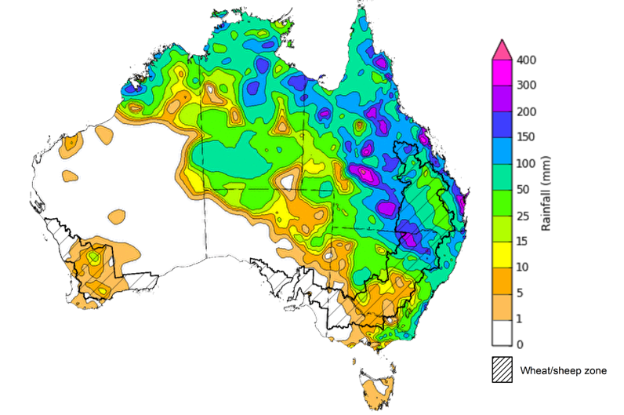

©Commonwealth of Australia 2025, Australian Bureau of Meteorology Issued: 2/4/2025

Note: The rainfall analyses and associated maps utilise data contained in the Bureau of Meteorology climate database, the Australian Data Archive for Meteorology (ADAM). The analyses are initially produced automatically from real-time data with limited [quality control](http://www.bom.gov.au/climate/headers/qc.shtml). They are intended to provide a general overview of rainfall across Australia as quickly as possible after the observations are received. For further information go to <http://www.bom.gov.au/climate/rainfall/>

### Rainfall forecast for the next eight days

Over the 8 days to 10 April 2025, **low-pressure systems** are expected to bring rainfall to parts of the north, south and east of the country.

* Falls of between 10-100 millimetres are likely for much of northern tropics, including the north of the Northern Territory and northern Queensland, with northern Western Australia expected to see between 10-50 millimetres.
* Southern regions of Western Australia are expected to receive 15-50 millimetres, while Tasmania is likely to receive 10-100 millimetres.
* Coastal regions of southeast Queensland, northern New South Wales, and southern Victoria are forecast to receive 10-25 millimetres of rainfall.
* High-pressure systems are expected to keep central and remaining southern regions largely dry.

Rainfall totals across cropping regions over the coming week are forecast to be highly variable.

* Rainfall totals of between 10-50 millimetres are expected in Western Australia, while northern Queensland is likely to see 10-100 millimetres over the period.
* In contrast, cropping regions in southern Queensland, New South Wales, Victoria, and South Australia are expected to receive little to no rainfall.
* If realised, these low rainfall totals across Queensland and northern New South Wales are likely to support the drying down of saturated soils and support the resumption of harvesting of summer crop and planting of winter crops in coming weeks.

#### Total forecast rainfall for the period 3 April to 10 April 2025

©Commonwealth of Australia 2025, Australian Bureau of Meteorology Issued 3/4/2025

Note: This rainfall forecast is produced from computer models. As the model outputs are not altered by weather forecasters, it is important to check local forecasts and warnings issued by the Bureau of Meteorology.

### Monthly rainfall

Rainfall during March 2025 was high across large areas of the northern, eastern and central Australia, while parts of southern and western Australia saw below average rainfall totals.

* Rainfall was **well** **below average** to **below average** across parts of western and southern Australia, including large areas of Tasmania, southern South Australia, western Victoria, as well as coastal and central parts of Western Australia.
* **Above average** to **extremely high** rainfall was recorded across much of Queensland, as well as parts of northern New South Wales and South Australia, eastern Northern Territory, southern and far-northern Western Australia and eastern Victoria.
* The remainder of Australia saw generally average March rainfall.

In cropping regions, March rainfall was variable, with generally below average and average rainfall in the southeast and above average rainfall in the northeast and southwest:

* Much of South Australia, northern Western Australia, and Victoria observed well below average to average rainfall.
* In Queensland, New South Wales and the remainder of Western Australia average to extremely high rainfall was experienced in most regions over the period.

**Rainfall percentiles for March 2025**

Note: Rainfall for March 2025 is compared with rainfall recorded for that period during the historical record (1900 to present). For further information, go to <http://www.bom.gov.au/climate/austmaps/about-rain-maps.shtml>

Source: Bureau of Meteorology

### 1.4 Monthly Soil Moisture

In March 2025, modelled **upper layer soil moisture** was generally average to above average across much of the country.

* Large areas of Tasmania, southern South Australia, and parts of Western Australia saw **very much below average to below average upper layer soil moisture.**
* In contrast, much of Queensland and New South Wales, as well as northern South Australia, the Northern Territory and much of Victoria saw **average to very much above upper layer soil moisture.**

At this time of year, upper layer soil moisture is important for late planted summer crops in northern New South Wales and Queensland and for pasture growth across northern Australia since plant germination and establishment utilise this moisture. It is also an important indicator of the ability to access paddocks for the harvesting of summer crops.

Across cropping regions, modelled **upper layer soil moisture** in March was generally average across much of the east and west, while some cropping regions in the south saw below average soil moisture.

* In Western Australia, Victoria, and southern New South Wales upper layer soil moisture was **broadly average**, with scattered areas of above average and below average soil moisture distributed across cropping regions.
* In Queensland and northern New South Wales, upper layer soil moisture was **above average**.
* In South Australia, upper layer soil moisture was **below average to average**.

**Average to above average upper layer soil moisture** in New South Wales and Queensland is likely to have **led to some disruption to the harvesting of summer crops for northern cropping regions**.

**Modelled upper layer soil moisture for March 2025**

Note: This map shows the levels of modelled upper layer soil moisture (0 to 10 centimetres) during March 2025. This map shows how modelled soil conditions during March 2025 compare with February conditions modelled over the reference period (1911 to 2016). Dark blue areas on the maps were much wetter in March 2025 than during the reference period. The bulk of plant roots occur in the top 20 centimetres of the soil profile. Soil moisture in the upper layer of the soil profile is therefore useful indicator of the availability of water, particularly for germinating seed.

Source: Bureau of Meteorology (<https://awo.bom.gov.au/about/overview>)

Across much of Australia, modelled **lower layer soil moisture** in March 2025 was average to above average, with areas of below average lower layer soil moisture across the country.

* Large areas of the north of the Northern Territory, southern South Australia, Victoria, Tasmania, and southern and west Western Australia were modelled as having **very much below average soil moisture.**
* By contrast, much of western Queensland, eastern and western New South Wales, eastern Victoria, and central Australia were modelled as having **above average to very much above average soil moisture over the period.**

At this time of year increased levels of lower layer soil moisture will be important to support late planted summer crops and pasture growth during a peak growth period.

Across cropping regions, modelled **lower layer soil moisture** was generally average in the east with areas of extremely low moisture modelled in the south.

* Much of Queensland, New South Wales and southern Western Australia saw **average modelled soil moisture.** In contrast, South Australia, Victoria, and parts of northern Western Australia saw **below average soil moisture for this time of year,** whileparts of northern Queensland and southwest Western Australia were modelled as having above average soil moisture**.**

**Average lower layer soil moisture** is likely to **provide a reserve of plant-available water for summer crops later in the growing season**. Lower-layer soil moisture plays a pivotal role in sustaining the growth of winter crops and pasture during their critical development stages. Large areas of South Australia and Victoria continue to show deficient levels of soil moisture which may impact the establishment of forthcoming winter crops particularly given an increased chance below the median rainfall outlook for the next three months.

**Modelled lower layer soil moisture for March 2025**

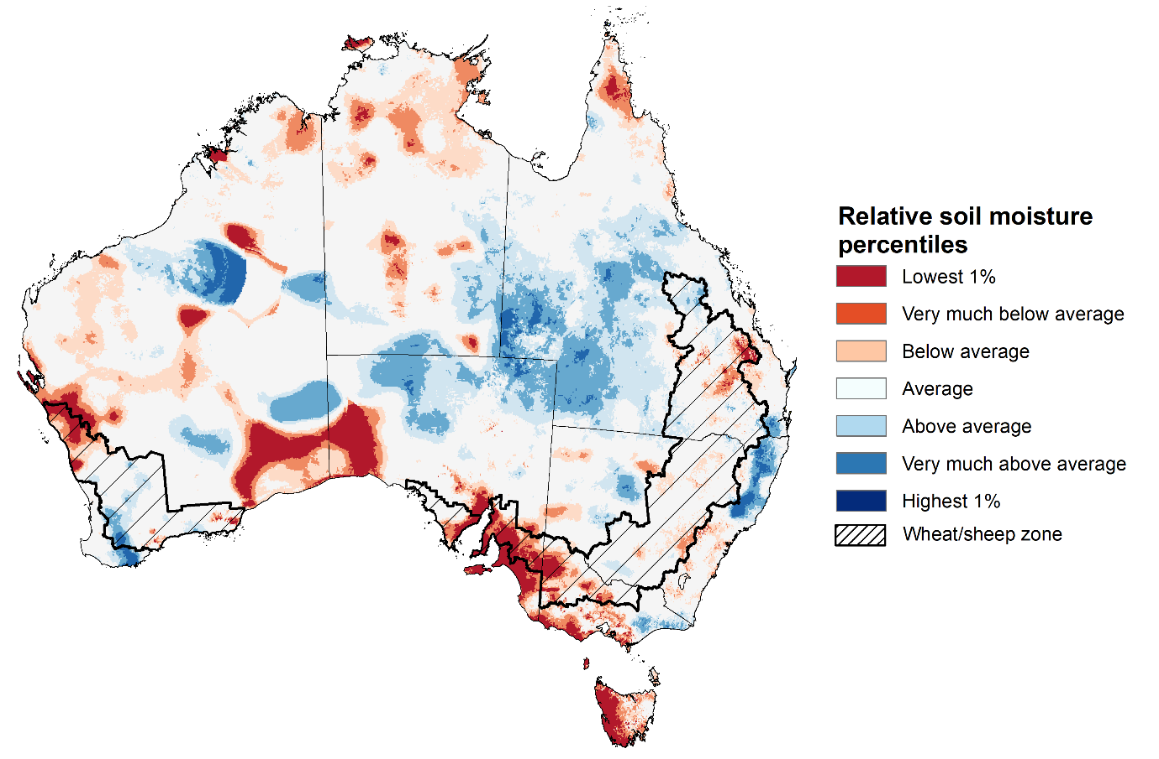

Note: This map shows the levels of modelled lower layer soil moisture (10 to 100 centimetres) during March 2025. This map shows how modelled soil conditions during March 2025 compare with February conditions modelled over the reference period (1911 to 2016). Dark blue areas on the maps were much wetter in March 2025 than during the reference period. The dark red areas were much drier than during the reference period. The bulk of plant roots occur in the top 20 centimetres of the soil profile. The lower layer soil moisture is a larger, deeper store that is slower to respond to rainfall and tends to reflect accumulated rainfall events over longer time periods.

Source: Bureau of Meteorology (<https://awo.bom.gov.au/about/overview>)

### 1.5 Pasture Growth

Pasture growth for the three months to March 2025 has been mixed across much of country, with northern and parts of eastern Australia experiencing improved pasture growth.

* **Average** to **extremely high** pasture growth was modelled across large areas of north-western and eastern Australia, including Western Australia, Queensland, as well as southern New South Wales and eastern Victoria.

This pasture growth is expected to support farmers maintaining stock numbers, provide opportunities to build standing dry matter availability and decrease the reliance on fodder to maintain livestock condition over the summer period.

* **By contrast, large areas of central, western, and south-eastern Australia saw relatively low pasture growth for this time of year.**

This lower pasture growth will likely see graziers in affected regions actively destocking or increased reliance on supplemental feed to maintain current stocking rates and production.

**Relative pasture growth for 3-months ending March 2025 (1 January to 31 March 2025)**

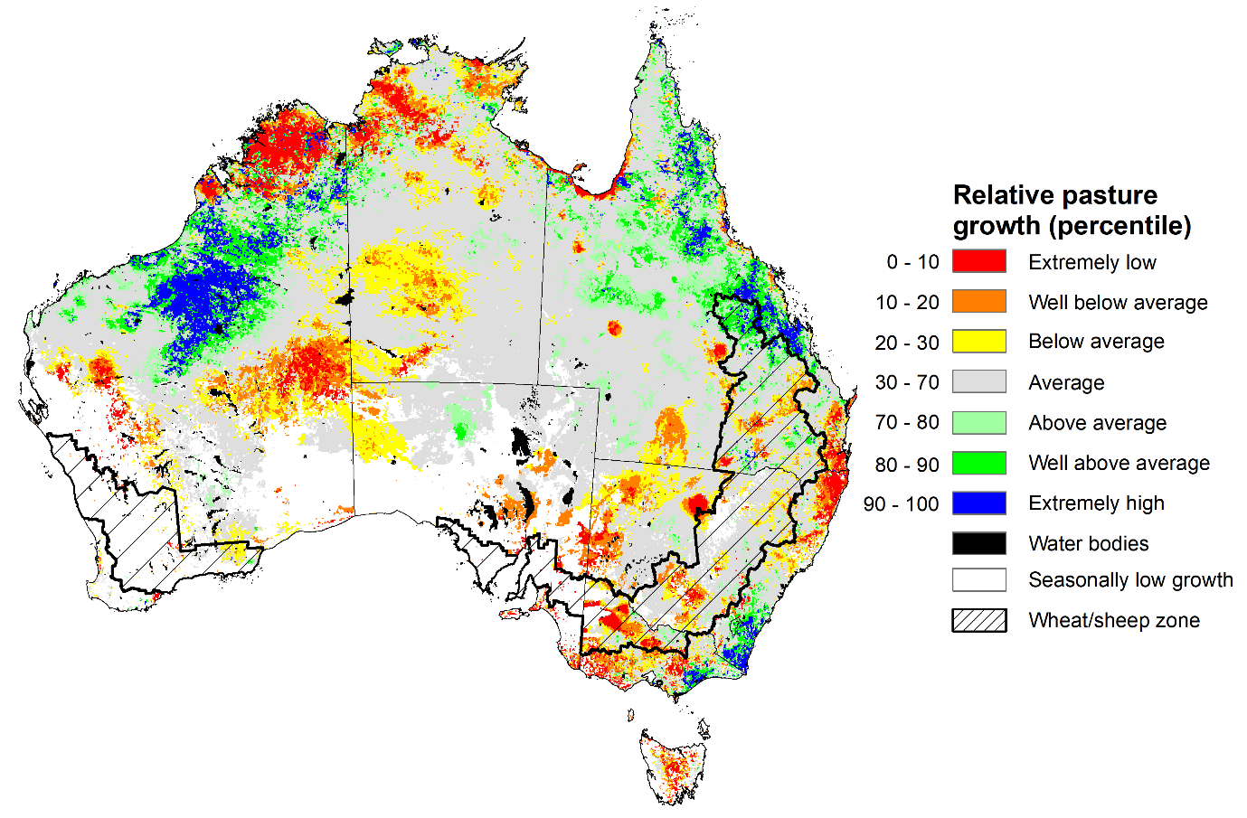

Notes: AussieGRASS pasture growth estimates are relative to the long-term record and shown in percentiles. Percentiles rank data on a scale of zero to 100. This analysis ranks pasture growth for the selected period against average pasture growth for the long-term record (1957 to 2016). Pasture growth is modelled at 5km2 grid cells.  
Source: Department of Environment, Science and Innovation

## **Water**

### Water markets – current week

Water storage levels in the Murray-Darling Basin (MDB) decreased between 27 March 2025 and 03 April 2025 by 140 gigalitres (GL). Current volume of water held in storage is 12,147 GL, equivalent to 54% of total storage capacity. This is 28 percent or 4,803 GL less than at the same time last year. Water storage data is sourced from the Bureau of Meteorology.

Allocation prices in the Victorian Murray below the Barmah Choke decreased from $196 on 27 March to $190 on 03 April. Prices are lower in regions above the Barmah choke due to the binding of the Barmah choke trade constraint.

#### Surface water trade activity, Southern Murray–Darling Basin

|  |
| --- |
| The trades shown reflect estimated market activity and do not encompass all register trades. The price is shown for the VIC Murray below the Barmah choke. Historical prices (before 1 July 2019) are ABARES estimates after removing outliers from BOM water register data. Prices after 1 July 2019 and prior to the 30 October 2019 reflect recorded transaction prices as sourced from Ruralco. Prices after the 30 October 2019 are sourced from Waterflow. Data for volume traded is sourced from the BOM water register. Only the price data shown is current on 17 October 2024. |

To access the full, interactive, weekly water dashboard, which contains the latest and historical water storage, water market and water allocation information, please visit <https://www.agriculture.gov.au/abares/products/weekly_update/weekly-update-0304324>

## **Commodities**

|  |  |  |  |  |  |  |  |  |
| --- | --- | --- | --- | --- | --- | --- | --- | --- |
| **Indicator** | **Week average** | **Unit** | **Latest Price** | **Previous Week** | **Weekly change** | | **Price 12 months ago** | **Annual change** |
| **Selected world indicator prices** |  |  |  |  |  |  | |  |
| AUD/USD Exchange rate | 02-Apr | A$/US$ | 0.63 | 0.63 | 0% | 0.65 | | -3% |
| Wheat – US no. 2 hard red winter wheat, FOB Gulf | 02-Apr | US$/t | 252 | 254 | -1% | 272 | | -7% |
| Corn – US no. 2 yellow corn, FOB Gulf | 02-Apr | US$/t | 209 | 207 | 1% | 191 | | 10% |
| Canola – Rapeseed, Canada, FOB Vancouver | 02-Apr | US$/t | 475 | 456 | 4% | 502 | | -5% |
| Cotton – Cotlook A Index | 02-Apr | USc/lb | 79 | 78 | 1% | 90 | | -12% |
| Sugar – Intercontinental Exchange, nearby futures, no.11 contract | 02-Apr | USc/lb | 19 | 19 | -1% | 20 | | -6% |
| Wool – Eastern Market Indicator | 02-Apr | Ac/kg clean | 1,249 | 1,245 | 0% | 1,157 | | 8% |
| Wool – Western Market Indicator | 02-Apr | Ac/kg clean | 1,414 | 1,400 | 1% | 1,291 | | 9% |
| **Selected Australian grain export prices** |  |  |  |  |  |  | |  |
| Australian Premium White (APW) Wheat, FOB Port Adelaide, SA | 02-Apr | A$/t | 390 | 394 | -1% | 391 | | 0% |
| Australian Standard White (ASW) Wheat, FOB Port Adelaide, SA | 02-Apr | A$/t | 382 | 386 | -1% | 371 | | 3% |
| Feed Barley – FOB Port Adelaide, SA | 02-Apr | A$/t | 359 | 362 | -1% | 360 | | 0% |
| Canola – FOB Kwinana, WA | 02-Apr | A$/t | 785 | 774 | 1% | 692 | | 13% |
| Grain Sorghum – FOB Brisbane, QLD | 02-Apr | A$/t | 431 | 430 | 0% | 451 | | -5% |
| **Selected domestic livestock indicator prices** |  |  |  |  |  |  | |  |
| Beef – Eastern Young Cattle Indicator | 02-Apr | Ac/kg cwt | 675 | 651 | 4% | 603 | | 12% |
| Mutton – Mutton indicator (18–24 kg fat score 2–3), VIC | 02-Apr | Ac/kg cwt | 453 | 417 | 9% | 256 | | 77% |
| Lamb – National Trade Lamb Indicator | 02-Apr | Ac/kg cwt | 781 | 769 | 2% | 642 | | 22% |
| Pig – Eastern Seaboard (60.1–75 kg), NSW buyer price | 19-Mar | Ac/kg cwt | 453 | 452 | 0% | 418 | | 8% |
| Live cattle – Light steers to Indonesia | 02-Apr | Ac/kg lwt | 360 | 365 | -1% | 350 | | 3% |
| **Global Dairy Trade (GDT) weighted average prices** |  |  |  |  |  |  | |  |
| Dairy – Whole milk powder | 02-Apr | US$/t | 4,062 | 4,052 | 0% | 3,258 | | 25% |
| Dairy – Skim milk powder | 02-Apr | US$/t | 2,876 | 2,729 | 5% | 2,546 | | 13% |
| Dairy – Cheddar cheese | 02-Apr | US$/t | 5,018 | 4,976 | 1% | 4,157 | | 21% |
| Dairy – Anhydrous milk fat | 02-Apr | US$/t | 6,705 | 6,561 | 2% | 6,998 | | -4% |
|  | | | | | | | | |

### Selected world indicator prices

### 3.2 Selected domestic crop indicator prices

### Selected domestic livestock indicator prices

### Global Dairy Trade (GDT) weighted average prices

### Selected fruit and vegetable prices

### 3.6 Selected domestic fodder indicator prices

## **4. Data attribution**

### Climate

* Bureau of Meteorology
* Weekly rainfall totals: www.bom.gov.au/climate/maps/rainfall/
* Monthly and last 3-month rainfall percentiles: [www.bom.gov.au/water/landscape/](http://www.bom.gov.au/water/landscape/)
* Temperature anomalies: [www.bom.gov.au/jsp/awap/temp/index.jsp](http://www.bom.gov.au/jsp/awap/temp/index.jsp)
* Rainfall forecast: [www.bom.gov.au/jsp/watl/rainfall/pme.jsp](http://www.bom.gov.au/jsp/watl/rainfall/pme.jsp)
* Seasonal outlook: [www.bom.gov.au/climate/outlooks/#/overview/summary/](http://www.bom.gov.au/climate/outlooks/#/overview/summary/)
* Climate drivers: <http://www.bom.gov.au/climate/enso/>
* Soil moisture: [www.bom.gov.au/water/landscape/](http://www.bom.gov.au/water/landscape/)
* Other
* Pasture growth: [www.longpaddock.qld.gov.au/aussiegrass/](http://www.longpaddock.qld.gov.au/aussiegrass/)
* 3-month global outlooks: [Environment and Climate Change Canada](https://weather.gc.ca/saisons/image_e.html?img=s234pfe1p_cal&bc=prob), [NOAA Climate Prediction Center](https://www.cpc.ncep.noaa.gov/products/predictions/long_range/seasonal.php?lead=2), [EUROBRISA CPTEC/INPE](http://eurobrisa.cptec.inpe.br/), European Centre for Medium-Range Weather Forecasts, [Hydrometcenter of Russia](https://meteoinfo.ru/en/climate/seasonal-forecasts), [National Climate Center Climate System Diagnosis and Prediction Room (NCC)](https://cmdp.ncc-cma.net/pred/cs2gen.php?pred_elem=RAINP#pred_seasonal), [International Research Institute for Climate and Society](https://iri.columbia.edu/our-expertise/climate/forecasts/seasonal-climate-forecasts/)
* Global production: <https://ipad.fas.usda.gov/ogamaps/cropmapsandcalendars.aspx>
* Autumn break: Pook et al., 2009, <https://rmets-onlinelibrary-wiley-com.virtual.anu.edu.au/doi/epdf/10.1002/joc.1833>

### Water

Prices

* Waterflow: <https://www.waterflow.io/>
* Ruralco: <https://www.ruralcowater.com.au/>
* Bureau of Meteorology:
* Allocation trade: <http://www.bom.gov.au/water/dashboards/#/water-markets/mdb/at>
* Storage volumes: <http://www.bom.gov.au/water/dashboards/#/water-storages/summary/drainage>
* Trade constraints:
* Water NSW: <https://www.waternsw.com.au/customer-service/ordering-trading-and-pricing/trading/murrumbidgee>
* Victorian Water Register: <https://www.waterregister.vic.gov.au/TradingRules2019/>

### Commodities

* Fruit and vegetables
* Datafresh: [www.freshstate.com.au](http://www.freshstate.com.au)
* Pigs
* Australian Pork Limited: [www.australianpork.com.au](http://www.australianpork.com.au)
* Dairy
* Global Dairy Trade: [www.globaldairytrade.info/en/product-results/](http://www.globaldairytrade.info/en/product-results/)
* World wheat, canola
* International Grains Council
* World coarse grains
* United States Department of Agriculture
* World cotton
* Cotlook: [www.cotlook.com/](http://www.cotlook.com/)
* World sugar
* New York Stock Exchange - Intercontinental Exchange
* Wool
* Australian Wool Exchange: [www.awex.com.au/](http://www.awex.com.au/)
* Domestic wheat, barley, sorghum, canola and fodder
* Jumbuk Consulting Pty Ltd: http://www.jumbukag.com.au/
* Cattle, beef, mutton, lamb, goat and live export
* Meat and Livestock Australia: [www.mla.com.au/Prices-and-market](http://www.mla.com.au/Prices-and-market)

© Commonwealth of Australia 2025

### Ownership of intellectual property rights

Unless otherwise noted, copyright (and any other intellectual property rights, if any) in this publication is owned by the Commonwealth of Australia (referred to as the Commonwealth).

### Creative Commons licence

All material in this publication is licensed under a [Creative Commons Attribution 4.0 International Licence](https://creativecommons.org/licenses/by/4.0/legalcode) except content supplied by third parties, logos and the Commonwealth Coat of Arms.

Inquiries about the licence and any use of this document should be emailed to [copyright@awe.gov.au](mailto:copyright@awe.gov.au).

https://www.agriculture.gov.au/sites/default/files/images/creative-commons-logo-small.png

### Cataloguing data

This publication (and any material sourced from it) should be attributed as:

ABARES 2025, Weekly Australian Climate, Water and Agricultural Update, Australian Bureau of Agricultural and Resource Economics and Sciences, Canberra, 3 April 2025. CC BY 4.0 DOI: <https://doi.org/10.25814/5f3e04e7d2503>

ISSN **2652-7561**

This publication is available at https://www.agriculture.gov.au/abares/products/weekly_update

Department of Agriculture, Fisheries and Forestry

GPO Box 858 Canberra ACT 2601

Telephone 1800 900 090

Web [agriculture.gov.au/abares](http://awe.gov.au/abares)

### Disclaimer

The Australian Government acting through the Department of Agriculture, Fisheries and Forestry, represented by the Australian Bureau of Agricultural and Resource Economics and Sciences, has exercised due care and skill in preparing and compiling the information and data in this publication. Notwithstanding, the Department of Agriculture, Fisheries and Forestry, ABARES, its employees and advisers disclaim all liability, including liability for negligence and for any loss, damage, injury, expense or cost incurred by any person as a result of accessing, using or relying on any of the information or data in this publication to the maximum extent permitted by law.

### Statement of Professional Independence

The views and analysis presented in ABARES publications, including this one, reflect ABARES professionally independent findings, based on scientific and economic concepts, principles, information and data. These views, analysis and findings may not reflect or be consistent with the views or positions of the Australian Government, or of organisations or groups who have commissioned ABARES reports or analysis. More information on [professional independence](https://www.agriculture.gov.au/abares/about/research-and-analysis#professional-independence) is provided on the ABARES website.

### Acknowledgements

This report was prepared by Holly Beale and Matthew Miller.