## No. 11/2025 20 March 2025

# Summary of key issues

* In the week ending 19 March 2025 monsoon lows and low-pressure systems brought rainfall to the north and south of Australia.
  + Rainfall totals were low in eastern cropping regions, with between 0-5 millimetres in Queensland, New South Wales, Victoria, and South Australia. This is likely to benefit the harvesting of summer crops, but likely to lead to a drawdown in soil moisture in these areas.
  + In Western Australia, 10-100 millimetres of rainfall fell in central and southern areas, with the north-western margins of the cropping region seeing between 0-10 millimetres. These falls are likely to provide a timely boost to soil moisture levels ahead of the planting of winter crops during April.
* Over the coming eight days, significant rainfall totals are expected to be received across the north and east of the country.
  + Rainfall totals of between 10-50 millimetres are forecast for cropping regions in New South Wales and Victoria. These falls are likely to provide a timely boost to soil moisture levels ahead of the planting of winter crops during April.
  + In summer cropping regions across northern New South Wales and Queensland, rainfall totals are expected to be between 5-25 millimetres. If realised, these lower rainfall totals are likely to see a largely uninterrupted harvest but may contribute to further drawdown of soil moisture in some regions.
* Globally, variable rainfall during February has led to mixed crop production prospects.
  + Global production conditions were generally favourable for rice and maize but more variable for wheat and soybeans.
  + Global production conditions have been slightly more favourable compared to those used to formulate ABARES forecasts of global grain supplies and world prices for 2024–25 in its March 2025 edition of the Agricultural Commodities Report. As a result, global grain and oilseed production are likely to increase slightly compared to those presented in the March forecast, due to slight improvements in global wheat and maize production.
* **Water storage levels** in the Murray-Darling Basin (MDB) decreased between 13 March 2025 and 20 March 2025 by 262 gigalitres (GL). Current volume of water held in storage is 12478 GL, equivalent to 56% of total storage capacity. This is 28 percent or 4,823 GL less than at the same time last year. Water storage data is sourced from the Bureau of Meteorology.
* **Allocation prices** in the Victorian Murray below the Barmah Choke decreased from $182 on 06March to $194 on 20 March. Prices are lower in regions above the Barmah choke due to the binding of the Barmah choke trade constraint.

## **Climate**

### Rainfall this week

In the week ending 19 March 2025, **monsoon lows brought** rainfall to the north of the country while **low-pressure systems** brought rainfall to the southeast and southwest**.** High-pressure systems kept much of the remainder of Australia largely dry.

* Parts of the northern tropics, including the far north of the Northern Territory and northern Queensland, recorded rainfall totals of between 5-200 millimetres, with greater rainfall totals in isolated areas of north-eastern Queensland.
* Rainfall totals of between 5-100 millimetres were recorded across much of the north and west of Western Australia, as well as south-eastern Victoria and Tasmania.
* Little to no rainfall was observed in remaining central and southern areas, including South Australia, New South Wales, eastern Western Australia, north-western Victoria, and southern regions of Queensland and the Northern Territory.

Rainfall totals were generally low across eastern cropping regions, but higher in the west.

* Western Australia saw between 10-100 millimetres in central and southern areas, with the north-western margins of the cropping region seeing between 0-10 millimetres.
  + These falls are likely to provide a timely boost to soil moisture levels ahead of the planting of winter crops during April.
* Little to no rainfall was also recorded across much of New South Wales, Victoria and South Australia cropping regions
* In summer cropping regions, rainfall totals were generally low, with much of Queensland and northern New South Wales seeing between 0-5 millimetres of rainfall. This is expected to see a decline in stored soil moisture but has likely allowed the uninterrupted harvesting of crops.

#### Rainfall for the week ending 19 March 2025

©Commonwealth of Australia 2025, Australian Bureau of Meteorology Issued: 19/3/2025

Note: The rainfall analyses and associated maps utilise data contained in the Bureau of Meteorology climate database, the Australian Data Archive for Meteorology (ADAM). The analyses are initially produced automatically from real-time data with limited [quality control](http://www.bom.gov.au/climate/headers/qc.shtml). They are intended to provide a general overview of rainfall across Australia as quickly as possible after the observations are received. For further information go to <http://www.bom.gov.au/climate/rainfall/>

### Rainfall forecast for the next eight days

Over the 8 days to 27 March 2025, **tropical lows and low-pressure troughs** are expected to bring significant rainfall totals to much of the north and east of the country.

* Falls of between 25-200 millimetres are likely for the northern Australia, including much of northern and western Queensland, the Northern Territory, and northern Western Australia. Rainfall totals of up to 300 millimetres are forecast for isolated regions of the far north.
* In New South Wales, Victoria, northern and eastern South Australia and Tasmania rainfall totals of 10-50 millimetres are expected, while south-eastern Queensland is forecast to receive 5 - 50 millimetres.
* High-pressure systems are expected to keep south-western regions largely dry, including southern Western Australia and the southwest of South Australia, where rainfall totals of 1- 15 millimetres are forecast

Rainfall totals across cropping regions over the coming week are forecast to be highly variable.

* Rainfall totals of between 10-50 millimetres are forecast for cropping regions in New South Wales and Victoria.
  + These falls are likely to provide a timely boost to soil moisture levels ahead of the planting of winter crops during April.
* In South Australia and Queensland, between 5-25 millimetres of rainfall is expected.
* In contrast, cropping regions in Western Australia are forecast to receive little to no rainfall over the period.
* In summer cropping regions across northern New South Wales and Queensland, rainfall totals are expected to be between 5-25 millimetres. If realised, these lower rainfall totals are likely to see a largely uninterrupted harvest but may contribute to further drawdown of soil moisture in some regions.

#### Total forecast rainfall for the period 20 March to 27 March 2025

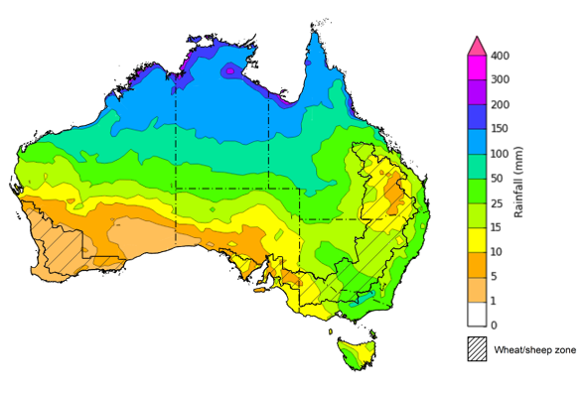

©Commonwealth of Australia 2025, Australian Bureau of Meteorology Issued 20/3/2025

Note: This rainfall forecast is produced from computer models. As the model outputs are not altered by weather forecasters, it is important to check local forecasts and warnings issued by the Bureau of Meteorology.

### February precipitation percentiles and current production conditions

Crop production is affected by long-term trends in average rainfall and temperature, interannual climate variability, shocks during specific growth stages, and extreme weather events. Some crops are more tolerant than others to certain types of stresses, and at each growth stage, different types of stresses affect crop species in different ways.

Precipitation anomalies and outlooks presented below indicate the current and expected future production conditions for major grain and oilseed producing countries (responsible for over 80% of global crop production). This is an important input to assessing the global grain supply outlook.

Rainfall in February 2025 was variable across the world’s major grain- and oilseed-producing regions:

* In the **southern hemisphere**, precipitation was below average across much of Brazil, Argentina, and parts of Australia. Above average precipitation occurred in parts of southeast Asia.
* In the **northern hemisphere**, precipitation was below average in central areas and the southwest of the United States, eastern India and China, western regions of the Russian Federation and Ukraine, and across much of Europe. Precipitation was above average in the northwest and east of the United States and parts of western Kazakhstan.

**Global precipitation percentiles, February 2025**

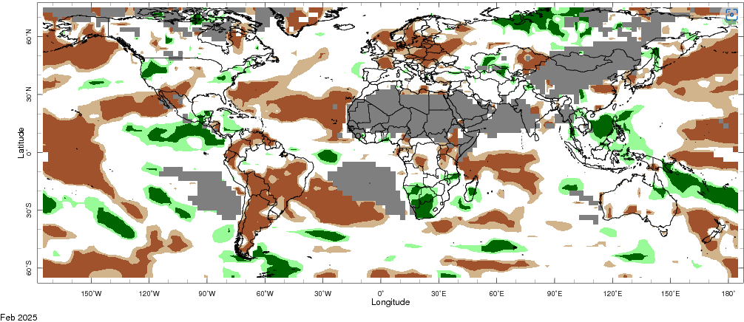Note: The world precipitation percentiles indicate a ranking of precipitation for December, with the driest (0th percentile) being 0 on the scale and the wettest (100th percentile) being 1 on the scale. Percentiles are based on precipitation estimates from the NOAA Climate Prediction Center’s [Climate Anomaly Monitoring System Outgoing Precipitation Index](https://iridl.ldeo.columbia.edu/maproom/Global/Precipitation/Percentiles.html) dataset. Precipitation estimates for January 2025 are compared with rainfall recorded for that period during the 1981 to 2010 base period.

Source: International Research Institute for Climate and Society

As of 28 February 2025, global production conditions were generally favourable for rice and maize, but variable for wheat and soybeans:

* **Wheat –** Conditions are mixed in major northern hemisphere growing regions, with dryness impacting crop development in the Russian Federation, Ukraine and across parts of Europe.
* **Maize –** Conditions are generally favourable in Argentina and Brazil, but are poor in parts of South Africa.
* **Rice –** Conditions are generally favourable, however, adverse climate conditions have negatively impacted rice crops in the Philippines.
* **Soybeans –** Dry climate conditions across parts of Argentina, Brazil, and South Africa are likely to adversely affect crop yields in these areas.

**Crop conditions, AMIS countries, 28 February 2025**

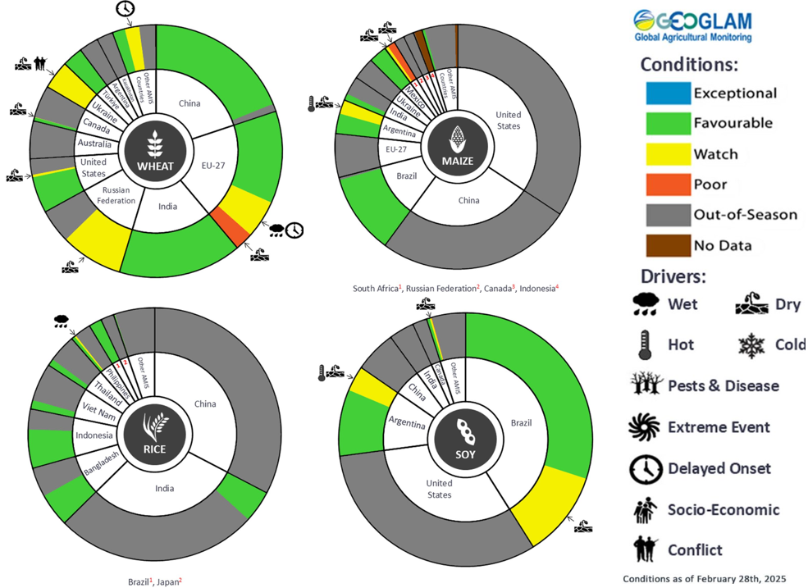

**AMIS** Agricultural Market Information System.

Source: AMIS

The global climate outlook for April 2025 to June 2025 indicates that mixed rainfall conditions are expected for the world’s major grain-producing and oilseed-producing regions. Outlooks and potential production impacts for the major grain and oilseed producing countries are presented in the following table.

**Rainfall outlook and potential impact on the future state of production conditions, April-June 2025**

|  |  |  |
| --- | --- | --- |
| **Region** | **April-June rainfall outlook** | **Potential impact on production** |
| **Argentina** | Average rainfall is more likely across much of Argentina. | Average rainfall is likely to be sufficient to support the development of sorghum, rice, millet, and the planting of wheat in May 2025. |
| **Black Sea Region** | Average rainfall is expected across much of the Black Sea region, with exceptions in Türkiye and Kazakhstan where below average to average rainfall is likely. | Average rainfall is likely to support the heading and growth of winter and spring wheat and canola in much of the Black Sea region. |
| **Brazil** | Below average rainfall likely in southern areas, with central Brazil likely to see below average to average rainfall | In areas of Brazil expected to see average rainfall, this is likely to support the silking of corn over the period. However, in those areas of central and southern Brazil expected to see below average rainfall this may reduce yield potential of summer planted corn as it may lead to a drawdown on soil moisture ahead of wheat planting in May and June. |
| **Canada** | Generally, average rainfall is expected over much of Canda, with scattered areas in the west likely to see above or below average rainfall. | Average rainfall is likely to be sufficient to support winter wheat development in Canada from March 2025 and the planting of spring wheat, canola, corn, soybeans and sunflower from May 2025. |
| **China** | Above average rainfall is expected throughout much of central China, with average rainfall expected in the west, and areas of below average rainfall in the northeast. | Average to above average rainfall across much China is likely to support the development of winter wheat and canola and the planting and development of early rice, single rice, cotton and spring wheat. Below average rainfall across parts of north-eastern China may affect the development of these crops from April 2025. |
| **Europe** | Average rainfall is likely for much of Europe. | Average rainfall is likely to support the heading of wheat and northern and southern Europe, as well as the flowering of cotton and corn in the south. |
| **South Asia (India)** | Above average rainfall is expected in central, western, and southern regions. Below average to average rainfall is likely across the northwest. | Above average rainfall may interrupt the planting of major crops, including wheat, canola, and rice. |
| **Southeast Asia (SEA)** | Average to above average rainfall is likely across much of Thailand, Vietnam, the Philippines, and Indonesia, with average rainfall expected in the remaining regions. | Average to above average rainfall in SEA may impede the planting of corn and rice crops in the region. |
| **The United States of America (US)** | Below average rainfall is likely for much of the southern and central United States, with average rainfall more likely across the north. | Below average rainfall in southern and central areas are likely to impact yield potential of winter wheat as it comes out of dormancy, as well as the planting and development of spring wheat, canola, corn, cotton, and rice. Average rainfall conditions expected across the northern US is like to support the heading of winter and spring wheat, and provide moisture for the planting of corn and soybeans in May. |

## **Water**

### Water markets – current week

Water storage levels in the Murray-Darling Basin (MDB) decreased between 13 March 2025 and 20 March 2025 by 262 gigalitres (GL). Current volume of water held in storage is 12478 GL, equivalent to 56% of total storage capacity. This is 28 percent or 4,823 GL less than at the same time last year. Water storage data is sourced from the BOM.

Allocation prices in the Victorian Murray below the Barmah Choke decreased from $182 on 06 March to $194 on 20 March. Prices are lower in regions above the Barmah choke due to the binding of the Barmah choke trade constraint.

.

#### Surface water trade activity, Southern Murray–Darling Basin

|  |
| --- |
| The trades shown reflect estimated market activity and do not encompass all register trades. The price is shown for the VIC Murray below the Barmah choke. Historical prices (before 1 July 2019) are ABARES estimates after removing outliers from BOM water register data. Prices after 1 July 2019 and prior to the 30 October 2019 reflect recorded transaction prices as sourced from Ruralco. Prices after the 30 October 2019 are sourced from Waterflow. Data for volume traded is sourced from the BOM water register. Only the price data shown is current on 17 October 2024. |

To access the full, interactive, weekly water dashboard, which contains the latest and historical water storage, water market and water allocation information, please visit <https://www.agriculture.gov.au/abares/products/weekly_update/weekly-update-200324>

## **Commodities**

|  |  |  |  |  |  |  |  |  |
| --- | --- | --- | --- | --- | --- | --- | --- | --- |
| **Indicator** | **Week average** | **Unit** | **Latest Price** | **Previous Week** | **Weekly change** | | **Price 12 months ago** | **Annual change** |
| **Selected world indicator prices** |  |  |  |  |  |  | |  |
| AUD/USD Exchange rate | 19-Mar | A$/US$ | 0.64 | 0.63 | 1% | 0.66 | | -3% |
| Wheat – US no. 2 hard red winter wheat, FOB Gulf | 19-Mar | US$/t | 269 | 258 | 4% | 274 | | -2% |
| Corn – US no. 2 yellow corn, FOB Gulf | 19-Mar | US$/t | 208 | 209 | -1% | 190 | | 9% |
| Canola – Rapeseed, Canada, FOB Vancouver | 19-Mar | US$/t | 443 | 434 | 2% | 498 | | -11% |
| Cotton – Cotlook A Index | 19-Mar | USc/lb | 79 | 78 | 1% | 99 | | -20% |
| Sugar – Intercontinental Exchange, nearby futures, no.11 contract | 19-Mar | USc/lb | 20 | 19 | 5% | 22 | | -7% |
| Wool – Eastern Market Indicator | 19-Mar | Ac/kg clean | 1,250 | 1,242 | 1% | 1,158 | | 8% |
| Wool – Western Market Indicator | 19-Mar | Ac/kg clean | 1,407 | 1,406 | 0% | 1,295 | | 9% |
| **Selected Australian grain export prices** |  |  |  |  |  |  | |  |
| Australian Premium White (APW) Wheat, FOB Port Adelaide, SA | 19-Mar | A$/t | 397 | 397 | 0% | 401 | | -1% |
| Australian Standard White (ASW) Wheat, FOB Port Adelaide, SA | 19-Mar | A$/t | 388 | 387 | 0% | 381 | | 2% |
| Feed Barley – FOB Port Adelaide, SA | 19-Mar | A$/t | 364 | 363 | 0% | 349 | | 4% |
| Canola – FOB Kwinana, WA | 19-Mar | A$/t | 785 | 811 | -3% | 686 | | 14% |
| Grain Sorghum – FOB Brisbane, QLD | 19-Mar | A$/t | 430 | 422 | 2% | 457 | | -6% |
| **Selected domestic livestock indicator prices** |  |  |  |  |  |  | |  |
| Beef – Eastern Young Cattle Indicator | 19-Mar | Ac/kg cwt | 660 | 656 | 1% | 595 | | 11% |
| Mutton – Mutton indicator (18–24 kg fat score 2–3), VIC | 19-Mar | Ac/kg cwt | 411 | 399 | 3% | 238 | | 73% |
| Lamb – National Trade Lamb Indicator | 19-Mar | Ac/kg cwt | 786 | 792 | -1% | 606 | | 30% |
| Pig – Eastern Seaboard (60.1–75 kg), NSW buyer price | 05-Mar | Ac/kg cwt | 452 | 452 | 0% | 419 | | 8% |
| Live cattle – Light steers to Indonesia | 19-Mar | Ac/kg lwt | 370 | 355 | 4% | 350 | | 6% |
| **Global Dairy Trade (GDT) weighted average prices** |  |  |  |  |  |  | |  |
| Dairy – Whole milk powder | 19-Mar | US$/t | 4,052 | 4,061 | 0% | 3,215 | | 26% |
| Dairy – Skim milk powder | 19-Mar | US$/t | 2,729 | 2,744 | -1% | 2,579 | | 6% |
| Dairy – Cheddar cheese | 19-Mar | US$/t | 4,976 | 4,915 | 1% | 4,235 | | 18% |
| Dairy – Anhydrous milk fat | 19-Mar | US$/t | 6,561 | 6,681 | -2% | 6,716 | | -2% |
|  | | | | | | | | |

### Selected world indicator prices

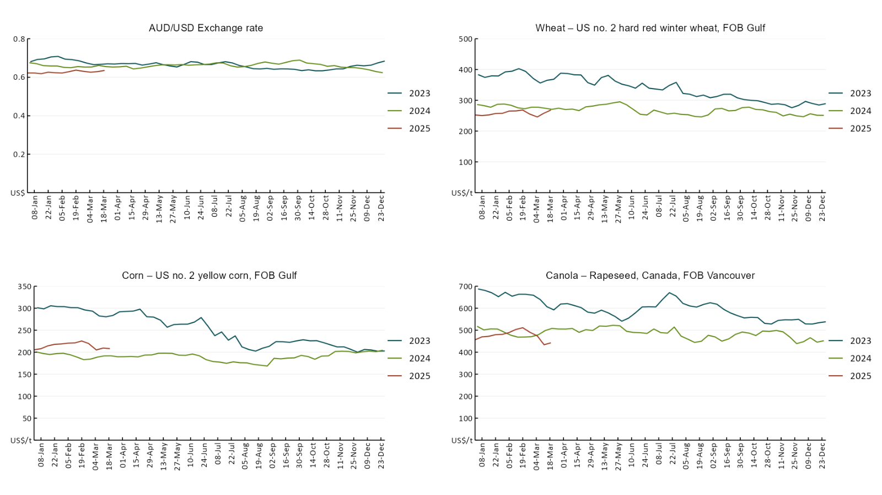

### 3.2 Selected domestic crop indicator prices

### Selected domestic livestock indicator prices

### Global Dairy Trade (GDT) weighted average prices

### Selected fruit and vegetable prices

### 3.6 Selected domestic fodder indicator prices

## **4. Data attribution**

### Climate

* Bureau of Meteorology
* Weekly rainfall totals: www.bom.gov.au/climate/maps/rainfall/
* Monthly and last 3-month rainfall percentiles: [www.bom.gov.au/water/landscape/](http://www.bom.gov.au/water/landscape/)
* Temperature anomalies: [www.bom.gov.au/jsp/awap/temp/index.jsp](http://www.bom.gov.au/jsp/awap/temp/index.jsp)
* Rainfall forecast: [www.bom.gov.au/jsp/watl/rainfall/pme.jsp](http://www.bom.gov.au/jsp/watl/rainfall/pme.jsp)
* Seasonal outlook: [www.bom.gov.au/climate/outlooks/#/overview/summary/](http://www.bom.gov.au/climate/outlooks/#/overview/summary/)
* Climate drivers: <http://www.bom.gov.au/climate/enso/>
* Soil moisture: [www.bom.gov.au/water/landscape/](http://www.bom.gov.au/water/landscape/)
* Other
* Pasture growth: [www.longpaddock.qld.gov.au/aussiegrass/](http://www.longpaddock.qld.gov.au/aussiegrass/)
* 3-month global outlooks: [Environment and Climate Change Canada](https://weather.gc.ca/saisons/image_e.html?img=s234pfe1p_cal&bc=prob), [NOAA Climate Prediction Center](https://www.cpc.ncep.noaa.gov/products/predictions/long_range/seasonal.php?lead=2), [EUROBRISA CPTEC/INPE](http://eurobrisa.cptec.inpe.br/), European Centre for Medium-Range Weather Forecasts, [Hydrometcenter of Russia](https://meteoinfo.ru/en/climate/seasonal-forecasts), [National Climate Center Climate System Diagnosis and Prediction Room (NCC)](https://cmdp.ncc-cma.net/pred/cs2gen.php?pred_elem=RAINP#pred_seasonal), [International Research Institute for Climate and Society](https://iri.columbia.edu/our-expertise/climate/forecasts/seasonal-climate-forecasts/)
* Global production: <https://ipad.fas.usda.gov/ogamaps/cropmapsandcalendars.aspx>
* Autumn break: Pook et al., 2009, <https://rmets-onlinelibrary-wiley-com.virtual.anu.edu.au/doi/epdf/10.1002/joc.1833>

### Water

Prices

* Waterflow: <https://www.waterflow.io/>
* Ruralco: <https://www.ruralcowater.com.au/>
* Bureau of Meteorology:
* Allocation trade: <http://www.bom.gov.au/water/dashboards/#/water-markets/mdb/at>
* Storage volumes: <http://www.bom.gov.au/water/dashboards/#/water-storages/summary/drainage>
* Trade constraints:
* Water NSW: <https://www.waternsw.com.au/customer-service/ordering-trading-and-pricing/trading/murrumbidgee>
* Victorian Water Register: <https://www.waterregister.vic.gov.au/TradingRules2019/>

### Commodities

* Fruit and vegetables
* Datafresh: [www.freshstate.com.au](http://www.freshstate.com.au)
* Pigs
* Australian Pork Limited: [www.australianpork.com.au](http://www.australianpork.com.au)
* Dairy
* Global Dairy Trade: [www.globaldairytrade.info/en/product-results/](http://www.globaldairytrade.info/en/product-results/)
* World wheat, canola
* International Grains Council
* World coarse grains
* United States Department of Agriculture
* World cotton
* Cotlook: [www.cotlook.com/](http://www.cotlook.com/)
* World sugar
* New York Stock Exchange - Intercontinental Exchange
* Wool
* Australian Wool Exchange: [www.awex.com.au/](http://www.awex.com.au/)
* Domestic wheat, barley, sorghum, canola and fodder
* Jumbuk Consulting Pty Ltd: http://www.jumbukag.com.au/
* Cattle, beef, mutton, lamb, goat and live export
* Meat and Livestock Australia: [www.mla.com.au/Prices-and-market](http://www.mla.com.au/Prices-and-market)

© Commonwealth of Australia 2025

### Ownership of intellectual property rights

Unless otherwise noted, copyright (and any other intellectual property rights, if any) in this publication is owned by the Commonwealth of Australia (referred to as the Commonwealth).

### Creative Commons licence

All material in this publication is licensed under a [Creative Commons Attribution 4.0 International Licence](https://creativecommons.org/licenses/by/4.0/legalcode) except content supplied by third parties, logos and the Commonwealth Coat of Arms.

Inquiries about the licence and any use of this document should be emailed to [copyright@awe.gov.au](mailto:copyright@awe.gov.au).

https://www.agriculture.gov.au/sites/default/files/images/creative-commons-logo-small.png

### Cataloguing data

This publication (and any material sourced from it) should be attributed as:

ABARES 2025, Weekly Australian Climate, Water and Agricultural Update, Australian Bureau of Agricultural and Resource Economics and Sciences, Canberra, 20 March 2025. CC BY 4.0 DOI: <https://doi.org/10.25814/5f3e04e7d2503>

ISSN **2652-7561**

This publication is available at https://www.agriculture.gov.au/abares/products/weekly_update

Department of Agriculture, Fisheries and Forestry

GPO Box 858 Canberra ACT 2601

Telephone 1800 900 090

Web [agriculture.gov.au/abares](http://awe.gov.au/abares)

### Disclaimer

The Australian Government acting through the Department of Agriculture, Fisheries and Forestry, represented by the Australian Bureau of Agricultural and Resource Economics and Sciences, has exercised due care and skill in preparing and compiling the information and data in this publication. Notwithstanding, the Department of Agriculture, Fisheries and Forestry, ABARES, its employees and advisers disclaim all liability, including liability for negligence and for any loss, damage, injury, expense or cost incurred by any person as a result of accessing, using or relying on any of the information or data in this publication to the maximum extent permitted by law.

### Statement of Professional Independence

The views and analysis presented in ABARES publications, including this one, reflect ABARES professionally independent findings, based on scientific and economic concepts, principles, information and data. These views, analysis and findings may not reflect or be consistent with the views or positions of the Australian Government, or of organisations or groups who have commissioned ABARES reports or analysis. More information on [professional independence](https://www.agriculture.gov.au/abares/about/research-and-analysis#professional-independence) is provided on the ABARES website.

### Acknowledgements

This report was prepared by Holly Beale and Matthew Miller.