## No. 4/2025 30 January 2025

# Summary of key issues

* In the week ending 29 January 2025, low-pressure systems brought rainfall to the north and east of Australia:
  + Some rainfall was recorded across **northern cropping regions**, but falls were highly variable, with between 10–50 millimetres beingrecorded across parts of western and northern **Queensland.**
  + Conditions across **southern cropping regions** were drier (receiving 0–10 millimetres).
* Over the coming eight days, low-pressure systems and troughs are expected to bring rainfall across the north and east of the country.
  + Across cropping regions, **Queensland** is expected to receive up to 100 millimetres of rainfall, and northern **New South Wales** to receive up to 50 millimetres. Little to no rainfall is expected in other cropping regions.
* **The northern rainfall onset was achieved earlier than normal** across much of northern Australia despite a record late monsoon onset. This indicates sufficient and timely rainfall has been recorded across much of northern Australia, likely stimulating and supporting pasture production across many northern grazing regions.
* **Water storage** in the Murray-Darling Basin (MDB) decreased between 23-30 January 2025 by 452 gigalitres (GL). Current volume of water held in storage is 14,571 GL, 23% less than this time last year and equivalent to 65% of total storage capacity. Water storage data is sourced from the Bureau of Meteorology.
* **Allocation prices** in the Victorian Murray below the Barmah Choke increased from $156 on 23 January to $159 on 30 January. Prices are lower in regions above the Barmah choke due to the binding of the Barmah choke trade constraint.

## **Climate**

### Rainfall this week

In the week ending 29 January 2025, low-pressure systems and a series of troughs brought rainfall and storms to the north and east of the country, while the remainder of the country was largely dry.

* The northern tropics, including the **Northern Territory** and northern **Western Australia** recorded falls between 25–150 millimetres. Meanwhile, much of northern **Queensland**, recorded falls between 25–200 millimetres, with up to 400 millimetres in isolated coastal areas.
* Eastern **Queensland,** eastern **New South Wales** and **Tasmania** received between 0–50 millimetres of rainfall, while eastern **Victoria** received between 0–25 millimetres.
* **South Australia**, southern **Western Australia**, and central inland regions of Australia recorded little to no rainfall over the period.

Rainfall totals were generally low across cropping regions:

* Southern cropping regions received little to no rainfall. This included much of **Western Australia, South Australia, Victoria**, **New South Wales**, and southern **Queensland** which received between 0–10 millimetres.
* Parts of northern and south-western **Queensland** recorded slightly higher rainfall totals, with falls between 10–50 millimetres recorded across some regions.
* Despite the lack of rainfall across many summer cropping areas, most areas remain on track to record above average yield due to close to average soil moisture levels for this time of year.

#### Rainfall for the week ending 29 January 2025

©Commonwealth of Australia 2025, Australian Bureau of Meteorology Issued: 29/1/2025

Note: The rainfall analyses and associated maps utilise data contained in the Bureau of Meteorology climate database, the Australian Data Archive for Meteorology (ADAM). The analyses are initially produced automatically from real-time data with limited [quality control](http://www.bom.gov.au/climate/headers/qc.shtml). They are intended to provide a general overview of rainfall across Australia as quickly as possible after the observations are received. For further information go to <http://www.bom.gov.au/climate/rainfall/>

### Rainfall forecast for the next eight days

Over the 8 days to 6 February 2025, **tropical lows and troughs are expected to bring rainfall and storms over the east and north** of Australia:

* Falls between 10–100 millimetres are likely for much of northern **Western Australia**, and the **Northern Territory**. In northern **Queensland**, falls are expected to be higher, between 50 to 300 millimetres.
* Between 5–50 millimetres are forecast for much of **New South Wales** and southern **Queensland,** with falls between 5–15 expected in **Victoria** and **Tasmania**.
* By contrast, a **high-pressure system is expected to keep much of the remainder of the south and interior of Australia largely dry**, including **South Australia** and southern **Western Australia**

Rainfall forecasts across cropping regions over the coming week are mixed:

* Low rainfall totals are expected in **southern cropping regions**, including across much of Western Australia, South Australia, Victoria, and southern and central New South Wales (between 1–10 millimetres).
* Higher rainfall is expected in **northern cropping regions**, with Queensland likely to receive between 10–100 millimetres. In northern New South Wales, falls between 10–50 millimetres are expected. Rainfall forecast for summer cropping regions in Queensland and New South Wales is likely to be sufficient to support average soil moisture levels and above average summer crop yield potentials.

#### Total forecast rainfall for the period 30 January to 6 February 2025

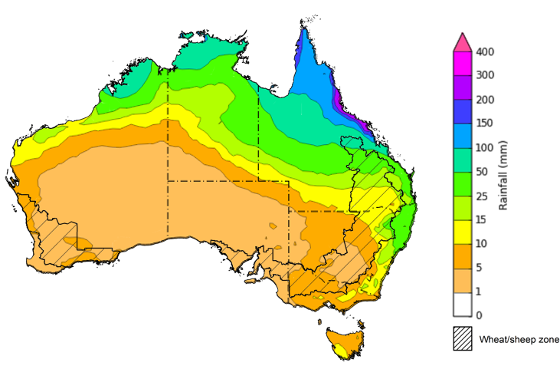

©Commonwealth of Australia 2025, Australian Bureau of Meteorology Issued 30/1/2025

Note: This rainfall forecast is produced from computer models. As the model outputs are not altered by weather forecasters, it is important to check local forecasts and warnings issued by the Bureau of Meteorology.

### Northern Rainfall Onset

The timing of **northern rainfall onset** is an important indicator for seasonal pasture growth and potential livestock production. The rainfall onset indicates the accumulation of at least 50 millimetres of rainfall after 1 September to stimulate plant growth after the northern dry season.

**The northern rainfall onset was achieved earlier than normal across large areas of northern Australia,** despite record-late monsoon onset in 2024–25. Since 1 September 2024, large areas of northern Australia have received at least 50 millimetres of rainfall, and the northern rainfall onset was achieved early across northern parts of Western Australia, the Northern Territory and large areas of western Queensland.

**Despite the** **delayed onset of the northern monsoon, sufficient and timely rainfall has been recorded across much of northern Australia**, likely stimulating and supporting pasture production across many northern grazing regions.

This is further supported by analysis of rainfall deciles between October-December 2024 which record average to above average rainfall across much of northern Australia. Isolated areas of Queensland saw below average rainfall over the period.

#### Rainfall deciles for the period 1 October to 31 December 2024

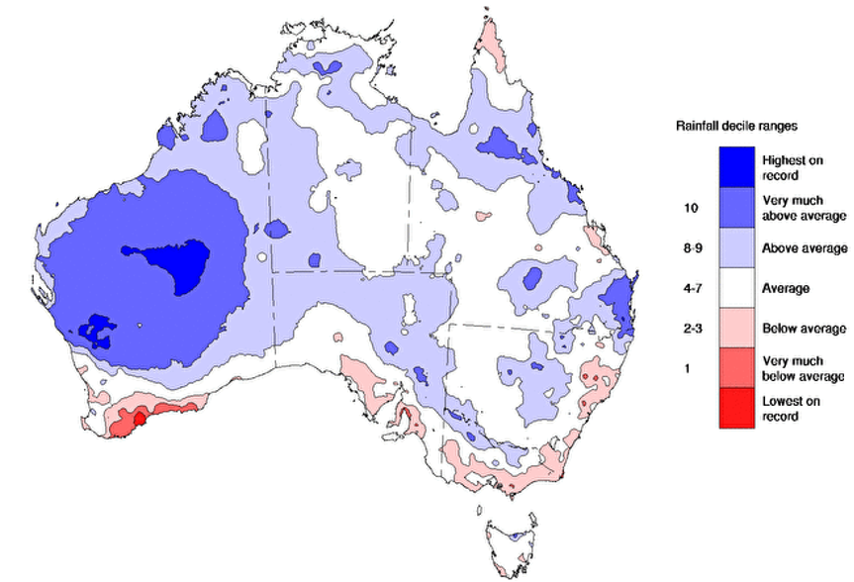

Source: Bureau of Meteorology, issued 21/01/25

## **Water**

### Water markets – current week

Water storage levels in the Victorian Murray below the Barmah Choke increased from $156 on 23 January to $159 on 30 January. Prices are lower in regions above the Barmah choke due to the binding of the Barmah choke trade constraint.

#### Water storages in the Murray-Darling Basin, 2013–2024

Allocation prices in the Victorian Murray below the Barmah Choke increased from $156 on 23 January to $159 on 30 January. Prices are lower in regions above the Barmah choke due to the binding of the Barmah choke trade constraint.

#### Surface water trade activity, Southern Murray–Darling Basin

|  |
| --- |
| The trades shown reflect estimated market activity and do not encompass all register trades. The price is shown for the VIC Murray below the Barmah choke. Historical prices (before 1 July 2019) are ABARES estimates after removing outliers from BOM water register data. Prices after 1 July 2019 and prior to the 30 October 2019 reflect recorded transaction prices as sourced from Ruralco. Prices after the 30 October 2019 are sourced from Waterflow. Data for volume traded is sourced from the BOM water register. Only the price data shown is current on 17 October 2024. |

To access the full, interactive, weekly water dashboard, which contains the latest and historical water storage, water market and water allocation information, please visit <https://www.agriculture.gov.au/abares/products/weekly_update/weekly-update-300124>

## **Commodities**

|  |  |  |  |  |  |  |  |  |
| --- | --- | --- | --- | --- | --- | --- | --- | --- |
| **Indicator** | **Week average** | **Unit** | **Latest Price** | **Previous Week** | **Weekly change** | | **Price 12 months ago** | **Annual change** |
| **Selected world indicator prices** |  |  |  |  |  |  | |  |
| AUD/USD Exchange rate | 29-Jan | A$/US$ | 0.62 | 0.63 | 0% | 0.66 | | -6% |
| Wheat – US no. 2 hard red winter wheat, FOB Gulf | 29-Jan | US$/t | 252 | 257 | -2% | 284 | | -11% |
| Corn – US no. 2 yellow corn, FOB Gulf | 29-Jan | US$/t | 219 | 218 | 1% | 197 | | 11% |
| Canola – Rapeseed, Canada, FOB Vancouver | 29-Jan | US$/t | 481 | 480 | 0% | 505 | | -5% |
| Cotton – Cotlook A Index | 29-Jan | USc/lb | 78 | 78 | 1% | 92 | | -15% |
| Sugar – Intercontinental Exchange, nearby futures, no.11 contract | 29-Jan | USc/lb | 19 | 18 | 9% | 22 | | -14% |
| Wool – Eastern Market Indicator | 22-Jan | Ac/kg clean | 1,186 | 1,190 | 0% | 1,192 | | 0% |
| Wool – Western Market Indicator | 22-Jan | Ac/kg clean | 1,325 | 1,339 | -1% | 1,312 | | 1% |
| **Selected Australian grain export prices** |  |  |  |  |  |  | |  |
| Australian Premium White (APW) Wheat, FOB Port Adelaide, SA | 29-Jan | A$/t | 403 | 404 | 0% | 444 | | -9% |
| Australian Standard White (ASW) Wheat, FOB Port Adelaide, SA | 29-Jan | A$/t | 393 | 394 | 0% | 422 | | -7% |
| Feed Barley – FOB Port Adelaide, SA | 29-Jan | A$/t | 367 | 365 | 0% | 375 | | -2% |
| Canola – FOB Kwinana, WA | 29-Jan | A$/t | 844 | 854 | -1% | 742 | | 14% |
| Grain Sorghum – FOB Brisbane, QLD | 29-Jan | A$/t | 410 | 408 | 1% | 478 | | -14% |
| **Selected domestic livestock indicator prices** |  |  |  |  |  |  | |  |
| Beef – Eastern Young Cattle Indicator | 29-Jan | Ac/kg cwt | 666 | 692 | -4% | 618 | | 8% |
| Mutton – Mutton indicator (18–24 kg fat score 2–3), VIC | 29-Jan | Ac/kg cwt | 345 | 350 | -1% | 263 | | 31% |
| Lamb – National Trade Lamb Indicator | 29-Jan | Ac/kg cwt | 789 | 790 | 0% | 740 | | 7% |
| Pig – Eastern Seaboard (60.1–75 kg), NSW buyer price | 08-Jan | Ac/kg cwt | 454 | 454 | 0% | 408 | | 11% |
| Live cattle – Light steers to Indonesia | 25-Dec | Ac/kg lwt | 350 | 350 | 0% | 298 | | 17% |
| **Global Dairy Trade (GDT) weighted average prices** |  |  |  |  |  |  | |  |
| Dairy – Whole milk powder | 22-Jan | US$/t | 3,988 | 3,804 | 5% | 3,322 | | 20% |
| Dairy – Skim milk powder | 22-Jan | US$/t | 2,729 | 2,682 | 2% | 2,626 | | 4% |
| Dairy – Cheddar cheese | 22-Jan | US$/t | 4,846 | 4,728 | 2% | 4,191 | | 16% |
| Dairy – Anhydrous milk fat | 22-Jan | US$/t | 6,616 | 7,169 | -8% | 5,719 | | 16% |
|  | | | | | | | | |

### Selected world indicator prices

### 3.2 Selected domestic crop indicator prices

### Selected domestic livestock indicator prices

### Global Dairy Trade (GDT) weighted average prices

### 3.6 Selected domestic fodder indicator prices

## **4. Data attribution**

### Climate

* Bureau of Meteorology
* Weekly rainfall totals: www.bom.gov.au/climate/maps/rainfall/
* Monthly and last 3-month rainfall percentiles: [www.bom.gov.au/water/landscape/](http://www.bom.gov.au/water/landscape/)
* Temperature anomalies: [www.bom.gov.au/jsp/awap/temp/index.jsp](http://www.bom.gov.au/jsp/awap/temp/index.jsp)
* Rainfall forecast: [www.bom.gov.au/jsp/watl/rainfall/pme.jsp](http://www.bom.gov.au/jsp/watl/rainfall/pme.jsp)
* Seasonal outlook: [www.bom.gov.au/climate/outlooks/#/overview/summary/](http://www.bom.gov.au/climate/outlooks/#/overview/summary/)
* Climate drivers: <http://www.bom.gov.au/climate/enso/>
* Soil moisture: [www.bom.gov.au/water/landscape/](http://www.bom.gov.au/water/landscape/)
* Other
* Pasture growth: [www.longpaddock.qld.gov.au/aussiegrass/](http://www.longpaddock.qld.gov.au/aussiegrass/)
* 3-month global outlooks: [Environment and Climate Change Canada](https://weather.gc.ca/saisons/image_e.html?img=s234pfe1p_cal&bc=prob), [NOAA Climate Prediction Center](https://www.cpc.ncep.noaa.gov/products/predictions/long_range/seasonal.php?lead=2), [EUROBRISA CPTEC/INPE](http://eurobrisa.cptec.inpe.br/), European Centre for Medium-Range Weather Forecasts, [Hydrometcenter of Russia](https://meteoinfo.ru/en/climate/seasonal-forecasts), [National Climate Center Climate System Diagnosis and Prediction Room (NCC)](https://cmdp.ncc-cma.net/pred/cs2gen.php?pred_elem=RAINP#pred_seasonal), [International Research Institute for Climate and Society](https://iri.columbia.edu/our-expertise/climate/forecasts/seasonal-climate-forecasts/)
* Global production: <https://ipad.fas.usda.gov/ogamaps/cropmapsandcalendars.aspx>
* Autumn break: Pook et al., 2009, <https://rmets-onlinelibrary-wiley-com.virtual.anu.edu.au/doi/epdf/10.1002/joc.1833>

### Water

Prices

* Waterflow: <https://www.waterflow.io/>
* Ruralco: <https://www.ruralcowater.com.au/>
* Bureau of Meteorology:
* Allocation trade: <http://www.bom.gov.au/water/dashboards/#/water-markets/mdb/at>
* Storage volumes: <http://www.bom.gov.au/water/dashboards/#/water-storages/summary/drainage>
* Trade constraints:
* Water NSW: <https://www.waternsw.com.au/customer-service/ordering-trading-and-pricing/trading/murrumbidgee>
* Victorian Water Register: <https://www.waterregister.vic.gov.au/TradingRules2019/>

### Commodities

* Fruit and vegetables
* Datafresh: [www.freshstate.com.au](http://www.freshstate.com.au)
* Pigs
* Australian Pork Limited: [www.australianpork.com.au](http://www.australianpork.com.au)
* Dairy
* Global Dairy Trade: [www.globaldairytrade.info/en/product-results/](http://www.globaldairytrade.info/en/product-results/)
* World wheat, canola
* International Grains Council
* World coarse grains
* United States Department of Agriculture
* World cotton
* Cotlook: [www.cotlook.com/](http://www.cotlook.com/)
* World sugar
* New York Stock Exchange - Intercontinental Exchange
* Wool
* Australian Wool Exchange: [www.awex.com.au/](http://www.awex.com.au/)
* Domestic wheat, barley, sorghum, canola and fodder
* Jumbuk Consulting Pty Ltd: http://www.jumbukag.com.au/
* Cattle, beef, mutton, lamb, goat and live export
* Meat and Livestock Australia: [www.mla.com.au/Prices-and-market](http://www.mla.com.au/Prices-and-market)

© Commonwealth of Australia 2025

### Ownership of intellectual property rights

Unless otherwise noted, copyright (and any other intellectual property rights, if any) in this publication is owned by the Commonwealth of Australia (referred to as the Commonwealth).

### Creative Commons licence

All material in this publication is licensed under a [Creative Commons Attribution 4.0 International Licence](https://creativecommons.org/licenses/by/4.0/legalcode) except content supplied by third parties, logos and the Commonwealth Coat of Arms.

Inquiries about the licence and any use of this document should be emailed to [copyright@awe.gov.au](mailto:copyright@awe.gov.au).

https://www.agriculture.gov.au/sites/default/files/images/creative-commons-logo-small.png

### Cataloguing data

This publication (and any material sourced from it) should be attributed as:

ABARES 2025, Weekly Australian Climate, Water and Agricultural Update, Australian Bureau of Agricultural and Resource Economics and Sciences, Canberra, 30 January 2025. CC BY 4.0 DOI: <https://doi.org/10.25814/5f3e04e7d2503>

ISSN **2652-7561**

This publication is available at https://www.agriculture.gov.au/abares/products/weekly_update

Department of Agriculture, Fisheries and Forestry

GPO Box 858 Canberra ACT 2601

Telephone 1800 900 090

Web [agriculture.gov.au/abares](http://awe.gov.au/abares)

### Disclaimer

The Australian Government acting through the Department of Agriculture, Fisheries and Forestry, represented by the Australian Bureau of Agricultural and Resource Economics and Sciences, has exercised due care and skill in preparing and compiling the information and data in this publication. Notwithstanding, the Department of Agriculture, Fisheries and Forestry, ABARES, its employees and advisers disclaim all liability, including liability for negligence and for any loss, damage, injury, expense or cost incurred by any person as a result of accessing, using or relying on any of the information or data in this publication to the maximum extent permitted by law.

### Statement of Professional Independence

The views and analysis presented in ABARES publications, including this one, reflect ABARES professionally independent findings, based on scientific and economic concepts, principles, information and data. These views, analysis and findings may not reflect or be consistent with the views or positions of the Australian Government, or of organisations or groups who have commissioned ABARES reports or analysis. More information on [professional independence](https://www.agriculture.gov.au/abares/about/research-and-analysis#professional-independence) is provided on the ABARES website.

### Acknowledgements

This report was prepared by Holly Beale and Matthew Miller.