## No. 3/2025 23 January 2025

# Summary of key issues

* In the week ending 22 January 2025, low-pressure systems brought rainfall to the north, west, and east of Australia:
  + Some rainfall was recorded across **northern cropping regions**, but falls were highly variable across Queensland and northern New South Wales (between 0–25 millimetres).
  + Conditions across **southern cropping regions** were drier (receiving 0–10 millimetres).
* Over the coming eight days, low-pressure systems and troughs are expected to bring rainfall across the north and east of the country.
  + Across cropping regions, Queensland and northern New South Wales are expected to receive up to 50 millimetres of rainfall. Little to no rainfall is expected in other cropping regions.
* The **national rainfall outlook for February to April 2025** indicates an increased probability of above median rainfall across much of the country, with exceptions in the southwest.
* Across cropping regions **rainfall outlook for February to April 2025** indicates:
  + There is a 75% chance of rainfall totals between 50–200 millimetres across Queensland and New South Wales.
  + If realised, these rainfall totals should improve soil moisture profiles and support summer pasture growth. They should also be sufficient a boost to soil moisture profiles and maintain above average yield expectations for summer crops in Queensland and New South Wales.
* **Water storage levels** in the Murray-Darling Basin (MDB) decreased between 16 January 2025 and 22 January 2025 by 278 gigalitres (GL). Current volume of water held in storage is 15,023 GL, 30% less than at the same time last year and 68% of total storage capacity. Water storage data is sourced from the Bureau of Meteorology.
* **Allocation prices** in the Victorian Murray below the Barmah Choke decreased from $158 on 16 January to $156 on 22 January. Prices are lower in regions above the Barmah choke due to the binding of the Barmah choke trade constraint.

## **Climate**

### Rainfall this week

In the week ending 22 January 2025, low-pressure systems and a series of troughs brought rainfall and storms to the north and east of the country, while tropical cyclone Sean brought heavy rainfall to the west. High-pressure systems kept much of central Australia dry.

* The northern tropics, including the **Northern Territory** and northern **Western Australia** recorded falls of between 25–200 millimetres. In northern Queensland, falls of between 25–100 millimetres of rainfall were observed.
* Eastern Queensland and Victoria received between 5–50 millimetres of rainfall; eastern New South Wales received between 5–100 millimetres, with up to 300 millimetres recorded in scattered coastal areas. Tasmania recorded 5–25 millimetres.
* **South Australia**, southern **Western Australia**, western **Victoria,** western **New South Wales** and central **Australia** recorded little to no rainfall over the period.

Rainfall totals were generally low across cropping regions:

* Southern cropping regions received little to no rainfall. This included much of **Western Australia, South Australia, Victoria**, and southwest **New South Wales**, which received between 0–10 millimetres.
* In the east, rainfall totals were higher, with **Queensland** and northern **New South Wales** recording between 0–25 millimetres.
* Despite the lack of rainfall across many summer cropping areas, most areas remain on track to record above average yield due to close to average soil moisture levels for this time of year.

#### Rainfall for the week ending 22 January 2025

©Commonwealth of Australia 2025, Australian Bureau of Meteorology Issued: 22/1/2025

Note: The rainfall analyses and associated maps utilise data contained in the Bureau of Meteorology climate database, the Australian Data Archive for Meteorology (ADAM). The analyses are initially produced automatically from real-time data with limited [quality control](http://www.bom.gov.au/climate/headers/qc.shtml). They are intended to provide a general overview of rainfall across Australia as quickly as possible after the observations are received. For further information go to <http://www.bom.gov.au/climate/rainfall/>

### Rainfall forecast for the next eight days

Over the 8 days to 30 January 2025, **low-pressure systems and troughs are expected to bring rainfall and storms over the east and north** of Australia:

* Falls between 10–100 millimetres are likely for much of northern **Western Australia**, the **Northern Territory**, and northern **Queensland**. Higher rainfall totals are expected in isolated areas, with up to 150 millimetres forecast in scattered areas of far-north Australia.
* Between 5–50 millimetres are forecast for much of eastern Queensland, New South Wales and Victoria, and Tasmania.
* By contrast, a **high-pressure system is expected to keep much of the south and interior of Australia largely dry**, including southern Western Australia and the Northern Territory, South Australia, western New South Wales and Victoria, and south-western Queensland.

Rainfall forecasts across cropping regions over the coming week are mixed:

* Low rainfall totals are expected in **southern cropping regions**, including across much of Western Australia, South Australia, Victoria, and southern and central New South Wales (between 1–10 millimetres).
* Higher rainfall is expected in **northern and eastern cropping regions**, with much of Queensland and northern New South Wales likely to receive between 10–50 millimetres. Rainfall forecast for summer cropping regions in Queensland and New South Wales is likely to be sufficient to support soil moisture levels and above average summer crop yield potentials.

#### Total forecast rainfall for the period 23 January to 30 January 2025

©Commonwealth of Australia 2025, Australian Bureau of Meteorology Issued 23/1/2025

Note: This rainfall forecast is produced from computer models. As the model outputs are not altered by weather forecasters, it is important to check local forecasts and warnings issued by the Bureau of Meteorology.

### Climate Outlook

The El Niño Southern Oscillation (ENSO), Southern Annular Mode (SAM), and Indian Ocean Dipole (IOD) climate drivers are currently neutral and having minimal influence on Australian rainfall. The IOD and SAM are likely to remain neutral over the coming weeks, however, indicators suggest that chances of a La Nina event are strengthening.

The most recent **rainfall outlook for February 2025** provided by the Bureau of Meteorology indicates that much of eastern Australia, including eastern Queensland and New South Wales, as well as parts of Western Australia are likely to see above median rainfall. For the remaining regions, rainfall is expected to be average.

* The Bureau of Meteorology’s climate model predicts a 75% chance of February rainfall totals between 50–300 millimetres across much of the northern Australia, with parts of far-north Queensland likely to see rainfall totals of up to 600 millimetres.
* Lower rainfall totals are expected across eastern areas, with much of south-eastern Queensland, eastern New South Wales, Victoria and Tasmania expected to see between 5–100 millimetres. Parts of eastern New South Wales are expected to see up to 200 millimetres in isolated areas.
* In South Australia, southern Western Australia, and western New South Wales little to no rainfall is expected.

Across cropping regions, the February rainfall outlook is highly variable:

* There is a 75% chance of between 5–50 millimetres across much of New South Wales and between 25–100 millimetres in Queensland. If realised, this rainfall is likely to support above average yield prospects for summer crops and average or better levels of pasture production in affected areas.
* Little to no rainfall is expected across remaining southern cropping regions. This forecast is typical for this time of year, expected to lead to continued low levels of pasture growth and increased livestock turn-off.

**Rainfall totals that have a 75% chance of occurring in February 2025**

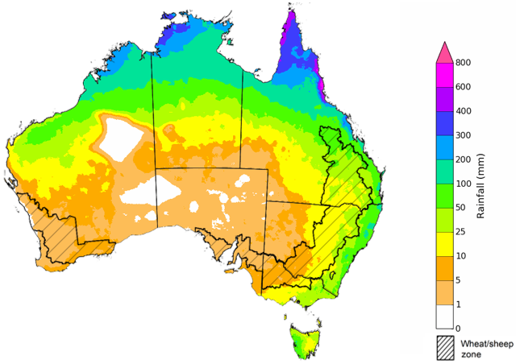

©Commonwealth of Australia 2025, Australian Bureau of Meteorology Issued: 23/1/2025

The Bureau of Meteorology’s **rainfall outlook for February to April 2025** indicates an increased probability of above average rainfall across much of the country, excluding much of the southwest.

Across cropping regions, the chance of receiving above median rainfall is between 55–75% across much of New South Wales, Queensland and Victoria. In South Australia and Western Australia, the chance of receiving above median rainfall is between 50–65%.

**Chance of exceeding the median rainfall** **February 2025 to April 2025**

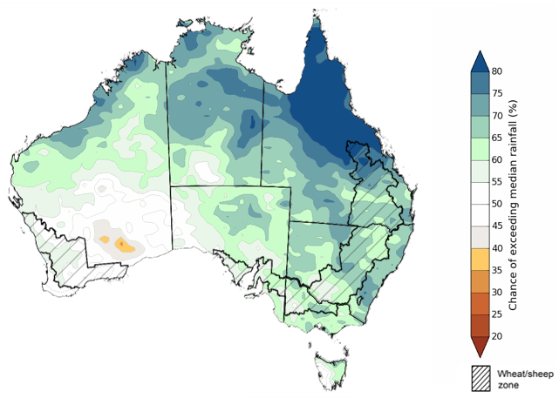

©Commonwealth of Australia 2025, Australian Bureau of Meteorology Issued: 23/1/2025

The rainfall outlook for February to April 2025 also includes rainfall totals which have a 75% of occurring:

* Between 200–600 millimetres are expected across much of northern Australia, including northern **Western Australia**, the **Northern Territory**, and **Queensland**. Rainfall totals greater than 600 millimetres are expected in the far-north of Australia.
* Rainfall totals between 25–200 millimetres are expected across much of the remainder of Queensland, Western Australia and the Northern Territory.
* Drier conditions are expected across southern Australia, including much of **New South Wales**, **Victoria** and **Tasmania**, with expected rainfall between 25–200 millimetres, with exceptions in coastal and alpine areas where greater rainfall is expected. Meanwhile, **South Australia** is likely to receive much lower falls of between 2–50 millimetres.

In cropping regions:

* Rainfall totals between 50–200 millimetres are forecast across much of Queensland and New South Wales, with a 75% likelihood. If realised, these forecast rainfall totals are likely to be sufficient to support late summer and early autumn pasture growth in these areas. Additionally, these expected falls are likely to provide a boost to soil moisture profiles and maintain above yield expectation for summer crops in Queensland and northern New South Wales.
* Forecast rainfall totals are lower in the south, between 25–100 millimetres with a 75% likelihood for much of Western Australia and Victoria, and between 10–50 millimetres in South Australia.

**Rainfall totals that have a 75% chance of occurring February 2025 to April 2025**

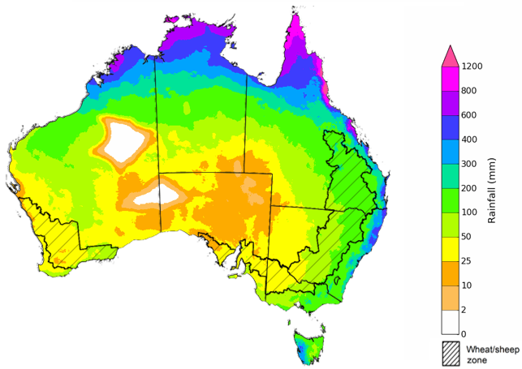

©Commonwealth of Australia 2025, Australian Bureau of Meteorology Issued: 23/1/2025

## **Water**

### Water markets – current week

Water storage levels in the Murray-Darling Basin (MDB) decreased between 16 January 2025 and 22 January 2025 by 278 gigalitres (GL). Current volume of water held in storage is 15 023 GL, equivalent to 68% of total storage capacity. This is 30 percent or 6,683GL less than at the same time last year. Water storage data is sourced from the BOM.

#### Water storages in the Murray-Darling Basin, 2013–2024

Allocation prices in the Victorian Murray below the Barmah Choke decreased from $158 on 16 January to $156 on 22 January. Prices are lower in regions above the Barmah choke due to the binding of the Barmah choke trade constraint.

#### Surface water trade activity, Southern Murray–Darling Basin

|  |
| --- |
| The trades shown reflect estimated market activity and do not encompass all register trades. The price is shown for the VIC Murray below the Barmah choke. Historical prices (before 1 July 2019) are ABARES estimates after removing outliers from BOM water register data. Prices after 1 July 2019 and prior to the 30 October 2019 reflect recorded transaction prices as sourced from Ruralco. Prices after the 30 October 2019 are sourced from Waterflow. Data for volume traded is sourced from the BOM water register. Only the price data shown is current on 17 October 2024. |

To access the full, interactive, weekly water dashboard, which contains the latest and historical water storage, water market and water allocation information, please visit <https://www.agriculture.gov.au/abares/products/weekly_update/weekly-update-230124>

## **Commodities**

|  |  |  |  |  |  |  |  |  |
| --- | --- | --- | --- | --- | --- | --- | --- | --- |
| **Indicator** | **Week average** | **Unit** | **Latest Price** | **Previous Week** | **Weekly change** | | **Price 12 months ago** | **Annual change** |
| **Selected world indicator prices** |  |  |  |  |  |  | |  |
| AUD/USD Exchange rate | 22-Jan | A$/US$ | 0.62 | 0.62 | 1% | 0.66 | | -6% |
| Wheat – US no. 2 hard red winter wheat, FOB Gulf | 22-Jan | US$/t | 256 | 253 | 1% | 284 | | -10% |
| Corn – US no. 2 yellow corn, FOB Gulf | 22-Jan | US$/t | 218 | 215 | 1% | 197 | | 10% |
| Canola – Rapeseed, Canada, FOB Vancouver | 22-Jan | US$/t | 476 | 473 | 1% | 505 | | -6% |
| Cotton – Cotlook A Index | 22-Jan | USc/lb | 78 | 78 | 0% | 92 | | -15% |
| Sugar – Intercontinental Exchange, nearby futures, no.11 contract | 22-Jan | USc/lb | 18 | 19 | -3% | 22 | | -19% |
| Wool – Eastern Market Indicator | 22-Jan | Ac/kg clean | 1,186 | 1,190 | 0% | 1,192 | | 0% |
| Wool – Western Market Indicator | 22-Jan | Ac/kg clean | 1,325 | 1,339 | -1% | 1,312 | | 1% |
| **Selected Australian grain export prices** |  |  |  |  |  |  | |  |
| Australian Premium White (APW) Wheat, FOB Port Adelaide, SA | 22-Jan | A$/t | 405 | 402 | 1% | 444 | | -9% |
| Australian Standard White (ASW) Wheat, FOB Port Adelaide, SA | 22-Jan | A$/t | 395 | 392 | 1% | 422 | | -6% |
| Feed Barley – FOB Port Adelaide, SA | 22-Jan | A$/t | 366 | 368 | -1% | 375 | | -3% |
| Canola – FOB Kwinana, WA | 22-Jan | A$/t | 855 | 872 | -2% | 742 | | 15% |
| Grain Sorghum – FOB Brisbane, QLD | 22-Jan | A$/t | 408 | 407 | 0% | 478 | | -15% |
| **Selected domestic livestock indicator prices** |  |  |  |  |  |  | |  |
| Beef – Eastern Young Cattle Indicator | 22-Jan | Ac/kg cwt | 697 | 706 | -1% | 618 | | 13% |
| Mutton – Mutton indicator (18–24 kg fat score 2–3), VIC | 22-Jan | Ac/kg cwt | 351 | 402 | -13% | 263 | | 33% |
| Lamb – National Trade Lamb Indicator | 22-Jan | Ac/kg cwt | 792 | 800 | -1% | 740 | | 7% |
| Pig – Eastern Seaboard (60.1–75 kg), NSW buyer price | 08-Jan | Ac/kg cwt | 454 | 454 | 0% | 408 | | 11% |
| Live cattle – Light steers to Indonesia | 25-Dec | Ac/kg lwt | 350 | 350 | 0% | 298 | | 17% |
| **Global Dairy Trade (GDT) weighted average prices** |  |  |  |  |  |  | |  |
| Dairy – Whole milk powder | 22-Jan | US$/t | 3,988 | 3,804 | 5% | 3,322 | | 20% |
| Dairy – Skim milk powder | 22-Jan | US$/t | 2,729 | 2,682 | 2% | 2,626 | | 4% |
| Dairy – Cheddar cheese | 22-Jan | US$/t | 4,846 | 4,728 | 2% | 4,191 | | 16% |
| Dairy – Anhydrous milk fat | 22-Jan | US$/t | 6,616 | 7,169 | -8% | 5,719 | | 16% |
|  | | | | | | | | |

### Selected world indicator prices

### 3.2 Selected domestic crop indicator prices

### Selected domestic livestock indicator prices

### Global Dairy Trade (GDT) weighted average prices

### Selected fruit and vegetable prices

### 3.6 Selected domestic fodder indicator prices

## **4. Data attribution**

### Climate

* Bureau of Meteorology
* Weekly rainfall totals: www.bom.gov.au/climate/maps/rainfall/
* Monthly and last 3-month rainfall percentiles: [www.bom.gov.au/water/landscape/](http://www.bom.gov.au/water/landscape/)
* Temperature anomalies: [www.bom.gov.au/jsp/awap/temp/index.jsp](http://www.bom.gov.au/jsp/awap/temp/index.jsp)
* Rainfall forecast: [www.bom.gov.au/jsp/watl/rainfall/pme.jsp](http://www.bom.gov.au/jsp/watl/rainfall/pme.jsp)
* Seasonal outlook: [www.bom.gov.au/climate/outlooks/#/overview/summary/](http://www.bom.gov.au/climate/outlooks/#/overview/summary/)
* Climate drivers: <http://www.bom.gov.au/climate/enso/>
* Soil moisture: [www.bom.gov.au/water/landscape/](http://www.bom.gov.au/water/landscape/)
* Other
* Pasture growth: [www.longpaddock.qld.gov.au/aussiegrass/](http://www.longpaddock.qld.gov.au/aussiegrass/)
* 3-month global outlooks: [Environment and Climate Change Canada](https://weather.gc.ca/saisons/image_e.html?img=s234pfe1p_cal&bc=prob), [NOAA Climate Prediction Center](https://www.cpc.ncep.noaa.gov/products/predictions/long_range/seasonal.php?lead=2), [EUROBRISA CPTEC/INPE](http://eurobrisa.cptec.inpe.br/), European Centre for Medium-Range Weather Forecasts, [Hydrometcenter of Russia](https://meteoinfo.ru/en/climate/seasonal-forecasts), [National Climate Center Climate System Diagnosis and Prediction Room (NCC)](https://cmdp.ncc-cma.net/pred/cs2gen.php?pred_elem=RAINP#pred_seasonal), [International Research Institute for Climate and Society](https://iri.columbia.edu/our-expertise/climate/forecasts/seasonal-climate-forecasts/)
* Global production: <https://ipad.fas.usda.gov/ogamaps/cropmapsandcalendars.aspx>
* Autumn break: Pook et al., 2009, <https://rmets-onlinelibrary-wiley-com.virtual.anu.edu.au/doi/epdf/10.1002/joc.1833>

### Water

Prices

* Waterflow: <https://www.waterflow.io/>
* Ruralco: <https://www.ruralcowater.com.au/>
* Bureau of Meteorology:
* Allocation trade: <http://www.bom.gov.au/water/dashboards/#/water-markets/mdb/at>
* Storage volumes: <http://www.bom.gov.au/water/dashboards/#/water-storages/summary/drainage>
* Trade constraints:
* Water NSW: <https://www.waternsw.com.au/customer-service/ordering-trading-and-pricing/trading/murrumbidgee>
* Victorian Water Register: <https://www.waterregister.vic.gov.au/TradingRules2019/>

### Commodities

* Fruit and vegetables
* Datafresh: [www.freshstate.com.au](http://www.freshstate.com.au)
* Pigs
* Australian Pork Limited: [www.australianpork.com.au](http://www.australianpork.com.au)
* Dairy
* Global Dairy Trade: [www.globaldairytrade.info/en/product-results/](http://www.globaldairytrade.info/en/product-results/)
* World wheat, canola
* International Grains Council
* World coarse grains
* United States Department of Agriculture
* World cotton
* Cotlook: [www.cotlook.com/](http://www.cotlook.com/)
* World sugar
* New York Stock Exchange - Intercontinental Exchange
* Wool
* Australian Wool Exchange: [www.awex.com.au/](http://www.awex.com.au/)
* Domestic wheat, barley, sorghum, canola and fodder
* Jumbuk Consulting Pty Ltd: http://www.jumbukag.com.au/
* Cattle, beef, mutton, lamb, goat and live export
* Meat and Livestock Australia: [www.mla.com.au/Prices-and-market](http://www.mla.com.au/Prices-and-market)

© Commonwealth of Australia 2025

### Ownership of intellectual property rights

Unless otherwise noted, copyright (and any other intellectual property rights, if any) in this publication is owned by the Commonwealth of Australia (referred to as the Commonwealth).

### Creative Commons licence

All material in this publication is licensed under a [Creative Commons Attribution 4.0 International Licence](https://creativecommons.org/licenses/by/4.0/legalcode) except content supplied by third parties, logos and the Commonwealth Coat of Arms.

Inquiries about the licence and any use of this document should be emailed to [copyright@awe.gov.au](mailto:copyright@awe.gov.au).

https://www.agriculture.gov.au/sites/default/files/images/creative-commons-logo-small.png

### Cataloguing data

This publication (and any material sourced from it) should be attributed as:

ABARES 2025, Weekly Australian Climate, Water and Agricultural Update, Australian Bureau of Agricultural and Resource Economics and Sciences, Canberra, 16 January 2025. CC BY 4.0 DOI: <https://doi.org/10.25814/5f3e04e7d2503>

ISSN **2652-7561**

This publication is available at https://www.agriculture.gov.au/abares/products/weekly_update

Department of Agriculture, Fisheries and Forestry

GPO Box 858 Canberra ACT 2601

Telephone 1800 900 090

Web [agriculture.gov.au/abares](http://awe.gov.au/abares)

### Disclaimer

The Australian Government acting through the Department of Agriculture, Fisheries and Forestry, represented by the Australian Bureau of Agricultural and Resource Economics and Sciences, has exercised due care and skill in preparing and compiling the information and data in this publication. Notwithstanding, the Department of Agriculture, Fisheries and Forestry, ABARES, its employees and advisers disclaim all liability, including liability for negligence and for any loss, damage, injury, expense or cost incurred by any person as a result of accessing, using or relying on any of the information or data in this publication to the maximum extent permitted by law.

### Statement of Professional Independence

The views and analysis presented in ABARES publications, including this one, reflect ABARES professionally independent findings, based on scientific and economic concepts, principles, information and data. These views, analysis and findings may not reflect or be consistent with the views or positions of the Australian Government, or of organisations or groups who have commissioned ABARES reports or analysis. More information on [professional independence](https://www.agriculture.gov.au/abares/about/research-and-analysis#professional-independence) is provided on the ABARES website.

### Acknowledgements

This report was prepared by Holly Beale and Matthew Miller.