## No. 2/2025 16 January 2025

# Summary of key issues

* In the week ending 15 January 2025, low-pressure systems brought rainfall to the north and east of Australia:
  + Many **northern cropping regions** recorded considerable rainfall totals (between 5–100 millimetres) across large areas of Queensland and northern New South Wales.
  + Conditions across **southern cropping regions** were drier (receiving 0–10 millimetres).
  + For eastern areas that recorded significant rainfall this week, this has likely provided a boost to soil moisture levels, benefitting summer crop production.
* Over the coming eight days, low-pressure systems are expected to bring rainfall across the north, east, and west of the country.
  + Across cropping regions, parts of Queensland, northern New South Wales and Western Australia are expected to receive up to 25 millimetres of rainfall. Little to no rainfall is expected in other cropping regions.
* **Global crop production prospects** are mixed following variable rainfall during December 2024:
  + In the southern hemisphere, rainfall was generally average to below average for major crop producing regions, with the exception of isolated areas of Australia and Indonesia.
  + In the northern hemisphere, conditions were mixed, with much of the United States and parts of the European Union and China seeing below average rainfall.
* According to BOM, **water storage levels** in the Murray-Darling Basin (MDB) decreased between 9–16 January 2025 by 178 gigalitres (GL). Current volume of water held in storage is 15,278 GL, 17% less than the same time last year and 69% of total storage capacity.
* **Allocation prices** in the Victorian Murray below the Barmah Choke on 16 January are $158. Prices are lower in regions above the Barmah choke due to the binding of the Barmah choke trade constraint.

## **Climate**

### Rainfall this week

In the week ending 15 January 2025, low-pressure systems and a series of troughs brought rainfall and storms to much of the north and east of the country, while central and southern regions remained largely dry.

* The northern tropics, including the **Northern Territory,** northern **Western Australia** and northern **Queensland** recorded falls of up to 100 millimetres. Parts of far-west Western Australia recorded up to 200 millimetres.
* Much of coastal and eastern **Queensland** and **New South Wales** received between 5–150 millimetres of rainfall; eastern **Victoria** and much of **Tasmania** received between 5–50 millimetres.
* **South Australia**, southern **Western Australia**, and western **Victoria** recorded little to no rainfall over the period, with isolated areas of up to 5 millimetres in some southern regions.

Rainfall totals were mixed across cropping regions:

* Southern cropping regions received little to no rainfall. This included much of **Western Australia, South Australia, Victoria**, and southwest **New South Wales**, which received between 0–5 millimetres.
* In the east, rainfall totals were generally higher, with **Queensland** and northern **New South Wales** recording between 5–100 millimetres. Higher rainfall totals occurred in eastern compared to western areas of New South Wales and Queensland cropping regions. For areas that recorded significant rainfall this week, this will likely provide a boost to soil moisture levels, benefitting summer crop production.

#### Rainfall for the week ending 15 January 2025

©Commonwealth of Australia 2025, Australian Bureau of Meteorology Issued: 15/1/2025

Note: The rainfall analyses and associated maps utilise data contained in the Bureau of Meteorology climate database, the Australian Data Archive for Meteorology (ADAM). The analyses are initially produced automatically from real-time data with limited [quality control](http://www.bom.gov.au/climate/headers/qc.shtml). They are intended to provide a general overview of rainfall across Australia as quickly as possible after the observations are received. For further information go to <http://www.bom.gov.au/climate/rainfall/>

### Rainfall forecast for the next eight days

Over the 8 days to 23 January 2025, **low-pressure troughs and systems rainfall and storms are expected over much of the east, north and west** of Australia:

* Falls between 15–150 millimetres are likely for much of northern Western Australia, the Northern Territory, northern Queensland, and coastal New South Wales. Higher rainfall totals are expected in isolated areas, with up to 200 millimetres forecast in scattered areas of far-north Western Australia. Between 15–100 millimetres are forecast for much of west Western Australia and southeast Queensland.
* By contrast, a **high-pressure system is expected to keep the south largely dry**, including east Western Australia, South Australia, and much of Victoria and central New South Wales (5–10 millimetres of rainfall), while east Victoria and Tasmania are forecast to see up to 15 millimetres in isolated areas.

Rainfall forecasts across cropping regions over the coming week are mixed:

* Low rainfall totals are expected in **southern cropping regions**, including across much of South Australia, Victoria, and southern and central New South Wales (between 5–10 millimetres)
* Higher rainfall is expected in **northern and western cropping regions**, with much of Queensland, northern New South Wales and Western Australia likely to receive between 10–25 millimetres. Rainfall forecast for summer cropping regions in Queensland should support soil moisture levels, while drier conditions in New South Wales could reduce stored soil moisture for planting and establishment.

#### Total forecast rainfall for the period 16 January to 23 January 2025

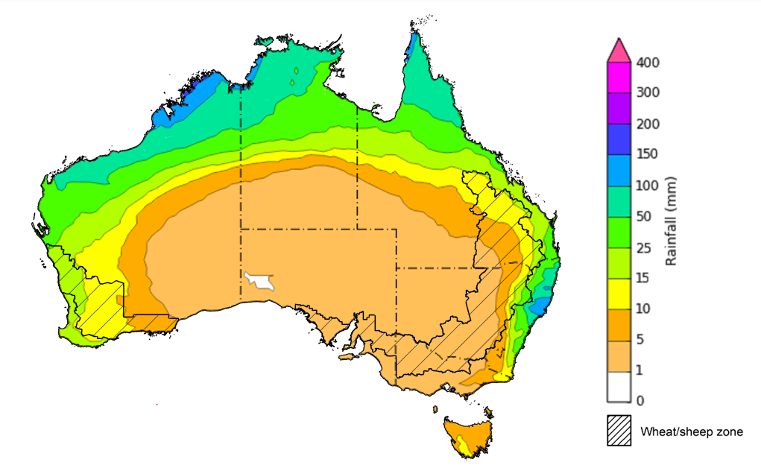

©Commonwealth of Australia 2025, Australian Bureau of Meteorology Issued 16/1/2025

Note: This rainfall forecast is produced from computer models. As the model outputs are not altered by weather forecasters, it is important to check local forecasts and warnings issued by the Bureau of Meteorology.

* 1. **Global crop production conditions and climate outlook**

Crop production is affected by long-term trends in average rainfall and temperature, interannual climate variability, shocks during specific growth stages, and extreme weather events. Some crops are more tolerant than others to certain types of stresses, and at each growth stage, different types of stresses affect crop species in different ways.

Precipitation anomalies and outlooks presented below indicate the current and expected future production conditions for major grain and oilseed producing countries (responsible for over 80% of global crop production). This is an important input to assessing the global grain supply outlook.

**December precipitation percentiles and current production conditions**

Rainfall in December 2024 was variable across the world’s major grain- and oilseed-producing regions:

* In the **southern hemisphere**, precipitation was below average in central Brazil, northern and eastern Argentina, and southwestern Australia. Rainfall was above average in large parts of South-East Asia and northern Australia.
* In the **northern hemisphere**, precipitation was below average in much of the southern United States and northern Mexico, western Europe, parts of the black sea regions, and eastern China. Precipitation was above average in southern India, the east of the Russian Federation, and the west of the Black Sea region.

**Global precipitation percentiles, December 2024**

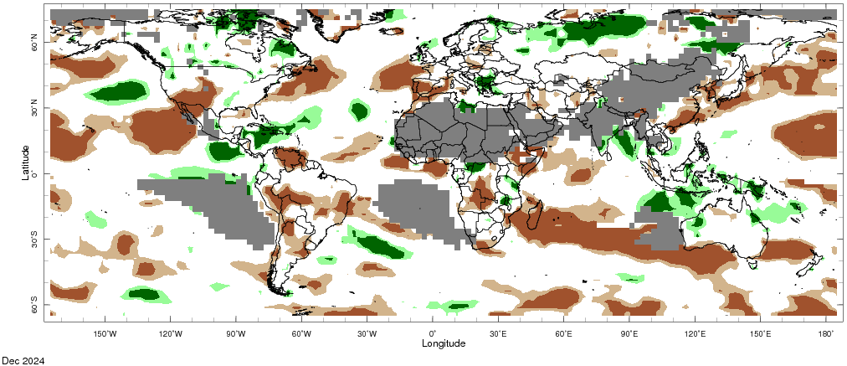

Note: The world precipitation percentiles indicate a ranking of precipitation for December, with the driest (0th percentile) being 0 on the scale and the wettest (100th percentile) being 1 on the scale. Percentiles are based on precipitation estimates from the NOAA Climate Prediction Center’s [Climate Anomaly Monitoring System Outgoing Precipitation Index](https://iridl.ldeo.columbia.edu/maproom/Global/Precipitation/Percentiles.html) dataset. Precipitation estimates for December 2024 are compared with rainfall recorded for that period during the 1981 to 2010 base period.

Source: International Research Institute for Climate and Society

**Rainfall outlook and potential impact on the future state of production conditions, February–April 2025**

|  |  |  |
| --- | --- | --- |
| **Region** | **February-April rainfall outlook** | **Potential impact on production** |
| **Argentina** | Average to above average rainfall is more likely across northern parts of Argentina, with much of eastern Argentina likely to see below average rainfall. | Below average rainfall in cropping regions in the east is likely to impact flowering of soybeans, rice, sorghum, and millet crops over February. |
| **Black Sea Region** | Below average to average rainfall is expected across much of the Black Sea region, including parts of Türkiye, Ukraine, and the west of the Russian Federation. | Winter wheat and canola will remain dormant throughout February and March across the Black Sea Region. Below average rainfall in many parts may reduce snowpack levels that protect crops from winterkill. |
| **Brazil** | Average rainfall is likely for much of northern and southern Brazil, with below average rainfall more likely in central regions. | Average rainfall in northern and southern Brazil may support the heading of rice, sorghum, millet, and sunflower in February, as well as the flowering and development of cotton and corn in March and April. Below average rainfall in central Brazil will likely adversely affect the growth, flowering and filling of these crops. |
| **Canada** | Generally, average to above average rainfall is likely across the south, except for parts of the south-east which is likely to see below average rainfall. | Above average rainfall in the western prairies is likely to provide sufficient snowpack to prevent winterkill of winter wheat from February to March and support the critical heading period in April. However, below average rainfall in the east may reduce snowpack levels that protect crops from winterkill. |
| **China** | Below average rainfall is likely across much of China, especially in eastern regions. Above average rainfall is more likely in the far north. | Drier than average conditions in eastern regions may reduce snowpack and increase the risk of winterkill for winter wheat and canola in February, as well as negatively impact the heading of these crops over April. |
| **Europe** | Average rainfall is likely for much of Europe, although parts of northern Europe, including Germany, are likely to see below average rainfall. | Average rainfall may support snowpack in parts of central Europe, decreasing the risk of winterkill for winter wheat and canola in February and March. However, low rainfall in the north may reduce snowpack and increase the risk of winterkill damage. Average rainfall in the south is likely to support the heading of winter wheat from March to April. |
| **South Asia (India)** | Above average rainfall is expected in the south. Average rainfall is likely across remaining areas. | Average or better rainfall across much of India will also support the heading and filling of winter wheat and canola in January. |
| **Southeast Asia (SEA)** | Average to above average rainfall is likely across much of Indonesia and parts of Thailand, with average rainfall expected in the remaining regions. | Average to above average rainfall in SEA may impede the harvest of corn, rice, and soybean in Indonesia, but may support the establishment of rice in Thailand. |
| **The United States of America (US)** | Generally, below average rainfall is likely for much of southern US, with above average rainfall more likely across the northeast and northwest. | Above average rainfall conditions expected across the northern US is likely to provide sufficient snow cover from February to protect winter wheat and canola through dormancy. However, below average rainfall across southern US presents a downside production risk for winter wheat. |

## **Water**

### Water markets – current week

Water storage levels in the Murray-Darling Basin (MDB) decreased between 9 January 2025 and 16 January 2025 by 178 gigalitres (GL). Current volume of water held in storage is 15 278 GL, equivalent to 69% of total storage capacity. This is 17 percent or 3,832GL less than at the same time last year. Water storage data is sourced from the Bureau of Meteorology.

#### Water storages in the Murray-Darling Basin, 2013–2024

Allocation prices in the Victorian Murray below the Barmah Choke on 16 January are $158. Prices are lower in regions above the Barmah choke due to the binding of the Barmah choke trade constraint.

.

#### Surface water trade activity, Southern Murray–Darling Basin

|  |
| --- |
| The trades shown reflect estimated market activity and do not encompass all register trades. The price is shown for the VIC Murray below the Barmah choke. Historical prices (before 1 July 2019) are ABARES estimates after removing outliers from BOM water register data. Prices after 1 July 2019 and prior to the 30 October 2019 reflect recorded transaction prices as sourced from Ruralco. Prices after the 30 October 2019 are sourced from Waterflow. Data for volume traded is sourced from the BOM water register. Only the price data shown is current on 17 October 2024. |

To access the full, interactive, weekly water dashboard, which contains the latest and historical water storage, water market and water allocation information, please visit <https://www.agriculture.gov.au/abares/products/weekly_update/weekly-update-160124>

## **Commodities**

|  |  |  |  |  |  |  |  |  |
| --- | --- | --- | --- | --- | --- | --- | --- | --- |
| **Indicator** | **Week average** | **Unit** | **Latest Price** | **Previous Week** | **Weekly change** | | **Price 12 months ago** | **Annual change** |
| **Selected world indicator prices** |  |  |  |  |  |  | |  |
| AUD/USD Exchange rate | 15-Jan | A$/US$ | 0.62 | 0.62 | -1% | 0.66 | | -7% |
| Wheat – US no. 2 hard red winter wheat, FOB Gulf | 15-Jan | US$/t | 254 | 251 | 1% | 284 | | -11% |
| Corn – US no. 2 yellow corn, FOB Gulf | 15-Jan | US$/t | 214 | 208 | 3% | 197 | | 9% |
| Canola – Rapeseed, Canada, FOB Vancouver | 15-Jan | US$/t | 483 | 470 | 3% | 505 | | -4% |
| Cotton – Cotlook A Index | 15-Jan | USc/lb | 78 | 79 | -1% | 92 | | -16% |
| Sugar – Intercontinental Exchange, nearby futures, no.11 contract | 15-Jan | USc/lb | 19 | 19 | -2% | 22 | | -15% |
| Wool – Eastern Market Indicator | 15-Jan | Ac/kg clean | 1,190 | 1,154 | 3% | 1,192 | | 0% |
| Wool – Western Market Indicator | 15-Jan | Ac/kg clean | 1,339 | 1,298 | 3% | 1,312 | | 2% |
| **Selected Australian grain export prices** |  |  |  |  |  |  | |  |
| Australian Premium White (APW) Wheat, FOB Port Adelaide, SA | 15-Jan | A$/t | 401 | 403 | -1% | 444 | | -10% |
| Australian Standard White (ASW) Wheat, FOB Port Adelaide, SA | 15-Jan | A$/t | 391 | 393 | -1% | 422 | | -7% |
| Feed Barley – FOB Port Adelaide, SA | 15-Jan | A$/t | 368 | 369 | 0% | 375 | | -2% |
| Canola – FOB Kwinana, WA | 15-Jan | A$/t | 874 | 858 | 2% | 742 | | 18% |
| Grain Sorghum – FOB Brisbane, QLD | 15-Jan | A$/t | 405 | 402 | 1% | 478 | | -15% |
| **Selected domestic livestock indicator prices** |  |  |  |  |  |  | |  |
| Beef – Eastern Young Cattle Indicator | 15-Jan | Ac/kg cwt | 705 | 711 | -1% | 618 | | 14% |
| Mutton – Mutton indicator (18–24 kg fat score 2–3), VIC | 15-Jan | Ac/kg cwt | 417 | 436 | -4% | 263 | | 59% |
| Lamb – National Trade Lamb Indicator | 15-Jan | Ac/kg cwt | 800 | 820 | -2% | 740 | | 8% |
| Pig – Eastern Seaboard (60.1–75 kg), NSW buyer price | 01-Jan | Ac/kg cwt | 454 | 454 | 0% | 408 | | 11% |
| Live cattle – Light steers to Indonesia | 25-Dec | Ac/kg lwt | 350 | 350 | 0% | 298 | | 17% |
| **Global Dairy Trade (GDT) weighted average prices** |  |  |  |  |  |  | |  |
| Dairy – Whole milk powder | 08-Jan | US$/t | 3,804 | 3,809 | 0% | 3,322 | | 15% |
| Dairy – Skim milk powder | 08-Jan | US$/t | 2,682 | 2,757 | -3% | 2,626 | | 2% |
| Dairy – Cheddar cheese | 08-Jan | US$/t | 4,728 | 4,682 | 1% | 4,191 | | 13% |
| Dairy – Anhydrous milk fat | 08-Jan | US$/t | 7,169 | 7,267 | -1% | 5,719 | | 25% |
|  | | | | | | | | |

### Selected world indicator prices

### 3.2 Selected domestic crop indicator prices

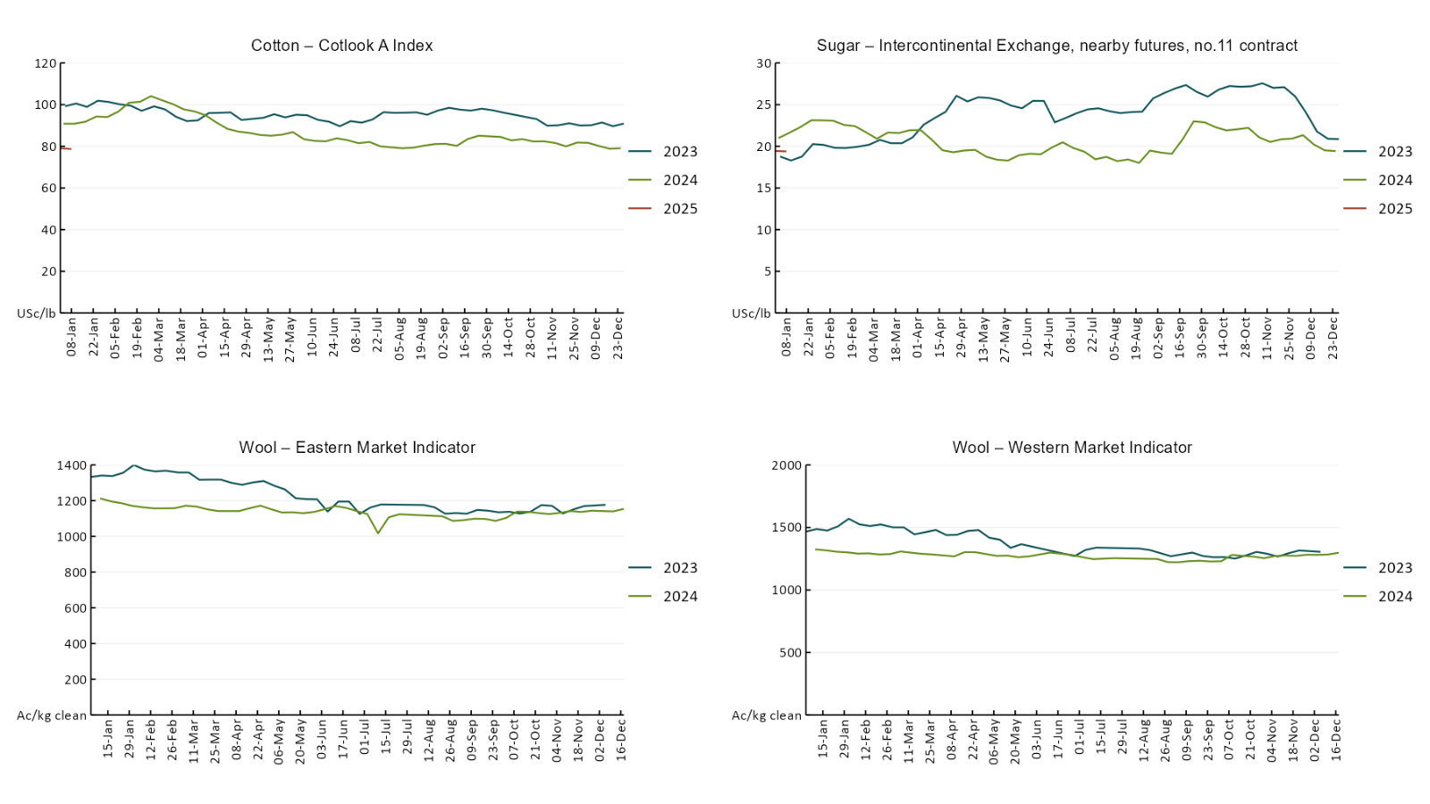

### Selected domestic livestock indicator prices

### Global Dairy Trade (GDT) weighted average prices

### Selected fruit and vegetable prices

### 3.6 Selected domestic fodder indicator prices

## **4. Data attribution**

### Climate

* Bureau of Meteorology
* Weekly rainfall totals: www.bom.gov.au/climate/maps/rainfall/
* Monthly and last 3-month rainfall percentiles: [www.bom.gov.au/water/landscape/](http://www.bom.gov.au/water/landscape/)
* Temperature anomalies: [www.bom.gov.au/jsp/awap/temp/index.jsp](http://www.bom.gov.au/jsp/awap/temp/index.jsp)
* Rainfall forecast: [www.bom.gov.au/jsp/watl/rainfall/pme.jsp](http://www.bom.gov.au/jsp/watl/rainfall/pme.jsp)
* Seasonal outlook: [www.bom.gov.au/climate/outlooks/#/overview/summary/](http://www.bom.gov.au/climate/outlooks/#/overview/summary/)
* Climate drivers: <http://www.bom.gov.au/climate/enso/>
* Soil moisture: [www.bom.gov.au/water/landscape/](http://www.bom.gov.au/water/landscape/)
* Other
* Pasture growth: [www.longpaddock.qld.gov.au/aussiegrass/](http://www.longpaddock.qld.gov.au/aussiegrass/)
* 3-month global outlooks: [Environment and Climate Change Canada](https://weather.gc.ca/saisons/image_e.html?img=s234pfe1p_cal&bc=prob), [NOAA Climate Prediction Center](https://www.cpc.ncep.noaa.gov/products/predictions/long_range/seasonal.php?lead=2), [EUROBRISA CPTEC/INPE](http://eurobrisa.cptec.inpe.br/), European Centre for Medium-Range Weather Forecasts, [Hydrometcenter of Russia](https://meteoinfo.ru/en/climate/seasonal-forecasts), [National Climate Center Climate System Diagnosis and Prediction Room (NCC)](https://cmdp.ncc-cma.net/pred/cs2gen.php?pred_elem=RAINP#pred_seasonal), [International Research Institute for Climate and Society](https://iri.columbia.edu/our-expertise/climate/forecasts/seasonal-climate-forecasts/)
* Global production: <https://ipad.fas.usda.gov/ogamaps/cropmapsandcalendars.aspx>
* Autumn break: Pook et al., 2009, <https://rmets-onlinelibrary-wiley-com.virtual.anu.edu.au/doi/epdf/10.1002/joc.1833>

### Water

Prices

* Waterflow: <https://www.waterflow.io/>
* Ruralco: <https://www.ruralcowater.com.au/>
* Bureau of Meteorology:
* Allocation trade: <http://www.bom.gov.au/water/dashboards/#/water-markets/mdb/at>
* Storage volumes: <http://www.bom.gov.au/water/dashboards/#/water-storages/summary/drainage>
* Trade constraints:
* Water NSW: <https://www.waternsw.com.au/customer-service/ordering-trading-and-pricing/trading/murrumbidgee>
* Victorian Water Register: <https://www.waterregister.vic.gov.au/TradingRules2019/>

### Commodities

* Fruit and vegetables
* Datafresh: [www.freshstate.com.au](http://www.freshstate.com.au)
* Pigs
* Australian Pork Limited: [www.australianpork.com.au](http://www.australianpork.com.au)
* Dairy
* Global Dairy Trade: [www.globaldairytrade.info/en/product-results/](http://www.globaldairytrade.info/en/product-results/)
* World wheat, canola
* International Grains Council
* World coarse grains
* United States Department of Agriculture
* World cotton
* Cotlook: [www.cotlook.com/](http://www.cotlook.com/)
* World sugar
* New York Stock Exchange - Intercontinental Exchange
* Wool
* Australian Wool Exchange: [www.awex.com.au/](http://www.awex.com.au/)
* Domestic wheat, barley, sorghum, canola and fodder
* Jumbuk Consulting Pty Ltd: http://www.jumbukag.com.au/
* Cattle, beef, mutton, lamb, goat and live export
* Meat and Livestock Australia: [www.mla.com.au/Prices-and-market](http://www.mla.com.au/Prices-and-market)

© Commonwealth of Australia 2025

### Ownership of intellectual property rights

Unless otherwise noted, copyright (and any other intellectual property rights, if any) in this publication is owned by the Commonwealth of Australia (referred to as the Commonwealth).

### Creative Commons licence

All material in this publication is licensed under a [Creative Commons Attribution 4.0 International Licence](https://creativecommons.org/licenses/by/4.0/legalcode) except content supplied by third parties, logos and the Commonwealth Coat of Arms.

Inquiries about the licence and any use of this document should be emailed to [copyright@awe.gov.au](mailto:copyright@awe.gov.au).

https://www.agriculture.gov.au/sites/default/files/images/creative-commons-logo-small.png

### Cataloguing data

This publication (and any material sourced from it) should be attributed as:

ABARES 2025, Weekly Australian Climate, Water and Agricultural Update, Australian Bureau of Agricultural and Resource Economics and Sciences, Canberra, 16 January 2025. CC BY 4.0 DOI: <https://doi.org/10.25814/5f3e04e7d2503>

ISSN **2652-7561**

This publication is available at https://www.agriculture.gov.au/abares/products/weekly_update

Department of Agriculture, Fisheries and Forestry

GPO Box 858 Canberra ACT 2601

Telephone 1800 900 090

Web [agriculture.gov.au/abares](http://awe.gov.au/abares)

### Disclaimer

The Australian Government acting through the Department of Agriculture, Fisheries and Forestry, represented by the Australian Bureau of Agricultural and Resource Economics and Sciences, has exercised due care and skill in preparing and compiling the information and data in this publication. Notwithstanding, the Department of Agriculture, Fisheries and Forestry, ABARES, its employees and advisers disclaim all liability, including liability for negligence and for any loss, damage, injury, expense or cost incurred by any person as a result of accessing, using or relying on any of the information or data in this publication to the maximum extent permitted by law.

### Statement of Professional Independence

The views and analysis presented in ABARES publications, including this one, reflect ABARES professionally independent findings, based on scientific and economic concepts, principles, information and data. These views, analysis and findings may not reflect or be consistent with the views or positions of the Australian Government, or of organisations or groups who have commissioned ABARES reports or analysis. More information on [professional independence](https://www.agriculture.gov.au/abares/about/research-and-analysis#professional-independence) is provided on the ABARES website.

### Acknowledgements

This report was prepared by Holly Beale and Matthew Miller.