## A picture containing text Description automatically generatedNo. 49/2024 19 December 2024

This is the last weekly Climate Update for 2024.

# The next Update will be published on 9 January 2025.

# Summary of key issues

* In the week ending 18 December 2024, low-pressure systems brought rainfall to the north and west of Australia.
  + Many northern cropping regions recorded significant rainfall totals this week. Totals of between 5 to 100 millimetres were recorded across large areas of Queensland, and up to 25 millimetres in parts of northern New South Wales and Western Australia.
  + Conditions across southern cropping regions of the country were drier, generally receiving 0 to 10 millimetres of rainfall.
  + For eastern areas that recorded significant rainfall this week, this has likely provided a boost to soil moisture levels benefitting summer crop production.
* Over the coming days, low-pressure systems are expected to bring rainfall across the north and parts of the south-east of the country.
  + Across cropping regions, parts of northern Queensland are expected to record falls of between 10 and 50 millimetres. Meanwhile, little to no rainfall is expected in other cropping regions.
* Globally, variable rainfall during November has led to mixed crop production prospects.
  + Global production conditions were generally favourable for rice and soybeans, but more variable for wheat and maize.
  + Global production conditions have been less favourable compared to those used to formulate ABARES forecasts of global grain supplies and world prices for 2024–25 in its December 2024 edition of the Agricultural Commodities Report. As a result, global grain and oilseed production are likely to decline slightly compared to those presented in the December forecast.
* Water storage levels in the Murray-Darling Basin (MDB) decreased between 12 December 2024 and 19 December 2024 by 54 gigalitres (GL). Current volume of water held in storage is 16 439 GL, equivalent to 74% of total storage capacity. This is 15 percent or 2,918GL less than at the same time last year. Water storage data is sourced from the Bureau of Meteorology.
* Allocation prices in the Victorian Murray below the Barmah Choke decreased from $144 on 12 December 2024 to $143 on 19 December 2024. Prices are lower in regions above the Barmah choke due to the binding of the Barmah choke trade constraint.

## **Climate**

### Rainfall this week

In the week ending 18 December 2024, low-pressure systems and troughs brought heavy rainfall to much of the north and west of the country. Falls of between 5 and 100 millimetres were recorded across much of the north of the Northern Territory, Western Australia and Queensland, with parts of central Western Australia seeing up to 150 millimetres. In Queensland, isolated coastal areas in the east saw up to 300 millimetres. High-pressure systems kept much of southern and central Australia largely dry, with the exception of Tasmania, which observed a maximum of 100 millimetres of rainfall in the west.

Across cropping regions, rainfall was low in the south, with much of South Australia, Victoria, New South Wales, south-western Queensland and southern Western Australia recording little to no rainfall. In contrast, cropping regions northern and eastern Queensland, and isolated areas of northern New South Wales saw between 5 and 100 millimetres of rainfall. Similarly, parts of northern Western Australia saw between 5 and 25 millimetres of rainfall. For those areas of eastern Australia that recorded significant rainfall this week, this will likely provide a boost to soil moisture levels benefitting summer crop production.

#### Rainfall for the week ending 18 December 2024

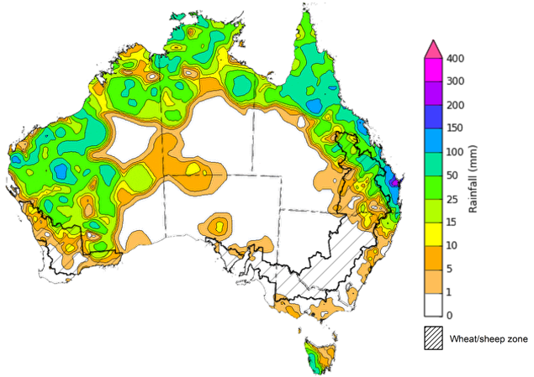

©Commonwealth of Australia 2024, Australian Bureau of Meteorology Issued: 18/12/2024

Note: The rainfall analyses and associated maps utilise data contained in the Bureau of Meteorology climate database, the Australian Data Archive for Meteorology (ADAM). The analyses are initially produced automatically from real-time data with limited [quality control](http://www.bom.gov.au/climate/headers/qc.shtml). They are intended to provide a general overview of rainfall across Australia as quickly as possible after the observations are received. For further information go to <http://www.bom.gov.au/climate/rainfall/>

### Rainfall forecast for the next eight days

Over the 8 days to 26 December 2024, low-pressure systems are expected to bring high rainfall totals to the northern tropics, with falls of between 25 and 100 millimetres likely for much of northern Australia. In Queensland, up to 150 millimetres of rainfall is forecast across the north-east. Lower 8-day rainfall totals are expected across parts of southern Victoria, with between 5 and 25 millimetres of rainfall forecast, and Tasmania where up to 50 millimetres forecast. High-pressure systems are expected to keep the remainder of the country largely dry, with little to no rainfall forecast for much of the southern two-thirds of the country.

Across cropping regions, rainfall totals are forecast to be low, with cropping regions across Western Australia, South Australia, Victoria, New South Wales, and southern Queensland likely to receive little to no rainfall over the period. In northern Queensland, showers of 10 to 50 millimetres are expected. Rainfall forecast for summer cropping regions in northern Queensland will likely provide a boost for soil moisture levels and support the germination and growth of crops already in the ground.

#### Total forecast rainfall for the period 19 December to 26 December 2024

©Commonwealth of Australia 2024, Australian Bureau of Meteorology Issued 19/12/2024

Note: This rainfall forecast is produced from computer models. As the model outputs are not altered by weather forecasters, it is important to check local forecasts and warnings issued by the Bureau of Meteorology.

* 1. **Global crop production conditions and climate outlook**

Crop production is affected by long-term trends in average rainfall and temperature, interannual climate variability, shocks during specific growth stages, and extreme weather events. Some crops are more tolerant than others to certain types of stresses, and at each growth stage, different types of stresses affect each crop species in different ways.

The precipitation anomalies and outlooks presented here give an indication of the current and future state of production conditions for the major grain and oilseed producing countries which are responsible for over 80% of global crop production. This is an important input to assessing the global grain supply outlook.

**November precipitation percentiles and current production conditions**

Rainfall in November 2024 was variable across the world’s major grain- and oilseed-producing regions.

In the southern hemisphere, precipitation was below average in northern and eastern Brazil and western Argentina. Rainfall was above average in large parts of Australia and part of South-East Asia. Rainfall was generally average in the remaining grain- and oilseed-producing regions in the southern hemisphere.

In the northern hemisphere, precipitation was below average in much of southern Europe, central and western India, parts of southern China and parts of northern Mexico. Precipitation was above average parts of the west of the Russian Federation, south-western China, southern Canada, and much of the centre and west of the United States. Rainfall was generally average in the remaining grain- and oilseed-producing nations in the northern hemisphere.

**Global precipitation percentiles, November 2024**

Note: The world precipitation percentiles indicate a ranking of precipitation for October, with the driest (0th percentile) being 0 on the scale and the wettest (100th percentile) being 1 on the scale. Percentiles are based on precipitation estimates from the NOAA Climate Prediction Center’s [Climate Anomaly Monitoring System Outgoing Precipitation Index](https://iridl.ldeo.columbia.edu/maproom/Global/Precipitation/Percentiles.html) dataset. Precipitation estimates for October 2024 are compared with rainfall recorded for that period during the 1981 to 2010 base period.

Source: International Research Institute for Climate and Society

As of 28 November 2024, global production conditions were generally favourable for rice and soybeans, but variable for wheat and maize:

* **Wheat –** in the northern hemisphere, winter wheat is developing under unfavourable climatic conditions, due to excessively wet conditions in Europe, dry planting conditions in the Russian Federation, the United States and Ukraine. In the southern hemisphere, harvest is progressing under variable conditions, with dryness impacting yield across parts of Argentina and Australia.
* **Maize –** in the northern hemisphere, harvest is ending under variable conditions. Sowing in Argentina, Brazil and South Africa is underway under favourable conditions.
* **Rice –** Conditions are generally favourable, however, adverse climate conditions have negatively impacted crops in the Philippines.
* **Soybeans –** Harvest in the northern hemisphere, and sowing in the southern hemisphere, is progressing under favourable conditions.

**Crop conditions, AMIS countries, 28 November 2024**

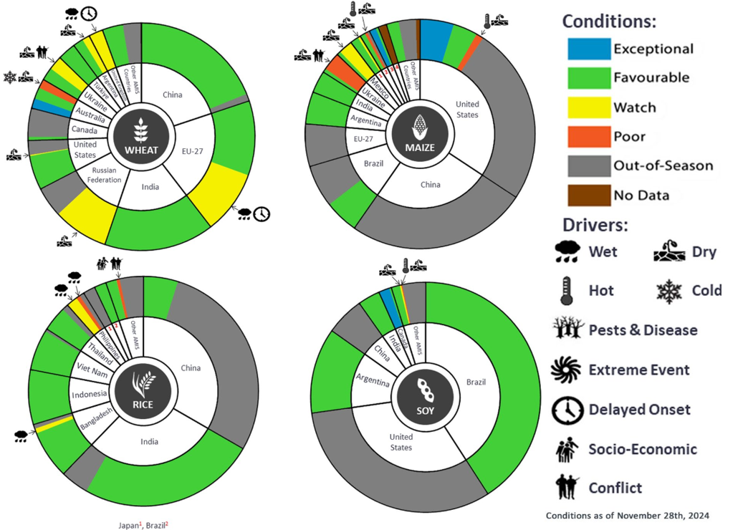

**AMIS** Agricultural Market Information System.

Source: AMIS

The global climate outlook for January 2025 to March 2025 indicates that mixed rainfall conditions are expected for the world’s major grain-producing and oilseed-producing regions. Outlooks and potential production impacts for the major grain and oilseed producing countries are presented in the following table.

**Rainfall outlook and potential impact on the future state of production conditions between** **January 2025 to March 2025**

|  |  |  |
| --- | --- | --- |
| **Region** | **January-March rainfall outlook** | **Potential impact on production** |
| **Argentina** | Average to above average rainfall is more likely across eastern and northern parts of Argentina. | Average to above average rainfall is likely to benefit flowering of corn, cotton, soybeans, rice, sorghum, millet, and sunflower crops over the January to March period. |
| **Black Sea Region** | Below average to average rainfall is expected across much of the Black Sea region, including parts of Türkiye, Ukraine, and west of the Russian Federation. | Winter wheat and canola will remain dormant throughout January to March across the Black Sea Region. Below average rainfall in many parts may reduce snowpack levels that protect crops from winterkill. |
| **Brazil** | Close to average rainfall is more likely for much of Brazil, with below average rainfall likely in the west. | Above average rainfall in northern Brazil may support the flowering of corn, soybeans, groundnuts, and cotton in from December to January, as well as the grain filling of these crops over January and February. Below average rainfall in west of Brazil will likely adversely affect the growth, flowering and filling of soybeans. |
| **Canada** | Generally, average to above average rainfall is likely across western cropping regions, with below average rainfall more likely in the east. | In the west average to above average rainfall is likely to provide sufficient snowpack to prevent winterkill of winter wheat from January to March. However, below average rainfall in the east may reduce snowpack levels that protect crops from winterkill. |
| **China** | Below average rainfall is likely across eastern regions of China. Average to above average rainfall is more likely in central regions. | Drier than average conditions in eastern regions may reduce snowpack and increase the risk of winterkill for winter wheat and canola from January to March. Higher rainfall in central regions may support the establishment of rice in March. |
| **Europe** | Average rainfall is likely for much of Europe, although parts of southern Europe are likely to see above average rainfall. Northern Europe, particularly Germany and surrounding areas, are likely to see below average rainfall. | Average rainfall may boost snowpack in parts of central Europe, decreasing the risk of winterkill for winter wheat and canola, however, low rainfall in the north may reduce snowpack and increase the risk of winterkill damage. Above average rainfall in the south is likely to support the heading of winter wheat. |
| **South Asia (India)** | Below average rainfall is likely in the west, with above average rainfall expected in the south. Average rainfall is likely across remaining areas. | Average or better rainfall across much of India will also support the heading and filling of winter wheat and canola in January. |
| **Southeast Asia (SEA)** | Average to above average rainfall is likely across much of Southeast Asia. | Average to above average rainfall in SEA may impede the harvest of corn, rice, and soybean in Indonesia Maylasia and the Philippines, but may support the establishment of rice in Thailand and Vietnam. |
| **The United States of America (US)** | Generally, below average rainfall is likely for much of southern half of the US, with above average rainfall more likely across the northern half. | Above average rainfall conditions expected across the northern US is likely to provide sufficient snow cover from January to March to protect winter wheat and canola through dormancy. However, below average rainfall across southern US presents a downside production risk for winter wheat. |

## **Water**

### Water markets – current week

Water storage levels in the Murray-Darling Basin (MDB) decreased between 12 December 2024 and 19 December 2024 by 54 gigalitres (GL). Current volume of water held in storage is 16 439 GL, equivalent to 74% of total storage capacity. This is 15 percent or 2,918GL less than at the same time last year. Water storage data is sourced from the Bureau of Meteorology.

#### Water storages in the Murray-Darling Basin, 2013–2024

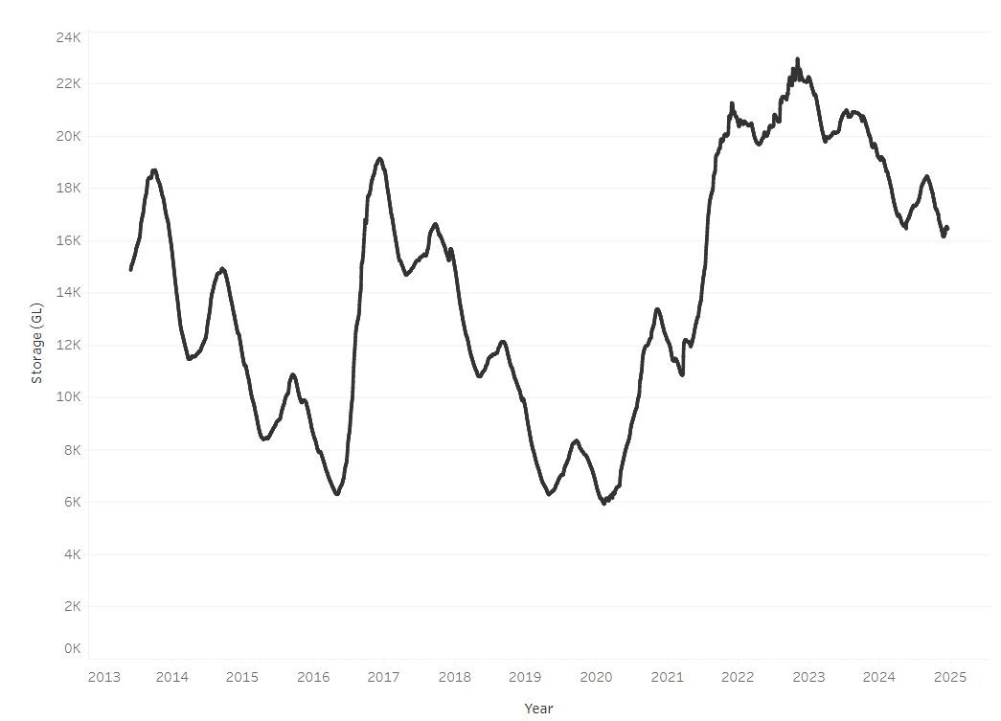

Allocation prices in the Victorian Murray below the Barmah Choke decreased from $144 on 12 December 2024 to $143 on 19 December 2024. Prices are lower in regions above the Barmah choke due to the binding of the Barmah choke trade constraint.

#### Surface water trade activity, Southern Murray–Darling Basin

|  |
| --- |
| The trades shown reflect estimated market activity and do not encompass all register trades. The price is shown for the VIC Murray below the Barmah choke. Historical prices (before 1 July 2019) are ABARES estimates after removing outliers from BOM water register data. Prices after 1 July 2019 and prior to the 30 October 2019 reflect recorded transaction prices as sourced from Ruralco. Prices after the 30 October 2019 are sourced from Waterflow. Data for volume traded is sourced from the BOM water register. Only the price data shown is current on 17 October 2024. |

To access the full, interactive, weekly water dashboard, which contains the latest and historical water storage, water market and water allocation information, please visit [https://www.agriculture.gov.au/abares/products/weekly_update/weekly-update-191224](https://www.agriculture.gov.au/abares/products/weekly_update/weekly-update-121224)

## **Commodities**

|  |  |  |  |  |  |  |  |  |
| --- | --- | --- | --- | --- | --- | --- | --- | --- |
| **Indicator** | **Week average** | **Unit** | **Latest Price** | **Previous Week** | **Weekly change** | | **Price 12 months ago** | **Annual change** |
| **Selected world indicator prices** |  |  |  |  |  |  | |  |
| AUD/USD Exchange rate | 18-Dec | A$/US$ | 0.63 | 0.64 | 0% | 0.68 | | -7% |
| Wheat – US no. 2 hard red winter wheat, FOB Gulf | 18-Dec | US$/t | 255 | 257 | -1% | 289 | | -12% |
| Corn – US no. 2 yellow corn, FOB Gulf | 18-Dec | US$/t | 201 | 205 | -2% | 203 | | -1% |
| Canola – Rapeseed, Canada, FOB Vancouver | 18-Dec | US$/t | 455 | 468 | -3% | 538 | | -15% |
| Cotton – Cotlook A Index | 18-Dec | USc/lb | 79 | 80 | -1% | 91 | | -13% |
| Sugar – Intercontinental Exchange, nearby futures, no.11 contract | 18-Dec | USc/lb | 20 | 20 | -3% | 21 | | -6% |
| Wool – Eastern Market Indicator | 18-Dec | Ac/kg clean | 1,154 | 1,140 | 1% | 1,176 | | -2% |
| Wool – Western Market Indicator | 18-Dec | Ac/kg clean | 1,298 | 1,284 | 1% | 1,263 | | 3% |
| **Selected Australian grain export prices** |  |  |  |  |  |  | |  |
| Australian Premium White (APW) Wheat, FOB Port Adelaide, SA | 18-Dec | A$/t | 403 | 402 | 0% | 442 | | -9% |
| Australian Standard White (ASW) Wheat, FOB Port Adelaide, SA | 18-Dec | A$/t | 393 | 392 | 0% | 422 | | -7% |
| Feed Barley – FOB Port Adelaide, SA | 18-Dec | A$/t | 367 | 366 | 0% | 375 | | -2% |
| Canola – FOB Kwinana, WA | 18-Dec | A$/t | 876 | 869 | 1% | 744 | | 18% |
| Grain Sorghum – FOB Brisbane, QLD | 18-Dec | A$/t | 405 | 403 | 0% | 476 | | -15% |
| **Selected domestic livestock indicator prices** |  |  |  |  |  |  | |  |
| Beef – Eastern Young Cattle Indicator | 18-Dec | Ac/kg cwt | 680 | 679 | 0% | 510 | | 33% |
| Mutton – Mutton indicator (18–24 kg fat score 2–3), VIC | 18-Dec | Ac/kg cwt | 395 | 392 | 1% | 131 | | 202% |
| Lamb – National Trade Lamb Indicator | 18-Dec | Ac/kg cwt | 886 | 868 | 2% | 618 | | 43% |
| Pig – Eastern Seaboard (60.1–75 kg), NSW buyer price | 27-Nov | Ac/kg cwt | 454 | 446 | 2% | 386 | | 18% |
| Live cattle – Light steers to Indonesia | 18-Dec | Ac/kg lwt | 350 | 350 | 0% | 290 | | 21% |
| **Global Dairy Trade (GDT) weighted average prices** |  |  |  |  |  |  | |  |
| Dairy – Whole milk powder | 18-Dec | US$/t | 3,809 | 3,984 | -4% | 3,279 | | 16% |
| Dairy – Skim milk powder | 18-Dec | US$/t | 2,757 | 2,848 | -3% | 2,972 | | -7% |
| Dairy – Cheddar cheese | 18-Dec | US$/t | 4,682 | 4,689 | 0% | 4,802 | | -2% |
| Dairy – Anhydrous milk fat | 18-Dec | US$/t | 7,267 | 7,583 | -4% | 5,562 | | 31% |
|  | | | | | | | | |

### Selected world indicator prices

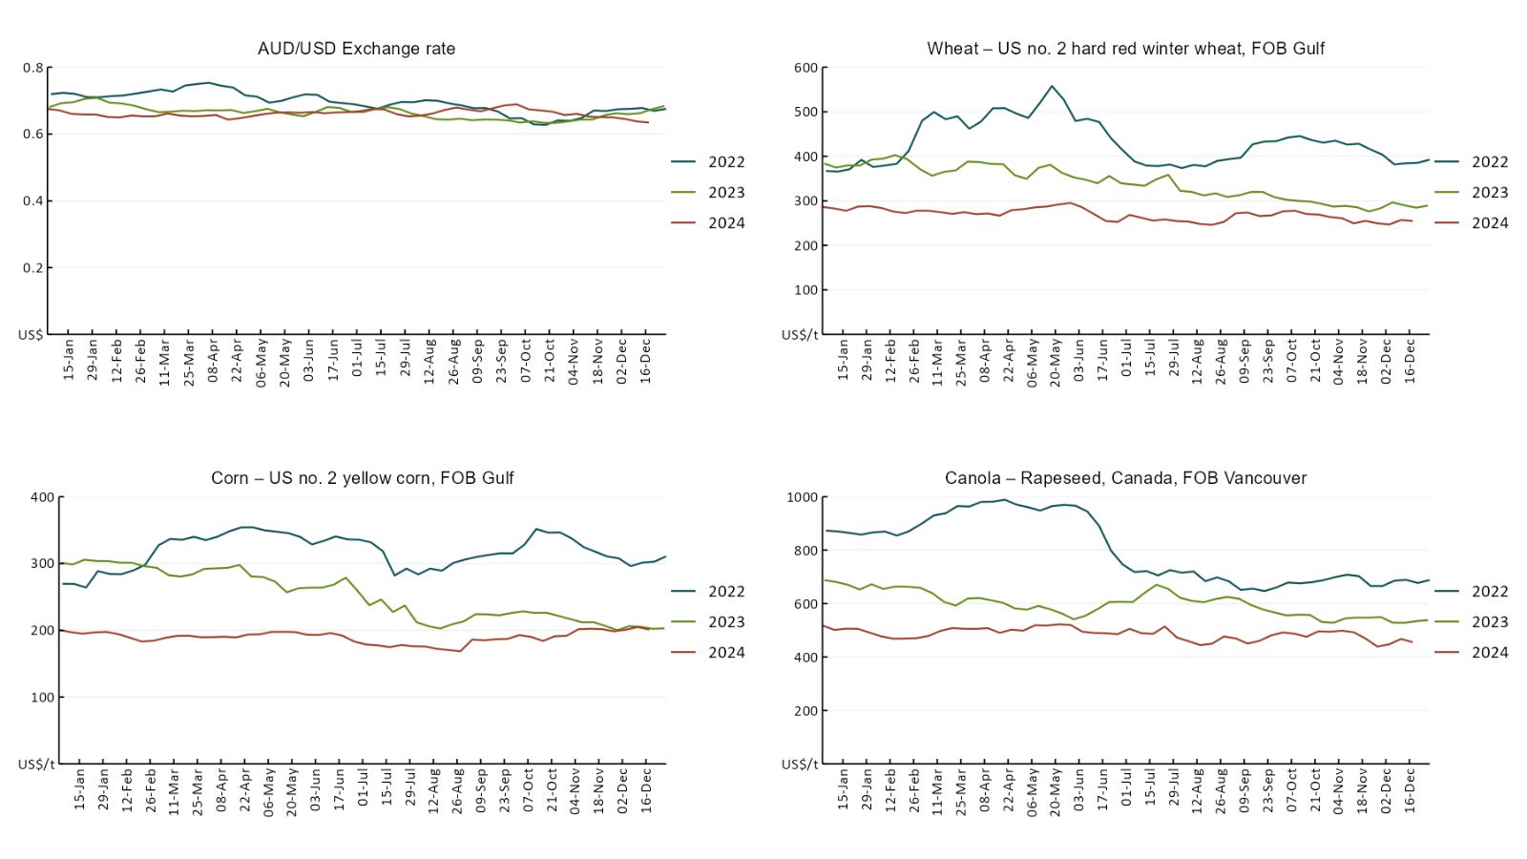

### 3.2 Selected domestic crop indicator prices

### Selected domestic livestock indicator prices

### Global Dairy Trade (GDT) weighted average prices

### Selected fruit and vegetable prices

### 3.6 Selected domestic fodder indicator prices

## **4. Data attribution**

### Climate

* Bureau of Meteorology
* Weekly rainfall totals: www.bom.gov.au/climate/maps/rainfall/
* Monthly and last 3-month rainfall percentiles: [www.bom.gov.au/water/landscape/](http://www.bom.gov.au/water/landscape/)
* Temperature anomalies: [www.bom.gov.au/jsp/awap/temp/index.jsp](http://www.bom.gov.au/jsp/awap/temp/index.jsp)
* Rainfall forecast: [www.bom.gov.au/jsp/watl/rainfall/pme.jsp](http://www.bom.gov.au/jsp/watl/rainfall/pme.jsp)
* Seasonal outlook: [www.bom.gov.au/climate/outlooks/#/overview/summary/](http://www.bom.gov.au/climate/outlooks/#/overview/summary/)
* Climate drivers: <http://www.bom.gov.au/climate/enso/>
* Soil moisture: [www.bom.gov.au/water/landscape/](http://www.bom.gov.au/water/landscape/)
* Other
* Pasture growth: [www.longpaddock.qld.gov.au/aussiegrass/](http://www.longpaddock.qld.gov.au/aussiegrass/)
* 3-month global outlooks: [Environment and Climate Change Canada](https://weather.gc.ca/saisons/image_e.html?img=s234pfe1p_cal&bc=prob), [NOAA Climate Prediction Center](https://www.cpc.ncep.noaa.gov/products/predictions/long_range/seasonal.php?lead=2), [EUROBRISA CPTEC/INPE](http://eurobrisa.cptec.inpe.br/), European Centre for Medium-Range Weather Forecasts, [Hydrometcenter of Russia](https://meteoinfo.ru/en/climate/seasonal-forecasts), [National Climate Center Climate System Diagnosis and Prediction Room (NCC)](https://cmdp.ncc-cma.net/pred/cs2gen.php?pred_elem=RAINP#pred_seasonal), [International Research Institute for Climate and Society](https://iri.columbia.edu/our-expertise/climate/forecasts/seasonal-climate-forecasts/)
* Global production: <https://ipad.fas.usda.gov/ogamaps/cropmapsandcalendars.aspx>
* Autumn break: Pook et al., 2009, <https://rmets-onlinelibrary-wiley-com.virtual.anu.edu.au/doi/epdf/10.1002/joc.1833>

### Water

Prices

* Waterflow: <https://www.waterflow.io/>
* Ruralco: <https://www.ruralcowater.com.au/>
* Bureau of Meteorology:
* Allocation trade: <http://www.bom.gov.au/water/dashboards/#/water-markets/mdb/at>
* Storage volumes: <http://www.bom.gov.au/water/dashboards/#/water-storages/summary/drainage>
* Trade constraints:
* Water NSW: <https://www.waternsw.com.au/customer-service/ordering-trading-and-pricing/trading/murrumbidgee>
* Victorian Water Register: <https://www.waterregister.vic.gov.au/TradingRules2019/>

### Commodities

* Fruit and vegetables
* Datafresh: [www.freshstate.com.au](http://www.freshstate.com.au)
* Pigs
* Australian Pork Limited: [www.australianpork.com.au](http://www.australianpork.com.au)
* Dairy
* Global Dairy Trade: [www.globaldairytrade.info/en/product-results/](http://www.globaldairytrade.info/en/product-results/)
* World wheat, canola
* International Grains Council
* World coarse grains
* United States Department of Agriculture
* World cotton
* Cotlook: [www.cotlook.com/](http://www.cotlook.com/)
* World sugar
* New York Stock Exchange - Intercontinental Exchange
* Wool
* Australian Wool Exchange: [www.awex.com.au/](http://www.awex.com.au/)
* Domestic wheat, barley, sorghum, canola and fodder
* Jumbuk Consulting Pty Ltd: http://www.jumbukag.com.au/
* Cattle, beef, mutton, lamb, goat and live export
* Meat and Livestock Australia: [www.mla.com.au/Prices-and-market](http://www.mla.com.au/Prices-and-market)

© Commonwealth of Australia 2024

### Ownership of intellectual property rights

Unless otherwise noted, copyright (and any other intellectual property rights, if any) in this publication is owned by the Commonwealth of Australia (referred to as the Commonwealth).

### Creative Commons licence

All material in this publication is licensed under a [Creative Commons Attribution 4.0 International Licence](https://creativecommons.org/licenses/by/4.0/legalcode) except content supplied by third parties, logos and the Commonwealth Coat of Arms.

Inquiries about the licence and any use of this document should be emailed to [copyright@awe.gov.au](mailto:copyright@awe.gov.au).

https://www.agriculture.gov.au/sites/default/files/images/creative-commons-logo-small.png

### Cataloguing data

This publication (and any material sourced from it) should be attributed as:

ABARES 2024, Weekly Australian Climate, Water and Agricultural Update, Australian Bureau of Agricultural and Resource Economics and Sciences, Canberra, 19 December 2024. CC BY 4.0 DOI: <https://doi.org/10.25814/5f3e04e7d2503>

ISSN **2652-7561**

This publication is available at https://www.agriculture.gov.au/abares/products/weekly_update

Department of Agriculture, Fisheries and Forestry

GPO Box 858 Canberra ACT 2601

Telephone 1800 900 090

Web [agriculture.gov.au/abares](http://awe.gov.au/abares)

### Disclaimer

The Australian Government acting through the Department of Agriculture, Fisheries and Forestry, represented by the Australian Bureau of Agricultural and Resource Economics and Sciences, has exercised due care and skill in preparing and compiling the information and data in this publication. Notwithstanding, the Department of Agriculture, Fisheries and Forestry, ABARES, its employees and advisers disclaim all liability, including liability for negligence and for any loss, damage, injury, expense or cost incurred by any person as a result of accessing, using or relying on any of the information or data in this publication to the maximum extent permitted by law.

### Statement of Professional Independence

The views and analysis presented in ABARES publications, including this one, reflect ABARES professionally independent findings, based on scientific and economic concepts, principles, information and data. These views, analysis and findings may not reflect or be consistent with the views or positions of the Australian Government, or of organisations or groups who have commissioned ABARES reports or analysis. More information on [professional independence](https://www.agriculture.gov.au/abares/about/research-and-analysis#professional-independence) is provided on the ABARES website.

### Acknowledgements

This report was prepared by Holly Beale and Matthew Miller.