## No. 46/2024 28 November 2024

# Summary of key issues

* In the week ending 27 November 2024, low-pressure systems and troughs brought rainfall to much of Australia.
  + Many southern cropping regions recorded significant rainfall. Totals of between 10 to 50 millimetres were recorded across Victoria, southern New South Wales and parts of eastern South Australia.
  + Cropping regions in central and northern New South Wales, Queensland and most of Western Australia were drier, generally receiving 0 to 10 millimetres of rainfall.
  + For south-eastern areas that recorded significant rainfall this week, this has likely delayed the harvest of remaining winter crops.
* Over the coming days, low-pressure systems are expected to bring rainfall across all states and territories.
  + Across cropping regions, rainfall is expected to be high in the east, with falls of between 50 and 100 millimetres forecast across much of New South Wales and parts of northern and southern Queensland. Meanwhile, falls of between 15 and 50 millimetres are forecast for the remainder of Queensland and New South Wales, and much of Victoria. In Western Australia and South Australia, rainfall totals are expected to be lower.
  + Rainfall forecast for summer cropping regions in New South Wales and Queensland will likely provide a boost for soil moisture levels and support the germination and growth of crops already in the ground.
* The national rainfall outlook for December 2024 to February 2025 indicates there is a high probability of above median rainfall in many eastern and western regions of the country.
  + Higher than median rainfall is expected in Queensland, New South Wales, Western Australia and Victoria.
  + There is a 75% chance of rainfall between 50 and 200 millimetres across most eastern cropping regions, with higher rainfall totals expected in Queensland and northern New South Wales likely to provide favourable growing conditions for the summer cropping season. Between 25 and 50 millimetres of rainfall is forecast in South Australia, while parts of eastern Victoria and Western Australia are expected to see up to 100 millimetres.
* Water storage levels in the Murray-Darling Basin (MDB) decreased between 21 November 2024 and 28 November 2024 by 174 gigalitres (GL). The current volume of water held in storage is 16,131 GL, equivalent to 72% of total storage capacity. This is 17 percent or 3,399 GL less than at the same time last year. Water storage data is sourced from the BOM.
* Water allocation prices in the Victorian Murray below the Barmah Choke decreased from $145 a ML on 21 November 2024 to $136 a ML on 28 November 2024. Prices are lower in regions above the Barmah choke because the Barmah choke trade constraint is currently binding.

## **Climate**

### Rainfall this week

For the week ending 27 November 2024, low-pressure systems and troughs brought rainfall much of Australia. A trough extending from the northwest to southeast brought rainfall totals of up to 100 millimetres in northern Western Australia, the Northern Territory, central and south-eastern South Australia, much of Victoria and isolated parts of southern New South Wales. Up to 150 millimetres of rainfall was recorded in some parts of the northern tropics in Queensland and the Northern Territory. In Western Australia, up to 50 millimetres of rainfall was recorded in central areas, and 5 and 25 millimetres in the southwest. In contrast, high-pressure systems kept much of northern New South Wales, southern Queensland and Tasmania relatively dry.

Across cropping regions, rainfall outcomes were mixed. Much of northern New South Wales, western South Australia, Queensland, and Western Australia saw little or no rainfall, with totals in these areas generally less than 10 millimetres. Rainfall totals were higher in the southeast, with between 10 and 50 millimetres recorded in southern New South Wales, Victoria, and eastern South Australia, with isolated areas seeing as much as 100 millimetres. For those south-eastern areas that recorded significant rainfall this week, this has likely delayed the harvest of remaining winter crops.

#### Rainfall for the week ending 27 November 2024

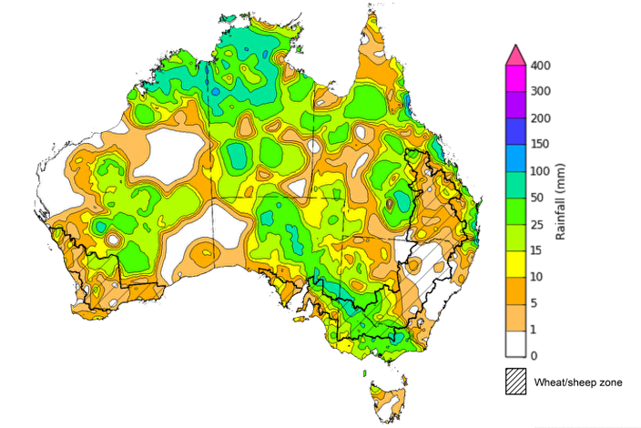

©Commonwealth of Australia 2024, Australian Bureau of Meteorology Issued: 27/11/2024

Note: The rainfall analyses and associated maps utilise data contained in the Bureau of Meteorology climate database, the Australian Data Archive for Meteorology (ADAM). The analyses are initially produced automatically from real-time data with limited [quality control](http://www.bom.gov.au/climate/headers/qc.shtml). They are intended to provide a general overview of rainfall across Australia as quickly as possible after the observations are received. For further information go to <http://www.bom.gov.au/climate/rainfall/>

### Rainfall forecast for the next eight days

Over the 8 days to 5 December 2024, significant rainfall and storms are expected across the north and east of Australia. Falls of between 10 and 100 millimetres are forecast for much of the Northern Territory, Queensland, New South Wales, Victoria, South Australia, Tasmania and the east and north-east of Western Australia. High pressure systems are expected to keep central and western areas comparatively dry, with much of the remainder of Western Australia forecast to receive between 5 and 10 millimetres of rainfall, and much of South Australia forecast to receive between 10 and 25 millimetres.

Across cropping regions, rainfall is forecast to be relatively low in the west, with much of Western Australia expected to receive between 5 and 10 millimetres. In the east, rainfall totals of between 15 and 100 millimetres are forecast for New South Wales, Queensland and much of Victoria. In South Australian cropping regions, between 10 and 25 millimetres is forecast.

If realised, rainfall across eastern cropping regions will likely interrupt the harvest of remaining winter crops. Rainfall forecast for summer cropping regions in northern New South Wales and Queensland will likely provide a boost for soil moisture levels and support the germination and growth of crops already in the ground.

#### Total forecast rainfall for the period 28 November to 5 December 2024

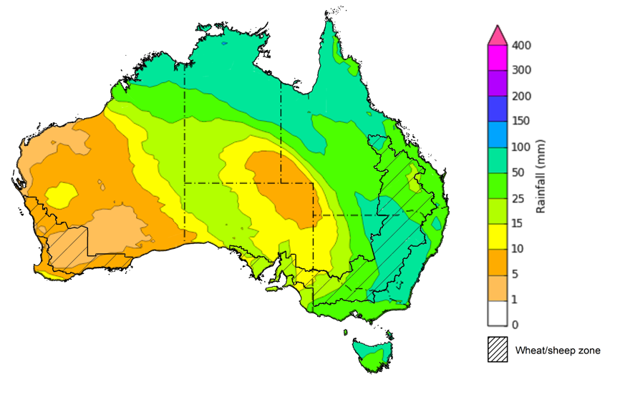

©Commonwealth of Australia 2024, Australian Bureau of Meteorology Issued 28/11/2024

Note: This rainfall forecast is produced from computer models. As the model outputs are not altered by weather forecasters, it is important to check local forecasts and warnings issued by the Bureau of Meteorology.

* 1. **National Climate Outlook**

The El Niño Southern Oscillation (ENSO) and Indian Ocean Dipole (IOD) climate drivers are currently neutral and having minimal influence on Australian rainfall. The Southern Annular Mode (SAM) is currently neutral and has a high chance to become positive in December. A positive SAM contributes to an increased chance of summer rain in south-eastern Australia.

The most recent rainfall outlook for December 2024 provided by the Bureau of Meteorology indicates that much of eastern Australia, including eastern Queensland, New South Wales, Victoria and Tasmania, as well as parts of Western Australia are likely to see above median rainfall. For the remaining regions, rainfall is likely to be similar to average.

According to the Bureau of Meteorology’s climate model, for December 2024, there is a 75% chance of rainfall between 25 and 100 millimetres across much of eastern Queensland, New South Wales and Victoria. Rainfall totals are likely to be higher in the north, with the northern tropics likely to receive between 100 and 200 millimetres of rainfall over the period, with isolated areas in the far-north of the Northern Territory and Queensland seeing as much as 300 millimetres. Tasmania is forecast to receive between 50 and 200 millimetres of rain in December. In contrast, much of western and central Australia is likely to receive between 5 and 50 millimetres.

Across cropping regions, there is a 75% chance of receiving between 25 and 100 millimetres of rainfall across much of Queensland and New South Wales in December 2024, with higher rainfall totals generally expected in eastern regions of these states. In South Australia, Victoria and eastern Western Australia, rainfall totals are expected to be between 10 and 25 millimetres. These relatively low expected rainfall totals across much of southern Australia continue to represent a significant downside risk for pasture growth over summer. However, if forecast rainfall totals are realised across much of New South Wales and Queensland, these falls are likely to be sufficient to support above average yield prospects for summer crops and average or better levels of pasture production in these regions.

**Rainfall totals that have a 75% chance of occurring in December 2024**

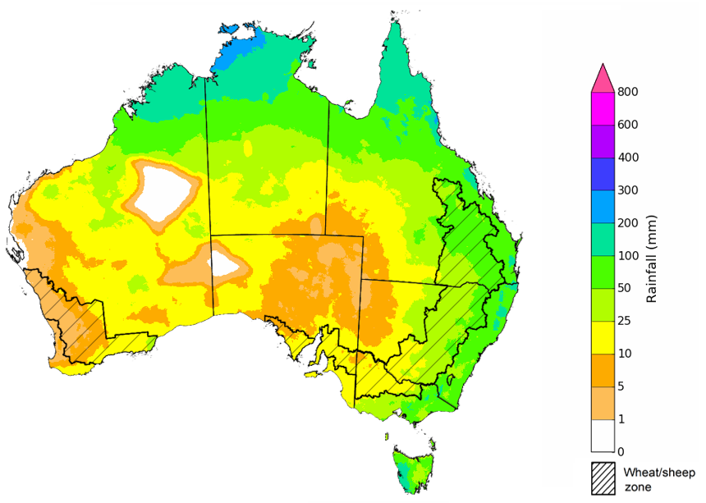

©Commonwealth of Australia 2024, Australian Bureau of Meteorology Issued: 28/11/2024

The rainfall outlook for December 2024 to February 2025 indicates an increased probability of above median rainfall across many eastern and western areas of Australia. In contrast, below median rainfall is slightly more likely across isolated areas of the Northern Territory. Much of the remainder of the country is showing an equal probability of above or below median rainfall.

Across cropping regions, the chance of receiving above median rainfall is between 60% and 80% across much of Queensland, New South Wales, Victoria and Western Australia. In South Australia, there are approximately equal chances of receiving above or below median rainfall.

**Chance of exceeding the median rainfall** **December 2024 to February 2025**

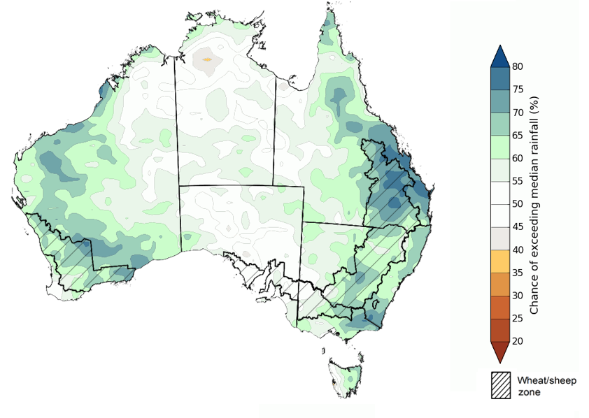

©Commonwealth of Australia 2024, Australian Bureau of Meteorology Issued: 28/11/2024

The outlook for December to February suggests a 75% chance of receiving rainfall totals of between 50 and 300 millimetres across much of Queensland, New South Wales, Victoria, Tasmania, and the Northern Territory. Rainfall totals in excess of 300 millimetres are forecast for the tropical north of Western Australia, the Northern Territory, and Queensland, as well as coastal areas of Queensland and New South Wales, and western Tasmania. Western Australia is likely to see between 25 and 200 millimetres, with rainfall totals generally higher in the north.

In summer cropping regions, there is a 75% chance of receiving between 100 and 300 millimetres of rainfall between December 2024 and February 2025. If realised, this will boost soil moisture profiles and would likely generate above average yield expectations for summer crops in Queensland and northern New South Wales. In winter cropping regions, rainfall totals from December 2024 to February 2025 are expected to be lower, with between 10 and 50 millimetres of rainfall likely across much of Western Australia and South Australia, and between 25 and 100 millimetres in Victoria.

**Rainfall totals that have a 75% chance of occurring December 2024 to February 2025**

©Commonwealth of Australia 2024, Australian Bureau of Meteorology Issued: 28/11/2024

## **Water**

### Water markets – current week

Water storage levels in the Murray-Darling Basin (MDB) decreased between 21 November 2024 and 28 November 2024 by 174 gigalitres (GL). Current volume of water held in storage is 16 131 GL, equivalent to 72% of total storage capacity. This is 17 percent or 3,399GL less than at the same time last year. Water storage data is sourced from the BOM.

#### Water storages in the Murray-Darling Basin, 2013–2024

Allocation prices in the Victorian Murray below the Barmah Choke decreased from $145 on 21 November 2024 to $136 on 28 November 2024. Prices are lower in regions above the Barmah choke due to the binding of the Barmah choke trade constraint.

#### Surface water trade activity, Southern Murray–Darling Basin

|  |
| --- |
| The trades shown reflect estimated market activity and do not encompass all register trades. The price is shown for the VIC Murray below the Barmah choke. Historical prices (before 1 July 2019) are ABARES estimates after removing outliers from BOM water register data. Prices after 1 July 2019 and prior to the 30 October 2019 reflect recorded transaction prices as sourced from Ruralco. Prices after the 30 October 2019 are sourced from Waterflow. Data for volume traded is sourced from the BOM water register. Only the price data shown is current on 17 October 2024. |

To access the full, interactive, weekly water dashboard, which contains the latest and historical water storage, water market and water allocation information, please visit <https://www.agriculture.gov.au/abares/products/weekly_update/weekly-update-281124>

## **Commodities**

|  |  |  |  |  |  |  |  |  |
| --- | --- | --- | --- | --- | --- | --- | --- | --- |
| **Indicator** | **Week average** | **Unit** | **Latest Price** | **Previous Week** | **Weekly change** | | **Price 12 months ago** | **Annual change** |
| **Selected world indicator prices** |  |  |  |  |  |  | |  |
| AUD/USD Exchange rate | 27-Nov | A$/US$ | 0.65 | 0.65 | 0% | 0.66 | | -1% |
| Wheat – US no. 2 hard red winter wheat, FOB Gulf | 27-Nov | US$/t | 271 | 266 | 2% | 297 | | -8% |
| Corn – US no. 2 yellow corn, FOB Gulf | 27-Nov | US$/t | 198 | 202 | -2% | 206 | | -4% |
| Canola – Rapeseed, Canada, FOB Vancouver | 27-Nov | US$/t | 446 | 469 | -5% | 529 | | -16% |
| Cotton – Cotlook A Index | 27-Nov | USc/lb | 82 | 80 | 2% | 90 | | -9% |
| Sugar – Intercontinental Exchange, nearby futures, no.11 contract | 27-Nov | USc/lb | 20 | 21 | -4% | 24 | | -16% |
| Wool – Eastern Market Indicator | 27-Nov | Ac/kg clean | 1,144 | 1,137 | 1% | 1,138 | | 1% |
| Wool – Western Market Indicator | 27-Nov | Ac/kg clean | 1,282 | 1,273 | 1% | 1,299 | | -1% |
| **Selected Australian grain export prices** |  |  |  |  |  |  | |  |
| Australian Premium White (APW) Wheat, FOB Port Adelaide, SA | 27-Nov | A$/t | 402 | 401 | 0% | 451 | | -11% |
| Australian Standard White (ASW) Wheat, FOB Port Adelaide, SA | 27-Nov | A$/t | 392 | 391 | 0% | 431 | | -9% |
| Feed Barley – FOB Port Adelaide, SA | 27-Nov | A$/t | 356 | 353 | 1% | 383 | | -7% |
| Canola – FOB Kwinana, WA | 27-Nov | A$/t | 844 | 861 | -2% | 766 | | 10% |
| Grain Sorghum – FOB Brisbane, QLD | 27-Nov | A$/t | 399 | 399 | 0% | 498 | | -20% |
| **Selected domestic livestock indicator prices** |  |  |  |  |  |  | |  |
| Beef – Eastern Young Cattle Indicator | 27-Nov | Ac/kg cwt | 630 | 629 | 0% | 530 | | 19% |
| Mutton – Mutton indicator (18–24 kg fat score 2–3), VIC | 27-Nov | Ac/kg cwt | 381 | 363 | 5% | 199 | | 92% |
| Lamb – National Trade Lamb Indicator | 27-Nov | Ac/kg cwt | 817 | 800 | 2% | 559 | | 46% |
| Pig – Eastern Seaboard (60.1–75 kg), NSW buyer price | 13-Nov | Ac/kg cwt | 444 | 440 | 1% | 376 | | 18% |
| Live cattle – Light steers to Indonesia | 27-Nov | Ac/kg lwt | 325 | 325 | 0% | 280 | | 16% |
| **Global Dairy Trade (GDT) weighted average prices** |  |  |  |  |  |  | |  |
| Dairy – Whole milk powder | 20-Nov | US$/t | 3,826 | 3,713 | 3% | 3,573 | | 7% |
| Dairy – Skim milk powder | 20-Nov | US$/t | 2,882 | 2,850 | 1% | 3,497 | | -18% |
| Dairy – Cheddar cheese | 20-Nov | US$/t | 4,834 | 4,973 | -3% | 4,966 | | -3% |
| Dairy – Anhydrous milk fat | 20-Nov | US$/t | 7,622 | 7,558 | 1% | 5,811 | | 31% |
|  | | | | | | | | |

### Selected world indicator prices

### 3.2 Selected domestic crop indicator prices

### Selected domestic livestock indicator prices

### Global Dairy Trade (GDT) weighted average prices

### Selected fruit and vegetable prices

### 3.6 Selected domestic fodder indicator prices

## **4. Data attribution**

### Climate

* Bureau of Meteorology
* Weekly rainfall totals: www.bom.gov.au/climate/maps/rainfall/
* Monthly and last 3-month rainfall percentiles: [www.bom.gov.au/water/landscape/](http://www.bom.gov.au/water/landscape/)
* Temperature anomalies: [www.bom.gov.au/jsp/awap/temp/index.jsp](http://www.bom.gov.au/jsp/awap/temp/index.jsp)
* Rainfall forecast: [www.bom.gov.au/jsp/watl/rainfall/pme.jsp](http://www.bom.gov.au/jsp/watl/rainfall/pme.jsp)
* Seasonal outlook: [www.bom.gov.au/climate/outlooks/#/overview/summary/](http://www.bom.gov.au/climate/outlooks/#/overview/summary/)
* Climate drivers: <http://www.bom.gov.au/climate/enso/>
* Soil moisture: [www.bom.gov.au/water/landscape/](http://www.bom.gov.au/water/landscape/)
* Other
* Pasture growth: [www.longpaddock.qld.gov.au/aussiegrass/](http://www.longpaddock.qld.gov.au/aussiegrass/)
* 3-month global outlooks: [Environment and Climate Change Canada](https://weather.gc.ca/saisons/image_e.html?img=s234pfe1p_cal&bc=prob), [NOAA Climate Prediction Center](https://www.cpc.ncep.noaa.gov/products/predictions/long_range/seasonal.php?lead=2), [EUROBRISA CPTEC/INPE](http://eurobrisa.cptec.inpe.br/), European Centre for Medium-Range Weather Forecasts, [Hydrometcenter of Russia](https://meteoinfo.ru/en/climate/seasonal-forecasts), [National Climate Center Climate System Diagnosis and Prediction Room (NCC)](https://cmdp.ncc-cma.net/pred/cs2gen.php?pred_elem=RAINP#pred_seasonal), [International Research Institute for Climate and Society](https://iri.columbia.edu/our-expertise/climate/forecasts/seasonal-climate-forecasts/)
* Global production: <https://ipad.fas.usda.gov/ogamaps/cropmapsandcalendars.aspx>
* Autumn break: Pook et al., 2009, <https://rmets-onlinelibrary-wiley-com.virtual.anu.edu.au/doi/epdf/10.1002/joc.1833>

### Water

Prices

* Waterflow: <https://www.waterflow.io/>
* Ruralco: <https://www.ruralcowater.com.au/>
* Bureau of Meteorology:
* Allocation trade: <http://www.bom.gov.au/water/dashboards/#/water-markets/mdb/at>
* Storage volumes: <http://www.bom.gov.au/water/dashboards/#/water-storages/summary/drainage>
* Trade constraints:
* Water NSW: <https://www.waternsw.com.au/customer-service/ordering-trading-and-pricing/trading/murrumbidgee>
* Victorian Water Register: <https://www.waterregister.vic.gov.au/TradingRules2019/>

### Commodities

* Fruit and vegetables
* Datafresh: [www.freshstate.com.au](http://www.freshstate.com.au)
* Pigs
* Australian Pork Limited: [www.australianpork.com.au](http://www.australianpork.com.au)
* Dairy
* Global Dairy Trade: [www.globaldairytrade.info/en/product-results/](http://www.globaldairytrade.info/en/product-results/)
* World wheat, canola
* International Grains Council
* World coarse grains
* United States Department of Agriculture
* World cotton
* Cotlook: [www.cotlook.com/](http://www.cotlook.com/)
* World sugar
* New York Stock Exchange - Intercontinental Exchange
* Wool
* Australian Wool Exchange: [www.awex.com.au/](http://www.awex.com.au/)
* Domestic wheat, barley, sorghum, canola and fodder
* Jumbuk Consulting Pty Ltd: http://www.jumbukag.com.au/
* Cattle, beef, mutton, lamb, goat and live export
* Meat and Livestock Australia: [www.mla.com.au/Prices-and-market](http://www.mla.com.au/Prices-and-market)

© Commonwealth of Australia 2024

### Ownership of intellectual property rights

Unless otherwise noted, copyright (and any other intellectual property rights, if any) in this publication is owned by the Commonwealth of Australia (referred to as the Commonwealth).

### Creative Commons licence

All material in this publication is licensed under a [Creative Commons Attribution 4.0 International Licence](https://creativecommons.org/licenses/by/4.0/legalcode) except content supplied by third parties, logos and the Commonwealth Coat of Arms.

Inquiries about the licence and any use of this document should be emailed to [copyright@awe.gov.au](mailto:copyright@awe.gov.au).

https://www.agriculture.gov.au/sites/default/files/images/creative-commons-logo-small.png

### Cataloguing data

This publication (and any material sourced from it) should be attributed as:

ABARES 2024, Weekly Australian Climate, Water and Agricultural Update, Australian Bureau of Agricultural and Resource Economics and Sciences, Canberra, 28 November 2024. CC BY 4.0 DOI: <https://doi.org/10.25814/5f3e04e7d2503>

ISSN **2652-7561**

This publication is available at https://www.agriculture.gov.au/abares/products/weekly_update

Department of Agriculture, Fisheries and Forestry

GPO Box 858 Canberra ACT 2601

Telephone 1800 900 090

Web [agriculture.gov.au/abares](http://awe.gov.au/abares)

### Disclaimer

The Australian Government acting through the Department of Agriculture, Fisheries and Forestry, represented by the Australian Bureau of Agricultural and Resource Economics and Sciences, has exercised due care and skill in preparing and compiling the information and data in this publication. Notwithstanding, the Department of Agriculture, Fisheries and Forestry, ABARES, its employees and advisers disclaim all liability, including liability for negligence and for any loss, damage, injury, expense or cost incurred by any person as a result of accessing, using or relying on any of the information or data in this publication to the maximum extent permitted by law.

### Statement of Professional Independence

The views and analysis presented in ABARES publications, including this one, reflect ABARES professionally independent findings, based on scientific and economic concepts, principles, information and data. These views, analysis and findings may not reflect or be consistent with the views or positions of the Australian Government, or of organisations or groups who have commissioned ABARES reports or analysis. More information on [professional independence](https://www.agriculture.gov.au/abares/about/research-and-analysis#professional-independence) is provided on the ABARES website.

### Acknowledgements

This report was prepared by Holly Beale.