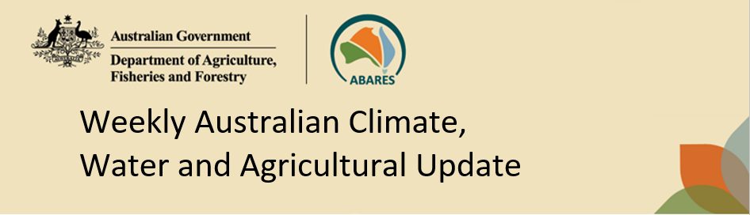
No. 42/2024 31 October 2024

Summary of key issues
- In the week ending 30 October 2024, low-pressure systems and troughs brought rainfall to western, northern, and eastern areas of Australia.
  - Across cropping regions, rainfall totals of between 10 and 100 millimetres were recorded in Queensland, which has likely interrupted harvest of winter crops in some areas. Little to no rainfall was recorded in southern and western cropping regions.
- Over coming days, low-pressure systems are expected to bring showers over parts of northern and eastern Australia. High-pressure systems are expected to keep remaining areas largely dry.
  - Across cropping regions, some rainfall is expected across north-eastern growing regions. If realised, these moderate falls are likely to allow for the uninterrupted harvest of winter crops.
  - Little to no rainfall forecast across southern Australia will provide for an uninterrupted harvest of winter crops for grain and hay where harvest has commenced. In areas which did not receive rainfall last week, farmers will be making decisions on whether to cut these crops for hay or turn them over for livestock grazing as grain yield and relative returns for grain compared to hay continue to decline.
- The northern rainfall onset, the period where the volume of rainfall needed to support plant growth occurs, for the 2024–25 season has commenced in central and northern areas of the Northern Territory and Western Australia. However, the northern rainfall onset has not yet occurred across large parts of Queensland outside of the south-east.
- Water storage levels in the Murray-Darling Basin (MDB) decreased between 24 October 2024 and 31 October 2024 by 149 gigalitres (GL). Current volume of water held in storage is 16 960 GL, equivalent to 76% of total storage capacity. This is 15 percent or 3,259GL less than at the same time last year. Water storage data is sourced from the BOM.
- Allocation prices in the Victorian Murray below the Barmah Choke increased from $134 on 24 October 2024 to $139 on 31 October 2024. Prices are lower in the Murrumbidgee due to the binding of the Murrumbidgee export limit.

Climate

Rainfall this week
For the week ending 30 October 2024, low pressure systems and a series of troughs brought showers to parts of western, northern, and eastern Australia. Rainfall totals of up to 50 millimetres were recorded across coastal New South Wales, the northern tropics, northern Western Australia, and western Tasmania. Isolated areas of south-east Queensland recorded falls of up to 100 millimetres. High pressure systems in the south kept the remainder of the country largely dry.
Across cropping regions, little to no rainfall was recorded across most western and southern growing regions. Meanwhile, much of Queensland recorded rainfall totals between 10 to 100 millimetres. With the harvest of winter crops underway, wet conditions across much of Queensland may have interrupted harvest in some areas. Little to no rainfall across southern and western cropping regions would have allowed for a largely uninterrupted harvest of winter crops.

Rainfall for the week ending 30 October 2024
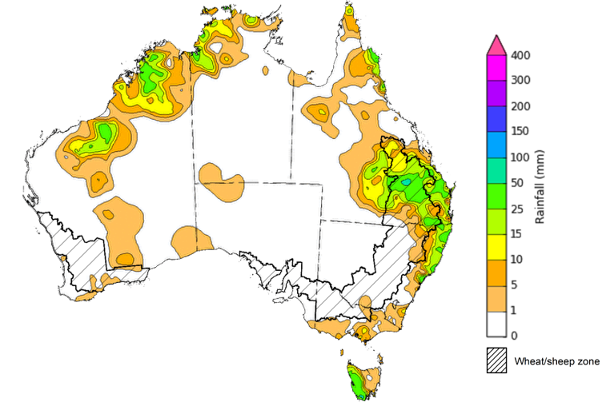
©Commonwealth of Australia 2024, Australian Bureau of Meteorology Issued: 30/10/2024
Note: The rainfall analyses and associated maps utilise data contained in the Bureau of Meteorology climate database, the Australian Data Archive for Meteorology (ADAM). The analyses are initially produced automatically from real-time data with limited quality control. They are intended to provide a general overview of rainfall across Australia as quickly as possible after the observations are received. For further information go to http://www.bom.gov.au/climate/rainfall/

Rainfall forecast for the next eight days
Over the 8 days to 7 November 2024, low pressure systems are expected to bring showers over parts of northern and eastern Australia. Rainfall of between 10 to 50 millimetres is expected across northern Western Australian and the Northern Territory, as well as south-eastern Queensland and eastern New South Wales. In Tasmania, rainfall totals up to 100 millimetres are forecast for parts of the west. Falls of between 5 and 25 millimetres are expected in southern areas of Victoria, South Australia and Western Australia. High pressure systems are expected to keep much of remaining areas of Australia largely dry.
Across cropping regions, little to no rainfall expected across most areas, with the exception of north-eastern growing regions where some rainfall is expected. Rainfall totals of between 5 and 25 millimetres are expected in Queensland, with eastern New South Wales and isolated areas of Victoria forecast to receive up to 15 millimetres.
If realised, these moderate falls across north-eastern cropping regions are likely to allow for an uninterrupted harvest of winter crops following a period of high rainfall in much of Queensland. Little to no rainfall forecast across southern Australia will provide for an uninterrupted harvest of winter crops for grain and hay where harvest has commenced. In areas which did not receive rainfall last week, another dry week will likely see further declines in grain yields and farmers will be making decisions on whether to cut these crops for hay or turn them over for livestock grazing as grain yield and relative returns for grain compared to hay continue to decline.

Total forecast rainfall for the period 31 October to 7 November 2024
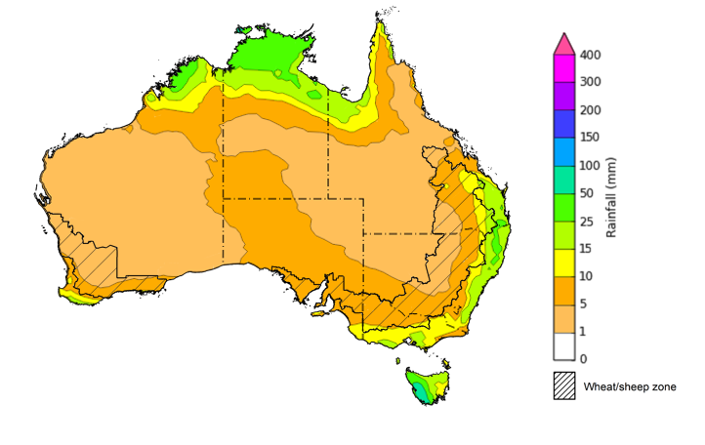
©Commonwealth of Australia 2024, Australian Bureau of Meteorology Issued 31/10/2024
Note: This rainfall forecast is produced from computer models. As the model outputs are not altered by weather forecasters, it is important to check local forecasts and warnings issued by the Bureau of Meteorology.

  - Northern Rainfall Onset
The northern rainfall onset outlook provides an indication of whether the first significant rains after the dry season are likely to be earlier or later than normal. The onset occurs when the total rainfall after 1 September reaches 50 millimetres, which is considered approximately the amount of rainfall required to stimulate plant growth. The northern rainfall onset for the 2024–25 season has commenced early in central and northern areas of the Northern Territory and Western Australia, but has not yet occurred in large parts of Queensland outside of the south-east.
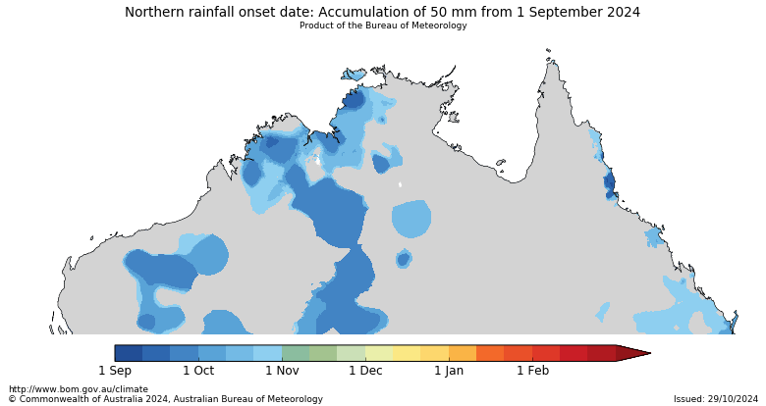
The areas of central Western Australia and the Northern Territory that have entered the northern rainfall onset do not typically experience the necessary amount of rainfall until early November to February. In contrast, the date of onset in Queensland this season is likely to be later than the historical median.
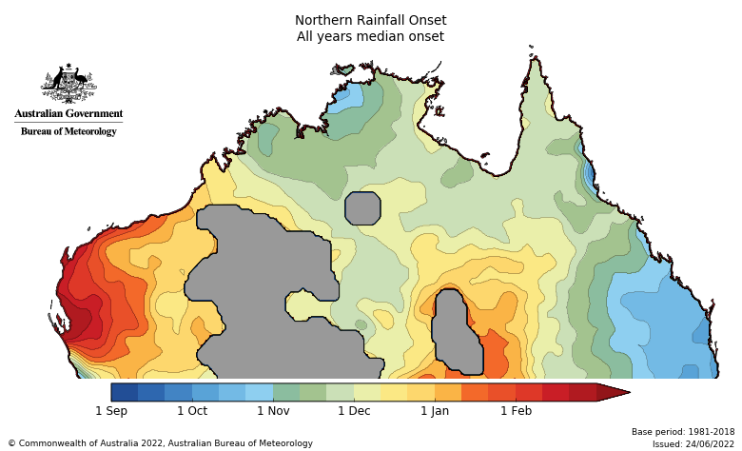

Water

Water markets – current week
Water storage levels in the Murray-Darling Basin (MDB) decreased between 24 October 2024 and 31 October 2024 by 149 gigalitres (GL). Current volume of water held in storage is 16 960 GL, equivalent to 76% of total storage capacity. This is 15 percent or 3,259GL less than at the same time last year. Water storage data is sourced from the BOM.

Water storages in the Murray-Darling Basin, 2013–2024
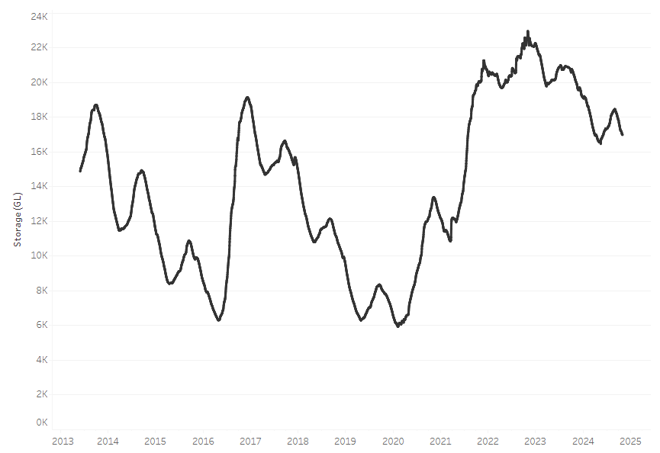

Allocation prices in the Victorian Murray below the Barmah Choke increased from $134 on 24 October 2024 to $139 on 31 October 2024. Prices are lower in the Murrumbidgee due to the binding of the Murrumbidgee export limit.

Surface water trade activity, Southern Murray–Darling Basin
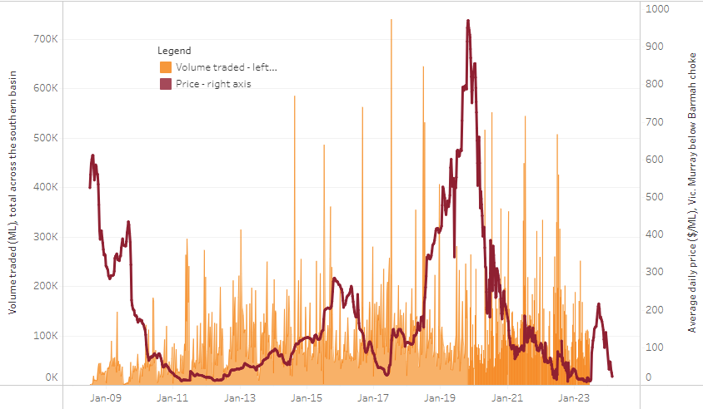
The trades shown reflect estimated market activity and do not encompass all register trades. The price is shown for the VIC Murray below the Barmah choke. Historical prices (before 1 July 2019) are ABARES estimates after removing outliers from BOM water register data. Prices after 1 July 2019 and prior to the 30 October 2019 reflect recorded transaction prices as sourced from Ruralco. Prices after the 30 October 2019 are sourced from Waterflow. Data for volume traded is sourced from the BOM water register. Only the price data shown is current on 17 October 2024.

To access the full, interactive, weekly water dashboard, which contains the latest and historical water storage, water market and water allocation information, please visit https://www.agriculture.gov.au/abares/products/weekly_update/weekly-update-311024

Commodities
Indicator | Week average | Unit | Latest Price | Previous Week | Weekly change |  | Price 12 months ago | Annual change
Selected world indicator prices
AUD/USD Exchange rate | 30-Oct | A$/US$ | 0.66 | 0.67 | -2% | 0.64 |  | 2%
Wheat – US no. 2 hard red winter wheat, FOB Gulf | 30-Oct | US$/t | 264 | 269 | -2% | 289 |  | -9%
Corn – US no. 2 yellow corn, FOB Gulf | 30-Oct | US$/t | 190 | 191 | -1% | 212 |  | -10%
Canola – Rapeseed, Canada, FOB Vancouver | 30-Oct | US$/t | 494 | 496 | -1% | 545 |  | -9%
Cotton – Cotlook 'A' Index | 30-Oct | USc/lb | 82 | 83 | -1% | 90 |  | -8%
Sugar – Intercontinental Exchange, nearby futures, no.11 contract | 30-Oct | USc/lb | 22 | 22 | 0% | 28 |  | -20%
Wool – Eastern Market Indicator | 30-Oct | Ac/kg clean | 1,125 | 1,131 | -1% | 1,127 |  | 0%
Wool – Western Market Indicator | 30-Oct | Ac/kg clean | 1,254 | 1,267 | -1% | 1,332 |  | -6%
Selected Australian grain export prices
Aust. premium white wheat (APW), FOB Port Adelaide, South Australia | 30-Oct | A$/t | 389 | 386 | 1% | 456 |  | -15%
Aust. standard white wheat (ASW), FOB Port Adelaide, South Australia | 30-Oct | A$/t | 377 | 374 | 1% | 436 |  | -13%
Feed Barley – FOB Port Adelaide, South Australia | 30-Oct | A$/t | 352 | 351 | 0% | 394 |  | -11%
Canola – FOB Kwinana, Western Australia | 30-Oct | A$/t | 818 | 802 | 2% | 785 |  | 4%
Grain Sorghum – FOB Brisbane, Queensland | 30-Oct | A$/t | 391 | 388 | 1% | 510 |  | -23%
Selected domestic livestock indicator prices
Beef – Eastern Young Cattle Indicator | 30-Oct | Ac/kg cwt | 629 | 625 | 1% | 363 |  | 73%
Mutton – Mutton indicator (18–24 kg fat score 2–3), Vic | 30-Oct | Ac/kg cwt | 328 | 297 | 11% | 97 |  | 239%
Lamb – National Trade Lamb Indicator | 30-Oct | Ac/kg cwt | 822 | 815 | 1% | 472 |  | 74%
Pig – Eastern Seaboard (60.1–75 kg), average of buyers & sellers | 16-Oct | Ac/kg cwt | 432 | 430 | 0% | 352 |  | 23%
Live cattle – Light steers to Indonesia | 30-Oct | Ac/kg lwt | 325 | 325 | 0% | 275 |  | 18%
Global Dairy Trade (GDT) weighted average prices ª
Dairy – Whole milk powder | 16-Oct | US$/t | 3,553 | 3,559 | 0% | 3,610 |  | -2%
Dairy – Skim milk powder | 16-Oct | US$/t | 2,745 | 2,795 | -2% | 3,575 |  | -23%
Dairy – Cheddar cheese | 16-Oct | US$/t | 4,702 | 4,606 | 2% | 5,046 |  | -7%
Dairy – Anhydrous milk fat | 16-Oct | US$/t | 7,229 | 7,213 | 0% | 5,677 |  | 27%

Selected world indicator prices
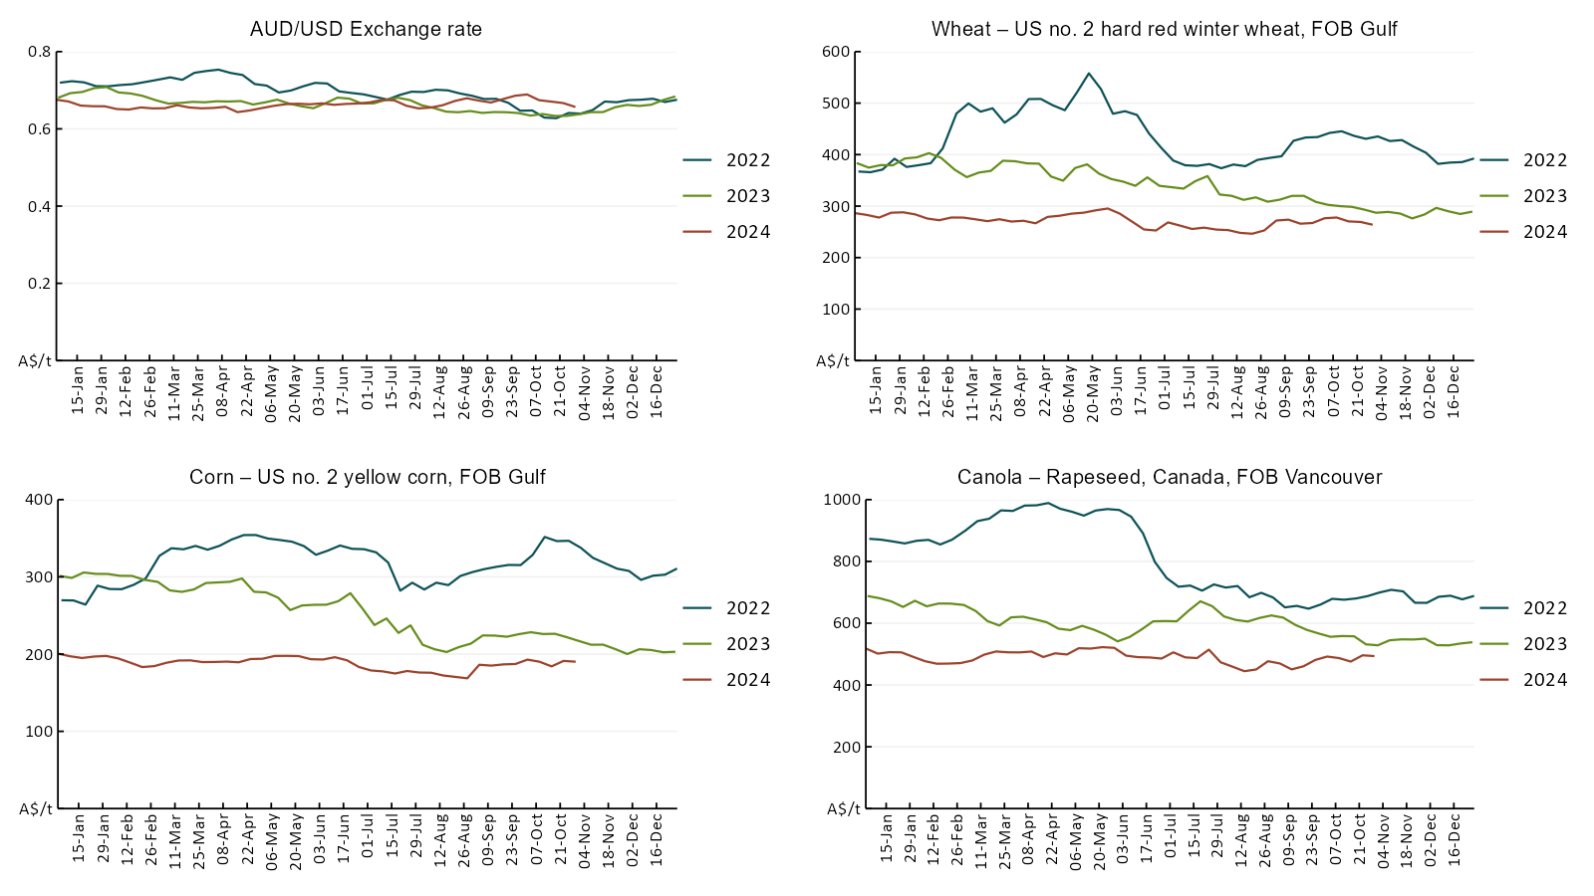

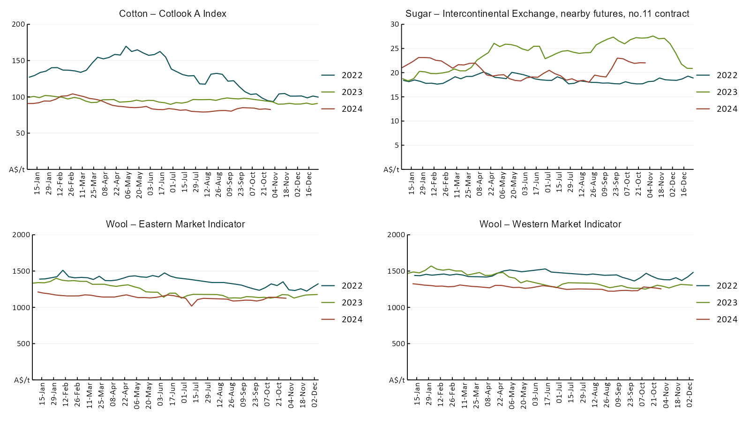

3.2 Selected domestic crop indicator prices
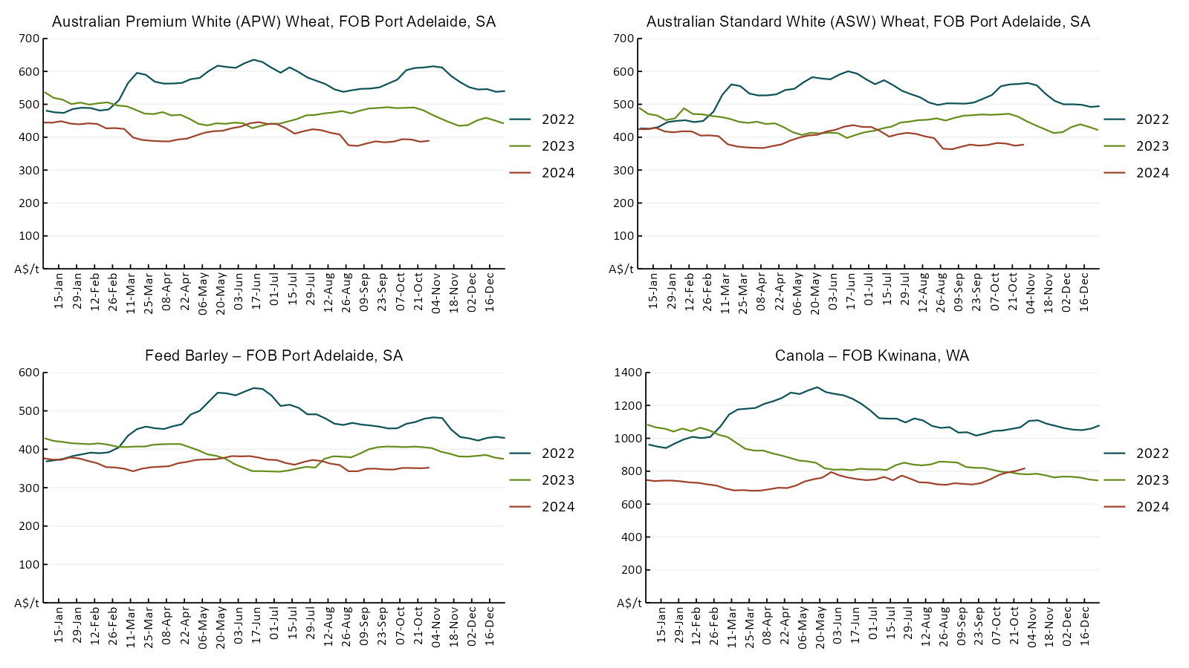
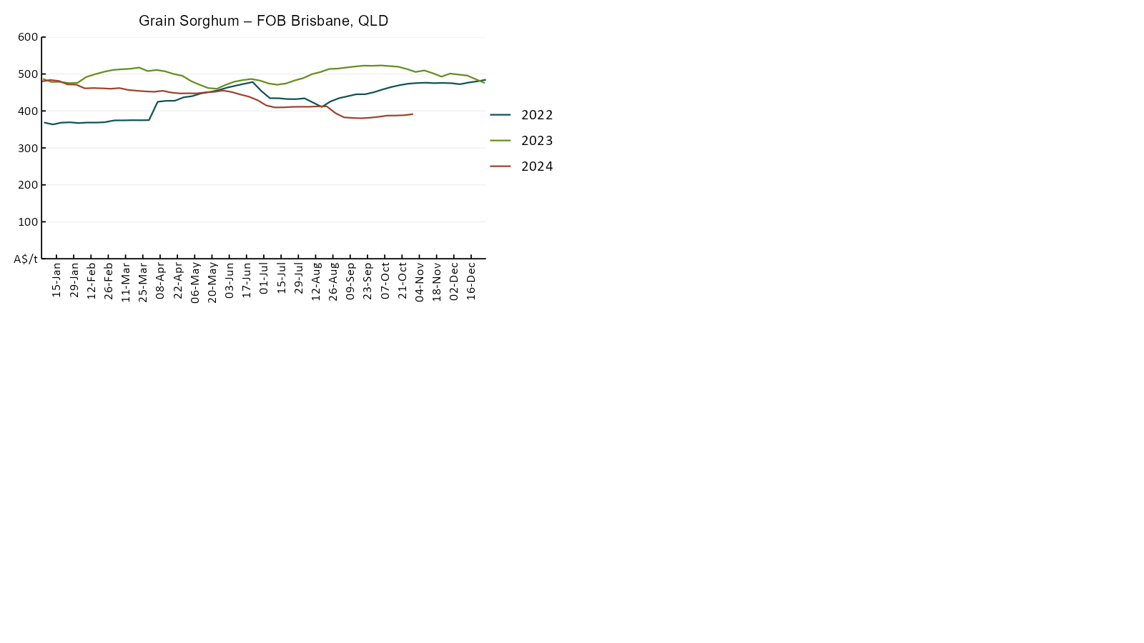

Selected domestic livestock indicator prices
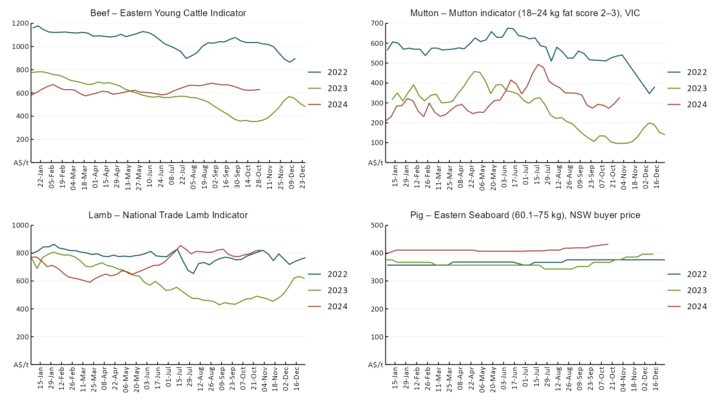
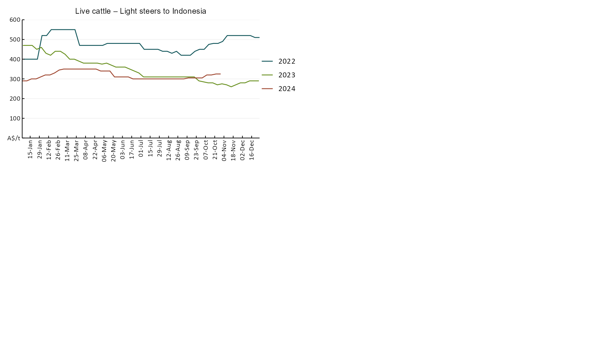

Global Dairy Trade (GDT) weighted average prices
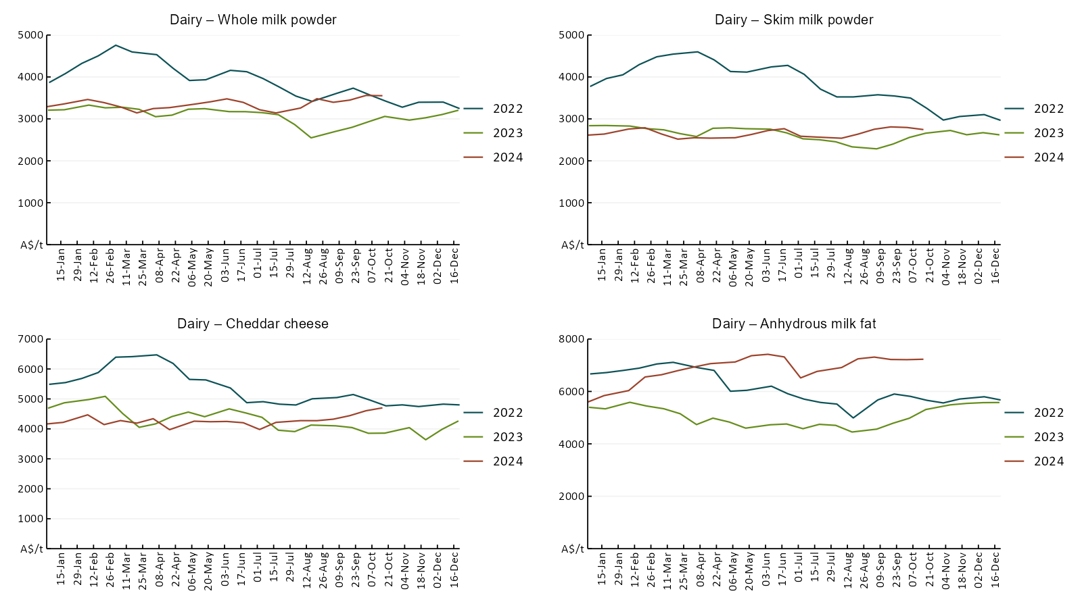

Selected fruit and vegetable prices
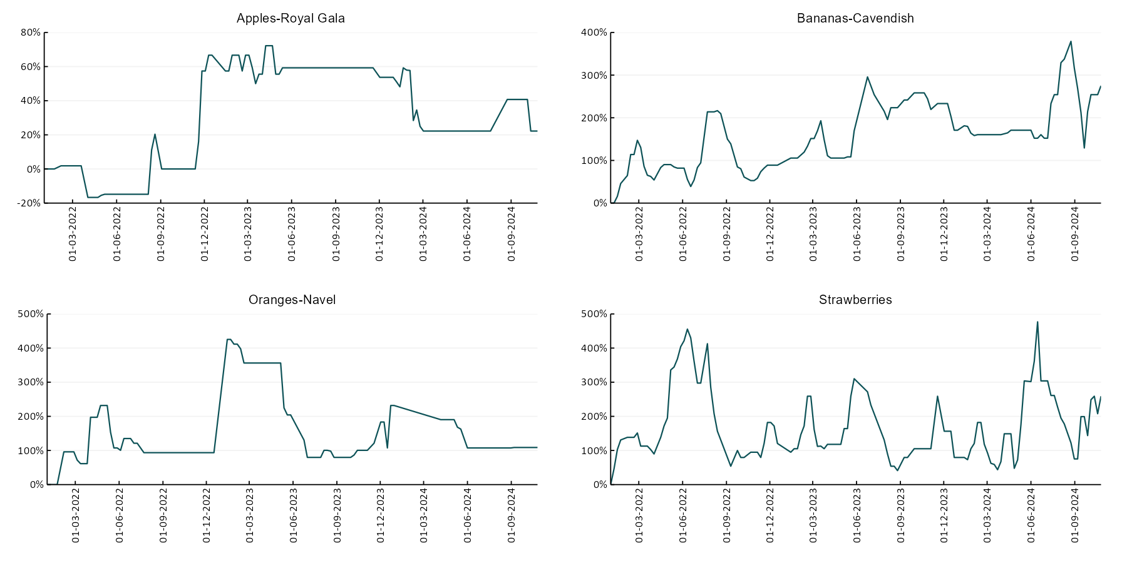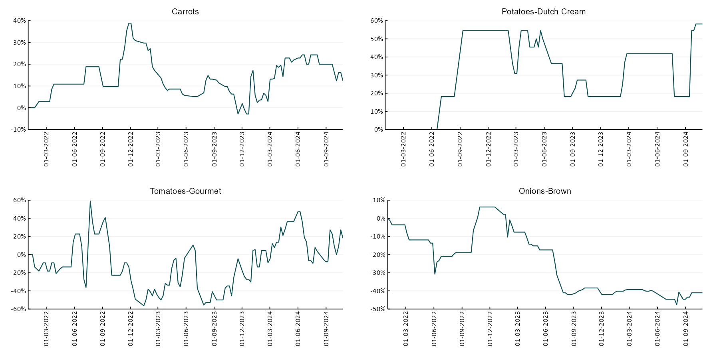

3.6 Selected domestic fodder indicator prices

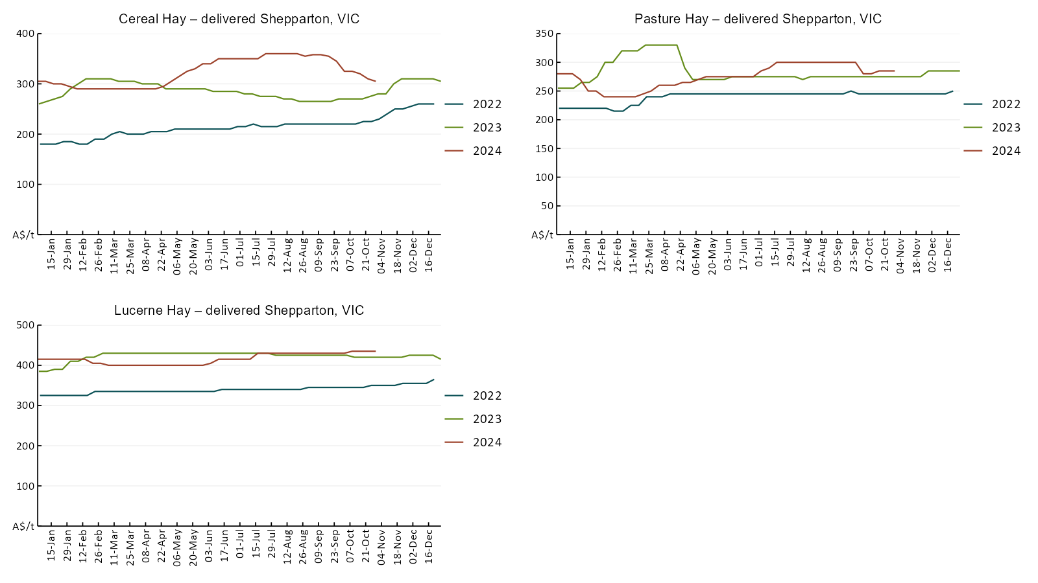

4. Data attribution

Climate
- Bureau of Meteorology
- Weekly rainfall totals: www.bom.gov.au/climate/maps/rainfall/
- Monthly and last 3-month rainfall percentiles: www.bom.gov.au/water/landscape/
- Temperature anomalies: www.bom.gov.au/jsp/awap/temp/index.jsp
- Rainfall forecast: www.bom.gov.au/jsp/watl/rainfall/pme.jsp
- Seasonal outlook: www.bom.gov.au/climate/outlooks/#/overview/summary/
- Climate drivers: http://www.bom.gov.au/climate/enso/
- Soil moisture: www.bom.gov.au/water/landscape/
- Other
- Pasture growth: www.longpaddock.qld.gov.au/aussiegrass/
- 3-month global outlooks: Environment and Climate Change Canada, NOAA Climate Prediction Center, EUROBRISA CPTEC/INPE, European Centre for Medium-Range Weather Forecasts, Hydrometcenter of Russia, National Climate Center Climate System Diagnosis and Prediction Room (NCC), International Research Institute for Climate and Society
- Global production: https://ipad.fas.usda.gov/ogamaps/cropmapsandcalendars.aspx
- Autumn break: Pook et al., 2009, https://rmets-onlinelibrary-wiley-com.virtual.anu.edu.au/doi/epdf/10.1002/joc.1833

Water
Prices
- Waterflow: https://www.waterflow.io/
- Ruralco: https://www.ruralcowater.com.au/
- Bureau of Meteorology:
- Allocation trade: http://www.bom.gov.au/water/dashboards/#/water-markets/mdb/at
- Storage volumes: http://www.bom.gov.au/water/dashboards/#/water-storages/summary/drainage
- Trade constraints:
- Water NSW: https://www.waternsw.com.au/customer-service/ordering-trading-and-pricing/trading/murrumbidgee
- Victorian Water Register: https://www.waterregister.vic.gov.au/TradingRules2019/

Commodities
- Fruit and vegetables
- Datafresh: www.freshstate.com.au
- Pigs
- Australian Pork Limited: www.australianpork.com.au
- Dairy
- Global Dairy Trade: www.globaldairytrade.info/en/product-results/
- World wheat, canola
- International Grains Council
- World coarse grains
- United States Department of Agriculture
- World cotton
- Cotlook: www.cotlook.com/
- World sugar
- New York Stock Exchange - Intercontinental Exchange
- Wool
- Australian Wool Exchange: www.awex.com.au/
- Domestic wheat, barley, sorghum, canola and fodder
- Jumbuk Consulting Pty Ltd: http://www.jumbukag.com.au/
- Cattle, beef, mutton, lamb, goat and live export
- Meat and Livestock Australia: www.mla.com.au/Prices-and-market
© Commonwealth of Australia 2024

Ownership of intellectual property rights
Unless otherwise noted, copyright (and any other intellectual property rights, if any) in this publication is owned by the Commonwealth of Australia (referred to as the Commonwealth).

Creative Commons licence
All material in this publication is licensed under a Creative Commons Attribution 4.0 International Licence except content supplied by third parties, logos and the Commonwealth Coat of Arms.
Inquiries about the licence and any use of this document should be emailed to copyright@awe.gov.au.


Cataloguing data
This publication (and any material sourced from it) should be attributed as:
ABARES 2024, Weekly Australian Climate, Water and Agricultural Update, Australian Bureau of Agricultural and Resource Economics and Sciences, Canberra, 24 October 2024. CC BY 4.0 DOI: https://doi.org/10.25814/5f3e04e7d2503
ISSN 2652-7561
This publication is available at https://www.agriculture.gov.au/abares/products/weekly_update
Department of Agriculture, Fisheries and Forestry
GPO Box 858 Canberra ACT 2601
Telephone 1800 900 090
Web agriculture.gov.au/abares

Disclaimer
The Australian Government acting through the Department of Agriculture, Fisheries and Forestry, represented by the Australian Bureau of Agricultural and Resource Economics and Sciences, has exercised due care and skill in preparing and compiling the information and data in this publication. Notwithstanding, the Department of Agriculture, Fisheries and Forestry, ABARES, its employees and advisers disclaim all liability, including liability for negligence and for any loss, damage, injury, expense or cost incurred by any person as a result of accessing, using or relying on any of the information or data in this publication to the maximum extent permitted by law.

Statement of Professional Independence
The views and analysis presented in ABARES publications, including this one, reflect ABARES professionally independent findings, based on scientific and economic concepts, principles, information and data. These views, analysis and findings may not reflect or be consistent with the views or positions of the Australian Government, or of organisations or groups who have commissioned ABARES reports or analysis. More information on professional independence is provided on the ABARES website.

Acknowledgements
This report was prepared by Matthew Miller.

