## No. 41/2024 24 October 2024

# Summary of key issues

* In the week ending 23 October 2024, a humid airmass combined with a series of troughs to bring showers and isolated thunderstorms to parts of northern, central and south-eastern Australia, with other areas largely dry.
  + Across cropping regions, rainfall totals of between 10 and 50 millimetres was recorded across large areas of south-eastern Australia. These falls were higher than what was forecast for the week across several regions, and as such a likely to have been sufficient to arrest further reduction in the yield potential of winter crops.
* Over coming days, low-pressure and frontal systems are expected to bring showers and storms over parts of northern and eastern Australia. High-pressure systems are expected to keep remaining areas largely dry.
  + Across cropping regions, some rainfall is expected across north-eastern growing regions. If realised, these falls across north-eastern cropping regions are likely to provide a boost to soil moisture levels and assist with the planting of summer crops. However, this forecast rainfall may result in some delays to the harvest of winter crops.
  + Little to no rainfall forecast across southern Australia will provide for an uninterrupted harvest of winter crops for grain and hay where harvest has commenced. However, as conditions remain dry across large areas of southern Australia, farmers will be continuing to make decisions on whether to cut crops for hay or turn them over for livestock grazing as grain yields and relative returns for grain compared to hay continue to decline.
* The national rainfall outlook for November 2024 to January 2025 indicates no strong tendency toward either above or below average rainfall across much of the country.
  + Across most cropping regions there is a 50% or greater chance of receiving above median rainfall. Higher than average rainfall is forecast in Queensland, New South Wales, Victoria and Western Australia.
  + There is 75% chance of rainfall totals being between 10 to 100 millimetres across most southern and eastern cropping regions, with higher falls expected in Queensland and northern New South Wales. If realised, these expected rainfall totals will likely improve soil moisture profiles, support late spring and summer pasture growth and provide a favourable start to the summer cropping season across eastern Australia.
* Water storage levels in the southern Murray-Darling Basin (MDB) decreased by 46 gigalitres (GL) between 16 October 2024 and 23 October 2024. Current volume of water held in storage is 17,166 GL, equivalent to 77% of total storage capacity. This is 16 percent or 3,246GL less than at the same time last year.
* Allocation prices in the Victorian Murray below the Barmah Choke decreased from $137 on 17 October 2024 to $134 on 24 October 2024. Prices are lower in the Murrumbidgee due to the binding of the Murrumbidgee export limit.

## **Climate**

### Rainfall this week

For the week ending 23 October 2024, a humid airmass combined with a series of troughs to bring showers and isolated thunderstorms to parts of northern, central and south-eastern Australia. Rainfall totals of up to 50 millimetres were recorded across Victoria, Tasmania, large areas of New South Wales, and eastern South Australia, and scattered areas of southern Queensland, southern and northern Western Australia and the Northern Territory. Isolated areas of Tasmania and eastern Victoria recorded falls up to 100 millimetres. High pressure systems saw much of the remainder of the country record little to no rainfall.

Across cropping regions, rainfall totals of between 5 and 50 millimetres was recorded across New South Wales, Victoria, eastern and central South Australia, and isolated areas of central Queensland and northern Western Australia. Little to no rainfall was recorded across remaining areas. Across most south-eastern growing regions rainfall totals were higher than what was forecast for the week, and as such a likely to have been sufficient to arrest further reduction in the yield potential of winter crops. In regions where average levels of stored soil moisture were available, crops and pastures would have been able to draw on these reserves to maintain current yield potentials. With the harvest of winter crops in full swing across northern cropping regions, mainly dry conditions across much of Queensland would have provided largely uninterrupted harvest conditions.

#### Rainfall for the week ending 23 October 2024

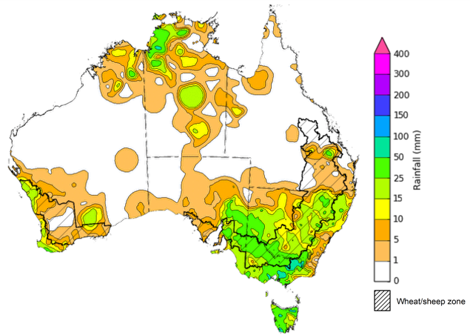

©Commonwealth of Australia 2024, Australian Bureau of Meteorology Issued: 23/10/2024

Note: The rainfall analyses and associated maps utilise data contained in the Bureau of Meteorology climate database, the Australian Data Archive for Meteorology (ADAM). The analyses are initially produced automatically from real-time data with limited [quality control](http://www.bom.gov.au/climate/headers/qc.shtml). They are intended to provide a general overview of rainfall across Australia as quickly as possible after the observations are received. For further information go to <http://www.bom.gov.au/climate/rainfall/>

### Rainfall forecast for the next eight days

Over the 8 days to 24 October 2024, low-pressure and frontal systems are expected to bring showers and storms over parts of northern and eastern Australia. Falls of between 10 and 50 millimetres are forecast for, eastern New South Wales, eastern Queensland and Tasmania. Falls of between 5 and 25 millimetres expected across parts of southern Victoria and parts of northern Western Australia and Queensland, and the Northern Territory. High pressure systems are expected to keep much of, western, central and southern Australia largely dry.

Across cropping regions, some rainfall is expected across north-eastern growing regions, with little to no rainfall expected across most cropping regions. Rainfall totals of between 5 and 50 millimetres are expected in Queensland and north-eastern New South Wales.

If realised, these falls across north-eastern cropping regions are likely to provide a boost to soil moisture levels and assist with the planting of summer crops. However, this forecast rainfall may result in some delays to the harvest of winter crops.

Little to no rainfall forecast across southern Australia will provide for an uninterrupted harvest of winter crops for grain and hay where harvest has commenced. However, as conditions remain dry across large areas of southern Australia, farmers will be continuing to make decisions on whether to cut crops for hay or turn them over for livestock grazing as grain yields and relative returns for grain compared to hay continue to decline.

#### Total forecast rainfall for the period 24 October to 31 October 2024

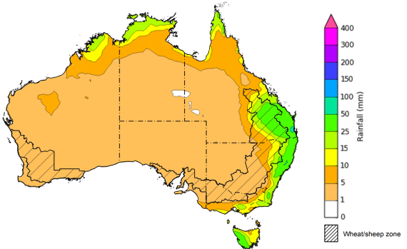

©Commonwealth of Australia 2024, Australian Bureau of Meteorology Issued 24/10/2024

Note: This rainfall forecast is produced from computer models. As the model outputs are not altered by weather forecasters, it is important to check local forecasts and warnings issued by the Bureau of Meteorology.

* 1. **National Climate Outlook**

The El Niño Southern Oscillation (ENSO) and Indian Ocean Dipole (IOD) climate drivers are currently neutral and having minimal influence on Australian rainfall. The Southern Annular Mode (SAM) has been neural for several weeks (as at 13 October). Forecasts indicate it is likely to remain neutral over the coming week. A neutral SAM has no strong relationship to forecast climate conditions.

The most recent rainfall outlook for November 2024 provided by the Bureau of Meteorology indicates that much of New South Wales, Queensland, eastern Victoria, South Australia, the Northern Territory and northern areas of Western Australia are likely to see above median rainfall (between 55 to 70% chance). There is a roughly equal probability of either above or below median rainfall across parts of western, south-eastern and northern Australia.

According to Bureau of Meteorology’s climate model, for November 2024, there is a 75% probability of rainfall totals of between 10 and 50 millimetres across much of eastern and central New South Wales, Victoria, eastern Queensland, the far south-west of Western Australia, eastern agricultural areas of South Australia, and much of the tropical north. Meanwhile, Tasmania and parts of eastern New South Wales, eastern Victoria and the north of the Northern Territory are expected to see falls of between 25 and 200 millimetres. Much of western and central Australia is expected to receive little to no rainfall.

Across cropping regions, there is a 75% chance of receiving between 10 and 50 millimetres of rainfall across much of New South Wales, Victoria and Queensland, with higher rainfall totals expected in north-eastern regions. In South Australia and southern Western Australia, rainfall totals are expected to be between 5 and 25 millimetres. These relatively low expected rainfall totals across much of southern Australia continue to represent a significant downside production risk for both winter crop production and pasture growth, particularly given the lack of rainfall in recent months and declining soil moisture levels across large areas. However, if forecast rainfall totals are realised across much of New South Wales and Queensland, these falls are likely to be sufficient to support above average yield prospects for winter and summer crops and average or better levels of pasture production in these states.

**Rainfall totals that have a 75% chance of occurring in November 2024**

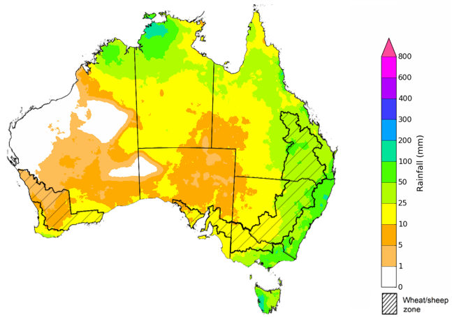

©Commonwealth of Australia 2024, Australian Bureau of Meteorology Issued: 24/10/2024

The rainfall outlook for November 2024 to January 2025 indicates no strong tendency toward either above or below average rainfall across much of the country. Below median rainfall is more likely across isolated areas of south-western Tasmania and parts of tropical northern Australia. Meanwhile, above median rainfall in more likely across parts of the eastern seaboard and north-western Western Australia

Across cropping regions, the probability of receiving above median rainfall is between 50% and 65% in New South Wales, Victoria, Queensland and Western Australia. In South Australia there is no strong tendency toward either above or below average rainfall. If above median rainfall is realised, this rainfall is likely to support the storage of soil moisture in eastern regions for the summer cropping period.

**Chance of exceeding the median rainfall** **November 2024 to January 2025**

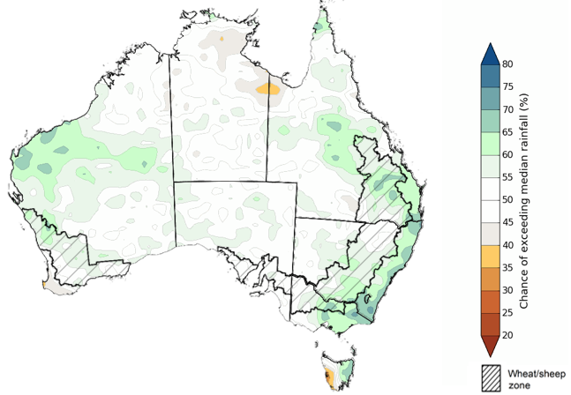

©Commonwealth of Australia 2024, Australian Bureau of Meteorology Issued: 24/10/2024

The outlook for November through to January suggests a 75% chance of rainfall totals between 50 and 300 millimetres across much of central and eastern New South Wales, Queensland, Victoria, Tasmania and the Northern Territory, and across parts of Western Australia. Rainfall totals in excess of 300 millimetres are forecast for alpine regions of Victoria and New South Wales, isolated coastal areas of eastern New South Wales and Queensland, western Tasmania and the tropical north of Queensland, Western Australia and the Northern Territory.

In cropping regions, there is a 75% chance of receiving between 100 and 300 millimetres of rainfall across much of Queensland, and between 50 and 200 millimetres across New South Wales and Victoria. Conditions are expected to be drier in Western Australia with forecast rainfall totals of between 10 and 100 millimetres, and in South Australia and Victoria, where falls of between 25 to 100 millimetres are expected.

Given harvest will be well underway across several regions, November through to January rainfall will have little influence on winter crop production prospects, other than its influence on harvest progress. Meanwhile, if the forecast November through to January rainfall totals are realised, they are likely to be sufficient to support late spring and summer pasture growth across eastern and northern Australia. Additionally, these expected falls are likely to be sufficient to maintain above yield expectation for summer crops.

**Rainfall totals that have a 75% chance of occurring November 2024 to January 2025**

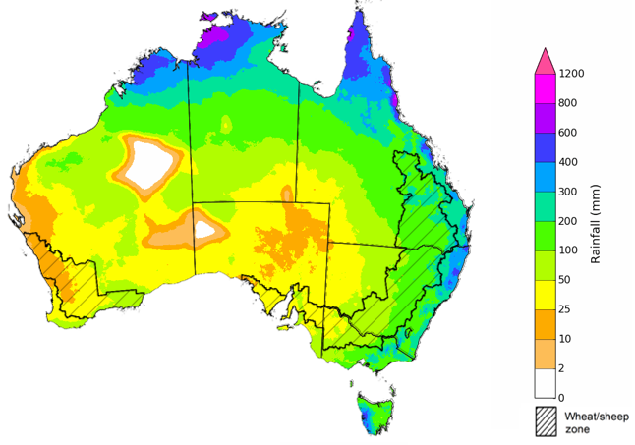

©Commonwealth of Australia 2024, Australian Bureau of Meteorology Issued: 24/10/2024

## **Water**

### Water markets – current week

Water storage levels in the southern Murray-Darling Basin (MDB) decreased between 16 October 2024 and 23 October 2024 by 46 gigalitres (GL). Current volume of water held in storage is 17,166 GL, equivalent to 77% of total storage capacity. This is 16 percent or 3,246GL less than at the same time last year. Water storage data is sourced from the Bureau of Meteorology.

#### Water storages in the Murray-Darling Basin, 2013–2024

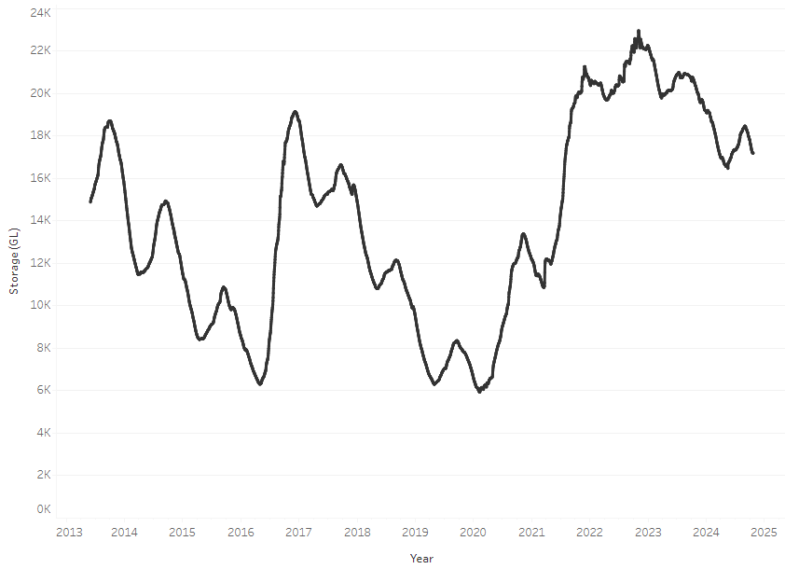

Allocation prices in the Victorian Murray below the Barmah Choke decreased from $137 on 17 October 2024 to $134 on 24 October 2024. Prices are lower in the Murrumbidgee due to the binding of the Murrumbidgee export limit.

#### Surface water trade activity, Southern Murray–Darling Basin

|  |
| --- |
| The trades shown reflect estimated market activity and do not encompass all register trades. The price is shown for the VIC Murray below the Barmah choke. Historical prices (before 1 July 2019) are ABARES estimates after removing outliers from BOM water register data. Prices after 1 July 2019 and prior to the 30 October 2019 reflect recorded transaction prices as sourced from Ruralco. Prices after the 30 October 2019 are sourced from Waterflow. Data for volume traded is sourced from the BOM water register. Only the price data shown is current on 24 October 2024. |

To access the full, interactive, weekly water dashboard, which contains the latest and historical water storage, water market and water allocation information, please visit <https://www.agriculture.gov.au/abares/products/weekly_update/weekly-update-241024>

## **Commodities**

|  |  |  |  |  |  |  |  |  |
| --- | --- | --- | --- | --- | --- | --- | --- | --- |
| **Indicator** | **Week average** | **Unit** | **Latest Price** | **Previous Week** | **Weekly change** | | **Price 12 months ago** | **Annual change** |
| **Selected world indicator prices** |  |  |  |  |  |  | |  |
| AUD/USD Exchange rate | 23-Oct | A$/US$ | 0.67 | 0.67 | 0% | 0.64 | | 5% |
| Wheat – US no. 2 hard red winter wheat, FOB Gulf | 23-Oct | US$/t | 270 | 270 | 0% | 287 | | -6% |
| Corn – US no. 2 yellow corn, FOB Gulf | 23-Oct | US$/t | 190 | 184 | 3% | 217 | | -12% |
| Canola – Rapeseed, Canada, FOB Vancouver | 23-Oct | US$/t | 489 | 476 | 3% | 529 | | -8% |
| Cotton – Cotlook 'A' Index | 23-Oct | USc/lb | 83 | 83 | 0% | 93 | | -11% |
| Sugar – Intercontinental Exchange, nearby futures, no.11 contract | 23-Oct | USc/lb | 21.8 | 21.9 | -1% | 27 | | -20% |
| Wool – Eastern Market Indicator | 23-Oct | Ac/kg clean | 1,131 | 1,138 | -1% | 1,127 | | 0% |
| Wool – Western Market Indicator | 23-Oct | Ac/kg clean | 1,267 | 1,273 | 0% | 1,332 | | -5% |
| **Selected Australian grain export prices** |  |  |  |  |  |  | |  |
| Aust. premium white wheat (APW), FOB Port Adelaide, South Australia | 23-Oct | A$/t | 387 | 393 | -1% | 469 | | -17% |
| Aust. standard white wheat (ASW), FOB Port Adelaide, South Australia | 23-Oct | A$/t | 375 | 381 | -1% | 449 | | -16% |
| Feed Barley – FOB Port Adelaide, South Australia | 23-Oct | A$/t | 350 | 351 | 0% | 403 | | -13% |
| Canola – FOB Kwinana, Western Australia | 23-Oct | A$/t | 796 | 793 | 0% | 781 | | 2% |
| Grain Sorghum – FOB Brisbane, Queensland | 23-Oct | A$/t | 388 | 388 | 0% | 506 | | -23% |
| **Selected domestic livestock indicator prices** |  |  |  |  |  |  | |  |
| Beef – Eastern Young Cattle Indicator | 23-Oct | Ac/kg cwt | 625 | 623 | 0% | 353 | | 77% |
| Mutton – Mutton indicator (18–24 kg fat score 2–3), Vic | 23-Oct | Ac/kg cwt | 290 | 273 | 6% | 97 | | 199% |
| Lamb – National Trade Lamb Indicator | 23-Oct | Ac/kg cwt | 809 | 796 | 2% | 482 | | 68% |
| Pig – Eastern Seaboard (60.1–75 kg), average of buyers & sellers | 09-Oct | Ac/kg cwt | 430 | 427 | 1% | 367 | | 17% |
| Live cattle – Light steers to Indonesia | 23-Oct | Ac/kg lwt | 325 | 320 | 2% | 275 | | 18% |
| **Global Dairy Trade (GDT) weighted average prices a** |  |  |  |  |  |  | |  |
| Dairy – Whole milk powder | 16-Oct | US$/t | 3,553 | 3,559 | 0% | 2,931 | | 21% |
| Dairy – Skim milk powder | 16-Oct | US$/t | 2,745 | 2,795 | -2% | 2,558 | | 7% |
| Dairy – Cheddar cheese | 16-Oct | US$/t | 4,702 | 4,606 | 2% | 3,853 | | 22% |
| Dairy – Anhydrous milk fat | 16-Oct | US$/t | 7,229 | 7,213 | 0% | 4,979 | | 45% |
|  | | | | | | | | |

### Selected world indicator prices

### 3.2 Selected domestic crop indicator prices

### Selected domestic livestock indicator prices

### Global Dairy Trade (GDT) weighted average prices

### Selected fruit and vegetable prices

### 3.6 Selected domestic fodder indicator prices

## **4. Data attribution**

### Climate

* Bureau of Meteorology
* Weekly rainfall totals: www.bom.gov.au/climate/maps/rainfall/
* Monthly and last 3-month rainfall percentiles: [www.bom.gov.au/water/landscape/](http://www.bom.gov.au/water/landscape/)
* Temperature anomalies: [www.bom.gov.au/jsp/awap/temp/index.jsp](http://www.bom.gov.au/jsp/awap/temp/index.jsp)
* Rainfall forecast: [www.bom.gov.au/jsp/watl/rainfall/pme.jsp](http://www.bom.gov.au/jsp/watl/rainfall/pme.jsp)
* Seasonal outlook: [www.bom.gov.au/climate/outlooks/#/overview/summary/](http://www.bom.gov.au/climate/outlooks/#/overview/summary/)
* Climate drivers: <http://www.bom.gov.au/climate/enso/>
* Soil moisture: [www.bom.gov.au/water/landscape/](http://www.bom.gov.au/water/landscape/)
* Other
* Pasture growth: [www.longpaddock.qld.gov.au/aussiegrass/](http://www.longpaddock.qld.gov.au/aussiegrass/)
* 3-month global outlooks: [Environment and Climate Change Canada](https://weather.gc.ca/saisons/image_e.html?img=s234pfe1p_cal&bc=prob), [NOAA Climate Prediction Center](https://www.cpc.ncep.noaa.gov/products/predictions/long_range/seasonal.php?lead=2), [EUROBRISA CPTEC/INPE](http://eurobrisa.cptec.inpe.br/), European Centre for Medium-Range Weather Forecasts, [Hydrometcenter of Russia](https://meteoinfo.ru/en/climate/seasonal-forecasts), [National Climate Center Climate System Diagnosis and Prediction Room (NCC)](https://cmdp.ncc-cma.net/pred/cs2gen.php?pred_elem=RAINP#pred_seasonal), [International Research Institute for Climate and Society](https://iri.columbia.edu/our-expertise/climate/forecasts/seasonal-climate-forecasts/)
* Global production: <https://ipad.fas.usda.gov/ogamaps/cropmapsandcalendars.aspx>
* Autumn break: Pook et al., 2009, <https://rmets-onlinelibrary-wiley-com.virtual.anu.edu.au/doi/epdf/10.1002/joc.1833>

### Water

Prices

* Waterflow: <https://www.waterflow.io/>
* Ruralco: <https://www.ruralcowater.com.au/>
* Bureau of Meteorology:
* Allocation trade: <http://www.bom.gov.au/water/dashboards/#/water-markets/mdb/at>
* Storage volumes: <http://www.bom.gov.au/water/dashboards/#/water-storages/summary/drainage>
* Trade constraints:
* Water NSW: <https://www.waternsw.com.au/customer-service/ordering-trading-and-pricing/trading/murrumbidgee>
* Victorian Water Register: <https://www.waterregister.vic.gov.au/TradingRules2019/>

### Commodities

* Fruit and vegetables
* Datafresh: [www.freshstate.com.au](http://www.freshstate.com.au)
* Pigs
* Australian Pork Limited: [www.australianpork.com.au](http://www.australianpork.com.au)
* Dairy
* Global Dairy Trade: [www.globaldairytrade.info/en/product-results/](http://www.globaldairytrade.info/en/product-results/)
* World wheat, canola
* International Grains Council
* World coarse grains
* United States Department of Agriculture
* World cotton
* Cotlook: [www.cotlook.com/](http://www.cotlook.com/)
* World sugar
* New York Stock Exchange - Intercontinental Exchange
* Wool
* Australian Wool Exchange: [www.awex.com.au/](http://www.awex.com.au/)
* Domestic wheat, barley, sorghum, canola and fodder
* Jumbuk Consulting Pty Ltd: http://www.jumbukag.com.au/
* Cattle, beef, mutton, lamb, goat and live export
* Meat and Livestock Australia: [www.mla.com.au/Prices-and-market](http://www.mla.com.au/Prices-and-market)

© Commonwealth of Australia 2024

### Ownership of intellectual property rights

Unless otherwise noted, copyright (and any other intellectual property rights, if any) in this publication is owned by the Commonwealth of Australia (referred to as the Commonwealth).

### Creative Commons licence

All material in this publication is licensed under a [Creative Commons Attribution 4.0 International Licence](https://creativecommons.org/licenses/by/4.0/legalcode) except content supplied by third parties, logos and the Commonwealth Coat of Arms.

Inquiries about the licence and any use of this document should be emailed to [copyright@awe.gov.au](mailto:copyright@awe.gov.au).

https://www.agriculture.gov.au/sites/default/files/images/creative-commons-logo-small.png

### Cataloguing data

This publication (and any material sourced from it) should be attributed as:

ABARES 2024, Weekly Australian Climate, Water and Agricultural Update, Australian Bureau of Agricultural and Resource Economics and Sciences, Canberra, 24 October 2024. CC BY 4.0 DOI: <https://doi.org/10.25814/5f3e04e7d2503>

ISSN **2652-7561**

This publication is available at https://www.agriculture.gov.au/abares/products/weekly_update

Department of Agriculture, Fisheries and Forestry

GPO Box 858 Canberra ACT 2601

Telephone 1800 900 090

Web [agriculture.gov.au/abares](http://awe.gov.au/abares)

### Disclaimer

The Australian Government acting through the Department of Agriculture, Fisheries and Forestry, represented by the Australian Bureau of Agricultural and Resource Economics and Sciences, has exercised due care and skill in preparing and compiling the information and data in this publication. Notwithstanding, the Department of Agriculture, Fisheries and Forestry, ABARES, its employees and advisers disclaim all liability, including liability for negligence and for any loss, damage, injury, expense or cost incurred by any person as a result of accessing, using or relying on any of the information or data in this publication to the maximum extent permitted by law.

### Statement of Professional Independence

The views and analysis presented in ABARES publications, including this one, reflect ABARES professionally independent findings, based on scientific and economic concepts, principles, information and data. These views, analysis and findings may not reflect or be consistent with the views or positions of the Australian Government, or of organisations or groups who have commissioned ABARES reports or analysis. More information on [professional independence](https://www.agriculture.gov.au/abares/about/research-and-analysis#professional-independence) is provided on the ABARES website.

### Acknowledgements

This report was prepared by Matthew Miller.