
No. 40/2024 17 October 2024

Summary of key issues
- In the week ending 16 October 2024, several cold fronts and onshore airflow brought rainfall to scattered areas northern, western and eastern Australia, with other areas largely dry.
  - Across cropping regions, some rainfall was recorded this week, but falls were generally below 25 millimetres. Across most southern growing regions rainfall totals were significantly less then what was forecast for the week, and as such a reduction in the yield potential of winter crops has likely continued in the past week.
- Over coming days, low-pressure and frontal systems are expected to bring showers and storms to parts of western, northern and south-eastern Australia. High-pressure systems are expected to keep remaining areas largely dry.
  - Across cropping regions, some rainfall is expected across southern growing regions, with heavier falls expected in the east. Rainfall totals of between 1 and 10 millimetres are expected in Queensland, while falls of between 10 and 50 millimetres are expected Victoria and central and southern New South Wales. Lighter falls of between 5 and 25 millimetres expected in South Australia and parts of southern Western Australia.
  - If realised, these falls across eastern Australia may be sufficient to stabilise winter crop yields across some growing regions.
- Globally, variable rainfall during September has led to mixed crop production prospects.
  - Global production conditions were generally favourable for rice and soybeans but variable for wheat and maize.
  - Global production conditions have been less favourable compared to those used to formulate ABARES forecasts of global grain supplies and world prices for 2024–25 in its September 2024 edition of the Agricultural Commodities Report. As a result, global grain and oilseed production are likely to decline compared to those presented in the September forecast.
  - In Australia, winter crop production conditions during spring have been less favourable across parts of south-eastern and south-western Australia, then those used to formulate ABARES forecasts winter grain, oilseed and pulse production in its September 2024 edition of the Agricultural Crop Report. This could result in a decline in winter crop production for 2024–25 compared to the September forecast.
- Water storage levels in the southern Murray-Darling Basin (MDB) have not been updated by the Bureau of Meteorology since 2 October 2024. Current volume of water held in storage is 17,779 GL, equivalent to 80% of total storage capacity. This is 12 percent or 2,784GL less than at the same time last year.
- Allocation prices in the Victorian Murray below the Barmah Choke decreased from $140 on 10 October 2024 to $137 on 17 October 2024. Prices are lower in the Murrumbidgee due to the binding of the Murrumbidgee export limit.

Climate

Rainfall this week
For the week ending 16 October 2024, several cold fronts moved through southern Australia and onshore airflow, brought showers and isolated thunderstorms to eastern Australia. Rainfall totals of up to 50 millimetres were recorded across parts of north-eastern and central New South Wales, and eastern Queensland, and scattered areas of southern Victoria, southern South Australia, northern Western Australia and the Northern Territory. Isolated areas of north-eastern New South Wales and eastern Queensland recorded falls up to 100 millimetres. High pressure systems saw much of the remainder of the country record little to no rainfall.
Across cropping regions, rainfall totals of between 5 and 25 millimetres was recorded across northern and western New South Wales, southern and northern Queensland and central South Australia. Little to no rainfall was recorded across remaining areas. Across most southern growing regions rainfall totals were significantly less then what was forecast for the week, and as such a reduction in the yield potential of winter crops has likely continued in the past week. In regions where average levels of stored soil moisture were available, crops and pastures would have been able to draw on these reserves to maintain current yield potentials.

Rainfall for the week ending 16 October 2024
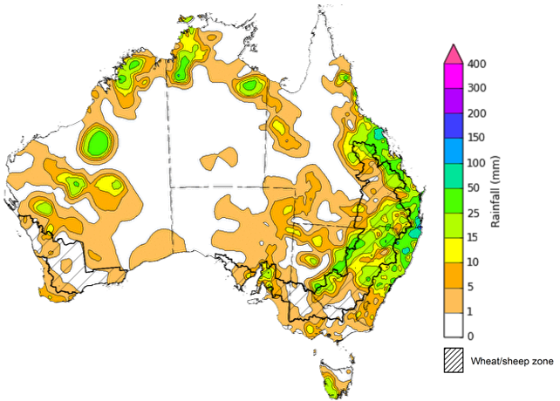
©Commonwealth of Australia 2024, Australian Bureau of Meteorology Issued: 16/10/2024
Note: The rainfall analyses and associated maps utilise data contained in the Bureau of Meteorology climate database, the Australian Data Archive for Meteorology (ADAM). The analyses are initially produced automatically from real-time data with limited quality control. They are intended to provide a general overview of rainfall across Australia as quickly as possible after the observations are received. For further information go to http://www.bom.gov.au/climate/rainfall/

Rainfall forecast for the next eight days
Over the 8 days to 24 October 2024, low-pressure and frontal systems are expected to bring showers and storms over parts of western, northern and south-eastern Australia. Falls of between 10 and 50 millimetres are forecast for Victoria, much of New South Wales, south-eastern South Australia and parts of northern Western Australia and the Northern Territory. Falls of between 5 and 15 millimetres expected across parts south-eastern Queensland and the far south-west of Western Australia. Rainfall totals of between 25 and 100 millimetres are forecast for Tasmania. High pressure systems are expected to keep much of north-eastern, western and central Australia largely dry.
Across cropping regions, some rainfall is expected across southern growing regions, with heavier falls expected in the east. Rainfall totals of between 1 and 10 millimetres are expected in Queensland, while falls of between 10 and 50 millimetres are expected Victoria and central and southern New South Wales. Lighter falls of between 5 and 25 millimetres expected in South Australia and parts of southern Western Australia.
If realised, these falls across eastern Australia may be sufficient to stabilise winter crop yields across some growing regions. However, in parts of western Victoria, South Australia and Western Australia these falls will likely be insufficient to prevent further declines in crop yields compared to those expected at the end of August, following very dry conditions during September and early October, and recent severe frost events.

Total forecast rainfall for the period 17 October to 24 October 2024
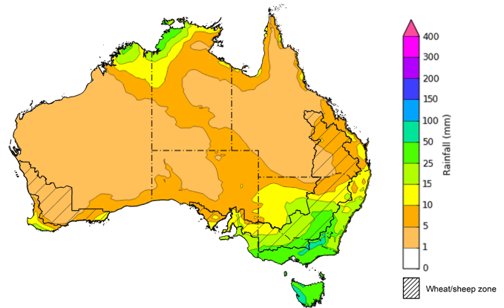
©Commonwealth of Australia 2024, Australian Bureau of Meteorology Issued 17/10/2024
Note: This rainfall forecast is produced from computer models. As the model outputs are not altered by weather forecasters, it is important to check local forecasts and warnings issued by the Bureau of Meteorology.

  - Global production conditions and climate outlook
Crop production is affected by long-term trends in average rainfall and temperature, interannual climate variability, shocks during specific growth stages, and extreme weather events. Some crops are more tolerant than others to certain types of stresses, and at each growth stage, different types of stresses affect each crop species in different ways.
The precipitation anomalies and outlooks presented here give an indication of the current and future state of production conditions for the major grain and oilseed producing countries which are responsible for over 80% of global production. This is an important input to assessing the global grain supply outlook.

September precipitation percentiles and current production conditions
As of the end of September 2024, rainfall was variable for the world’s major grain- and oilseed-producing nations.
In the southern hemisphere, precipitation was general average across northern Argentina, much of eastern Australia and southern Brazil. In contrast, central and eastern Argentina, western and central Australia, and central and northern Brazil experienced below average rainfall. Rainfall was generally average in the remaining grain- and oilseed-producing regions in the southern hemisphere.
In the northern hemisphere, precipitation was below average in parts of eastern Europe, northern Ukraine, large areas of the Russian Federation, northern Mexico and parts of the north and south-west of the United States. Precipitation was generally average to above average in the remaining grain- and oilseed-producing nations in the northern hemisphere.

Global precipitation percentiles, September 2024

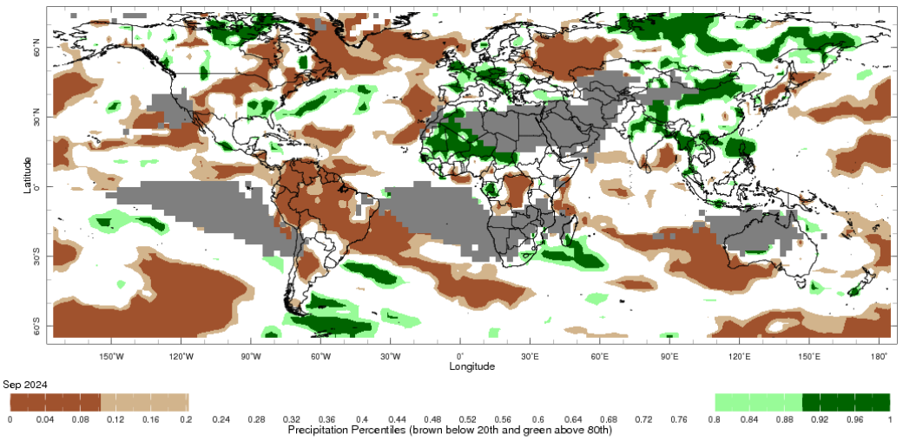

Note: The world precipitation percentiles indicate a ranking of precipitation for September, with the driest (0th percentile) being 0 on the scale and the wettest (100th percentile) being 1 on the scale. Percentiles are based on precipitation estimates from the NOAA Climate Prediction Center’s Climate Anomaly Monitoring System Outgoing Precipitation Index dataset. Precipitation estimates for September 2024 are compared with rainfall recorded for that period during the 1981 to 2010 base period.
Source: International Research Institute for Climate and Society
As of 28 September 2024, global production conditions were generally favourable for rice and soybeans but variable for wheat and maize:
- Wheat – in the northern hemisphere the spring wheat harvest is progressing under generally favourable conditions. However, areas of concern were evident across parts of Canada following adverse weather conditions in recent months. Winter wheat sowing is beginning under mixed conditions in the Russian Federation and Ukraine as crops are being sown into dry soils. Planting is also progressing in the US under favourable conditions. In the southern hemisphere crops are developing variable conditions in Australia and Argentina, with dryness impacting crop development in northern and western Argentina and parts of western and south-eastern Australia.
- Maize – in the southern hemisphere, sowing of the spring planted crop is beginning under generally favourable conditions in Brazil. In the northern hemisphere, there are areas of production concern in Mexico, Bulgaria, Greece, Hungary, Romania, Ukraine and the Russian Federation due to hot and dry conditions. Elsewhere in the northern hemisphere production conditions are generally favourable.
- Rice – conditions are generally favourable, however heavy rainfall and flooding has negatively affected production prospects in the Philippians, Thailand, Vietnam and parts of Bangladesh.
- Soybeans – in the northern hemisphere, generally favourable production conditions persist with the exception of parts of the Ukraine with some production concerns evident due to hot and dry conditions.
Crop conditions, AMIS countries, 28 September 2024
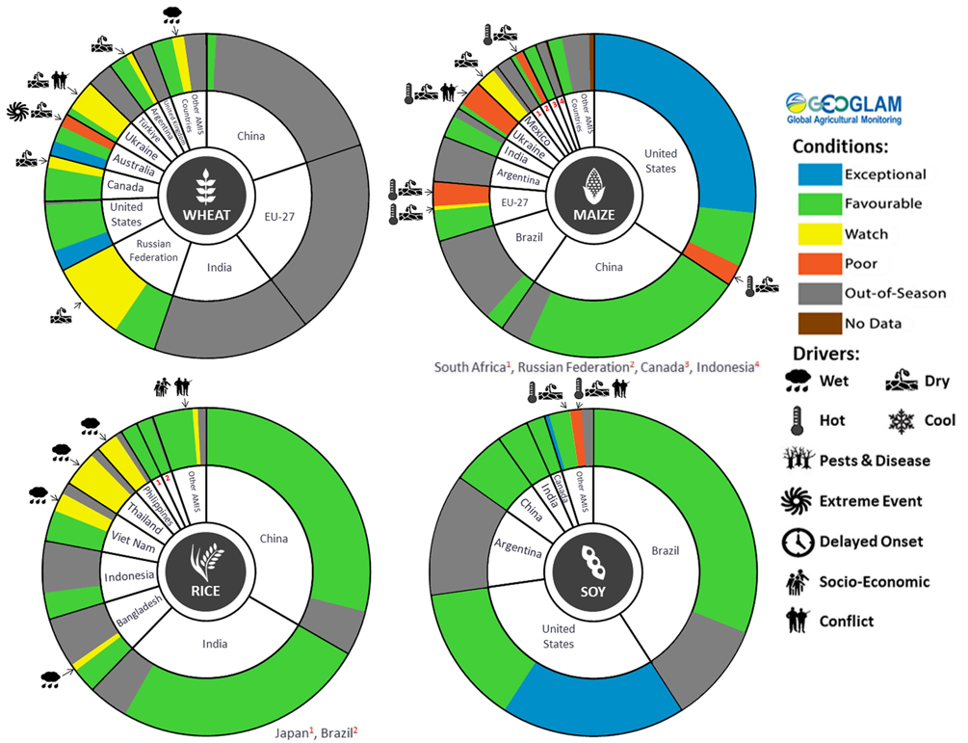
AMIS Agricultural Market Information System.
Source: AMIS

The global climate outlook for November 2024 to January 2025 indicates that mixed rainfall conditions are expected for the world’s major grain-producing and oilseed-producing regions. Outlooks and potential production impacts for the major grain and oilseed producing countries are presented in the following table.

Rainfall outlook and potential impact on the future state of production conditions between November 2024 to January 2025
Region | November-January rainfall outlook | Potential impact on production
Argentina | Below average rainfall is more likely across eastern parts of Argentina. Average rainfall is expected in western and northern areas. | Average rainfall is likely to support the silking, flowering and grain filling of corn, as well as the flowering of cotton, ground nuts, soybeans and sunflowers. The wet conditions mays also support the planting and vegetative growth of millet, rice and sorghum.
Black Sea Region | Generally, average rainfall is expected across much of the Balack Sea region, with below average rainfall in isolated areas, in southern Kazakhstan and Türkiye. | Winter wheat and canola will remain dormant throughout November to January across the Black Sea Region. Average rainfall in many parts may provide sufficient snowpack to protect crops from winterkill.
Brazil | Below average rainfall is more likely across northern parts of Brazil. Close to average rainfall in more likely for the remainder of Brazil. | Average rainfall in parts of southern Brazil may adversely affect the harvesting of wheat in November. Meanwhile, average rainfall in southern is likely to benefit flowering of corn, cotton, groundnuts and soybeans, as well as the grain filling on corn in January. Below average rainfall in northern and central Brazil will likely adversely affect the growth, flowering and filling of soybeans.
Canada | Generally, average to above average rainfall is likely across much of Canada. | Average to above average rainfall in parts of Canada may delay harvesting and cause grain quality concerns for corn, soybean and sunflower in November. Average to above average rainfall is also likely to provide sufficient snowpack to prevent winterkill of winter wheat and canola through December and January.
China | Average to above average rainfall is more likely across much of China, while below average rainfall is more likely across some eastern regions. | Average rainfall in northern and western China is likely to benefit the harvesting of cotton, corn, sorghum, soybean, sunflower and groundnuts. Wet conditions across northern and western China may boost snowpack, lowering the risk of winterkill for winter wheat and canola.
Europe | Average rainfall is more likely for much of Europe, with parts of northern Europe likely to see below average rainfall. | Average rainfall may boost snowpack in parts of central Europe, decreasing the risk of winterkill for winter wheat and canola. Meanwhile, close to average rainfall through November to January should provide sufficient snowpack for dormant crops in northern Europe.
South Asia (India) | Close to average rainfall is likely across much of India. | Average rainfall across much of India will support the harvesting of corn, cotton, groundnuts, millet, rice, sorghum and sunflower. Average rainfall across much of India will also support the vegetative growth and heading of winter wheat and canola.
Southeast Asia (SEA) | Average to above average rainfall is likely across much of Southeast Asia. | Average to above average rainfall in SEA is likely to benefit the growth and development of dry-season rice throughout November to January.
The United States of America (US) | Generally, below average rainfall is likely for much of southern half of the US, with average rainfall more likely across the northern half. | Below rainfall across southern US is likely to support harvesting of corn, sorghum and soybeans in November. Average rainfall conditions expected across the northern US is likely to provide sufficient snow cover through December and January to protect winter wheat and canola through dormancy.

Water

Water markets – current week
Water storage levels in the southern Murray-Darling Basin (MDB) have not been updated by the Bureau of Meteorology since 2 October 2024. Current volume of water held in storage is 17,779 GL, equivalent to 80% of total storage capacity. This is 12 percent or 2,784GL less than at the same time last year. Water storage data is sourced from the Bureau of Meteorology.

Water storages in the Murray-Darling Basin, 2013–2024
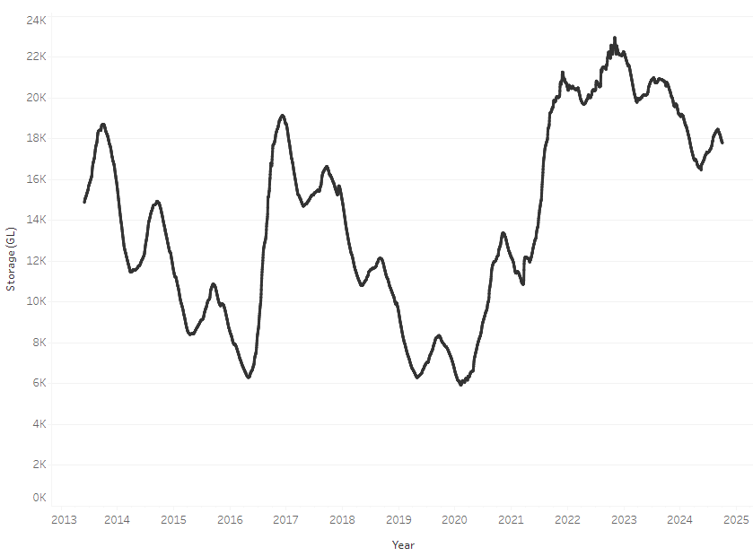
Allocation prices in the Victorian Murray below the Barmah Choke decreased from $140 on 10 October 2024 to $137 on 17 October 2024. Prices are lower in the Murrumbidgee due to the binding of the Murrumbidgee export limit.

Surface water trade activity, Southern Murray–Darling Basin
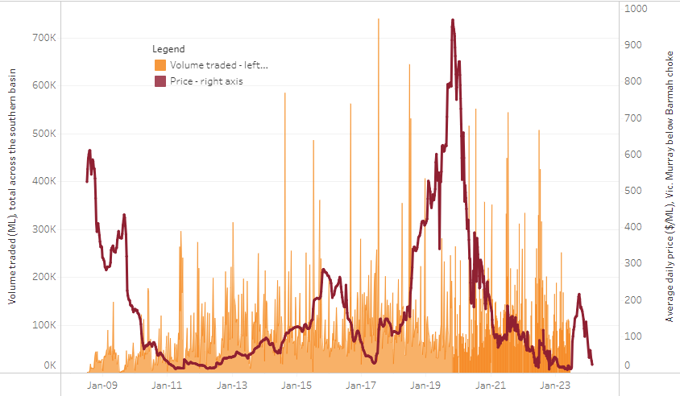
The trades shown reflect estimated market activity and do not encompass all register trades. The price is shown for the VIC Murray below the Barmah choke. Historical prices (before 1 July 2019) are ABARES estimates after removing outliers from BOM water register data. Prices after 1 July 2019 and prior to the 30 October 2019 reflect recorded transaction prices as sourced from Ruralco. Prices after the 30 October 2019 are sourced from Waterflow. Data for volume traded is sourced from the BOM water register. Only the price data shown is current on 17 October 2024.

To access the full, interactive, weekly water dashboard, which contains the latest and historical water storage, water market and water allocation information, please visit https://www.agriculture.gov.au/abares/products/weekly_update/weekly-update-171024

Commodities
Indicator | Week average | Unit | Latest Price | Previous Week | Weekly change |  | Price 12 months ago | Annual change
Selected world indicator prices
AUD/USD Exchange rate | 16-Oct | A$/US$ | 0.67 | 0.67 | 0% | 0.63 |  | 6%
Wheat – US no. 2 hard red winter wheat, FOB Gulf | 16-Oct | US$/t | 271 | 278 | -3% | 293 |  | -8%
Corn – US no. 2 yellow corn, FOB Gulf | 16-Oct | US$/t | 184 | 190 | -3% | 222 |  | -17%
Canola – Rapeseed, Canada, FOB Vancouver | 16-Oct | US$/t | 476 | 487 | -2% | 532 |  | -11%
Cotton – Cotlook 'A' Index | 16-Oct | USc/lb | 83 | 84 | -2% | 94 |  | -12%
Sugar – Intercontinental Exchange, nearby futures, no.11 contract | 16-Oct | USc/lb | 22.6 | 22.3 | 1% | 27 |  | -17%
Wool – Eastern Market Indicator | 16-Oct | Ac/kg clean | 1,138 | 1,139 | 0% | 1,131 |  | 1%
Wool – Western Market Indicator | 16-Oct | Ac/kg clean | 1,273 | 1,281 | -1% | 1,339 |  | -5%
Selected Australian grain export prices
Aust. premium white wheat (APW), FOB Port Adelaide, South Australia | 16-Oct | A$/t | 395 | 394 | 0% | 482 |  | -18%
Aust. standard white wheat (ASW), FOB Port Adelaide, South Australia | 16-Oct | A$/t | 383 | 382 | 0% | 463 |  | -17%
Feed Barley – FOB Port Adelaide, South Australia | 16-Oct | A$/t | 352 | 351 | 0% | 406 |  | -13%
Canola – FOB Kwinana, Western Australia | 16-Oct | A$/t | 795 | 777 | 2% | 784 |  | 1%
Grain Sorghum – FOB Brisbane, Queensland | 16-Oct | A$/t | 388 | 387 | 0% | 513 |  | -24%
Selected domestic livestock indicator prices
Beef – Eastern Young Cattle Indicator | 16-Oct | Ac/kg cwt | 625 | 626 | 0% | 353 |  | 77%
Mutton – Mutton indicator (18–24 kg fat score 2–3), Vic | 16-Oct | Ac/kg cwt | 271 | 287 | -6% | 96 |  | 181%
Lamb – National Trade Lamb Indicator | 16-Oct | Ac/kg cwt | 796 | 788 | 1% | 491 |  | 62%
Pig – Eastern Seaboard (60.1–75 kg), average of buyers & sellers | 02-Oct | Ac/kg cwt | 427 | 425 | 0% | 367 |  | 16%
Live cattle – Light steers to Indonesia | 16-Oct | Ac/kg lwt | 320 | 320 | 0% | 270 |  | 19%
Global Dairy Trade (GDT) weighted average prices ª
Dairy – Whole milk powder | 16-Oct | US$/t | 3,553 | 3,559 | 0% | 2,931 |  | 21%
Dairy – Skim milk powder | 16-Oct | US$/t | 2,745 | 2,795 | -2% | 2,558 |  | 7%
Dairy – Cheddar cheese | 16-Oct | US$/t | 4,702 | 4,606 | 2% | 3,853 |  | 22%
Dairy – Anhydrous milk fat | 16-Oct | US$/t | 7,229 | 7,213 | 0% | 4,979 |  | 45%

Selected world indicator prices
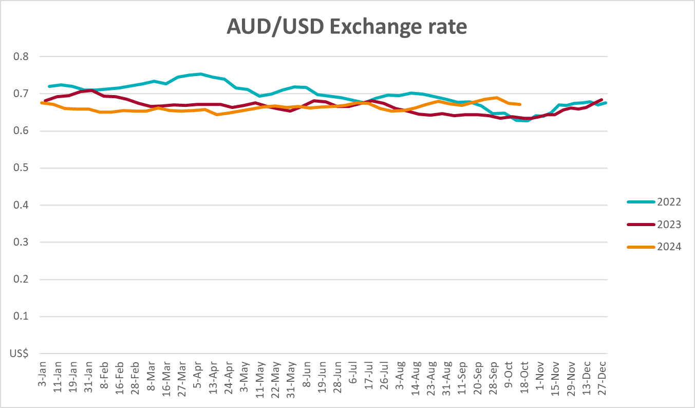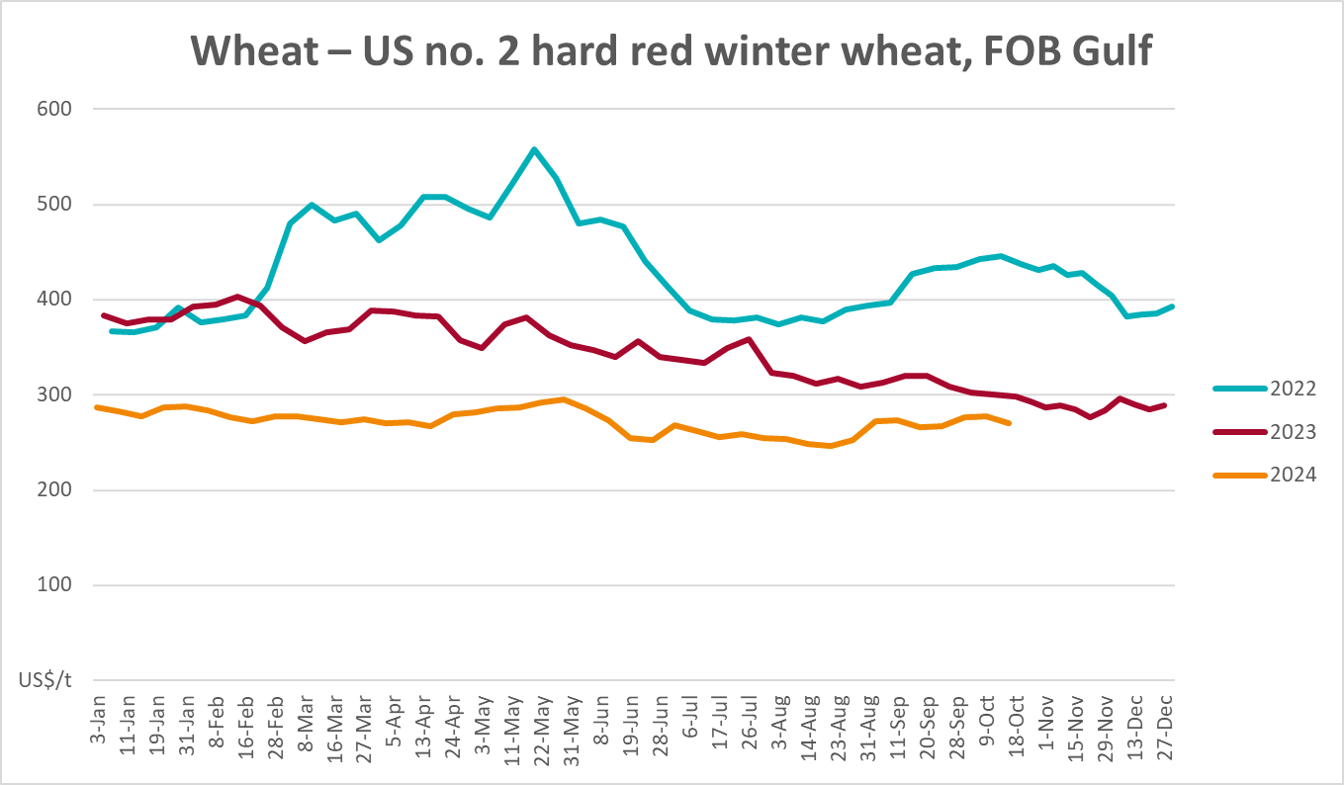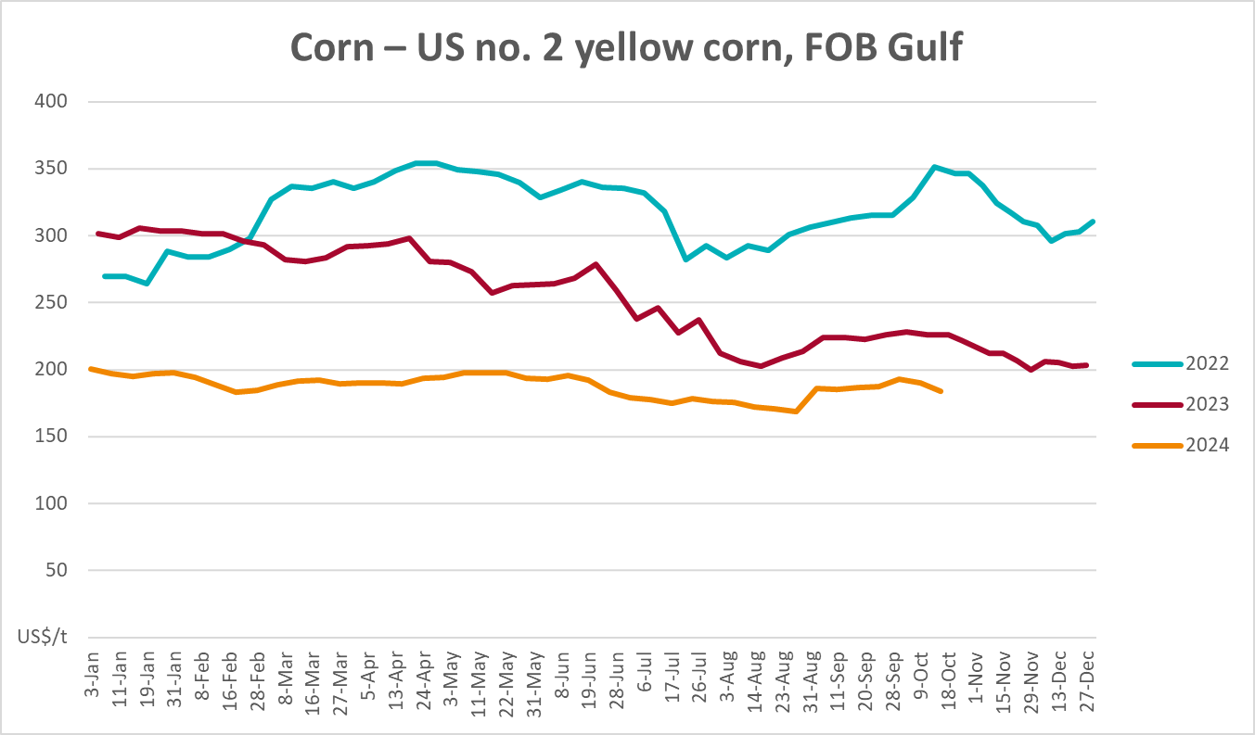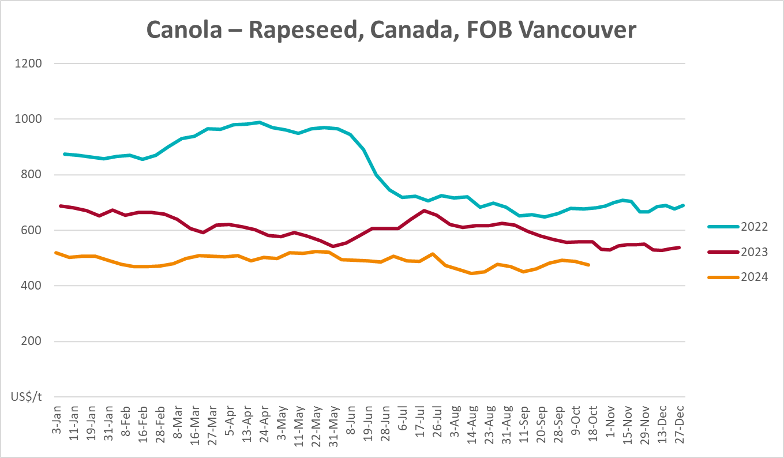
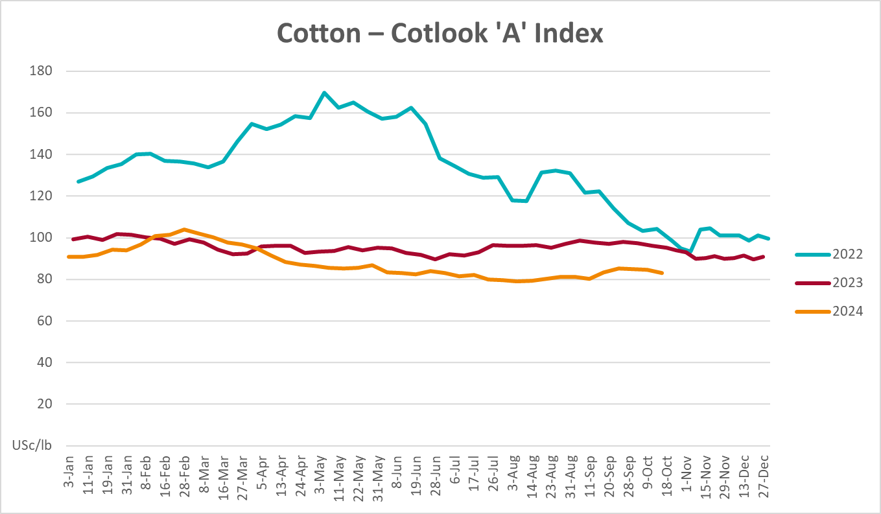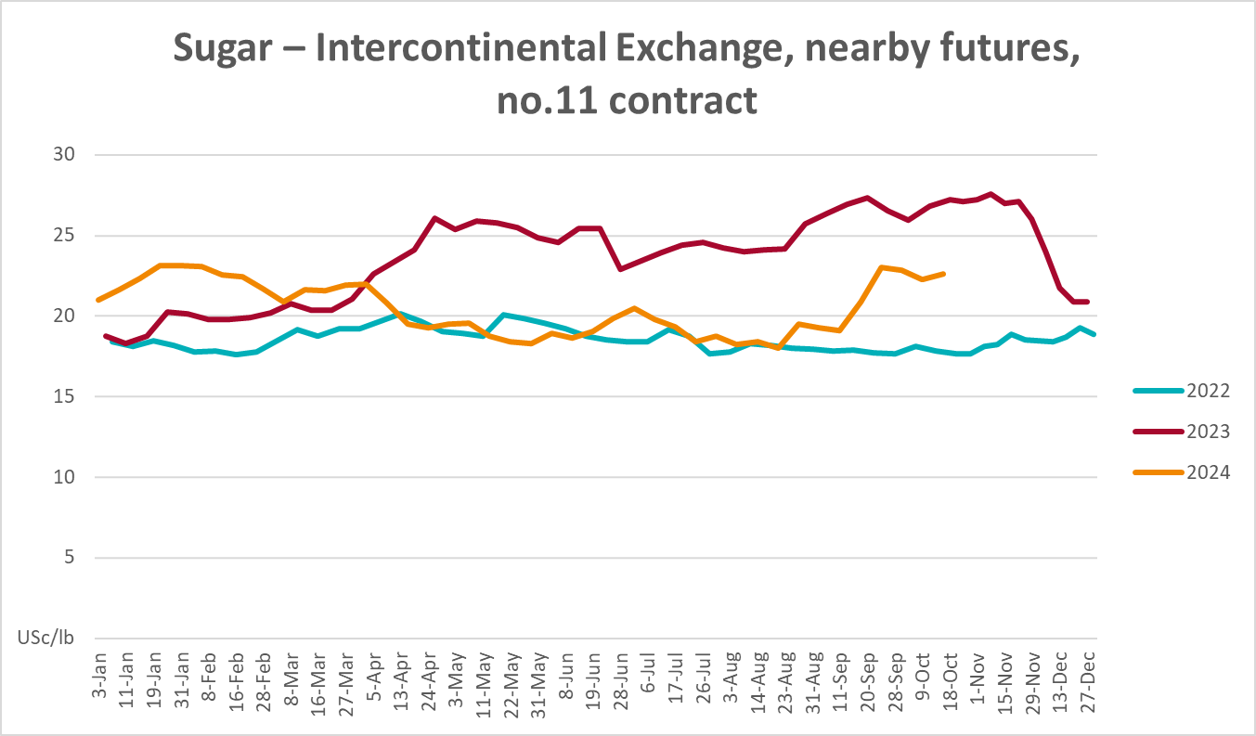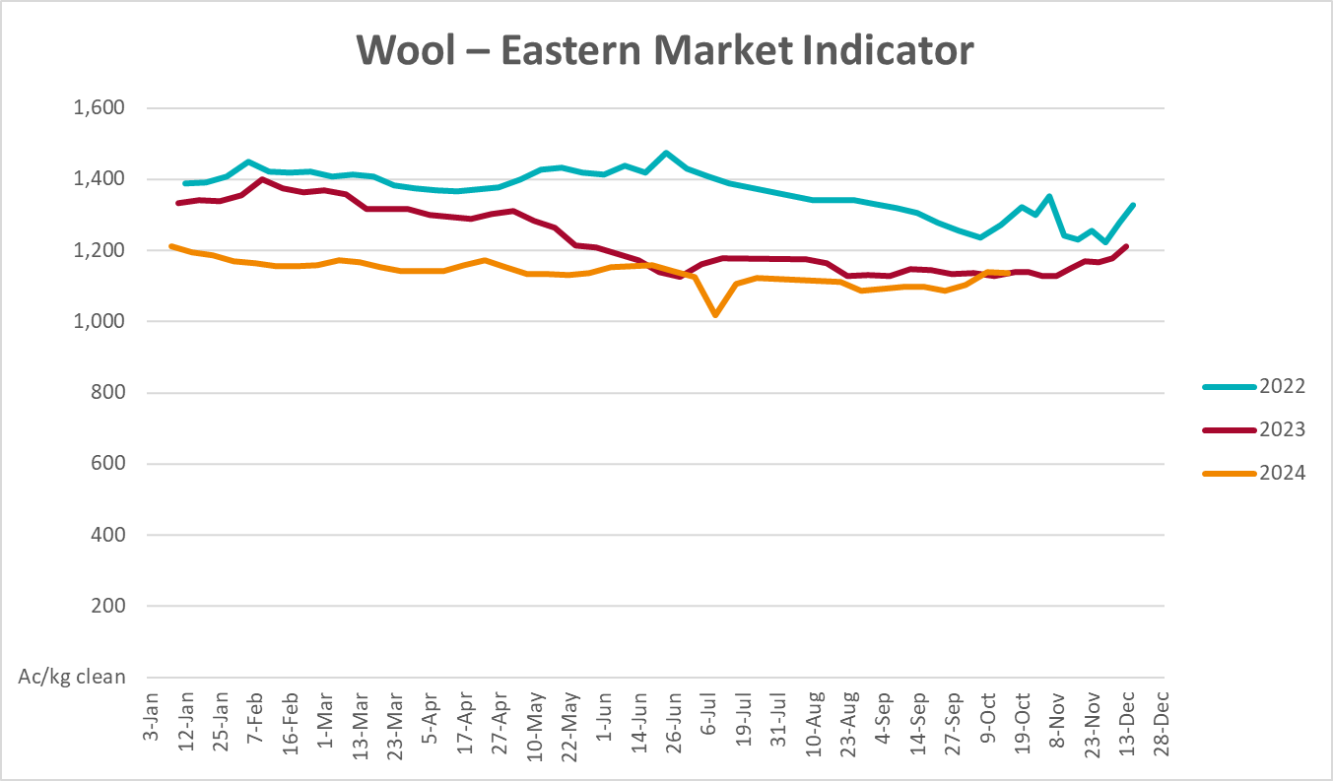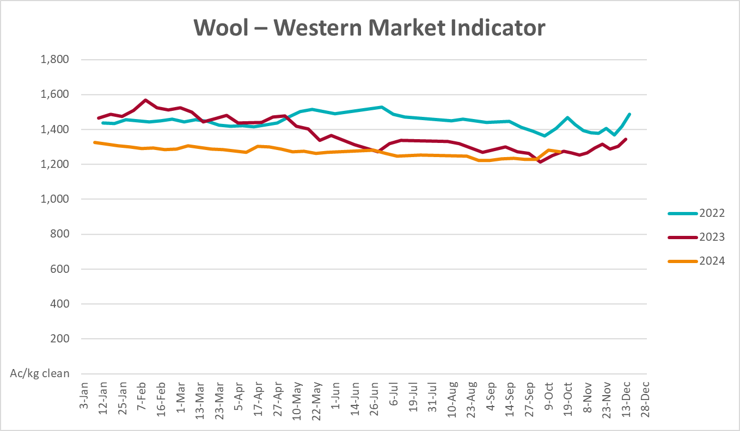

3.2 Selected domestic crop indicator prices
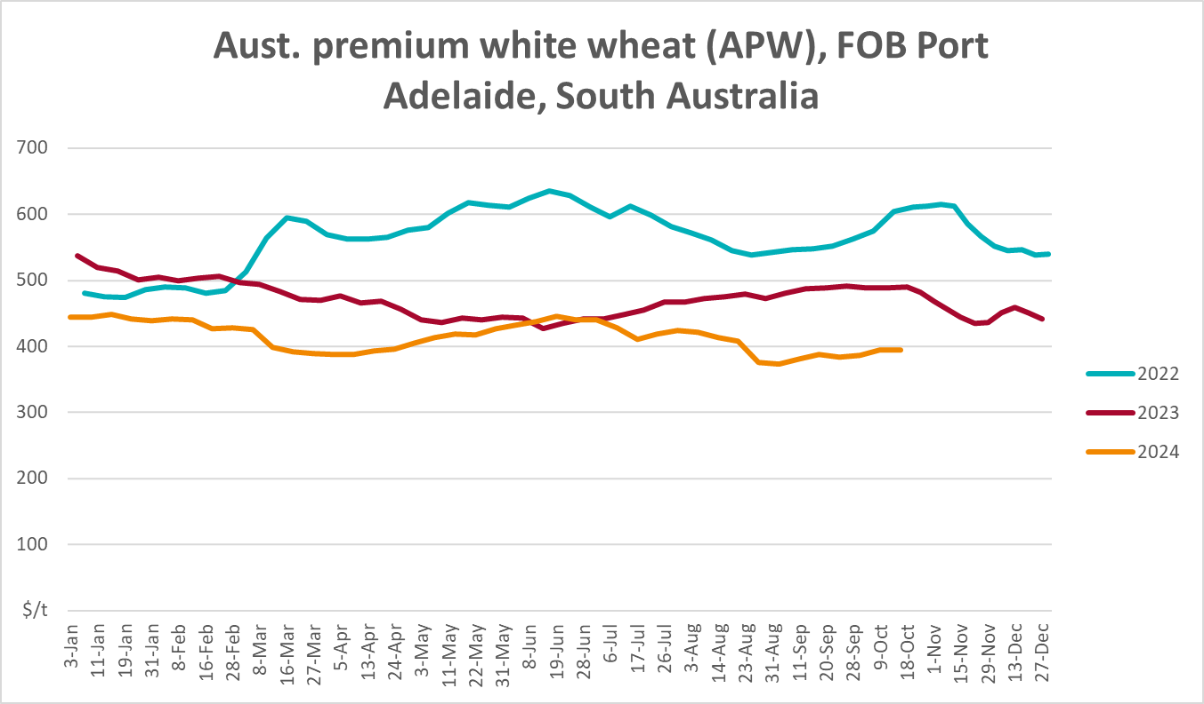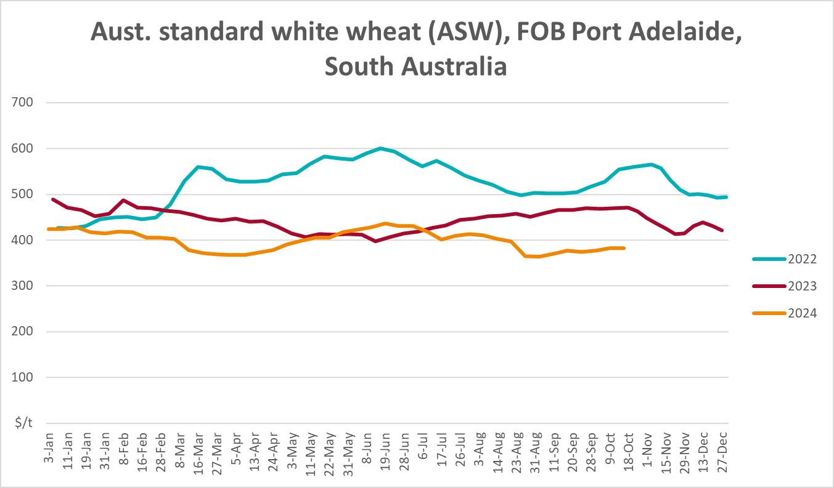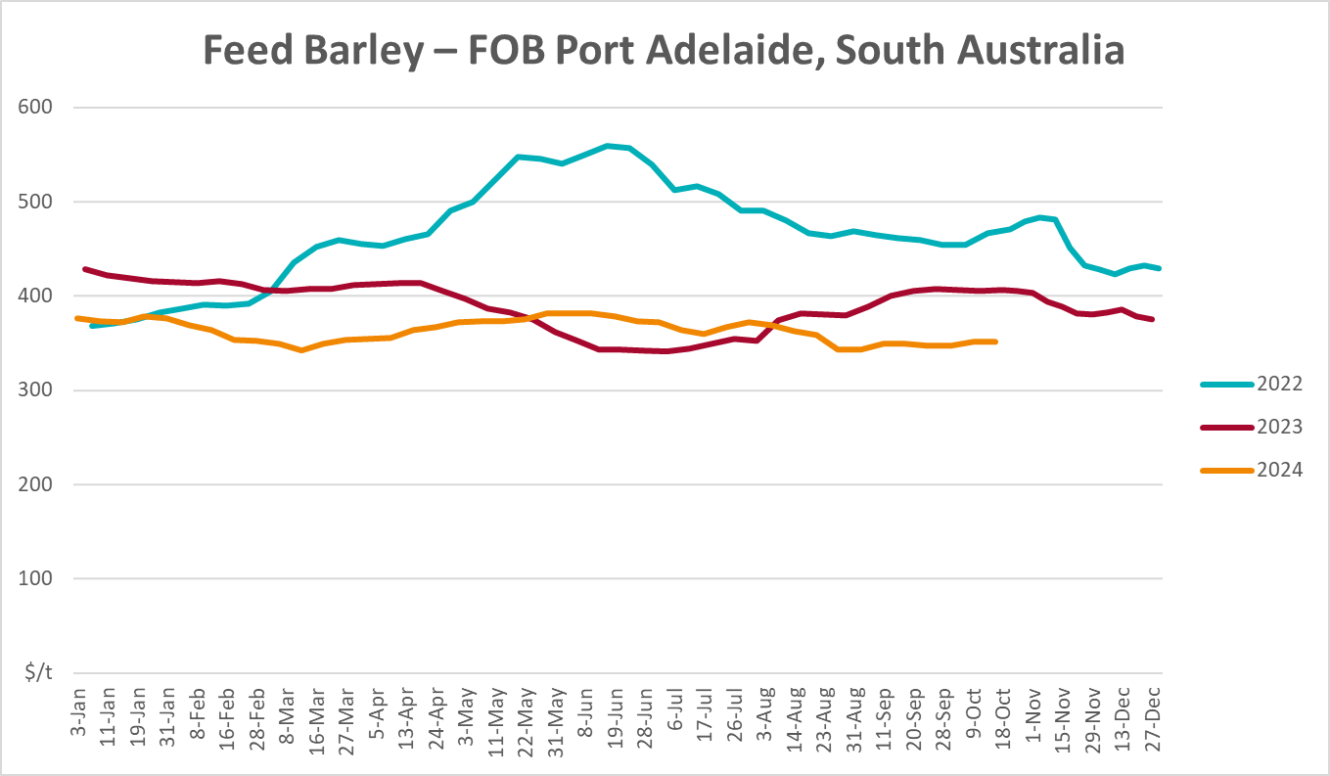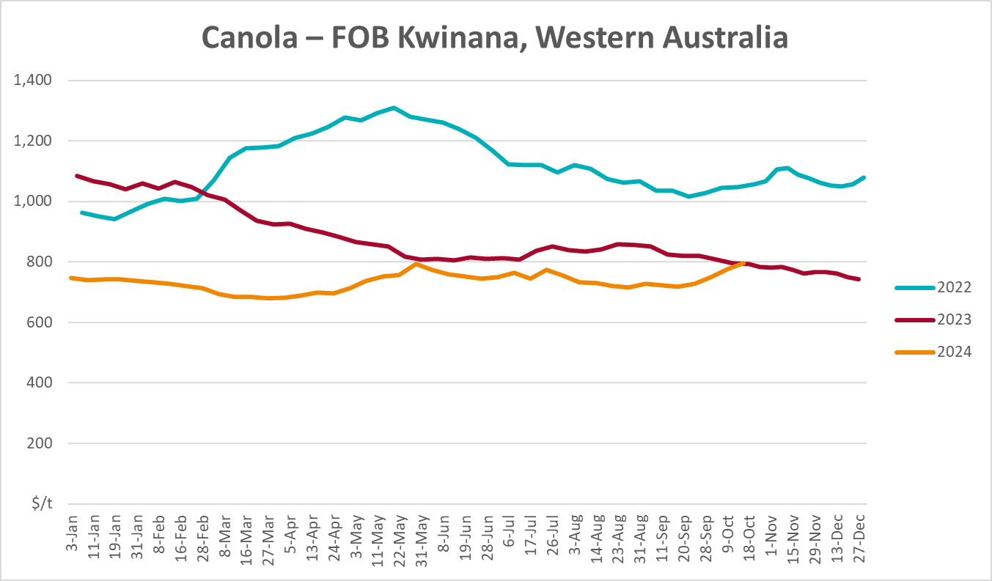
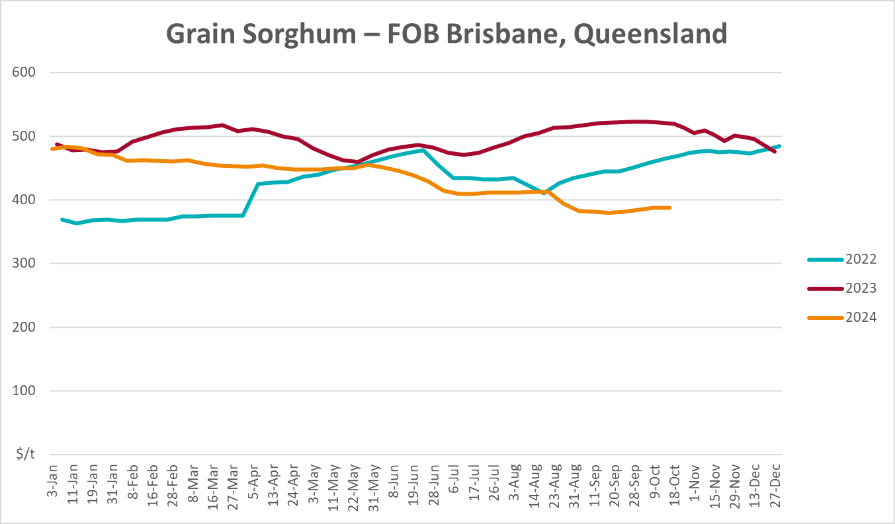

Selected domestic livestock indicator prices
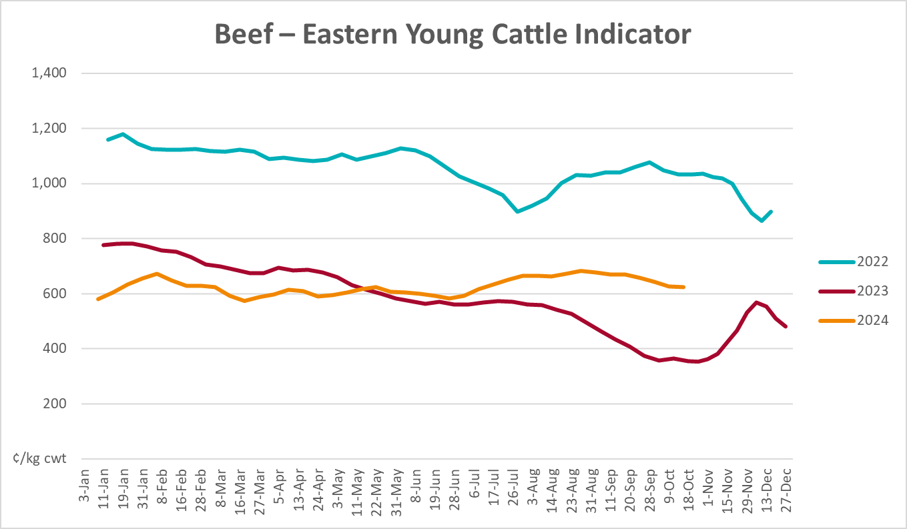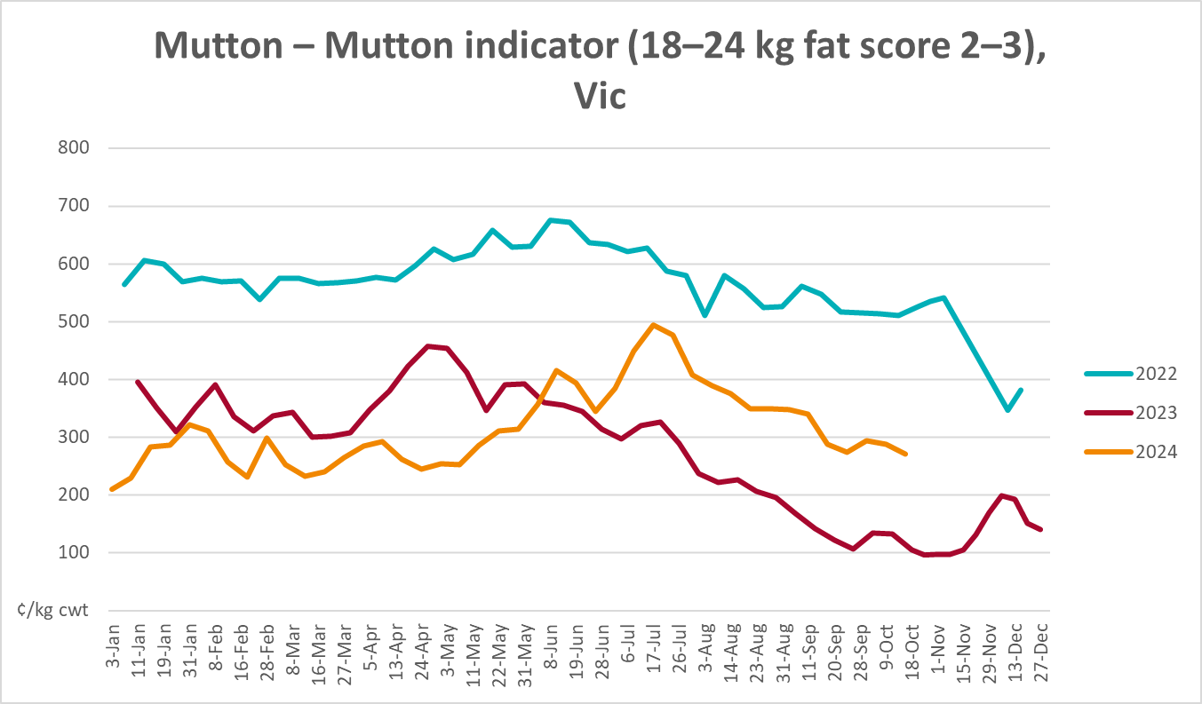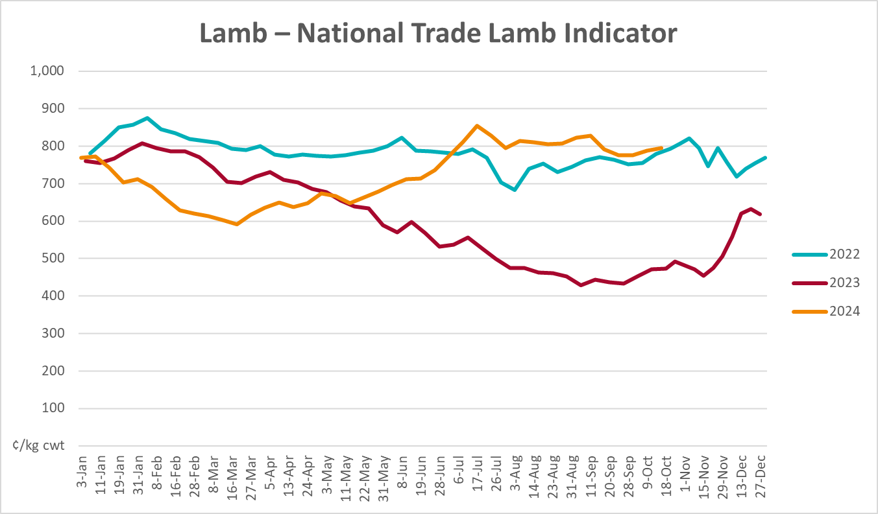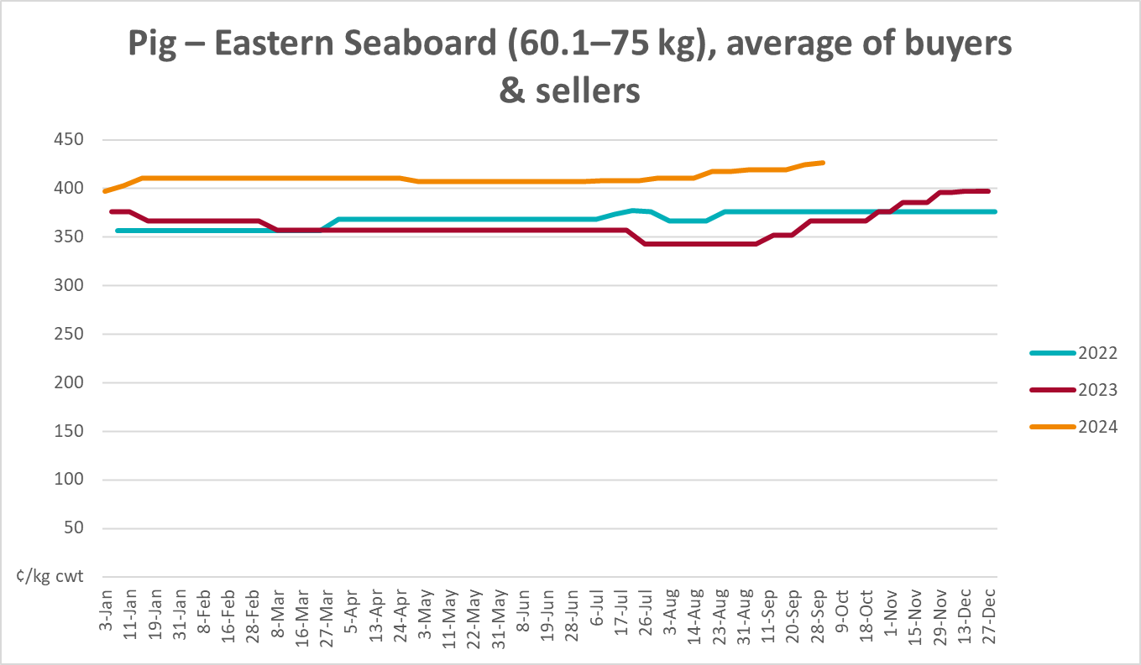
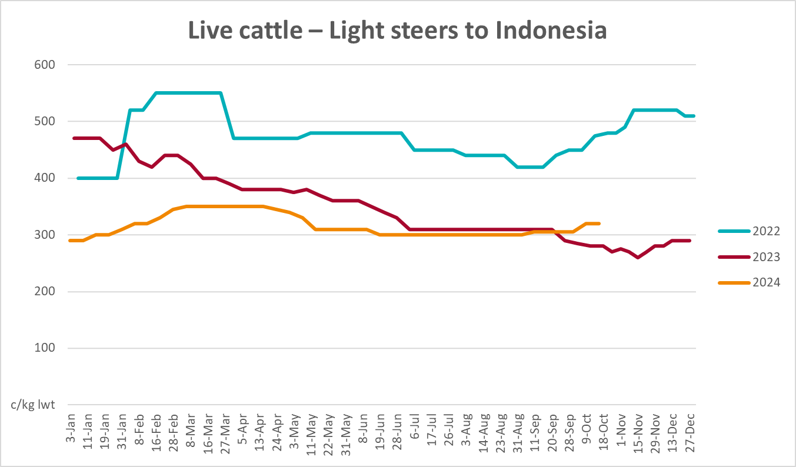

Global Dairy Trade (GDT) weighted average prices
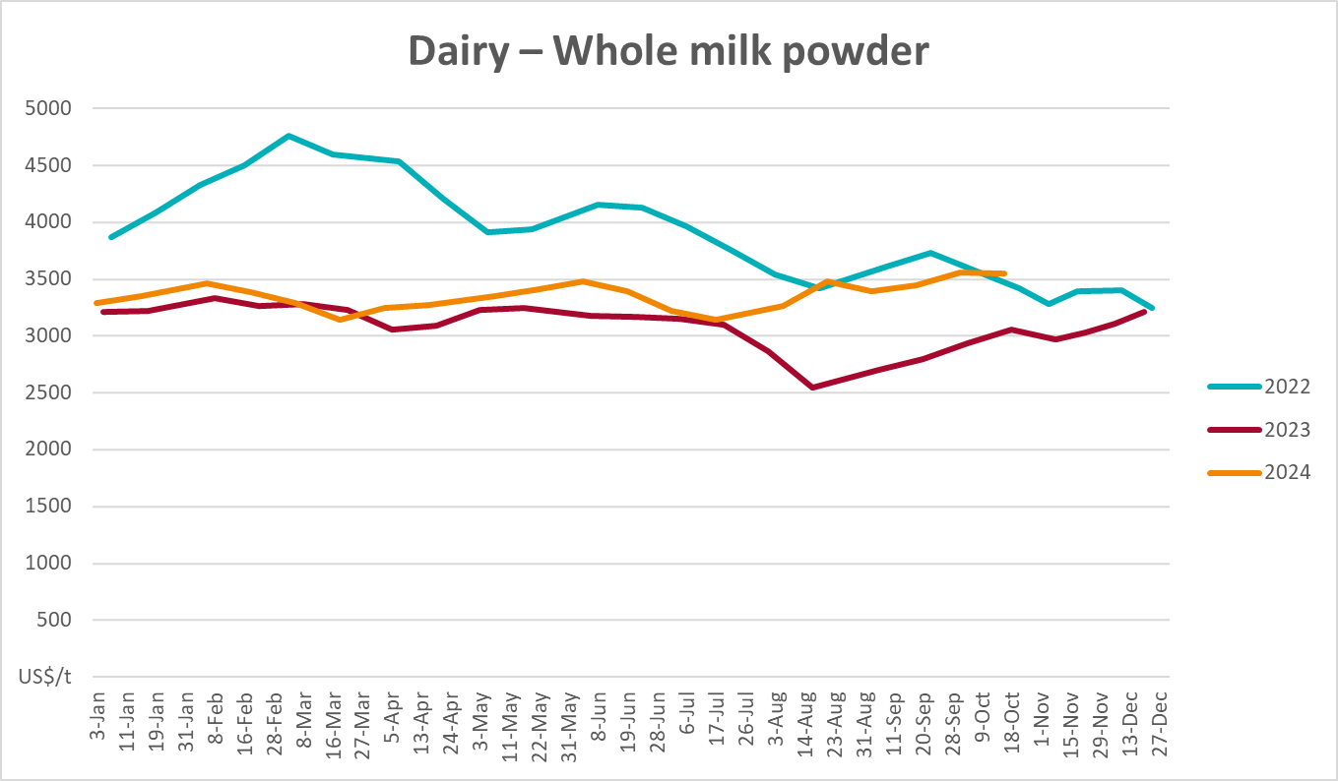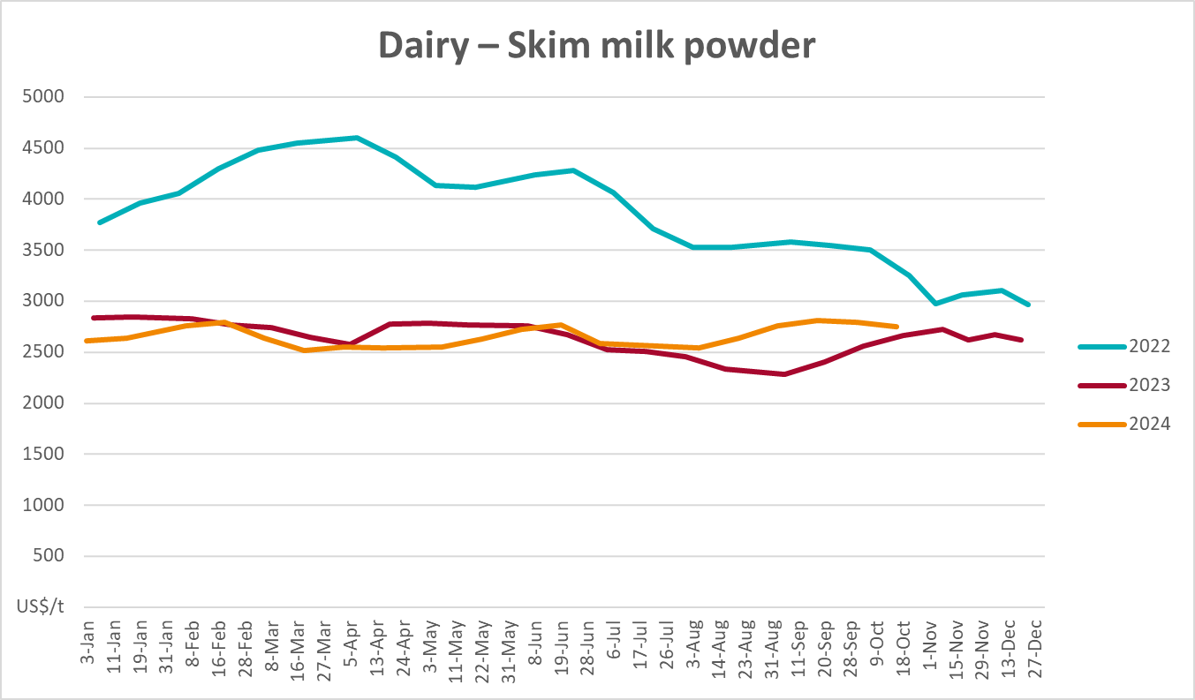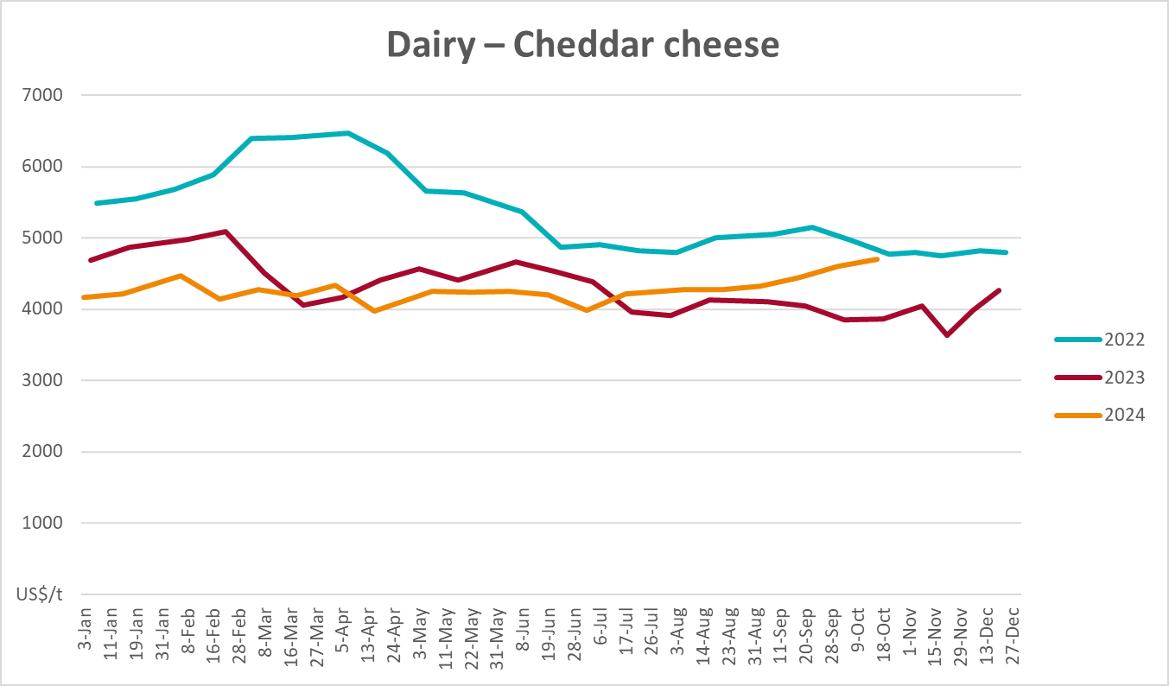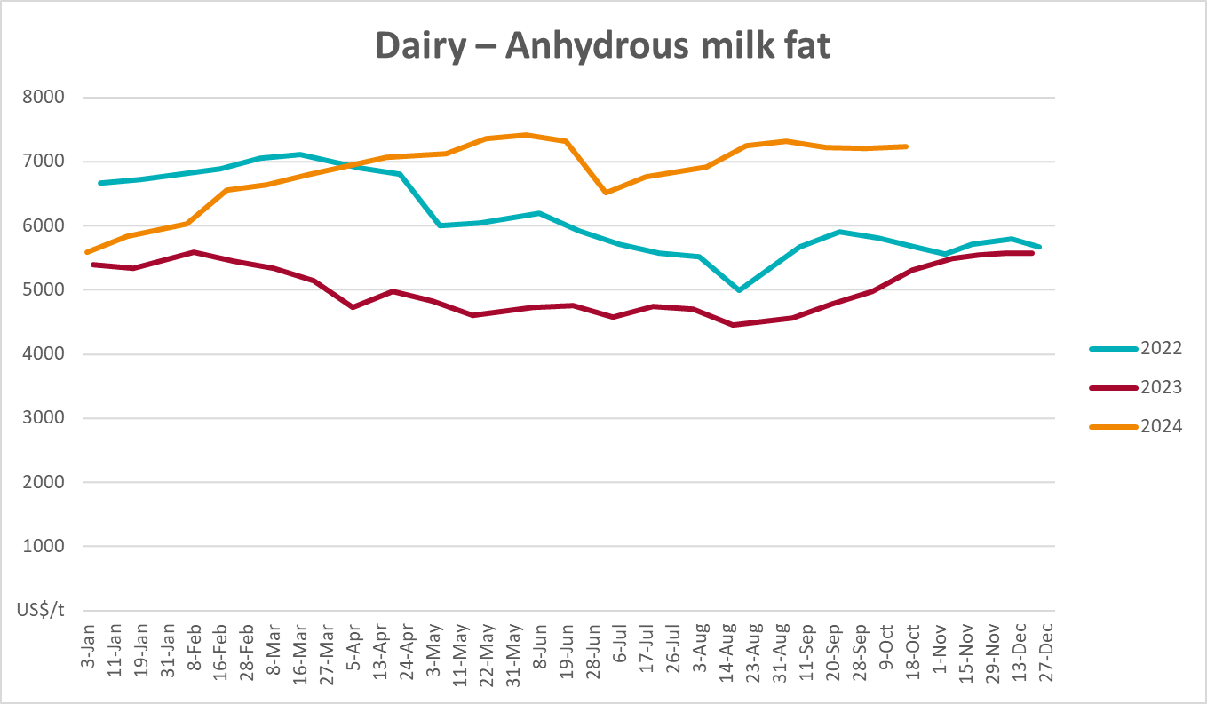

Selected fruit and vegetable prices
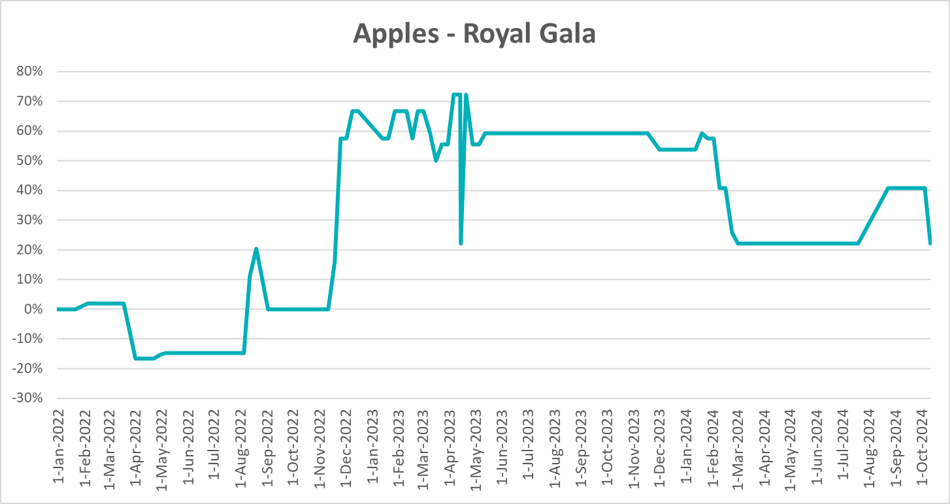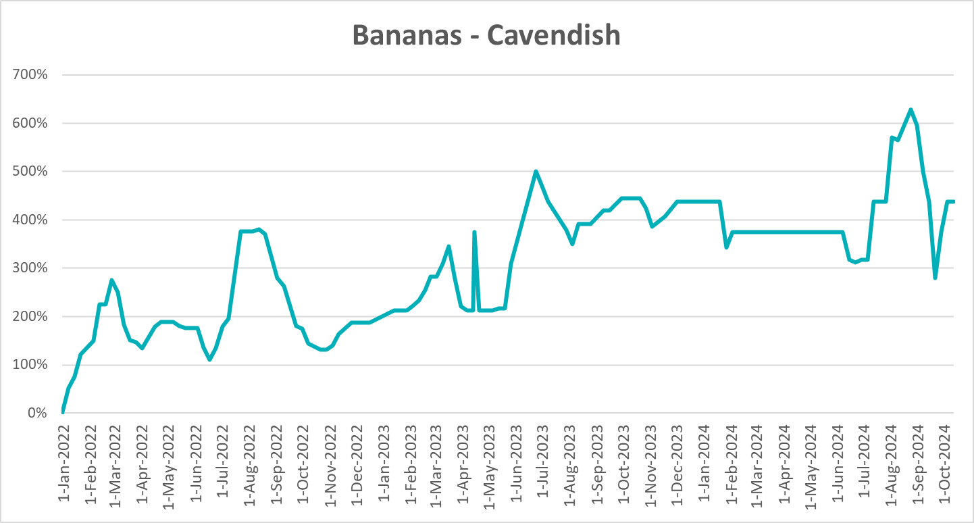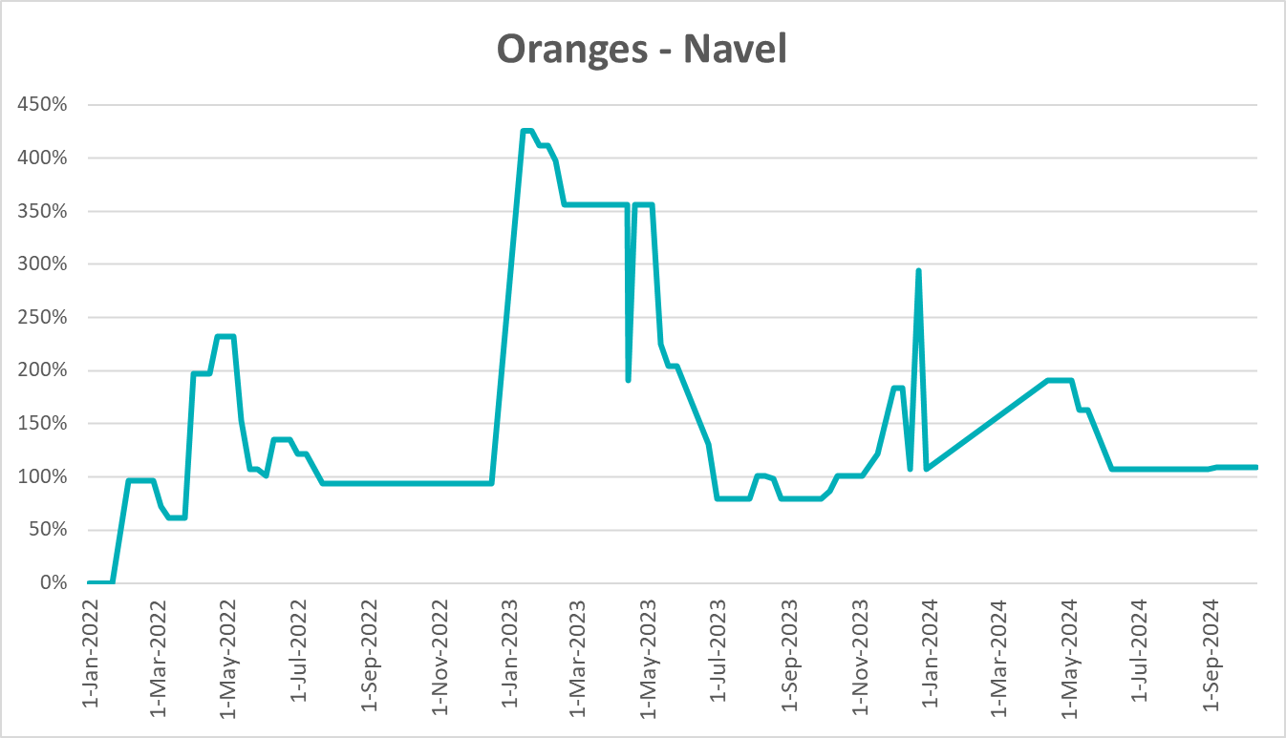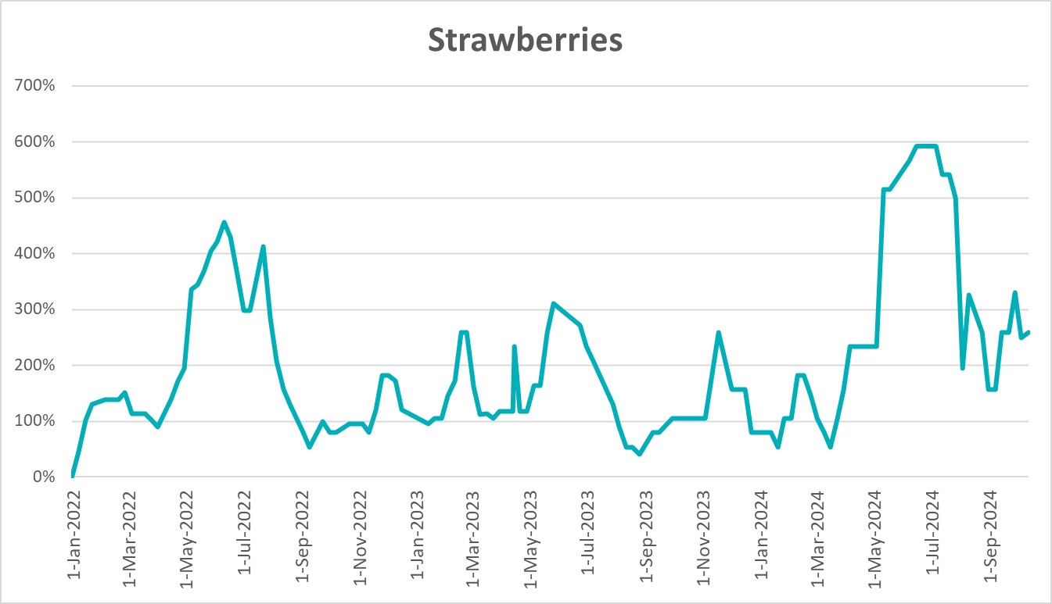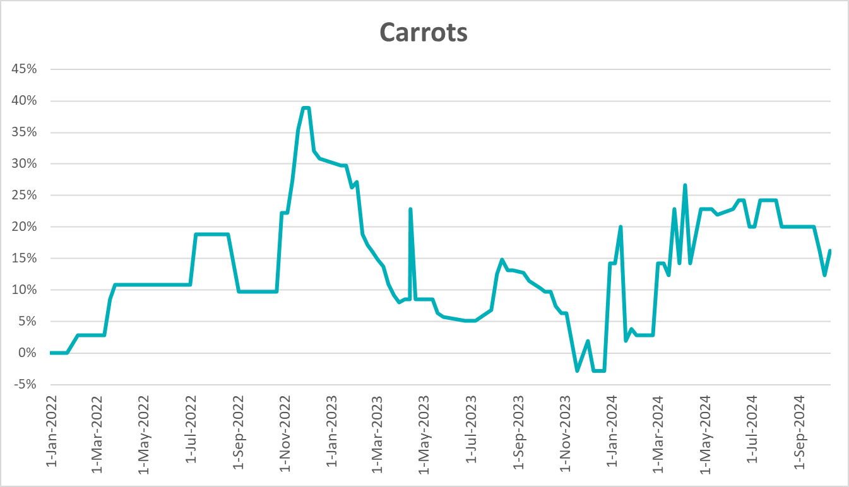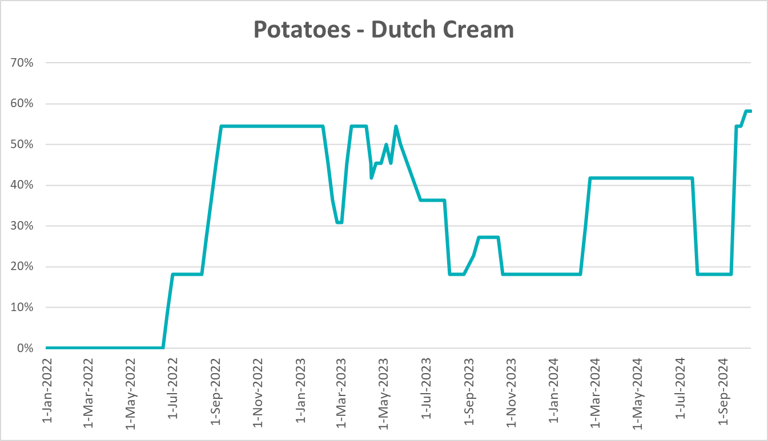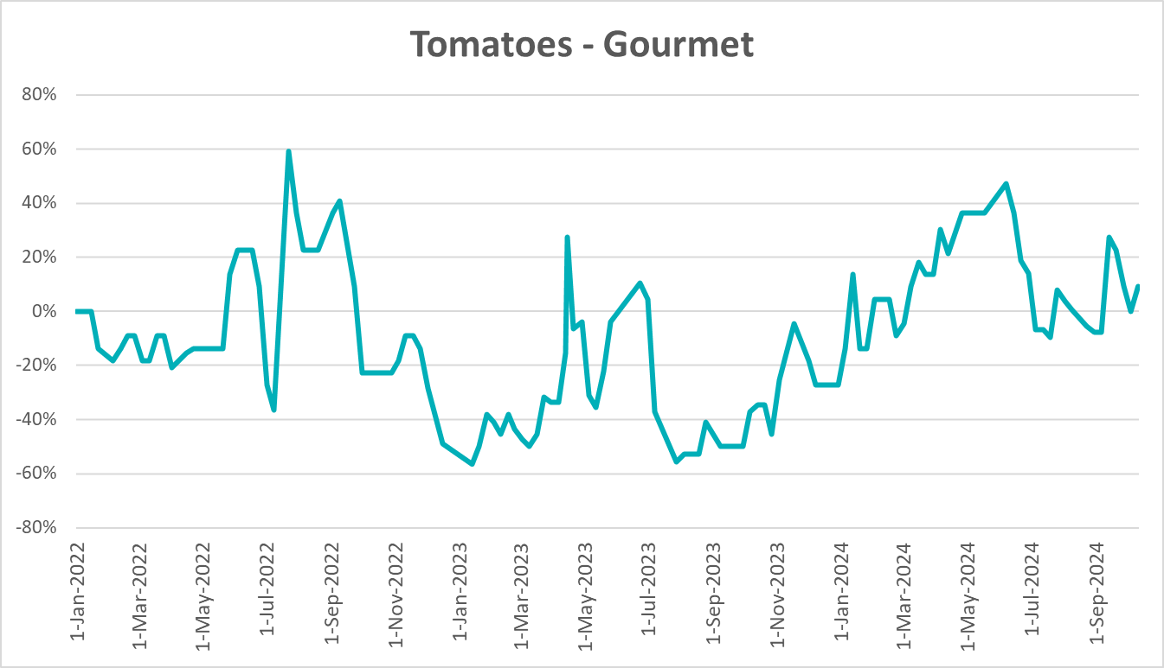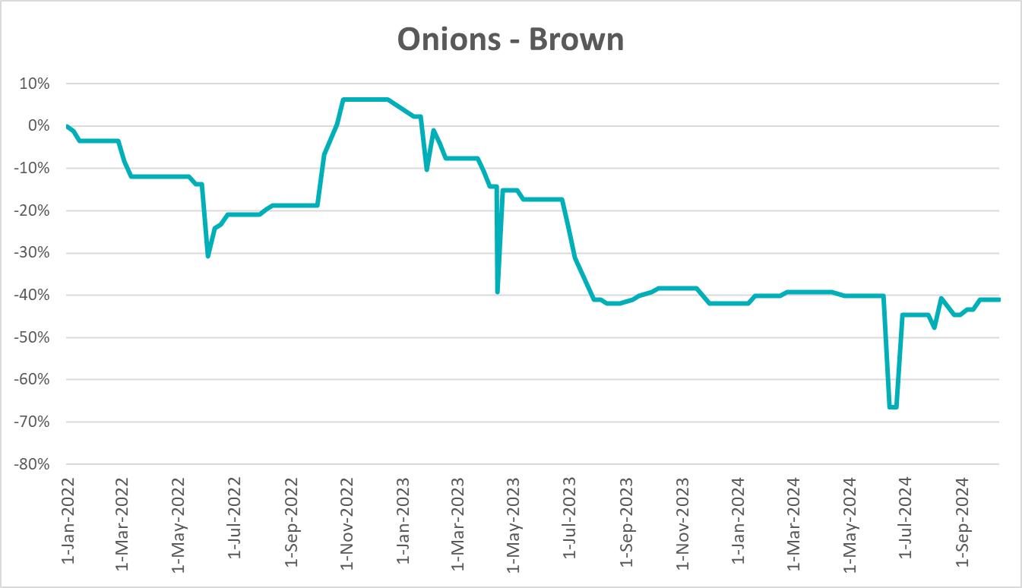

3.6 Selected domestic fodder indicator prices

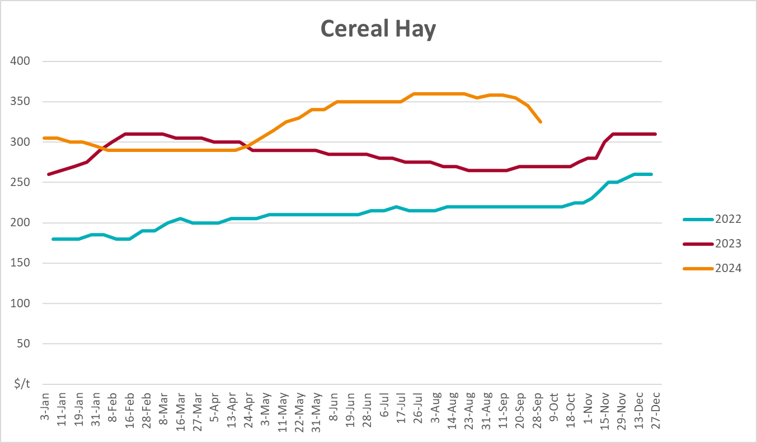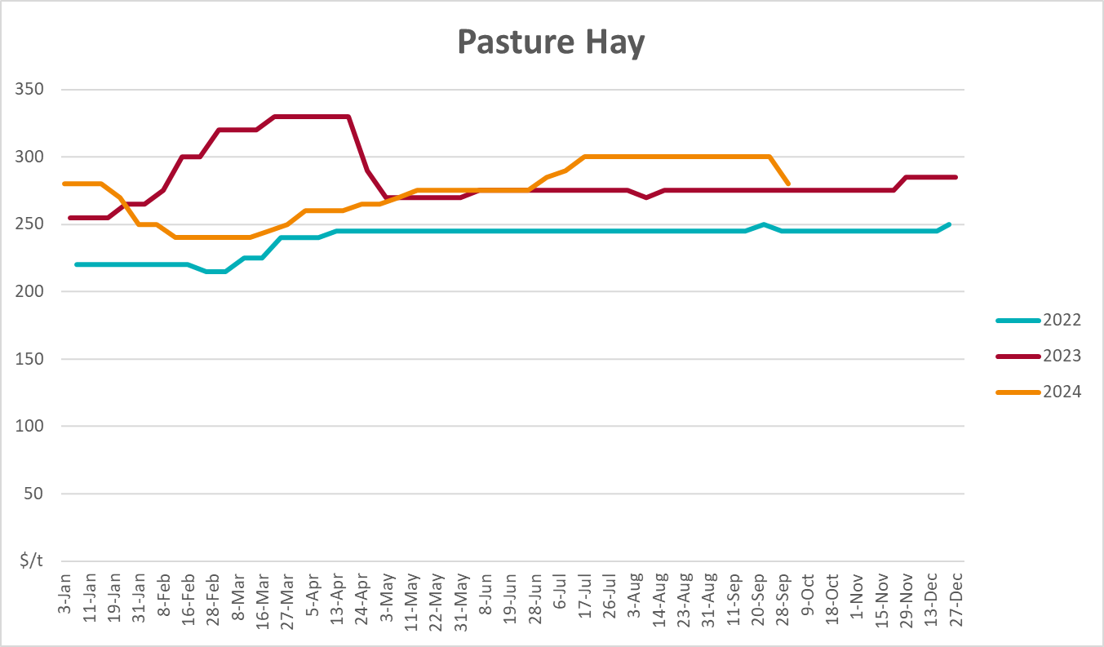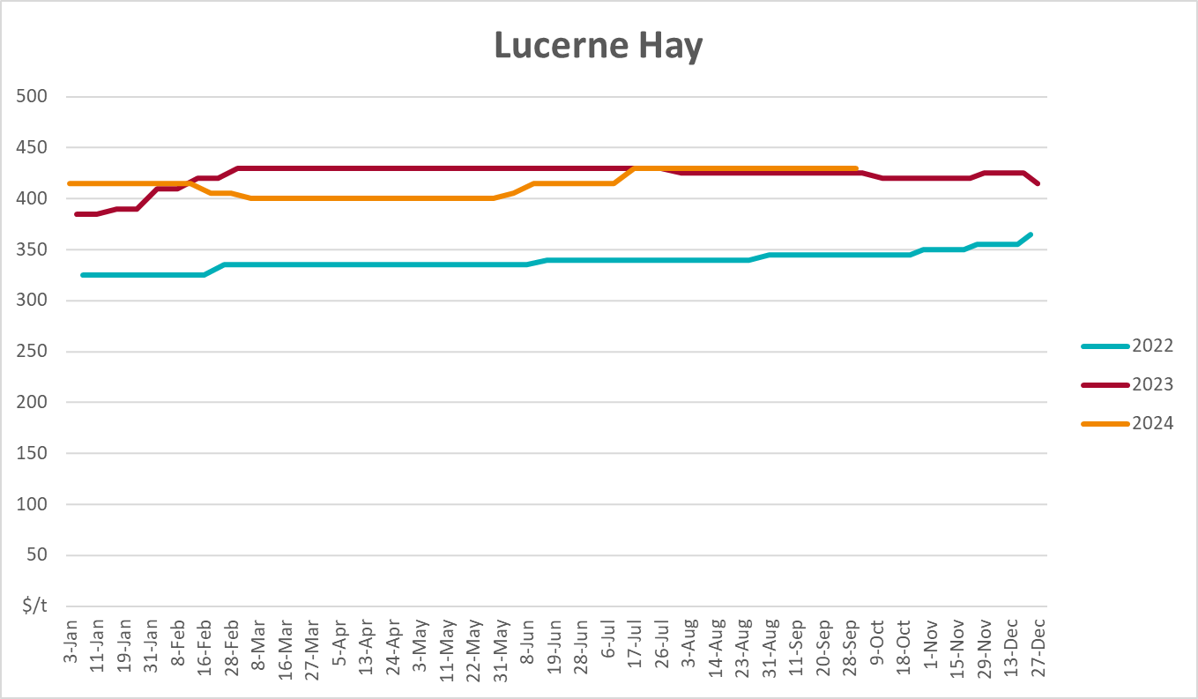

4. Data attribution

Climate
- Bureau of Meteorology
- Weekly rainfall totals: www.bom.gov.au/climate/maps/rainfall/
- Monthly and last 3-month rainfall percentiles: www.bom.gov.au/water/landscape/
- Temperature anomalies: www.bom.gov.au/jsp/awap/temp/index.jsp
- Rainfall forecast: www.bom.gov.au/jsp/watl/rainfall/pme.jsp
- Seasonal outlook: www.bom.gov.au/climate/outlooks/#/overview/summary/
- Climate drivers: http://www.bom.gov.au/climate/enso/
- Soil moisture: www.bom.gov.au/water/landscape/
- Other
- Pasture growth: www.longpaddock.qld.gov.au/aussiegrass/
- 3-month global outlooks: Environment and Climate Change Canada, NOAA Climate Prediction Center, EUROBRISA CPTEC/INPE, European Centre for Medium-Range Weather Forecasts, Hydrometcenter of Russia, National Climate Center Climate System Diagnosis and Prediction Room (NCC), International Research Institute for Climate and Society
- Global production: https://ipad.fas.usda.gov/ogamaps/cropmapsandcalendars.aspx
- Autumn break: Pook et al., 2009, https://rmets-onlinelibrary-wiley-com.virtual.anu.edu.au/doi/epdf/10.1002/joc.1833

Water
Prices
- Waterflow: https://www.waterflow.io/
- Ruralco: https://www.ruralcowater.com.au/
- Bureau of Meteorology:
- Allocation trade: http://www.bom.gov.au/water/dashboards/#/water-markets/mdb/at
- Storage volumes: http://www.bom.gov.au/water/dashboards/#/water-storages/summary/drainage
- Trade constraints:
- Water NSW: https://www.waternsw.com.au/customer-service/ordering-trading-and-pricing/trading/murrumbidgee
- Victorian Water Register: https://www.waterregister.vic.gov.au/TradingRules2019/

Commodities
- Fruit and vegetables
- Datafresh: www.freshstate.com.au
- Pigs
- Australian Pork Limited: www.australianpork.com.au
- Dairy
- Global Dairy Trade: www.globaldairytrade.info/en/product-results/
- World wheat, canola
- International Grains Council
- World coarse grains
- United States Department of Agriculture
- World cotton
- Cotlook: www.cotlook.com/
- World sugar
- New York Stock Exchange - Intercontinental Exchange
- Wool
- Australian Wool Exchange: www.awex.com.au/
- Domestic wheat, barley, sorghum, canola and fodder
- Jumbuk Consulting Pty Ltd: http://www.jumbukag.com.au/
- Cattle, beef, mutton, lamb, goat and live export
- Meat and Livestock Australia: www.mla.com.au/Prices-and-market
© Commonwealth of Australia 2024

Ownership of intellectual property rights
Unless otherwise noted, copyright (and any other intellectual property rights, if any) in this publication is owned by the Commonwealth of Australia (referred to as the Commonwealth).

Creative Commons licence
All material in this publication is licensed under a Creative Commons Attribution 4.0 International Licence except content supplied by third parties, logos and the Commonwealth Coat of Arms.
Inquiries about the licence and any use of this document should be emailed to copyright@awe.gov.au.


Cataloguing data
This publication (and any material sourced from it) should be attributed as:
ABARES 2024, Weekly Australian Climate, Water and Agricultural Update, Australian Bureau of Agricultural and Resource Economics and Sciences, Canberra, 17 October 2024. CC BY 4.0 DOI: https://doi.org/10.25814/5f3e04e7d2503
ISSN 2652-7561
This publication is available at https://www.agriculture.gov.au/abares/products/weekly_update
Department of Agriculture, Fisheries and Forestry
GPO Box 858 Canberra ACT 2601
Telephone 1800 900 090
Web agriculture.gov.au/abares

Disclaimer
The Australian Government acting through the Department of Agriculture, Fisheries and Forestry, represented by the Australian Bureau of Agricultural and Resource Economics and Sciences, has exercised due care and skill in preparing and compiling the information and data in this publication. Notwithstanding, the Department of Agriculture, Fisheries and Forestry, ABARES, its employees and advisers disclaim all liability, including liability for negligence and for any loss, damage, injury, expense or cost incurred by any person as a result of accessing, using or relying on any of the information or data in this publication to the maximum extent permitted by law.

Statement of Professional Independence
The views and analysis presented in ABARES publications, including this one, reflect ABARES professionally independent findings, based on scientific and economic concepts, principles, information and data. These views, analysis and findings may not reflect or be consistent with the views or positions of the Australian Government, or of organisations or groups who have commissioned ABARES reports or analysis. More information on professional independence is provided on the ABARES website.

Acknowledgements
This report was prepared by Matthew Miller.

