## No. 39/2024 10 October 2024

# Summary of key issues

* In the week ending 9 October 2024, several cold fronts and low-pressure systems brought rainfall to scattered areas northern, western and eastern Australia, with other areas largely dry.
  + Across cropping regions, some rainfall was recorded this week, but falls were generally below 10 millimetres in most areas.
  + In areas where stored soil moisture has declined to low levels across parts of south-eastern and south-western Australia, little to no rainfall has likely led to continued reductions in yield potential, exacerbated by severe frosts in September.
* Over coming days, low-pressure and frontal systems are expected to bring showers and storms to parts of western, northern and eastern Australia. High-pressure systems are expected to keep remaining areas largely dry.
  + Across cropping regions, some rainfall is expected across southern growing regions, with heavier falls expected in the east. Rainfall totals of between 5 and 25 millimetres are expected in Queensland, while falls of between 10 and 50 millimetres are expected Victoria and New South Wales. Lighter falls of between 5 and 15 millimetres expected in South Australia and southern Western Australia.
  + If realised, these falls across eastern Australia may be sufficient to stabilise winter crop yields across some growing regions. However, in parts of western Victoria, South Australia and Western Australia these falls will likely be insufficient to prevent further declines in crop yields compared to those expected at the end of August, following very dry conditions during September and recent severe frost events.
* The national rainfall outlook for November 2024 to January 2025 indicates an increased probability of above median rainfall across much of the country.
  + Across most cropping regions there is a 50% or greater chance of receiving above median rainfall. Higher than average rainfall is expected in northern Queensland, New South Wales, Victoria and South Australia.
  + There is 75% chance of rainfall totals being between 50 to 200 millimetres across most southern and eastern cropping regions, with higher rainfall expected in Queensland and northern New South Wales. If realised, these expected rainfall totals will likely improve soil moisture profiles, support late spring and summer pasture growth and provide a favourable start to the summer cropping season across eastern Australia.
* Water storage levels in the southern Murray-Darling Basin (MDB) have not been updated by the Bureau of Meteorology since 2 October 2024. Current volume of water held in storage is 17 779 GL, equivalent to 80% of total storage capacity. This is 12 percent or 2,784GL less than at the same time last year.
* Allocation prices in the Victorian Murray below the Barmah Choke decreased from $143 on 3 October 2024 to $140 on 10 October 2024. Prices are lower in the Murrumbidgee due to the binding of the Murrumbidgee export limit.

## **Climate**

### Rainfall this week

For the week ending 9 October 2024, several cold fronts and a low-pressure trough moved through southern Australia, bringing showers and isolated thunderstorms. Rainfall totals of up to 50 millimetres were recorded across parts of southern and northern New South Wales, southern Victoria, western South Australia and scattered areas of Queensland, Western Australia and the Northern Territory. In Tasmania, cold fronts brought rainfall totals of up to 100 millimetres in the west. High pressure systems saw much of the remainder of the country record little to no rainfall.

Across cropping regions, rainfall totals of between 1 and 15 millimetres was recorded across most areas this week. Across the south-east rainfall totals were significantly less then what was forecast for the week, and as such a reduction in the yield potential of winter crops across most southern growing regions has likely continued in the past week.

In regions where average levels of stored soil moisture were available, crops and pastures would have been able to draw on these reserves to maintain current yield potentials. However, in areas where stored soil moisture levels are low, little to no rainfall has likely to lead to reduced yield potential, exacerbated by severe frosts during September.

#### Rainfall for the week ending 9 October 2024

©Commonwealth of Australia 2024, Australian Bureau of Meteorology Issued: 10/10/2024

Note: The rainfall analyses and associated maps utilise data contained in the Bureau of Meteorology climate database, the Australian Data Archive for Meteorology (ADAM). The analyses are initially produced automatically from real-time data with limited [quality control](http://www.bom.gov.au/climate/headers/qc.shtml). They are intended to provide a general overview of rainfall across Australia as quickly as possible after the observations are received. For further information go to <http://www.bom.gov.au/climate/rainfall/>

### Rainfall forecast for the next eight days

Over the 8 days to 17 October 2024, low-pressure and frontal systems are expected to bring showers and storms over parts of western, northern and eastern Australia. Up to 50 millimetres is forecast for Victoria, much of New South Wales and south-eastern Queensland. Falls of between 5 and 25 millimetres expected across parts of western and south-eastern South Australia, parts of southern and northern Western Australia and isolated areas of tropical northern Australia. Rainfall totals of between 15 and 50 millimetres are forecast for Tasmania. High pressure systems are expected to keep much of north-eastern and central Australia largely dry.

Across cropping regions, some rainfall is expected across southern growing regions, with heavier falls expected in the east. Rainfall totals of between 5 and 25 millimetres are expected in Queensland, while falls of between 10 and 50 millimetres are expected Victoria and New South Wales. Lighter falls of between 5 and 15 millimetres expected in South Australia and southern Western Australia.

If realised, these falls across eastern Australia may be sufficient to stabilise winter crop yields across some growing regions. However, in parts of western Victoria, South Australia and Western Australia these falls will likely be insufficient to prevent further declines in crop yields compared to those expected at the end of August, following very dry conditions during September and recent severe frost events.

#### Total forecast rainfall for the period 10 October to 17 October 2024

©Commonwealth of Australia 2024, Australian Bureau of Meteorology Issued 10/10/2024

Note: This rainfall forecast is produced from computer models. As the model outputs are not altered by weather forecasters, it is important to check local forecasts and warnings issued by the Bureau of Meteorology.

* 1. **National Climate Outlook**

The El Niño Southern Oscillation (ENSO) and Indian Ocean Dipole (IOD) climate drivers are currently neutral and having minimal influence on Australian rainfall. The Southern Annular Mode (SAM) has been negative for several weeks (as at 28 September). Forecasts indicate it is likely to become neutral over the coming week. A neutral SAM has no strong relationship to forecast climate conditions.

The most recent rainfall outlook for November 2024 provided by the Bureau of Meteorology indicates that much of New South Wales, southern Queensland, northern Victoria, South Australia and northern areas of Western Australia are likely to see above median rainfall (between 55 to 70% chance). There is a roughly equal probability of either above or below median rainfall across large areas of western, central and northern Australia.

According to Bureau of Meteorology’s climate model, for November 2024, there is a 75% probability of rainfall totals of between 10 and 50 millimetres across much of eastern and central New South Wales, Victoria, eastern Queensland, the far south-west of Western Australia, eastern agricultural areas of South Australia, and much of the tropical north. Meanwhile, Tasmania and parts of eastern New South Wales, eastern Victoria and the north of the Northern Territory are expected to see falls of between 25 and 200 millimetres. Much of western and central Australia is expected to receive little to no rainfall.

Across cropping regions, there is a 75% chance of receiving between 10 and 50 millimetres of rainfall across much of Queensland and New South Wales, with higher rainfall totals expected in eastern regions. In South Australia, Victoria and southern Western Australia, rainfall totals are expected to be between 5 and 25 millimetres. These relatively low expected rainfall totals across much of southern Australia continue to represent a significant downside production risk for both winter crop production and pasture growth, particularly given the lack of rainfall in recent weeks and declining soil moisture levels across large areas. However, if forecast rainfall totals are realised across much of New South Wales and Queensland, these falls are likely to be sufficient to support above average yield prospects for winter and summer crops and average or better levels of pasture production.

**Rainfall totals that have a 75% chance of occurring in November 2024**

©Commonwealth of Australia 2024, Australian Bureau of Meteorology Issued: 26/09/2024

The rainfall outlook for November 2024 to January 2025 indicates an increased probability of above average rainfall across much of the country. In contrast, below median rainfall is more likely across isolated areas of south-western Tasmania.

Across cropping regions, the probability of receiving above median rainfall is between 50% and 65% in Queensland and Western Australia. In New South Wales, Victoria and South Australia, the probability of above median rainfall is between 60% to 75%. If above median rainfall is realised, this rainfall is likely to support the storage of soil moisture in eastern regions for the summer cropping period and contribute to improving soil moisture in south-eastern regions.

**Chance of exceeding the median rainfall** **November 2024 to January 2025**

©Commonwealth of Australia 2024, Australian Bureau of Meteorology Issued: 10/10/2024

The outlook for November through to January suggests a 75% chance of rainfall totals between 50 and 300 millimetres across much of New South Wales, Queensland, Victoria, Tasmania and the Northern Territory, and across parts of South Australia and Western Australia. Rainfall totals in excess of 300 millimetres are forecast for alpine regions of Victoria and New South Wales, isolated coastal areas of eastern New South Wales and Queensland, western Tasmania and the tropical north of Queensland, Western Australia and the Northern Territory.

In cropping regions, there is a 75% chance of receiving between 100 and 300 millimetres of rainfall across much of Queensland, and between 50 and 200 millimetres across New South Wales and Victoria. Conditions are expected to be drier in Western Australia and South Australia, with forecast rainfall to between 10 and 100 millimetres, and 25 to 100 millimetres, respectively.

Given harvest will be well underway across several regions, November through to January rainfall will have little influence on winter crop production prospects, other than its influence on harvest progress. Meanwhile, if the forecast November through to January rainfall totals are realised, they are likely to be sufficient to support late spring and summer pasture growth across eastern and northern Australia. Additionally, these expected falls are likely to be sufficient to maintain above yield expectation for summer crops.

**Rainfall totals that have a 75% chance of occurring November 2024 to January 2025**

©Commonwealth of Australia 2024, Australian Bureau of Meteorology Issued: 10/10/2024

## **Water**

### Water markets – current week

Water storage levels in the southern Murray-Darling Basin (MDB) have not been updated by the Bureau of Meteorology since 2 October 2024. Current volume of water held in storage is 17 779 GL, equivalent to 80% of total storage capacity. This is 12 percent or 2,784GL less than at the same time last year. Water storage data is sourced from the Bureau of Meteorology.

#### Water storages in the Murray-Darling Basin, 2013–2024

Allocation prices in the Victorian Murray below the Barmah Choke decreased from $143 on 3 October 2024 to $140 on 10 October 2024. Prices are lower in the Murrumbidgee due to the binding of the Murrumbidgee export limit.

#### Surface water trade activity, Southern Murray–Darling Basin

|  |
| --- |
| The trades shown reflect estimated market activity and do not encompass all register trades. The price is shown for the VIC Murray below the Barmah choke. Historical prices (before 1 July 2019) are ABARES estimates after removing outliers from BOM water register data. Prices after 1 July 2019 and prior to the 30 October 2019 reflect recorded transaction prices as sourced from Ruralco. Prices after the 30 October 2019 are sourced from Waterflow. Data for volume traded is sourced from the BOM water register. Only the price data shown is current on 10 October 2024. |

To access the full, interactive, weekly water dashboard, which contains the latest and historical water storage, water market and water allocation information, please visit <https://www.agriculture.gov.au/abares/products/weekly_update/weekly-update-101024>

## **Commodities**

|  |  |  |  |  |  |  |  |  |
| --- | --- | --- | --- | --- | --- | --- | --- | --- |
| **Indicator** | **Week average** | **Unit** | **Latest Price** | **Previous Week** | **Weekly change** | | **Price 12 months ago** | **Annual change** |
| **Selected world indicator prices** |  |  |  |  |  |  | |  |
| AUD/USD Exchange rate | 09-Oct | A$/US$ | 0.67 | 0.69 | -2% | 0.63 | | 6% |
| Wheat – US no. 2 hard red winter wheat, FOB Gulf | 09-Oct | US$/t | 277 | 276 | 0% | 299 | | -7% |
| Corn – US no. 2 yellow corn, FOB Gulf | 09-Oct | US$/t | 191 | 193 | -1% | 226 | | -16% |
| Canola – Rapeseed, Canada, FOB Vancouver | 09-Oct | US$/t | 493 | 492 | 0% | 558 | | -12% |
| Cotton – Cotlook 'A' Index | 09-Oct | USc/lb | 85 | 85 | 0% | 95 | | -11% |
| Sugar – Intercontinental Exchange, nearby futures, no.11 contract | 09-Oct | USc/lb | 22.5 | 22.9 | -2% | 27 | | -17% |
| Wool – Eastern Market Indicator | 02-Oct | Ac/kg clean | 1,104 | 1,087 | 2% | 1,163 | | -5% |
| Wool – Western Market Indicator | 02-Oct | Ac/kg clean | 1,230 | 1,228 | 0% | 1,271 | | -3% |
| **Selected Australian grain export prices** |  |  |  |  |  |  | |  |
| Aust. premium white wheat (APW), FOB Port Adelaide, South Australia | 09-Oct | A$/t | 394 | 386 | 2% | 490 | | -20% |
| Aust. standard white wheat (ASW), FOB Port Adelaide, South Australia | 09-Oct | A$/t | 383 | 376 | 2% | 471 | | -19% |
| Feed Barley – FOB Port Adelaide, South Australia | 09-Oct | A$/t | 352 | 347 | 1% | 407 | | -13% |
| Canola – FOB Kwinana, Western Australia | 09-Oct | A$/t | 772 | 750 | 3% | 794 | | -3% |
| Grain Sorghum – FOB Brisbane, Queensland | 09-Oct | A$/t | 388 | 384 | 1% | 520 | | -25% |
| **Selected domestic livestock indicator prices** |  |  |  |  |  |  | |  |
| Beef – Eastern Young Cattle Indicator | 09-Oct | Ac/kg cwt | 627 | 643 | -2% | 364 | | 72% |
| Mutton – Mutton indicator (18–24 kg fat score 2–3), Vic | 09-Oct | Ac/kg cwt | 294 | 293 | 0% | 106 | | 178% |
| Lamb – National Trade Lamb Indicator | 09-Oct | Ac/kg cwt | 785 | 776 | 1% | 473 | | 66% |
| Pig – Eastern Seaboard (60.1–75 kg), average of buyers & sellers | 25-Sep | Ac/kg cwt | 425 | 419 | 1% | 367 | | 16% |
| Live cattle – Light steers to Indonesia | 09-Oct | Ac/kg lwt | 305 | 305 | 0% | 280 | | 9% |
| **Global Dairy Trade (GDT) weighted average prices a** |  |  |  |  |  |  | |  |
| Dairy – Whole milk powder | 02-Oct | US$/t | 3,559 | 3,448 | 3% | 2,799 | | 27% |
| Dairy – Skim milk powder | 02-Oct | US$/t | 2,795 | 2,809 | 0% | 2,400 | | 16% |
| Dairy – Cheddar cheese | 02-Oct | US$/t | 4,606 | 4,441 | 4% | 4,044 | | 14% |
| Dairy – Anhydrous milk fat | 02-Oct | US$/t | 7,213 | 7,220 | 0% | 4,787 | | 51% |
|  | | | | | | | | |

### Selected world indicator prices

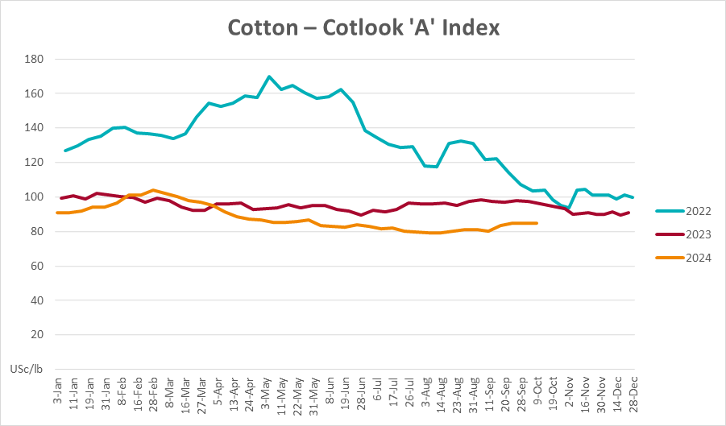

### 3.2 Selected domestic crop indicator prices

### Selected domestic livestock indicator prices

### Global Dairy Trade (GDT) weighted average prices

### Selected fruit and vegetable prices

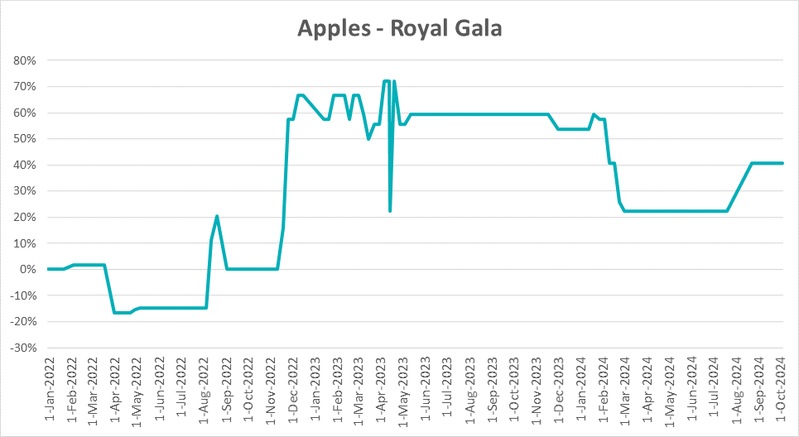

### 3.6 Selected domestic fodder indicator prices

## **4. Data attribution**

### Climate

* Bureau of Meteorology
* Weekly rainfall totals: www.bom.gov.au/climate/maps/rainfall/
* Monthly and last 3-month rainfall percentiles: [www.bom.gov.au/water/landscape/](http://www.bom.gov.au/water/landscape/)
* Temperature anomalies: [www.bom.gov.au/jsp/awap/temp/index.jsp](http://www.bom.gov.au/jsp/awap/temp/index.jsp)
* Rainfall forecast: [www.bom.gov.au/jsp/watl/rainfall/pme.jsp](http://www.bom.gov.au/jsp/watl/rainfall/pme.jsp)
* Seasonal outlook: [www.bom.gov.au/climate/outlooks/#/overview/summary/](http://www.bom.gov.au/climate/outlooks/#/overview/summary/)
* Climate drivers: <http://www.bom.gov.au/climate/enso/>
* Soil moisture: [www.bom.gov.au/water/landscape/](http://www.bom.gov.au/water/landscape/)
* Other
* Pasture growth: [www.longpaddock.qld.gov.au/aussiegrass/](http://www.longpaddock.qld.gov.au/aussiegrass/)
* 3-month global outlooks: [Environment and Climate Change Canada](https://weather.gc.ca/saisons/image_e.html?img=s234pfe1p_cal&bc=prob), [NOAA Climate Prediction Center](https://www.cpc.ncep.noaa.gov/products/predictions/long_range/seasonal.php?lead=2), [EUROBRISA CPTEC/INPE](http://eurobrisa.cptec.inpe.br/), European Centre for Medium-Range Weather Forecasts, [Hydrometcenter of Russia](https://meteoinfo.ru/en/climate/seasonal-forecasts), [National Climate Center Climate System Diagnosis and Prediction Room (NCC)](https://cmdp.ncc-cma.net/pred/cs2gen.php?pred_elem=RAINP#pred_seasonal), [International Research Institute for Climate and Society](https://iri.columbia.edu/our-expertise/climate/forecasts/seasonal-climate-forecasts/)
* Global production: <https://ipad.fas.usda.gov/ogamaps/cropmapsandcalendars.aspx>
* Autumn break: Pook et al., 2009, <https://rmets-onlinelibrary-wiley-com.virtual.anu.edu.au/doi/epdf/10.1002/joc.1833>

### Water

Prices

* Waterflow: <https://www.waterflow.io/>
* Ruralco: <https://www.ruralcowater.com.au/>
* Bureau of Meteorology:
* Allocation trade: <http://www.bom.gov.au/water/dashboards/#/water-markets/mdb/at>
* Storage volumes: <http://www.bom.gov.au/water/dashboards/#/water-storages/summary/drainage>
* Trade constraints:
* Water NSW: <https://www.waternsw.com.au/customer-service/ordering-trading-and-pricing/trading/murrumbidgee>
* Victorian Water Register: <https://www.waterregister.vic.gov.au/TradingRules2019/>

### Commodities

* Fruit and vegetables
* Datafresh: [www.freshstate.com.au](http://www.freshstate.com.au)
* Pigs
* Australian Pork Limited: [www.australianpork.com.au](http://www.australianpork.com.au)
* Dairy
* Global Dairy Trade: [www.globaldairytrade.info/en/product-results/](http://www.globaldairytrade.info/en/product-results/)
* World wheat, canola
* International Grains Council
* World coarse grains
* United States Department of Agriculture
* World cotton
* Cotlook: [www.cotlook.com/](http://www.cotlook.com/)
* World sugar
* New York Stock Exchange - Intercontinental Exchange
* Wool
* Australian Wool Exchange: [www.awex.com.au/](http://www.awex.com.au/)
* Domestic wheat, barley, sorghum, canola and fodder
* Jumbuk Consulting Pty Ltd: http://www.jumbukag.com.au/
* Cattle, beef, mutton, lamb, goat and live export
* Meat and Livestock Australia: [www.mla.com.au/Prices-and-market](http://www.mla.com.au/Prices-and-market)

© Commonwealth of Australia 2024

### Ownership of intellectual property rights

Unless otherwise noted, copyright (and any other intellectual property rights, if any) in this publication is owned by the Commonwealth of Australia (referred to as the Commonwealth).

### Creative Commons licence

All material in this publication is licensed under a [Creative Commons Attribution 4.0 International Licence](https://creativecommons.org/licenses/by/4.0/legalcode) except content supplied by third parties, logos and the Commonwealth Coat of Arms.

Inquiries about the licence and any use of this document should be emailed to [copyright@awe.gov.au](mailto:copyright@awe.gov.au).

https://www.agriculture.gov.au/sites/default/files/images/creative-commons-logo-small.png

### Cataloguing data

This publication (and any material sourced from it) should be attributed as:

ABARES 2024, Weekly Australian Climate, Water and Agricultural Update, Australian Bureau of Agricultural and Resource Economics and Sciences, Canberra, 10 October 2024. CC BY 4.0 DOI: <https://doi.org/10.25814/5f3e04e7d2503>

ISSN **2652-7561**

This publication is available at https://www.agriculture.gov.au/abares/products/weekly_update

Department of Agriculture, Fisheries and Forestry

GPO Box 858 Canberra ACT 2601

Telephone 1800 900 090

Web [agriculture.gov.au/abares](http://awe.gov.au/abares)

### Disclaimer

The Australian Government acting through the Department of Agriculture, Fisheries and Forestry, represented by the Australian Bureau of Agricultural and Resource Economics and Sciences, has exercised due care and skill in preparing and compiling the information and data in this publication. Notwithstanding, the Department of Agriculture, Fisheries and Forestry, ABARES, its employees and advisers disclaim all liability, including liability for negligence and for any loss, damage, injury, expense or cost incurred by any person as a result of accessing, using or relying on any of the information or data in this publication to the maximum extent permitted by law.

### Statement of Professional Independence

The views and analysis presented in ABARES publications, including this one, reflect ABARES professionally independent findings, based on scientific and economic concepts, principles, information and data. These views, analysis and findings may not reflect or be consistent with the views or positions of the Australian Government, or of organisations or groups who have commissioned ABARES reports or analysis. More information on [professional independence](https://www.agriculture.gov.au/abares/about/research-and-analysis#professional-independence) is provided on the ABARES website.

### Acknowledgements

This report was prepared by Matthew Miller.