## No. 36/2024 19 September 2024

# Summary of key issues

* In the week ending 18 September 2024, a series of cold fronts and low-pressure systems brought rainfall to parts of northern and south-eastern Australia, with other areas largely dry.
  + Across cropping regions, rainfall totals ranged from 5 and 25 millimetres across parts of eastern Victoria and southern Queensland, with parts of northern New South Wales recording between 5 and 50 millimetres. Remaining areas were largely dry.
* Over coming days, low-pressure and frontal systems are expected to bring showers and storms across a broad band of the country, extending from the north-west to the south-east. High-pressure systems are expected to keep the north-eastern and south-western parts of the country largely dry.
  + Across cropping regions, rainfall totals of between 10 and 25 millimetres are expected in Victoria and South Australia, with falls of between 5 and 15 millimetres expected in New South Wales. Western Australia and Queensland are expected to see little to no rainfall. If realised, these falls may be sufficient to arrest declines in soil moisture levels and winter crop yields across some southern growing regions.
* Globally, variable rainfall during August has led to mixed crop production prospects.
  + Global production conditions were generally favourable for rice and soybeans but variable for wheat and maize.
  + Global production conditions remain generally unchanged from those used to formulate ABARES forecasts of global grain supplies and world prices for 2024–25 in its September 2024 edition of the Agricultural Commodities Report.
  + In Australia, winter crop production conditions across parts of south-eastern Australia have been less favourable during September-to-date compared to those used to formulate ABARES forecasts winter grain, oilseed and pulse production in its September 2024 edition of the Agricultural Crop Report. This could result in a decline in winter crop production for 2024–25 compared to the September forecast.
* Water storage levels in the Murray-Darling Basin (MDB) decreased between 12 September 2024 and 19 September by 136 gigalitres (GL). Current volume of water held in storage is 18,140 GL, equivalent to 81% of total storage capacity. This is 12 percent or 2,660 GL less than at the same time last year.
* Allocation prices in the Victorian Murray below the Barmah Choke remained at $145/ML (megalitre) between the 12 September 2024 and the 19 September 2024. Prices are lower in the Murrumbidgee due to the binding of the Murrumbidgee export limit.

## **Climate**

### Rainfall this week

For the week ending 18 September 2024, a series of cold fronts moved through south-eastern Australia, bringing showers, isolated thunderstorms, below average temperatures and severe frosts, as well as snow to elevated areas of Tasmania, Victoria and New South Wales. Rainfall totals of up to 50 millimetres were recorded in eastern areas of Victoria, north-eastern New South Wales and parts of northern Queensland and the Northern Territory. In Tasmania, cold fronts brought rainfall totals of up to 100 millimetres in the west. High pressure systems saw much of the remainder of the country record little to no rainfall.

Across cropping regions, little to no rainfall was recorded across most areas this week. Isolated areas of eastern Victoria and southern Queensland recorded rainfall totals of between 5 and 25 millimetres, with parts of northern New South Wales seeing between 5 and 50 millimetres. Little to no rainfall across most cropping regions has likely contributed to a drawdown of stored soil moisture. Where average levels of stored soil moisture are available, crops and pastures would have been able to draw on these reserves to maintain current yield potentials. However, in areas where stored soil moisture levels are low, little to no rainfall is likely to lead to reduced yield potential, exacerbated by severe frosts and windy conditions in some areas.

#### Rainfall for the week ending 18 September 2024

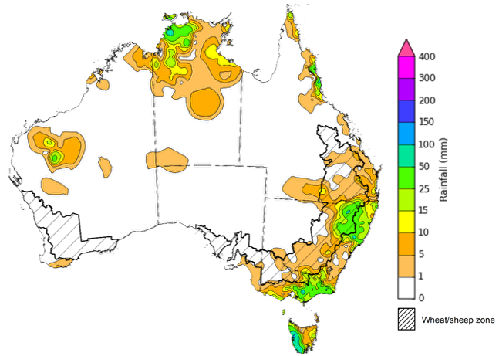

©Commonwealth of Australia 2024, Australian Bureau of Meteorology Issued: 18/09/2024

Note: The rainfall analyses and associated maps utilise data contained in the Bureau of Meteorology climate database, the Australian Data Archive for Meteorology (ADAM). The analyses are initially produced automatically from real-time data with limited [quality control](http://www.bom.gov.au/climate/headers/qc.shtml). They are intended to provide a general overview of rainfall across Australia as quickly as possible after the observations are received. For further information go to <http://www.bom.gov.au/climate/rainfall/>

### Rainfall forecast for the next eight days

Over the 8 days to 26 September 2024, low-pressure and frontal systems are expected to bring showers and storms over north-western, central and south-eastern parts of the country. Up to 150 millimetres is forecast for parts of northern Western Australia, western Northern Territory and western Tasmania. Meanwhile, rainfall totals of between 10 and 50 millimetres are forecast for a broad band extending from north-western to south-eastern Australia. High pressure systems are expected to keep much of north-eastern and south-western Australia largely dry.

Across cropping regions, conditions are forecast to be highly variable. Rainfall totals of between 10 and 25 millimetres are expected in Victoria and South Australia, with falls of between 5 and 15 millimetres expected in New South Wales. In contrast, much of Western Australia and Queensland are expected to see little to no rainfall, with forecasts of between 1 and 10 millimetres.

If realised, these falls may be sufficient to arrest declines in soil moisture levels and winter crop yields across some southern growing regions. However, in parts of south-eastern Australia these falls may arrive too late to prevent crop yields falling below those expected at the end of August, following very dry conditions during September-to-date and recent severe frost events.

#### Total forecast rainfall for the period 19 September to 26 September 2024

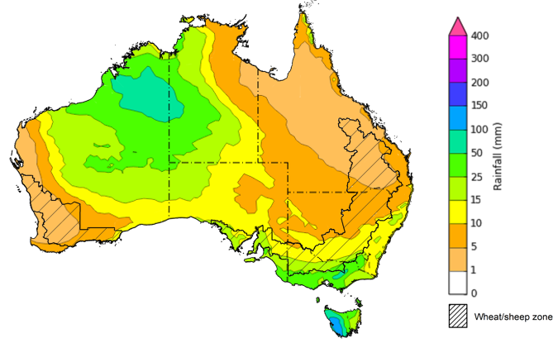

©Commonwealth of Australia 2024, Australian Bureau of Meteorology Issued 19/09/2024

Note: This rainfall forecast is produced from computer models. As the model outputs are not altered by weather forecasters, it is important to check local forecasts and warnings issued by the Bureau of Meteorology.

### Global production conditions and climate outlook

Crop production is affected by long-term trends in average rainfall and temperature, interannual climate variability, shocks during specific growth stages, and extreme weather events. Some crops are more tolerant than others to certain types of stresses, and at each growth stage, different types of stresses affect each crop species in different ways.

The precipitation anomalies and outlooks presented here give an indication of the current and future state of production conditions for the major grain and oilseed producing countries which are responsible for over 80% of global production. This is an important input to assessing the global grain supply outlook.

**August precipitation percentiles and current production conditions**

As of the end of August 2024, rainfall was variable for the world’s major grain- and oilseed-producing nations.

In the southern hemisphere, precipitation was general average across much of Argentina and central and southern Brazil. In contrast, parts of south-eastern Australia experienced below average rainfall. Rainfall was generally average in the remaining grain- and oilseed-producing regions in the southern hemisphere.

In the northern hemisphere, precipitation was below average in parts of central and eastern Europe, northern Ukraine, central Canada, central China, northern Mexico and parts of the south-east of the United States. Precipitation was generally average to above average in the remaining grain- and oilseed-producing nations in the northern hemisphere.

**Global precipitation percentiles, August 2024**

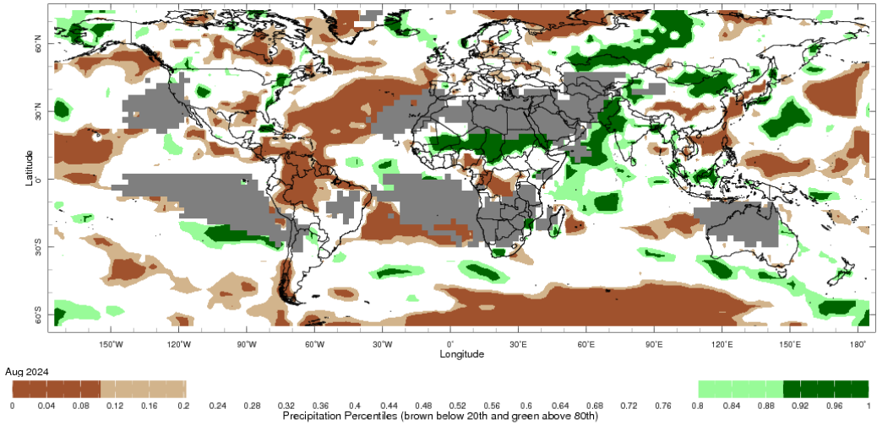

Note: The world precipitation percentiles indicate a ranking of precipitation for August, with the driest (0th percentile) being 0 on the scale and the wettest (100th percentile) being 1 on the scale. Percentiles are based on precipitation estimates from the NOAA Climate Prediction Center’s [Climate Anomaly Monitoring System Outgoing Precipitation Index](https://iridl.ldeo.columbia.edu/maproom/Global/Precipitation/Percentiles.html) dataset. Precipitation estimates for August 2024 are compared with rainfall recorded for that period during the 1981 to 2010 base period.

Source: International Research Institute for Climate and Society

As of 28 August 2024, global production conditions were generally favourable for rice and soybeans but variable for wheat and maize:

* **Wheat –** in the northern hemisphere the winter wheat harvest is progressing under variable conditions, with areas of concern in parts of Europe, the Russian Federation, Canada, the United Kingdom and Ukraine, following adverse weather conditions in recent months. However, above average yields are expected elsewhere in Europe and in the United States. In the southern hemisphere crops are developing under generally favourable conditions in Australia and Argentina.
* **Maize –** in the southern hemisphere, the harvest of the summer planted crop is wrapping up under generally favourable conditions in Brazil. In the northern hemisphere, there are areas of production concern in Mexico, Bulgaria, Greece, Hungary, Romania, Ukraine and the Russian Federation due to hot and dry conditions. Elsewhere in the northern hemisphere production conditions are generally favourable.
* **Rice –** conditions are generally favourable, however heavy rainfall and flooding has negatively affected production prospects in the Philippians and parts of Bangladesh.
* **Soybeans –** in the northern hemisphere, generally favourable production conditions persist with the exception of parts of the Russian Federation and Ukraine with some production concerns evident due to hot and dry conditions.

**Crop conditions, AMIS countries, 28 August 2024**

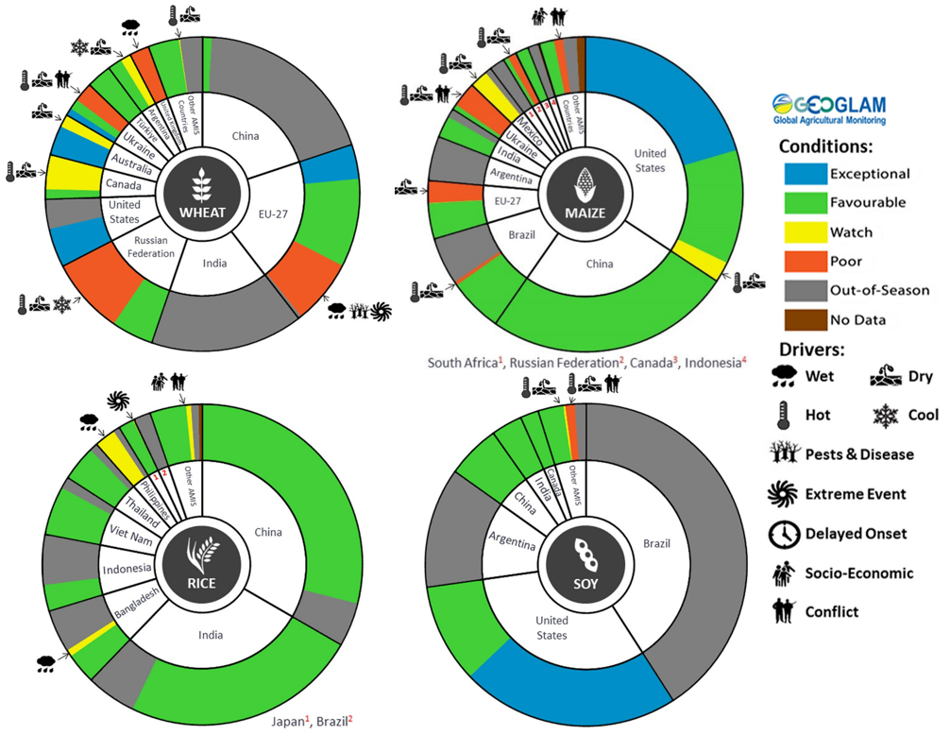

**AMIS** Agricultural Market Information System.

Source: AMIS

The global climate outlook for October 2024 to December 2024 indicates that mixed rainfall conditions are expected for the world’s major grain-producing and oilseed-producing regions. Outlooks and potential production impacts for the major grain and oilseed producing countries are presented in the following table.

**Rainfall outlook and potential impact on the future state of production conditions between** **October 2024 to December 2024**

|  |  |  |
| --- | --- | --- |
| **Region** | **October-December rainfall outlook** | **Potential impact on production** |
| **Argentina** | Below average rainfall is more likely across eastern parts of Argentina. Average rainfall is expected in western areas. | Below average rainfall in eastern areas is likely to adversely affect the heading and grain development of wheat and the planting and establishment of cotton and late-planted corn in October. These conditions may also adversely impact early corn silking, and the flowering of cotton and late corn in November and December. More favourable production conditions are expected across the remainder of the country. |
| **Black Sea Region** | Generally, average rainfall is expected across much of the Balack Sea region, with below average rainfall in isolated areas, in southern Kazakhstan and southernTürkiye. | Average rainfall is likely to support boll development and grain filling for cotton, corn and sunflower, as well as the development of winter wheat and canola in October. In November and December winter wheat and canola will enter dormancy, and average rainfall is likely to provide sufficient snowpack to prevent winterkill. |
| **Brazil** | Below average rainfall is more likely across northern and southern parts of Brazil. Close to average rainfall in more likely for the remainder of Brazil. | Below average rainfall in parts of southern Brazil would allow for uninterrupted harvesting of wheat in October and November. However, below average rainfall is likely to adversely affect flowering of corn and soybeans in December and will affect the planting and growth of soybeans and first crop corn in northern and southern Brazil. |
| **Canada** | Generally, average to above average rainfall is likely across much of Canada. | Average rainfall may favour harvesting and reduce grain quality concerns for canola, corn, soybean, spring wheat and sunflower in October and November. Average rainfall is also likely to provide sufficient snowpack to prevent winterkill of winter wheat in December. |
| **China** | Average to above average rainfall is more likely across much of China, while below average rainfall is more likely across some eastern and western regions. | Average rainfall in China is likely to aid the harvesting of cotton, corn, sorghum, soybean, sunflower, groundnuts and single rice. These conditions will also likely benefit grain filling of late-sown rice in October and November. |
| **Europe** | Average rainfall is more likely for much of Europe. | Average rainfall is expected to aid the harvesting of corn, cotton, sorghum, soybean and sunflower in south-eastern and south-western Europe. Average rainfall across much of Europe is also likely to benefit the planting of canola and winter wheat. |
| **South Asia (India)** | Average to above average rainfall is more likely across much of India. | Average to above average rainfall is likely to benefit cotton boll formation in the south during October and the planting of canola and winter wheat in November. However, these conditions may impede harvesting of corn, sorghum, rice, millet, groundnuts and sunflower. |
| **Southeast Asia (SEA)** | Average to above average rainfall is likely across much of Southeast Asia. | Average to above average rainfall in SEA is likely to may disrupt harvesting corn and rice harvesting in October. |
| **The United States of America (US)** | Generally, below average rainfall is likely for much of southern half of the US, with average rainfall more likely across the northern half. | Below average rainfall across much of southern US is likely to support harvesting of soybeans, sunflower, millet, cotton, rice, corn, sorghum and groundnuts in October and November. The average rainfall conditions expected across the northern US is likely to support establishment and growth of canola and winter wheat, as well as provide sufficient snow cover in December. |

## **Water**

### Water markets – current week

Water storage levels in the Murray-Darling Basin (MDB) decreased between 12 September 2024 and 19 September by 136 gigalitres (GL). Current volume of water held in storage is 18,140 GL, equivalent to 81% of total storage capacity. This is 12 percent or 2,660 GL less than at the same time last year. Water storage data is sourced from the Bureau of Meteorology.

#### Water storages in the Murray-Darling Basin, 2013–2024

|  |
| --- |
| Water storage data is sourced from the Bureau of Meteorology. |

Allocation prices in the Victorian Murray below the Barmah Choke remained at $145/ML (megalitre) between the 12 September 2024 and the 19 September 2024. Prices are lower in the Murrumbidgee due to the binding of the Murrumbidgee export limit.

#### Surface water trade activity, Southern Murray–Darling Basin

|  |
| --- |
| The trades shown reflect estimated market activity and do not encompass all register trades. The price is shown for the VIC Murray below the Barmah choke. Historical prices (before 1 July 2019) are ABARES estimates after removing outliers from BOM water register data. Prices after 1 July 2019 and prior to the 30 October 2019 reflect recorded transaction prices as sourced from Ruralco. Prices after the 30 October 2019 are sourced from Waterflow. Data for volume traded is sourced from the BOM water register. Only the price data shown is current on 19 September 2024. |

To access the full, interactive, weekly water dashboard, which contains the latest and historical water storage, water market and water allocation information, please visit <https://www.agriculture.gov.au/abares/products/weekly_update/weekly-update-19924>

## **Commodities**

|  |  |  |  |  |  |  |  |  |
| --- | --- | --- | --- | --- | --- | --- | --- | --- |
| **Indicator** | **Week average** | **Unit** | **Latest Price** | **Previous Week** | **Weekly change** | | **Price 12 months ago** | **Annual change** |
| **Selected world indicator prices** |  |  |  |  |  |  | |  |
| AUD/USD Exchange rate | 18-Sep | A$/US$ | 0.67 | 0.67 | 1% | 0.64 | | 5% |
| Wheat – US no. 2 hard red winter wheat, FOB Gulf | 18-Sep | US$/t | 268 | 274 | -2% | 308 | | -13% |
| Corn – US no. 2 yellow corn, FOB Gulf | 18-Sep | US$/t | 188 | 185 | 1% | 226 | | -17% |
| Canola – Rapeseed, Canada, FOB Vancouver | 18-Sep | US$/t | 450 | 451 | 0% | 567 | | -21% |
| Cotton – Cotlook 'A' Index | 18-Sep | USc/lb | 83 | 80 | 3% | 98 | | -15% |
| Sugar – Intercontinental Exchange, nearby futures, no.11 contract | 18-Sep | USc/lb | 19.9 | 19.1 | 4% | 27 | | -25% |
| Wool – Eastern Market Indicator | 18-Sep | Ac/kg clean | 1,098 | 1,099 | 0% | 1,179 | | -7% |
| Wool – Western Market Indicator | 18-Sep | Ac/kg clean | 1,234 | 1,231 | 0% | 1,366 | | -10% |
| **Selected Australian grain export prices** |  |  |  |  |  |  | |  |
| Aust. premium white wheat (APW), FOB Port Adelaide, South Australia | 18-Sep | A$/t | 387 | 381 | 2% | 491 | | -21% |
| Aust. standard white wheat (ASW), FOB Port Adelaide, South Australia | 18-Sep | A$/t | 377 | 371 | 2% | 469 | | -20% |
| Feed Barley – FOB Port Adelaide, South Australia | 18-Sep | A$/t | 350 | 349 | 0% | 407 | | -14% |
| Canola – FOB Kwinana, Western Australia | 18-Sep | A$/t | 717 | 723 | -1% | 820 | | -13% |
| Grain Sorghum – FOB Brisbane, Queensland | 18-Sep | A$/t | 381 | 381 | 0% | 522 | | -27% |
| **Selected domestic livestock indicator prices** |  |  |  |  |  |  | |  |
| Beef – Eastern Young Cattle Indicator | 18-Sep | Ac/kg cwt | 670 | 669 | 0% | 408 | | 64% |
| Mutton – Mutton indicator (18–24 kg fat score 2–3), Vic | 18-Sep | Ac/kg cwt | 294 | 340 | -13% | 106 | | 178% |
| Lamb – National Trade Lamb Indicator | 18-Sep | Ac/kg cwt | 797 | 828 | -4% | 433 | | 84% |
| Pig – Eastern Seaboard (60.1–75 kg), average of buyers & sellers | 04-Sep | Ac/kg cwt | 419 | 418 | 0% | 352 | | 19% |
| Live cattle – Light steers to Indonesia | 18-Sep | Ac/kg lwt | 305 | 305 | 0% | 290 | | 5% |
| **Global Dairy Trade (GDT) weighted average prices a** |  |  |  |  |  |  | |  |
| Dairy – Whole milk powder | 18-Sep | US$/t | 3,448 | 3,396 | 2% | 2,702 | | 28% |
| Dairy – Skim milk powder | 18-Sep | US$/t | 2,809 | 2,753 | 2% | 2,286 | | 23% |
| Dairy – Cheddar cheese | 18-Sep | US$/t | 4,441 | 4,324 | 3% | 4,102 | | 8% |
| Dairy – Anhydrous milk fat | 18-Sep | US$/t | 7,220 | 7,311 | -1% | 4,561 | | 58% |
|  | | | | | | | | |

### Selected world indicator prices

### 3.2 Selected domestic crop indicator prices

### Selected domestic livestock indicator prices

### Global Dairy Trade (GDT) weighted average prices

### Selected fruit and vegetable prices

### 3.6 Selected domestic fodder indicator prices

## **4. Data attribution**

### Climate

* Bureau of Meteorology
* Weekly rainfall totals: www.bom.gov.au/climate/maps/rainfall/
* Monthly and last 3-month rainfall percentiles: [www.bom.gov.au/water/landscape/](http://www.bom.gov.au/water/landscape/)
* Temperature anomalies: [www.bom.gov.au/jsp/awap/temp/index.jsp](http://www.bom.gov.au/jsp/awap/temp/index.jsp)
* Rainfall forecast: [www.bom.gov.au/jsp/watl/rainfall/pme.jsp](http://www.bom.gov.au/jsp/watl/rainfall/pme.jsp)
* Seasonal outlook: [www.bom.gov.au/climate/outlooks/#/overview/summary/](http://www.bom.gov.au/climate/outlooks/#/overview/summary/)
* Climate drivers: <http://www.bom.gov.au/climate/enso/>
* Soil moisture: [www.bom.gov.au/water/landscape/](http://www.bom.gov.au/water/landscape/)
* Other
* Pasture growth: [www.longpaddock.qld.gov.au/aussiegrass/](http://www.longpaddock.qld.gov.au/aussiegrass/)
* 3-month global outlooks: [Environment and Climate Change Canada](https://weather.gc.ca/saisons/image_e.html?img=s234pfe1p_cal&bc=prob), [NOAA Climate Prediction Center](https://www.cpc.ncep.noaa.gov/products/predictions/long_range/seasonal.php?lead=2), [EUROBRISA CPTEC/INPE](http://eurobrisa.cptec.inpe.br/), European Centre for Medium-Range Weather Forecasts, [Hydrometcenter of Russia](https://meteoinfo.ru/en/climate/seasonal-forecasts), [National Climate Center Climate System Diagnosis and Prediction Room (NCC)](https://cmdp.ncc-cma.net/pred/cs2gen.php?pred_elem=RAINP#pred_seasonal), [International Research Institute for Climate and Society](https://iri.columbia.edu/our-expertise/climate/forecasts/seasonal-climate-forecasts/)
* Global production: <https://ipad.fas.usda.gov/ogamaps/cropmapsandcalendars.aspx>
* Autumn break: Pook et al., 2009, <https://rmets-onlinelibrary-wiley-com.virtual.anu.edu.au/doi/epdf/10.1002/joc.1833>

### Water

Prices

* Waterflow: <https://www.waterflow.io/>
* Ruralco: <https://www.ruralcowater.com.au/>
* Bureau of Meteorology:
* Allocation trade: <http://www.bom.gov.au/water/dashboards/#/water-markets/mdb/at>
* Storage volumes: <http://www.bom.gov.au/water/dashboards/#/water-storages/summary/drainage>
* Trade constraints:
* Water NSW: <https://www.waternsw.com.au/customer-service/ordering-trading-and-pricing/trading/murrumbidgee>
* Victorian Water Register: <https://www.waterregister.vic.gov.au/TradingRules2019/>

### Commodities

* Fruit and vegetables
* Datafresh: [www.freshstate.com.au](http://www.freshstate.com.au)
* Pigs
* Australian Pork Limited: [www.australianpork.com.au](http://www.australianpork.com.au)
* Dairy
* Global Dairy Trade: [www.globaldairytrade.info/en/product-results/](http://www.globaldairytrade.info/en/product-results/)
* World wheat, canola
* International Grains Council
* World coarse grains
* United States Department of Agriculture
* World cotton
* Cotlook: [www.cotlook.com/](http://www.cotlook.com/)
* World sugar
* New York Stock Exchange - Intercontinental Exchange
* Wool
* Australian Wool Exchange: [www.awex.com.au/](http://www.awex.com.au/)
* Domestic wheat, barley, sorghum, canola and fodder
* Jumbuk Consulting Pty Ltd: http://www.jumbukag.com.au/
* Cattle, beef, mutton, lamb, goat and live export
* Meat and Livestock Australia: www.mla.com.au/Prices-and-market

© Commonwealth of Australia 2024

### Ownership of intellectual property rights

Unless otherwise noted, copyright (and any other intellectual property rights, if any) in this publication is owned by the Commonwealth of Australia (referred to as the Commonwealth).

### Creative Commons licence

All material in this publication is licensed under a [Creative Commons Attribution 4.0 International Licence](https://creativecommons.org/licenses/by/4.0/legalcode) except content supplied by third parties, logos and the Commonwealth Coat of Arms.

Inquiries about the licence and any use of this document should be emailed to [copyright@awe.gov.au](mailto:copyright@awe.gov.au).

https://www.agriculture.gov.au/sites/default/files/images/creative-commons-logo-small.png

### Cataloguing data

This publication (and any material sourced from it) should be attributed as:

ABARES 2024, Weekly Australian Climate, Water and Agricultural Update, Australian Bureau of Agricultural and Resource Economics and Sciences, Canberra, 19 September 2024. CC BY 4.0 DOI: <https://doi.org/10.25814/5f3e04e7d2503>

ISSN **2652-7561**

This publication is available at https://www.agriculture.gov.au/abares/products/weekly_update

Department of Agriculture, Fisheries and Forestry

GPO Box 858 Canberra ACT 2601

Telephone 1800 900 090

Web [agriculture.gov.au/abares](http://awe.gov.au/abares)

### Disclaimer

The Australian Government acting through the Department of Agriculture, Fisheries and Forestry, represented by the Australian Bureau of Agricultural and Resource Economics and Sciences, has exercised due care and skill in preparing and compiling the information and data in this publication. Notwithstanding, the Department of Agriculture, Fisheries and Forestry, ABARES, its employees and advisers disclaim all liability, including liability for negligence and for any loss, damage, injury, expense or cost incurred by any person as a result of accessing, using or relying on any of the information or data in this publication to the maximum extent permitted by law.

### Statement of Professional Independence

The views and analysis presented in ABARES publications, including this one, reflect ABARES professionally independent findings, based on scientific and economic concepts, principles, information and data. These views, analysis and findings may not reflect or be consistent with the views or positions of the Australian Government, or of organisations or groups who have commissioned ABARES reports or analysis. More information on [professional independence](https://www.agriculture.gov.au/abares/about/research-and-analysis#professional-independence) is provided on the ABARES website.

### Acknowledgements

This report was prepared by Matthew Miller.