## No. 35/2024 12 September 2024

# Summary of key issues

* In the week ending 11 September 2024, a series of cold fronts and low-pressure systems brought rainfall to parts of western and southern Australia, with other areas largely dry.
  + Across cropping regions, rainfall totals ranged from 5 and 25 millimetres across Western Australia and South Australia, with Victoria recording between 5 and 10 millimetres. Remaining areas were largely dry.
* Over coming days, low-pressure systems are expected to bring showers over eastern and northern parts of the country. High-pressure systems are expected to keep the central and western parts of the country largely dry.
  + Across cropping regions, rainfall totals of between 5 and 25 millimetres are expected in Queensland, and between 5 and 50 millimetres in New South Wales. Western Australia, South Australia, and Victoria are expected to see little to no rainfall. If realised, this is expected to contribute to declines in soil moisture in southern areas.
* The national rainfall outlook for October to December is a high probability of above median rainfall across the eastern half of the country.
  + Across most cropping regions there is a 60% or greater chance of receiving above median rainfall. Higher than average rainfall is expected in parts of Queensland New South Wales, Victoria, and South Australia. In contrast, median to below median rainfall is expected in in parts of Western Australia.
  + There is 75% chance of rainfall totals being between 50 to 200 millimetres across most cropping regions, with higher rainfall expected in Queensland. If realised, these expected rainfall totals will likely be sufficient in maintaining crop yields and provide a favourable start to the summer cropping season.
* Water storage levels in the Murray-Darling Basin (MDB) decreased between 05 September 2024 and 12 September by 146 gigalitres (GL). Current volume of water held in storage is 18 277 GL, equivalent to 82% of total storage capacity. This is 6 percent or 1,355 GL less than at the same time last year. Water storage data is sourced from the BOM.
* Allocation prices in the Victorian Murray below the Barmah Choke decreased from $147/ML (megalitre) on the 05 September 2024 to $145/ML on the 12 September 2024. Prices are lower in the Murrumbidgee due to the binding of the Murrumbidgee export limit.

## **Climate**

### Rainfall this week

For the week ending 11 September 2024, a series of cold fronts and low-pressure systems brought rainfall to parts of western and southern Australia, and scattered areas of central and eastern Australia. Rainfall totals of up to 50 millimetres were recorded in southern areas of Western Australia, South Australia and Victoria. In Tasmania, cold fronts brought rainfall totals of up to 150 millimetres in the west.

Across cropping regions, little to no rainfall was recorded across most areas this week. Parts of southern Victoria recorded rainfall totals of between 5 and 15 millimetres, with parts of western South Australia and Western Australia seeing between 5 and 25 millimetres. Little to no rainfall across south-eastern and eastern cropping regions has likely contributed to a drawdown of stored soil moisture. Where average to above average levels of stored soil moisture are available, crops and pastures would have been able to draw on these reserves to maintain current yield potentials. However, in areas where stored soil moisture levels are low, little to no rainfall is likely to lead to reduced yield potential, exacerbated by warm and windy conditions in some areas.

#### Rainfall for the week ending 11 September 2024

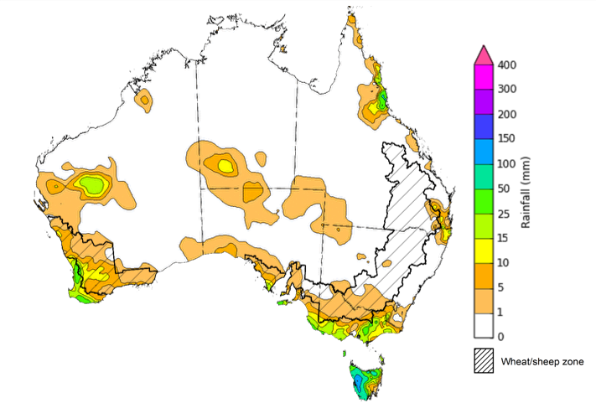

©Commonwealth of Australia 2024, Australian Bureau of Meteorology Issued: 11/09/2024

Note: The rainfall analyses and associated maps utilise data contained in the Bureau of Meteorology climate database, the Australian Data Archive for Meteorology (ADAM). The analyses are initially produced automatically from real-time data with limited [quality control](http://www.bom.gov.au/climate/headers/qc.shtml). They are intended to provide a general overview of rainfall across Australia as quickly as possible after the observations are received. For further information go to <http://www.bom.gov.au/climate/rainfall/>

### Rainfall forecast for the next eight days

Over the 8 days to 19 September 2024, low-pressure systems are expected to bring showers over eastern and northern parts of the country. A maximum of 50 millimetres of rainfall is forecast in the northern tropics, eastern Queensland, eastern New South Wales and southern Victoria. High pressure systems are expected to keep much of western and central Australia largely dry.

Across cropping regions, conditions are forecast to be mixed. In the east, rainfall totals of between 5 and 25 millimetres are expected in Queensland, and between 5 and 50 millimetres in New South Wales. In contrast, much of Western Australia and South Australia are expected to see little to no rainfall, with Victoria forecast to receive between 1 and 10 millimetres. If realised, this lack of rainfall across southern growing regions is likely to contribute to further declines in soil moisture and present a downside risk to winter crop production.

#### Total forecast rainfall for the period 12 September to 19 September 2024

©Commonwealth of Australia 2024, Australian Bureau of Meteorology Issued 12/09/2024

Note: This rainfall forecast is produced from computer models. As the model outputs are not altered by weather forecasters, it is important to check local forecasts and warnings issued by the Bureau of Meteorology.

### National Climate Outlook

The El Niño Southern Oscillation (ENSO) and Indian Ocean Dipole (IOD) climate drivers are currently neutral and having minimal influence on Australian rainfall. The Southern Annular Mode (SAM) is positive (as at 1 September). Forecasts indicate it is likely to become neutral over the coming week. A neutral SAM has no strong relationship to forecast climate conditions.

The most recent rainfall outlook for October 2024 provided by the Bureau of Meteorology indicates that much of northern and eastern Australia is likely to see above median rainfall (between 55 to 80% chance). There is a roughly equal probability of either above or below median rainfall in much of western and southern Australia, except for parts of central and south-west Western Australia, and western Tasmania which are more likely to see below median rainfall.

According to Bureau of Meteorology’s climate model, for October 2024, there is a 75% probability of rainfall totals of between 10 and 50 millimetres across much of eastern New South Wales, eastern Queensland, the far south-west of Western Australia, Victoria. Meanwhile, Tasmania is expected to see falls of between 25 millimetres in the east to 200 millimetres in western areas. Much of northern and central Australia is expected to receive little to no rainfall. This is consistent with the Bureau of Meteorology’s forecast of a delay northern rainfall onset.

Across cropping regions, there is a 75% chance of receiving between 10 and 50 millimetres of rainfall across much of Queensland, New South Wales and Victoria, with higher rainfall totals expected in eastern regions. In Western Australia and South Australia, rainfall totals are expected to be between 5 and 25 millimetres. These rainfall totals, if realised, are likely to be sufficient to support above average yield prospects of winter crops in regions with ample sub-soil moisture reserves. However, in areas with limited stored soil moisture, these falls are likely to only be sufficient to maintain current close to average yield expectations.

**Rainfall totals that have a 75% chance of occurring in October 2024**

©Commonwealth of Australia 2024, Australian Bureau of Meteorology Issued: 12/09/2024

The rainfall outlook for October to December 2024 indicates an increased probability of above average rainfall across much of the eastern two-thirds of the country. In contrast, below median rainfall is more likely across isolated areas of western and northern Australia as well as western Tasmania. Remaining areas of Australia have roughly equal chance of receiving above or below median rainfall.

Across cropping regions, the probability of receiving median rainfall is greater than 60% in Queensland and New South Wales. In Victoria and South Australia, the probability of above median rainfall is between 50 to 70%, while Western Australia has a roughly equal chance of above or below median rainfall across most regions. As of September 2024, many of these areas have below average modelled lower layer soil moisture. If above median rainfall is realised, this rainfall is likely to support the storage of soil moisture in eastern regions for the summer cropping period and contribute to improving soil moisture in southern regions.

**Chance of exceeding the median rainfall** **October to December 2024**

©Commonwealth of Australia 2024, Australian Bureau of Meteorology Issued: 12/09/2024

The outlook for October through to December suggests a 75% chance of rainfall totals between 50 and 300 millimetres across much of New South Wales, Queensland, Victoria, Tasmania and the Northern Territory, and across parts of South Australia and Western Australia. Rainfall totals in excess of 300 millimetres are forecast for alpine regions of Victoria and New South Wales, isolated coastal areas of eastern New South Wales and Queensland, western Tasmania and the tropical north of the Northern Territory.

In cropping regions, there is a 75% chance of receiving between 100 and 300 millimetres of rainfall across much of Queensland, and between 50 and 200 millimetres across New South Wales and Victoria. Conditions are expected to be drier in Western Australia and South Australia, with forecast rainfall to between 10 and 100 millimetres, and 25 to 100 millimetres, respectively.

If realised, these expected rainfall totals are likely to be sufficient to support the growth and development of winter crops, boost soil moisture profile and assist in maintaining current winter crop yield expectations in most regions and provide a favourable start to the summer cropping season across eastern Australia. However, a potential downside production risk still remains across isolated regions across southern Australia exhibiting extremely low soil moisture levels leading into spring.

Livestock producers, especially those in the east and far north, are expected to experience improved pasture production given this favourable rainfall outlook over the October to December period.

**Rainfall totals that have a 75% chance of occurring October to December 2024**

©Commonwealth of Australia 2024, Australian Bureau of Meteorology Issued: 12/09/2024

## **Water**

### Water markets – current week

Water storage levels in the Murray-Darling Basin (MDB) decreased between 5 September 2024 and 12 September by 146 gigalitres (GL). Current volume of water held in storage is 18 277 GL, equivalent to 82% of total storage capacity. This is 6 percent or 1,355 GL less than at the same time last year. Water storage data is sourced from the BOM.

#### Water storages in the Murray-Darling Basin, 2013–2024

|  |
| --- |
| Water storage data is sourced from the Bureau of Meteorology. |

Allocation prices in the Victorian Murray below the Barmah Choke decreased from $147/ML (megalitre) on the 5 September 2024 to $145/ML on the 12 September 2024. Prices are lower in the Murrumbidgee due to the binding of the Murrumbidgee export limit.

|  |  |
| --- | --- |
| **Region** | **$/ML** |
| NSW Murray Above | 101 |
| NSW Murrumbidgee | 145 |
| VIC Goulburn-Broken | 110 |
| VIC Murray Below | 148 |

#### Surface water trade activity, Southern Murray–Darling Basin

|  |
| --- |
| The trades shown reflect estimated market activity and do not encompass all register trades. The price is shown for the VIC Murray below the Barmah choke. Historical prices (before 1 July 2019) are ABARES estimates after removing outliers from BOM water register data. Prices after 1 July 2019 and prior to the 30 October 2019 reflect recorded transaction prices as sourced from Ruralco. Prices after the 30 October 2019 are sourced from Waterflow. Data for volume traded is sourced from the BOM water register. Only the price data shown is current on 12 September 2024. |

To access the full, interactive, weekly water dashboard, which contains the latest and historical water storage, water market and water allocation information, please visit <https://www.agriculture.gov.au/abares/products/weekly_update/weekly-update-12924>

## **Commodities**

|  |  |  |  |  |  |  |  |
| --- | --- | --- | --- | --- | --- | --- | --- |
| **Indicator** | **Week average** | **Unit** | **Latest Price** | **Previous Week** | **Weekly change** | **Price 12 months ago** | **Annual change** |
| **Selected world indicator prices** |  |  |  |  |  |  |  |
| AUD/USD Exchange rate | 11-Sep | A$/US$ | 0.67 | 0.67 | -1% | 0.64 | 4% |
| Wheat – US no. 2 hard red winter wheat, FOB Gulf | 11-Sep | US$/t | 272 | 272 | 0% | 320 | -15% |
| Corn – US no. 2 yellow corn, FOB Gulf | 11-Sep | US$/t | 185 | 186 | 0% | 223 | -17% |
| Canola – Rapeseed, Canada, FOB Vancouver | 11-Sep | US$/t | 459 | 470 | -2% | 578 | -21% |
| Cotton – Cotlook 'A' Index | 11-Sep | USc/lb | 79 | 81 | -2% | 97 | -18% |
| Sugar – Intercontinental Exchange, nearby futures, no.11 contract | 11-Sep | USc/lb | 18.8 | 19.2 | -2% | 27 | -31% |
| Wool – Eastern Market Indicator | 11-Sep | Ac/kg clean | 1,099 | 1,091 | 1% | 1,162 | -5% |
| Wool – Western Market Indicator | 11-Sep | Ac/kg clean | 1,231 | 1,222 | 1% | 1,337 | -8% |
| **Selected Australian grain export prices** |  |  |  |  |  |  |  |
| Aust. premium white wheat (APW), FOB Port Adelaide, South Australia | 11-Sep | A$/t | 379 | 373 | 2% | 488 | -22% |
| Aust. standard white wheat (ASW), FOB Port Adelaide, South Australia | 11-Sep | A$/t | 369 | 363 | 2% | 466 | -21% |
| Feed Barley – FOB Port Adelaide, South Australia | 11-Sep | A$/t | 348 | 343 | 2% | 405 | -14% |
| Canola – FOB Kwinana, Western Australia | 11-Sep | A$/t | 727 | 727 | 0% | 820 | -11% |
| Grain Sorghum – FOB Brisbane, Queensland | 11-Sep | A$/t | 382 | 383 | 0% | 522 | -27% |
| **Selected domestic livestock indicator prices** |  |  |  |  |  |  |  |
| Beef – Eastern Young Cattle Indicator | 11-Sep | Ac/kg cwt | 669 | 678 | -1% | 436 | 53% |
| Mutton – Mutton indicator (18–24 kg fat score 2–3), Vic | 11-Sep | Ac/kg cwt | 347 | 348 | 0% | 122 | 184% |
| Lamb – National Trade Lamb Indicator | 11-Sep | Ac/kg cwt | 835 | 822 | 2% | 437 | 91% |
| Pig – Eastern Seaboard (60.1–75 kg), average of buyers & sellers | 28-Aug | Ac/kg cwt | 418 | 411 | 2% | 343 | 22% |
| Live cattle – Light steers to Indonesia | 11-Sep | Ac/kg lwt | 305 | 300 | 2% | 310 | -2% |
| **Global Dairy Trade (GDT) weighted average prices a** |  |  |  |  |  |  |  |
| Dairy – Whole milk powder | 04-Sep | US$/t | 3,396 | 3,482 | -2% | 2,548 | 33% |
| Dairy – Skim milk powder | 04-Sep | US$/t | 2,753 | 2,636 | 4% | 2,333 | 18% |
| Dairy – Cheddar cheese | 04-Sep | US$/t | 4,324 | 4,274 | 1% | 4,127 | 5% |
| Dairy – Anhydrous milk fat | 04-Sep | US$/t | 7,311 | 7,244 | 1% | 4,452 | 64% |
| **a** Global Dairy Trade prices are updated twice monthly on the first and third Tuesday of each month. | | | | | | | |

### Selected world indicator prices

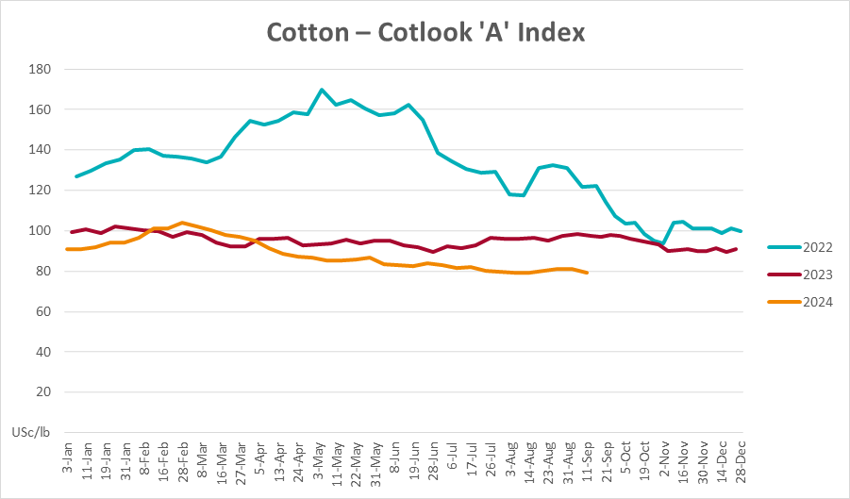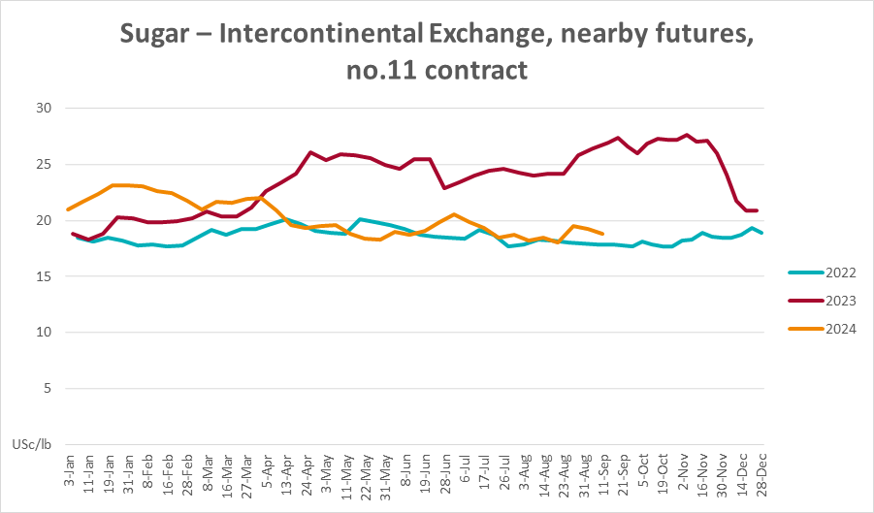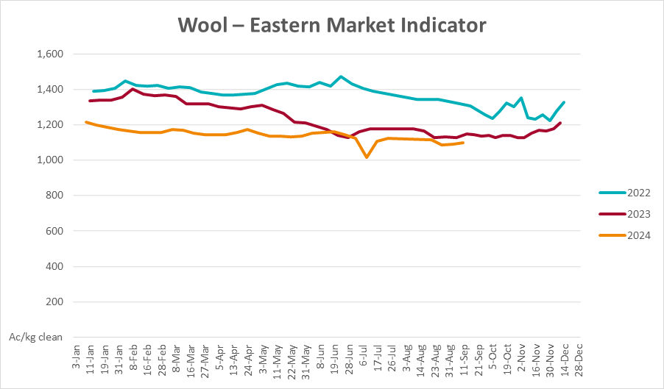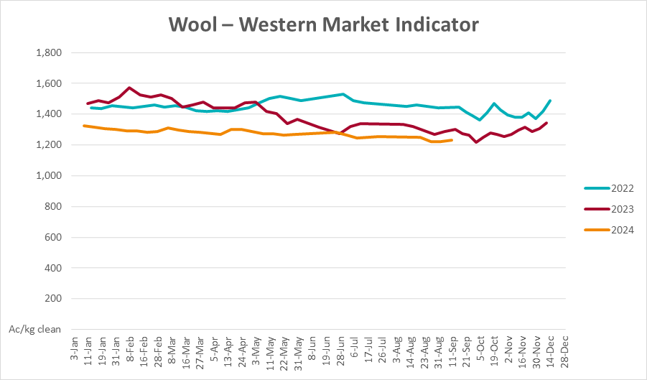

### 3.2 Selected domestic crop indicator prices

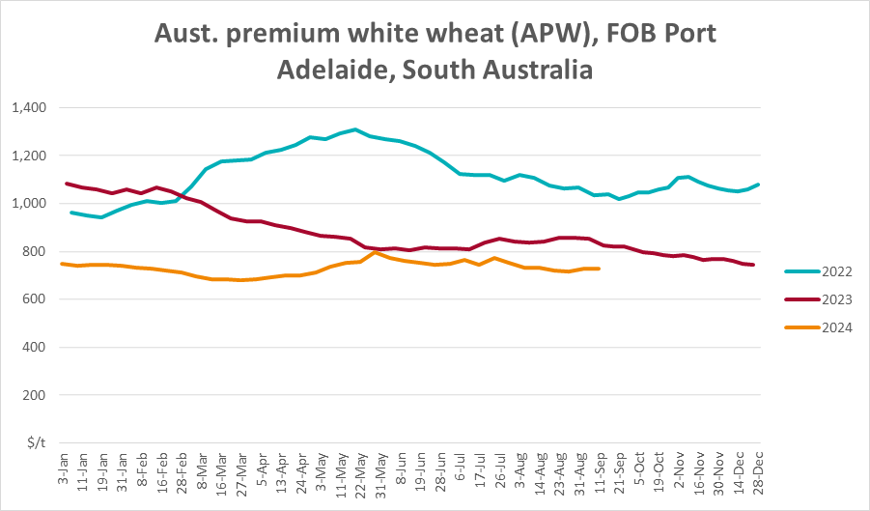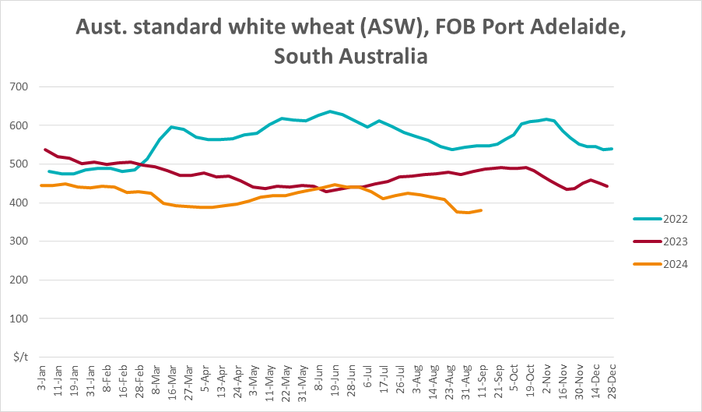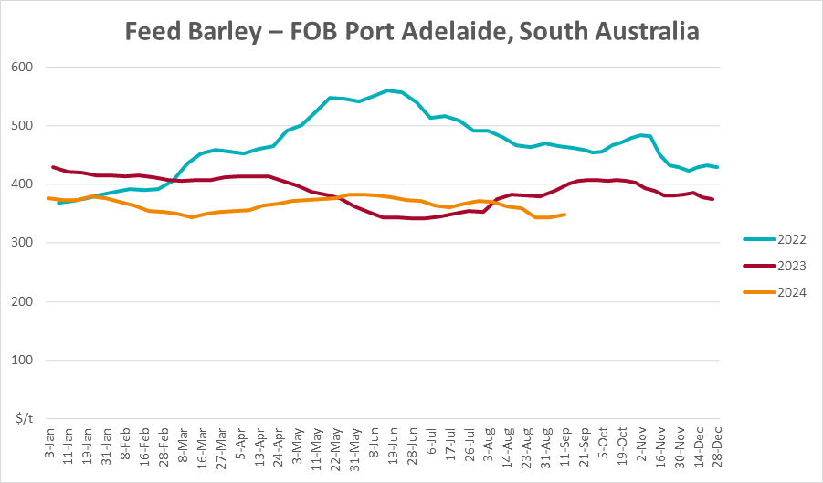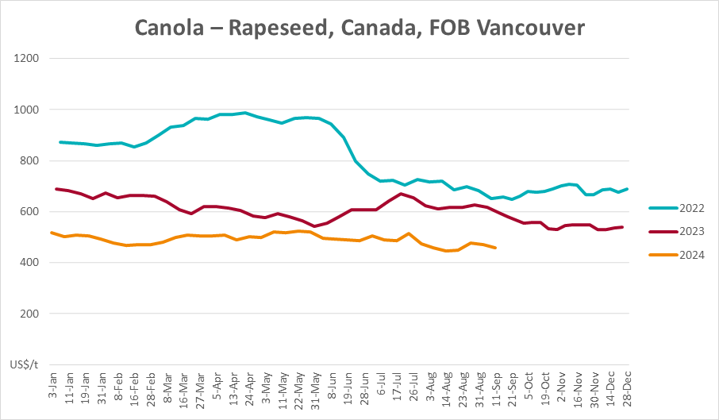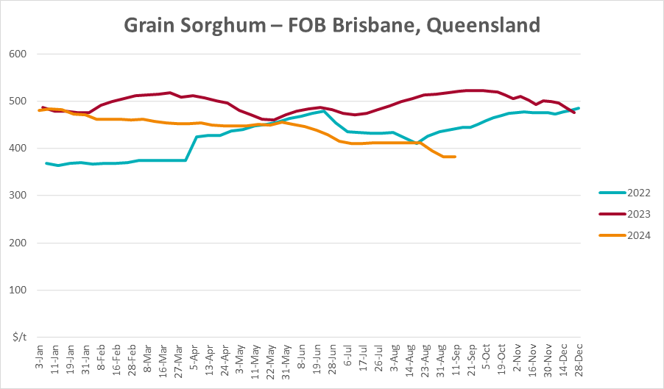

### Selected domestic livestock indicator prices

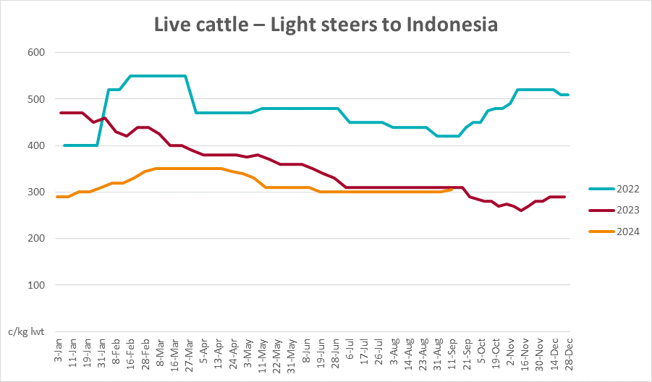

### Global Dairy Trade (GDT) weighted average prices

### Selected fruit and vegetable prices

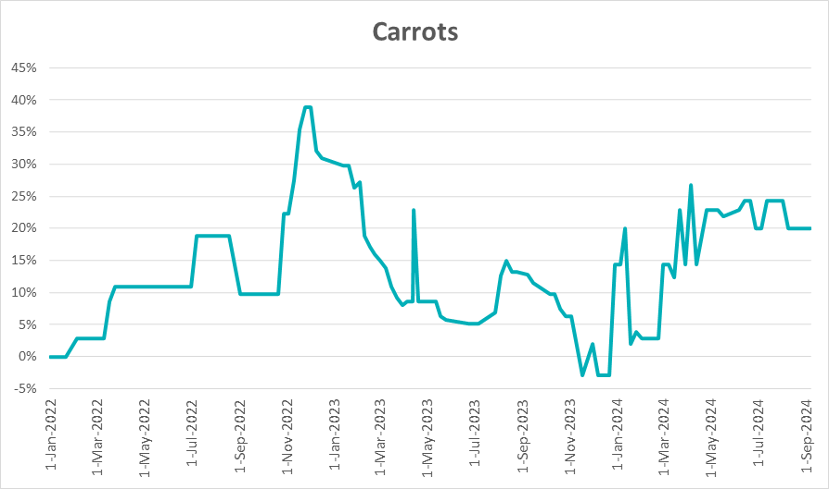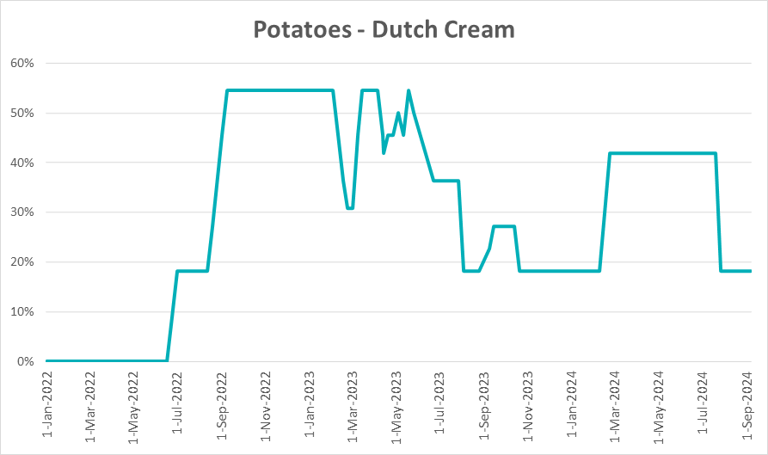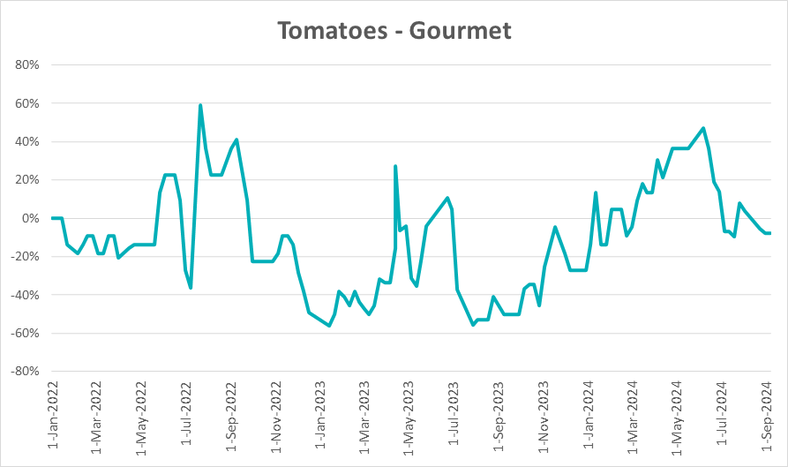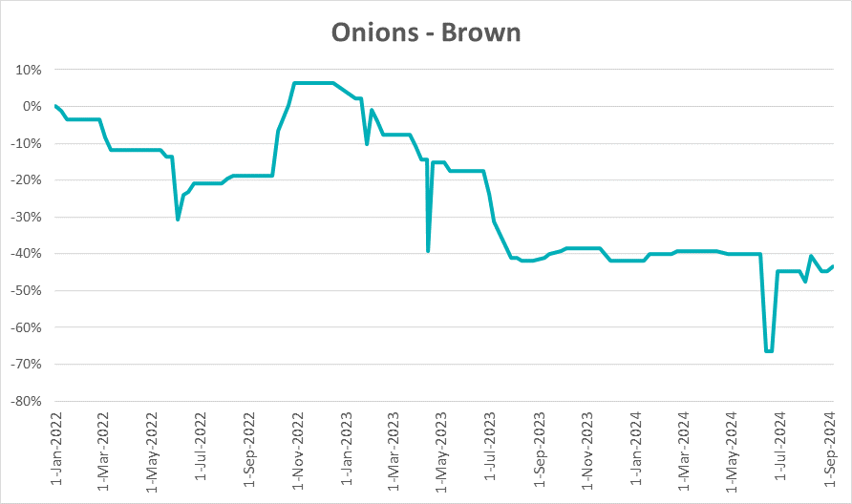

### 3.6 Selected domestic fodder indicator prices

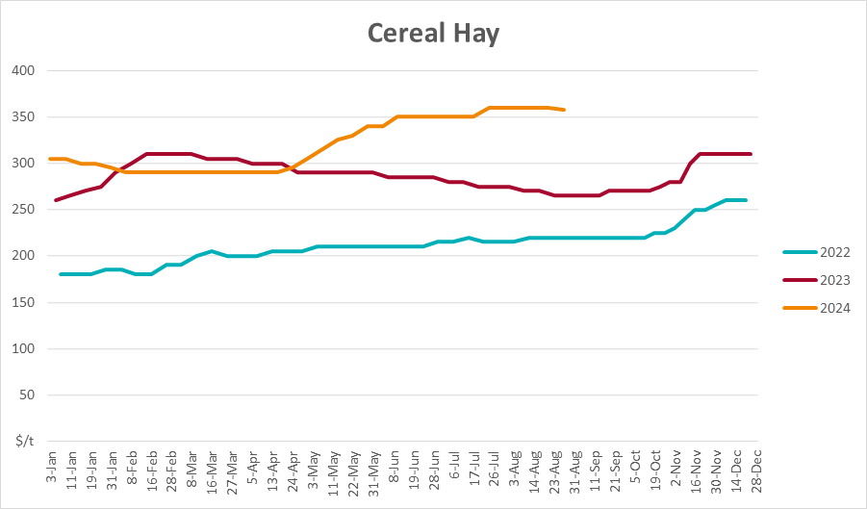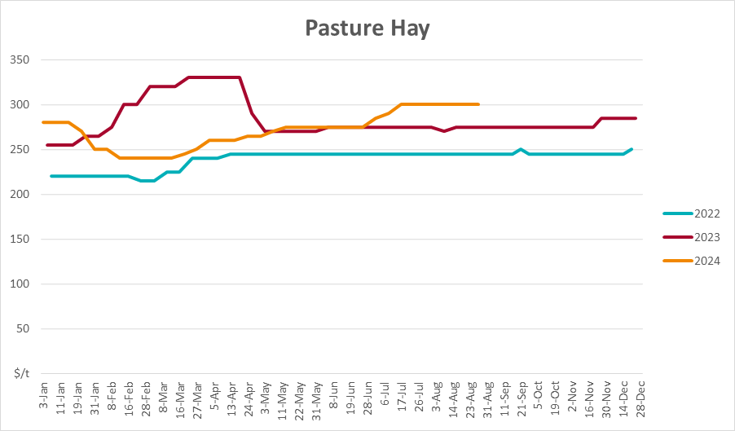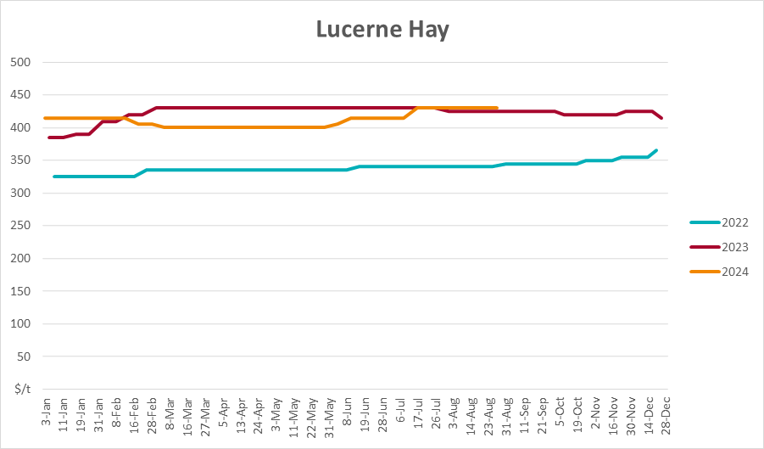

## **4. Data attribution**

### Climate

* Bureau of Meteorology
* Weekly rainfall totals: www.bom.gov.au/climate/maps/rainfall/
* Monthly and last 3-month rainfall percentiles: [www.bom.gov.au/water/landscape/](http://www.bom.gov.au/water/landscape/)
* Temperature anomalies: [www.bom.gov.au/jsp/awap/temp/index.jsp](http://www.bom.gov.au/jsp/awap/temp/index.jsp)
* Rainfall forecast: [www.bom.gov.au/jsp/watl/rainfall/pme.jsp](http://www.bom.gov.au/jsp/watl/rainfall/pme.jsp)
* Seasonal outlook: [www.bom.gov.au/climate/outlooks/#/overview/summary/](http://www.bom.gov.au/climate/outlooks/#/overview/summary/)
* Climate drivers: <http://www.bom.gov.au/climate/enso/>
* Soil moisture: [www.bom.gov.au/water/landscape/](http://www.bom.gov.au/water/landscape/)
* Other
* Pasture growth: [www.longpaddock.qld.gov.au/aussiegrass/](http://www.longpaddock.qld.gov.au/aussiegrass/)
* 3-month global outlooks: [Environment and Climate Change Canada](https://weather.gc.ca/saisons/image_e.html?img=s234pfe1p_cal&bc=prob), [NOAA Climate Prediction Center](https://www.cpc.ncep.noaa.gov/products/predictions/long_range/seasonal.php?lead=2), [EUROBRISA CPTEC/INPE](http://eurobrisa.cptec.inpe.br/), European Centre for Medium-Range Weather Forecasts, [Hydrometcenter of Russia](https://meteoinfo.ru/en/climate/seasonal-forecasts), [National Climate Center Climate System Diagnosis and Prediction Room (NCC)](https://cmdp.ncc-cma.net/pred/cs2gen.php?pred_elem=RAINP#pred_seasonal), [International Research Institute for Climate and Society](https://iri.columbia.edu/our-expertise/climate/forecasts/seasonal-climate-forecasts/)
* Global production: <https://ipad.fas.usda.gov/ogamaps/cropmapsandcalendars.aspx>
* Autumn break: Pook et al., 2009, <https://rmets-onlinelibrary-wiley-com.virtual.anu.edu.au/doi/epdf/10.1002/joc.1833>

### Water

Prices

* Waterflow: <https://www.waterflow.io/>
* Ruralco: <https://www.ruralcowater.com.au/>
* Bureau of Meteorology:
* Allocation trade: <http://www.bom.gov.au/water/dashboards/#/water-markets/mdb/at>
* Storage volumes: <http://www.bom.gov.au/water/dashboards/#/water-storages/summary/drainage>
* Trade constraints:
* Water NSW: <https://www.waternsw.com.au/customer-service/ordering-trading-and-pricing/trading/murrumbidgee>
* Victorian Water Register: <https://www.waterregister.vic.gov.au/TradingRules2019/>

### Commodities

* Fruit and vegetables
* Datafresh: [www.freshstate.com.au](http://www.freshstate.com.au)
* Pigs
* Australian Pork Limited: [www.australianpork.com.au](http://www.australianpork.com.au)
* Dairy
* Global Dairy Trade: [www.globaldairytrade.info/en/product-results/](http://www.globaldairytrade.info/en/product-results/)
* World wheat, canola
* International Grains Council
* World coarse grains
* United States Department of Agriculture
* World cotton
* Cotlook: [www.cotlook.com/](http://www.cotlook.com/)
* World sugar
* New York Stock Exchange - Intercontinental Exchange
* Wool
* Australian Wool Exchange: [www.awex.com.au/](http://www.awex.com.au/)
* Domestic wheat, barley, sorghum, canola and fodder
* Jumbuk Consulting Pty Ltd: http://www.jumbukag.com.au/
* Cattle, beef, mutton, lamb, goat and live export
* Meat and Livestock Australia: www.mla.com.au/Prices-and-market

© Commonwealth of Australia 2024

### Ownership of intellectual property rights

Unless otherwise noted, copyright (and any other intellectual property rights, if any) in this publication is owned by the Commonwealth of Australia (referred to as the Commonwealth).

### Creative Commons licence

All material in this publication is licensed under a [Creative Commons Attribution 4.0 International Licence](https://creativecommons.org/licenses/by/4.0/legalcode) except content supplied by third parties, logos and the Commonwealth Coat of Arms.

Inquiries about the licence and any use of this document should be emailed to [copyright@awe.gov.au](mailto:copyright@awe.gov.au).

https://www.agriculture.gov.au/sites/default/files/images/creative-commons-logo-small.png

### Cataloguing data

This publication (and any material sourced from it) should be attributed as:

ABARES 2024, Weekly Australian Climate, Water and Agricultural Update, Australian Bureau of Agricultural and Resource Economics and Sciences, Canberra, 29 August 2024. CC BY 4.0 DOI: <https://doi.org/10.25814/5f3e04e7d2503>

ISSN **2652-7561**

This publication is available at https://www.agriculture.gov.au/abares/products/weekly_update

Department of Agriculture, Fisheries and Forestry

GPO Box 858 Canberra ACT 2601

Telephone 1800 900 090

Web [agriculture.gov.au/abares](http://awe.gov.au/abares)

### Disclaimer

The Australian Government acting through the Department of Agriculture, Fisheries and Forestry, represented by the Australian Bureau of Agricultural and Resource Economics and Sciences, has exercised due care and skill in preparing and compiling the information and data in this publication. Notwithstanding, the Department of Agriculture, Fisheries and Forestry, ABARES, its employees and advisers disclaim all liability, including liability for negligence and for any loss, damage, injury, expense or cost incurred by any person as a result of accessing, using or relying on any of the information or data in this publication to the maximum extent permitted by law.

### Statement of Professional Independence

The views and analysis presented in ABARES publications, including this one, reflect ABARES professionally independent findings, based on scientific and economic concepts, principles, information and data. These views, analysis and findings may not reflect or be consistent with the views or positions of the Australian Government, or of organisations or groups who have commissioned ABARES reports or analysis. More information on [professional independence](https://www.agriculture.gov.au/abares/about/research-and-analysis#professional-independence) is provided on the ABARES website.

### Acknowledgements

This report was prepared by Holly Beale and Matthew Miller.