## No. 33/2024 29 August 2024

# Summary of key issues

* In the week ending 28 August 2024, a high-pressure system kept much of the country mainly dry, with rainfall largely in the southwest and southeast of the country.
  + Across cropping regions, rainfall totals ranging from 5 to 50 millimetres were recorded across Western Australia, central to southern New South Wales and eastern Victoria; up to 10 millimetres in parts of South Australia; while Queensland and northern New South Wales cropping regions recorded no rainfall. Where recorded, this rainfall is expected to not only support the yield prospects of winter crops, but also assist in maintaining the soil moisture reserves particularly in southern Western Australia and central New South Wales.
* Over coming days, cold fronts are expected to bring a cold change with showers to the south-west and south-east of Australia, including Tasmania. High-pressure systems are expected to keep the central and northern parts of the country largely dry.
  + Across cropping regions, rainfall totals of between 5 and 25 millimetres are forecast across Western Australia. Victoria is expected to receive up to 50 millimetres of rainfall, with much of South Australia forecast to receive between 5 and 10 millimetres. If realised, this rainfall is expected to support the growth of crops and pastures in southern regions, with crops in New South Wales and Queensland to draw on stored soil moisture to support growth.
* The national rainfall outlook for Spring 2024 indicated an increased probability of above median rainfall across eastern central areas of the country. However, much of Western Australia, and northwestern areas in the Northern Territory are more likely to receive below median rainfall, with the probability below 40% of exceeding median rain.
  + There is at least a 75% chance of receiving between 50 and 200 millimetres of rainfall across Queensland and New South Wales, and between 25 and 100 millimetres in the remaining states. If realised, these expected rainfall totals will likely be sufficient to support the flowering and grain filling stages of winter crop development, boost soil moisture profiles, assist in maintaining current winter crop yield expectations in most regions and provide a favourable start to the summer cropping season.
* Water storage levels in the Murray-Darling Basin (MDB) increased between 22 August 2024 by 75 gigalitres (GL). Current volume of water held in storage is 18 390 GL, equivalent to 83% of total storage capacity. This is 10% or 2,495GL less than at the same time last year. Water storage data is sourced from the BOM.
* Allocation prices in the Victorian Murray below the Barmah Choke decreased from $148 on 22 August 2024 to $147 on 29 August 2024. Prices are lower in the Murrumbidgee due to the binding of the Murrumbidgee export limit.

## **Climate**

### Rainfall this week

For the week ending 28 August 2024, a high-pressure system kept much of the country mainly dry. Several weather systems moved through south-west Western Australia and Tasmania, bringing widespread light to moderate rainfall, with localised heavy falls. A strong cold front swept through southeastern Australia, bringing severe thunderstorms across parts of Victoria and southern New South Wales, resulting in rainfall totals of between 10 to 100 millimetres.

Across cropping regions, rainfall totals ranging from 5 to 50 millimetres were recorded across Western Australia, central to southern New South Wales and eastern Victoria. Falls of up to 10 millimetres were recorded in parts of South Australia, while Queensland and northern New South Wales cropping regions recorded no rainfall. Where recorded, this rainfall is expected to not only support the yield prospects of winter crops, but also assist in maintaining the soil moisture reserves particularly in southern Western Australia and central New South Wales. Little to no rainfall across northern New South Wales and Queensland is expected to contribute to a drawdown of soil moisture, as crops utilised average to above average levels of stored soil moisture to maintain current yield potentials.

#### Rainfall for the week ending 28 August 2024

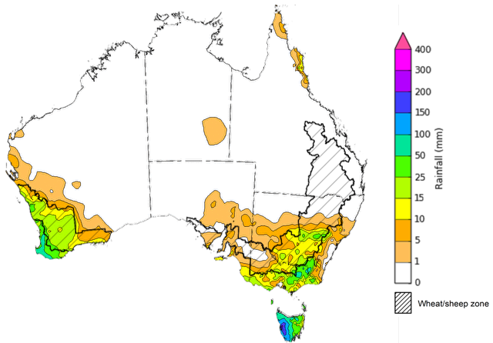

©Commonwealth of Australia 2024, Australian Bureau of Meteorology Issued: 28/08/2024

Note: The rainfall analyses and associated maps utilise data contained in the Bureau of Meteorology climate database, the Australian Data Archive for Meteorology (ADAM). The analyses are initially produced automatically from real-time data with limited [quality control](http://www.bom.gov.au/climate/headers/qc.shtml). They are intended to provide a general overview of rainfall across Australia as quickly as possible after the observations are received. For further information go to <http://www.bom.gov.au/climate/rainfall/>

### Rainfall forecast for the next eight days

Over the 8 days to 5 September 2024, cold fronts are expected to bring a cold change with showers to the south-west and south-east of Australia, including Tasmania. High-pressure systems are expected to keep the central and northern parts of the country largely dry.

Across cropping regions, rainfall totals of between 5 and 25 millimetres are forecast across Western Australia, with higher rainfall totals in the far south-western regions. Meanwhile, Victoria is expected to receive up to 50 millimetres of rainfall, with much of South Australia forecast to receive between 5 and 10 millimetres. Little to no rainfall is forecast for New South Wales and Queensland cropping regions, with a maximum of 5 millimetres of rainfall. If realised, this rainfall is expected to support the growth of crops and pastures in southern regions, with crops in New South Wales and Queensland to draw on stored soil moisture to support growth.

#### Total forecast rainfall for the period 29 August to 5 September 2024

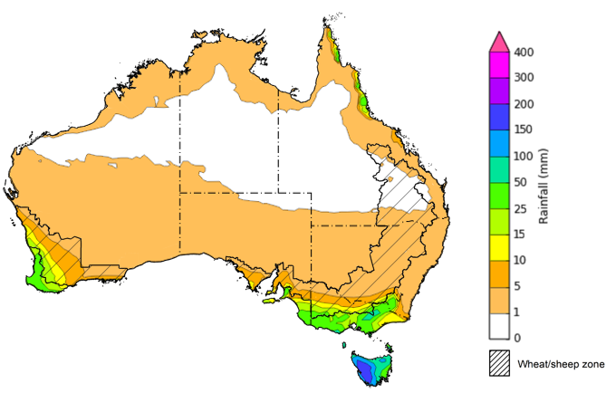

©Commonwealth of Australia 2024, Australian Bureau of Meteorology Issued 29/08/2024

Note: This rainfall forecast is produced from computer models. As the model outputs are not altered by weather forecasters, it is important to check local forecasts and warnings issued by the Bureau of Meteorology.

### 1.3 Potential Frost

Frost occurs on clear nights during the late autumn to early spring period, when the air temperature drops to 2°C or lower and is most pronounced in the southern and eastern agricultural regions. The weather events that typically generate damaging frosts are from the passage of cold fronts, followed by cold southerly winds and a high-pressure ridge. The severity and extent of subsequent damage is variable across the landscape. Crop damage from frost may occur at any stage of development but is most damaging around flowering and grain filling in spring. During the early stages of plant growth, frost can damage emerging crop.

Severe frosts (minimum temperatures below -2°C) can cause freezing damage to a crop when there is rapid ice crystal formation form within the tissue. The ice crystals physically rupture cell walls and membranes within the cells. Damage can be seen once thawed as dark green water-soaked areas. Ten days after a frost event, bleached leaves, stems and reproductive tissue might be evident depending on the growth stage of the crop.

During between 1 August and 28 August 2024, cropping regions across much of Victoria and southern New South Wales and parts of western Queensland, eastern South Australia and eastern Western Australia experienced at least 10 frost events. Central and northeastern areas in New South Wales recorded up to 15 frost events. Depending on the growth stage of crops and the severity and length of time crops were subjected to frost, this presents a localised risk to crop production in these areas.

**Number of days with minimum temperature below 2°C in August 2024**

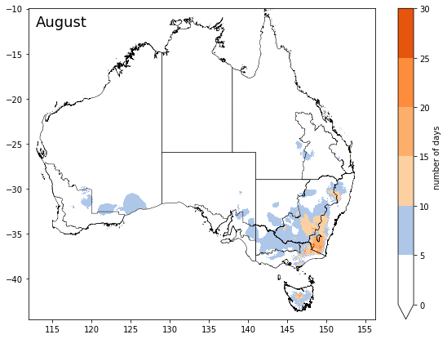

©Commonwealth of Australia 2024, Australian Bureau of Meteorology

Note: Based on standard 30-year climatology (1993-2022)

### National Climate Outlook

The most recent rainfall outlook for September 2024 provided by the Bureau of Meteorology indicates an increased likelihood of above median rainfall across eastern half of the country, including Tasmania. In contrast, there is an increased likelihood of below median rainfall across Western Australia.

According to Bureau of Meteorology’s climate model, for September 2024 there is a 75% probability of rainfall totals between 10 and 100 millimetres across eastern New South Wales, Victoria, and southern areas of Western Australia and South Australia. South-eastern Queensland is expected to receive up to 25 millimetres of rainfall. Alpine areas in New South Wales and Victoria will likely receive rainfall of up to 200 millimetres. Tasmania is expected to receive up to 300 millimetres of rainfall. The northern areas of the country are expected to remain largely dry.

Across cropping regions, there is a 75% chance of receiving between 10 and 50 millimetres of rainfall in New South Wales, Victoria, South Australia and Western Australia. If realised, these rainfall totals are likely to be sufficient to support growth of crops through September. In Queensland, rainfall totals of between 5 and 25 millimetres are expected across southern cropping regions, while little to no rainfall is expected for northern cropping regions. This expected lack of rainfall in the central to northern areas is unlikely to negatively impact winter crop development, due to above average levels of stored soil moisture maintain current yield potentials.

**Rainfall totals that have a 75% chance of occurring in September 2024**

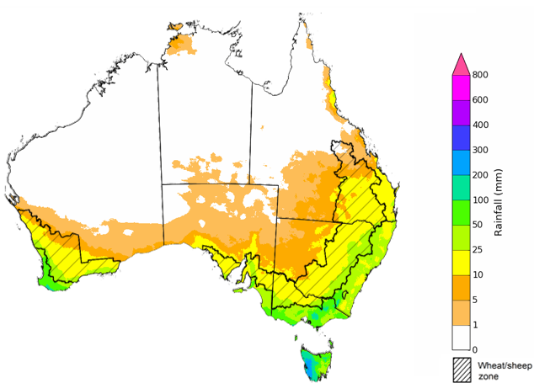

©Commonwealth of Australia 2024, Australian Bureau of Meteorology Issued: 29/08/2024

The El Niño Southern Oscillation (ENSO) and Indian Ocean Dipole (IOD) climate drivers are currently neutral and having minimal influence on Australian rainfall.

The rainfall outlook for September through November 2024 indicates that above median rainfall is more likely across eastern and central areas of the country. In contrast, much of Western Australia, and northwestern areas in the Northern Territory are more likely to receive below median rainfall, with the probability below 40% of exceeding median rain in these areas. Remaining areas have equal chance of receiving above or below median rainfall.

Across cropping regions, the probability of exceeding median rainfall is between 60% and 75% in Queensland and New South Wales and parts of South Australia. The chance of above median in the most of South Australia and Victoria is between 50% and 65%. By contrast, the outlook for Western Australia is for below median rainfall in the northern half of the cropping regions and an equal chance of either above or below median rainfall in southern half. If realised, this rainfall would support ABARES forecasts of above average winter crop yields in New South Wales and Queensland, and help support current yield expectations in Victoria, South Australia and Western Australia. The buildup of soil moisture from rainfall in northern New South Wales and Queensland will also prepare for an ideal start to the summer cropping season.

**Chance of exceeding the median rainfall** **September to November 2024**

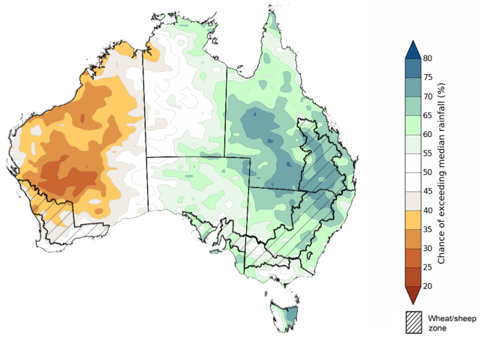

©Commonwealth of Australia 2024, Australian Bureau of Meteorology Issued: 29/08/2024

The outlook for September through to November suggests a 75% chance of rainfall totals between 25 and 200 millimetres occurring in the eastern, southern and northern part of the country, with heavier falls of up to 600 millimetres forecast for alpine regions of Victoria and New South Wales. Western Tasmania is expected to receive falls in excess of 600 millimetres.

In cropping regions, there is at least a 75% chance of receiving between 50 and 200 millimetres of rainfall across much of New South Wales, Queensland and Victoria, and between 25 and 100 millimetres in South Australia and Western Australia.

These expected rainfall totals are likely to be sufficient to support the flowering and grain filling stages of winter crop development, boost soil moisture profile, assist in maintaining current winter crop yield expectations in most regions and provide a favourable start to the summer cropping season.

Livestock producers, especially those in the south and east of the country, are expected to experience close to average pasture production on the back of the improving rainfall outlook over the spring season.

**Rainfall totals that have a 75% chance of occurring September to November 2024**

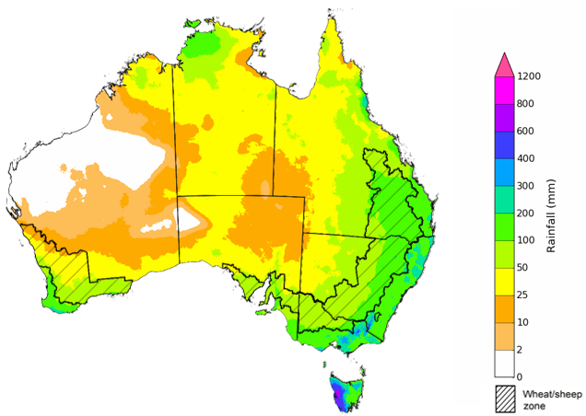

©Commonwealth of Australia 2024, Australian Bureau of Meteorology Issued: 29/08/2024

The northern rainfall onset outlook provides an indication of whether the first significant rains after the dry season are likely to be earlier or later than normal. The onset occurs when the total rainfall after 1 September reaches 50 millimetres, which is considered approximately the amount of rainfall required to stimulate plant growth. The northern rainfall onset for the 2024–25 season is likely to be later than usual for most of the western parts of northern Australia, but earlier for parts of the east. Much of Western Australia have a 60–70% chance of a later than usual northern rainfall onset. Across Queensland and Top End of Northern Territory, the rainfall onset is likely (60–75%) to be earlier than usual. These odds have increased in the last fortnight. Elsewhere, the northern rainfall onset is likely to be closer to the normal onset date.

**Chance of early Northern Rainfall Onset**

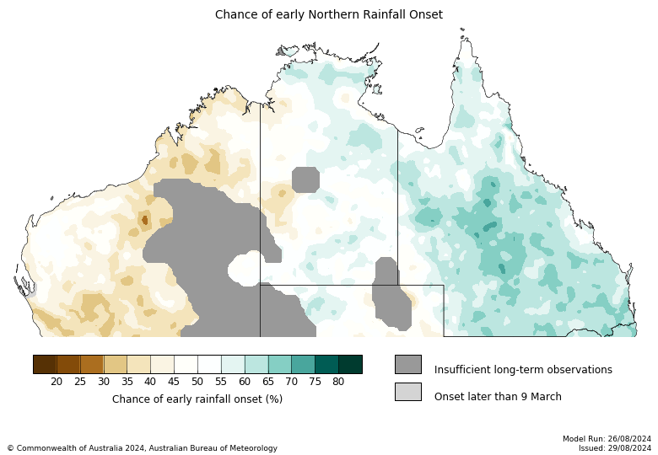

## **Water**

### Water markets – current week

Water storage levels in the Murray-Darling Basin (MDB) increased between 22 August 2024 by 75 gigalitres (GL). Current volume of water held in storage is 18 390 GL, equivalent to 83% of total storage capacity. This is 10% or 2,495GL less than at the same time last year. Water storage data is sourced from the BOM.

#### Water storages in the Murray-Darling Basin, 2013–2024

|  |
| --- |
| Water storage data is sourced from the Bureau of Meteorology. |

Allocation prices in the Victorian Murray below the Barmah Choke decreased from $148 on 22 August 2024 to $147 on 29 August 2024. Prices are lower in the Murrumbidgee due to the binding of the Murrumbidgee export limit.

|  |  |
| --- | --- |
| **Region** | **$/ML** |
| NSW Murray Above | 105 |
| NSW Murrumbidgee | 130 |
| VIC Goulburn-Broken | 110 |
| VIC Murray Below | 146 |

#### Surface water trade activity, Southern Murray–Darling Basin

|  |
| --- |
| The trades shown reflect estimated market activity and do not encompass all register trades. The price is shown for the VIC Murray below the Barmah choke. Historical prices (before 1 July 2019) are ABARES estimates after removing outliers from BOM water register data. Prices after 1 July 2019 and prior to the 30 October 2019 reflect recorded transaction prices as sourced from Ruralco. Prices after the 30 October 2019 are sourced from Waterflow. Data for volume traded is sourced from the BOM water register. Only the price data shown is current on 29 August 2024. |

To access the full, interactive, weekly water dashboard, which contains the latest and historical water storage, water market and water allocation information, please visit [https://www.agriculture.gov.au/abares/products/weekly_update/weekly-update-29824](https://www.agriculture.gov.au/abares/products/weekly_update/weekly-update-22824)

## **Commodities**

|  |  |  |  |  |  |  |  |
| --- | --- | --- | --- | --- | --- | --- | --- |
| **Indicator** | **Week average** | **Unit** | **Latest Price** | **Previous Week** | **Weekly change** | **Price 12 months ago** | **Annual change** |
| **Selected world indicator prices** |  |  |  |  |  |  |  |
| AUD/USD Exchange rate | 28-Aug | A$/US$ | 0.68 | 0.67 | 1% | 0.64 | 6% |
| Wheat – US no. 2 hard red winter wheat, fob Gulf | 28-Aug | US$/t | 247 | 246 | 0% | 313 | -21% |
| Corn – US no. 2 yellow corn, fob Gulf | 28-Aug | US$/t | 167 | 170 | -2% | 224 | -25% |
| Canola – Rapeseed, Canada, fob Vancouver | 28-Aug | US$/t | 470 | 450 | 4% | 618 | -24% |
| Cotton – Cotlook 'A' Index | 28-Aug | USc/lb | 82 | 80 | 2% | 98 | -17% |
| Sugar – Intercontinental Exchange, nearby futures, no.11 contract | 28-Aug | USc/lb | 19.3 | 18.0 | 7% | 26 | -27% |
| Wool – Eastern Market Indicator | 28-Aug | Ac/kg clean | 1,087 | 1,113 | -2% | 1,139 | -5% |
| Wool – Western Market Indicator | 28-Aug | Ac/kg clean | 1,223 | 1,248 | -2% | 1,418 | -14% |
| **Selected Australian grain export prices** |  |  |  |  |  |  |  |
| Milling Wheat – APW, Port Adelaide, SA | 28-Aug | A$/t | 379 | 408 | -7% | 481 | -21% |
| Feed Wheat – ASW, Port Adelaide, SA | 28-Aug | A$/t | 368 | 397 | -7% | 459 | -20% |
| Feed Barley – Port Adelaide, SA | 28-Aug | A$/t | 345 | 359 | -4% | 389 | -11% |
| Canola – Kwinana, WA | 28-Aug | A$/t | 712 | 720 | -1% | 853 | -16% |
| Grain Sorghum – Brisbane, QLD | 28-Aug | A$/t | 403 | 412 | -2% | 518 | -22% |
| **Selected domestic livestock indicator prices** |  |  |  |  |  |  |  |
| Beef – Eastern Young Cattle Indicator | 28-Aug | Ac/kg cwt | 683 | 672 | 2% | 494 | 38% |
| Mutton – Mutton indicator (18–24 kg fat score 2–3), Vic | 28-Aug | Ac/kg cwt | 352 | 350 | 1% | 168 | 110% |
| Lamb – National Trade Lamb Indicator | 28-Aug | Ac/kg cwt | 807 | 805 | 0% | 429 | 88% |
| Pig – Eastern Seaboard (60.1–75 kg), average of buyers & sellers | 14-Aug | Ac/kg cwt | 411 | 411 | 0% | 343 | 20% |
| Live cattle – Light steers to Indonesia | 10-Jul | Ac/kg lwt | 300 | 300 | 0% | 310 | -3% |
| **Global Dairy Trade (GDT) weighted average prices a** |  |  |  |  |  |  |  |
| Dairy – Whole milk powder | 21-Aug | US$/t | 3,482 | 3,259 | 7% | 2,864 | 22% |
| Dairy – Skim milk powder | 21-Aug | US$/t | 2,636 | 2,539 | 4% | 2,454 | 7% |
| Dairy – Cheddar cheese | 21-Aug | US$/t | 4,274 | 4,275 | 0% | 3,910 | 9% |
| Dairy – Anhydrous milk fat | 21-Aug | US$/t | 7,244 | 6,912 | 5% | 4,705 | 54% |
| **a** Global Dairy Trade prices are updated twice monthly on the first and third Tuesday of each month. | | | | | | | |

### Selected world indicator prices

### 3.2 Selected domestic crop indicator prices

### Selected domestic livestock indicator prices

### Global Dairy Trade (GDT) weighted average prices

### Selected fruit and vegetable prices

### 3.6 Selected domestic fodder indicator prices

## **4. Data attribution**

### Climate

Bureau of Meteorology

* Weekly rainfall totals: www.bom.gov.au/climate/maps/rainfall/
* Monthly and last 3-month rainfall percentiles: [www.bom.gov.au/water/landscape/](http://www.bom.gov.au/water/landscape/)
* Temperature anomalies: [www.bom.gov.au/jsp/awap/temp/index.jsp](http://www.bom.gov.au/jsp/awap/temp/index.jsp)
* Rainfall forecast: [www.bom.gov.au/jsp/watl/rainfall/pme.jsp](http://www.bom.gov.au/jsp/watl/rainfall/pme.jsp)
* Seasonal outlook: [www.bom.gov.au/climate/outlooks/#/overview/summary/](http://www.bom.gov.au/climate/outlooks/#/overview/summary/)
* Climate drivers: <http://www.bom.gov.au/climate/enso/>
* Soil moisture: [www.bom.gov.au/water/landscape/](http://www.bom.gov.au/water/landscape/)

Other

* Pasture growth: [www.longpaddock.qld.gov.au/aussiegrass/](http://www.longpaddock.qld.gov.au/aussiegrass/)
* 3-month global outlooks: [Environment and Climate Change Canada](https://weather.gc.ca/saisons/image_e.html?img=s234pfe1p_cal&bc=prob), [NOAA Climate Prediction Center](https://www.cpc.ncep.noaa.gov/products/predictions/long_range/seasonal.php?lead=2), [EUROBRISA CPTEC/INPE](http://eurobrisa.cptec.inpe.br/), European Centre for Medium-Range Weather Forecasts, [Hydrometcenter of Russia](https://meteoinfo.ru/en/climate/seasonal-forecasts), [National Climate Center Climate System Diagnosis and Prediction Room (NCC)](https://cmdp.ncc-cma.net/pred/cs2gen.php?pred_elem=RAINP#pred_seasonal), [International Research Institute for Climate and Society](https://iri.columbia.edu/our-expertise/climate/forecasts/seasonal-climate-forecasts/)
* Global production: <https://ipad.fas.usda.gov/ogamaps/cropmapsandcalendars.aspx>
* Autumn break: Pook et al., 2009, <https://rmets-onlinelibrary-wiley-com.virtual.anu.edu.au/doi/epdf/10.1002/joc.1833>

### Water

Prices

* Waterflow: <https://www.waterflow.io/>
* Ruralco: <https://www.ruralcowater.com.au/>

Bureau of Meteorology:

* Allocation trade: <http://www.bom.gov.au/water/dashboards/#/water-markets/mdb/at>
* Storage volumes: <http://www.bom.gov.au/water/dashboards/#/water-storages/summary/drainage>

Trade constraints:

* Water NSW: <https://www.waternsw.com.au/customer-service/ordering-trading-and-pricing/trading/murrumbidgee>
* Victorian Water Register: <https://www.waterregister.vic.gov.au/TradingRules2019/>

### Commodities

Fruit and vegetables

* Datafresh: [www.freshstate.com.au](http://www.freshstate.com.au)

Pigs

* Australian Pork Limited: [www.australianpork.com.au](http://www.australianpork.com.au)

Dairy

* Global Dairy Trade: [www.globaldairytrade.info/en/product-results/](http://www.globaldairytrade.info/en/product-results/)

World wheat, canola

* International Grains Council

World coarse grains

* United States Department of Agriculture

World cotton

* Cotlook: [www.cotlook.com/](http://www.cotlook.com/)

World sugar

* New York Stock Exchange - Intercontinental Exchange

Wool

* Australian Wool Exchange: [www.awex.com.au/](http://www.awex.com.au/)

Domestic wheat, barley, sorghum, canola and fodder

* Jumbuk Consulting Pty Ltd: http://www.jumbukag.com.au/

Cattle, beef, mutton, lamb, goat and live export

* Meat and Livestock Australia: www.mla.com.au/Prices-and-market

© Commonwealth of Australia 2024

### Ownership of intellectual property rights

Unless otherwise noted, copyright (and any other intellectual property rights, if any) in this publication is owned by the Commonwealth of Australia (referred to as the Commonwealth).

### Creative Commons licence

All material in this publication is licensed under a [Creative Commons Attribution 4.0 International Licence](https://creativecommons.org/licenses/by/4.0/legalcode) except content supplied by third parties, logos and the Commonwealth Coat of Arms.

Inquiries about the licence and any use of this document should be emailed to [copyright@awe.gov.au](mailto:copyright@awe.gov.au).

https://www.agriculture.gov.au/sites/default/files/images/creative-commons-logo-small.png

### Cataloguing data

This publication (and any material sourced from it) should be attributed as:

ABARES 2023, Weekly Australian Climate, Water and Agricultural Update, Australian Bureau of Agricultural and Resource Economics and Sciences, Canberra, 29 August 2024. CC BY 4.0 DOI: <https://doi.org/10.25814/5f3e04e7d2503>

ISSN **2652-7561**

This publication is available at https://www.agriculture.gov.au/abares/products/weekly_update

Department of Agriculture, Fisheries and Forestry

GPO Box 858 Canberra ACT 2601

Telephone 1800 900 090

Web [agriculture.gov.au/abares](http://awe.gov.au/abares)

### Disclaimer

The Australian Government acting through the Department of Agriculture, Fisheries and Forestry, represented by the Australian Bureau of Agricultural and Resource Economics and Sciences, has exercised due care and skill in preparing and compiling the information and data in this publication. Notwithstanding, the Department of Agriculture, Fisheries and Forestry, ABARES, its employees and advisers disclaim all liability, including liability for negligence and for any loss, damage, injury, expense or cost incurred by any person as a result of accessing, using or relying on any of the information or data in this publication to the maximum extent permitted by law.

### Statement of Professional Independence

The views and analysis presented in ABARES publications, including this one, reflect ABARES professionally independent findings, based on scientific and economic concepts, principles, information and data. These views, analysis and findings may not reflect or be consistent with the views or positions of the Australian Government, or of organisations or groups who have commissioned ABARES reports or analysis. More information on [professional independence](https://www.agriculture.gov.au/abares/about/research-and-analysis#professional-independence) is provided on the ABARES website.

### Acknowledgements

This report was prepared by Kavina Dayal and Holly Beale.