## No. 31/2024 15 August 2024

# Summary of key issues

* In the week ending 14 August 2024 a series of low-pressure troughs and a low-pressure system and cold front brought rainfall totals of up to 200 millimetres to eastern Australia and up to 50 millimetres in south-west Western Australia and Tasmania.
  + Across cropping regions, rainfall totals ranging from 10 to 150 millimetres were recorded in Queensland, with falls of between 5 and 50 millimetres were recorded across much of New South Wales. This rainfall will not only support the yield prospects of winter crops, but also assist in the build-up of soil moisture reserves for the timely planting of summer crops. Western Australian cropping regions recorded falls of between 5 and 25 millimetres.
* Over coming days, low-pressure systems are expected to bring rainfall to the southern half of the country. Meanwhile, a high-pressure system is expected to keep the northern half of the country dry and largely cloud free.
  + Across cropping regions, rainfall totals of between 10 and 50 millimetres are forecast across Western Australia, South Australia, Victoria, and southern New South Wales. If realised, rainfall in these cropping areas is expected to provide a boost to plant growth and soil moisture levels following recent dryness.
* Globally, variable rainfall during July has led to mixed crop production prospects.
  + Global production conditions were generally favourable for rice and soybeans but variable for wheat and maize.
  + Global production conditions remain generally unchanged from those used to formulate ABARES forecasts of global grain supplies and world prices for 2024–25 in its June 2024 edition of the Agricultural Commodities Report.
* Water storage levels in the Murray-Darling Basin (MDB) increased between 08 August 2024 and 15 August 2024 by 91 gigalitres (GL). Current volume of water held in storage is 18 194 GL, equivalent to 82% of total storage capacity. This is 10 percent or 2,709 GL less than at the same time last year. Water storage data is sourced from the BOM.
* Allocation prices in the Victorian Murray below the Barmah Choke increased from $142 on 08 August 2024 to $146 on 15 August 2024. Prices are lower in the Murrumbidgee due to the binding of the Murrumbidgee export limit.

## **Climate**

### Rainfall this week

For the week ending 14 August 2024, a series of low-pressure troughs and a low-pressure system brought rainfall totals of up to 200 millimetres to eastern Australia. A cold front resulted in showers of up to 50 millimetres in south-west Western Australia and Tasmania. In contrast, a high-pressure system kept large parts of southern, central and northern Australia mostly dry.

Across cropping regions, rainfall totals ranging from 10 to 150 millimetres were recorded in Queensland, with falls of between 5 and 50 millimetres were recorded across much of New South Wales. This rainfall will not only support the yield prospects of winter crops, but also assist in the build-up of soil moisture reserves for the timely planting of summer crops. Western Australian cropping regions recorded falls of between 5 and 25 millimetres, with higher rainfall totals observed along western cropping margins. Little to no rainfall was recorded across much of South Australia, Victoria, and parts of southern New South Wales. This is expected to see a continued drawdown in soil moisture reserves and some moisture stress in crops with minimal soil moisture reserves.

#### Rainfall for the week ending 14 August 2024

©Commonwealth of Australia 2024, Australian Bureau of Meteorology Issued: 14/08/2024

Note: The rainfall analyses and associated maps utilise data contained in the Bureau of Meteorology climate database, the Australian Data Archive for Meteorology (ADAM). The analyses are initially produced automatically from real-time data with limited [quality control](http://www.bom.gov.au/climate/headers/qc.shtml). They are intended to provide a general overview of rainfall across Australia as quickly as possible after the observations are received. For further information go to <http://www.bom.gov.au/climate/rainfall/>

### Rainfall forecast for the next eight days

Over the 8 days to 22 August 2024, low-pressure systems are expected to bring rainfall to the southern half of the country. Meanwhile, a high-pressure system will keep the northern half of the country dry and largely cloud free.

Across cropping regions, rainfall totals of between 10 and 50 millimetres are forecast across Western Australia, South Australia, Victoria, and southern New South Wales. If realised, rainfall in these cropping areas is expected to provide a boost to plant growth and soil moisture levels following recent dryness. Following a wet week, cropping regions in northern New South Wales and Queensland is forecast to receive lighter falls of up to 10 millimetres.

#### Total forecast rainfall for the period 15 July to 22 August 2024

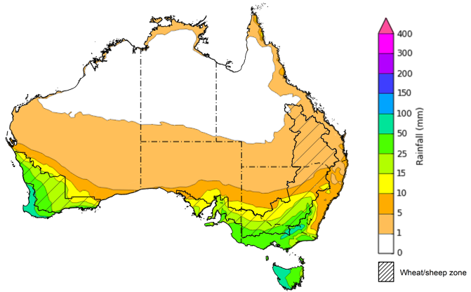

©Commonwealth of Australia 2024, Australian Bureau of Meteorology Issued 15/08/2024

Note: This rainfall forecast is produced from computer models. As the model outputs are not altered by weather forecasters, it is important to check local forecasts and warnings issued by the Bureau of Meteorology.

### Global production conditions and climate outlook

Crop production is affected by long-term trends in average rainfall and temperature, interannual climate variability, shocks during specific growth stages, and extreme weather events. Some crops are more tolerant than others to certain types of stresses, and at each growth stage, different types of stresses affect each crop species in different ways.

The precipitation anomalies and outlooks presented here give an indication of the current and future state of production conditions for the major grain and oilseed producing countries which are responsible for over 80% of global production. This is an important input to assessing the global grain supply outlook.

**July precipitation percentiles and current production conditions**

As of the end of July 2024, rainfall was variable for the world’s major grain- and oilseed-producing nations.

In the southern hemisphere, precipitation was below average across much of Argentina and parts of northern and southern Brazil. In contrast, parts of western Australia experienced above average rainfall. Rainfall was generally average in the remaining grain- and oilseed-producing regions in the southern hemisphere.

In the northern hemisphere, precipitation was below average in parts of southern and eastern Europe, central and southern Canada and parts of the northern United States. Precipitation was generally average to above average in the remaining grain- and oilseed-producing nations in the northern hemisphere.

**Global precipitation percentiles, July 2024**

Note: The world precipitation percentiles indicate a ranking of precipitation for July, with the driest (0th percentile) being 0 on the scale and the wettest (100th percentile) being 1 on the scale. Percentiles are based on precipitation estimates from the NOAA Climate Prediction Center’s [Climate Anomaly Monitoring System Outgoing Precipitation Index](https://iridl.ldeo.columbia.edu/maproom/Global/Precipitation/Percentiles.html) dataset. Precipitation estimates for July 2024 are compared with rainfall recorded for that period during the 1981 to 2010 base period.

Source: International Research Institute for Climate and Society

As of 28 July 2024, global production conditions were generally favourable for rice and soybeans but variable for wheat and maize:

* **Wheat –** in the northern hemisphere the winter wheat harvest is progressing under variable conditions, with areas of concern in parts of Europe, the Russian Federation, and Ukraine, following adverse weather conditions in recent months. However, above average yields are expected elsewhere in Europe and in the United States and Canada. In the southern hemisphere crops are developing under generally favourable conditions in Australia and Argentina.
* **Maize –** in the southern hemisphere, the harvest is progressing under mixed conditions in South America. In the northern hemisphere, there are areas of production concern in Mexico, the North China Plain, Romania, and Ukraine due to hot and dry conditions. Elsewhere in the northern hemisphere production conditions are generally favourable.
* **Rice –** conditions are generally favourable, however transplanting in parts of eastern India has been delayed due to lack of rainfall in the area.
* **Soybeans –** in the northern hemisphere, generally favourable production conditions persist with the exception of parts of the Russian Federation and Ukraine with some production concerns evident due to hot and dry conditions.

**Crop conditions, AMIS countries, 28 July 2024**

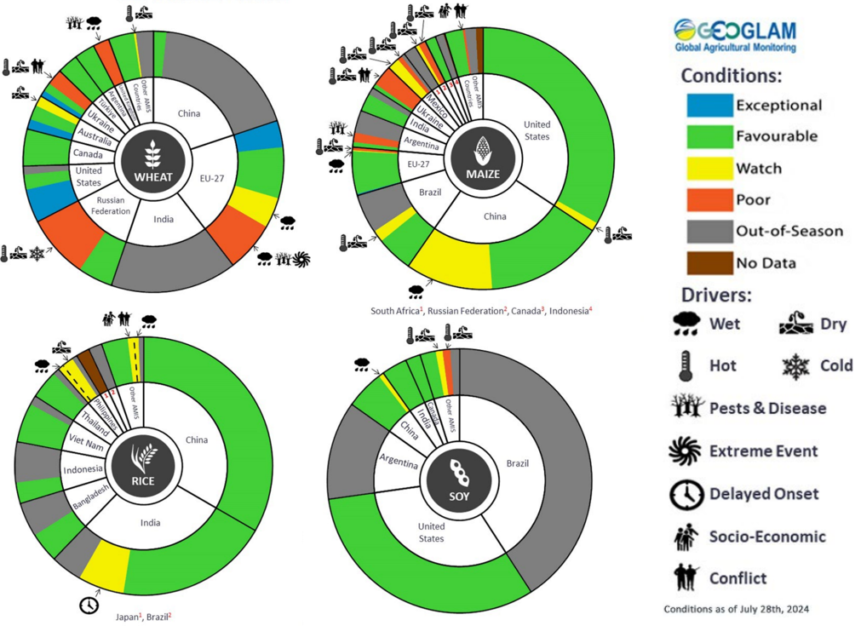

**AMIS** Agricultural Market Information System.

Source: AMIS

The global climate outlook for September 2024 to November 2024 indicates that mixed rainfall conditions are expected for the world’s major grain-producing and oilseed-producing regions. Outlooks and potential production impacts for the major grain and oilseed producing countries are presented in the following table.

**Rainfall outlook and potential impact on the future state of production conditions between** **September 2024 to November 2024**

|  |  |  |
| --- | --- | --- |
| **Region** | **September-November rainfall outlook** | **Potential impact on production** |
| **Argentina** | Below average rainfall is more likely across western and eastern parts of Argentina. Average to above average is expected in the northern and southern areas. | Below average rainfall is likely to impact the heading and filling of wheat and the planting of corn, cotton and soybeans. These conditions may also present risk to early corn silking, and the planting of soybeans, sunflower, rice, sorghum and millet in November. Average to above average rainfall across parts of northern Argentina is likely to benefit corn and soybean planting and development through the September to November period. |
| **Black Sea Region** | Generally, average rainfall is expected, with below average rainfall in isolated areas, in Ukraine, Kazakhstan and the Russia Federation. Above average rainfall is expected in Türkiye. | Average rainfall is likely to support spring wheat harvesting in the north-east of Russia and early cotton harvesting in southern regions. Average rainfall across Kazakhstan and Ukraine is likely to support winter wheat and rapeseed planting in September, and corn and sunflower filling in September and October. |
| **Brazil** | Below average rainfall is more likely across northern and southern parts of Brazil. Above average rainfall in more likely in eastern Brazil. | Below average rainfall across much of Brazil is likely adversely corn and soybean planting and development in October and November. Above average rainfall in parts of eastern Brazil is likely to benefit wheat filling leading up to harvest in October, as well as corn and soybean planting and development in September and October. |
| **Canada** | Generally, average rainfall is likely across much of Canada. Above and below average rainfall is likely in isolated areas. | Average rainfall could be sufficient to maintain the yield potential of corn, soybeans and sunflower at the grain filling and maturing stage through September and October. |
| **China** | Average to above average rainfall is more likely across much of China, while below average rainfall is more likely in the western regions. | Average to above average rainfall is likely to benefit the development and harvest of cotton, corn, sorghum, soybean, sunflower, groundnuts and spring wheat across north-eastern, southern and western China. In central China, above average rainfall is likely to support the planting of winter wheat and rapeseed in October. |
| **Europe** | Average rainfall is more likely for much of Europe. | Average rainfall may benefit the development and harvest of corn, cotton and sorghum in western and central Europe. Average rainfall may also benefit winter wheat and rapeseed planting in parts of western and central Europe during October and November. |
| **South Asia (India)** | Above average rainfall is more likely across much of India. | Above average rainfall is likely to benefit cotton blooming in the south during September. It will also assist corn, sorghum, rice, millet, groundnuts and sunflower filling in September leading up to harvest in October and November, and winter wheat and rapeseed planting in November. |
| **Southeast Asia (SEA)** | Above average rainfall is likely across Indonesia and southern Malaysia. Average rainfall is likely in Thailand. | Above average rainfall in SEA is likely to benefit corn and rice maturing during September leading up to harvest in October. |
| **The United States of America (US)** | Generally, below average rainfall is likely for much of southern half of the US, with average rainfall more likely across the northern half. | Below average rainfall is likely to adversely affect the filling and maturing of soybeans, sunflower, millet, cotton, rice, corn, sorghum and groundnuts in September leading up to harvest in October and November. |

## **Water**

### Water markets – current week

Water storage levels in the Murray-Darling Basin (MDB) increased between 08 August 2024 and 15 August 2024 by 91 gigalitres (GL). Current volume of water held in storage is 18 194 GL, equivalent to 82% of total storage capacity. This is 10 percent or 2,709 GL less than at the same time last year. Water storage data is sourced from the BOM.

#### Water storages in the Murray-Darling Basin, 2013–2024

|  |
| --- |
| Water storage data is sourced from the Bureau of Meteorology. |

Allocation prices in the Victorian Murray below the Barmah Choke increased from $142 on 08 August 2024 to $146 on 15 August 2024. Prices are lower in the Murrumbidgee due to the binding of the Murrumbidgee export limit.0

|  |  |
| --- | --- |
| **Region** | **$/ML** |
| NSW Murray Above | 105 |
| NSW Murrumbidgee | 130 |
| VIC Goulburn-Broken | 110 |
| VIC Murray Below | 146 |

#### Surface water trade activity, Southern Murray–Darling Basin

|  |
| --- |
| The trades shown reflect estimated market activity and do not encompass all register trades. The price is shown for the VIC Murray below the Barmah choke. Historical prices (before 1 July 2019) are ABARES estimates after removing outliers from BOM water register data. Prices after 1 July 2019 and prior to the 30 October 2019 reflect recorded transaction prices as sourced from Ruralco. Prices after the 30 October 2019 are sourced from Waterflow. Data for volume traded is sourced from the BOM water register. Only the price data shown is current on 15 August 2024. |

To access the full, interactive, weekly water dashboard, which contains the latest and historical water storage, water market and water allocation information, please visit <https://www.agriculture.gov.au/abares/products/weekly_update/weekly-update-15824>

## **Commodities**

|  |  |  |  |  |  |  |  |
| --- | --- | --- | --- | --- | --- | --- | --- |
| **Indicator** | **Week average** | **Unit** | **Latest Price** | **Previous Week** | **Weekly change** | **Price 12 months ago** | **Annual change** |
| **Selected world indicator prices** |  |  |  |  |  |  |  |
| AUD/USD Exchange rate | 14-Aug | A$/US$ | 0.66 | 0.66 | 1% | 0.64 | 3% |
| Wheat – US no. 2 hard red winter wheat, fob Gulf | 14-Aug | US$/t | 249 | 253 | -2% | 317 | -21% |
| Corn – US no. 2 yellow corn, fob Gulf | 14-Aug | US$/t | 174 | 176 | -1% | 209 | -17% |
| Canola – Rapeseed, Canada, fob Vancouver | 14-Aug | US$/t | 447 | 459 | -3% | 617 | -28% |
| Cotton – Cotlook 'A' Index | 14-Aug | USc/lb | 80 | 79 | 1% | 95 | -16% |
| Sugar – Intercontinental Exchange, nearby futures, no.11 contract | 14-Aug | USc/lb | 18.7 | 18.2 | 3% | 24 | -23% |
| Wool – Eastern Market Indicator | 24-Jul | Ac/kg clean | 1,124 | 1,107 | 2% | 1,209 | -7% |
| Wool – Western Market Indicator | 24-Jul | Ac/kg clean | 1,254 | 1,247 | 1% | 1,472 | -15% |
| **Selected Australian grain export prices** |  |  |  |  |  |  |  |
| Milling Wheat – APW, Port Adelaide, SA | 14-Aug | A$/t | 413 | 421 | -2% | 479 | -14% |
| Feed Wheat – ASW, Port Adelaide, SA | 14-Aug | A$/t | 402 | 410 | -2% | 457 | -12% |
| Feed Barley – Port Adelaide, SA | 14-Aug | A$/t | 362 | 369 | -2% | 381 | -5% |
| Canola – Kwinana, WA | 14-Aug | A$/t | 734 | 732 | 0% | 858 | -14% |
| Grain Sorghum – Brisbane, QLD | 14-Aug | A$/t | 412 | 411 | 0% | 514 | -20% |
| **Selected domestic livestock indicator prices** |  |  |  |  |  |  |  |
| Beef – Eastern Young Cattle Indicator | 14-Aug | Ac/kg cwt | 661 | 665 | -1% | 542 | 22% |
| Mutton – Mutton indicator (18–24 kg fat score 2–3), Vic | 14-Aug | Ac/kg cwt | 383 | 389 | -2% | 206 | 86% |
| Lamb – National Trade Lamb Indicator | 14-Aug | Ac/kg cwt | 811 | 813 | 0% | 460 | 76% |
| Pig – Eastern Seaboard (60.1–75 kg), average of buyers & sellers | 31-Jul | Ac/kg cwt | 411 | 408 | 1% | 343 | 20% |
| Live cattle – Light steers to Indonesia | 14-Aug | Ac/kg lwt | 300 | 300 | 0% | 310 | -3% |
| **Global Dairy Trade (GDT) weighted average prices a** |  |  |  |  |  |  |  |
| Dairy – Whole milk powder | 07-Aug | US$/t | 3,259 | 3,142 | 4% | 3,100 | 5% |
| Dairy – Skim milk powder | 07-Aug | US$/t | 2,539 | 2,566 | -1% | 2,503 | 1% |
| Dairy – Cheddar cheese | 07-Aug | US$/t | 4,275 | 4,217 | 1% | 3,955 | 8% |
| Dairy – Anhydrous milk fat | 07-Aug | US$/t | 6,912 | 6,764 | 2% | 4,745 | 46% |
| **a** Global Dairy Trade prices are updated twice monthly on the first and third Tuesday of each month. | | | | | | | |

### Selected world indicator prices

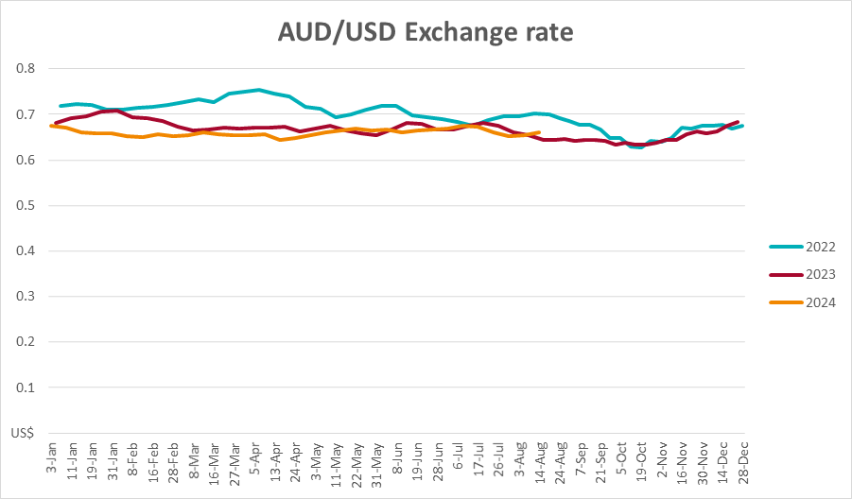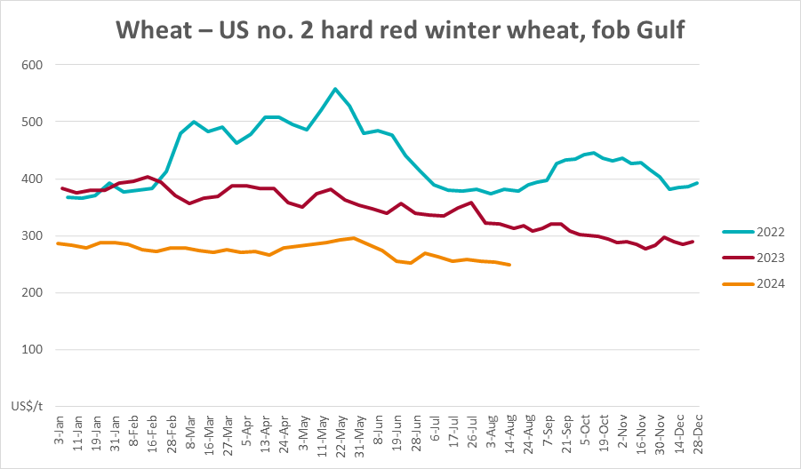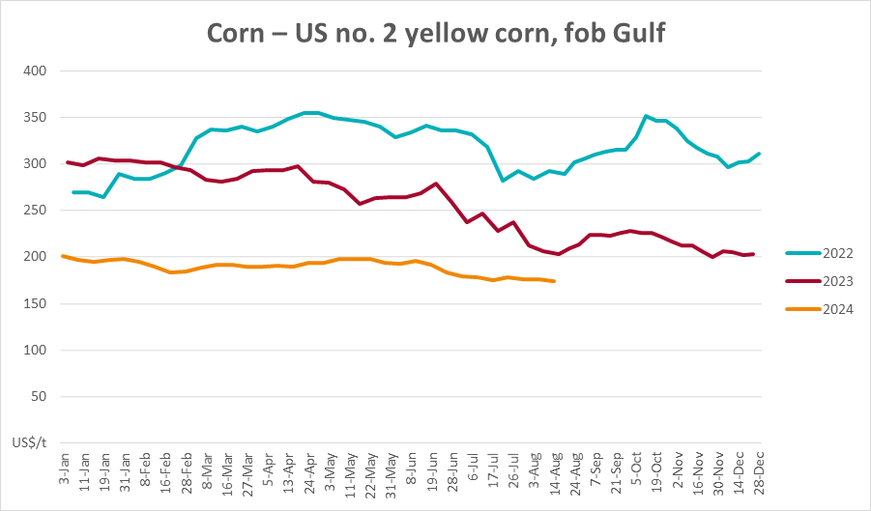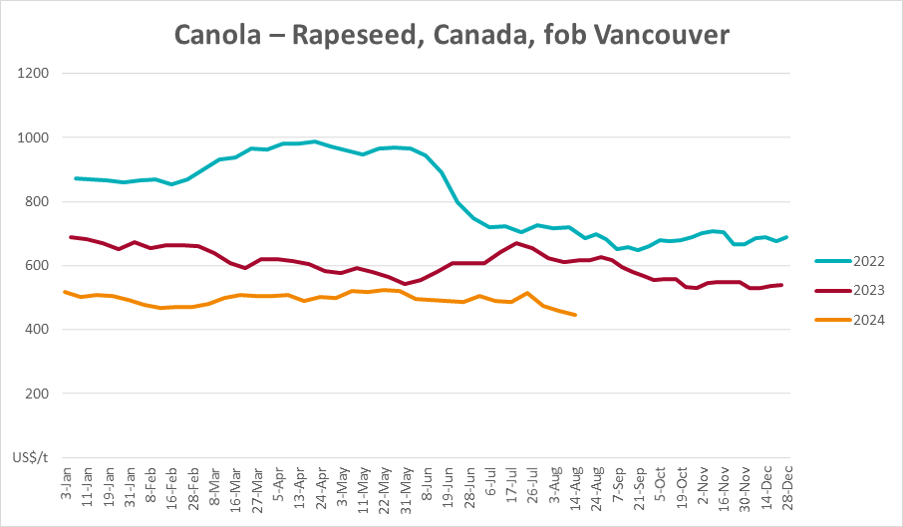

### 3.2 Selected domestic crop indicator prices

### Selected domestic livestock indicator prices

### Global Dairy Trade (GDT) weighted average prices

### Selected fruit and vegetable prices

### 3.6 Selected domestic fodder indicator prices

## **4. Data attribution**

### Climate

Bureau of Meteorology

* Weekly rainfall totals: www.bom.gov.au/climate/maps/rainfall/
* Monthly and last 3-month rainfall percentiles: [www.bom.gov.au/water/landscape/](http://www.bom.gov.au/water/landscape/)
* Temperature anomalies: [www.bom.gov.au/jsp/awap/temp/index.jsp](http://www.bom.gov.au/jsp/awap/temp/index.jsp)
* Rainfall forecast: [www.bom.gov.au/jsp/watl/rainfall/pme.jsp](http://www.bom.gov.au/jsp/watl/rainfall/pme.jsp)
* Seasonal outlook: [www.bom.gov.au/climate/outlooks/#/overview/summary/](http://www.bom.gov.au/climate/outlooks/#/overview/summary/)
* Climate drivers: <http://www.bom.gov.au/climate/enso/>
* Soil moisture: [www.bom.gov.au/water/landscape/](http://www.bom.gov.au/water/landscape/)

Other

* Pasture growth: [www.longpaddock.qld.gov.au/aussiegrass/](http://www.longpaddock.qld.gov.au/aussiegrass/)
* 3-month global outlooks: [Environment and Climate Change Canada](https://weather.gc.ca/saisons/image_e.html?img=s234pfe1p_cal&bc=prob), [NOAA Climate Prediction Center](https://www.cpc.ncep.noaa.gov/products/predictions/long_range/seasonal.php?lead=2), [EUROBRISA CPTEC/INPE](http://eurobrisa.cptec.inpe.br/), European Centre for Medium-Range Weather Forecasts, [Hydrometcenter of Russia](https://meteoinfo.ru/en/climate/seasonal-forecasts), [National Climate Center Climate System Diagnosis and Prediction Room (NCC)](https://cmdp.ncc-cma.net/pred/cs2gen.php?pred_elem=RAINP#pred_seasonal), [International Research Institute for Climate and Society](https://iri.columbia.edu/our-expertise/climate/forecasts/seasonal-climate-forecasts/)
* Global production: <https://ipad.fas.usda.gov/ogamaps/cropmapsandcalendars.aspx>
* Autumn break: Pook et al., 2009, <https://rmets-onlinelibrary-wiley-com.virtual.anu.edu.au/doi/epdf/10.1002/joc.1833>

### Water

Prices

* Waterflow: <https://www.waterflow.io/>
* Ruralco: <https://www.ruralcowater.com.au/>

Bureau of Meteorology:

* Allocation trade: <http://www.bom.gov.au/water/dashboards/#/water-markets/mdb/at>
* Storage volumes: <http://www.bom.gov.au/water/dashboards/#/water-storages/summary/drainage>

Trade constraints:

* Water NSW: <https://www.waternsw.com.au/customer-service/ordering-trading-and-pricing/trading/murrumbidgee>
* Victorian Water Register: <https://www.waterregister.vic.gov.au/TradingRules2019/>

### Commodities

Fruit and vegetables

* Datafresh: [www.freshstate.com.au](http://www.freshstate.com.au)

Pigs

* Australian Pork Limited: [www.australianpork.com.au](http://www.australianpork.com.au)

Dairy

* Global Dairy Trade: [www.globaldairytrade.info/en/product-results/](http://www.globaldairytrade.info/en/product-results/)

World wheat, canola

* International Grains Council

World coarse grains

* United States Department of Agriculture

World cotton

* Cotlook: [www.cotlook.com/](http://www.cotlook.com/)

World sugar

* New York Stock Exchange - Intercontinental Exchange

Wool

* Australian Wool Exchange: [www.awex.com.au/](http://www.awex.com.au/)

Domestic wheat, barley, sorghum, canola and fodder

* Jumbuk Consulting Pty Ltd: http://www.jumbukag.com.au/

Cattle, beef, mutton, lamb, goat and live export

* Meat and Livestock Australia: www.mla.com.au/Prices-and-market

© Commonwealth of Australia 2024

### Ownership of intellectual property rights

Unless otherwise noted, copyright (and any other intellectual property rights, if any) in this publication is owned by the Commonwealth of Australia (referred to as the Commonwealth).

### Creative Commons licence

All material in this publication is licensed under a [Creative Commons Attribution 4.0 International Licence](https://creativecommons.org/licenses/by/4.0/legalcode) except content supplied by third parties, logos and the Commonwealth Coat of Arms.

Inquiries about the licence and any use of this document should be emailed to [copyright@awe.gov.au](mailto:copyright@awe.gov.au).

https://www.agriculture.gov.au/sites/default/files/images/creative-commons-logo-small.png

### Cataloguing data

This publication (and any material sourced from it) should be attributed as:

ABARES 2023, Weekly Australian Climate, Water and Agricultural Update, Australian Bureau of Agricultural and Resource Economics and Sciences, Canberra, 15 August 2024. CC BY 4.0 DOI: <https://doi.org/10.25814/5f3e04e7d2503>

ISSN **2652-7561**

This publication is available at https://www.agriculture.gov.au/abares/products/weekly_update

Department of Agriculture, Fisheries and Forestry

GPO Box 858 Canberra ACT 2601

Telephone 1800 900 090

Web [agriculture.gov.au/abares](http://awe.gov.au/abares)

### Disclaimer

The Australian Government acting through the Department of Agriculture, Fisheries and Forestry, represented by the Australian Bureau of Agricultural and Resource Economics and Sciences, has exercised due care and skill in preparing and compiling the information and data in this publication. Notwithstanding, the Department of Agriculture, Fisheries and Forestry, ABARES, its employees and advisers disclaim all liability, including liability for negligence and for any loss, damage, injury, expense or cost incurred by any person as a result of accessing, using or relying on any of the information or data in this publication to the maximum extent permitted by law.

### Statement of Professional Independence

The views and analysis presented in ABARES publications, including this one, reflect ABARES professionally independent findings, based on scientific and economic concepts, principles, information and data. These views, analysis and findings may not reflect or be consistent with the views or positions of the Australian Government, or of organisations or groups who have commissioned ABARES reports or analysis. More information on [professional independence](https://www.agriculture.gov.au/abares/about/research-and-analysis#professional-independence) is provided on the ABARES website.

### Acknowledgements

This report was prepared by Kavina Dayal and Holly Beale.