## No. 27/2024 18 July 2024

# Summary of key issues

* In the week ending 17 July 2024, a trough triggered rainfall in New South Wales, while low pressure systems resulted in rainfall in Tasmania, Victoria, and southern parts of South Australia, and Western Australia.
  + Across cropping regions, rainfall totals of between 5 and 25 millimetres were recorded in central and southern New South Wales, Victoria, and South Australia. In Western Australia, rainfall totals of between 5 and 10 millimetres were recorded in scattered areas. Recent rainfall continues to benefit the build-up of soil moisture across south-eastern areas of the wheat/sheep zone.
* Over coming days, a high-pressure system will keep much of the northern half of the country dry. Low pressure systems in the south are forecast to generate up to 100 millimetres of rainfall.
  + Across cropping regions, little to no rainfall is expected in Queensland, much of New South Wales, northern Victoria and eastern South Australia. Meanwhile, parts of southern New South Wales and Victoria, and central and western South Australia are forecast to receive between 5 and 25 millimetres of rainfall. In Western Australia, between 25 and 50 millimetres of rainfall is forecast in the far-west, while eastern areas are expected to receive between 10 and 25 millimetres.
  + If realised, these rainfall totals are expected to continue supporting winter crop growth across much of southern Australia but dry conditions in Queensland and much of New South Wales will likely result in a decline in soil moisture.
* Globally, variable rainfall during June has led to mixed crop production prospects.
  + Global production conditions were generally favourable for rice and soybeans but variable for wheat and maize.
  + Global production conditions have slightly improved from those used to formulate ABARES forecasts of global grain supplies and world prices for 2024–25 in its June 2024 edition of the Agricultural Commodities Report. Global corn and rice production expectations remain unchanged, while increases in corn production in the United States is offsetting a slight decline in global wheat production.
* Water storage levels in the Murray-Darling Basin (MDB) increased between 11 July 2024 and 18 July 2024 by 88 gigalitres (GL). Current volume of water held in storage is 17 461 GL, equivalent to 78% of total storage capacity. This is 16% or 3,439 GL less than at the same time last year. Water storage data is sourced from the BOM.
* Allocation prices in the Victorian Murray below the Barmah Choke decreased from $134 on 11 July 2024 to $118 on 18 July 2024. Prices are lower in the Murrumbidgee due to the binding of the Murrumbidgee export limit. *Since start of financial year (when allocations are announced) there have been no trades in the NSW Murray Above Choke.

## **Climate**

### Rainfall this week

For the week ending 17 July 2024, a trough brought rainfall to New South Wales, while low pressure systems resulted in rainfall in Tasmania, Victoria and southern parts of South Australia. Rainfall totals up to 10 millimetres were also recorded in southern areas of Western Australia.

Across cropping regions, rainfall totals of between 5 and 25 millimetres were recorded in central and southern New South Wales, Victoria and South Australia. Rainfall totals of between 5 and 10 millimetres were recorded across scattered areas of Western Australia. Little to no rainfall were recorded in remaining cropping regions. Recent rainfall continues to benefit the build-up of soil moisture across south-eastern areas of the wheat/sheep zone.

#### Rainfall for the week ending 17 July 2024

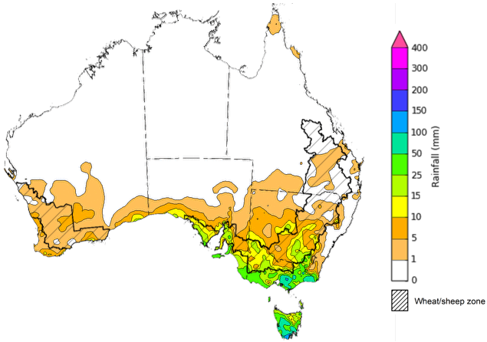

©Commonwealth of Australia 2024, Australian Bureau of Meteorology Issued: 17/07/2024

Note: The rainfall analyses and associated maps utilise data contained in the Bureau of Meteorology climate database, the Australian Data Archive for Meteorology (ADAM). The analyses are initially produced automatically from real-time data with limited [quality control](http://www.bom.gov.au/climate/headers/qc.shtml). They are intended to provide a general overview of rainfall across Australia as quickly as possible after the observations are received. For further information go to <http://www.bom.gov.au/climate/rainfall/>

### Rainfall forecast for the next eight days

Over the 8 days to 25 July, a high-pressure system is expected to keep much of the northern half of the country dry. Low-pressure systems in the south-west and south-east are expected to bring a maximum of 100 millimetres of rainfall across western Tasmania and isolated areas of Western Australia and Victoria. A maximum of 50 millimetres of rainfall is forecast for parts of southern New South Wales, and South Australia.

Across cropping regions, little to no rainfall is expected across Queensland, much of New South Wales, northern Victoria and eastern South Australia. Meanwhile parts of southern New South Wales and Victoria, and central and South Australia are forecast to receive between 5 and 25 millimetres of rainfall. In Western Australia, between 25 and 50 millimetres of rainfall is forecast in the far-west, while eastern areas are expected to receive between 10 and 25 millimetres. If realised, these rainfall totals are expected to continue supporting winter crop growth across much of southern Australia but dry conditions in Queensland and much of New South Wales will likely result in a decline in soil moisture in those states.

#### Total forecast rainfall for the period 18 July to 25 July 2024

©Commonwealth of Australia 2024, Australian Bureau of Meteorology Issued 18/07/2024

Note: This rainfall forecast is produced from computer models. As the model outputs are not altered by weather forecasters, it is important to check local forecasts and warnings issued by the Bureau of Meteorology.

### Global production conditions and climate outlook

Crop production is affected by long-term trends in average rainfall and temperature, interannual climate variability, shocks during specific growth stages, and extreme weather events. Some crops are more tolerant than others to certain types of stresses, and at each growth stage, different types of stresses affect each crop species in different ways.

The precipitation anomalies and outlooks presented here give an indication of the current and future state of production conditions for the major grain and oilseed producing countries which are responsible for over 80% of global production. This is an important input to assessing the global grain supply outlook.

**June precipitation percentiles and current production conditions**

As of the end of June 2024, rainfall was variable for the world’s major grain- and oilseed-producing nations.

In the southern hemisphere, precipitation was below average across large parts of western and central Brazil, central Argentina, and much of southeast Australia. Meanwhile, parts of southern Brazil and Argentina, and Western Australia experienced above average rainfall. Rainfall was generally average in the remaining grain- and oilseed-producing regions in the southern hemisphere.

In the northern hemisphere, precipitation was generally below average in the eastern parts of India and China, north-western USA and isolated areas of southern Canada. Precipitation was average to above average in the remaining grain- and oilseed-producing regions in the northern hemisphere.

**Global precipitation percentiles, June 2024**

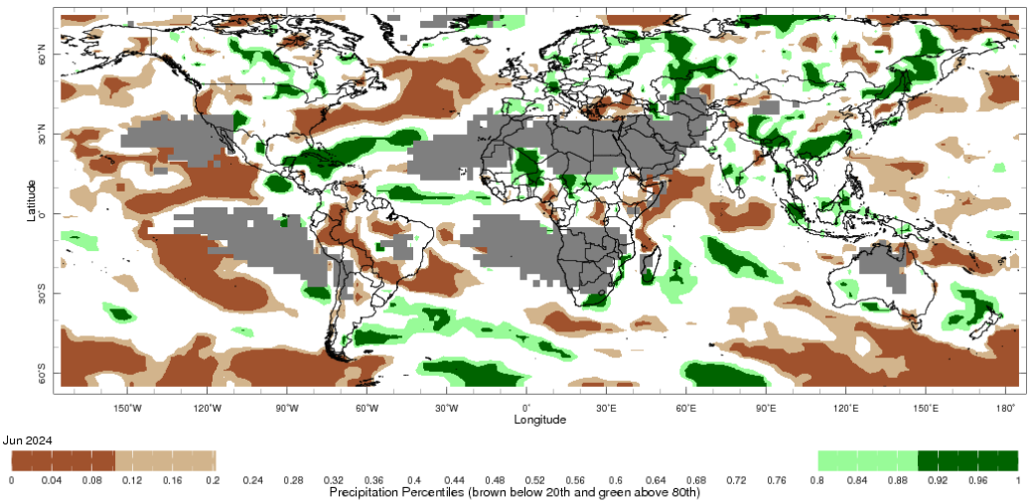

Note: The world precipitation percentiles indicate a ranking of precipitation for June, with the driest (0th percentile) being 0 on the scale and the wettest (100th percentile) being 1 on the scale. Percentiles are based on precipitation estimates from the NOAA Climate Prediction Center’s [Climate Anomaly Monitoring System Outgoing Precipitation Index](https://iridl.ldeo.columbia.edu/maproom/Global/Precipitation/Percentiles.html) dataset. Precipitation estimates for June 2024 are compared with rainfall recorded for that period during the 1981 to 2010 base period.

Source: International Research Institute for Climate and Society

As of 28 June 2024, global production conditions were generally favourable for rice and soybeans but variable for wheat and maize:

* **Wheat –** in the northern hemisphere the winter wheat harvest is progressing with areas of concern in parts of Europe, the Russian Federation, and Ukraine. In the southern hemisphere, sowing continues in Argentina, while crops develop under generally favourable condition in Australia.
* **Maize –** in the southern hemisphere, the harvest is progressing under mixed conditions. In the northern hemisphere, there are areas of concern in Mexico, the North China Plain, Romania, and Ukraine due to hot and dry conditions.
* **Rice –** conditions are generally favourable, albeit with some dry conditions in parts of China, southern Vietnam, and the Philippines.
* **Soybeans –** in the northern hemisphere, sowing is nearing completion under favourable conditions except near the conflict areas in Ukraine.

**Crop conditions, AMIS countries, 28 June 2024**

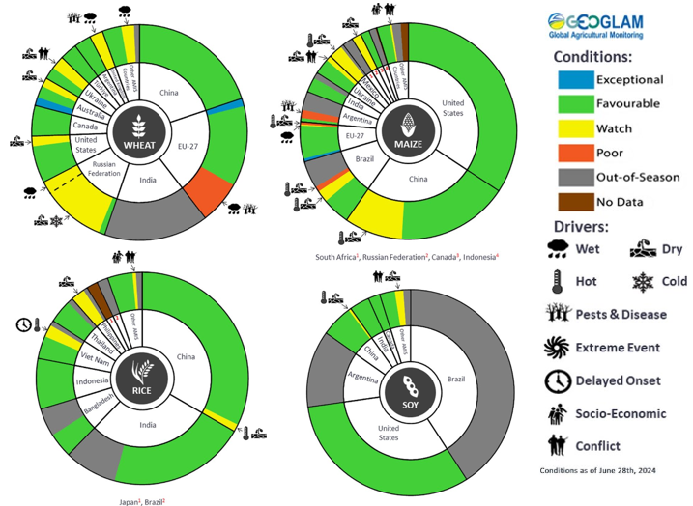

**AMIS** Agricultural Market Information System.

Source: AMIS

The global climate outlook for August 2024 to October 2024 indicates that mixed rainfall conditions are expected for the world’s major grain-producing and oilseed-producing regions. Outlooks and potential production impacts for the major grain and oilseed producing countries are presented in this table.

**Rainfall outlook and potential impact on the future state of production conditions between** **August 2024 to October 2024**

|  |  |  |
| --- | --- | --- |
| **Region** | **August-October rainfall outlook** | **Potential impact on production** |
| **Argentina** | Below average rainfall is more likely across much of Argentina. | Below average rainfall is likely to adversely affect the heading and grain fill of wheat and planting of corn, cotton and soybeans through September and October. |
| **Black Sea Region** | Generally, below average rainfall is expected in Türkiye and the south-west of the Russian Federation. Above average rainfall is expected in southern Ukraine. | Below average rainfall between August and October is likely to negatively affect grain fill for spring wheat but support uninterrupted harvest in the north of the Black Sea Region. In the south of the Black Sea Region, below average rainfall is likely to have negative impacts on cotton, corn and sunflower development and winter wheat and rapeseed harvesting and planting. |
| **Brazil** | Below average rainfall is more likely across northern and southern parts of Brazil. Above average rainfall in more like in central Brazil. | Below average rainfall in southern Brazil is likely to negatively affect wheat heading, and grain fill in August and September leading up to harvest in October. Below average rainfall elsewhere is likely to adversely affect corn and soybean planting and development in September and October. |
| **Canada** | Generally, average rainfall is likely across much of Canada. Below average rainfall is likely in some southern regions. | Average rainfall is likely to benefit corn, soybeans and sunflower flowering in August and support grain development through September and October. |
| **China** | Average to above average rainfall is more likely across much of China, while below average rainfall is more likely in the southwestern regions. | Average to above average rainfall is likely to support the development and harvest of cotton, rice, corn, sorghum, soybean, sunflower, groundnuts, and spring wheat. Additionally, average to above average rainfall is likely to support late rice heading in September and planting of winter wheat and rapeseed in October. |
| **Europe** | Average rainfall is more likely for much of central Europe between August and October 2024. Below average rainfall is likely in the west. | Average rainfall may be sufficient to support yield prospects of corn, cotton and sorghum in northern Europe. Below average rainfall may also impact winter wheat and rapeseed planting in parts of western Europe during October. |
| **South Asia (India)** | Above average rainfall is more likely across much of India. | Above average rainfall is likely to benefit corn, sorghum, rice, millet, groundnuts, and sunflower flowering and filling in August and September leading up to harvest in October, and cotton blooming in the south in September. |
| **Southeast Asia (SEA)** | Average to above average rainfall is likely across Indonesia and southern Malaysia. Average rainfall is likely in Thailand. | Average to above average rainfall between August and October is likely to support corn and rice filling and maturing in SEA leading up to harvest in October. |
| **The United States of America (US)** | Generally, below average rainfall is likely for much of central and southern US, with average rainfall more likely elsewhere. | Across the east of the US average rainfall is likely to benefit soybeans, sunflower and millet flowering in August and the development of these crops as well as rice, corn, sorghum and groundnuts leading up to harvest in October. Below average rainfall likely to affect the yield prospects of corn, spring wheat and soybeans in central and southern US. |

## **Water**

### Water markets – current week

Water storage levels in the Murray-Darling Basin (MDB) increased between 11 July 2024 and 18 July 2024 by 88 gigalitres (GL). Current volume of water held in storage is 17 461 GL, equivalent to 78% of total storage capacity. This is 16% or 3,439 GL less than at the same time last year. Water storage data is sourced from the BOM.

#### Water storages in the Murray-Darling Basin, 2013–2024

|  |
| --- |
| Water storage data is sourced from the Bureau of Meteorology. |

Allocation prices in the Victorian Murray below the Barmah Choke decreased from $134 on 11 July 2024 to $118 on 18 July 2024. Prices are lower in the Murrumbidgee due to the binding of the Murrumbidgee export limit. *Since start of financial year (when allocations are announced) there have been no trades in the NSW Murray Above Choke.

|  |  |
| --- | --- |
| **Region** | **$/ML** |
| NSW Murray Above | NA |
| NSW Murrumbidgee | 104 |
| VIC Goulburn-Broken | 94 |
| VIC Murray Below | 118 |

#### Surface water trade activity, Southern Murray–Darling Basin

|  |
| --- |
| The trades shown reflect estimated market activity and do not encompass all register trades. The price is shown for the VIC Murray below the Barmah choke. Historical prices (before 1 July 2019) are ABARES estimates after removing outliers from BOM water register data. Prices after 1 July 2019 and prior to the 30 October 2019 reflect recorded transaction prices as sourced from Ruralco. Prices after the 30 October 2019 are sourced from Waterflow. Data for volume traded is sourced from the BOM water register. Only the price data shown is current on 18 July 2024. |

To access the full, interactive, weekly water dashboard, which contains the latest and historical water storage, water market and water allocation information, please visit <https://www.agriculture.gov.au/abares/products/weekly_update/weekly-update-18724>

## **Commodities**

|  |  |  |  |  |  |  |  |
| --- | --- | --- | --- | --- | --- | --- | --- |
| **Indicator** | **Week average** | **Unit** | **Latest Price** | **Previous Week** | **Weekly change** | **Price 12 months ago** | **Annual change** |
| **Selected world indicator prices** |  |  |  |  |  |  |  |
| AUD/USD Exchange rate | 17-Jul | A$/US$ | 0.67 | 0.68 | 0% | 0.67 | 0% |
| Wheat – US no. 2 hard red winter wheat, fob Gulf | 17-Jul | US$/t | 253 | 262 | -4% | 358 | -29% |
| Corn – US no. 2 yellow corn, fob Gulf | 17-Jul | US$/t | 175 | 178 | -1% | 237 | -26% |
| Canola – Rapeseed, Canada, fob Vancouver | 17-Jul | US$/t | 481 | 489 | -2% | 655 | -27% |
| Cotton – Cotlook 'A' Index | 17-Jul | USc/lb | 82 | 82 | 1% | 96 | -15% |
| Sugar – Intercontinental Exchange, nearby futures, no.11 contract | 17-Jul | USc/lb | 19.7 | 19.8 | 0% | 25 | -20% |
| Wool – Eastern Market Indicator | 17-Jul | Ac/kg clean | 1,107 | 1,017 | 9% | 1,214 | -9% |
| Wool – Western Market Indicator | 10-Jul | Ac/kg clean | 1,247 | 1,262 | -1% | 1,442 | -14% |
| **Selected Australian grain export prices** |  |  |  |  |  |  |  |
| Milling Wheat – APW, Port Adelaide, SA | 17-Jul | A$/t | 411 | 428 | -4% | 466 | -12% |
| Feed Wheat – ASW, Port Adelaide, SA | 17-Jul | A$/t | 402 | 419 | -4% | 445 | -10% |
| Feed Barley – Port Adelaide, SA | 17-Jul | A$/t | 360 | 364 | -1% | 354 | 2% |
| Canola – Kwinana, WA | 17-Jul | A$/t | 744 | 765 | -3% | 852 | -13% |
| Grain Sorghum – Brisbane, QLD | 17-Jul | A$/t | 411 | 410 | 0% | 483 | -15% |
| **Selected domestic livestock indicator prices** |  |  |  |  |  |  |  |
| Beef – Eastern Young Cattle Indicator | 17-Jul | Ac/kg cwt | 630 | 615 | 2% | 572 | 10% |
| Mutton – Mutton indicator (18–24 kg fat score 2–3), Vic | 17-Jul | Ac/kg cwt | 496 | 450 | 10% | 290 | 71% |
| Lamb – National Trade Lamb Indicator | 17-Jul | Ac/kg cwt | 850 | 811 | 5% | 499 | 71% |
| Pig – Eastern Seaboard (60.1–75 kg), average of buyers & sellers | 26-Jun | Ac/kg cwt | 407 | 407 | 0% | 357 | 14% |
| Live cattle – Light steers to Indonesia | 17-Jul | Ac/kg lwt | 300 | 300 | 0% | 310 | -3% |
| **Global Dairy Trade (GDT) weighted average prices a** |  |  |  |  |  |  |  |
| Dairy – Whole milk powder | 17-Jul | US$/t | 3,142 | 3,218 | -2% | 3,149 | 0% |
| Dairy – Skim milk powder | 17-Jul | US$/t | 2,566 | 2,586 | -1% | 2,525 | 2% |
| Dairy – Cheddar cheese | 17-Jul | US$/t | 4,217 | 3,980 | 6% | 4,386 | -4% |
| Dairy – Anhydrous milk fat | 17-Jul | US$/t | 6,764 | 6,517 | 4% | 4,579 | 48% |
| **Selected world indicator prices** |  |  |  |  |  |  |  |
| **a** Global Dairy Trade prices are updated twice monthly on the first and third Tuesday of each month. | | | | | | | |

### Selected world indicator prices

### Selected domestic crop indicator prices

### Selected domestic livestock indicator prices

### Global Dairy Trade (GDT) weighted average prices

### Selected fruit and vegetable prices

### 3.6 Selected domestic fodder indicator prices

## **4. Data attribution**

### Climate

Bureau of Meteorology

* Weekly rainfall totals: www.bom.gov.au/climate/maps/rainfall/
* Monthly and last 3-month rainfall percentiles: [www.bom.gov.au/water/landscape/](http://www.bom.gov.au/water/landscape/)
* Temperature anomalies: [www.bom.gov.au/jsp/awap/temp/index.jsp](http://www.bom.gov.au/jsp/awap/temp/index.jsp)
* Rainfall forecast: [www.bom.gov.au/jsp/watl/rainfall/pme.jsp](http://www.bom.gov.au/jsp/watl/rainfall/pme.jsp)
* Seasonal outlook: [www.bom.gov.au/climate/outlooks/#/overview/summary/](http://www.bom.gov.au/climate/outlooks/#/overview/summary/)
* Climate drivers: <http://www.bom.gov.au/climate/enso/>
* Soil moisture: [www.bom.gov.au/water/landscape/](http://www.bom.gov.au/water/landscape/)

Other

* Pasture growth: [www.longpaddock.qld.gov.au/aussiegrass/](http://www.longpaddock.qld.gov.au/aussiegrass/)
* 3-month global outlooks: [Environment and Climate Change Canada](https://weather.gc.ca/saisons/image_e.html?img=s234pfe1p_cal&bc=prob), [NOAA Climate Prediction Center](https://www.cpc.ncep.noaa.gov/products/predictions/long_range/seasonal.php?lead=2), [EUROBRISA CPTEC/INPE](http://eurobrisa.cptec.inpe.br/), European Centre for Medium-Range Weather Forecasts, [Hydrometcenter of Russia](https://meteoinfo.ru/en/climate/seasonal-forecasts), [National Climate Center Climate System Diagnosis and Prediction Room (NCC)](https://cmdp.ncc-cma.net/pred/cs2gen.php?pred_elem=RAINP#pred_seasonal), [International Research Institute for Climate and Society](https://iri.columbia.edu/our-expertise/climate/forecasts/seasonal-climate-forecasts/)
* Global production: <https://ipad.fas.usda.gov/ogamaps/cropmapsandcalendars.aspx>
* Autumn break: Pook et al., 2009, <https://rmets-onlinelibrary-wiley-com.virtual.anu.edu.au/doi/epdf/10.1002/joc.1833>

### Water

Prices

* Waterflow: <https://www.waterflow.io/>
* Ruralco: <https://www.ruralcowater.com.au/>

Bureau of Meteorology:

* Allocation trade: <http://www.bom.gov.au/water/dashboards/#/water-markets/mdb/at>
* Storage volumes: <http://www.bom.gov.au/water/dashboards/#/water-storages/summary/drainage>

Trade constraints:

* Water NSW: <https://www.waternsw.com.au/customer-service/ordering-trading-and-pricing/trading/murrumbidgee>
* Victorian Water Register: <https://www.waterregister.vic.gov.au/TradingRules2019/>

### Commodities

Fruit and vegetables

* Datafresh: [www.freshstate.com.au](http://www.freshstate.com.au)

Pigs

* Australian Pork Limited: [www.australianpork.com.au](http://www.australianpork.com.au)

Dairy

* Global Dairy Trade: [www.globaldairytrade.info/en/product-results/](http://www.globaldairytrade.info/en/product-results/)

World wheat, canola

* International Grains Council

World coarse grains

* United States Department of Agriculture

World cotton

* Cotlook: [www.cotlook.com/](http://www.cotlook.com/)

World sugar

* New York Stock Exchange - Intercontinental Exchange

Wool

* Australian Wool Exchange: [www.awex.com.au/](http://www.awex.com.au/)

Domestic wheat, barley, sorghum, canola and fodder

* Jumbuk Consulting Pty Ltd: http://www.jumbukag.com.au/

Cattle, beef, mutton, lamb, goat and live export

* Meat and Livestock Australia: www.mla.com.au/Prices-and-market

© Commonwealth of Australia 2024

### Ownership of intellectual property rights

Unless otherwise noted, copyright (and any other intellectual property rights, if any) in this publication is owned by the Commonwealth of Australia (referred to as the Commonwealth).

### Creative Commons licence

All material in this publication is licensed under a [Creative Commons Attribution 4.0 International Licence](https://creativecommons.org/licenses/by/4.0/legalcode) except content supplied by third parties, logos and the Commonwealth Coat of Arms.

Inquiries about the licence and any use of this document should be emailed to [copyright@awe.gov.au](mailto:copyright@awe.gov.au).

https://www.agriculture.gov.au/sites/default/files/images/creative-commons-logo-small.png

### Cataloguing data

This publication (and any material sourced from it) should be attributed as:

ABARES 2023, Weekly Australian Climate, Water and Agricultural Update, Australian Bureau of Agricultural and Resource Economics and Sciences, Canberra, 18 July 2024. CC BY 4.0 DOI: <https://doi.org/10.25814/5f3e04e7d2503>

ISSN **2652-7561**

This publication is available at https://www.agriculture.gov.au/abares/products/weekly_update

Department of Agriculture, Fisheries and Forestry

GPO Box 858 Canberra ACT 2601

Telephone 1800 900 090

Web [agriculture.gov.au/abares](http://awe.gov.au/abares)

### Disclaimer

The Australian Government acting through the Department of Agriculture, Fisheries and Forestry, represented by the Australian Bureau of Agricultural and Resource Economics and Sciences, has exercised due care and skill in preparing and compiling the information and data in this publication. Notwithstanding, the Department of Agriculture, Fisheries and Forestry, ABARES, its employees and advisers disclaim all liability, including liability for negligence and for any loss, damage, injury, expense or cost incurred by any person as a result of accessing, using or relying on any of the information or data in this publication to the maximum extent permitted by law.

### Statement of Professional Independence

The views and analysis presented in ABARES publications, including this one, reflect ABARES professionally independent findings, based on scientific and economic concepts, principles, information and data. These views, analysis and findings may not reflect or be consistent with the views or positions of the Australian Government, or of organisations or groups who have commissioned ABARES reports or analysis. More information on [professional independence](https://www.agriculture.gov.au/abares/about/research-and-analysis#professional-independence) is provided on the ABARES website.

### Acknowledgements

This report was prepared by Kavina Dayal and Holly Beale.