## No. 24/2024 27 June 2024

# Summary of key issues

* In the week ending 26 June 2024, a high-pressure system kept majority of the country largely dry. Isolated areas of rainfall were recorded across parts of the west, south and northeast.
  + Across cropping regions, rainfall was limited, with falls of between 5 and 25 millimetres in scattered areas of Western Australia and northern Queensland. Meanwhile, falls of between 10 and 15 millimetres were recorded in South Australian and western Victoria. Remaining areas recorded little to no rainfall. Where received, this rainfall is expected to support the establishment and growth of winter crops.
* Over coming days, rainfall is forecast for much of southern two-thirds of Australia, associated with a low-pressure system and cold fronts to the west and south, and onshore flow from high-pressure system to the east.
  + Across cropping regions, rainfall is expected across all states with totals of between 5 and 25 millimetres forecast for much of New South Wales, Queensland and Western Australia. Meanwhile, lighter falls of between 1 and 10 millimetres are forecast for cropping regions in southern New South Wales, Victoria and South Australia.
  + If realised, this forecast is expected to support the winter crop development across most growing regions.
* The national rainfall outlook for July to September is for above median rainfall more likely across interior areas of the country and scattered areas of coastal New South Wales.
  + Across most cropping regions, the probability of exceeding median rainfall is between 45% and 70%. However, parts of northern Western Australia are showing an increased likelihood of experiencing below median rainfall. The outlook shows at least a 75% chance of receiving between 50 and 200 millimetres of rainfall across much of New South Wales, Victoria, South Australia and Western Australia. In Queensland, falls of between 25 and 100 millimetres are expected, with drier conditions forecast for far north.
  + If realised, these expected rainfall totals will likely be sufficient to support growth and establishment of winter crops. Expected rainfall is also expected to boost soil moisture profile and assist in maintaining above average forecast winter crops yields.
* Water storage levels in the Murray-Darling Basin (MDB) increased between 20 June 2024 and 27 June 2024 by 76 gigalitres (GL). Current volume of water held in storage is 17 299 GL, equivalent to 78% of total storage capacity. This is 15 percent or 3,506 GL less than at the same time last year. Water storage data is sourced from the BOM.
* Allocation prices in the Victorian Murray below the Barmah Choke increased from $29 on 20 June 2024 to $43 on 27 June 2024. Prices are lower in the Murrumbidgee due to the binding of the Murrumbidgee export limit.

## **Climate**

### Rainfall this week

For the week ending 26 June 2024, a high-pressure system kept the majority of the country largely dry. Isolated areas of rainfall were recorded across parts of west, south and northeast Australia. A front brought rainfall totals of up to 25 millimetres on the South Australian coast and Tasmania, and up to 15 millimetres in isolated areas of Victoria. A series of low-pressure trough brought up to 50 millimetres of rainfall to north-eastern Queensland, while a trough brought isolated showers of up to 25 millimetres in Western Australia.

Across cropping regions, rainfall was limited, with falls of between 5 and 25 millimetres in scattered areas of Western Australia and northern Queensland. Meanwhile, falls of between 10 and 15 millimetres were recorded in South Australian and western Victoria. Remaining areas recorded little to no rainfall.

#### Rainfall for the week ending 26 June 2024

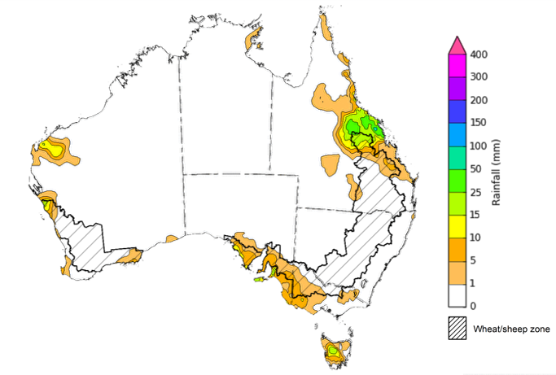

©Commonwealth of Australia 2024, Australian Bureau of Meteorology Issued: 26/06/2024

Note: The rainfall analyses and associated maps utilise data contained in the Bureau of Meteorology climate database, the Australian Data Archive for Meteorology (ADAM). The analyses are initially produced automatically from real-time data with limited [quality control](http://www.bom.gov.au/climate/headers/qc.shtml). They are intended to provide a general overview of rainfall across Australia as quickly as possible after the observations are received. For further information go to <http://www.bom.gov.au/climate/rainfall/>

### Rainfall forecast for the next eight days

Over the 8 days to 4 July 2024, rainfall is forecast for much of southern two-thirds of Australia, associated with low pressure system and cold fronts to the west and south, and onshore flow from high-pressure system to the east.

Across cropping regions, rainfall is expected across all states with totals of between 5 and 25 millimetres forecast for much of New South Wales, Queensland and Western Australia. Meanwhile, lighter falls of between 1 and 10 millimetres are forecast for cropping regions in southern New South Wales, Victoria and South Australia. If realised, this forecast is expected to support the winter crop development across most growing regions.

#### Total forecast rainfall for the period 27 June to 4 July 2024

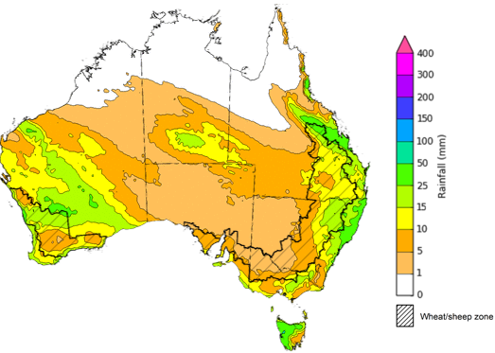

©Commonwealth of Australia 2024, Australian Bureau of Meteorology Issued 27/06/2024

Note: This rainfall forecast is produced from computer models. As the model outputs are not altered by weather forecasters, it is important to check local forecasts and warnings issued by the Bureau of Meteorology.

### National Climate Outlook

The most recent rainfall outlook for July 2024 provided by the Bureau of Meteorology indicates an increased likelihood of above median rainfall across parts of western, central and coastal eastern Australia. There is an increased likelihood of below median rainfall across parts of southern Victoria, as well as parts of South Australia and Western Australia, as well as Tasmania and northern Australia.

According to Bureau of Meteorology’s climate model, for July 2024 there is a 75% probability of rainfall totals between 10 and 100 millimetres across much of central and eastern New South Wales, Victoria, southern South Australia, the southwest of Western Australia, and Tasmania. Alpine areas in Victoria, the far west Western Australia and Tasmania will likely receive rainfall of up to 200 millimetres. The north of the country is expected to remain largely dry, typical of this time of year, with exceptions in parts of the tropical northeast Queensland where up to 100 millimetres of rainfall is expected.

Across cropping regions, there is a 75% chance of receiving between 10 and 50 millimetres of rainfall in New South Wales, Victoria, South Australia and Western Australia. In Queensland, rainfall totals of between 5 and 25 millimetres are expected across southern growing regions, while little to no rainfall is forecast for northern growing regions. If realised, this rainfall is likely to be sufficient to support growth of winter crops across most cropping regions. Meanwhile, for Queensland cropping areas, crop growth is expected to be supported by a drawdown of stored soil moisture.

**Rainfall totals that have a 75% chance of occurring in July 2024**

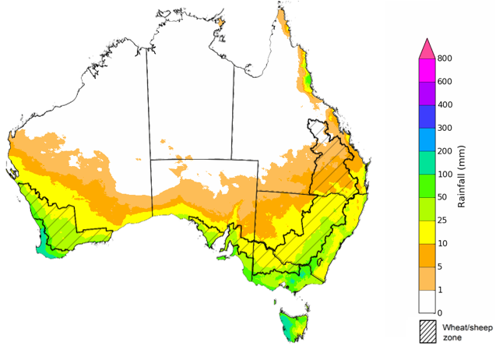

©Commonwealth of Australia 2024, Australian Bureau of Meteorology Issued: 27/06/2024

The El Niño Southern Oscillation (ENSO) and Indian Ocean Dipole (IOD) climate drivers are currently neutral and having minimal influence on Australian rainfall.

The rainfall outlook for July through September 2024 indicates that above median rainfall is more likely across interior areas of the country and scattered areas of coastal New South Wales. Conversely, parts northern and southern Australia are expected to receive below median rainfall, with the probability of receiving median rainfall falling below 40% in isolated areas of parts of southern South Australia, Victoria, southwest Westen Australia, and across the northern tropic and Tasmania.

Across cropping regions, the probability of exceeding median rainfall is between 45% and 70% in across most growing regions. However, isolated northern parts of Western Australia’s cropping zone are showing an increased likelihood of experiencing below median rainfall.

**Chance of exceeding the median rainfall** **July to September 2024**

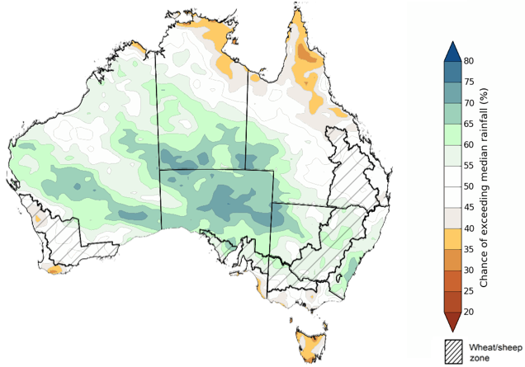

©Commonwealth of Australia 2024, Australian Bureau of Meteorology Issued: 27/06/2024

The outlook for July through September 2024 suggests a 75% chance of rainfall totals of between 25 to 200 millimetres likely across southern parts of the country, with heavier falls of up to 600 millimetres forecast for isolated areas of far southwest Western Australia, alpine regions of Victoria and New South Wales, and western Tasmania. In Queensland, falls of between 25 and 100 millimetres are expected in the southeast and parts of the northeast. Much of the remainder of the country is expected to receive little to no rainfall, consistent with these regions entering their dry season.

In cropping regions, there is at least a 75% chance of receiving between 50 and 200 millimetres of rainfall across much of New South Wales, Victoria, South Australia and Western Australia. In Queensland, falls of between 25 and 100 millimetres are expected, with drier conditions forecast for far northern cropping regions.

Expected rainfall is likely to be sufficient to support growth of winter crops and also expected to boost soil moisture profile and assist in maintaining above average forecast winter crops yields.

Livestock producers, especially those in the south, are expected to experience close to average pasture production on the back of the improving rainfall outlook over the July to September period.

**Rainfall totals that have a 75% chance of occurring** **July to September 2024**

©Commonwealth of Australia 2024, Australian Bureau of Meteorology Issued: 27/06/2024

## **Water**

### Water markets – current week

Water storage levels in the Murray-Darling Basin (MDB) increased between 20 June 2024 and 27 June 2024 by 76 gigalitres (GL). Current volume of water held in storage is 17 299 GL, equivalent to 78% of total storage capacity. This is 15 percent or 3,506 GL less than at the same time last year. Water storage data is sourced from the BOM.

#### Water storages in the Murray-Darling Basin, 2013–2024

|  |
| --- |
| Water storage data is sourced from the Bureau of Meteorology. |

Allocation prices in the Victorian Murray below the Barmah Choke increased from $29 on 20 June 2024 to $43 on 27 June 2024. Prices are lower in the Murrumbidgee due to the binding of the Murrumbidgee export limit.

|  |  |
| --- | --- |
| **Region** | **$/ML** |
| NSW Murray Above | 15 |
| NSW Murrumbidgee | 5 |
| VIC Goulburn-Broken | 31 |
| VIC Murray Below | 43 |

#### Surface water trade activity, Southern Murray–Darling Basin

|  |
| --- |
| The trades shown reflect estimated market activity and do not encompass all register trades. The price is shown for the VIC Murray below the Barmah choke. Historical prices (before 1 July 2019) are ABARES estimates after removing outliers from BOM water register data. Prices after 1 July 2019 and prior to the 30 October 2019 reflect recorded transaction prices as sourced from Ruralco. Prices after the 30 October 2019 are sourced from Waterflow. Data for volume traded is sourced from the BOM water register. Only the price data shown is current on 27 June 2024. |

To access the full, interactive, weekly water dashboard, which contains the latest and historical water storage, water market and water allocation information, please visit <https://www.agriculture.gov.au/abares/products/weekly_update/weekly-update-27624>

## **Commodities**

|  |  |  |  |  |  |  |  |
| --- | --- | --- | --- | --- | --- | --- | --- |
| **Indicator** | **Week average** | **Unit** | **Latest Price** | **Previous Week** | **Weekly change** | **Price 12 months ago** | **Annual change** |
| **Selected world indicator prices** |  |  |  |  |  |  |  |
| AUD/USD Exchange rate | 26-Jun | A$/US$ | 0.67 | 0.66 | 0% | 0.67 | 0% |
| Wheat – US no. 2 hard red winter wheat, fob Gulf | 26-Jun | US$/t | 249 | 257 | -3% | 337 | -26% |
| Corn – US no. 2 yellow corn, fob Gulf | 26-Jun | US$/t | 187 | 194 | -4% | 238 | -21% |
| Canola – Rapeseed, Canada, fob Vancouver | 26-Jun | US$/t | 482 | 489 | -2% | 606 | -21% |
| Cotton – Cotlook 'A' Index | 26-Jun | USc/lb | 83 | 82 | 1% | 92 | -10% |
| Sugar – Intercontinental Exchange, nearby futures, no.11 contract | 26-Jun | USc/lb | 19.6 | 19.0 | 3% | 23 | -16% |
| Wool – Eastern Market Indicator | 26-Jun | Ac/kg clean | 1,142 | 1,160 | -2% | 1,310 | -13% |
| Wool – Western Market Indicator | 26-Jun | Ac/kg clean | 1,281 | 1,269 | 1% | 1,480 | -13% |
| **Selected Australian grain export prices** |  |  |  |  |  |  |  |
| Milling Wheat – APW, Port Adelaide, SA | 26-Jun | A$/t | 442 | 446 | -1% | 441 | 0% |
| Feed Wheat – ASW, Port Adelaide, SA | 26-Jun | A$/t | 433 | 437 | -1% | 419 | 3% |
| Feed Barley – Port Adelaide, SA | 26-Jun | A$/t | 374 | 380 | -2% | 342 | 9% |
| Canola – Kwinana, WA | 26-Jun | A$/t | 746 | 753 | -1% | 812 | -8% |
| Grain Sorghum – Brisbane, QLD | 26-Jun | A$/t | 432 | 439 | -2% | 474 | -9% |
| **Selected domestic livestock indicator prices** |  |  |  |  |  |  |  |
| Beef – Eastern Young Cattle Indicator | 26-Jun | Ac/kg cwt | 584 | 595 | -2% | 561 | 4% |
| Mutton – Mutton indicator (18–24 kg fat score 2–3), Vic | 26-Jun | Ac/kg cwt | 351 | 406 | -14% | 297 | 18% |
| Lamb – National Trade Lamb Indicator | 26-Jun | Ac/kg cwt | 725 | 716 | 1% | 538 | 35% |
| Pig – Eastern Seaboard (60.1–75 kg), average of buyers & sellers | 26-Jun | Ac/kg cwt | 407 | 407 | 0% | 357 | 14% |
| Live cattle – Light steers to Indonesia | 26-Jun | Ac/kg lwt | 300 | 300 | 0% | 330 | -9% |
| **Global Dairy Trade (GDT) weighted average prices a** |  |  |  |  |  |  |  |
| Dairy – Whole milk powder | 19-Jun | US$/t | 3,394 | 3,478 | -2% | 3,173 | 7% |
| Dairy – Skim milk powder | 19-Jun | US$/t | 2,766 | 2,722 | 2% | 2,755 | 0% |
| Dairy – Cheddar cheese | 19-Jun | US$/t | 4,205 | 4,248 | -1% | 4,668 | -10% |
| Dairy – Anhydrous milk fat | 19-Jun | US$/t | 7,317 | 7,417 | -1% | 4,728 | 55% |
| **Selected world indicator prices** |  |  |  |  |  |  |  |
| **a** Global Dairy Trade prices are updated twice monthly on the first and third Tuesday of each month. | | | | | | | |

### Selected world indicator prices

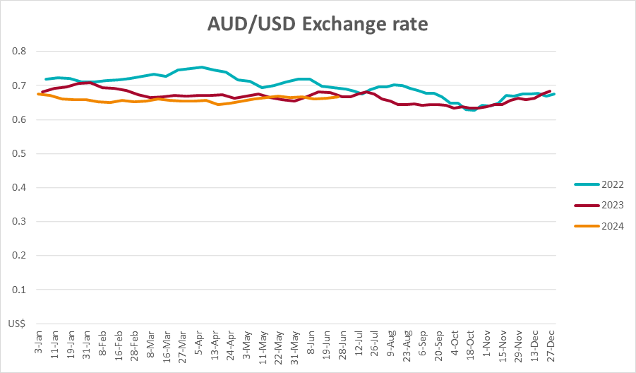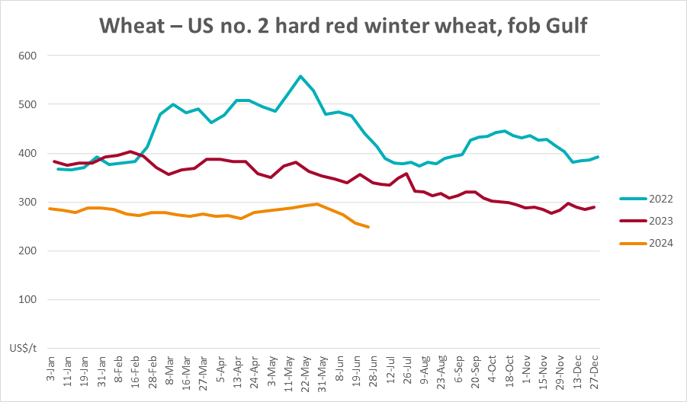

### Selected domestic crop indicator prices

### Selected domestic livestock indicator prices

### Global Dairy Trade (GDT) weighted average prices

### Selected fruit and vegetable prices

### 3.6 Selected domestic fodder indicator prices

## **4. Data attribution**

### Climate

Bureau of Meteorology

* Weekly rainfall totals: www.bom.gov.au/climate/maps/rainfall/
* Monthly and last 3-month rainfall percentiles: [www.bom.gov.au/water/landscape/](http://www.bom.gov.au/water/landscape/)
* Temperature anomalies: [www.bom.gov.au/jsp/awap/temp/index.jsp](http://www.bom.gov.au/jsp/awap/temp/index.jsp)
* Rainfall forecast: [www.bom.gov.au/jsp/watl/rainfall/pme.jsp](http://www.bom.gov.au/jsp/watl/rainfall/pme.jsp)
* Seasonal outlook: [www.bom.gov.au/climate/outlooks/#/overview/summary/](http://www.bom.gov.au/climate/outlooks/#/overview/summary/)
* Climate drivers: <http://www.bom.gov.au/climate/enso/>
* Soil moisture: [www.bom.gov.au/water/landscape/](http://www.bom.gov.au/water/landscape/)

Other

* Pasture growth: [www.longpaddock.qld.gov.au/aussiegrass/](http://www.longpaddock.qld.gov.au/aussiegrass/)
* 3-month global outlooks: [Environment and Climate Change Canada](https://weather.gc.ca/saisons/image_e.html?img=s234pfe1p_cal&bc=prob), [NOAA Climate Prediction Center](https://www.cpc.ncep.noaa.gov/products/predictions/long_range/seasonal.php?lead=2), [EUROBRISA CPTEC/INPE](http://eurobrisa.cptec.inpe.br/), European Centre for Medium-Range Weather Forecasts, [Hydrometcenter of Russia](https://meteoinfo.ru/en/climate/seasonal-forecasts), [National Climate Center Climate System Diagnosis and Prediction Room (NCC)](https://cmdp.ncc-cma.net/pred/cs2gen.php?pred_elem=RAINP#pred_seasonal), [International Research Institute for Climate and Society](https://iri.columbia.edu/our-expertise/climate/forecasts/seasonal-climate-forecasts/)
* Global production: <https://ipad.fas.usda.gov/ogamaps/cropmapsandcalendars.aspx>
* Autumn break: Pook et al., 2009, <https://rmets-onlinelibrary-wiley-com.virtual.anu.edu.au/doi/epdf/10.1002/joc.1833>

### Water

Prices

* Waterflow: <https://www.waterflow.io/>
* Ruralco: <https://www.ruralcowater.com.au/>

Bureau of Meteorology:

* Allocation trade: <http://www.bom.gov.au/water/dashboards/#/water-markets/mdb/at>
* Storage volumes: <http://www.bom.gov.au/water/dashboards/#/water-storages/summary/drainage>

Trade constraints:

* Water NSW: <https://www.waternsw.com.au/customer-service/ordering-trading-and-pricing/trading/murrumbidgee>
* Victorian Water Register: <https://www.waterregister.vic.gov.au/TradingRules2019/>

### Commodities

Fruit and vegetables

* Datafresh: [www.freshstate.com.au](http://www.freshstate.com.au)

Pigs

* Australian Pork Limited: [www.australianpork.com.au](http://www.australianpork.com.au)

Dairy

* Global Dairy Trade: [www.globaldairytrade.info/en/product-results/](http://www.globaldairytrade.info/en/product-results/)

World wheat, canola

* International Grains Council

World coarse grains

* United States Department of Agriculture

World cotton

* Cotlook: [www.cotlook.com/](http://www.cotlook.com/)

World sugar

* New York Stock Exchange - Intercontinental Exchange

Wool

* Australian Wool Exchange: [www.awex.com.au/](http://www.awex.com.au/)

Domestic wheat, barley, sorghum, canola and fodder

* Jumbuk Consulting Pty Ltd: http://www.jumbukag.com.au/

Cattle, beef, mutton, lamb, goat and live export

* Meat and Livestock Australia: www.mla.com.au/Prices-and-market

© Commonwealth of Australia 2023

### Ownership of intellectual property rights

Unless otherwise noted, copyright (and any other intellectual property rights, if any) in this publication is owned by the Commonwealth of Australia (referred to as the Commonwealth).

### Creative Commons licence

All material in this publication is licensed under a [Creative Commons Attribution 4.0 International Licence](https://creativecommons.org/licenses/by/4.0/legalcode) except content supplied by third parties, logos and the Commonwealth Coat of Arms.

Inquiries about the licence and any use of this document should be emailed to [copyright@awe.gov.au](mailto:copyright@awe.gov.au).

https://www.agriculture.gov.au/sites/default/files/images/creative-commons-logo-small.png

### Cataloguing data

This publication (and any material sourced from it) should be attributed as:

ABARES 2023, Weekly Australian Climate, Water and Agricultural Update, Australian Bureau of Agricultural and Resource Economics and Sciences, Canberra, 27 June 2024. CC BY 4.0 DOI: <https://doi.org/10.25814/5f3e04e7d2503>

ISSN **2652-7561**

This publication is available at https://www.agriculture.gov.au/abares/products/weekly_update

Department of Agriculture, Fisheries and Forestry

GPO Box 858 Canberra ACT 2601

Telephone 1800 900 090

Web [agriculture.gov.au/abares](http://awe.gov.au/abares)

### Disclaimer

The Australian Government acting through the Department of Agriculture, Fisheries and Forestry, represented by the Australian Bureau of Agricultural and Resource Economics and Sciences, has exercised due care and skill in preparing and compiling the information and data in this publication. Notwithstanding, the Department of Agriculture, Fisheries and Forestry, ABARES, its employees and advisers disclaim all liability, including liability for negligence and for any loss, damage, injury, expense or cost incurred by any person as a result of accessing, using or relying on any of the information or data in this publication to the maximum extent permitted by law.

### Statement of Professional Independence

The views and analysis presented in ABARES publications, including this one, reflect ABARES professionally independent findings, based on scientific and economic concepts, principles, information and data. These views, analysis and findings may not reflect or be consistent with the views or positions of the Australian Government, or of organisations or groups who have commissioned ABARES reports or analysis. More information on [professional independence](https://www.agriculture.gov.au/abares/about/research-and-analysis#professional-independence) is provided on the ABARES website.

### Acknowledgements

This report was prepared by Kavina Dayal, Holly Beale and Matthew Miller.