## No. 22/2024 13 June 2024

# Summary of key issues

* In the week ending 12 June 2024, rainfall was isolated to the southern parts of the country.
  + Across cropping regions, rainfall totals were high in the south-west and south-east, and low in the remaining regions. In Western Australia, up to 150 millimetres of rainfall was observed. New South Wales, Victoria, South Australia and Queensland recorded largely less than 10 millimetres of rainfall with exception in central New South Wales and along eastern cropping margins in Victoria where up to 100 millimetres and 25 millimetres of rainfall, respectively, was recorded.
  + This week of rainfall likely provided a further relief to winter cropping areas, particularly in Western Australia, supporting soil moisture content for the progressing season, allowing for the germination of dry sown crops.
* Over coming days, little to no rainfall is forecast for central and northern parts of the country. A low-pressure system is expected to bring rainfall of up to 50 millimetres to isolated parts of southern South Australia, up to 25 millimetres in Victoria and falls of between 5 and 15 millimetres across southern New South Wales and Tasmania. Meanwhile onshore flow is expected to bring falls of up to 50 millimetres to far-west Western Australia.
  + Across cropping regions, rainfall totals of up to 15 millimetres are expected in southern New South Wales, and across parts of eastern Western Australia and Victoria. Following several weeks of little to no rain, widespread falls of between 10 and 25 millimetres is forecast in South Australia and western Victoria.
  + If realised, this rainfall will facilitate the germination and establishment of winter crops in these areas.
* The national rainfall outlook for July to September is for above median rainfall for central areas and coastal New South Wales.
  + Across cropping regions, the probability of exceeding median rainfall is between 45% and 65% in Queensland, and northern and central New South Wales. Meanwhile, most cropping regions in South Australia, Victoria, southern parts of New South Wales and Western Australia are more likely to experience below median rainfall.
* Water storage levels in the Murray-Darling Basin (MDB) increased between 06 June 2024 and 13 June 2024 by 161 gigalitres (GL). Current volume of water held in storage is 17 139 GL, equivalent to 77% of total storage capacity. This is 15 percent or 3,404 GL less than at the same time last year. Water storage data is sourced from the BOM.
* Allocation prices in the Victorian Murray below the Barmah Choke decreased from $21 on 6 June 2024 to $20 on 13 June 2024. Prices are lower in the Murrumbidgee due to the binding of the Murrumbidgee export limit.

## **Climate**

### Rainfall this week

For the week ending 12 June 2024, rainfall was isolated to the south of the country. Low-pressure troughs brought up to 300 millimetres of rainfall to scattered areas of New South Wales, with Victoria receiving up to 100 millimetres. Meanwhile, a cold front brought up to 150 millimetres of rainfall in south-west Western Australia that had severe rainfall deficiencies in recent months. In Tasmania, a cold font brought a maximum of 100 millimetres of rainfall. A High-pressure system kept central to northern Australia largely dry.

Across cropping regions, rainfall totals were high in the south-west and south-east, and low in the remaining regions. In Western Australia, up to 150 millimetres of rainfall was observed. New South Wales, Victoria, South Australia and Queensland recorded largely less than 10 millimetres of rainfall with exception in central New South Wales and along eastern cropping margins in Victoria where up to 100 millimetres and 25 millimetres of rainfall, respectively, was recorded. This week of rainfall likely provided a further relief to winter cropping areas, particularly in Western Australia, supporting soil moisture content for the progressing season, allowing for the germination of dry sown crops.

#### Rainfall for the week ending 12 June 2024

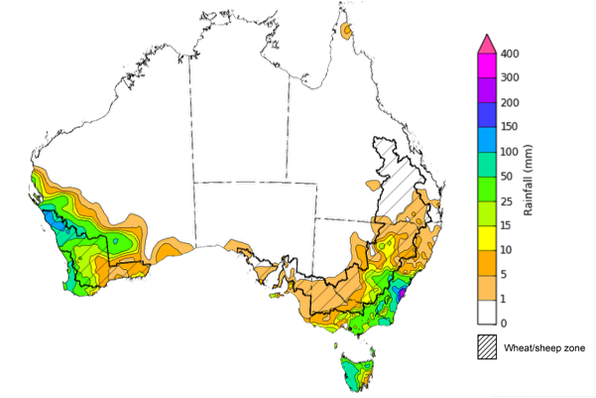

©Commonwealth of Australia 2024, Australian Bureau of Meteorology Issued: 12/06/2024

Note: The rainfall analyses and associated maps utilise data contained in the Bureau of Meteorology climate database, the Australian Data Archive for Meteorology (ADAM). The analyses are initially produced automatically from real-time data with limited [quality control](http://www.bom.gov.au/climate/headers/qc.shtml). They are intended to provide a general overview of rainfall across Australia as quickly as possible after the observations are received. For further information go to <http://www.bom.gov.au/climate/rainfall/>

### Rainfall forecast for the next eight days

Over the 8 days to 20 June 2024, little to no rainfall is forecast for central and northern parts of the country. High-pressure systems in the north are expected to persist, while a low-pressure system is expected to develop in the Great Australian Bight. This is expected to bring rainfall of up to 50 millimetres to isolated parts of southern South Australia, up to 25 millimetres in Victoria and falls of between 5 and 15 millimetres across southern New South Wales and Tasmania. Meanwhile a low-pressure trough is expected to bring falls of up to 50 millimetres to far-west Western Australia.

Across cropping regions, rainfall totals of up to 15 millimetres are expected in southern New South Wales, and across parts of eastern Western Australia and Victoria. Following several weeks of little to no rain, widespread falls of between 10 and 25 millimetres is forecast in South Australia and western Victoria. If realised, this rainfall will facilitate the germination and establishment of winter crops in these areas. Little to no rainfall is expected in the remaining cropping regions, with Queensland and northern New South Wales to remain dry.

#### Total forecast rainfall for the period 13 June to 20 June 2024

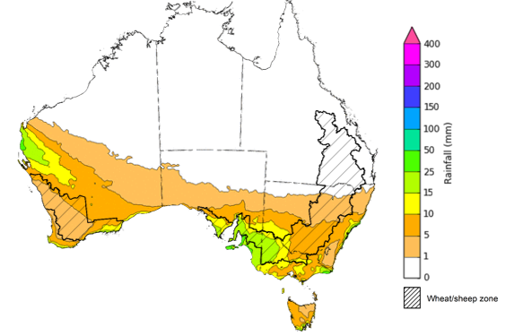

©Commonwealth of Australia 2024, Australian Bureau of Meteorology Issued 13/06/2024

Note: This rainfall forecast is produced from computer models. As the model outputs are not altered by weather forecasters, it is important to check local forecasts and warnings issued by the Bureau of Meteorology.

### National Climate Outlook

The most recent rainfall outlook for July 2024 provided by the Bureau of Meteorology indicates an increased likelihood of below median rainfall across parts of southern and northern Australia. Above median rainfall is more likely across parts of central Australia and coastal New South Wales. There is not strong tendency of above or below median rainfall across the remainder of Australia.

According to Bureau of Meteorology’s climate model, for July 2024 there is a 75% probability of rainfall totals between 10 and 100 millimetres across much of eastern New South Wales, Victoria, southern South Australia, the southwest of Western Australia and Tasmania. The north of the country is expected to remain largely dry, typical of this time of year, with exceptions in the tropical north of Queensland where up to 100 millimetres of rainfall is expected.

Across cropping regions, there is a 75% chance of receiving between 10 and 50 millimetres of rainfall in New South Wales, Victoria, South Australia and Western Australia. In Queensland, a maximum of 25 millimetres of rainfall is expected. If realised, this rainfall is likely to be sufficient to support growth of winter crops, however, Queensland cropping areas are expected to experience a drawdown of soil moisture.

**Rainfall totals that have a 75% chance of occurring in July 2024**

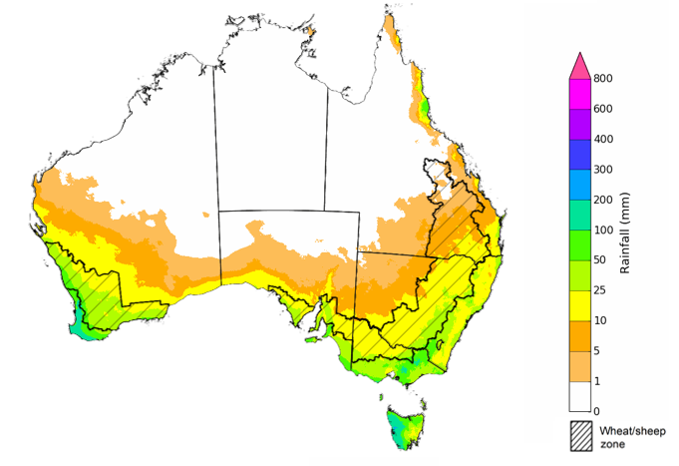

©Commonwealth of Australia 2024, Australian Bureau of Meteorology Issued: 13/06/2024

The El Niño Southern Oscillation (ENSO) and Indian Ocean Dipole (IOD) climate drivers are currently neutral and having minimal influence on Australian rainfall.

The rainfall outlook for July through September 2024 indicates that above median rainfall is more likely across central parts of the country and scattered areas of coastal New South Wales. Conversely, northern and southern parts of the country are expected to receive below median rainfall, with the probability of receiving median rainfall falling below 40% in parts of the northern tropic and southern South Australia, Victoria, southwest Westen Australia, parts of southern New South Wales and northern Tasmania.

Across cropping regions, the probability of exceeding median rainfall is between 45% and 65% in Queensland, and northern and central New South Wales. Meanwhile, most cropping regions in South Australia, Victoria, southern parts of New South Wales and Western Australia are more likely to experience below median rainfall.

**Chance of exceeding the median rainfall** **July to September 2024**

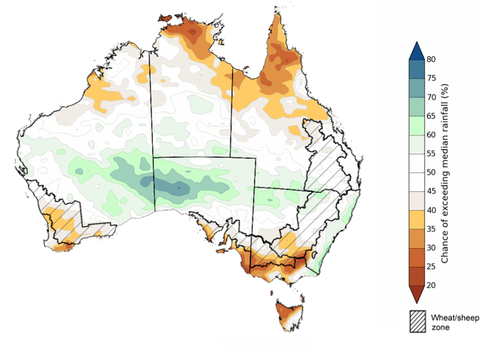

©Commonwealth of Australia 2024, Australian Bureau of Meteorology Issued: 13/06/2024

The outlook for July through September 2024 suggests a 75% chance of rainfall totals of between 25 to 200 millimetres likely across southern parts of the country, with heavier falls of up to 600 millimetres forecast for isolated areas of far southwest Western Australia, alpine regions of Victoria and New South Wales, and western Tasmania. In Queensland, falls of between 25 and 100 millimetres are expected in the southeast and parts of the northeast. Much of the remainder of the country is expected to receive little to no rainfall, consistent with these regions entering their dry season.

In cropping regions, there is at least a 75% chance of receiving between 50 and 100 millimetres of rainfall across much of New South Wales, Victoria, South Australia and Western Australia. In Queensland, falls of between 25 and 100 millimetres are expected, with drier conditions forecast for far northern cropping regions.

If realised, these expected rainfall totals will likely be sufficient to support growth and establishment of winter crops, particularly in South Australia, Western Australia and western parts of Victoria where soil moisture levels are currently well below average. Expected rainfall across remaining cropping regions will further boost soil moisture profile and will assist in maintaining above average forecast winter crops yields.

Livestock producers, especially those in the south, are expected to experience close to average pasture production on the back of the improving rainfall outlook over the July to September period.

**Rainfall totals that have a 75% chance of occurring** **July to September 2024**

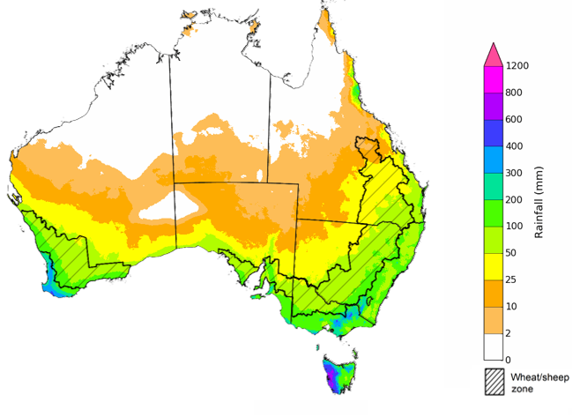

©Commonwealth of Australia 2024, Australian Bureau of Meteorology Issued: 13/06/2024

## **Water**

### Water markets – current week

Water storage levels in the Murray-Darling Basin (MDB) increased between 06 June 2024 and 13 June 2024 by 161 gigalitres (GL). Current volume of water held in storage is 17 139 GL, equivalent to 77% of total storage capacity. This is 15 percent or 3,404 GL less than at the same time last year. Water storage data is sourced from the BOM.

#### Water storages in the Murray-Darling Basin, 2013–2024

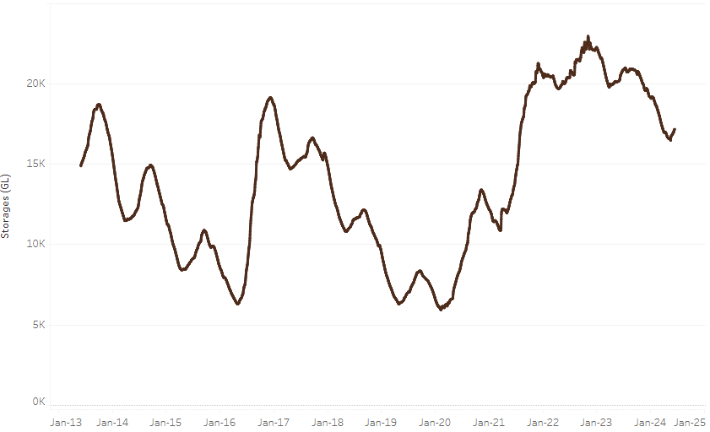

|  |
| --- |
| Water storage data is sourced from the Bureau of Meteorology. |

Allocation prices in the Victorian Murray below the Barmah Choke decreased from $21 on 6 June 2024 to $20 on 13 June 2024. Prices are lower in the Murrumbidgee due to the binding of the Murrumbidgee export limit.

|  |  |
| --- | --- |
| **Region** | **$/ML** |
| NSW Murray Above | 18 |
| NSW Murrumbidgee | 5 |
| VIC Goulburn-Broken | 15 |
| VIC Murray Below | 20 |

#### Surface water trade activity, Southern Murray–Darling Basin

|  |
| --- |
| The trades shown reflect estimated market activity and do not encompass all register trades. The price is shown for the VIC Murray below the Barmah choke. Historical prices (before 1 July 2019) are ABARES estimates after removing outliers from BOM water register data. Prices after 1 July 2019 and prior to the 30 October 2019 reflect recorded transaction prices as sourced from Ruralco. Prices after the 30 October 2019 are sourced from Waterflow. Data for volume traded is sourced from the BOM water register. Only the price data shown is current on 13 June 2024. |

To access the full, interactive, weekly water dashboard, which contains the latest and historical water storage, water market and water allocation information, please visit <https://www.agriculture.gov.au/abares/products/weekly_update/weekly-update-13624>

## **Commodities**

|  |  |  |  |  |  |  |  |
| --- | --- | --- | --- | --- | --- | --- | --- |
| **Indicator** | **Week average** | **Unit** | **Latest Price** | **Previous Week** | **Weekly change** | **Price 12 months ago** | **Annual change** |
| **Selected world indicator prices** |  |  |  |  |  |  |  |
| AUD/USD Exchange rate | 12-Jun | A$/US$ | 0.66 | 0.67 | -1% | 0.68 | -3% |
| Wheat – US no. 2 hard red winter wheat, fob Gulf | 12-Jun | US$/t | 274 | 285 | -4% | 356 | -23% |
| Corn – US no. 2 yellow corn, fob Gulf | 12-Jun | US$/t | 196 | 193 | 1% | 279 | -30% |
| Canola – Rapeseed, Canada, fob Vancouver | 12-Jun | US$/t | 493 | 495 | 0% | 606 | -19% |
| Cotton – Cotlook 'A' Index | 12-Jun | USc/lb | 83 | 83 | 0% | 92 | -10% |
| Sugar – Intercontinental Exchange, nearby futures, no.11 contract | 12-Jun | USc/lb | 18.7 | 18.9 | -1% | 25 | -27% |
| Wool – Eastern Market Indicator | 05-Jun | Ac/kg clean | 1,152 | 1,137 | 1% | 1,289 | -11% |
| Wool – Western Market Indicator | 29-May | Ac/kg clean | 1,269 | 1,262 | 1% | 1,462 | -13% |
| **Selected Australian grain export prices** |  |  |  |  |  |  |  |
| Milling Wheat – APW, Port Adelaide, SA | 12-Jun | A$/t | 438 | 432 | 1% | 435 | 1% |
| Feed Wheat – ASW, Port Adelaide, SA | 12-Jun | A$/t | 428 | 422 | 1% | 407 | 5% |
| Feed Barley – Port Adelaide, SA | 12-Jun | A$/t | 381 | 382 | 0% | 343 | 11% |
| Canola – Kwinana, WA | 12-Jun | A$/t | 759 | 774 | -2% | 815 | -7% |
| Grain Sorghum – Brisbane, QLD | 12-Jun | A$/t | 446 | 451 | -1% | 486 | -8% |
| **Selected domestic livestock indicator prices** |  |  |  |  |  |  |  |
| Beef – Eastern Young Cattle Indicator | 12-Jun | Ac/kg cwt | 602 | 605 | 0% | 562 | 7% |
| Mutton – Mutton indicator (18–24 kg fat score 2–3), Vic | 12-Jun | Ac/kg cwt | 408 | 357 | 14% | 345 | 18% |
| Lamb – National Trade Lamb Indicator | 12-Jun | Ac/kg cwt | 710 | 697 | 2% | 567 | 25% |
| Pig – Eastern Seaboard (60.1–75 kg), average of buyers & sellers | 29-May | Ac/kg cwt | 407 | 407 | 0% | 357 | 14% |
| Live cattle – Light steers to Indonesia | 12-Jun | Ac/kg lwt | 310 | 310 | 0% | 350 | -11% |
| **Global Dairy Trade (GDT) weighted average prices a** |  |  |  |  |  |  |  |
| Dairy – Whole milk powder | 05-Jun | US$/t | 3,478 | 3,408 | 2% | 3,244 | 7% |
| Dairy – Skim milk powder | 05-Jun | US$/t | 2,722 | 2,629 | 4% | 2,766 | -2% |
| Dairy – Cheddar cheese | 05-Jun | US$/t | 4,248 | 4,239 | 0% | 4,407 | -4% |
| Dairy – Anhydrous milk fat | 05-Jun | US$/t | 7,417 | 7,365 | 1% | 4,600 | 61% |
| **Selected world indicator prices** |  |  |  |  |  |  |  |
| **a** Global Dairy Trade prices are updated twice monthly on the first and third Tuesday of each month. | | | | | | | |

### Selected world indicator prices

### Selected domestic crop indicator prices

### Selected domestic livestock indicator prices

### Global Dairy Trade (GDT) weighted average prices

### Selected fruit and vegetable prices

### 3.6 Selected domestic fodder indicator prices

## **4. Data attribution**

### Climate

Bureau of Meteorology

* Weekly rainfall totals: www.bom.gov.au/climate/maps/rainfall/
* Monthly and last 3-month rainfall percentiles: [www.bom.gov.au/water/landscape/](http://www.bom.gov.au/water/landscape/)
* Temperature anomalies: [www.bom.gov.au/jsp/awap/temp/index.jsp](http://www.bom.gov.au/jsp/awap/temp/index.jsp)
* Rainfall forecast: [www.bom.gov.au/jsp/watl/rainfall/pme.jsp](http://www.bom.gov.au/jsp/watl/rainfall/pme.jsp)
* Seasonal outlook: [www.bom.gov.au/climate/outlooks/#/overview/summary/](http://www.bom.gov.au/climate/outlooks/#/overview/summary/)
* Climate drivers: <http://www.bom.gov.au/climate/enso/>
* Soil moisture: [www.bom.gov.au/water/landscape/](http://www.bom.gov.au/water/landscape/)

Other

* Pasture growth: [www.longpaddock.qld.gov.au/aussiegrass/](http://www.longpaddock.qld.gov.au/aussiegrass/)
* 3-month global outlooks: [Environment and Climate Change Canada](https://weather.gc.ca/saisons/image_e.html?img=s234pfe1p_cal&bc=prob), [NOAA Climate Prediction Center](https://www.cpc.ncep.noaa.gov/products/predictions/long_range/seasonal.php?lead=2), [EUROBRISA CPTEC/INPE](http://eurobrisa.cptec.inpe.br/), European Centre for Medium-Range Weather Forecasts, [Hydrometcenter of Russia](https://meteoinfo.ru/en/climate/seasonal-forecasts), [National Climate Center Climate System Diagnosis and Prediction Room (NCC)](https://cmdp.ncc-cma.net/pred/cs2gen.php?pred_elem=RAINP#pred_seasonal), [International Research Institute for Climate and Society](https://iri.columbia.edu/our-expertise/climate/forecasts/seasonal-climate-forecasts/)
* Global production: <https://ipad.fas.usda.gov/ogamaps/cropmapsandcalendars.aspx>
* Autumn break: Pook et al., 2009, <https://rmets-onlinelibrary-wiley-com.virtual.anu.edu.au/doi/epdf/10.1002/joc.1833>

### Water

Prices

* Waterflow: <https://www.waterflow.io/>
* Ruralco: <https://www.ruralcowater.com.au/>

Bureau of Meteorology:

* Allocation trade: <http://www.bom.gov.au/water/dashboards/#/water-markets/mdb/at>
* Storage volumes: <http://www.bom.gov.au/water/dashboards/#/water-storages/summary/drainage>

Trade constraints:

* Water NSW: <https://www.waternsw.com.au/customer-service/ordering-trading-and-pricing/trading/murrumbidgee>
* Victorian Water Register: <https://www.waterregister.vic.gov.au/TradingRules2019/>

### Commodities

Fruit and vegetables

* Datafresh: [www.freshstate.com.au](http://www.freshstate.com.au)

Pigs

* Australian Pork Limited: [www.australianpork.com.au](http://www.australianpork.com.au)

Dairy

* Global Dairy Trade: [www.globaldairytrade.info/en/product-results/](http://www.globaldairytrade.info/en/product-results/)

World wheat, canola

* International Grains Council

World coarse grains

* United States Department of Agriculture

World cotton

* Cotlook: [www.cotlook.com/](http://www.cotlook.com/)

World sugar

* New York Stock Exchange - Intercontinental Exchange

Wool

* Australian Wool Exchange: [www.awex.com.au/](http://www.awex.com.au/)

Domestic wheat, barley, sorghum, canola and fodder

* Jumbuk Consulting Pty Ltd: http://www.jumbukag.com.au/

Cattle, beef, mutton, lamb, goat and live export

* Meat and Livestock Australia: www.mla.com.au/Prices-and-market

© Commonwealth of Australia 2023

### Ownership of intellectual property rights

Unless otherwise noted, copyright (and any other intellectual property rights, if any) in this publication is owned by the Commonwealth of Australia (referred to as the Commonwealth).

### Creative Commons licence

All material in this publication is licensed under a [Creative Commons Attribution 4.0 International Licence](https://creativecommons.org/licenses/by/4.0/legalcode) except content supplied by third parties, logos and the Commonwealth Coat of Arms.

Inquiries about the licence and any use of this document should be emailed to [copyright@awe.gov.au](mailto:copyright@awe.gov.au).

https://www.agriculture.gov.au/sites/default/files/images/creative-commons-logo-small.png

### Cataloguing data

This publication (and any material sourced from it) should be attributed as:

ABARES 2023, Weekly Australian Climate, Water and Agricultural Update, Australian Bureau of Agricultural and Resource Economics and Sciences, Canberra, 13 June 2024. CC BY 4.0 DOI: <https://doi.org/10.25814/5f3e04e7d2503>

ISSN **2652-7561**

This publication is available at https://www.agriculture.gov.au/abares/products/weekly_update

Department of Agriculture, Fisheries and Forestry

GPO Box 858 Canberra ACT 2601

Telephone 1800 900 090

Web [agriculture.gov.au/abares](http://awe.gov.au/abares)

### Disclaimer

The Australian Government acting through the Department of Agriculture, Fisheries and Forestry, represented by the Australian Bureau of Agricultural and Resource Economics and Sciences, has exercised due care and skill in preparing and compiling the information and data in this publication. Notwithstanding, the Department of Agriculture, Fisheries and Forestry, ABARES, its employees and advisers disclaim all liability, including liability for negligence and for any loss, damage, injury, expense or cost incurred by any person as a result of accessing, using or relying on any of the information or data in this publication to the maximum extent permitted by law.

### Statement of Professional Independence

The views and analysis presented in ABARES publications, including this one, reflect ABARES professionally independent findings, based on scientific and economic concepts, principles, information and data. These views, analysis and findings may not reflect or be consistent with the views or positions of the Australian Government, or of organisations or groups who have commissioned ABARES reports or analysis. More information on [professional independence](https://www.agriculture.gov.au/abares/about/research-and-analysis#professional-independence) is provided on the ABARES website.

### Acknowledgements

This report was prepared by Kavina Dayal, Holly Beale and Matthew Miller.