## No. 19/2024 23 May 2024

# Summary of key issues

* In the week ending 22 May 2024, a high-pressure system kept much of Australia dry. Exceptions were: central parts of Western Australia, which recorded up to 15 millimetres of rainfall associated with a low pressure trough; along the eastern coastline that recorded up to 50 millimetres of rainfall in some areas associated with moist onshore flow; and Tasmania recorded up to 100 millimetres of rainfall from cold fronts.
  + Across cropping regions, isolated falls of up to 25 millimetres were recorded in north-eastern New South Wales and up to 50 millimetres in far south-eastern Queensland. Mostly dry conditions elsewhere would have allowed planting operations of winter crops and harvest of summer crops to continue without delay.
  + Lack of rainfall in Victoria, South Australia and Western Australia would delay the germination of winter crops and result in further declines in soil moisture.
* Over coming days, high-pressure systems are expected to keep Australia largely dry. The main exceptions being western Tasmania and the far southwest Western Australia where cold fronts are expected to bring up to 50 millimetres of rainfall. A low-pressure system is also expected to bring rainfall totals of up to 100 millimetres to isolated areas of north-eastern Queensland.
  + Across cropping regions, conditions are forecast to be largely dry, with a maximum of 5 millimetres of rainfall forecast for scattered areas in Queensland and New South Wales, and much of western Victoria, South Australia and Western Australia.
  + Risks to production from declining soil moisture continue, particularly in Western Australia, South Australia and western Victoria where rainfall has been deficient for much of April and May-to-date.
* The national rainfall outlook for June to August is for above median rainfall for much of the southern half of Australia, with exceptions in Victoria and Tasmania.
  + Across cropping regions, the probability of exceeding median rainfall is between 40% and 60% in the eastern states and South Australia, while Western Australia cropping regions have a higher probability (50 to 75%) of receiving above median rainfall.
* Water storage levels in the Murray-Darling Basin (MDB) increased between 16 May 2024 and 23 May 2024 by 85 gigalitres (GL). Current volume of water held in storage is 16 726 GL, equivalent to 75% of total storage capacity. This is 15 percent or 3,378 GL less than at the same time last year. Water storage data is sourced from the BOM.
* Allocation prices in the Victorian Murray below the Barmah Choke decreased from $22 on 16 May 2024 to $20 on 23 May 2024. Prices are lower in the Murrumbidgee due to the binding of the Murrumbidgee export limit.

## **Climate**

### Rainfall this week

For the week ending 22 May 2024, a high-pressure system brought dry conditions to much of Australia. Exceptions were: central parts of Western Australia, which recorded up to 15 millimetres of rainfall associated with a low pressure trough; along the eastern coastline recorded up to 50 millimetres of rainfall in some areas associated with moist onshore flow; and Tasmania recorded up to 100 millimetres of rainfall from cold fronts.

Across cropping regions, isolated falls of up to 25 millimetres were recorded in north-eastern New South Wales and up to 50 millimetres in far south-eastern Queensland. Most cropping regions recorded little to no rainfall for the week ending 22 May 2024. Mostly dry conditions in New South Wales and Queensland would have allowed planting operations of winter crops and harvest of summer crops to continue without delay. Across Victoria, South Australia and Western Australia the lack of rainfall would have continued to delay the germination of winter crops and resulted in further declines in soil moisture.

#### Rainfall for the week ending 22 May 2024

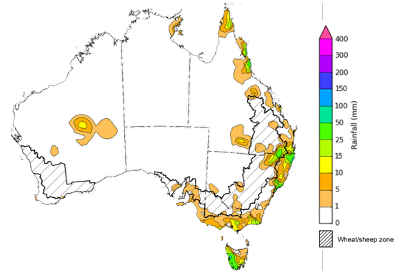

©Commonwealth of Australia 2024, Australian Bureau of Meteorology Issued: 22/05/2024

Note: The rainfall analyses and associated maps utilise data contained in the Bureau of Meteorology climate database, the Australian Data Archive for Meteorology (ADAM). The analyses are initially produced automatically from real-time data with limited [quality control](http://www.bom.gov.au/climate/headers/qc.shtml). They are intended to provide a general overview of rainfall across Australia as quickly as possible after the observations are received. For further information go to <http://www.bom.gov.au/climate/rainfall/>

### Rainfall forecast for the next eight days

Over the 8 days to 30 May 2024, high-pressure systems are expected to keep Australia largely dry. The main exceptions being western Tasmania and the far southwest of Western Australia where cold fronts are expected to bring up to 50 millimetres of rainfall. A low-pressure system is expected to bring rainfall to totals of up to 100 millimetres to isolated areas of north-eastern Queensland.

Across cropping regions, conditions are expected to remain dry. A maximum of 5 millimetres of rainfall is forecast for scattered areas in Queensland and New South Wales, and much of western Victoria, South Australia and Western Australia. Risks to production remain from declining soil moisture where rainfall has been deficient for much of April and May to date.

#### Total forecast rainfall for the period 23 May to 30 May 2024

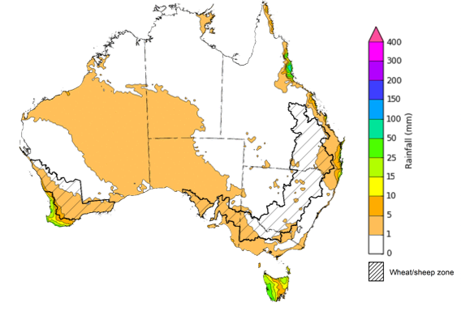

©Commonwealth of Australia 2024, Australian Bureau of Meteorology Issued 23/05/2024

Note: This rainfall forecast is produced from computer models. As the model outputs are not altered by weather forecasters, it is important to check local forecasts and warnings issued by the Bureau of Meteorology.

### National Climate Outlook

The most recent rainfall outlook for June 2024 provided by the Bureau of Meteorology indicates an increased likelihood of above median rainfall across much of Western Australia and South Australia, as well as parts of southern Queensland and western New South Wales. Below median rainfall is more likely across parts of tropical northern Australia, southern New South Wales extending into northeastern Victoria, and along scattered area of Australia’s southern coastline and Tasmania. There is an equal chance of either above or below median rainfall likely elsewhere.

According to Bureau of Meteorology’s climate model, for June 2024 there is a 75% probability of rainfall totals between 25 to 50 millimetres across parts of New South Wales and coastal Queensland and much of Victoria, and southern South Australia. High elevation and coastal areas can receive up to 100 millimetres of rainfall in these states. Far southwest Western Australia and western Tasmania are anticipated to receive up to 200 millimetres of rainfall. The northern Australia is expected to remain largely dry.

Across cropping regions, there is a 75% chance of rainfall totals between 10 to 50 millimetres in New South Wales, Victoria, South Australia and up to 100 millimetres in Western Australia. In Queensland, a maximum of 25 millimetres is expected in the south. If realised, these expected rainfall totals should be sufficient to allow for the germination and establishment of winter crops.

**Rainfall totals that have a 75% chance of occurring in June 2024**

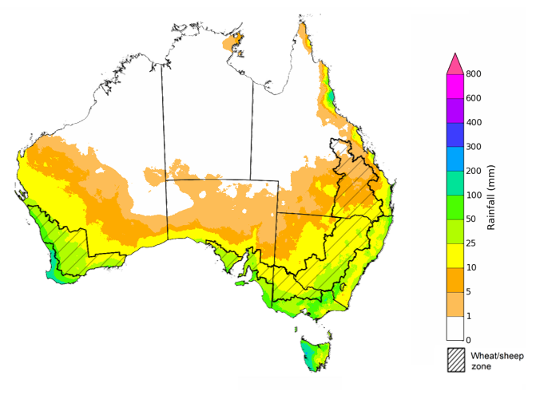

©Commonwealth of Australia 2024, Australian Bureau of Meteorology Issued: 23/05/2024

The El Niño Southern Oscillation (ENSO) and Indian Ocean Dipole (IOD) climate drivers are currently neutral and having minimal influence on Australian rainfall.

The rainfall outlook for June through August indicates that above median rainfall is more likely across much of the southern half of Australia, with exceptions in southern parts of Victoria and South Australia, as well as in Tasmania, where below median rainfall is more likely. In the Northern Tropics, which has entered its dry season, rainfall totals over the period are expected to be below the median, except for in parts of northeast Queensland where above median rainfall is highly likely. Remaining areas have an equal chance of having above or below median rainfall.

Across cropping regions, the probability of exceeding median rainfall is between 40% and 60% in the eastern states and South Australia, while Western Australia cropping regions have a higher probability (between 50 and 75%) of receiving above median rainfall.

**Chance of exceeding the median rainfall** **June to August 2024**

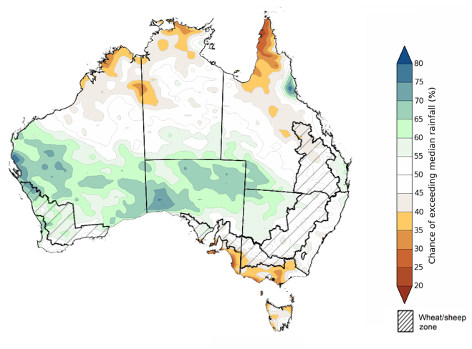

©Commonwealth of Australia 2024, Australian Bureau of Meteorology Issued: 23/05/2024

The outlook for June to August 2024 suggests there is at least a 75% chance of rainfall totals of up to 200 millimetres across much of southern Australia, with up to 400 millimetres likely in scattered parts of New South Wales, Victoria and South Australia. In western Tasmania, rainfall is expected to reach up to 800 millimetres over the period. Far southwest Western Australia is likely to receive up to 600 millimetres of rainfall. In contrast, northern Australia is likely to remain largely dry.

In cropping regions, there is at least a 75% chance of receiving between 100 and 200 millimetres across much of South Australia, Western Australia and parts of southern Victoria and eastern New South Wales. Remaining areas across eastern South Australia, Victoria and New South Wales, as well as southern Queensland are expected to receive between 50 and 100 millimetres. Central and northern cropping regions in Queensland are expected to receive rainfall totals of between 10 and 50 millimetres.

Considering the recent declines in upper layer soil moisture levels, particularly in South Australia, Western Australia and western parts of Victoria, sufficient and timely rainfall will be required in the coming months to facilitate the germination and establishment of winter crops. This generally favourable rainfall outlook of June to August is expected to support the germination of dry sown crops and follow up winter crop planting towards the end of the ideal planting window.

Livestock producers, especially those in the south, are expected to experience close to average pasture production on the back of the improving rainfall outlook over the June to August period.

**Rainfall totals that have a 75% chance of occurring** **June to August 2024**

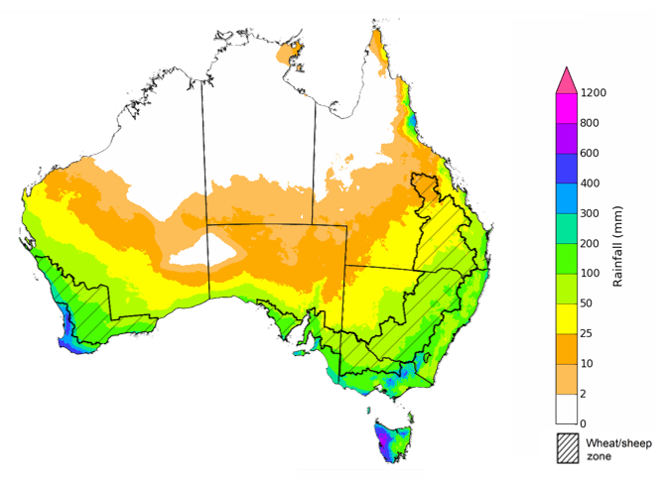

©Commonwealth of Australia 2024, Australian Bureau of Meteorology Issued: 23/05/2024

## **Water**

### Water markets – current week

Water storage levels in the Murray-Darling Basin (MDB) increased between 16 May 2024 and 23 May 2024 by 85 gigalitres (GL). Current volume of water held in storage is 16 726 GL, equivalent to 75% of total storage capacity. This is 15 percent or 3,378 GL less than at the same time last year. Water storage data is sourced from the BOM.

#### Water storages in the Murray-Darling Basin, 2013–2024

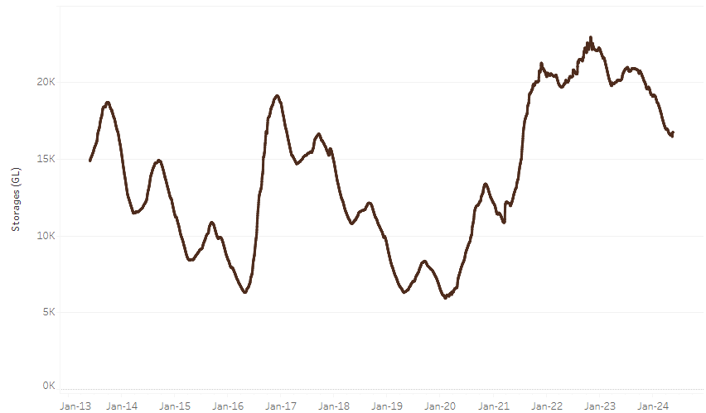

|  |
| --- |
| Water storage data is sourced from the Bureau of Meteorology. |

Allocation prices in the Victorian Murray below the Barmah Choke decreased from $22 on 16 May 2024 to $20 on 23 May 2024. Prices are lower in the Murrumbidgee due to the binding of the Murrumbidgee export limit.

|  |  |
| --- | --- |
| **Region** | **$/ML** |
| NSW Murray Above | 20 |
| NSW Murrumbidgee | 12 |
| VIC Goulburn-Broken | 16 |
| VIC Murray Below | 21 |

#### Surface water trade activity, Southern Murray–Darling Basin

|  |
| --- |
| The trades shown reflect estimated market activity and do not encompass all register trades. The price is shown for the VIC Murray below the Barmah choke. Historical prices (before 1 July 2019) are ABARES estimates after removing outliers from BOM water register data. Prices after 1 July 2019 and prior to the 30 October 2019 reflect recorded transaction prices as sourced from Ruralco. Prices after the 30 October 2019 are sourced from Waterflow. Data for volume traded is sourced from the BOM water register. Only the price data shown is current on 23 May 2024. |

To access the full, interactive, weekly water dashboard, which contains the latest and historical water storage, water market and water allocation information, please visit <https://www.agriculture.gov.au/abares/products/weekly_update/weekly-update-23524>

## **Commodities**

|  |  |  |  |  |  |  |  |
| --- | --- | --- | --- | --- | --- | --- | --- |
| **Indicator** | **Week average** | **Unit** | **Latest Price** | **Previous Week** | **Weekly change** | **Price 12 months ago** | **Annual change** |
| **Selected world indicator prices** |  |  |  |  |  |  |  |
| AUD/USD Exchange rate | 22-May | A$/US$ | 0.67 | 0.66 | 1% | 0.65 | 2% |
| Wheat – US no. 2 hard red winter wheat, fob Gulf | 22-May | US$/t | 292 | 293 | 0% | 353 | -17% |
| Corn – US no. 2 yellow corn, fob Gulf | 22-May | US$/t | 197 | 199 | -1% | 264 | -25% |
| Canola – Rapeseed, Canada, fob Vancouver | 22-May | US$/t | 522 | 520 | 0% | 541 | -3% |
| Cotton – Cotlook 'A' Index | 22-May | USc/lb | 86 | 86 | 0% | 95 | -10% |
| Sugar – Intercontinental Exchange, nearby futures, no.11 contract | 15-May | USc/lb | 18.8 | 19.6 | -4% | 25 | -26% |
| Wool – Eastern Market Indicator | 22-May | Ac/kg clean | 1,130 | 1,135 | 0% | 1,318 | -14% |
| Wool – Western Market Indicator | 22-May | Ac/kg clean | 1,262 | 1,275 | -1% | 1,445 | -13% |
| **Selected Australian grain export prices** |  |  |  |  |  |  |  |
| Milling Wheat – APW, Port Adelaide, SA | 22-May | A$/t | 418 | 420 | 0% | 444 | -6% |
| Feed Wheat – ASW, Port Adelaide, SA | 22-May | A$/t | 406 | 407 | 0% | 414 | -2% |
| Feed Barley – Port Adelaide, SA | 22-May | A$/t | 375 | 375 | 0% | 361 | 4% |
| Canola – Kwinana, WA | 22-May | A$/t | 758 | 751 | 1% | 809 | -6% |
| Grain Sorghum – Brisbane, QLD | 22-May | A$/t | 450 | 450 | 0% | 470 | -4% |
| **Selected domestic livestock indicator prices** |  |  |  |  |  |  |  |
| Beef – Eastern Young Cattle Indicator | 22-May | Ac/kg cwt | 624 | 611 | 2% | 601 | 4% |
| Mutton – Mutton indicator (18–24 kg fat score 2–3), Vic | 22-May | Ac/kg cwt | 309 | 277 | 11% | 392 | -21% |
| Lamb – National Trade Lamb Indicator | 22-May | Ac/kg cwt | 658 | 648 | 2% | 589 | 12% |
| Pig – Eastern Seaboard (60.1–75 kg), average of buyers & sellers | 01-May | Ac/kg cwt | 407 | 411 | -1% | 357 | 14% |
| Goats – Eastern States (12.1–16 kg) | 27-Dec | Ac/kg cwt | 180 | 180 | 0% | 350 | -49% |
| Live cattle – Light steers to Indonesia | 22-May | Ac/kg lwt | 310 | 340 | -9% | 360 | -14% |
| **Global Dairy Trade (GDT) weighted average prices a** |  |  |  |  |  |  |  |
| Dairy – Whole milk powder | 22-May | US$/t | 3,408 | 3,350 | 2% | 3,230 | 6% |
| Dairy – Skim milk powder | 22-May | US$/t | 2,629 | 2,551 | 3% | 2,787 | -6% |
| Dairy – Cheddar cheese | 22-May | US$/t | 4,239 | 4,257 | 0% | 4,561 | -7% |
| Dairy – Anhydrous milk fat | 22-May | US$/t | 7,365 | 7,124 | 3% | 4,832 | 52% |
| **a** Global Dairy Trade prices are updated twice monthly on the first and third Tuesday of each month. | | | | | | | |

### Selected world indicator prices

### Selected domestic crop indicator prices

### Selected domestic livestock indicator prices

### Global Dairy Trade (GDT) weighted average prices

### Selected fruit and vegetable prices

### 3.6 Selected domestic fodder indicator prices

## **4. Data attribution**

### Climate

Bureau of Meteorology

* Weekly rainfall totals: www.bom.gov.au/climate/maps/rainfall/
* Monthly and last 3-month rainfall percentiles: [www.bom.gov.au/water/landscape/](http://www.bom.gov.au/water/landscape/)
* Temperature anomalies: [www.bom.gov.au/jsp/awap/temp/index.jsp](http://www.bom.gov.au/jsp/awap/temp/index.jsp)
* Rainfall forecast: [www.bom.gov.au/jsp/watl/rainfall/pme.jsp](http://www.bom.gov.au/jsp/watl/rainfall/pme.jsp)
* Seasonal outlook: [www.bom.gov.au/climate/outlooks/#/overview/summary/](http://www.bom.gov.au/climate/outlooks/#/overview/summary/)
* Climate drivers: <http://www.bom.gov.au/climate/enso/>
* Soil moisture: [www.bom.gov.au/water/landscape/](http://www.bom.gov.au/water/landscape/)

Other

* Pasture growth: [www.longpaddock.qld.gov.au/aussiegrass/](http://www.longpaddock.qld.gov.au/aussiegrass/)
* 3-month global outlooks: [Environment and Climate Change Canada](https://weather.gc.ca/saisons/image_e.html?img=s234pfe1p_cal&bc=prob), [NOAA Climate Prediction Center](https://www.cpc.ncep.noaa.gov/products/predictions/long_range/seasonal.php?lead=2), [EUROBRISA CPTEC/INPE](http://eurobrisa.cptec.inpe.br/), European Centre for Medium-Range Weather Forecasts, [Hydrometcenter of Russia](https://meteoinfo.ru/en/climate/seasonal-forecasts), [National Climate Center Climate System Diagnosis and Prediction Room (NCC)](https://cmdp.ncc-cma.net/pred/cs2gen.php?pred_elem=RAINP#pred_seasonal), [International Research Institute for Climate and Society](https://iri.columbia.edu/our-expertise/climate/forecasts/seasonal-climate-forecasts/)
* Global production: <https://ipad.fas.usda.gov/ogamaps/cropmapsandcalendars.aspx>
* Autumn break: Pook et al., 2009, <https://rmets-onlinelibrary-wiley-com.virtual.anu.edu.au/doi/epdf/10.1002/joc.1833>

### Water

Prices

* Waterflow: <https://www.waterflow.io/>
* Ruralco: <https://www.ruralcowater.com.au/>

Bureau of Meteorology:

* Allocation trade: <http://www.bom.gov.au/water/dashboards/#/water-markets/mdb/at>
* Storage volumes: <http://www.bom.gov.au/water/dashboards/#/water-storages/summary/drainage>

Trade constraints:

* Water NSW: <https://www.waternsw.com.au/customer-service/ordering-trading-and-pricing/trading/murrumbidgee>
* Victorian Water Register: <https://www.waterregister.vic.gov.au/TradingRules2019/>

### Commodities

Fruit and vegetables

* Datafresh: [www.freshstate.com.au](http://www.freshstate.com.au)

Pigs

* Australian Pork Limited: [www.australianpork.com.au](http://www.australianpork.com.au)

Dairy

* Global Dairy Trade: [www.globaldairytrade.info/en/product-results/](http://www.globaldairytrade.info/en/product-results/)

World wheat, canola

* International Grains Council

World coarse grains

* United States Department of Agriculture

World cotton

* Cotlook: [www.cotlook.com/](http://www.cotlook.com/)

World sugar

* New York Stock Exchange - Intercontinental Exchange

Wool

* Australian Wool Exchange: [www.awex.com.au/](http://www.awex.com.au/)

Domestic wheat, barley, sorghum, canola and fodder

* Jumbuk Consulting Pty Ltd: http://www.jumbukag.com.au/

Cattle, beef, mutton, lamb, goat and live export

* Meat and Livestock Australia: www.mla.com.au/Prices-and-market

© Commonwealth of Australia 2023

### Ownership of intellectual property rights

Unless otherwise noted, copyright (and any other intellectual property rights, if any) in this publication is owned by the Commonwealth of Australia (referred to as the Commonwealth).

### Creative Commons licence

All material in this publication is licensed under a [Creative Commons Attribution 4.0 International Licence](https://creativecommons.org/licenses/by/4.0/legalcode) except content supplied by third parties, logos and the Commonwealth Coat of Arms.

Inquiries about the licence and any use of this document should be emailed to [copyright@awe.gov.au](mailto:copyright@awe.gov.au).

https://www.agriculture.gov.au/sites/default/files/images/creative-commons-logo-small.png

### Cataloguing data

This publication (and any material sourced from it) should be attributed as:

ABARES 2023, Weekly Australian Climate, Water and Agricultural Update, Australian Bureau of Agricultural and Resource Economics and Sciences, Canberra, 23 May 2024. CC BY 4.0 DOI: <https://doi.org/10.25814/5f3e04e7d2503>

ISSN **2652-7561**

This publication is available at https://www.agriculture.gov.au/abares/products/weekly_update

Department of Agriculture, Fisheries and Forestry

GPO Box 858 Canberra ACT 2601

Telephone 1800 900 090

Web [agriculture.gov.au/abares](http://awe.gov.au/abares)

### Disclaimer

The Australian Government acting through the Department of Agriculture, Fisheries and Forestry, represented by the Australian Bureau of Agricultural and Resource Economics and Sciences, has exercised due care and skill in preparing and compiling the information and data in this publication. Notwithstanding, the Department of Agriculture, Fisheries and Forestry, ABARES, its employees and advisers disclaim all liability, including liability for negligence and for any loss, damage, injury, expense or cost incurred by any person as a result of accessing, using or relying on any of the information or data in this publication to the maximum extent permitted by law.

### Statement of Professional Independence

The views and analysis presented in ABARES publications, including this one, reflect ABARES professionally independent findings, based on scientific and economic concepts, principles, information and data. These views, analysis and findings may not reflect or be consistent with the views or positions of the Australian Government, or of organisations or groups who have commissioned ABARES reports or analysis. More information on [professional independence](https://www.agriculture.gov.au/abares/about/research-and-analysis#professional-independence) is provided on the ABARES website.

### Acknowledgements

This report was prepared by Kavina Dayal, Holly Beale and Matthew Miller.