## No. 11/2024 21 March 2024

# Summary of key issues

* In the week ending 20 March 2024, the monsoon lows generated rain and storms in the tropics extending to central Western Australia and far-north Queensland. Tropical Cyclone Megan generated higher than anticipated rainfall in the north, reaching 300 millimetres in some areas.
  + Across cropping regions, New South Wales recorded up to 100 millimetres of rainfall, while up to 25 millimetres was recorded in Victoria, South Australia and Northern Queensland. Minimal rainfall occurred in Western Australia with cropping regions receiving rainfall of only up to 10 millimetres.
* Over the coming days, the northern half of the country is expected to receive up to 300 millimetres of rainfall associated with low pressure systems.
  + A wet week in Queensland and northern New South Wales cropping regions will likely interrupt harvest of summer crops but boost soil moisture levels for winter crops.
  + A drier week is expected in remaining cropping regions and will likely see a decline in soil moisture levels.
* Globally, variable rainfall during February has led to mixed crop production prospects.
  + Global production conditions were generally favourable for rice while mixed for wheat, soybeans and maize.
  + Global production conditions have generally remained largely unchanged, except for in South America, compared to those used to formulate ABARES forecasts of global grain supplies and world prices for 2023–24 in its March 2024 edition of the Agricultural Commodities Report. As a result, global grain and oilseed production are likely to remain similar to those presented in the March forecast, with falls in corn production to be offset by increase in rice and wheat production.
* Water storage levels in the Murray-Darling Basin (MDB) decreased between 7 March 2024 and 14 March 2024 by 190 gigalitres (GL). Current volume of water held in storage is 17 553 GL, equivalent to 78% of total storage capacity. This is 13 percent or 2536 GL less than at the same time last year.
* Allocation prices in the Victorian Murray below the Barmah Choke increased from $26 on 7 March 2024 to $27 on 14 March 2024. Prices are lower in the Murrumbidgee due to the binding of the Murrumbidgee export limit.

## **Climate**

### Rainfall this week

For the week ending 20 March 2024, monsoon lows generated rain and storms in the tropics extending to central Western Australia and far-north Queensland. Tropical Cyclone Megan generated higher than anticipated rainfall around the Gulf of Carpentaria, reaching 400 millimetres in some areas.

A low-pressure trough resulted in showers and thunderstorms in New South Wales, eastern Victoria and southern parts of South Australia. Meanwhile, a cold front in Tasmania brought rainfall exceeding 25 millimetres in some areas.

Across cropping regions, rainfall totals up to 50 millimetres were recorded across parts of New South Wales, while up to 25 millimetres was recorded across scatted areas of Victoria, South Australia and Queensland. Minimal rainfall occurred in Western Australia with cropping regions receiving no more than 10 millimetres.

Minimal rainfall across much of Queensland’s cropping regions allowed an uninterrupted harvest of summer crops. Rainfall across New South Wales will contribute to soil moisture storage for the winter cropping season.

#### Rainfall for the week ending 20 March 2024

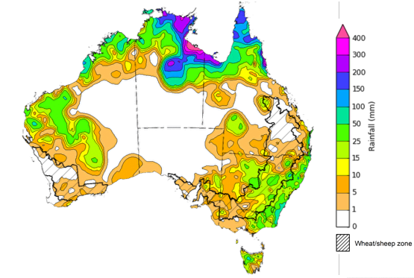

©Commonwealth of Australia 2024, Australian Bureau of Meteorology Issued: 20/03/2024

Note: The rainfall analyses and associated maps utilise data contained in the Bureau of Meteorology climate database, the Australian Data Archive for Meteorology (ADAM). The analyses are initially produced automatically from real-time data with limited [quality control](http://www.bom.gov.au/climate/headers/qc.shtml). They are intended to provide a general overview of rainfall across Australia as quickly as possible after the observations are received. For further information go to <http://www.bom.gov.au/climate/rainfall/>

### Rainfall forecast for the next eight days

Over the 8 days to 28 March 2024, low pressure systems are expected to generate rainfall totals of up to 300 millimetres across most of the northern half of the country. High pressure systems will keep the southern half of the country generally dry. A cold front will result in rainfall in western Tasmania.

Across cropping regions, rainfall totals up to 100 millimetres are forecast for Queensland and up to 50 millimetres in northern New South Wales. If realised, these falls will boost soil moisture levels for pasture growth and prepare the season for the winter crops. However, the expected rainfall is likely to interrupt harvest of summer crops. Little to no rainfall is expected across the remaining cropping regions. With drier conditions in the recent weeks, particularly in South Australia and Victoria, soil moisture levels are likely to continue declining.

#### Total forecast rainfall for the period 21 March to 28 March 2024

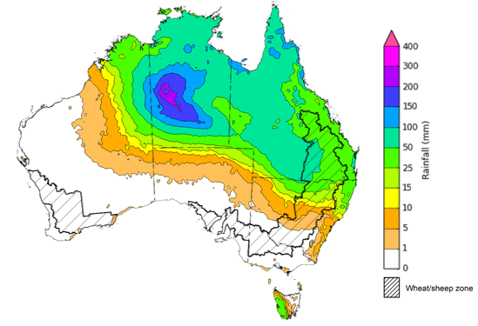

©Commonwealth of Australia 2024, Australian Bureau of Meteorology Issued 21/03/2024

Note: This rainfall forecast is produced from computer models. As the model outputs are not altered by weather forecasters, it is important to check local forecasts and warnings issued by the Bureau of Meteorology.

### Global production conditions and climate outlook

Crop production is affected by long-term trends in average rainfall and temperature, interannual climate variability, shocks during specific growth stages, and extreme weather events. Some crops are more tolerant than others to certain types of stresses, and at each growth stage, different types of stresses affect each crop species in different ways.

The precipitation anomalies and outlooks presented here give an indication of the current and future state of production conditions for the major grain and oilseed producing countries which are responsible for over 80% of global production. This is an important input to assessing the global grain supply outlook.

**February precipitation percentiles and current production conditions**

As of the end of February 2024, rainfall was mixed for the world’s major grain-producing and oilseed-producing regions.

Precipitation was below average across large parts of southern hemisphere cropping regions. Precipitation was average to above average in the most of northern hemisphere grain and oilseed producing regions.

**Global precipitation percentiles, February 2024**

Note: The world precipitation percentiles indicate a ranking of precipitation for February, with the driest (0th percentile) being 0 on the scale and the wettest (100th percentile) being 1 on the scale. Percentiles are based on precipitation estimates from the NOAA Climate Prediction Center’s [Climate Anomaly Monitoring System Outgoing Precipitation Index](https://iridl.ldeo.columbia.edu/maproom/Global/Precipitation/Percentiles.html) dataset. Precipitation estimates for February 2024 are compared with rainfall recorded for that period during the 1981 to 2010 base period.

Source: International Research Institute for Climate and Society

As of 28 February 2024, global production conditions were generally favourable for rice, but variable for wheat, maize and soybeans.

* **Wheat**: In the northern hemisphere, winter wheat begins to break winter dormancy and enters early growth stage in the southern regions generally under variable conditions in parts of Europe, Ukraine, the Russian Federation, and north America.
* **Maize**: In the southern hemisphere, harvesting of the spring-planted crop is continuing under dry conditions in Brazil as conditions improve in Argentina. Dry conditions develop in South Africa, which may present a downside risk.
* **Rice**: In India, transplanting of the Rabi crop continues in the east under favourable conditions. In Bangladesh, Boro season rice is favourable. In southeast Asia, conditions are favourable in Indonesia as dry conditions develop in Thailand and the Philippines.
* **Soybeans**: In the southern hemisphere, harvesting is continuing in Brazil under dry conditions and recent rainfall improves crops in Argentina.

**Crop conditions, AMIS countries, 28 February 2024**

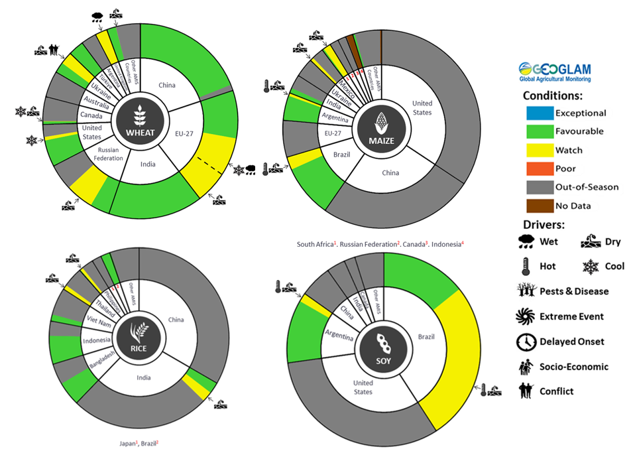

**AMIS** Agricultural Market Information System.

Source: AMIS

The global climate outlook for April 2024 to June 2024 indicates that mixed rainfall conditions are expected for the world’s major grain-producing and oilseed-producing regions. Outlooks and potential production impacts for the major grain and oilseed producing countries are presented in the table.

**Rainfall outlook and potential impact on the future state of production conditions between** **April 2024 to June 2024**

|  |  |  |
| --- | --- | --- |
| **Region** | **April-June rainfall outlook** | **Potential impact on production** |
| **Argentina** | Below average rainfall is more likely across western parts of Argentina between April and June 2024. Generally, average rainfall is likely in the eastern half of the country. | Average rainfall in the east is likely to be sufficient to support the development of sorghum, rice, millet, and the planting of wheat in May 2024. |
| **Black Sea Region** | Average to above average rainfall is likely for Ukraine, Türkiye and the Russian Federation. | Above average rainfall in Ukraine and Türkiye may support winter wheat and canola development, as well as cotton, corn and sunflower planting from March 2024. Average or above average rainfall across the Russian Federation is likely to support similar crops in the south and the planting and development of spring wheat planting in the north from April 2024. |
| **Brazil** | Below average rainfall is more likely across much of Brazil, with exceptions in the eastern areas where average to above average rainfall is likely. | Below average rainfall across southern and central western Brazil is likely to hinder the development of cotton and corn, and the harvesting of soybeans. Below average rainfall in the south is likely to hinder the development and harvesting of rice, sorghum, millet, sunflower, soybeans, cotton, nuts and corn, and the planting of wheat in May 2024. |
| **Canada** | Generally, average to above average rainfall is more likely across much of central and southern Canada between April and June 2024. | Average rainfall is likely to be sufficient to support winter wheat development in Canada from March 2024 and the planting of spring wheat, canola, corn, soybeans and sunflower from May 2024. |
| **China** | Average to above average rainfall is more likely across much of central and eastern China while below average rainfall is more likely across parts of southern China. | Average to above average rainfall across much China is likely to support the development of winter wheat and canola and the planting and development of early rice, single rice, cotton and spring wheat. Below average rainfall across southern China may affect the development of these crops from April 2024. |
| **Europe** | Average to above average rainfall is more likely for much of Europe between April and June 2024. | Average to above average rainfall across Europe is likely to support winter wheat and canola development and the planting and development of corn, cotton, spring wheat, April and June 2024. |
| **South Asia (India)** | Above average rainfall is more likely across much of southern India, while central India is likely to experience average rainfall. | Above average rainfall is likely to support the development of wheat and canola in India. |
| **Southeast Asia (SEA)** | Below average rainfall is likely across SEA. Above average rainfall is forecast for much of Indonesia. | Below average rainfall across most of Southeast Asia is likely to affect corn and rice planting, development and harvesting. Below average rainfall may adversely impact rice, corn and soybean production. Above average rainfall in Indonesia is likely to support the planting of spring wheat and rice. |
| **The United States of America (US)** | Average to above average rainfall is more likely for eastern half of US while below average to average rainfall is more likely in the isolated parts in the west. | Average or better rainfall in the US is likely to support winter wheat as it comes out of dormancy, as well as the planting and development of spring wheat, canola, corn, cotton, and rice. |

## **Water**

### Water markets – current week

Water storage levels in the Murray-Darling Basin (MDB) decreased between 14 March 2024 and 21 March 2024 by 166 gigalitres (GL). Current volume of water held in storage is 17 327 GL, equivalent to 78% of total storage capacity. This is 13 percent or 2539 GL less than at the same time last year.

#### Water storages in the Murray-Darling Basin, 2013–2024

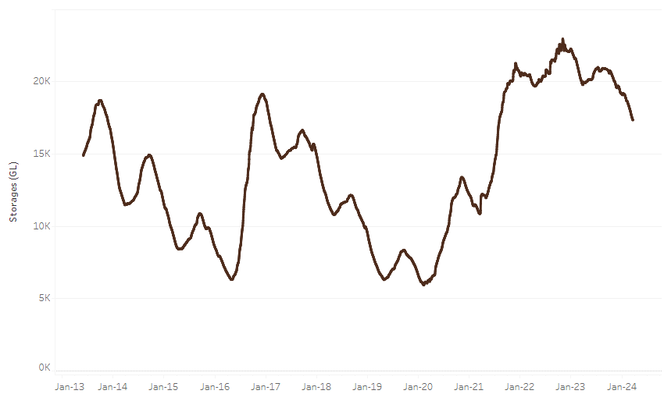

|  |
| --- |
| Water storage data is sourced from the Bureau of Meteorology. |

Allocation prices in the Victorian Murray below the Barmah Choke increased from $27 on 14 March 2024 to $30 on 21 March 2024. Prices are lower in the Murrumbidgee and regions above the Barmah choke due to the binding of the Murrumbidgee export limit and Barmah choke trade constraint.

|  |  |
| --- | --- |
| **Region** | **$/ML** |
| NSW Murray Above | 18 |
| NSW Murrumbidgee | 24 |
| VIC Goulburn-Broken | 29 |
| VIC Murray Below | 30 |

#### Surface water trade activity, Southern Murray–Darling Basin

|  |
| --- |
| The trades shown reflect estimated market activity and do not encompass all register trades. The price is shown for the VIC Murray below the Barmah choke. Historical prices (before 1 July 2019) are ABARES estimates after removing outliers from BOM water register data. Prices after 1 July 2019 and prior to the 30 October 2019 reflect recorded transaction prices as sourced from Ruralco. Prices after the 30 October 2019 are sourced from Waterflow. Data for volume traded is sourced from the BOM water register. Only the price data shown is current on 21 March 2024. |

To access the full, interactive, weekly water dashboard, which contains the latest and historical water storage, water market and water allocation information, please visit <https://www.agriculture.gov.au/abares/products/weekly_update/weekly-update-21324>

## **Commodities**

|  |  |  |  |  |  |  |  |
| --- | --- | --- | --- | --- | --- | --- | --- |
| **Indicator** | **Week ended** | **Unit** | **Latest Price** | **Previous Week** | **Weekly change** | **Price 12 months ago** | **Annual change** |
| **Selected world indicator prices** |  |  |  |  |  |  |  |
| AUD/USD Exchange rate | 20-Mar | A$/US$ | 0.65 | 0.66 | -1% | 0.67 | -2% |
| Wheat – US no. 2 hard red winter wheat, fob Gulf | 20-Mar | US$/t | 269 | 274 | -2% | 388 | -31% |
| Corn – US no. 2 yellow corn, fob Gulf | 20-Mar | US$/t | 192 | 192 | 0% | 292 | -34% |
| Canola – Rapeseed, Canada, fob Vancouver | 20-Mar | US$/t | 505 | 498 | 1% | 619 | -18% |
| Cotton – Cotlook 'A' Index | 20-Mar | USc/lb | 99 | 100 | -2% | 92 | 7% |
| Sugar – Intercontinental Exchange, nearby futures, no.11 contract | 20-Mar | USc/lb | 21.6 | 21.6 | 0% | 21 | 2% |
| Wool – Eastern Market Indicator | 20-Mar | Ac/kg clean | 1,152 | 1,167 | -1% | 1,356 | -15% |
| Wool – Western Market Indicator | 20-Mar | Ac/kg clean | 1,289 | 1,298 | -1% | 1,487 | -13% |
| **Selected Australian grain export prices** |  |  |  |  |  |  |  |
| Milling Wheat – APW, Port Adelaide, SA | 20-Mar | A$/t | 393 | 399 | -1% | 470 | -16% |
| Feed Wheat – ASW, Port Adelaide, SA | 20-Mar | A$/t | 373 | 379 | -1% | 443 | -16% |
| Feed Barley – Port Adelaide, SA | 20-Mar | A$/t | 349 | 343 | 2% | 412 | -15% |
| Canola – Kwinana, WA | 20-Mar | A$/t | 688 | 683 | 1% | 925 | -26% |
| Grain Sorghum – Brisbane, QLD | 20-Mar | A$/t | 455 | 457 | 0% | 508 | -10% |
| **Selected domestic livestock indicator prices** |  |  |  |  |  |  |  |
| Beef – Eastern Young Cattle Indicator | 20-Mar | Ac/kg cwt | 575 | 593 | -3% | 674 | -15% |
| Mutton – Mutton indicator (18–24 kg fat score 2–3), Vic | 20-Mar | Ac/kg cwt | 240 | 232 | 4% | 308 | -22% |
| Lamb – National Trade Lamb Indicator | 20-Mar | Ac/kg cwt | 589 | 602 | -2% | 718 | -18% |
| Pig – Eastern Seaboard (60.1–75 kg), average of buyers & sellers | 06-Mar | Ac/kg cwt | 411 | 411 | 0% | 357 | 15% |
| Goats – Eastern States (10.1–12 kg) | 27-Dec | Ac/kg cwt | 170 | 170 | 0% | 350 | -51% |
| Live cattle – Light steers to Indonesia | 20-Mar | Ac/kg lwt | 350 | 350 | 0% | 390 | -10% |
| **Global Dairy Trade (GDT) weighted average prices a** |  |  |  |  |  |  |  |
| Dairy – Whole milk powder | 20-Mar | US$/t | 3,143 | 3,286 | -4% | 3,277 | -4% |
| Dairy – Skim milk powder | 20-Mar | US$/t | 2,517 | 2,640 | -5% | 2,739 | -8% |
| Dairy – Cheddar cheese | 20-Mar | US$/t | 4,192 | 4,277 | -2% | 4,509 | -7% |
| Dairy – Anhydrous milk fat | 20-Mar | US$/t | 6,794 | 6,637 | 2% | 5,340 | 27% |
| **a** Global Dairy Trade prices are updated twice monthly on the first and third Tuesday of each month. | | | | | | | |

### Selected world indicator prices

### Selected domestic crop indicator prices

### Selected domestic livestock indicator prices

### Global Dairy Trade (GDT) weighted average prices

### Selected fruit and vegetable prices

### 3.6 Selected domestic fodder indicator prices

## **4. Data attribution**

### Climate

Bureau of Meteorology

* Weekly rainfall totals: www.bom.gov.au/climate/maps/rainfall/
* Monthly and last 3-month rainfall percentiles: [www.bom.gov.au/water/landscape/](http://www.bom.gov.au/water/landscape/)
* Temperature anomalies: [www.bom.gov.au/jsp/awap/temp/index.jsp](http://www.bom.gov.au/jsp/awap/temp/index.jsp)
* Rainfall forecast: [www.bom.gov.au/jsp/watl/rainfall/pme.jsp](http://www.bom.gov.au/jsp/watl/rainfall/pme.jsp)
* Seasonal outlook: [www.bom.gov.au/climate/outlooks/#/overview/summary/](http://www.bom.gov.au/climate/outlooks/#/overview/summary/)
* Climate drivers: <http://www.bom.gov.au/climate/enso/>
* Soil moisture: [www.bom.gov.au/water/landscape/](http://www.bom.gov.au/water/landscape/)

Other

* Pasture growth: [www.longpaddock.qld.gov.au/aussiegrass/](http://www.longpaddock.qld.gov.au/aussiegrass/)
* 3-month global outlooks: [Environment and Climate Change Canada](https://weather.gc.ca/saisons/image_e.html?img=s234pfe1p_cal&bc=prob), [NOAA Climate Prediction Center](https://www.cpc.ncep.noaa.gov/products/predictions/long_range/seasonal.php?lead=2), [EUROBRISA CPTEC/INPE](http://eurobrisa.cptec.inpe.br/), European Centre for Medium-Range Weather Forecasts, [Hydrometcenter of Russia](https://meteoinfo.ru/en/climate/seasonal-forecasts), [National Climate Center Climate System Diagnosis and Prediction Room (NCC)](https://cmdp.ncc-cma.net/pred/cs2gen.php?pred_elem=RAINP#pred_seasonal), [International Research Institute for Climate and Society](https://iri.columbia.edu/our-expertise/climate/forecasts/seasonal-climate-forecasts/)
* Global production: <https://ipad.fas.usda.gov/ogamaps/cropmapsandcalendars.aspx>
* Autumn break: Pook et al., 2009, <https://rmets-onlinelibrary-wiley-com.virtual.anu.edu.au/doi/epdf/10.1002/joc.1833>

### Water

Prices

* Waterflow: <https://www.waterflow.io/>
* Ruralco: <https://www.ruralcowater.com.au/>

Bureau of Meteorology:

* Allocation trade: <http://www.bom.gov.au/water/dashboards/#/water-markets/mdb/at>
* Storage volumes: <http://www.bom.gov.au/water/dashboards/#/water-storages/summary/drainage>

Trade constraints:

* Water NSW: <https://www.waternsw.com.au/customer-service/ordering-trading-and-pricing/trading/murrumbidgee>
* Victorian Water Register: <https://www.waterregister.vic.gov.au/TradingRules2019/>

### Commodities

Fruit and vegetables

* Datafresh: [www.freshstate.com.au](http://www.freshstate.com.au)

Pigs

* Australian Pork Limited: [www.australianpork.com.au](http://www.australianpork.com.au)

Dairy

* Global Dairy Trade: [www.globaldairytrade.info/en/product-results/](http://www.globaldairytrade.info/en/product-results/)

World wheat, canola

* International Grains Council

World coarse grains

* United States Department of Agriculture

World cotton

* Cotlook: [www.cotlook.com/](http://www.cotlook.com/)

World sugar

* New York Stock Exchange - Intercontinental Exchange

Wool

* Australian Wool Exchange: [www.awex.com.au/](http://www.awex.com.au/)

Domestic wheat, barley, sorghum, canola and fodder

* Jumbuk Consulting Pty Ltd: http://www.jumbukag.com.au/

Cattle, beef, mutton, lamb, goat and live export

* Meat and Livestock Australia: www.mla.com.au/Prices-and-market

© Commonwealth of Australia 2023

### Ownership of intellectual property rights

Unless otherwise noted, copyright (and any other intellectual property rights, if any) in this publication is owned by the Commonwealth of Australia (referred to as the Commonwealth).

### Creative Commons licence

All material in this publication is licensed under a [Creative Commons Attribution 4.0 International Licence](https://creativecommons.org/licenses/by/4.0/legalcode) except content supplied by third parties, logos and the Commonwealth Coat of Arms.

Inquiries about the licence and any use of this document should be emailed to [copyright@awe.gov.au](mailto:copyright@awe.gov.au).

https://www.agriculture.gov.au/sites/default/files/images/creative-commons-logo-small.png

### Cataloguing data

This publication (and any material sourced from it) should be attributed as:

ABARES 2023, Weekly Australian Climate, Water and Agricultural Update, Australian Bureau of Agricultural and Resource Economics and Sciences, Canberra, 21 March 2024. CC BY 4.0 DOI: <https://doi.org/10.25814/5f3e04e7d2503>

ISSN **2652-7561**

This publication is available at https://www.agriculture.gov.au/abares/products/weekly_update

Department of Agriculture, Fisheries and Forestry

GPO Box 858 Canberra ACT 2601

Telephone 1800 900 090

Web [agriculture.gov.au/abares](http://awe.gov.au/abares)

### Disclaimer

The Australian Government acting through the Department of Agriculture, Fisheries and Forestry, represented by the Australian Bureau of Agricultural and Resource Economics and Sciences, has exercised due care and skill in preparing and compiling the information and data in this publication. Notwithstanding, the Department of Agriculture, Fisheries and Forestry, ABARES, its employees and advisers disclaim all liability, including liability for negligence and for any loss, damage, injury, expense or cost incurred by any person as a result of accessing, using or relying on any of the information or data in this publication to the maximum extent permitted by law.

### Statement of Professional Independence

The views and analysis presented in ABARES publications, including this one, reflect ABARES professionally independent findings, based on scientific and economic concepts, principles, information and data. These views, analysis and findings may not reflect or be consistent with the views or positions of the Australian Government, or of organisations or groups who have commissioned ABARES reports or analysis. More information on [professional independence](https://www.agriculture.gov.au/abares/about/research-and-analysis#professional-independence) is provided on the ABARES website.

### Acknowledgements

This report was prepared by Kavina Dayal, Holly Beale and Matthew Miller.