## No. 9/2024 7 March 2024

# Summary of key issues

* In the week ending 6 March 2024, rainfall was recorded across the majority of the mainland.
* Over the coming days, widespread storms and showers are forecast for much of northern Australia and Western Australia. Southerly onshore winds will bring showers to coastal New South Wales and Queensland. A cold front will bring showers to the western Tasmania.
  + A dry week in Queensland and New South Wales will support uninterrupted harvest of early planted summer crops.
  + If realized, forecast rainfall for a fourth week in a row across Western Australian cropping regions will provide some boost to soil moisture levels following several months of dryness. However, additional rainfall during the forthcoming autumn months will be imperative for adequately preparing for the winter cropping season.
* February 2024 rainfall across Western Australia and New South Wales was predominantly average to above average, whereas Queensland cropping regions observed generally average rainfall. South Australia and much of Victoria had extremely low rainfall for February.
* Upper and lower levels of soil moisture are average to extremely high across cropping regions with exceptions in South Australia and western Victoria and southern Western Australia where upper layer soil moisture is deficient. Current levels of lower layer soil moisture are expected to provide a solid foundation for the upcoming winter cropping season.
* Average to extremely high pasture production occurred across much of eastern and northern parts of the country. This will likely enable farmers to continue to maintain current stock numbers and provide opportunities to build standing dry matter availability.
* Water storage levels in the Murray-Darling Basin (MDB) decreased between 29 February 2024 and 7 March 2024 by 197 gigalitres (GL). Current volume of water held in storage is 17 819 GL, equivalent to 80% of total storage capacity. This is 12 percent or 2488 GL less than at the same time last year.
* Allocation prices in the Victorian Murray below the Barmah Choke increased from $25 on 29 February 2024 to $26 on 7 March 2024. Prices are lower in the Murrumbidgee and regions above the Barmah choke due to the binding of the Murrumbidgee export limit and Barmah choke trade constraint.

## **Climate**

### Rainfall this week

For the week ending 6 March 2024, extensive storms and showers linked with the monsoon trough were recorded across much of northern Australia and Western Australia. A sequence of troughs traversed Western Australia, Queensland, the Northern Territory, South Australia, and New South Wales, precipitating widespread showers and isolated thunderstorms across the majority of the mainland. A cold front moved across Tasmania, resulting in rainfall across the state.

In cropping regions, rainfall totals of up to 100 millimetres were recorded across large areas of Western Australia. This marks the third consecutive week of rainfall in Western Australia following a prolonged period of dryness. While these rainfall events likely provided respite from the preceding dry spell in Western Australia's cropping regions, further rainfall will still be necessary to bolster moisture levels before the commencement of winter crop planting.

Rainfall totals reaching up to 50 millimetres were recorded in both western and eastern Queensland, as well as in central New South Wales. These falls will further enhance the yield potential of summer crops in Queensland. Moreover, they will contribute to sustaining soil moisture levels to support pasture growth and consolidate soil moisture reserves in preparation for the forthcoming winter cropping season.

In contrast, cropping regions in South Australia, Victoria, and southern New South Wales remained dry during this week.

#### Rainfall for the week ending 6 March 2024

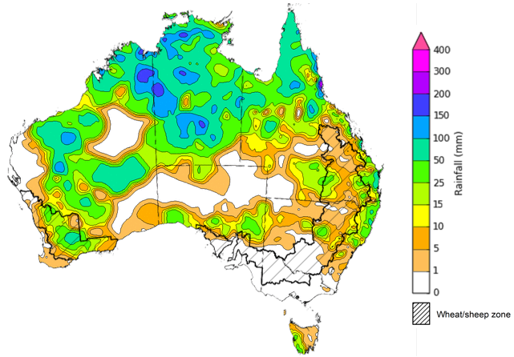

©Commonwealth of Australia 2024, Australian Bureau of Meteorology Issued: 6/03/2024

Note: The rainfall analyses and associated maps utilise data contained in the Bureau of Meteorology climate database, the Australian Data Archive for Meteorology (ADAM). The analyses are initially produced automatically from real-time data with limited [quality control](http://www.bom.gov.au/climate/headers/qc.shtml). They are intended to provide a general overview of rainfall across Australia as quickly as possible after the observations are received. For further information go to <http://www.bom.gov.au/climate/rainfall/>

### Rainfall forecast for the next eight days

Over the 8 days to 14 March 2024, widespread storms and showers are forecast for much of Western Australia and Australia’s tropical north. Southerly onshore winds are expected to bring showers to parts of eastern New South Wales and Queensland. Meanwhile, a cold front is expected to bring showers to western Tasmania. A high-pressure system is likely to keep much of the remainder of the country mainly dry.

Across cropping regions, rainfall totals up to 10 millimetres are forecast for northern Queensland and parts of eastern New South Wales and southern Victoria. If realised, these falls will continue to benefit soil moisture levels for pasture growth and support the growth of long season and later sown summer crops. With the harvest of early planted summer crop now underway, dry conditions over the next 8-days would support an uninterrupted harvest.

For the fourth week in a row large area of Western Australia are expected to receive up to 50 millimetres of rainfall. If realised, these falls will continue to build soil moisture levels ahead of the upcoming winter cropping season. However, timely falls will be required closer to planting of winter crops to consolidate this recent boost in soil moisture.

Little to no rainfall is expected across remaining cropping regions.

#### Total forecast rainfall for the period 7 March to 14 March 2024

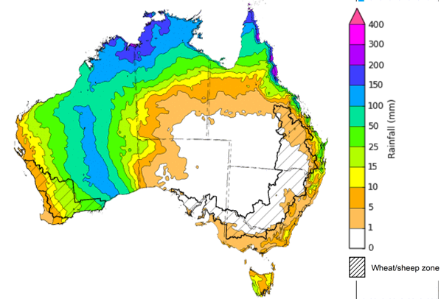

©Commonwealth of Australia 2024, Australian Bureau of Meteorology Issued 7/03/2024

Note: This rainfall forecast is produced from computer models. As the model outputs are not altered by weather forecasters, it is important to check local forecasts and warnings issued by the Bureau of Meteorology.

### Monthly rainfall

Rainfall during February 2024 was generally above average to extremely high for parts of northern, eastern and south-western Australia, and below average across most of central Western Australia, western and southern South Australia and Victoria, and Tasmania.

In cropping regions, rainfall across Western Australia and New South Wales was predominantly average to above average, whereas Queensland cropping regions observed generally average rainfall. In contrast, February rainfall was generally extremely low in South Australia and much of Victoria.

The eastern cropping regions benefited from rainfall levels surpassing the average, fortifying soil moisture reserves that were previously established by the moist conditions of December and January. Although the rainfall observed in the western agricultural regions during February provided some relief from preceding dry spells, additional rainfall during the forthcoming autumn months will be imperative for adequately preparing for the winter cropping season.

**Rainfall percentiles for February 2024**

Note: Rainfall for February 2024 is compared with rainfall recorded for that period during the historical record (1900 to present). For further information, go to <http://www.bom.gov.au/jsp/awap/>

Source: Bureau of Meteorology

### Monthly soil moisture

Upper layer soil moisture levels for February 2024 varied considerably throughout Australia. Extremely low upper layer soil moisture was modelled for much of western and southern Victoria, southern parts of South Australia, and expansive areas in central, southeastern, and northern Western Australia, and Tasmania. In contrast, upper layer soil moisture levels were modelled to be above average for north-eastern South Australia, central New South Wales, a significant portion of Queensland, and the northern regions of the Northern Territory. Average levels of upper-layer soil moisture were modelled for the remaining areas of Australia.

During this time of the year, the status of upper layer soil moisture assumes critical importance for late-planted summer crops in northern New South Wales and Queensland, as well as for pasture growth throughout northern Australia, given that plant germination and establishment heavily rely on this moisture. It is also an important indicator of the ability to access paddocks for the harvesting of early planted summer crops.

Across cropping regions, upper layer soil moisture was generally at or above average levels for this time of the year, with exceptions noted in South Australia, large areas of western Victoria, and the southern margins of Western Australia, where it was markedly deficient.

**Modelled upper layer soil moisture for February 2024**

Note: This map shows the levels of modelled upper layer soil moisture (0 to 10 centimetres) during February 2024. This map shows how modelled soil conditions during February 2024 compare with February conditions modelled over the reference period (1911 to 2016). Dark blue areas on the maps were much wetter in February 2024 than during the reference period. The bulk of plant roots occur in the top 20 centimetres of the soil profile. Soil moisture in the upper layer of the soil profile is therefore useful indicator of the availability of water, particularly for germinating seed.

Source: Bureau of Meteorology ([Australian Water Resources Assessment Landscape model](http://www.bom.gov.au/water/landscape/))

Lower layer soil moisture plays a pivotal role in sustaining the growth of summer crops and pasture during their peak development stages. Across much of the country, lower layer soil moisture ranged from average to above average in February. However, areas of below average lower layer soil moisture were evident across parts of north-western and southern Western Australia, portions of southern Northern Territory, western South Australia, southern Victoria, and throughout eastern Tasmania.

Within Australian cropping regions, lower layer soil moisture was generally average to very much above average. Notable exceptions being parts of central South Australia, southern Western Australia, and scattered areas of north-eastern New South Wales, where levels fell below the average range. These elevated levels of lower layer soil moisture are expected to sustain above average yield prospects for summer crops across New South Wales and southern Queensland and promote strong pasture growth rates across much of eastern and northern Australia. Additionally, these current levels of lower layer soil moisture are expected to provide a solid foundation for the upcoming winter cropping season.

**Modelled lower layer soil moisture for February 2024**

Note: This map shows the levels of modelled lower layer soil moisture (10 to 100 centimetres) during February 2024. This map shows how modelled soil conditions during February 2024 compare with February conditions modelled over the reference period (1911 to 2016). Dark blue areas on the maps were much wetter in February 2024 than during the reference period. The dark red areas were much drier than during the reference period. The bulk of plant roots occur in the top 20 centimetres of the soil profile. The lower layer soil moisture is a larger, deeper store that is slower to respond to rainfall and tends to reflect accumulated rainfall events over longer time periods.

Source: Bureau of Meteorology ([Australian Water Resources Assessment Landscape model](http://www.bom.gov.au/water/landscape/))

### Pasture growth

December to February is the peak pasture growth period for northern Australia which typically provides the bulk of feed to maintain production through the low pasture growth months of the northern dry season. Across southern Australia, December to February pasture growth is typically low reflecting lower rainfall totals, high temperatures and high evapotranspiration rates at this time of year. Pasture availability during this period influences the growth, branding and marking rates of lambs and calves, livestock turnoff and the production of meat, milk, and wool.

For the 3 months to February 2024, above average rainfall totals and mild summer temperatures resulted in average to well above average pasture production for this time of year across most grazing regions. However, extremely low to below average pasture growth rates were recorded across parts of central Australia, and northwest and southern parts of Western Australia, western Tasmania and across relatively small area in the northeast New South Wales.

Average to extremely high pasture production occurred across much of eastern and northern parts of the country. This will likely enable farmers to continue to maintain current stock numbers and provide opportunities to build standing dry matter availability.

#### Relative pasture growth for 3-months ending February 2024 (1 December to 29 February 2024)

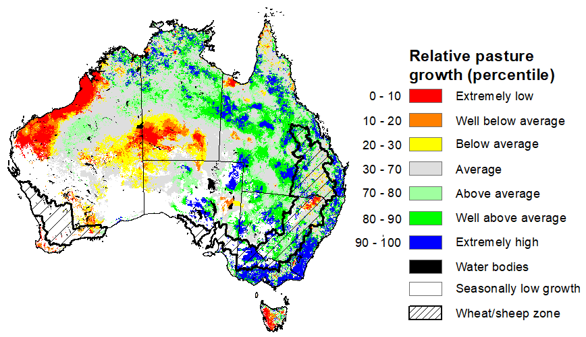

Notes: AussieGRASS pasture growth estimates are relative to the long-term record and shown in percentiles. Percentiles rank data on a scale of zero to 100. This analysis ranks pasture growth for the selected period against average pasture growth for the long-term record (1957 to 2016). Pasture growth is modelled at 5km2 grid cells.

Source: Queensland Department of Science, Information Technology and Innovation

## **Water**

### Water markets – current week

Water storage levels in the Murray-Darling Basin (MDB) decreased between 29 February 2024 and 7 March 2024 by 197 gigalitres (GL). Current volume of water held in storage is 17 819 GL, equivalent to 80% of total storage capacity. This is 12 percent or 2488 GL less than at the same time last year.

#### Water storages in the Murray-Darling Basin, 2013–2024

|  |
| --- |
| Water storage data is sourced from the Bureau of Meteorology. |

Allocation prices in the Victorian Murray below the Barmah Choke increased from $25 on 29 February 2024 to $26 on 7 March 2024. Prices are lower in the Murrumbidgee and regions above the Barmah choke due to the binding of the Murrumbidgee export limit and Barmah choke trade constraint.

|  |  |
| --- | --- |
| **Region** | **$/ML** |
| NSW Murray Above | 12 |
| NSW Murrumbidgee | 24 |
| VIC Goulburn-Broken | 25 |
| VIC Murray Below | 26 |

#### Surface water trade activity, Southern Murray–Darling Basin

|  |
| --- |
| The trades shown reflect estimated market activity and do not encompass all register trades. The price is shown for the VIC Murray below the Barmah choke. Historical prices (before 1 July 2019) are ABARES estimates after removing outliers from BOM water register data. Prices after 1 July 2019 and prior to the 30 October 2019 reflect recorded transaction prices as sourced from Ruralco. Prices after the 30 October 2019 are sourced from Waterflow. Data for volume traded is sourced from the BOM water register. Only the price data shown is current on 7 March 2024. |

To access the full, interactive, weekly water dashboard, which contains the latest and historical water storage, water market and water allocation information, please visit <https://www.agriculture.gov.au/abares/products/weekly_update/weekly-update-70324>

## **Commodities**

|  |  |  |  |  |  |  |  |
| --- | --- | --- | --- | --- | --- | --- | --- |
| **Indicator** | **Week ended** | **Unit** | **Latest Price** | **Previous Week** | **Weekly change** | **Price 12 months ago** | **Annual change** |
| **Selected world indicator prices** |  |  |  |  |  |  |  |
| AUD/USD Exchange rate | 06-Mar | A$/US$ | 0.65 | 0.65 | 0% | 0.67 | -2% |
| Wheat – US no. 2 hard red winter wheat, fob Gulf | 06-Mar | US$/t | 280 | 278 | 1% | 365 | -23% |
| Corn – US no. 2 yellow corn, fob Gulf | 06-Mar | US$/t | 187 | 184 | 1% | 281 | -33% |
| Canola – Rapeseed, Canada, fob Vancouver | 06-Mar | US$/t | 473 | 471 | 1% | 607 | -22% |
| Cotton – Cotlook 'A' Index | 06-Mar | USc/lb | 102 | 104 | -2% | 94 | 8% |
| Sugar – Intercontinental Exchange, nearby futures, no.11 contract | 06-Mar | USc/lb | 20.7 | 21.7 | -4% | 20 | 2% |
| Wool – Eastern Market Indicator | 06-Mar | Ac/kg clean | 1,172 | 1,158 | 1% | 1,341 | -13% |
| Wool – Western Market Indicator | 06-Mar | Ac/kg clean | 1,308 | 1,287 | 2% | 1,486 | -12% |
| **Selected Australian grain export prices** |  |  |  |  |  |  |  |
| Milling Wheat – APW, Port Adelaide, SA | 06-Mar | A$/t | 433 | 428 | 1% | 483 | -10% |
| Feed Wheat – ASW, Port Adelaide, SA | 06-Mar | A$/t | 410 | 406 | 1% | 455 | -10% |
| Feed Barley – Port Adelaide, SA | 06-Mar | A$/t | 352 | 353 | 0% | 407 | -13% |
| Canola – Kwinana, WA | 06-Mar | A$/t | 701 | 713 | -2% | 971 | -28% |
| Grain Sorghum – Brisbane, QLD | 06-Mar | A$/t | 463 | 460 | 1% | 514 | -10% |
| **Selected domestic livestock indicator prices** |  |  |  |  |  |  |  |
| Beef – Eastern Young Cattle Indicator | 06-Mar | Ac/kg cwt | 628 | 629 | 0% | 699 | -10% |
| Mutton – Mutton indicator (18–24 kg fat score 2–3), Vic | 06-Mar | Ac/kg cwt | 267 | 299 | -11% | 300 | -11% |
| Lamb – National Trade Lamb Indicator | 06-Mar | Ac/kg cwt | 613 | 620 | -1% | 705 | -13% |
| Pig – Eastern Seaboard (60.1–75 kg), average of buyers & sellers | 21-Feb | Ac/kg cwt | 411 | 411 | 0% | 367 | 12% |
| Goats – Eastern States (10.1–12 kg) | 27-Dec | Ac/kg cwt | 170 | 170 | 0% | 350 | -51% |
| Live cattle – Light steers to Indonesia | 06-Mar | Ac/kg lwt | 350 | 345 | 1% | 400 | -13% |
| **Global Dairy Trade (GDT) weighted average prices a** |  |  |  |  |  |  |  |
| Dairy – Whole milk powder | 06-Mar | US$/t | 3,286 | 3,388 | -3% | 3,264 | 1% |
| Dairy – Skim milk powder | 06-Mar | US$/t | 2,640 | 2,788 | -5% | 2,769 | -5% |
| Dairy – Cheddar cheese | 06-Mar | US$/t | 4,277 | 4,143 | 3% | 5,086 | -16% |
| Dairy – Anhydrous milk fat | 06-Mar | US$/t | 6,637 | 6,552 | 1% | 5,447 | 22% |
| **a** Global Dairy Trade prices are updated twice monthly on the first and third Tuesday of each month. | | | | | | | |

### Selected world indicator prices

### Selected domestic crop indicator prices

### Selected domestic livestock indicator prices

### Global Dairy Trade (GDT) weighted average prices

### Selected fruit and vegetable prices

### 3.6 Selected domestic fodder indicator prices

## **4. Data attribution**

### Climate

Bureau of Meteorology

* Weekly rainfall totals: www.bom.gov.au/climate/maps/rainfall/
* Monthly and last 3-month rainfall percentiles: [www.bom.gov.au/water/landscape/](http://www.bom.gov.au/water/landscape/)
* Temperature anomalies: [www.bom.gov.au/jsp/awap/temp/index.jsp](http://www.bom.gov.au/jsp/awap/temp/index.jsp)
* Rainfall forecast: [www.bom.gov.au/jsp/watl/rainfall/pme.jsp](http://www.bom.gov.au/jsp/watl/rainfall/pme.jsp)
* Seasonal outlook: [www.bom.gov.au/climate/outlooks/#/overview/summary/](http://www.bom.gov.au/climate/outlooks/#/overview/summary/)
* Climate drivers: <http://www.bom.gov.au/climate/enso/>
* Soil moisture: [www.bom.gov.au/water/landscape/](http://www.bom.gov.au/water/landscape/)

Other

* Pasture growth: [www.longpaddock.qld.gov.au/aussiegrass/](http://www.longpaddock.qld.gov.au/aussiegrass/)
* 3-month global outlooks: [Environment and Climate Change Canada](https://weather.gc.ca/saisons/image_e.html?img=s234pfe1p_cal&bc=prob), [NOAA Climate Prediction Center](https://www.cpc.ncep.noaa.gov/products/predictions/long_range/seasonal.php?lead=2), [EUROBRISA CPTEC/INPE](http://eurobrisa.cptec.inpe.br/), European Centre for Medium-Range Weather Forecasts, [Hydrometcenter of Russia](https://meteoinfo.ru/en/climate/seasonal-forecasts), [National Climate Center Climate System Diagnosis and Prediction Room (NCC)](https://cmdp.ncc-cma.net/pred/cs2gen.php?pred_elem=RAINP#pred_seasonal), [International Research Institute for Climate and Society](https://iri.columbia.edu/our-expertise/climate/forecasts/seasonal-climate-forecasts/)
* Global production: <https://ipad.fas.usda.gov/ogamaps/cropmapsandcalendars.aspx>
* Autumn break: Pook et al., 2009, <https://rmets-onlinelibrary-wiley-com.virtual.anu.edu.au/doi/epdf/10.1002/joc.1833>

### Water

Prices

* Waterflow: <https://www.waterflow.io/>
* Ruralco: <https://www.ruralcowater.com.au/>

Bureau of Meteorology:

* Allocation trade: <http://www.bom.gov.au/water/dashboards/#/water-markets/mdb/at>
* Storage volumes: <http://www.bom.gov.au/water/dashboards/#/water-storages/summary/drainage>

Trade constraints:

* Water NSW: <https://www.waternsw.com.au/customer-service/ordering-trading-and-pricing/trading/murrumbidgee>
* Victorian Water Register: <https://www.waterregister.vic.gov.au/TradingRules2019/>

### Commodities

Fruit and vegetables

* Datafresh: [www.freshstate.com.au](http://www.freshstate.com.au)

Pigs

* Australian Pork Limited: [www.australianpork.com.au](http://www.australianpork.com.au)

Dairy

* Global Dairy Trade: [www.globaldairytrade.info/en/product-results/](http://www.globaldairytrade.info/en/product-results/)

World wheat, canola

* International Grains Council

World coarse grains

* United States Department of Agriculture

World cotton

* Cotlook: [www.cotlook.com/](http://www.cotlook.com/)

World sugar

* New York Stock Exchange - Intercontinental Exchange

Wool

* Australian Wool Exchange: [www.awex.com.au/](http://www.awex.com.au/)

Domestic wheat, barley, sorghum, canola and fodder

* Jumbuk Consulting Pty Ltd: http://www.jumbukag.com.au/

Cattle, beef, mutton, lamb, goat and live export

* Meat and Livestock Australia: www.mla.com.au/Prices-and-market

© Commonwealth of Australia 2023

### Ownership of intellectual property rights

Unless otherwise noted, copyright (and any other intellectual property rights, if any) in this publication is owned by the Commonwealth of Australia (referred to as the Commonwealth).

### Creative Commons licence

All material in this publication is licensed under a [Creative Commons Attribution 4.0 International Licence](https://creativecommons.org/licenses/by/4.0/legalcode) except content supplied by third parties, logos and the Commonwealth Coat of Arms.

Inquiries about the licence and any use of this document should be emailed to [copyright@awe.gov.au](mailto:copyright@awe.gov.au).

https://www.agriculture.gov.au/sites/default/files/images/creative-commons-logo-small.png

### Cataloguing data

This publication (and any material sourced from it) should be attributed as:

ABARES 2023, Weekly Australian Climate, Water and Agricultural Update, Australian Bureau of Agricultural and Resource Economics and Sciences, Canberra, 7 March 2024. CC BY 4.0 DOI: <https://doi.org/10.25814/5f3e04e7d2503>

ISSN **2652-7561**

This publication is available at https://www.agriculture.gov.au/abares/products/weekly_update

Department of Agriculture, Fisheries and Forestry

GPO Box 858 Canberra ACT 2601

Telephone 1800 900 090

Web [agriculture.gov.au/abares](http://awe.gov.au/abares)

### Disclaimer

The Australian Government acting through the Department of Agriculture, Fisheries and Forestry, represented by the Australian Bureau of Agricultural and Resource Economics and Sciences, has exercised due care and skill in preparing and compiling the information and data in this publication. Notwithstanding, the Department of Agriculture, Fisheries and Forestry, ABARES, its employees and advisers disclaim all liability, including liability for negligence and for any loss, damage, injury, expense or cost incurred by any person as a result of accessing, using or relying on any of the information or data in this publication to the maximum extent permitted by law.

### Statement of Professional Independence

The views and analysis presented in ABARES publications, including this one, reflect ABARES professionally independent findings, based on scientific and economic concepts, principles, information and data. These views, analysis and findings may not reflect or be consistent with the views or positions of the Australian Government, or of organisations or groups who have commissioned ABARES reports or analysis. More information on [professional independence](https://www.agriculture.gov.au/abares/about/research-and-analysis#professional-independence) is provided on the ABARES website.

### Acknowledgements

This report was prepared by Kavina Dayal and Matthew Miller.