## No. 6/2024 15 February 2024

# Summary of key issues

* In the week ending 14 February 2024, troughs generated showers in the tropics, extending into southern Queensland and northern New South Wales. Onshore winds brought showers to the coastal region of southeast Queensland and New South Wales. A high-pressure system kept elsewhere dry.
* Over the coming days, a monsoonal low-pressure system is expected to generate heavy rainfall of up to 300 millimetres in the tropical north. Onshore winds will bring showers to the eastern parts of the country. A high-pressure system will keep much of central and south-western areas of the country dry.
  + Rainfall in Queensland and New South Wales will continue to support development of summer crops and pasture growth but dry conditions elsewhere, particularly in Western Australia, will continue to see a decline in soil moisture levels. Significant rainfall in autumn will be required in these areas to support the planting of winter crops.
* Globally, variable rainfall during January has led to mixed crop production prospects.
  + Global production conditions were generally favourable for maize and soybeans, but variable for wheat and rice.
  + Global production conditions have generally improved, except for South America, compared to those used to formulate ABARES forecasts of global grain supplies and world prices for 2023-24 in its December 2023 edition of the Agricultural Commodities Report. As a result, global grain production is likely to be higher, but global oilseed production is expected to be lower than that forecast in December.
* Water storage levels in the Murray-Darling Basin (MDB) decreased between 7 February 2024 and 14 February 2024 by 125 gigalitres (GL). Current volume of water held in storage is 18 517 GL. This is 13 percent or 2652 GL less than at the same time last year.
* Allocation prices in the Victorian Murray below the Barmah Choke decreased from $42 on 8 February 2024 to $32 on 15 February 2024. Prices are lower in the Murrumbidgee, regions above the Barmah choke and the Goulburn-Broken due to the binding of the Murrumbidgee export limit, Barmah choke trade constraint, and the Goulburn intervalley trade limit.

## **Climate**

### Rainfall this week

For the week ending 14 February 2024, troughs generated showers in the tropics, extending into southern Queensland and northern New South Wales. Onshore winds brought showers to the coastal region of southeast Queensland and New South Wales. A high-pressure system kept elsewhere dry.

Across cropping regions, rainfall totals of up to 50 millimetres were recorded across parts of Queensland and New South Wales. These falls will continue to support the ongoing growth and lift the yield potential of summer crops. Additionally, these falls will help maintain soil moisture levels to support pasture growth and build reserves ahead of the upcoming winter cropping season. By contrast, Western Australia, South Australia, and western Victoria remained dry, with declining levels of soil moisture.

#### Rainfall for the week ending 14 February 2024

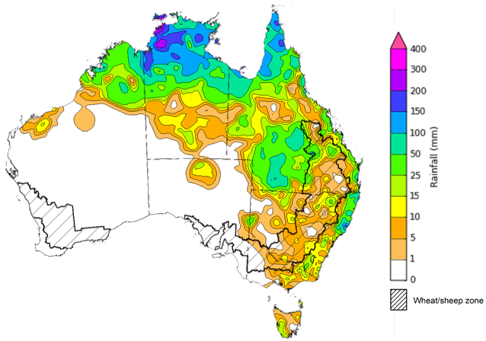

©Commonwealth of Australia 2024, Australian Bureau of Meteorology Issued: 14/02/2024

Note: The rainfall analyses and associated maps utilise data contained in the Bureau of Meteorology climate database, the Australian Data Archive for Meteorology (ADAM). The analyses are initially produced automatically from real-time data with limited [quality control](http://www.bom.gov.au/climate/headers/qc.shtml). They are intended to provide a general overview of rainfall across Australia as quickly as possible after the observations are received. For further information go to <http://www.bom.gov.au/climate/rainfall/>

### Rainfall forecast for the next eight days

Over the 8 days to 22 February 2024, a monsoonal low-pressure system is expected to generate heavy rainfall of up to 300 millimetres in the tropical north. Onshore winds will bring showers to the eastern parts of the country. A high-pressure system will keep much of central and south-western areas of the country dry.

Across cropping regions, rainfall totals up to 50 millimetres are forecast for Queensland and central and northern New South Wales and up to 10 millimetres in Victoria and southern New South Wales. If realised, these falls will continue to benefit soil moisture levels for pasture growth and support the growth of long season and later sown summer crops. With the harvest of early planted summer crop now underway, wet weather over the next 8-days is likely to result in some harvest delays.

Little to no rainfall is expected across remaining cropping regions. Western Australian cropping regions continue to experience dry conditions and declining soil moisture levels and will require significant rainfall during autumn to support the planting of winter crops.

#### Total forecast rainfall for the period 15 February to 22 February 2024

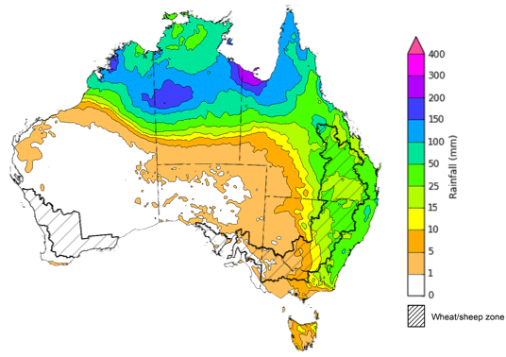

©Commonwealth of Australia 2024, Australian Bureau of Meteorology Issued 15/02/2024

Note: This rainfall forecast is produced from computer models. As the model outputs are not altered by weather forecasters, it is important to check local forecasts and warnings issued by the Bureau of Meteorology.

### Global production conditions and climate outlook

Crop production is affected by long-term trends in average rainfall and temperature, interannual climate variability, shocks during specific growth stages, and extreme weather events. Some crops are more tolerant than others to certain types of stresses, and at each growth stage, different types of stresses affect each crop species in different ways.

The precipitation anomalies and outlooks presented here give an indication of the current and future state of production conditions for the major grain and oilseed producing countries which are responsible for over 80% of global production. This is an important input to assessing the global grain supply outlook.

**January precipitation percentiles and current production conditions**

As of the end of January 2024, rainfall was mixed for the world’s major grain-producing and oilseed-producing regions.

The precipitation was below average across parts of South and North America. Precipitation was average to above average in the remaining grain and oilseed producing regions.

**Global precipitation percentiles, January 2024**

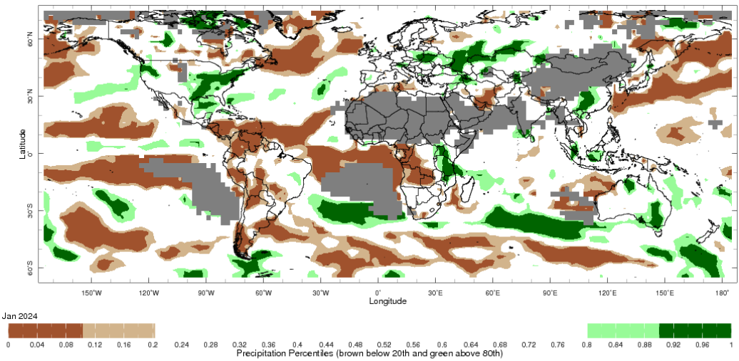

Note: The world precipitation percentiles indicate a ranking of precipitation for January, with the driest (0th percentile) being 0 on the scale and the wettest (100th percentile) being 1 on the scale. Percentiles are based on precipitation estimates from the NOAA Climate Prediction Center’s [Climate Anomaly Monitoring System Outgoing Precipitation Index](https://iridl.ldeo.columbia.edu/maproom/Global/Precipitation/Percentiles.html) dataset. Precipitation estimates for January 2024 are compared with rainfall recorded for that period during the 1981 to 2010 base period.

Source: International Research Institute for Climate and Society

As of 28 January 2024, global production conditions were generally favourable for maize and soybeans, but variable for wheat and rice. In the northern hemisphere, recent dry conditions have affected planting and crop establishment for wheat in Ukraine and the Russian Federation, but October rains have established favourable soil moisture for sowing and germination in Türkiye, UK and China. In the southern hemisphere, the area affected by dry conditions continues to expand in Brazil.

**Wheat**: in the southern hemisphere, harvesting is wrapping up in Argentina under mixed conditions as the earlier severe drought affected much of the country. In the northern hemisphere, winter wheat is experiencing mixed conditions in parts of Europe, the Black Sea region, the US, and Canada.

**Maize**: in the southern hemisphere, conditions are favourable in Argentina and South Africa while harvesting is beginning in Brazil for the spring-planted crop under mixed conditions. Conditions are favourable in India for the Rabi crop.

**Rice**: in India, transplanting of the Rabi crop continues. In Bangladesh, rice harvest is wrapping up and next season rice is sown. In Southeast Asia, wet-season rice is beginning in Indonesia as the sowing of dry-season rice ramps up in the northern countries.

**Soybeans**: in the southern hemisphere, harvesting is beginning in Brazil under mixed conditions as sowing is wrapping in Argentina under favourable conditions.

**Crop conditions, AMIS countries, 28 January 2024**

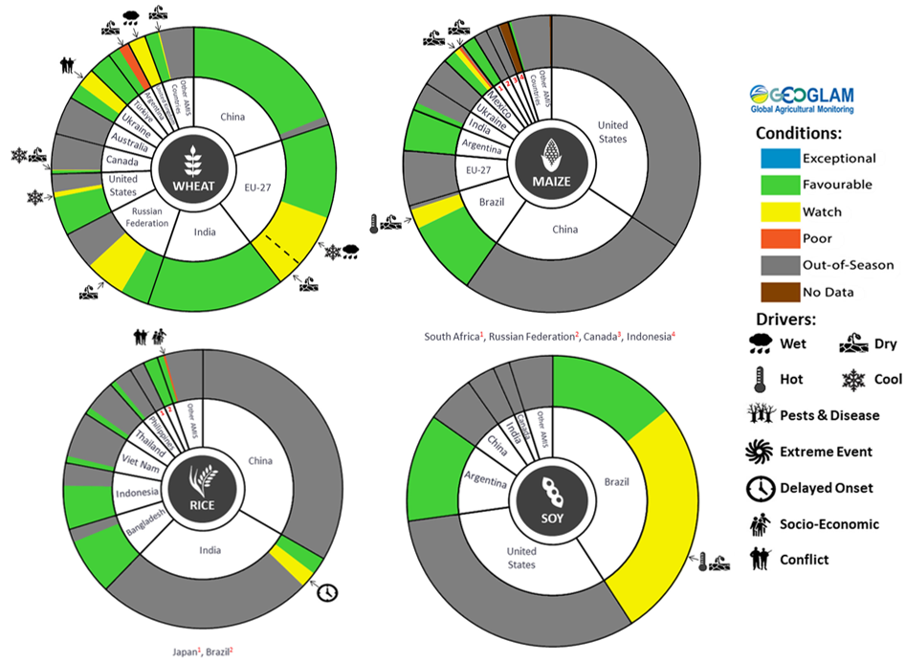

**AMIS** Agricultural Market Information System.

Source: AMIS

The global climate outlook for March 2024 to May 2024 indicates that mixed rainfall conditions are expected for the world’s major grain-producing and oilseed-producing regions. Outlooks and potential production impacts for the major grain and oilseed producing countries are presented in the table.

**Rainfall outlook and potential impact on the future state of production conditions between** **March 2024 to May 2024**

|  |  |  |
| --- | --- | --- |
| **Region** | **March-May rainfall outlook** | **Potential impact on production** |
| **Argentina** | Below average rainfall is more likely across western half of Argentina between March and May 2024. Average rainfall is likely in the eastern half of the country. | Below average rainfall is likely to hinder the development of sorghum, rice, millet, soybeans, corn, sunflower, cotton and nuts, and the planting of wheat in May 2024. |
| **Black Sea Region** | Above average rainfall is forecast for Kazakhstan, Ukraine and the Russian Federation. | Above average rainfall in parts of Kazakhstan and Ukraine may support winter wheat and canola development, as well as cotton, corn and sunflower planting from March 2024. Average or above normal rainfall across the Russian Federation is likely to support similar crops in the south and the planting and development of spring wheat planting in the north from April 2024. |
| **Brazil** | Below average rainfall is more likely across central and western Brazil while above average rainfall is more likely across parts of southern Brazil. | Below average rainfall across central Brazil is likely to hinder the development of cotton and corn, and the harvesting of soybeans. Above average rainfall in the south should support the development and harvesting of rice, sorghum, millet, sunflower, soybeans, cotton, nuts and corn, and the planting of wheat in May 2024. |
| **Canada** | Average to above average rainfall is more likely across much of Canada between March and May 2024 | Above rainfall is likely to support winter wheat development in Canada from March 2023 and the planting of spring wheat, canola, corn, soybeans and sunflower from May 2023. |
| **China** | Average to above average rainfall is more likely across much of China while below average rainfall is more likely across parts of southern China. | Average to above average rainfall across much China is likely to support the development of winter wheat and canola and the planting and development of early rice, single rice, cotton, spring wheat, corn, sorghum, soybeans, sunflower and nuts. Below average rainfall across southern China may affect the development of these crops from March 2024. |
| **Europe** | Average to above average rainfall is more likely for much of Europe between March and May 2024. | Average to above average rainfall across Europe is likely to support winter wheat and canola development and the planting and development of corn, cotton, spring wheat, soybeans, sunflower and sorghum between March and May 2024. |
| **South Asia (India)** | Average rainfall is more likely across much of India. | Average rainfall is likely to support the development of wheat and canola in India. |
| **Southeast Asia (SEA)** | Below average rainfall is likely across SEA. | Below average rainfall across most of Southeast Asia is likely to affect corn and rice planting, development and harvesting. Below average rainfall may adversely impact rice, corn and soybean production. |
| **The United States of America (US)** | Above average rainfall is more likely for eastern half of US while average rainfall is more likely for western half of US. | Average or better rainfall in the US is likely to support winter wheat as it comes out of dormancy, as well as the planting and development of spring wheat, canola, corn, cotton, rice, soybeans and nuts. |

## **Water**

### Water markets – current week

Water storage levels in the Murray-Darling Basin (MDB) decreased between 7 February 2024 and 14 February 2024 by 125 gigalitres (GL). Current volume of water held in storage is 18 517 GL. This is 13 percent or 2652 GL less than at the same time last year.

#### Water storages in the Murray-Darling Basin, 2013–2024

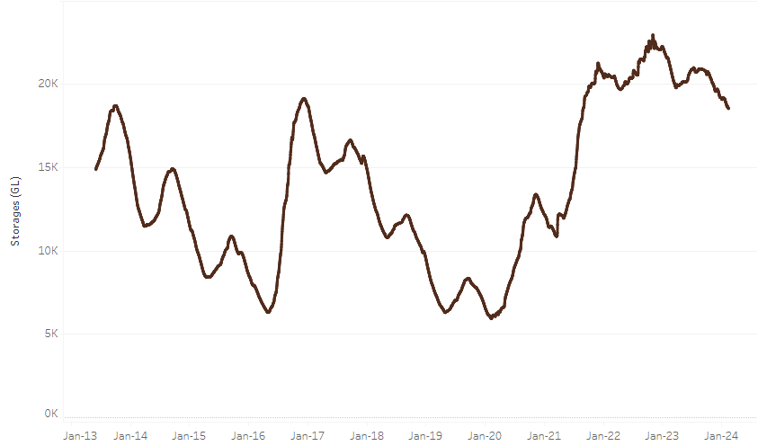

|  |
| --- |
| Water storage data is sourced from the Bureau of Meteorology. |

Allocation prices in the Victorian Murray below the Barmah Choke decreased from $42 on 8 February 2024 to $32 on 15 February 2024. Prices are lower in the Murrumbidgee, regions above the Barmah choke and the Goulburn-Broken due to the binding of the Murrumbidgee export limit, Barmah choke trade constraint, and the Goulburn intervalley trade limit.

|  |  |
| --- | --- |
| **Region** | **$/ML** |
| NSW Murray Above | 18 |
| NSW Murrumbidgee | 18 |
| VIC Goulburn-Broken | 27 |
| VIC Murray Below | 32 |

#### Surface water trade activity, Southern Murray–Darling Basin

|  |
| --- |
| The trades shown reflect estimated market activity and do not encompass all register trades. The price is shown for the VIC Murray below the Barmah choke. Historical prices (before 1 July 2019) are ABARES estimates after removing outliers from BOM water register data. Prices after 1 July 2019 and prior to the 30 October 2019 reflect recorded transaction prices as sourced from Ruralco. Prices after the 30 October 2019 are sourced from Waterflow. Data for volume traded is sourced from the BOM water register. Only the price data shown is current on 15 February 2024. |

To access the full, interactive, weekly water dashboard, which contains the latest and historical water storage, water market and water allocation information, please visit <https://www.agriculture.gov.au/abares/products/weekly_update/weekly-update-15224>

## **Commodities**

|  |  |  |  |  |  |  |  |
| --- | --- | --- | --- | --- | --- | --- | --- |
| **Indicator** | **Week ended** | **Unit** | **Latest Price** | **Previous Week** | **Weekly change** | **Price 12 months ago** | **Annual change** |
| **Selected world indicator prices** |  |  |  |  |  |  |  |
| AUD/USD Exchange rate | 14-Feb | A$/US$ | 0.65 | 0.65 | 0% | 0.69 | -5% |
| Wheat – US no. 2 hard red winter wheat, fob Gulf | 14-Feb | US$/t | 280 | 284 | -1% | 394 | -29% |
| Corn – US no. 2 yellow corn, fob Gulf | 14-Feb | US$/t | 191 | 194 | -2% | 296 | -36% |
| Canola – Rapeseed, Canada, fob Vancouver | 14-Feb | US$/t | 477 | 477 | 0% | 663 | -28% |
| Cotton – Cotlook 'A' Index | 14-Feb | USc/lb | 99 | 97 | 3% | 97 | 2% |
| Sugar – Intercontinental Exchange, nearby futures, no.11 contract | 14-Feb | USc/lb | 22.6 | 23.1 | -2% | 20 | 14% |
| Wool – Eastern Market Indicator | 07-Feb | Ac/kg clean | 1,163 | 1,171 | -1% | 1,224 | -5% |
| Wool – Western Market Indicator | 07-Feb | Ac/kg clean | 1,291 | 1,301 | -1% | 1,379 | -6% |
| **Selected Australian grain export prices** |  |  |  |  |  |  |  |
| Milling Wheat – APW, Port Adelaide, SA | 14-Feb | A$/t | 443 | 442 | 0% | 506 | -12% |
| Feed Wheat – ASW, Port Adelaide, SA | 14-Feb | A$/t | 420 | 418 | 0% | 470 | -11% |
| Feed Barley – Port Adelaide, SA | 14-Feb | A$/t | 365 | 370 | -1% | 412 | -12% |
| Canola – Kwinana, WA | 14-Feb | A$/t | 729 | 732 | 0% | 1,049 | -30% |
| Grain Sorghum – Brisbane, QLD | 14-Feb | A$/t | 462 | 461 | 0% | 506 | -9% |
| **Selected domestic livestock indicator prices** |  |  |  |  |  |  |  |
| Beef – Eastern Young Cattle Indicator | 14-Feb | Ac/kg cwt | 656 | 672 | -2% | 752 | -13% |
| Mutton – Mutton indicator (18–24 kg fat score 2–3), Vic | 14-Feb | Ac/kg cwt | 276 | 311 | -11% | 311 | -11% |
| Lamb – National Trade Lamb Indicator | 14-Feb | Ac/kg cwt | 667 | 691 | -4% | 787 | -15% |
| Pig – Eastern Seaboard (60.1–75 kg), average of buyers & sellers | 31-Jan | Ac/kg cwt | 411 | 411 | 0% | 367 | 12% |
| Goats – Eastern States (10.1–12 kg) | 27-Dec | Ac/kg cwt | 170 | 170 | 0% | 350 | -51% |
| Live cattle – Light steers to Indonesia | 14-Feb | Ac/kg lwt | 320 | 320 | 0% | 440 | -27% |
| **Global Dairy Trade (GDT) weighted average prices a** |  |  |  |  |  |  |  |
| Dairy – Whole milk powder | 07-Feb | US$/t | 3,463 | 3,353 | 3% | 3,218 | 8% |
| Dairy – Skim milk powder | 07-Feb | US$/t | 2,758 | 2,638 | 5% | 2,842 | -3% |
| Dairy – Cheddar cheese | 07-Feb | US$/t | 4,469 | 4,217 | 6% | 4,871 | -8% |
| Dairy – Anhydrous milk fat | 07-Feb | US$/t | 6,033 | 5,842 | 3% | 5,337 | 13% |
| **a** Global Dairy Trade prices are updated twice monthly on the first and third Tuesday of each month. | | | | | | | |

### Selected world indicator prices

### Selected domestic crop indicator prices

### Selected domestic livestock indicator prices

### Global Dairy Trade (GDT) weighted average prices

### Selected fruit and vegetable prices

### 3.6 Selected domestic fodder indicator prices

## **4. Data attribution**

### Climate

Bureau of Meteorology

* Weekly rainfall totals: www.bom.gov.au/climate/maps/rainfall/
* Monthly and last 3-month rainfall percentiles: [www.bom.gov.au/water/landscape/](http://www.bom.gov.au/water/landscape/)
* Temperature anomalies: [www.bom.gov.au/jsp/awap/temp/index.jsp](http://www.bom.gov.au/jsp/awap/temp/index.jsp)
* Rainfall forecast: [www.bom.gov.au/jsp/watl/rainfall/pme.jsp](http://www.bom.gov.au/jsp/watl/rainfall/pme.jsp)
* Seasonal outlook: [www.bom.gov.au/climate/outlooks/#/overview/summary/](http://www.bom.gov.au/climate/outlooks/#/overview/summary/)
* Climate drivers: <http://www.bom.gov.au/climate/enso/>
* Soil moisture: [www.bom.gov.au/water/landscape/](http://www.bom.gov.au/water/landscape/)

Other

* Pasture growth: [www.longpaddock.qld.gov.au/aussiegrass/](http://www.longpaddock.qld.gov.au/aussiegrass/)
* 3-month global outlooks: [Environment and Climate Change Canada](https://weather.gc.ca/saisons/image_e.html?img=s234pfe1p_cal&bc=prob), [NOAA Climate Prediction Center](https://www.cpc.ncep.noaa.gov/products/predictions/long_range/seasonal.php?lead=2), [EUROBRISA CPTEC/INPE](http://eurobrisa.cptec.inpe.br/), European Centre for Medium-Range Weather Forecasts, [Hydrometcenter of Russia](https://meteoinfo.ru/en/climate/seasonal-forecasts), [National Climate Center Climate System Diagnosis and Prediction Room (NCC)](https://cmdp.ncc-cma.net/pred/cs2gen.php?pred_elem=RAINP#pred_seasonal), [International Research Institute for Climate and Society](https://iri.columbia.edu/our-expertise/climate/forecasts/seasonal-climate-forecasts/)
* Global production: <https://ipad.fas.usda.gov/ogamaps/cropmapsandcalendars.aspx>
* Autumn break: Pook et al., 2009, <https://rmets-onlinelibrary-wiley-com.virtual.anu.edu.au/doi/epdf/10.1002/joc.1833>

### Water

Prices

* Waterflow: <https://www.waterflow.io/>
* Ruralco: <https://www.ruralcowater.com.au/>

Bureau of Meteorology:

* Allocation trade: <http://www.bom.gov.au/water/dashboards/#/water-markets/mdb/at>
* Storage volumes: <http://www.bom.gov.au/water/dashboards/#/water-storages/summary/drainage>

Trade constraints:

* Water NSW: <https://www.waternsw.com.au/customer-service/ordering-trading-and-pricing/trading/murrumbidgee>
* Victorian Water Register: <https://www.waterregister.vic.gov.au/TradingRules2019/>

### Commodities

Fruit and vegetables

* Datafresh: [www.freshstate.com.au](http://www.freshstate.com.au)

Pigs

* Australian Pork Limited: [www.australianpork.com.au](http://www.australianpork.com.au)

Dairy

* Global Dairy Trade: [www.globaldairytrade.info/en/product-results/](http://www.globaldairytrade.info/en/product-results/)

World wheat, canola

* International Grains Council

World coarse grains

* United States Department of Agriculture

World cotton

* Cotlook: [www.cotlook.com/](http://www.cotlook.com/)

World sugar

* New York Stock Exchange - Intercontinental Exchange

Wool

* Australian Wool Exchange: [www.awex.com.au/](http://www.awex.com.au/)

Domestic wheat, barley, sorghum, canola and fodder

* Jumbuk Consulting Pty Ltd: http://www.jumbukag.com.au/

Cattle, beef, mutton, lamb, goat and live export

* Meat and Livestock Australia: www.mla.com.au/Prices-and-market

© Commonwealth of Australia 2023

### Ownership of intellectual property rights

Unless otherwise noted, copyright (and any other intellectual property rights, if any) in this publication is owned by the Commonwealth of Australia (referred to as the Commonwealth).

### Creative Commons licence

All material in this publication is licensed under a [Creative Commons Attribution 4.0 International Licence](https://creativecommons.org/licenses/by/4.0/legalcode) except content supplied by third parties, logos and the Commonwealth Coat of Arms.

Inquiries about the licence and any use of this document should be emailed to [copyright@awe.gov.au](mailto:copyright@awe.gov.au).

https://www.agriculture.gov.au/sites/default/files/images/creative-commons-logo-small.png

### Cataloguing data

This publication (and any material sourced from it) should be attributed as:

ABARES 2023, Weekly Australian Climate, Water and Agricultural Update, Australian Bureau of Agricultural and Resource Economics and Sciences, Canberra, 15 February 2024. CC BY 4.0 DOI: <https://doi.org/10.25814/5f3e04e7d2503>

ISSN **2652-7561**

This publication is available at https://www.agriculture.gov.au/abares/products/weekly_update

Department of Agriculture, Fisheries and Forestry

GPO Box 858 Canberra ACT 2601

Telephone 1800 900 090

Web [agriculture.gov.au/abares](http://awe.gov.au/abares)

### Disclaimer

The Australian Government acting through the Department of Agriculture, Fisheries and Forestry, represented by the Australian Bureau of Agricultural and Resource Economics and Sciences, has exercised due care and skill in preparing and compiling the information and data in this publication. Notwithstanding, the Department of Agriculture, Fisheries and Forestry, ABARES, its employees and advisers disclaim all liability, including liability for negligence and for any loss, damage, injury, expense or cost incurred by any person as a result of accessing, using or relying on any of the information or data in this publication to the maximum extent permitted by law.

### Statement of Professional Independence

The views and analysis presented in ABARES publications, including this one, reflect ABARES professionally independent findings, based on scientific and economic concepts, principles, information and data. These views, analysis and findings may not reflect or be consistent with the views or positions of the Australian Government, or of organisations or groups who have commissioned ABARES reports or analysis. More information on [professional independence](https://www.agriculture.gov.au/abares/about/research-and-analysis#professional-independence) is provided on the ABARES website.

### Acknowledgements

This report was prepared by Kavina Dayal and Matthew Miller.